**Homework #3 Report**

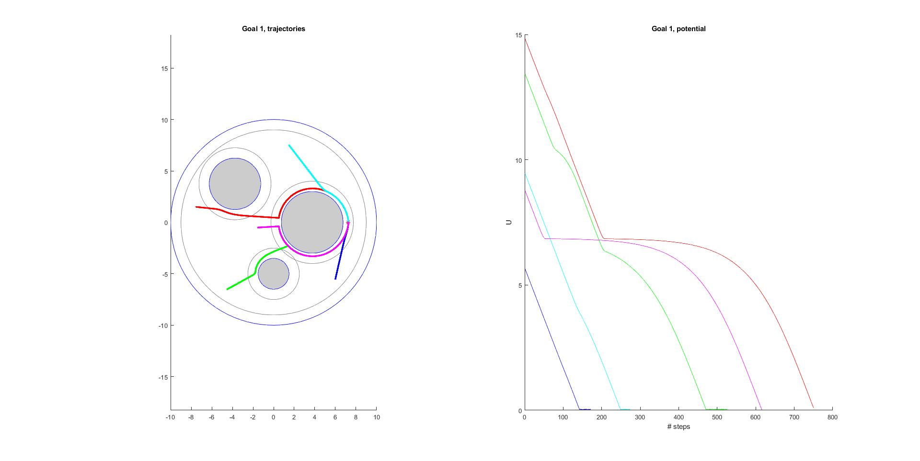**Question 2.1: Figures for Conic and Quadratic Potential Based Planner**

Figure c) Conic, epsilon 0.1 and repulsive weight = 0.05

Zoomed in view of Goal 1 (left) and Goal 2 (right) showing the goal being reached for goals 1 and 2 respectively. These images demonstrate the “chattering” effect that can occur with conics.

Figure d) Quadratic, epsilon =0.001 and repulsive weight = 0.01

Figure e) Quadratic, epsilon = 0.01 and repulsive weight = 0.075

Figure f) Quadratic, epsilon =0.0125 repulsive weight = 0.075

Zoomed in view of approach to Goal 1 (left) and Goal 2 (right). Notice that the step size gets incrementally smaller as it approaches the goal, and therefore it never actually reaches the goal.

Figure a) Conic, epsilon = 0.01 and repulsive weight = 0.01

Figure b) Conic, epsilon = 0.05 and repulsive weight = 0.05

Figure g) Quadratic, epsilon 0.075 and repulsive weight of 0.1

**Question 2.2: Total Potential and Total Potential Gradient Visualization**

Figure h) Conic repulsive potential = 0.01. Corresponds to figure a

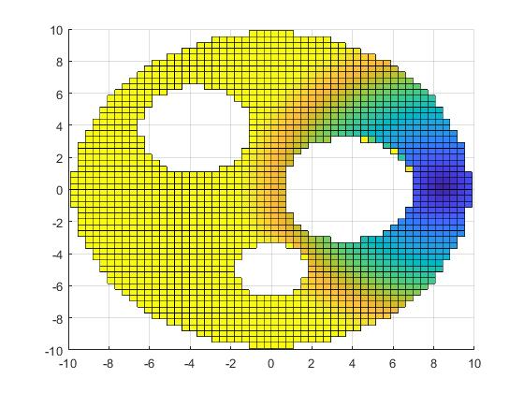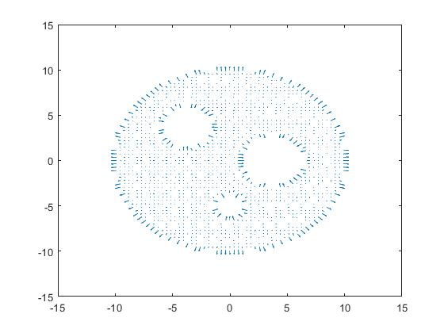

Figure i) Conic repulsive potential = 0.05 Corresponds to figures b and c

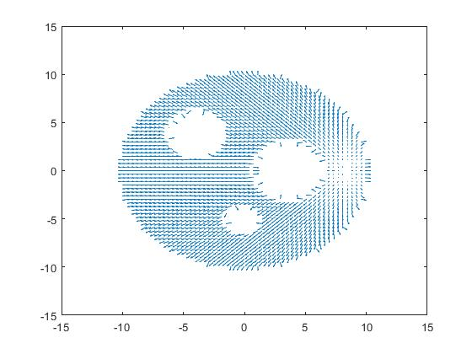

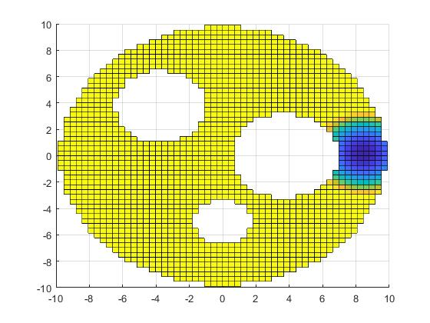

Figure j) Quadratic repulsive potential = 0.01. Corresponds to figure d

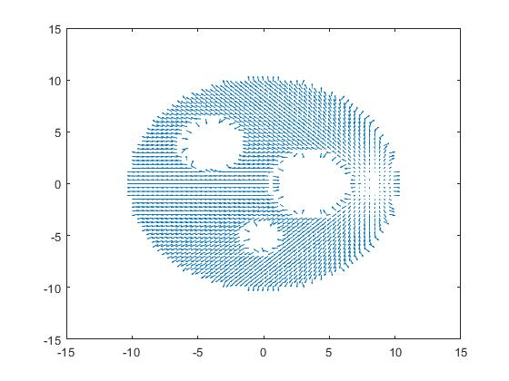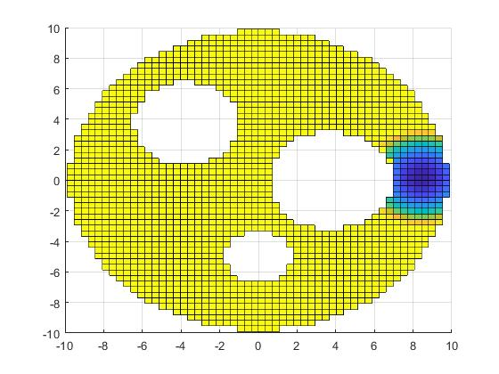

Figure k) Quadratic repulsive potential = 0.075. Corresponds to figures e and f

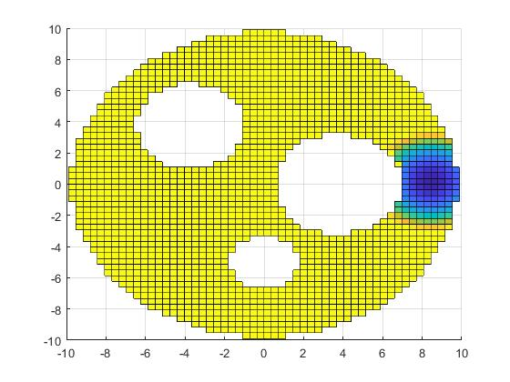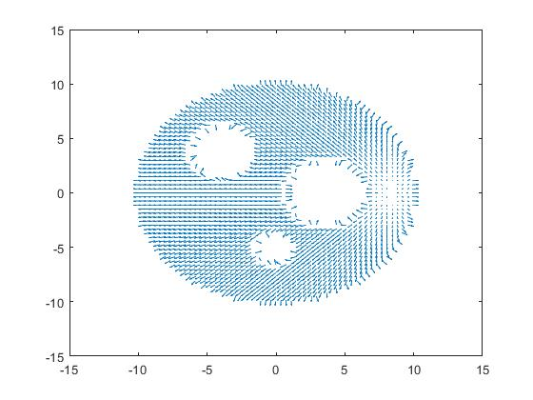

Figure k) Quadratic repulsive potential = 0.1. Corresponds to figure g

**Question 2.3: Effects of Epsilon and Repulsive Weight on Planner Performance**

For the conic planner (*figures a, b, and c)*, it does not reach the goal for lower values of epsilon (*figures a and b*). It only reaches the goal at relatively high values of epsilon (*figure c*). Once it does reach the vicinity of the goal, the chattering effect is observed as the planner causes the robot to bounce back and forth over the goal, since the step size is too large to allow it to successfully “reach” the goal without overshooting it.

For the quadratic planner (*figures d, e, and f*), it runs into an issue where it never technically reaches the goal because the step size is reduced as the robot gets closer to the goal. However, it gets relatively close to the goal (*figure f*) with a much smaller epsilon value than the conic. Larger values of epsilon (*Figure g, below)* allow some starting locations to reach the goal. However, these values also cause errors in for other starting locations, where the planner the robot to either get “stuck” inside of the obstacles or end up very far outside of the configuration space. This is likely because the step size is too large, regardless of the repulsive weights and the planner causes it to step too far toward the obstacle.

Specific scenarios for values of epsilon and repulsive weight:

* **Small epsilon/Small repulsive weight**: In this particular case, both the conic and quadratic planners did not reach the goal, although they did not run into any errors either.
  + This was similar to what we discussed in class because too small of a step size (epsilon) means that it takes too long for the robot to reach the goal.
* **Small epsilon/Small repulsive weight**: This case was similar to the above case, in that both versions of the planner never had the robot reach the goal, or even get very close.
  + The reason being is that the step size was still too small, so the robots never even got very close to the obstacles. Again, this is to be expected from class discussion and intuition.
* **Large epsilon/Small repulsive weight**: This case caused some issues with the quadratic planner because for several of the starting locations, the planner would step too far toward the object and either get stuck in/on the obstacle or end up “launched” outside of the configuration space (*similar to figure g, above*). However, it was the only way that the conic planner was actually able to reach the goal (*figure c*). So, the performance in this scenario was very dependent on the shape.
  + This dramatic change in position for the quadratic is likely because it stepped too close to the object where the repulsive potential goes to infinity, thus causing the gradient to be extremely large and the next step to push the robot out of the sphere world entirely. This could occur when the influence distance is less than the step size, because in this case the repulsive potential will have no effect on the next step in the path, allowing the planner to step too close, or “into” the obstacle. While this makes sense mathematically, it doesn’t really reflect what I expected from what we did in class. In practice, I would also expect the robot to be unable to teleport to a new location instantaneously, and so I intuit that once it began moving (rapidly) away, the potential should return to a valid condition and the planner should work normally.
* **Large epsilon/Large repulsive weight:** This generally had the best performance from both the conic and the quadratic planners, with both essentially behaving the same and reaching the goal from the same start locations (*teal and blue*). The same issue of the quadratic planner getting stuck still occurred but because the repulsive potential was much higher from the obstacles, the conic was also stuck for the same starting locations (*red, magenta, and green*) as the quadratic.
  + This was what I had expected from class because as the repulsive potential gets larger, the planner will be more likely to get stuck between obstacles and end up in a local minimum.

**Question 2.4: Relation between value of potential U and success/failure to reach goal**

The planner was able to guide the robot successfully to the goal in the cases when the potential, ***U*** was able to successfully reach zero, or get close to zero.If the slope of the potential curve was steep enough to reach zero in the number of steps, NSteps = 100 it was able to successfully reach the goal location (*figure g, blue and teal*). If the potential curve was not steep enough to reach zero in NSteps, it failed to reach the goal, but it may reach the goal if provided sufficiently more steps (*figure e, green*).

However,if the robot got stuck, the potential tended to show a relatively flat line from the stuck point to the cutoff point NSteps = 100 and the robot failed to reach the goal entirely (*figure c, magenta)*. In this case it is unclear if more steps would allow it to reach the goal. In the other cases, when the robot ended up either inside of an obstacle or jettisoned outside of the sphere world, the potential curve ended abruptly where the error occurred and it also failed to reach the goal (*figure g, red, green, magenta*).

**Question 2.5: Difference between goals and Effect of shape**

The difference between the goals provided was the fact that **Goal 1** was inside of the influence of one of the obstacles, whereas **Goal 2** was outside of the obstacle’s influence. This had an effect on the trajectory of the robot as it approached the goal. In some cases, (*figure g, goal 1*) it meant that the repulsive potential from the object was too strong for the robot to actually reach the goal point. Or, in other cases, (*figure c, goal 1*) it caused the robot to chatter away, and then toward the goal location as the repulsive potential pushed it away from the obstacle. In the case of **Goal 2,** if the robot was able to reach **Goal 2** it usually stopped at the goal location. The exception is the conic case, where sometimes chattering would occur as the planner caused the robot to repeatedly overstep the goal (*figure c*).

**Question 3.1: Expression for**