foieGras an R package for animal movement data: rapid quality control, behavioural estimation and simulation

# Abstract

### Keywords:

# 1 | Introduction (388)

The collection of animal-borne sensor data has become essential for understanding the movements, behaviour, social interactions, foraging ecology, physiology, habitat use and population dynamics of mobile and/or cryptic species. In addition, the sophistication and precision of current sensor technology now enables the use of tagged animals to collect *in situ* environmental information that compliments data collected from traditional Earth observing platforms (McMahon et al., 2021). However, in each of these applications, common issues with tracking data such as irregularly timed measurements, sensor biases and location measurement errors must be overcome. Underlying animal movement processes must also be adequately characterised before robust inferences can be made about where animals are and what they are doing when they record or transmit information.

State-space models (SSMs) are powerful tools for conducting quality control of and making behavioural inference from animal tracking data (Patterson et al., 2008). Within this framework, an animal’s true location and/or behaviour in the wild are unobserved states, while measurements recorded by animal-borne sensors provide noisy observations. The SSM comprises both a movement process model (e.g., a correlated random walk) and a measurement model that are fit to animal tracks to estimate true location and behaviour states, thereby separating ecologically-meaningful signals from the noise of sensor measurements.

Here we introduce foieGras (pronounced “*fwah grah*”), a package for fitting SSMs in R (R Core Team, 2021). This package has two aims: (1) to be a simple and fast implementation of SSMs to quality control error-prone animal location data (Jonsen et al. 2020); and (2) for inference of changes in behaviour along animal tracks (Jonsen et al., 2019). Although several implementations of SSMs for animal movement data exist, e.g. bsam (Jonsen et al., 2005), crawl (Johnson et al., 2008), and ctmm (Calabrese et al., 2016), their utility often is hampered by their technical complexity. foieGras has a more user-friendly implementation suitable for novices, yet users can exert control over many aspects of the package functions via optional arguments, accommodating the needs of experienced users.

We describe the main features of foieGras and illustrate its use through a set of applications drawing on Argos and GPS tracking data. Full R code and data for each of the applications is provided in the Supporting Information. Additional details on package functions and use can be found in the help files and package vignettes.

# 2 | foieGras overview (1573)

The workflow for foieGras is deliberately simple, with many of the usual data processing and formatting steps handled automatically. Here we describe the main capabilities of foieGras and list the main functions in Table 1.

## 2.1 | Data preparation

Animal tracks, consisting of a time-series of location coordinates for multiple animals, are read into R as a data frame. The canonical data format for Argos tracks consists of a data frame with 5 columns corresponding to the following named variables: id (animal id), date (date and time), lc (location class), lon (longitude), lat (latitude). Optionally, an additional 3 columns, smaj (semi-major axis), smin (semi-minor axis), eor (ellipse orientation), providing Argos error ellipse information may be included.

Other non-Argos location data types can be accommodated by foieGras including GPS, processed light-level geolocations, acoustic telemetry, coded VHF telemetry etc. These can be specified by modifying the lc column. In the case of GPS data, all lc = "G" and measurement error in the GPS locations is assumed to have a standard deviation of 0.1 x Argos class 3 locations (approximately 30 m). If location standard errors exist, these can be added by appending the columns lonerr and laterr to the data (see the Overview vignette for further details). Other data types are classified as “General” and rely on user inputs.

## 2.2 | State-space model fitting - fit_ssm

State-space models are fit using the function fit_ssm. Based on the inputs to lc and optional information on measurement errors outlined above, an appropriate error model is automatically selected for each observation (Jonsen et al., 2020). This capability allows different tracking data types, such as Argos and GPS, to be combined in a single input data frame and to be fit in a single SSM.

There are a large number of arguments that can be set in fit_ssm, and these are explained in the documentation. We focus on the essential arguments here:

* data the input data structured as described in **2.1**
* model the process model to be used
* time.step the prediction time interval (h)

The function first invokes an automated data processing stage where the following occurs: 1) data type (Argos Least-Squares, Argos Kalman Filter/Smoother, GPS, or General is determined; 2) date-times are converted to POSIXt format, chronological order is ensured, and duplicate date-time records are removed; 3) observations occurring less than min.dt seconds after a prior observation are removed (default: 60 s); 4) a speed filter [sda from the trip R package; Sumner et al. (2009)] is used to identify potential extreme locations to be ignored by the SSM; 5) locations are projected from spherical lon,lat coordinates to global Mercator x,y coordinates in km.

The function then fits a state-space model to the processed data, where the process model (one of rw, crw, or mp) is specified by the user via the model argument, and the measurement model(s) are selected automatically. The model is fit by numerical optimization of the likelihood using either optim or nlminb. The R package TMB, Template Model Builder (Kristensen et al., 2016), is used to compute the gradient function in C++ via reverse-mode auto-differentiation and the Laplace Approximation is used to integrate out the latent states (random effects). Fits to one versus multiple individuals are handled automatically, with sequential SSM fits occurring in the latter case. No hierarchical or pooled estimation among individuals is currently available.

fit_ssm returns a ssm_df fit object (a nested data frame with class ssm_df). The outer data frame lists the individual id(s), basic convergence information and a list with class ssm. This list contains fairly dense information on the estimated parameters and states, predictions, processed data, optimizer results, and other diagnostic and contextual information.

Users can extract a simple data frame of SSM fitted (location estimates corresponding to the observation times) or predicted values (locations predicted at regular time.step intervals) using the grab function. Parameter estimates, AIC and other model fit information can be viewed in tabular form using summary.

## 2.3 | Behavioural estimation - fit_ssm, fit_mpm

Move persistence, an index of the consistency of along-track movements based on autocorrelation in speed and direction, can be estimated as a continuous (0 - 1), time-varying latent variable that represents changes in movement behaviour (Jonsen et al., 2019). There are two approaches in foieGras for estimating move persistence. The first is to use fit_ssm with model = 'mp', which fits a continuous-time move persistence model in state-space form, simultaneously estimating true locations and move persistence from error-prone telemetry data. This approach is most appropriate for fitting to irregularly-timed and error-prone Argos data as both components are taken into account explicitly. The second is to pass either location data with minimal error (e.g. GPS locations), or SSM-estimated regular locations from an ssm_df fit object to fit_mpm. We illustrate both approaches in Application 3.2.

## 2.4 | Model checking and visualization - osar, plot, map

foieGras implements three techniques to check and visualize model fit to confirm a fit_ssm model adequately describes the data:

1. the osar function computes one-step-ahead (prediction) residuals (Thygesen et al., 2017) for x and y values from the fitted model via the oneStepPredict function from the TMB R package. plot.osar visualizes osar residuals as time-series plots, quantile-quantile plots, or autocorrelation functions.
2. the plot.ssm_df function can be applied to ssm_df fit objects to plot fitted or predicted values alongside observations as either 1-D time-series (type = 1), or as 2-D tracks with 95% confidence intervals or ellipses type = 2). When the fitted SSM is the move persistence model (i.e., model = 'mp'), 1-D time-series (type = 3) or 2-D track plots (type = 4) of move persistence behaviour can be viewed.
3. The map function can be applied to fit_ssm objects to generate maps for single or multiple individuals. By default, map uses coastline data from the rnaturalearth R package (South, 2022a) if the rnaturalearthhires (South, 2022b) R package is installed, but can also use tiled maps for finer-scale detail, if the rosm (Dunnington, 2019) and ggspatial (Dunnington, 2021) R packages are installed. Mapping aesthetics (e.g., plot symbols, sizes, colours, fills) can be customized via the aes and aes_lst functions. See code in SI for examples.

~~All foieGras visualizations draw on the ggplot2 R package (Wickham, 2016), with multi-panel plots also using the patchwork R package (Pedersen, 2020), and generally can be modified through additive calls in the usual ggplot2 manner. See code in SI for examples.~~

## 2.5 | Simulation - sim, simfit, sim_filter

Track simulation can be helpful for evaluating the degree to which statistical movement models capture essential features of animal movement data (Michelot et al., 2017). The sim function can simulate a variety of movement processes, including the rw, crw, and mp process models, as well as simple multiple movement state switching processes (e.g. transiting to foraging). Simulations from different process models can be used to evaluate the robustness of SSM location and move persistence estimates to model misspecification (see SI).

Simulation is also used frequently in habitat usage modelling to provide a measure of habitat availability (Aarts et al., 2012) by generating a source of ‘background’ points representing a null model of the distribution of foraging animals in the absence of external drivers (Hindell et al., 2020; S. J. Phillips et al., 2009; Raymond et al., 2015). The simfit function extracts movement parameters from a ssm_df fit object and simulates a user-defined number of random tracks of the same duration from these parameters. The argument cpf = TRUE allows the user to simulate central place foragers by ensuring that the simulated tracks start and end at approximately the same location. It is possible to constrain movements to remain mostly in water via a potential function (Preisler et al., 2013), implemented by the grad and beta arguments. These are illustrated in the code for Application 3.3.

The choice of null points can have a large impact on the performance of habitat suitability models (Lobo et al., 2010; S. J. Phillips et al., 2009; Hazen et al. 2021), and so the sim_filter function provides a tool to filter the simulated tracks based on their similarity to the original path. The filtering is based on one of two metrics that capture the difference in the net displacement and bearing between the two paths (see similarity_flag for more detail). This metric is motivated by the ‘flag value’ described in Hazen et al. (2017). The user can also specify the quantile of flag values to retain; i.e. keep = 0.25 (the default) will return a simfit object containing those simulated tracks with flag values in the top 25% of values calculated for the input simfit object.

## 2.6 | Path rerouting - route_path

As the SSMs implemented in foieGras have no information about potential barriers to animal movement it is possible for locations to be estimated in implausible locations, such as on land for marine species. To overcome this, foieGras makes use of the pathroutr R package (London, 2020) to efficiently re-route locations from land back to water by using visibility graphs (Jan et al., 2014). The route_path function can be applied to either a fit_ssm model fit (ssm_df object) or the simulations generated by simfit. When the input is an ssm_df object the re-routed path can be appended to the object for visualisation and use in subsequent analyses. When the input is a simfit object the locations within the simulation are replaced with the re-routed paths. We illustrate how the latter can be achieved in Application 3.3.

# 3 | Applications (904)

We illustrate the main capabilities of foieGras through a set of applications for demonstration purposes only, not intended as a comprehensive guide for conducting analyses with foieGras. More complete code and data for reproducing the applications and for gaining a deeper understanding of foieGras functions are provided in the Supplementary Information.

## 3.1 | SSM validation with prediction residuals

We use a sub-adult male southern elephant seal (*Mirounga leonina*) track included as example data in foieGras (sese2, id: ct36-E-09), sourced from from the Australian Integrated Marine Observing System (IMOS; data publicly available via [imos.aodn.org.au](http://imos.aodn.org.au)) deployments at Îles Kerguelen in collaboration with the French IPEV and SNO-MEMO programmes. The data are temporally irregular Argos Least-Squares based locations, 74 % of which are in the poorest location quality classes: A and B. We fit both the rw and crw models using fit_ssm with a speed filter threshold (vmax) of 4 ms-1 and a 12-h time step. We calculate prediction residuals using osar, and then use the generic plot method for osar residuals to assess and compare the model fits (Fig. ).

Is there space to write a code block for each example rather than directing the reader to SI? Or could we have an inset panel somewhere with a single set of example code?

fit.rw <- fit_ssm(sese1, vmax = 4, model = “rw”, time.step = 12)

re.rw <- osar(fit.rw)

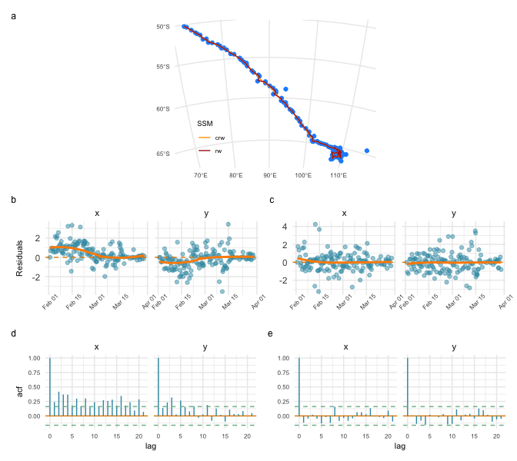

State-space model fits to a southern elephant seal track (a), and diagnostic plots for assessing goodness-of-fit of the rw (b - prediction residual time-series; d - prediction residual autocorrelation) and crw (c,e) state-space models. All residual plots generated using the plot.osar function.

The plots of predicted states on top of the observations suggest both models yield similar fits (Fig. a; orange vs red lines). However, corresponding predicted locations from the two models differ by a median 6.62 km (range: 0.02, 53.02 km), and there are marked trends in the time-series of residuals for the rw model fit (Fig. b) with significantly positive autocorrelation in both the x and y directions (Fig. d). The crw prediction residuals show little trend through time and have relatively little autocorrelation (Fig. c,e), implying that the crw process model provides a better fit to the data.

## 3.2 | Inferring move persistence from Argos and GPS data

### *Argos data - southern elephant seals*

Drawing on additional IMOS tracking data from Îles Kerguelen, we infer move persistence, $γ_{t}$, along four southern elephant seal tracks. We fitted the mp SSM with a 12-h prediction interval with fit_ssm, using the Argos Kalman filter-derived error ellipse provided with each observation (Jonsen et al., 2020). The mp SSM simultaneously estimates locations and $γ_{t}$, and their uncertainties. We then assess how $γ_{t}$ changes along the seals’ tracks to infer regions where the seals spend disproportionately more or less time during their foraging trips.

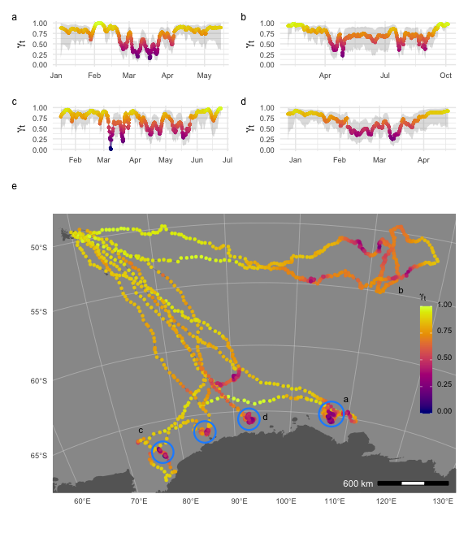

Inferred move persistence, $γ_{t}$, time-series for four southern elephant seals (a-d; grey envelopes are 95 % CI’s, note differing date ranges on the x axes), and along their 2-D tracks (e; track labels, a-d, correspond to the time-series plots). Locations associated with low $γ_{t}$ (purple) are indicative of slow, undirected movements, whereas high $γ_{t}$ (yellow) is indicative of faster, directed movements. Blue circles highlight bouts of spatially constrained low $γ_{t}$.

The three southern elephant seals that foraged in the Antarctic shelf region all engaged in spatially constrained bouts of low move persistence while over the shelf (Fig. a,c,d; blue circles in e). Without additional data it is unclear exactly what these bouts of low move persistence represent. They could reflect area-restricted search and foraging within dense prey aggregations, physical constraints of dense ice on horizontal movements, resting on sea-ice, or some combination of these. Conversely, the seal on a pelagic foraging trip engaged in slower, more meandering movements with less spatially constrained bouts of lower move persistence (Fig. b, e). This general movement pattern may be consistent with searching for suitable foraging resources within the highly variable eddy fields between the Subantarctic and Polar Fronts (Jonsen et al., 2019).

### *GPS data - little penguins*

To illustrate how move persistence can be estimated from non-Argos animal tracking data, we use four little penguin (*Eudyptula minor*) GPS tracks from daily foraging trips during the chick-rearing period from Montague Island, NSW, Australia, and described in L. Phillips et al. (2021). The data are temporally irregular GPS locations, with high frequency sampling (15 s on average) intermittently disrupted by the birds’ diving behaviour. We fitted the crw SSM to the GPS data to predict temporally regular locations at 5-min intervals, and assumed consistently small bivariate normal location measurement errors (ie. $±$ 10 m sd). We then used fit_mpm to estimate $γ_{t}$ from these regularised locations.

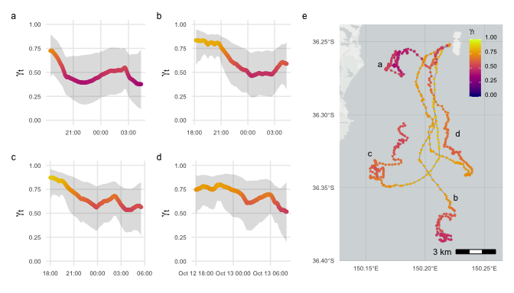

Inferred move persistence, $γ_{t}$, 1-D time-series (a-d; grey envelopes are 95 % CI’s) and along little penguin GPS tracks (e).

The little penguins departed Montague Is. with relatively fast movements, three directed southward (Fig. tracks b-d in e) and one less directed and remaining close to the island (track a), before slowing down and engaging in meandering movements (orange - red in Fig. e). The spatially diffuse bouts of relatively low move persistence within the penguin tracks may reflect the fine-scale patchiness of their forage-fish prey with search and prey-capture occurring both within and among discrete neighbouring prey aggregations (Carroll et al., 2017). **Lach/Gemma could we overlay SVM-inferred prey captures for these birds? (G123f02, G124m10, G126m05, L013m01)**

## 3.3 | Simulating tracks from foieGras model fits

To illustrate how to simulate tracks from foieGras model fits we use a juvenile harp seal (*Pagophilus groenlandicus*) track from the Gulf of St Lawrence, Canada, described in Grecian et al. (2022). The data are temporally irregular Argos locations including error ellipse information. We fit the crw model using fit_ssm with a 4 ms-1 speed filter threshold (vmax) and a 12-h prediction interval (time.step). fit_ssm(locs, model = “crw”, vmax = 4, time.step = 12)

We simulated 50 animal movement paths from the crw process model using simfit, and applied a potential function using the grad and beta arguments to constrain the simulated paths to largely remain in water. These tracks were then filtered based on their similarity to the original path using sim_filter and the top 10% retained (keep = 0.1)(Fig. a,b). As the potential function does not guarantee all locations remain off land, we re-routed any remaining simulated locations from land back to water using route_path (Fig. c). In combination, these functions provide a pragmatic approach to generate and objectively filter pseudo-tracks for use in movement or habitat modelling applications.

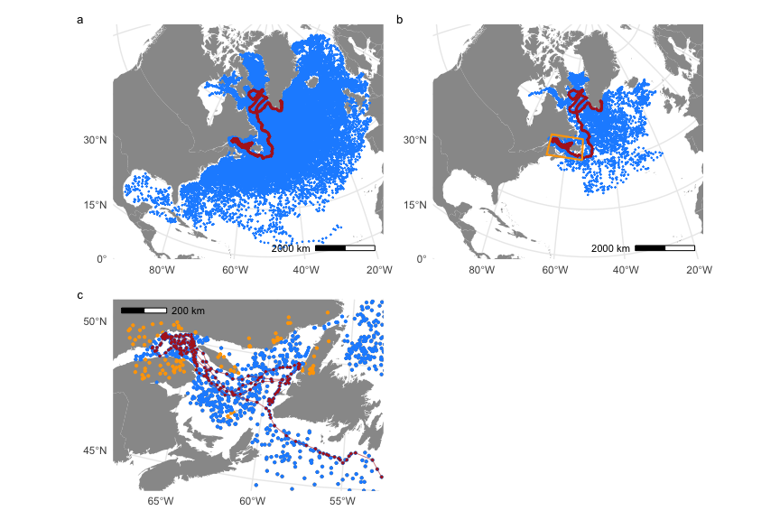

Simulating (a) 100 movement paths from a correlated random walk process model; (b) filtering those tracks to select the top 10% based on their similarity to the original SSM-predicted track (red); and (c) re-routing simulated locations on land (orange) back to ocean (blue). The orange box in (b) indicates region magnified in (c). SSM-predicted track (red) overlaid in all panels for context.

# 4 | Conclusions (159)

The foieGras package facilitates fitting state-space models for quality control of animal location data and for inferring behavioural change along animal tracks. We achieve these goals via a simple yet extensible workflow, model parsimony, and computational speed. These traits accommodate both novice and advanced users, and facilitate use in automated, operational quality-assurance/quality-control processes for animal-borne ocean observations (Jonsen et al., 2020; McMahon et al., 2021).

Future extensions of the functionality of foieGras include use of a hidden Markov model to infer relationships between behaviour and environmental or individual covariates (McClintock & Michelot, 2018; e.g., Michelot et al., 2016) and the inference of move persistence - covariate relationships among multiple individuals in a mixed-effect model framework using the mpmm package [Jonsen et al. (2019); <https://github.com/ianjonsen/mpmm>].

# **Error! Hyperlink reference not valid.Error! Hyperlink reference not valid.**Acknowledgements

We thank Marie Auger-Méthé for contributing original code to the movement persistence models. IDJ acknowledges support from a Macquarie University co-Funded Fellowship and from partners: the US Office of Naval Research, Marine Mammal Program (grant N00014-18-1-2405); the Integrated Marine Observing System (IMOS); Taronga Conservation Society; the Ocean Tracking Network; Birds Canada; and Innovasea/VEMCO. TAP was supported by CSIRO Oceans & Atmosphere internal research funding scheme. IMOS supported seal fieldwork. IMOS is a national collaborative research infrastructure, supported by the Australian Government and operated by a consortium of institutions as an unincorporated joint venture, with the University of Tasmania as Lead Agent. Field work at Illes Kerguelen was conducted as part of the IPEV programme No 109 (PI H. WEIMERSKIRCH) and of the SNO-MEMO programme (PI C. GUINET) in collaboration with IMOS. CTD tags funded by CNES-TOSCA and IMOS. Little penguin fieldwork supported by an Australian Research Council Linkage grant to IDJ, GC and RGH (LP160100162). Harp seal fieldwork funded by Fisheries and Oceans Canada and a bursary from Department for Business, Energy and Industrial Strategy (BEIS) administered by the NERC Arctic Office. All animal tagging procedures approved and executed under the Animal Ethics Committee guidelines of Macquarie University (elephant seals & little penguins), Canadian Council on Animal Care and University of St Andrews (harp seals).

# Author’s Contributions

IDJ developed the R package; WJG contributed harp seal data and to the R package; LP, GC, and RGH contributed little penguin data; CRM and RGH contributed southern elephant seal data; IDJ and TAP developed the state-space models; IDJ wrote an initial draft of the manuscript with contributions from WJG; all authors edited the manuscript.

# Data Accessibility

All code and data used here are provided in the foieGras package for R or in the Supplementary Information. The latest stable and cross-platform tested version of the package (currently, 1.0-7) is available via ROpenSci’s R-universe, at <https://ianjonsen.r-universe.dev/ui#package:foieGras>. The latest partially tested stable and development versions are available on the GitHub repository: <https://github.com/ianjonsen/foieGras>. An older version of foieGras (0.7-6) remains on CRAN at , however, we recommend users upgrade to the latest R-universe version for full access to the functionality presented here.

# ORCID

*Ian D Jonsen*   
*W James Grecian -* 0000-0002-6428-719X  
*Lachlan Phillips*   
*Gemma Carroll* - 0000-0001-7776-0946  
*Clive R McMahon*   
*Robert G Harcourt*   
*Mark A Hindell*   
*Toby A Patterson*

# References

Aarts, G., Fieberg, J., & Matthiopoulos, J. (2012). Comparative interpretation of count, presence–absence and point methods for species distribution models. *Methods in Ecology and Evolution*, *3*(1), 177–187. <https://doi.org/10.1111/j.2041-210x.2011.00141.x>

Albertsen, C. M., Whoriskey, K., Yurkowski, D., Nielsen, A., & Mills Flemming, J. (2015). Fast fitting of non-Gaussian state-space models to animal movement data via Template Model Builder. *Ecology*, *96*, 2598–2604.

Auger-Méthé, M., Albertsen, C. M., Jonsen, I. D., Derocher, A. E., Lidgard, D. C., Studholme, K. R., Bowen, W. D., Crossin, G. T., & Flemming, J. M. (2017). Spatiotemporal modelling of marine movement data using Template Model Builder (TMB). *Marine Ecology Progress Series*, *565*, 237–249.

Baktoft, H., Gjelland, K. Ø., Økland, F., & Thygesen, U. H. (2017). Positioning of aquatic animals based on time-of-arrival and random walk models using YAPS (yet another positioning solver). *Scientific Reports*, *7*, 14294. <https://doi.org/10.1038/s41598-017-14278-z>

Calabrese, J. M., Fleming, C. H., & Gurarie, E. (2016). Ctmm: An R package for analyzing animal relocation data as a continuous-time stochastic process. *Methods in Ecology and Evolution*, *7*, 1124–1132.

Carroll, G., Cox, M., Harcourt, R., Pitcher, B., Slip, D., & Jonsen, I. (2017). Hierarchical influences of prey distribution on patterns of prey capture by a marine predator. *Functional Ecology*, *31*, 1750–1760.

Dunnington, D. (2019). *Rosm: Plot raster map tiles from open street map and other sources*. <https://CRAN.R-project.org/package=rosm>

Dunnington, D. (2021). *Ggspatial: Spatial data framework for ggplot2*. <https://CRAN.R-project.org/package=ggspatial>

Grecian, W. J., Stenson, G. B., Biuw, M., Boehme, L., Folkow, L. P., Goulet, P. J., Jonsen, I. D., Malde, A., Nordøy, E. S., Rosing-Asvid, A., & Smout, S. (2022). Environmental drivers of population-level variation in the migratory and diving ontogeny of an arctic top predator. *Royal Society Open Science*, *9*(3). <https://doi.org/10.1098/rsos.211042>

Hazen, E. L., Palacios, D. M., Forney, K. A., Howell, E. A., Becker, E., Hoover, A. L., Irvine, L., DeAngelis, M., Bograd, S. J., Mate, B. R., & Bailey, H. (2017). WhaleWatch: a dynamic management tool for predicting blue whale density in the California Current. *Journal of Applied Ecology*, *54*(5), 1415–1428. <https://doi.org/10.1111/1365-2664.12820>

Hindell, M. A., Reisinger, R. R., Ropert-Coudert, Y., Hückstädt, L. A., Trathan, P. N., Bornemann, H., Charrassin, J.-B., Chown, S. L., Costa, D. P., Danis, B.others. (2020). Tracking of marine predators to protect southern ocean ecosystems. *Nature*, *580*(7801), 87–92.

Hooten, M. B., Scharf, H. R., & Morales, J. M. (2019). Running on empty: Recharge dynamics from animal movement data. *Ecology Letters*, *22*, 377–389.

Jan, G. E., Sun, C.-C., Tsai, W. C., & Lin, T.-H. (2014). An o(n log n) shortest path algorithm based on delaunay triangulation. *IEEE/ASME Transactions on Mechatronics*, *19*(2), 660–666. <https://doi.org/10.1109/TMECH.2013.2252076>

Johnson, D. S., London, J. M., Lea, M.-A., & Durban, J. W. (2008). Continuous-time correlated random walk model for animal telemetry data. *Ecology*, *89*(5), 1208–1215.

Jonsen, I. D., Basson, M., Bestley, S., Bravington, M. V., Patterson, T. A., Pedersen, M. W., Thomson, R., Thygesen, U. H., & Wotherspoon, S. J. (2013). State-space models for bio-loggers: A methodological road map. *Deep Sea Research II*, *88-89*, 34–46.

Jonsen, I. D., McMahon, C. R., Patterson, T. A., Auger-Méthé, M., Harcourt, R., Hindell, M. A., & Bestley, S. (2019). Movement responses to environment: Fast inference of variation among southern elephant seals with a mixed effects model. *Ecology*, *100*, e02566.

Jonsen, I. D., Patterson, T. A., Costa, D. P., Doherty, P. D., Godley, B. J., Grecian, W. J., Guinet, C., Hoenner, X., Kienle, S. S., Robinson, P. W., Votier, S. C., Whiting, S., Witt, M. J., Hindell, M. A., Harcourt, R. G., & McMahon, C. R. (2020). A continuous-time state-space model for rapid quality control of Argos locations from animal-borne tags. *Movement Ecology*, *8*, 31.

Jonsen, I., Flemming, J., & Myers, R. (2005). Robust state–space modeling of animal movement data. *Ecology*, *86*(11), 2874–2880.

Kristensen, K., Nielsen, A., Berg, C. W., Skaug, H., & Bell, B. M. (2016). TMB: Automatic differentiation and Laplace approximation. *Journal of Statistical Software*, *70*, 1–21.

Lobo, J. M., Jiménez-Valverde, A., & Hortal, J. (2010). The uncertain nature of absences and their importance in species distribution modelling. *Ecography*, *33*(1), 103–114. https://doi.org/<https://doi.org/10.1111/j.1600-0587.2009.06039.x>

London, J. M. (2020). *Pathroutr: An r package for (re-)routing paths around barriers* (v0.1.1-beta) [Computer software]. Zenodo. <https://doi.org/10.5281/zenodo.4321827>

McClintock, B. T., & Michelot, T. (2018). MomentuHMM: R package for generalized hidden Markov models of animal movement. *Methods in Ecology and Evolution*, *9*, 1518–1530.

McMahon, C. R., Roquet, F., Baudel, S., Belbeoch, M., Bestley, S., Blight, C., Boehme, L., Carse, F., Costa, D. P., Fedak, M. A., Guinet, C., Harcourt, R., Heslop, E., Hindell, M. A., Hoenner, X., Holland, K., Holland, M., Jaine, F. R. A., Jeanniard du Dot, T., … Woodward, B. (2021). Animal borne ocean sensors – AniBOS – an essential component of the global ocean observing system. *Frontiers in Marine Science*, *8*, 751840.

Michelot, T., Langrock, R., Bestley, S., Jonsen, I. D., Photopoulou, T., & Patterson, T. A. (2017). Estimation and simulation of foraging trips in land‐based marine predators. *Ecology*, *98*(7), 1932–1944.

Michelot, T., Langrock, R., & Patterson, T. A. (2016). MoveHMM: An R package for the statistical modelling of animal movement data using hidden Markov models. *Methods in Ecology and Evolution*, *7*, 1308–1315.

Patterson, T. A., Parton, A., Langrock, R., Blackwell, P. G., Thomas, L., & King, R. (2017). Statistical modelling of individual animal movement: An overview of key methods and a discussion of practical challenges. *AStA Advances in Statistical Analysis*, *101*, 399–438.

Patterson, T. A., Thomas, L., Wilcox, C., Ovaskainen, O., & Matthiopoulos, J. (2008). State-space models of individual animal movement. *Trends in Ecology and Evolution*, *23*, 87–94.

Pedersen, T. L. (2020). *Patchwork: The composer of plots*. <https://CRAN.R-project.org/package=patchwork>

Phillips, L., Carroll, G., Jonsen, I. D., Harcourt, R. G., Brierley, A., Wilkins, A., & Cox, M. (2021). Variability in prey field structure drives inter-annual differences in prey encounter by a marine predator, the little penguin. *Proceedings of the Royal Society B*, *In Review*.

Phillips, S. J., Dudík, M., Elith, J., Graham, C. H., Lehmann, A., Leathwick, J., & Ferrier, S. (2009). Sample selection bias and presence-only distribution models: implications for background and pseudo-absence data. *Ecological Applications*, *19*(1), 181–197. <https://doi.org/10.1890/07-2153.1>

Preisler, H. K., Ager, A. A., & Wisdom, M. J. (2013). Analyzing animal movement patterns using potential functions. *Ecosphere*, *4*, 1–13.

R Core Team. (2021). *R: A language and environment for statistical computing*. R Foundation for Statistical Computing. <https://www.R-project.org/>

Raymond, B., Lea, M.-A., Patterson, T., Andrews-Goff, V., Sharples, R., Charrassin, J.-B., Cottin, M., Emmerson, L., Gales, N., Gales, R., Goldsworthy, S. D., Harcourt, R., Kato, A., Kirkwood, R., Lawton, K., Ropert-Coudert, Y., Southwell, C., Hoff, J. van den, Wienecke, B., … Hindell, M. A. (2015). Important marine habitat off east Antarctica revealed by two decades of multi-species predator tracking. *Ecography*, *38*, 121–129.

Schick, R. S., New, L. F., Thomas, L., Costa, D. P., Hindell, M. A., McMahon, C. R., Robinson, P. W., Simmons, S. E., Thums, M., J., Harwood., & Clark, J. S. (2013). Estimating resource acquisition and at‐sea body condition of a marine predator. *Journal of Animal Ecology*, *82*, 1300–3015.

Service Argos. (2016). *Argos Users’ Manual*. CLS. <http://www.argos-system.org/manual>

South, A. (2022a). *Rnaturalearth: World map data from natural earth*.

South, A. (2022b). *Rnaturalearthhires: High resolution world vector map data from natural earth used in rnaturalearth*.

Sumner, M. D., Wotherspoon, S. J., & Hindell, M. A. (2009). Bayesian estimation of animal movement from archival and satellite tags. *PLoS ONE*, *4*(10). <https://journals.plos.org/plosone/article?id=10.1371/journal.pone.0007324>

Thygesen, U. H., Albertsen, C. M., Berg, C. W., Kristensen, K., & Neilsen, A. (2017). Validation of ecological state space models using the Laplace approximation. *Environmental and Ecological Statistics*. [https://doi.org/DOI: 10.1007/s10651-017-0372-4](https://doi.org/DOI:%2010.1007/s10651-017-0372-4)

Whoriskey, K., Auger-Méthé, M., Albertsen, C. M., Whoriskey, F. G., Binder, T. R., Kreuger, C. C., & Mills Flemming, J. (2017). A hidden markov movement model for rapidly identifying behavioral states from animal tracks. *Ecology and Evolution*, *7*, 2112–2121.

Wickham, H. (2016). *ggplot2: Elegant graphics for data analysis*. Springer-Verlag New York. <https://ggplot2.tidyverse.org>