**Design Doc**

Kobawks

Chris Mupton, Ian Kage, Connor Chaucy, Slater De Mont, Paul Saidi

\\banner.main.ad.rit.edu\students\cmm8397\IGMProfile\Desktop\Platform.png

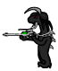

You play as an alien named Kobawks that crashed landed. All your stuff is taken.

Kobawks is a Platform game, where you jump on these platforms to make it through the level and try to get to the end.

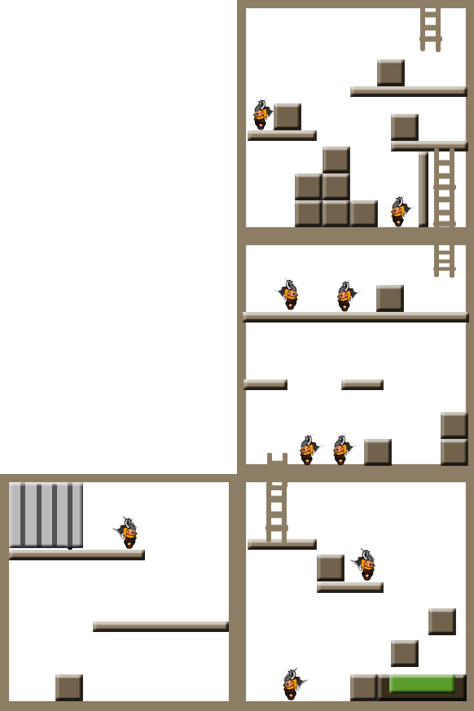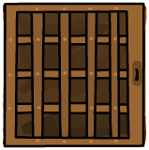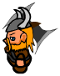

Platforms: Can jump on some, can jump through some.

Ladder: Climb to get to higher area.

Slime Pit: Fall in and die.

Enemy: You can stun enemies or avoid them by jumping over them.

Block: Can jump over and push boxes to solve puzzles.

Level Three

Level Four

Level Two

Level One

You start off in a jail cell. You have escaped and must make your way to your ship. But in order to do so you must make it out of the Viking stronghold.

You must fight bosses, and overcome puzzles to make your way out. You can push blocks and climb ladders and make your way through various levels.

You battle the Vikings with your gun. They’re the ones who trapped you and put you in the basement.