# Running the jar file

To run the .jar file. Open a cmd to the folder where the jar file is located and run java -jar Angular-Assessment-API-0.0.1-SNAPSHOT.jar 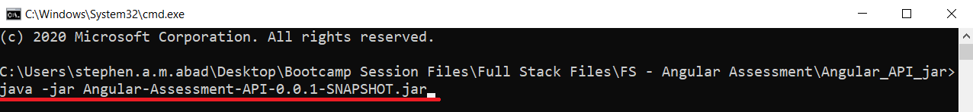If you want to close the running jar file, press Ctrl + C on the command prompt.

# Base URL

http://localhost:8080/api

# Endpoints

## GET /users

Returns a list of all users

### Example Response:

{

"id": 1,

"name": "Maria Anderson",

"email": "maria@test.com",

"contact": "030-0074321"

},

{

"id": 2,

"name": "Antonio Moreno",

"email": "Antonio@gmail.com",

"contact": "(5) 555-3932"

},

{

"id": 3,

"name": "Thomas Hardy",

"email": "thomas@yahoo.com",

"contact": "(171) 555-7788"

}

## GET /users/:id

Returns a single user given an existing id

### Example Response:

{

"id": 1,

"name": "Maria Anderson",

"email": "maria@test.com",

"contact": "030-0074321"

}

## POST /add

Returns a single user given an existing id

### Example Request:

{

"name": "John Smith",

"email": "john.smith@email.com",

"contact": "030-0074321"

}

### Example Response:

{

"id": 4,

"name": "John Smith",

"email": "john.smith@email.com",

"contact": "030-0074321"

}

## PUT /update/:id

Updates the user with the given id and request body and returns the user details upon successful update

### Example Request:

{

"name": "Maria Johnson",

"email": "maria@gmail.com",

"contact": "030-0074321"

}

### Example Response:

{

"id": 1,

"name": "Maria Johnson",

"email": "maria@gmail.com",

"contact": "030-0074321"

}

## DELETE /delete/:id

Deletes the user with the given id. Does not return a response.