**Overview**

IMDb is the world’s most popular and authoritative source for movies, TV and celebrity content. It has been ranked as the #1 movie website in the world with a combined web and mobile audience of more than 250 million unique monthly visitors. Many people rely on critics to gauge the quality of a movie. However, this would require people to take some time to go through a reasonable amount of critics review after a movie is released. Hence, there are people who use their instincts and gut feeling to judge whether a movie is good or not instead but human instinct is sometimes unreliable and herd mentality may influence our judgments as well especially for movies produced by companies such as Marvel, DC Comics, Disney and etc.

**Dataset**

The dataset consists of 5043 movie records with its duration, movie gross, budget and etc. as features. Many people rely on critics to gauge the quality of a movie. However, this would require people to take some time to go through a reasonable amount of critics’ review after a movie is released. Hence, there are people who use their instincts and gut feeling to judge whether a movie is good or not instead but human instinct is sometimes unreliable and herd mentality may influence our judgments as well especially for movies produced by companies such as Marvel, DC Comics, Disney and etc. Therefore, the target is to identify which features of a movie contribute to the IMDb score of the movie the most so that we will be able to better identify a good movie without going through critics’ review and using our instincts.

**Features of a movie**

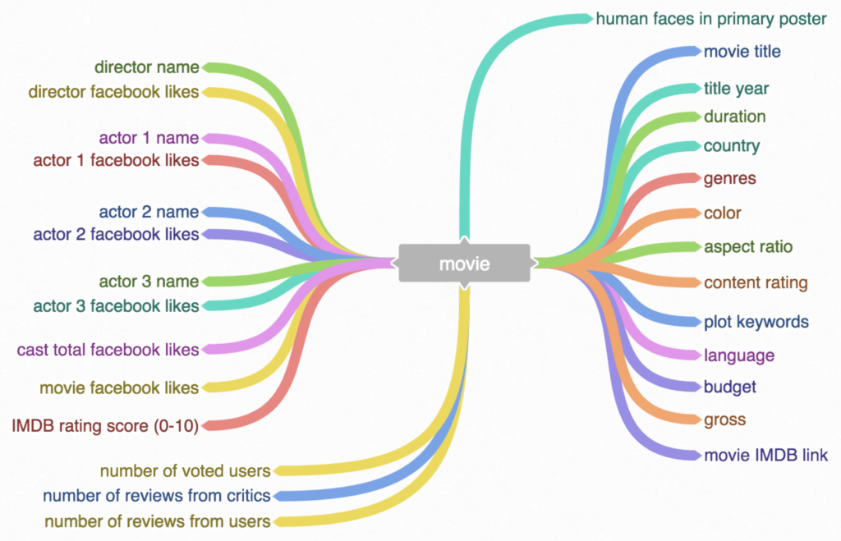

**Actor 1 – 3** refer to the top 3 actors / actresses of a movie who have the most number of Facebook likes on their Facebook page. This is based on an assumption that leading actor / actress tends to have more Facebook popularity than supporting actor / actress and no matter how great a movie is, there will be no more than 2 leading actors/actresses.

**Cast total facebook likes** is calculated by summing up the Facebook popularity of all the available cast members.

**Gross** refers to a movie’s gross earnings in USD.