Voices Silenced
Executed Dissidents of the Islamic Republic of Iran
1979 – 2026
Biographical roster for Carmen Sandiego-style game design.
Thirteen profiles — portrait images included.

About This Roster
This document profiles thirteen executed or imprisoned dissidents from the Islamic Republic of Iran, spanning 1982 to 2026. Each entry is designed as a source card for a pixel art, Carmen Sandiego-style educational game about the ongoing conflict in Iran.
Each profile includes: name, era, biographical text, fate, and the filepath of a 96×96 pixel art portrait generated for use in the game. Portrait images are embedded in this document and also available as standalone PNG files in the accompanying zip archive.

1. Sadegh Ghotbzadeh
Revolutionary Purges (1979–1982)
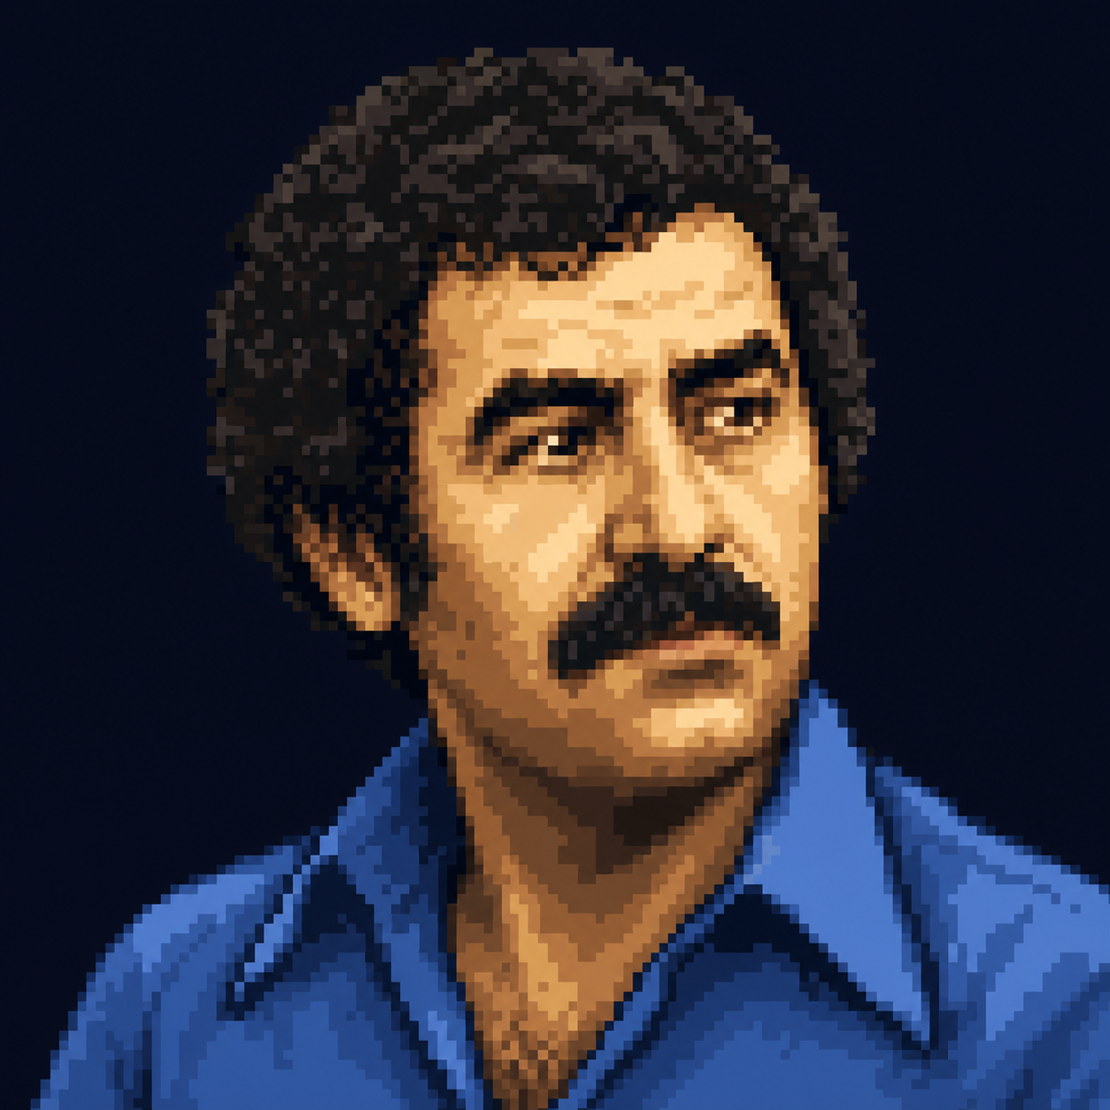 | Born: February 24, 1936  Died / Status: September 15, 1982, age 46  Fate: Executed by firing squad at Evin Prison — by the regime he helped bring to power.  Image file: portrait_ghotbzadeh_v2.png

Biography
Sadegh Ghotbzadeh was one of Ayatollah Khomeini's closest aides during the Paris exile that preceded the 1979 Islamic Revolution. Charismatic and ideologically versatile, he served as the head of Iranian state television and radio immediately after the revolution, then as Iran's Foreign Minister during the American hostage crisis of 1979–1981.
As the revolution's authoritarian character became unmistakable, Ghotbzadeh grew deeply disillusioned. In 1982, he was implicated in an alleged plot to assassinate Khomeini and dissolve the clerical government. Whether the conspiracy was real or manufactured, he was arrested, subjected to a show trial, and executed.
He stands as one of the most tragic figures of the revolution: a founding insider consumed by the system he helped create.
Game Card Tags: Revolutionary Insider · Foreign Minister · Purge Victim

2. Shapour Bakhtiar
Exile Assassinations (1979–1991)
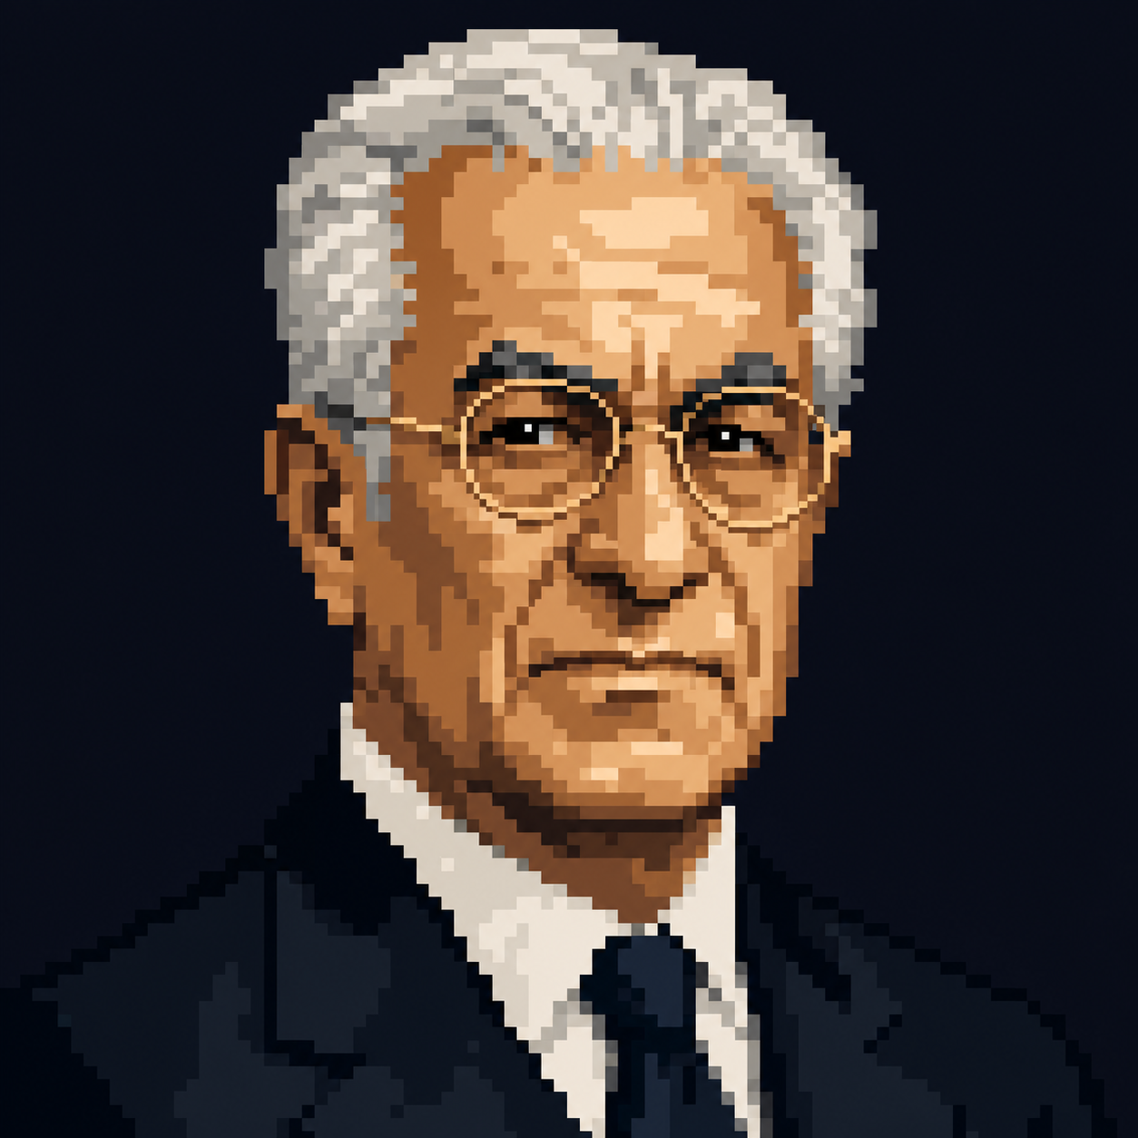 | Born: 1914  Died / Status: August 6, 1991, age ~77  Fate: Stabbed to death by Iranian intelligence agents in his Paris home.  Image file: portrait_bakhtiar_v2.png

Biography
Shapour Bakhtiar was the Shah's last Prime Minister, appointed in a desperate final attempt to steer Iran toward constitutional government before the revolution made it impossible. A lifelong socialist democrat and member of the National Front, he was politically opposed to the Shah's authoritarianism — yet accepted the post out of conviction that Iran needed a lawful transition, not a clerical theocracy.
The Islamic Republic sentenced him to death in absentia in 1979. Bakhtiar fled to France and became the most prominent Iranian opposition figure in exile, broadcasting into Iran, organizing diaspora resistance, and surviving at least one earlier assassination attempt.
In August 1991, IRGC-linked agents reached him. He was found stabbed to death in his Suresnes apartment, along with his secretary. French authorities convicted several Iranian nationals in absentia. IRGC involvement was formally confirmed in 2025.
Game Card Tags: Last PM of the Shah · Democratic Exile · Targeted Assassination

3. Dariush Forouhar & Parvaneh Forouhar
Chain Murders (1998)
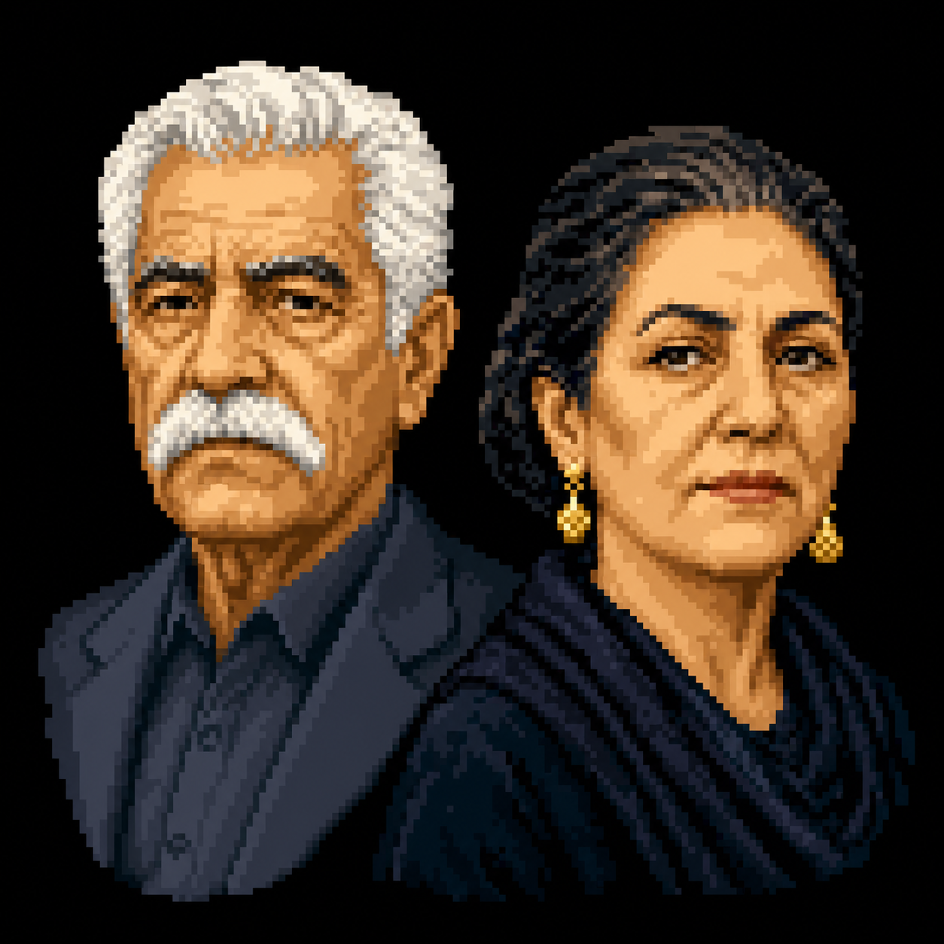 | Born: Dariush: 1928 | Parvaneh: March 20, 1939  Died / Status: Both murdered November 22, 1998 (Dariush, age 70; Parvaneh, age 59)  Fate: Stabbed to death in their Tehran home by Ministry of Intelligence agents. Dariush stabbed 11 times; Parvaneh stabbed 24 times.  Image file: portrait_forouhars_v2.png

Biography
Dariush Forouhar was a towering figure in Iranian nationalist politics — a former Labor Minister under Prime Minister Mosaddegh and a founding leader of the Iran Nation Party. Parvaneh Eskandari Forouhar was a human rights activist and writer who became one of the most vocal defenders of civil liberties in the Islamic Republic.
After the revolution, the couple refused to flee. For two decades they held open democratic salons in their Tehran home — a quiet act of extraordinary defiance. They documented human rights abuses, corresponded with international organizations, and continued publishing.
Their murders in November 1998 exposed the Islamic Republic's covert ''Chain Murders'' program — a Ministry of Intelligence campaign that had killed dozens of intellectuals, writers, and dissidents over the preceding years. The killings became one of the most significant political scandals in the Islamic Republic's history and led to the arrest (though not serious prosecution) of several intelligence officials.
Game Card Tags: Nationalist Couple · Chain Murders · Civil Resistance

4. Fereydoun Farrokhzad
Chain Murders — Exile Killings (1992)
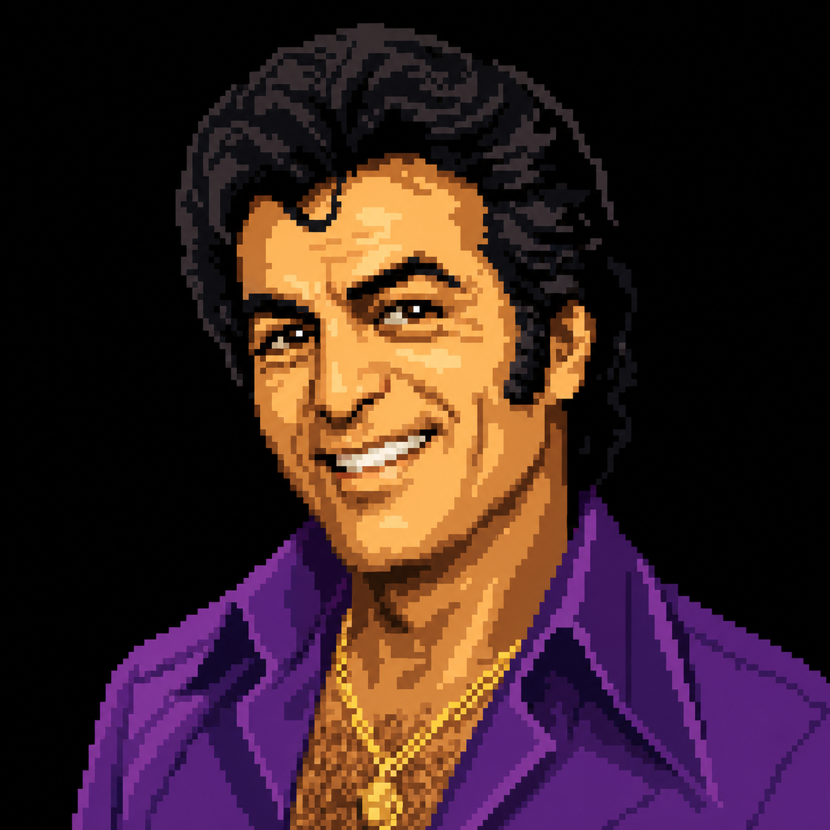 | Born: September 29, 1938  Died / Status: August 7, 1992, age 53  Fate: Stabbed to death in his Bonn, Germany apartment by agents linked to the IRGC.  Image file: portrait_farrokhzad_v2.png

Biography
Fereydoun Farrokhzad was one of Iran's most beloved entertainers: a flamboyant TV host, singer, and comedian who had his own national television program before the revolution. He was also the brother of Forough Farrokhzad, widely regarded as the greatest modern Iranian poet.
After the revolution, Farrokhzad's secular, exuberant persona made him anathema to the clerical government. He settled in Germany, where his television broadcasts reached hundreds of thousands of Iranians in the diaspora. He used his platform to criticize the Islamic Republic with wit and sharpness, and became one of the most listened-to voices in exile media.
In August 1992 he was found stabbed to death in his apartment in Bonn, his body bearing numerous wounds. The killing bore all the hallmarks of an IRGC-directed Chain Murder abroad. In 2025, a former IRGC minister stated publicly that the IRGC had paid foreign agents to carry out such assassinations during this period.
Game Card Tags: TV Celebrity · Exile Voice · Chain Murder Victim

5. Neda Agha-Soltan
Green Movement (2009)
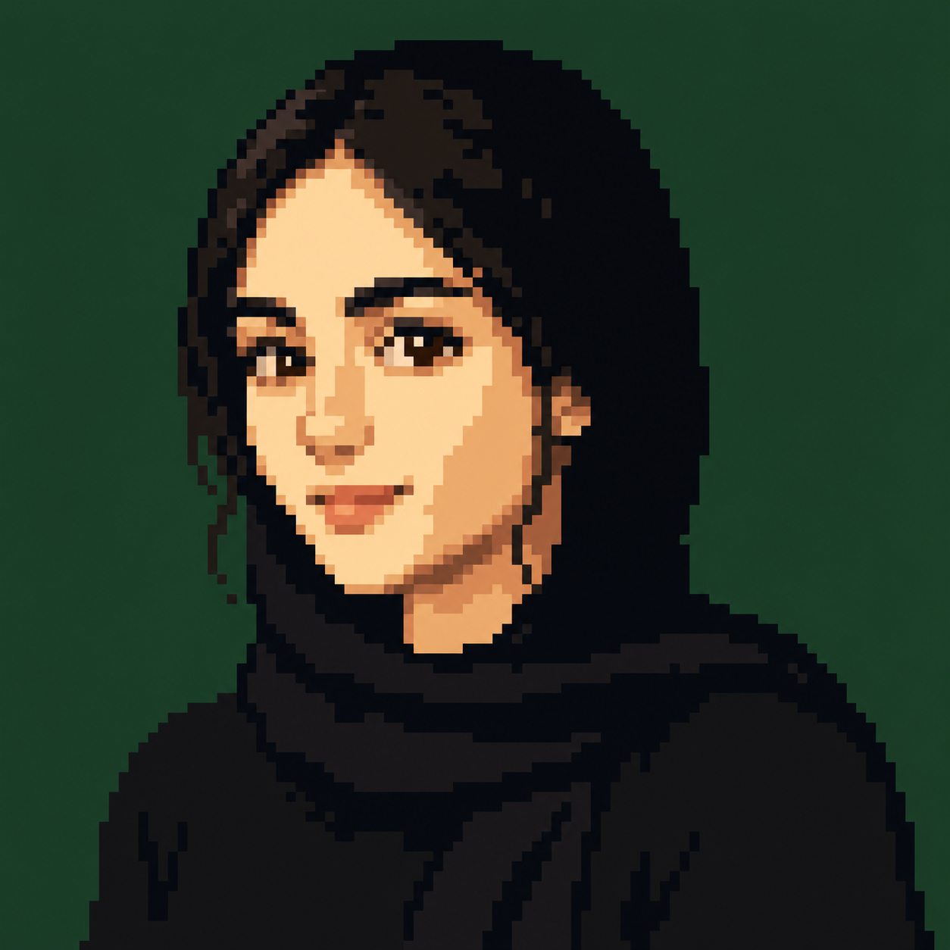 | Born: January 23, 1983  Died / Status: June 20, 2009, age 26  Fate: Shot in the chest by a Basij sniper during protests in Tehran.  Image file: portrait_neda_v2.png

Biography
Neda Agha-Soltan was a philosophy and music student who had joined the massive street protests following Iran's disputed June 2009 presidential election, in which widespread fraud allowed Mahmoud Ahmadinejad to claim re-election over reformist candidate Mir Hossein Mousavi.
On June 20, she stepped out of a car near Karegar Street to escape the heat. A Basij militia sniper shot her in the chest. Bystanders, including her music teacher and a physician, tried to save her as her blood pooled on the pavement. Someone recorded it on a mobile phone. Within hours, the video had circled the globe.
Time Magazine called her death ''probably the most widely witnessed death in human history.'' Her image — young, dark-eyed, dying with absolute clarity on camera — became the defining symbol of the Green Movement and of Iranian resistance worldwide. The Islamic Republic denied responsibility and attempted to suppress or distort the footage.
Game Card Tags: Symbol of Resistance · Green Movement · Global Icon

6. Zahra Kazemi
Press Crackdown (2003)
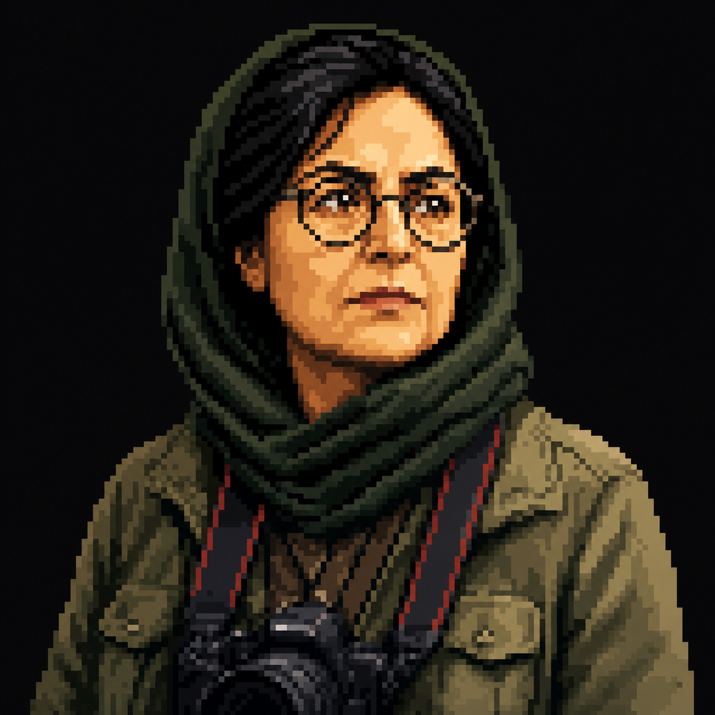 | Born: 1955  Died / Status: July 11, 2003, age ~47  Fate: Died from torture sustained while in Iranian state custody at Evin Prison.  Image file: portrait_kazemi_v2.png

Biography
Zahra Kazemi was an Iranian-Canadian freelance photojournalist based in Montreal. In June 2003 she traveled to Tehran to document the student protest movement. She was arrested outside Evin Prison while photographing the families of political detainees gathered at the gates.
In custody, she was subjected to systematic torture — including a skull fracture, sexual assault, and severe brain damage. She fell into a coma and died on July 11, 2003. The Iranian government initially claimed she had died of a stroke, then offered inconsistent explanations.
Her death caused Canada to downgrade its diplomatic relations with Iran. A reformist Iranian doctor who had examined her and confirmed the torture findings was himself later imprisoned. Despite international pressure, no one was ever convicted. Her case became emblematic of the regime's war on journalism and its complete immunity from accountability.
Game Card Tags: Photojournalist · Torture Victim · Press Freedom

7. Ramin Hossein-Panahi
Kurdish Persecution (2017–2018)
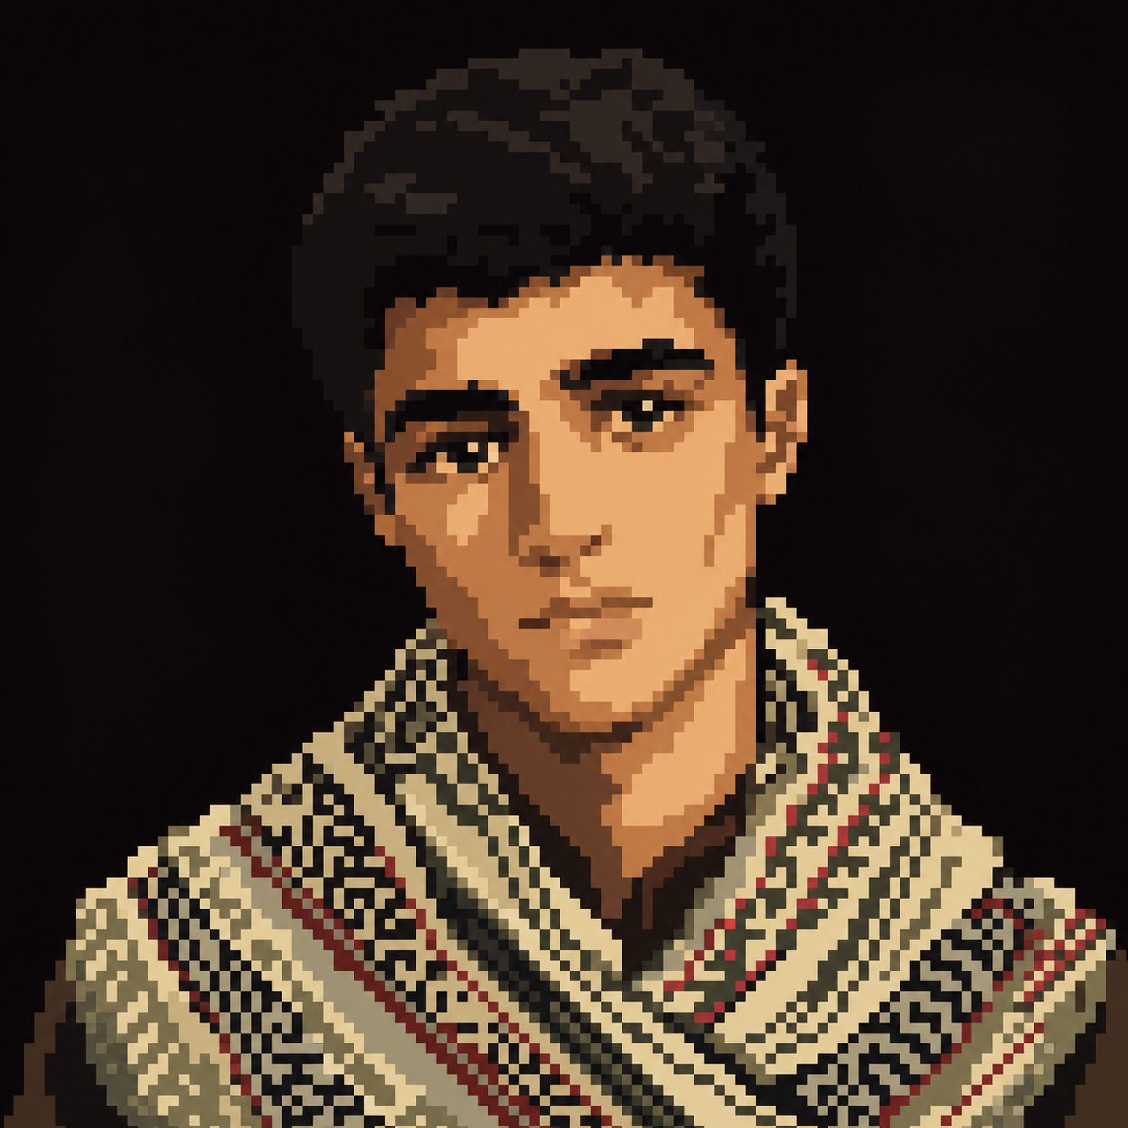 | Born: 1995  Died / Status: September 8, 2018, age ~22–23  Fate: Hanged at Raja'i Shahr Prison, alongside his cousins Zaniar and Loghman Moradi.  Image file: portrait_panahi_v2.png

Biography
Ramin Hossein-Panahi was a young Iranian Kurd from the town of Javanroud in Kermanshah Province, arrested in 2017 and accused of membership in PJAK, the Kurdish guerrilla organization. Human rights organizations concluded his trial was grossly unfair: evidence of torture was extensive, he was denied access to an attorney of his choosing, and the charges were never substantiated.
His case attracted particular international attention due to the suffering it caused his family. During one near-execution, security forces surrounded his family's home as they gathered to mourn; his niece Nishtiman, overwhelmed with fear and grief, took her own life at the scene. The family's anguish was documented and circulated by human rights organizations.
Ramin was hanged in September 2018 alongside cousins Zaniar and Loghman Moradi, who had been on death row since 2009. His execution highlighted the systematic criminalization of Kurdish political identity in Iran.
Game Card Tags: Kurdish Dissident · Ethnic Persecution · Unfair Trial

8. Navid Afkari
Economic Protests (2018–2020)
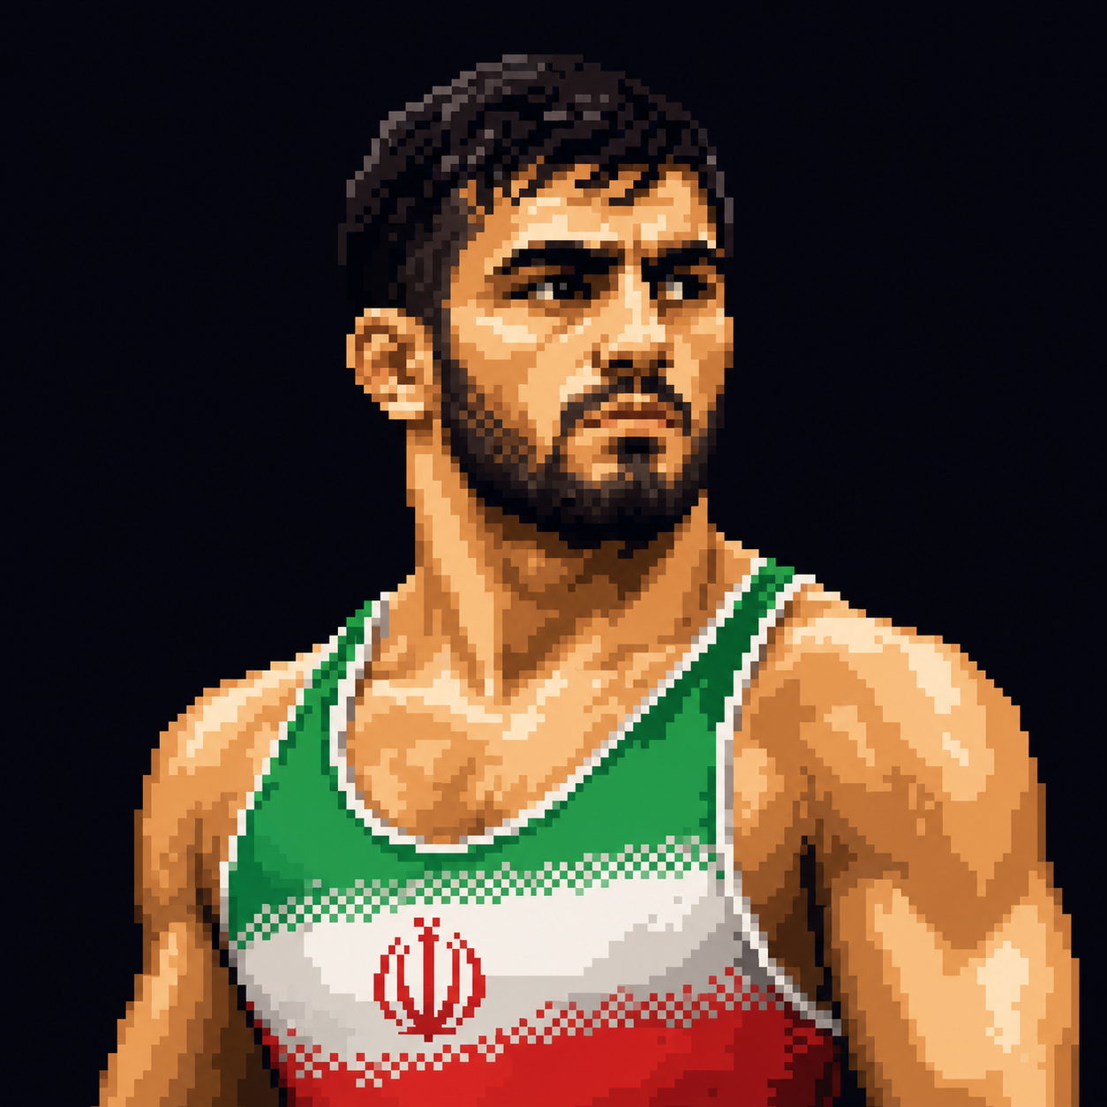 | Born: July 22, 1993  Died / Status: September 12, 2020, age 27  Fate: Secretly hanged. Family not notified until after execution.  Image file: portrait_afkari_v2.png

Biography
Navid Afkari was a national-level Iranian wrestling champion — a sport with deep cultural significance in Iran. He was arrested following the August 2018 economic protests that swept Iranian cities in response to government corruption and mismanagement, and charged with the killing of a plainclothes security official during the unrest.
Afkari consistently maintained his innocence. From inside prison, he managed to smuggle out an audio recording in which he described the torture used to extract his confession, named those responsible, and pleaded for his life. The recording circulated internationally and generated an extraordinary response: U.S. President Donald Trump personally appealed to Iran to spare him. The International Olympic Committee formally requested clemency.
Iran executed him in secret on September 12, 2020 — without notifying his family, his lawyers, or the international bodies that had intervened. The covert timing was designed to deny any last-minute appeal. His family was informed only afterward.
Game Card Tags: Wrestling Champion · Secret Execution · Global Outcry

9. Mohsen Shekari
Woman, Life, Freedom Uprising (2022)
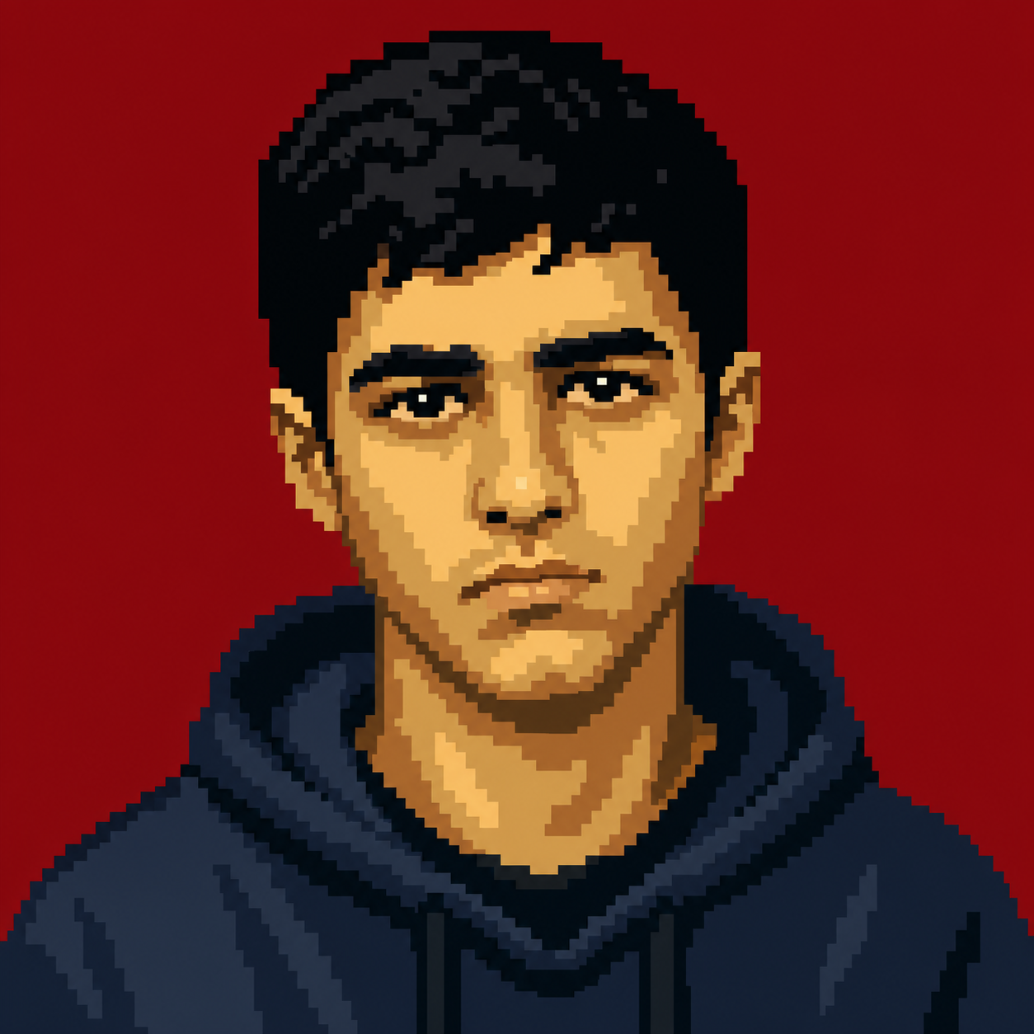 | Born: February 24, 2000  Died / Status: December 8, 2022, age 22  Fate: Hanged — the first protester executed as a direct result of the 2022 Mahsa Amini uprising.  Image file: portrait_shekari_v2.png

Biography
Mohsen Shekari was 22 years old when he became the first person executed as a direct consequence of the 2022 ''Woman, Life, Freedom'' uprising — the mass protests that erupted across Iran after 22-year-old Mahsa (Jina) Amini died in morality police custody in September 2022.
Shekari was arrested in September 2022 and charged with blocking a street and injuring a Basij member with a knife. The trial lasted under three weeks from arrest to death sentence. He was hanged on December 8, 2022, while protests were still raging across the country.
The speed and transparency of his execution — announced publicly by state media — was a deliberate act of terror theater, designed to shock the protest movement into submission. Instead, it intensified international condemnation and rallied further protests. The Islamic Republic executed several more protesters in the following weeks.
Game Card Tags: First WLF Execution · Terror Theater · Protest Martyr

10. Majidreza Rahnavard
Woman, Life, Freedom Uprising (2022)
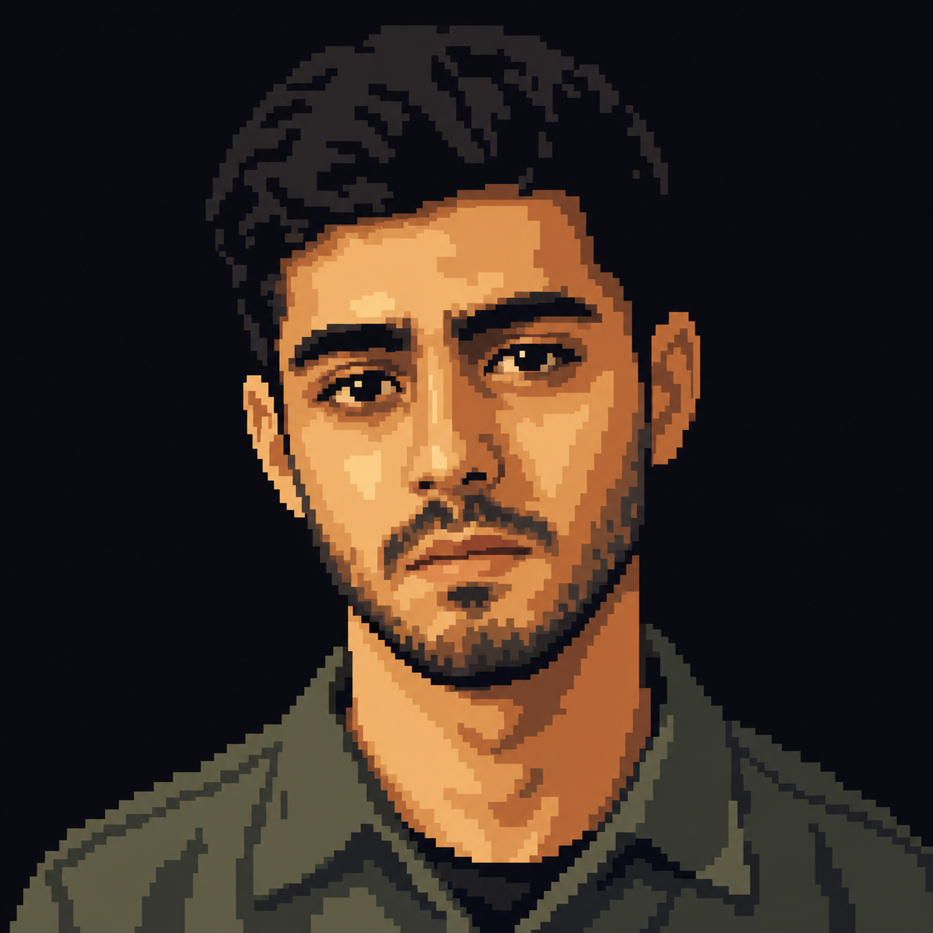 | Born: June 16, 1999  Died / Status: December 12, 2022, age 23  Fate: Publicly hanged from a construction crane in Mashhad — the first public execution of the WLF uprising.  Image file: portrait_rahnavard_v2.png

Biography
Majidreza Rahnavard was a 23-year-old who became the second protester executed during the Woman, Life, Freedom uprising and the first to be publicly hanged — from a construction crane in Mashhad, in deliberate spectacle designed to terrorize onlookers and the wider public.
He was accused of killing two members of the Basij militia during the protests. His trial consisted of a single session. From conviction to execution: two weeks. The entire process violated every standard of due process.
The choice to hang him publicly, visibly, from construction equipment in an open space, was a conscious echo of medieval state terror — a signal that the Islamic Republic was willing to make examples in the most visceral way possible to suppress the uprising. International outcry was immediate and widespread.
Game Card Tags: Public Execution · Crane Hanging · WLF Martyr

11. Behnam Mahjoubi
Sufi Minority Persecution (2018–2021)
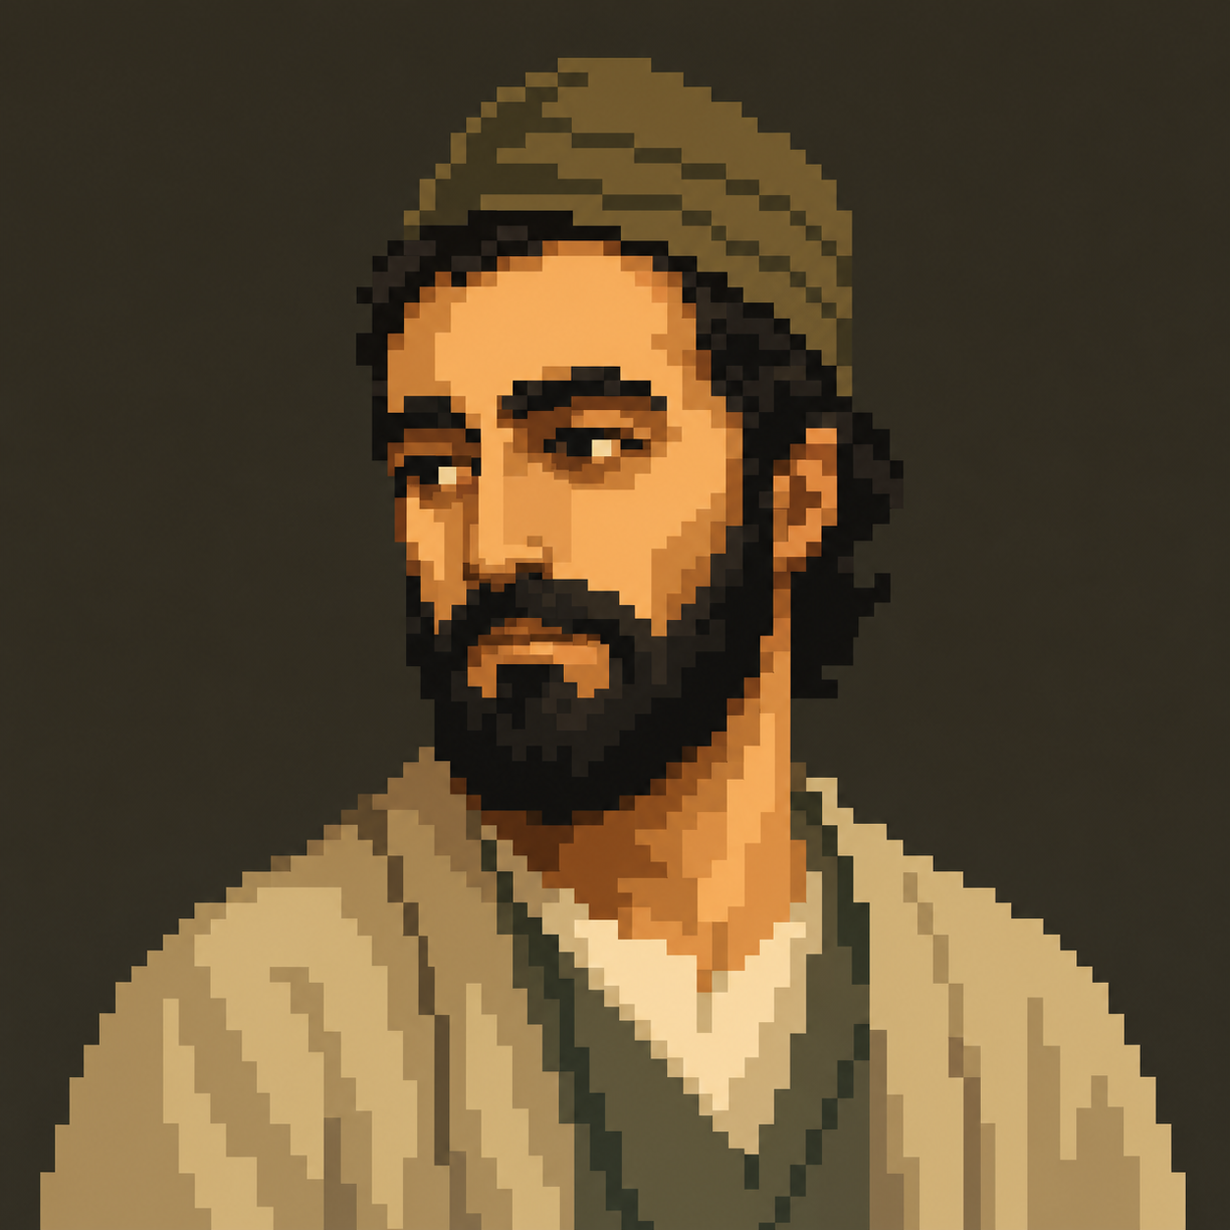 | Born: c. 1985  Died / Status: February 21, 2021, age ~35  Fate: Died in Evin Prison from torture and deliberate medical neglect. The regime claimed self-poisoning.  Image file: portrait_mahjoubi_v2.png

Biography
Behnam Mahjoubi was a member of the Gonabadi dervish Sufi order — one of Iran's most persecuted religious minorities. In 2018, after the IRGC cracked down violently on Gonabadi dervishes who had organized protests in Tehran, Mahjoubi was arrested.
He suffered from severe epilepsy. In custody at Evin Prison, his condition was deliberately denied treatment. He experienced repeated seizures without medical intervention. His family and attorneys repeatedly petitioned for his transfer to a medical facility; authorities refused. Videos of him in acute medical crisis, clearly untreated, were shared by human rights organizations.
He died on February 21, 2021. The Islamic Republic claimed he had poisoned himself — a claim rejected by his family, his attorneys, and every independent human rights organization that reviewed the case. His death represented the convergence of religious persecution, medical torture, and deliberate state cruelty.
Game Card Tags: Sufi Minority · Medical Neglect · Evin Prison

12. Maryam Akbari Monfared
1988 Massacre Legacy & Ongoing Imprisonment
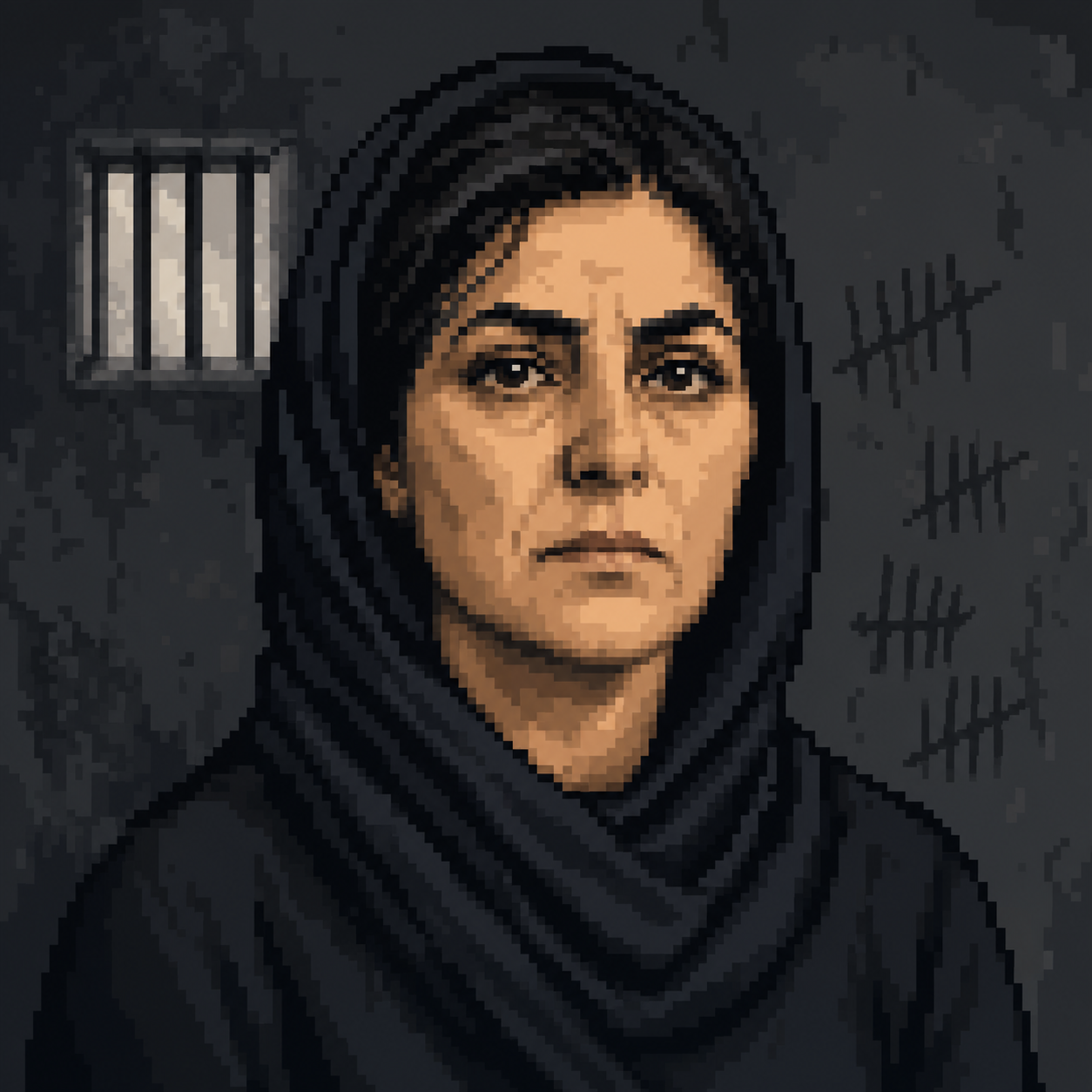 | Born: December 14, 1976  Died / Status: N/A — status: imprisoned (released 2024 after 17 years; status uncertain)  Fate: Sentenced to 15 years; sentence repeatedly extended. Filed formal complaint against 1988 massacre from inside Evin Prison.  Image file: portrait_monfared_v2.png

Biography
Maryam Akbari Monfared carries a grief almost unimaginable: three of her brothers and a sister were among the thousands of political prisoners executed in the 1988 massacre — a secret, systematic killing campaign ordered by Khomeini that targeted members of the Mojahedin-e Khalq and other leftist groups held in Iranian prisons. Estimates of the dead range from 4,000 to 30,000.
Monfared herself was later imprisoned in Evin Prison on charges related to political activities. In 2016, from inside her cell, she wrote and filed a formal legal complaint demanding accountability for the 1988 massacre and naming its perpetrators — including senior officials who remain in power. Human rights organizations have called this one of the most extraordinary acts of defiance in the Islamic Republic's history.
Her sentence was repeatedly extended in retaliation. She was reportedly released in 2024 after seventeen years of imprisonment, though her current status remains uncertain. Her case and her family's story stand as a living archive of the Islamic Republic's foundational violence.
Game Card Tags: 1988 Massacre · Defiance from Prison · Survivor

13. Saleh Mohammadi
January 2026 Uprising
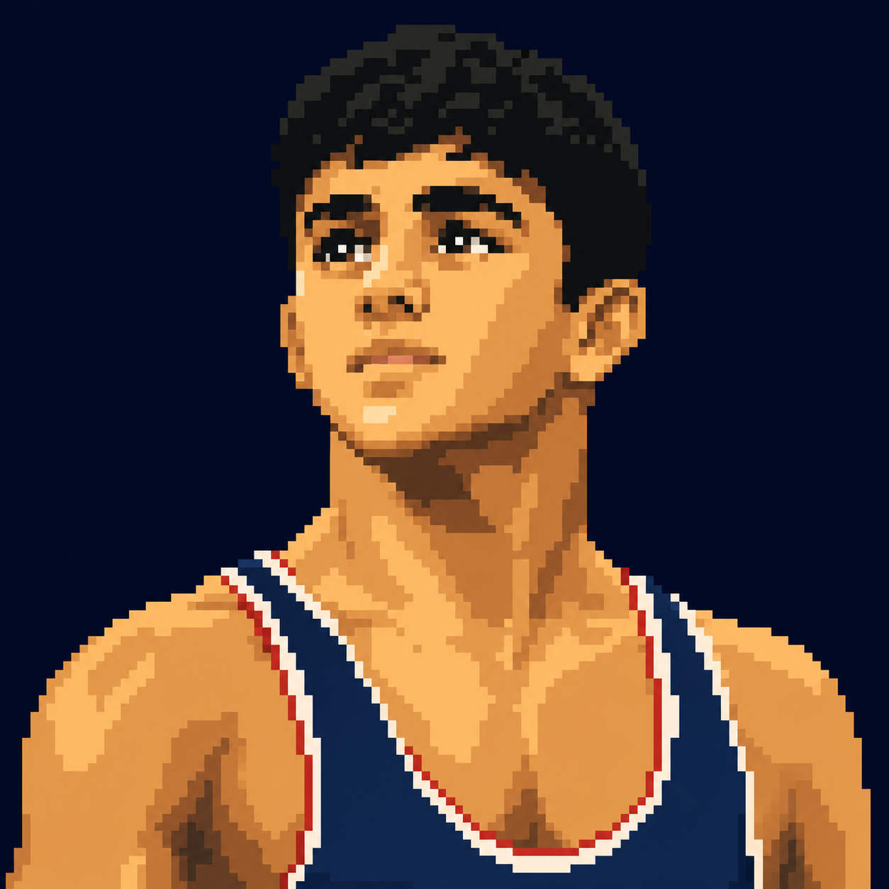 | Born: March 11, 2007  Died / Status: March 19, 2026, age 19  Fate: Publicly hanged in Qom alongside Mehdi Ghasemi and Saeed Davoudi.  Image file: portrait_mohammadi_v2.png

Biography
Saleh Mohammadi was a national-level freestyle wrestling champion — a bronze medalist at the 2024 Saitiev Cup — who had just turned 19 years old when the Islamic Republic hanged him publicly in Qom. He was arrested on January 15, 2026, accused of killing a police officer during the January 8 protests that erupted across Iran following economic collapse and government mismanagement.
His family, his coaches, and closed-circuit television footage supported his alibi. He was denied access to an independent attorney. His confessions, according to his own testimony, were extracted under torture. He was sentenced to death in under three weeks. He turned 19 in his prison cell on March 11. His last public Instagram post read: ''And we stood stronger than we ever imagined for ourselves.'' He was hanged publicly on March 19.
U.S. President Trump publicly condemned the execution. Iranian wrestler Alireza Karimi, competing at an international tournament the same day, withdrew in protest and dedicated his withdrawal to Mohammadi's memory. His execution — of a teenager, a national sports champion, on fabricated evidence — became a defining moment of the 2026 uprising.
Game Card Tags: Wrestling Champion · January 2026 · Teenage Martyr

