**Soil Mate Project Plan**

**Version 1.2**

**February 15th**

**Introduction:**

Finding local produce and knowing when that produce is in season is a difficult task for the average consumer. SoilMate is a website that will improve accessibility to fresh produce for community members from local suppliers. The purpose of this project is to identify what produce is in season in the region, offer recipes based on the selected produce and locate suppliers in the area.

The main focus in our first sprint will be to orient ourselves with the software and protocols which will be new to the majority of the team. The software that will be utilized includes, Drupal, Acquia Dev Desktop stack and JIRA. The team will be using JIRA for project planning, tracking, reporting as well as defect tracking. The Agile/Scrum approach will be adopted as the project management framework. An additional priority in the first sprint will be selecting an API that will supply recipes based on the selected produce.

Once these priorities have been achieved the building phase will begin which will include creating the website and designing the interface and tools required to display the data. During the entirety of the research and development process, the database will be generated and populated as more information becomes available.

**Team members:**

Ian: Product Owner

Travis: Scrum Master

Dan: Scrum Member

Jerad: Scrum Member

Kerry: Scrum Member

Stakeholder: Matt Gomez - CEO and creator of SoilMate

**Hardware / software requirements:**

The team will be using Drupal paired with Acquia Dev Desktop for local development. We will be running an apache server with a MySQL database. Our ticket management software will be JIRA and we have already set up or tasks/backlog as well as an area to track bugs.

**Project Backlog**

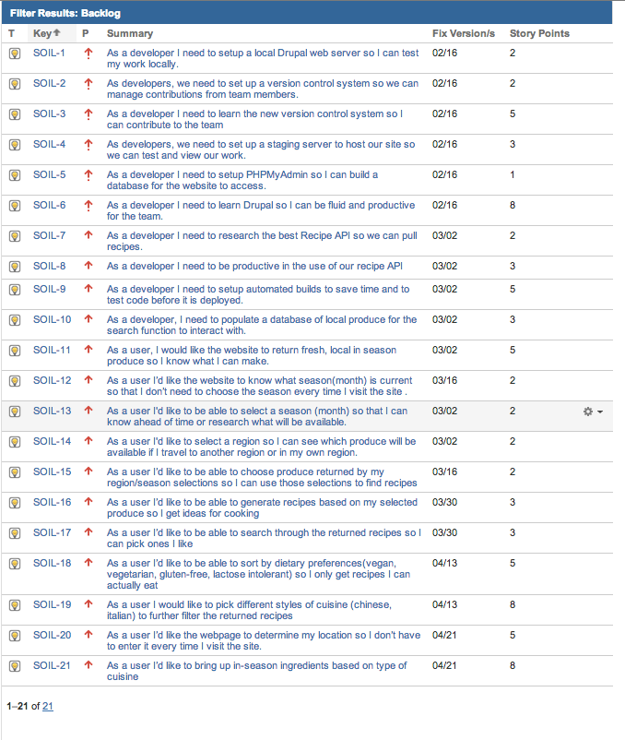

**Defect tracking plan:**

Through the use of Jira, our team will mark each defect and bug as tasks to be resolved. They will be prioritized on level of hindrance and time required. Defects will be discussed in our weekly meeting time.

**Meeting schedule (Communication Plan):**

The team will be meeting once a week for a sit down meeting to discuss the current sprint as well as do the next weeks sprint planning. We are in constant online communication as well as speaking face to face daily. After each sprint (before the beginning of the next sprint) our team will discuss the prior sprint making changes to improve what caused shortfalls and note what we found to be successful.

**Sprint Rhythm:**

Two week sprints, with constant online communication regarding what each member is currently working on and any issues they are encountering. Verbal communication daily. Weekly sit down meeting.

**Risks:**

|  |  |  |  |  |
| --- | --- | --- | --- | --- |
| ID | Impact | Risk Items | Repercussion | Days Lost |
| 01 | Critical | 4 out 5 team members have no experience with Drupal | Project can not be built if team is not taught Drupal | 14 |
| 02 | Critical | 4 out of 5 team members have never used a version control software | Project could be lost or overwritten leading to project failure | 2 |
| 03 | Critical | 4 out of 5 team members have never used an API | Project will be half complete | 4 |
| 04 | Critical | We are relying heavily on one person to knowledge transfer | A lot of time will be spent teaching | -- |
| 05 | Moderate | Slightly different schedules | Slightly less often Scrums, or alternating days | Negligible |

As previously mentioned the learning curve of the new technology impacting the workflow is a primary risk. Research and dedication, as well as Ian’s past experience should alleviate this. Another risk we may face is the generation of the database slowing the progress, as well as the recipe functionality impacting the rate of deliverables.

**Build plan:**

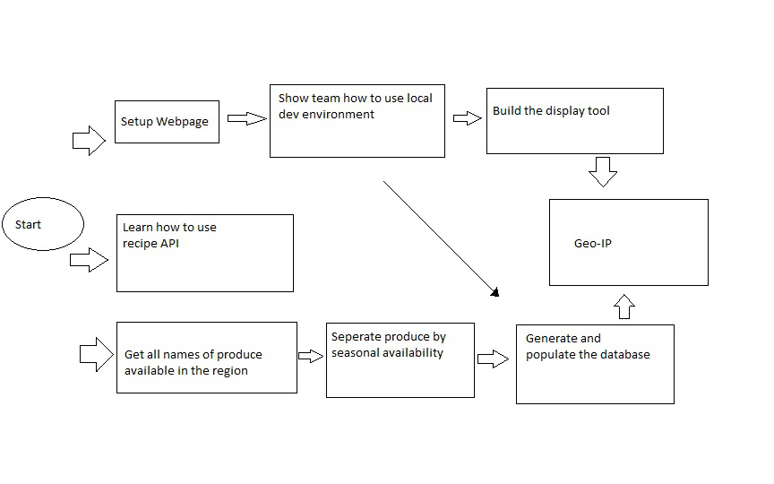

|  |  |
| --- | --- |
| Milestone 1 | – Get website setup on local machines  – Research and document best API for recipes  – Start learning Drupal |
| Milestone 2 | - Make successful calls to Recipe API  - Start entering Produce into database |
| Milestone 3 | - Pull produce successfully from database onto a page |
| Milestone 4 | - Take returned produce and send it in the API call  - Only display ingredients that are in season  - Successfully retrieve recipes with selected ingredients |
| Milestone 5 | - Start designing the user interface for returned produce and recipes |
| Milestone 6 | - Have the basic styling and layout done to the website |
| Milestone 7 | - Have the design complete and make sure acceptance criteria is met |

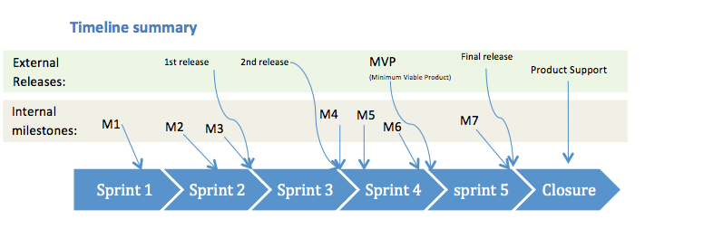

We will be using GitHub version control software we intend on daily integration and testing to insure the highest quality of product. We are looking into using automated build scripts to automatically grab new commits each night.

**Requirements gathering: (Product Backlog planning )**

SoilMate requirements will be gathered through constant (weekly) communication with our sponsor, our team will be merging and testing individual components on a daily basis to avoid/detect errors as early as possible. Demos will be given to the sponsor after every sprint. Upon the completion of our project there will be a pre-release presentation to the sponsor, after which the market release date will be given (from the sponsor), to which our team will assist in. After which, we will provide short-term support, at the end of which the sponsor will be offered a long-term support option.