Smart Incubator / Brooder Controller - Technical Report
Differential Equations Group Project 14 | Group members: ____________________ | Code: brooder_sim.py, webapp/app.py, experiments.py
1. Problem, assumptions and governing ODEs
Objective: keep a poultry brooder near a target temperature (35 °C for day-old chicks) with a heater under PI/PID control while the outdoor temperature falls at night and rain increases the heat loss. Assumptions: (i) one well-mixed temperature T for air and bedding (lumped capacitance); (ii) heat loss to ambient proportional to T - Ta (Newton cooling) with the loss coefficient raised by a factor (1 + k·rain) in rain/wind; (iii) chicks add a constant metabolic heat Q = n·q; (iv) the heater is ideal (no lag) but limited to 0 <= P <= Pmax and cannot cool; (v) the sensor is ideal; (vi) controller is evaluated continuously (its states are integrated with the plant).
C dT/dt = P + Q - g(t)(T - Ta(t)), g = (1 + k·rain(t))/R, P = clip(u, 0, Pmax)
dI/dt = e + (P - u)/Kp, dTm/dt = (T - Tm)/τd, u = Kp e + Ki I - Kd (T - Tm)/τd, e = Tset - T
State vector y = [T, I, Tm]: brooder temperature (°C), integral of error (K·s) and low-pass-filtered temperature (°C), so (T - Tm)/τd is a noise-free estimate of dT/dt (derivative on the measurement, no set-point kick). The term (P - u)/Kp is back-calculation anti-windup (Tt = Ti = Kp/Ki). Parameters (illustrative, simplified): C = 8000 J/K, R = 0.20 K/W (UA = 5 W/K, plant time constant RC = 27 min), k = 0.3, Q = 20 × 0.4 = 8 W, Pmax = 150 W, Tset = 35 °C, Kp = 8 W/K, Ki = 0.01 W/(K·s), Kd = 0, τd = 60 s. Initial conditions: cold start T(0) = Ta = 25 °C, I(0) = 0; for disturbance tests the loop is first run to steady state. Without control and with constant P the exact solution is T = T∞ + (T0 - T∞)e^(-t/τ). With Kd = 0, constant Ta and no saturation, [T, I] obeys a linear system x' = Ax + b with exact solution found by eigen-decomposition; its characteristic equation C s² + (Kp + g)s + Ki = 0 gives ωn = √(Ki/C) and ζ = (Kp + g)/(2√(C·Ki)) (ζ = 0.73 for the defaults). Steady-state heater power needed: Preq = g(Tset - Ta) - Q (e.g. 107 W at 12 °C, 141.5 W at 12 °C with rain).
2. Numerical methods and validation
Explicit Euler (yn+1 = yn + h f) and classical RK4 were implemented by us (brooder/solvers.py) and used for the whole coupled system; no ODE library is used. Reference solutions: the exact PI-loop solution above (T0 = 30 °C, Ta = 20 °C, 4 h, heater unsaturated) and, for the PID loop, a refined RK4 run with h = 0.1 s.
h (s) | Euler max error (K) | order | RK4 max error (K) | order
300 | 5.227e-01 | - | 4.329e-04 | -
150 | 2.320e-01 | 1.17 | 2.516e-05 | 4.10
75 | 1.100e-01 | 1.08 | 1.517e-06 | 4.05
30 | 4.275e-02 | 1.03 | 3.795e-08 | 4.02

Observed orders are ≈1 for Euler and ≈4 for RK4, as theory predicts; at h = 300 s Euler is off by 0.52 K but RK4 by 0.0004 K. Against the refined reference on the PID loop (h = 40/20/10/5 s) the Euler error halves each time (5.9e-2 → 7.2e-3 K) while the RK4 error drops from 3.4e-5 to 4.2e-9 K. Open-loop validation against T(t) = T∞ + (T0 - T∞)e^(-t/τ) gave the same orders. Stability (numerical, not physical): the derivative filter (τd = 60 s) makes the PID loop stiff; explicit Euler needs h < 2τd = 120 s just for the filter and in the loop it already produces a false ≈1–2 K limit cycle at h = 100 s (Fig. 1, right) and diverges (|Tm - T| ~ 10⁶ K) at h = 130 s, while RK4 remains accurate. The physical system is stable for all gains used, so this behaviour is purely a numerical artefact; the program detects it and stops with a message.
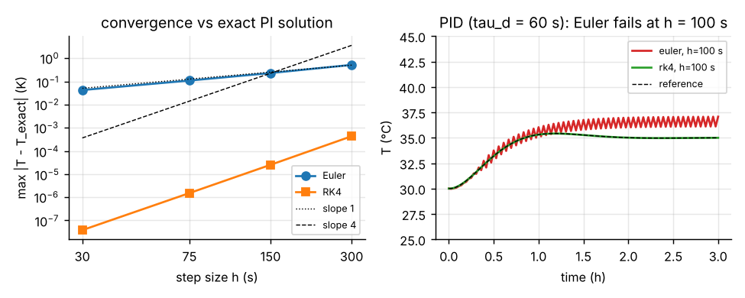
Fig. 1 Left: error vs step size against the exact PI solution (slopes 1 and 4). Right: PID loop, h = 100 s - Euler wrong, RK4 matches the reference.
3. Experiments and physical interpretation
Disturbances: cold night = ambient ramps 25 → 12 °C in 30 min (loop starts at steady state); rain = loss coefficient ×1.3 at Ta = 15 °C. Measures: peak deviation |e|max, recovery time (|e| < 0.5 K from then on), steady-state error (mean e over the last 30 min). RK4, h = 2 s.
E1 - controller type and tuning (Fig. 2).
controller | cold night: peak / recovery / SSE | rain: peak / recovery / SSE
P (Kp=8) | 8.23 K / never min / 8.231 K | 8.41 K / never min / 8.414 K
PI (8, 0.01) | 2.77 K / 70 min / 0.0 K | 1.4 K / 47 min / 0.0 K
PID (8, 0.01, 3000) | 2.67 K / 75 min / 0.0 K | 1.3 K / 52 min / 0.0 K
PI fast (20, 0.03) | 1.16 K / 45 min / 0.0 K | 0.78 K / 22 min / -0.0 K

P-only control cannot remove the load: the heater only works when e ≠ 0, so a steady error e = Preq/(Kp + g) = 107/13 ≈ 8.2 K remains (cold night, no rain). Integral action drives the error to zero at the price of slower recovery; recovery is governed mainly by Ki and the peak mainly by Kp (grid in Fig. 5: peak 6.3 → 0.8 K and recovery 168 → 37 min across Kp = 2–20, Ki = 0.002–0.05). Large Ki lowers ζ (0.18 for Kp = 2, Ki = 0.05) and makes temperature oscillate; small Ki with large Kp is over-damped but takes hours (372 min). The D-term brings no benefit here (peak 2.77 → 2.67 K but recovery 70 → 75 min; Kd = 12000 is slower still): the plant is first-order and slow, so there is little to anticipate and D only amplifies sensor noise in a real system.
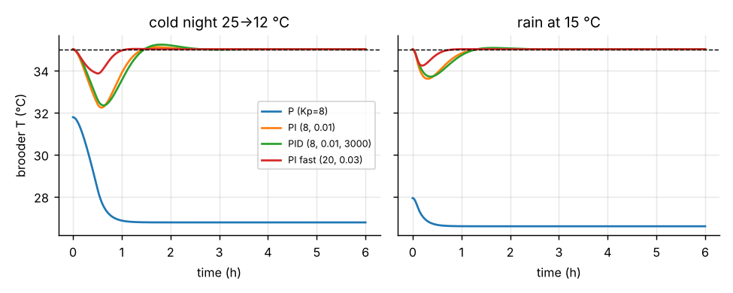
Fig. 2 Response to a cold night (left) and to rain (right) for P, PI, PID and a faster PI.
E2 - heater capacity (Fig. 3) and E3 - insulation (Fig. 4), cold night 12 °C (+ rain in E2).
Pmax (W) | needed (W) | peak (K) | recovery | SSE (K)
60 | 141.5 | 12.54 | never | 12.54
100 | 141.5 | 6.38 | never | 6.38
150 | 141.5 | 3.87 | 76 min | 0.0
250 | 141.5 | 3.87 | 76 min | 0.0

R (K/W) | RC (min) | needed (W) | peak (K) | recovery | SSE (K) | 30 °C after heater fails
0.1 | 13 | 222.0 | 7.2 | never | 7.2 | 3 min
0.2 | 27 | 107.0 | 2.77 | 70 min | 0.0 | 7 min
0.4 | 53 | 49.5 | 1.55 | 61 min | -0.0 | 16 min

A heater whose capacity is below the steady load (141.5 W at 12 °C with rain) cannot hold the target however it is tuned: the command saturates and T settles at the open-loop equilibrium Ta + (Pmax + Q)/g (22.5 °C for 60 W, 28.6 °C for 100 W) - a steady-state error caused by actuator saturation, not by the controller. Above the needed power more capacity does not help (150 W and 250 W give identical results): recovery is then limited by the loop gains. Insulation acts on both sides: R = 0.1 K/W needs 222 W and fails; R = 0.4 K/W needs only 49.5 W, reduces the peak (1.55 K) and gives a 16 min grace period after a heater failure (3 min for R = 0.1), at the cost of slower passive response (RC = 53 min).
E4 - start-up and integral windup (Fig. 6).
Cold start 20 → 35 °C with Ki = 0.05: the heater saturates while e is large, so without anti-windup the integral keeps growing and the temperature overshoots by 7.01 K (46.7 %, i.e. ≈ 42 °C, heat stress for chicks) and needs 85 min to settle; with back-calculation the overshoot is 2.7 K (18.0 %) and settling takes 56 min.
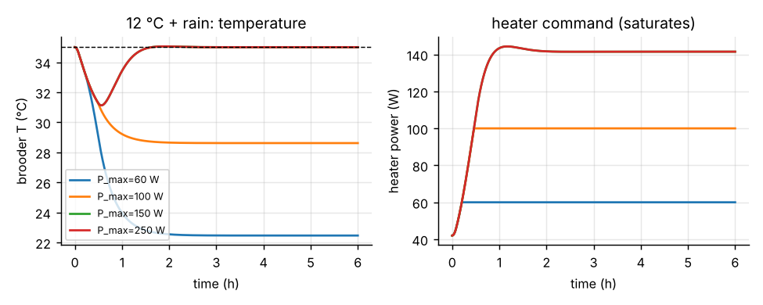  Fig. 3 Heater capacity | 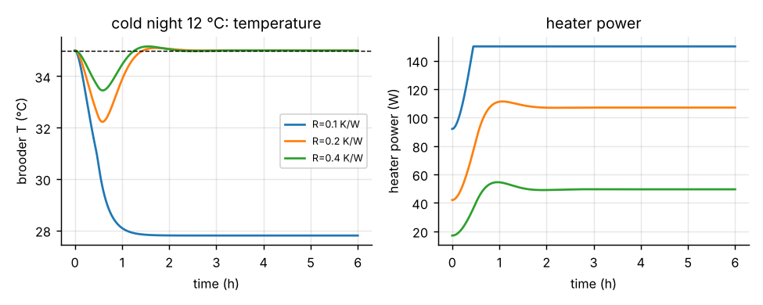  Fig. 4 Insulation
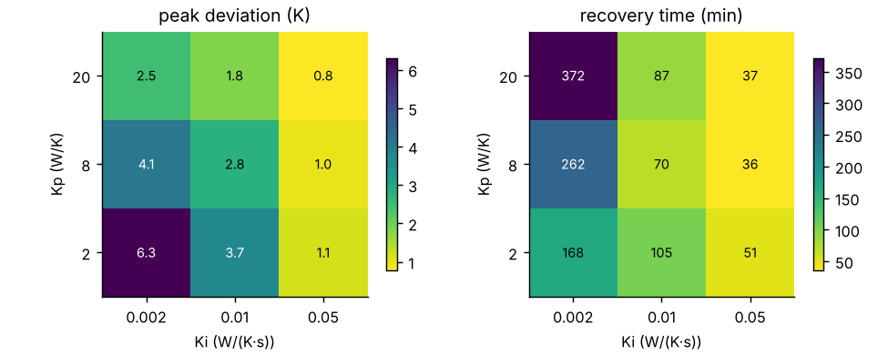  Fig. 5 Kp-Ki grid, cold night | 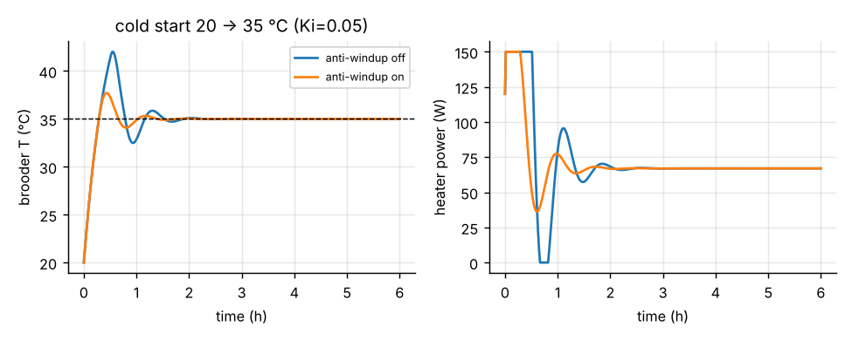  Fig. 6 Anti-windup
4. Events, approximations and limitations
Events/boundaries implemented in the program: heater power clipped to [0, Pmax]; heater-saturation warning; chick chilling (T < 31 °C) and heat-stress (T > 38.5 °C) alarms; target-reached (|e| < 0.5 K for 5 min); heater fault; automatic recovery-time/peak/steady-state measurement after each disturbance; numerical-instability stop. Limitations: single-node thermal model (no air/bedding/box gradients, no humidity, ventilation or ambient radiation); constant k and Q; ideal sensor and heater without lag or noise; continuous-time controller (a sampled controller would add a delay); parameters are illustrative and should be fitted to a measured cooling curve (T(t) = T∞ + (T0 - T∞)e^(-t/RC) gives RC and, with a known heater power, R); the clip and the rain/ambient step changes make the right-hand side only piecewise smooth, so RK4 order degrades slightly across them; chick positions on screen are an illustration driven by T, not part of the ODE model. Conclusion: a PI controller with anti-windup removes the steady-state error for a first-order thermal plant, performance is bounded by heater capacity and insulation rather than by tuning, and RK4 is the safer solver (accuracy and stability) at step sizes up to the 100 s range, where explicit Euler gives physically wrong answers.
5. Browser application: architecture and user journey
The Flask web application provides a browser interface to the same brooder model and numerical methods described above. Flask renders the pages and validates requests, the Python model computes simulation results on the server, and SQLite stores accounts and saved runs. The web app is educational software; it does not connect to or control physical brooder equipment.
Page or route | Purpose
GET / | Public welcome page with a local chick photo, sample readings, account links, theme switch and Pip guide.
GET/POST /signup and /login | Create an account or start a session. Both routes use the shared auth.html template.
GET /app | Protected dashboard for beginner setup, optional advanced settings, simulation playback, charts, metrics and saved runs.
POST /api/simulate | Validate input, run the model and return parameters, metrics and time series; save the run when requested.
GET /api/runs and GET/DELETE /api/runs/<id> | List, load or remove the signed-in user's runs. Each query is scoped to the current account.

5.1 Account page: auth.html
webapp/templates/auth.html is one Jinja template used by both the sign-up and sign-in routes. Flask supplies a mode value, any validation error, and the submitted username. The mode controls the page title, heading, helper text, password hints, submit label and link to the other account flow, so the two pages stay visually consistent without duplicating the form. A successful account action establishes a session and redirects to the protected dashboard.
The form posts to the current route and includes a hidden CSRF token from the Flask session. Labels are associated with their inputs; browser autocomplete hints identify username, new-password and current-password fields. Sign-up requires a 3–32 character username and an 8–128 character password. The server independently checks these limits, the allowed username characters and case-insensitive uniqueness. Browser attributes improve usability but are not the security boundary. Validation errors are announced with role=alert, the username is preserved, and the password is never returned to the page.
Passwords are stored as Werkzeug password hashes, not readable text. Sign-in checks the submitted password against the stored hash and uses a generic invalid-username-or-password message. The CSRF guard validates state-changing requests, and the login-required wrapper protects the dashboard and API. Saved-run reads and deletes include the current user ID, preventing one account from accessing another account's records.
5.2 Appearance, accessibility and guided help
On wide screens, auth.html uses a split story-and-form layout. Below 850 px the form is placed first so it is reachable before the decorative story on smaller screens. The story panel includes the local chick photograph, descriptive alternative text, a source credit and a CC0 dedication. The footer reminds visitors that this is a learning simulation and real brooders still need careful monitoring.
The welcome page and dashboard expose Dark mode / Light mode controls. They save the selection in the browser's brooder-theme local-storage key. The account page reads the saved choice and, before one is saved, follows the system color preference. This is a browser-side presentation setting; it does not change model parameters or server-side account data.
The shared Meet Pip guide explains the welcome page, account forms and dashboard. Its written instructions remain available as a fallback; speech synthesis starts only after the visitor chooses Read aloud. The interface uses semantic form labels, keyboard-focus styling and responsive layouts to support first-time users.
5.3 Persistence, configuration and limitations
The default SQLite database is webapp/runs.db; BROODER_DB can point to a separate database for testing or deployment. User rows contain a username and password hash. Saved runs contain their label, parameters, metrics, time series and owning user ID. A new account receives legacy unassigned runs once, when it is the first account created after the migration.
All simulation API routes require a signed-in session. The session secret is generated at startup for local use; set BROODER_SECRET_KEY to a stable, private value when sessions must survive restarts. Deployments should use a production WSGI server and appropriate secure-cookie and HTTPS settings. The numerical model remains simplified and must not be used as a substitute for sensors, alarms or supervision on a real brooder.

