

|  |
| --- |
|  |
| User Manual |
| Michael Boge, Aron Hardy-Bardsley, Ian Mckay, Shiwei Zhang |

Preamble

The following documentation outlines the information regarding the usage of News Feeder and the News Feeder Downloader. This information is aimed towards users who are experiencing issues with the installation and/or usage of the product. If, after reading this document, you are still experiencing issues please contact us at [support@newsfeeder.co](mailto:support@newsfeeder.co) or visit our website for other contact information at <http://newsfeeder.co/contact/>.

Table of Contents

Preamble 1

Table of Contents 2

Introduction 3

Getting Started 4

Minimum Requirements 4

Installing 4

Uninstalling 5

Windows Vista / Windows 7 5

Account Setup 6

Creating your account 6

Signing in to your account 8

Using the web interface 9

Adding a sheet 9

Viewing a sheet 11

Viewing an item 11

Managing global settings 11

Managing profile information 11

Removing a sheet 13

Adding feeds to a sheet 14

Removing feeds from a sheet 16

Importing OPML 17

Frequently Asked Questions 19

What is News Feeder? 19

How secure is News Feeder? 19

How to subscribe to feeds 19

Glossary of Terms 20

Introduction

News Feeder is a service which acts as an online news feed aggregator. Its main purpose is to provide a single location and format to view news content instead of our users having to go to a number of different websites for their specific news.

News Feeder allows its users to specify preferences as to which type of articles they wish to view. These can be based on a number of criteria such as location, category, author, publishing site or specific feed URL's. The system will crawl feeds which match these criteria and store the articles in the system's database. The stored content can be of any media type, including text, images, video and geolocation information.

Our users can then view the stored content in an organised layout, similar to that of a standard news sheet. These sheets will allow our user's to set a number of filtering options to ensure certain types of content are not displayed to them.

Getting Started

If you are having trouble installing the News Feeder Downloader application, please see the troubleshooting section.

# Minimum Requirements

To install the News Feeder Downloader application you must meet the following requirements:

* Web Browser (for initial download)
* Runs on Microsoft Windows 2000 or greater
* Runs on Linux 2.6.x kernel
* Runs on Mac OS X
* Support for 32-bit and 64-bit systems
* Working network connection
* Printer (if printing)

To use the News Feeder web service you must meet the following requirements:

* Web Browser
* Screen resolution of 480x320 or greater
* Working network connection
* Printer (if printing)

# Installing

The News Feeder web service requires no installation. Simply visit the website.

To install the News Feeder Downloader application, please follow these steps:

**Step 1.** Using your web browser go to the download link below: <http://newsfeeder.co/download/>

**Step 2.** Select the appropriate download link for your operating system. For more information, please see: <http://newsfeeder.co/faqs/>

**Step 3.** Download and open your installer

**Step 4.** Follow the steps of the installer

# Uninstalling

To uninstall the News Feeder Downloader application, please follow these steps:

## Windows Vista / Windows 7

**Step 1.** Open the Windows Start Menu

**Step 2.** Click the “All Programs” link

**Step 3.** Scroll down, and click the “News Feeder Downloader” program folder

**Step 4.** Click the “Uninstall” link in the program folder

**Step 5.** Follow the uninstaller prompts

Account Setup

# Creating your account

1. Navigate to the News Feeder website, <http://newsfeeder.co>.
2. Click the **Login** link in the upper-right corner.

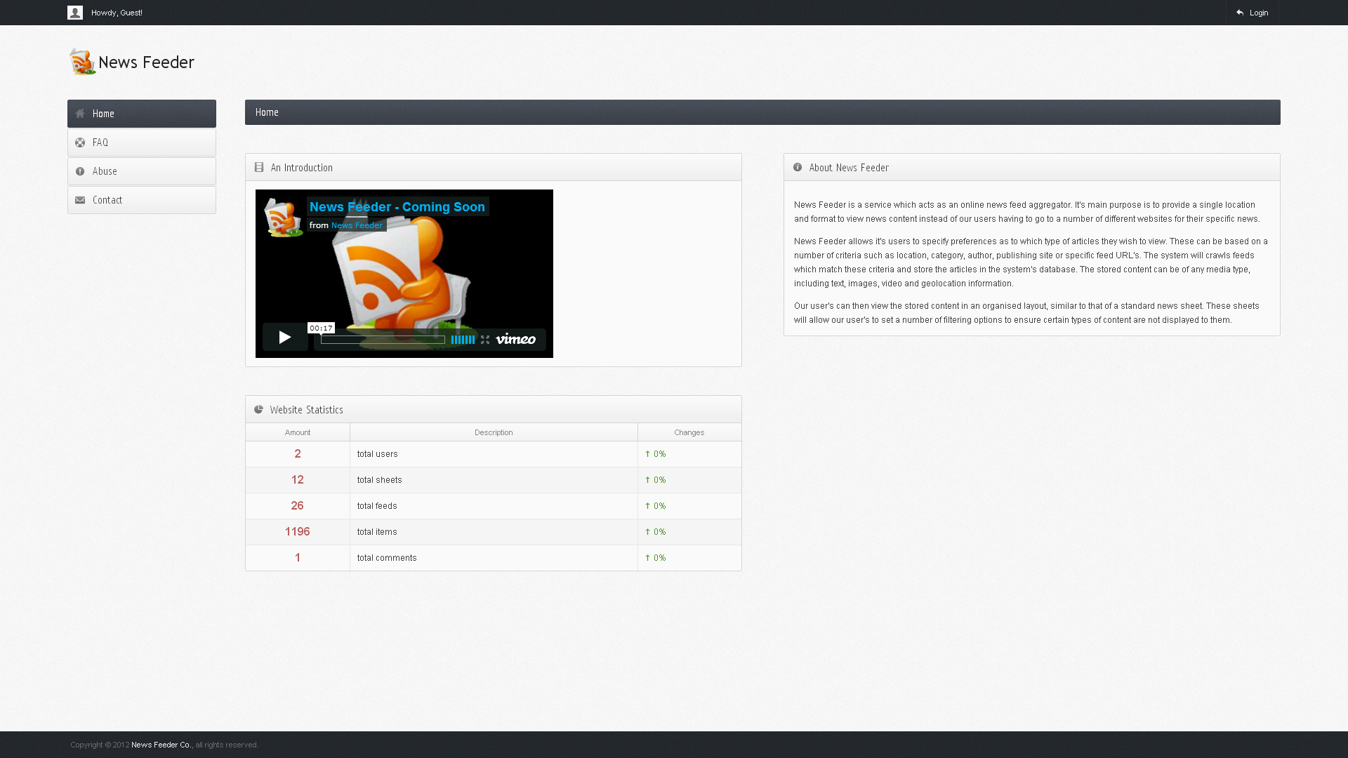

1. Click the **Register** link in the upper-right corner.

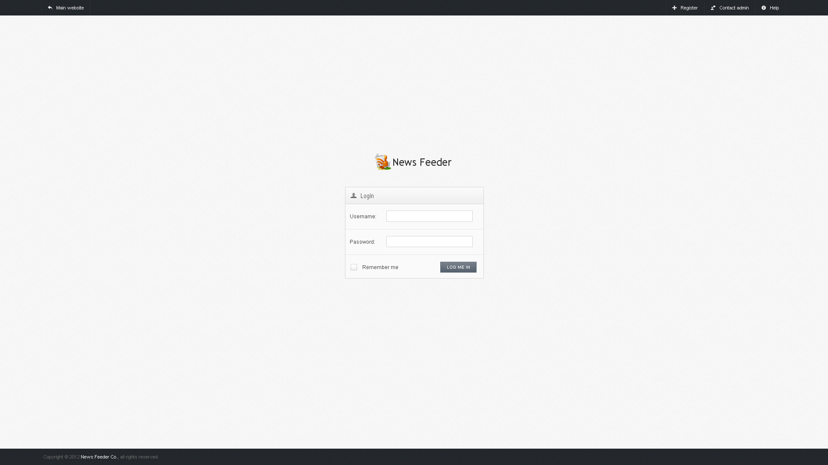

1. Fill in your full name, username, password, e-mail address and optionally select a profile picture.

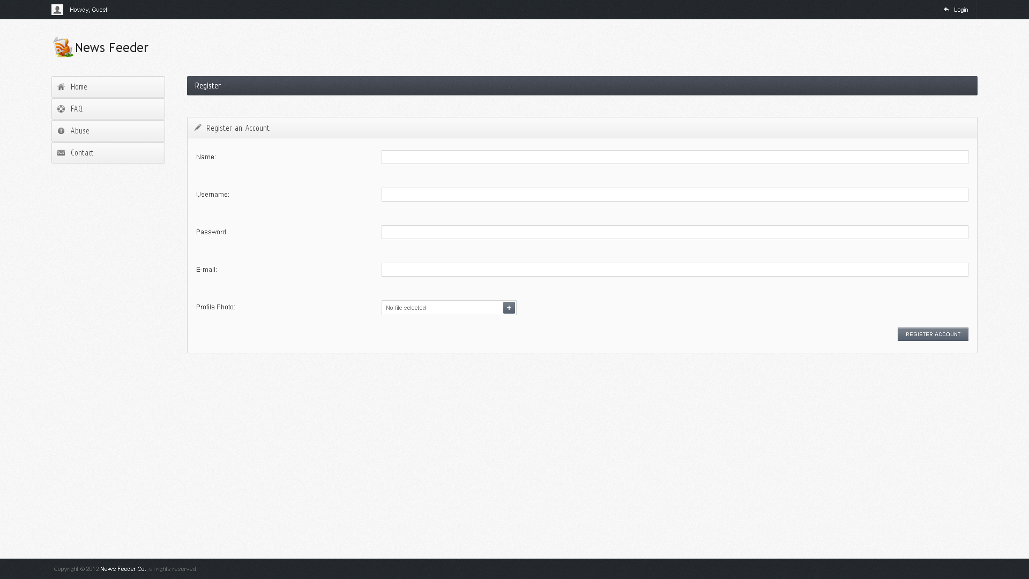

1. Click the **Register Account** button in the lower-right corner.
2. If your account registration was successful, you will now be in your Account Dashboard.

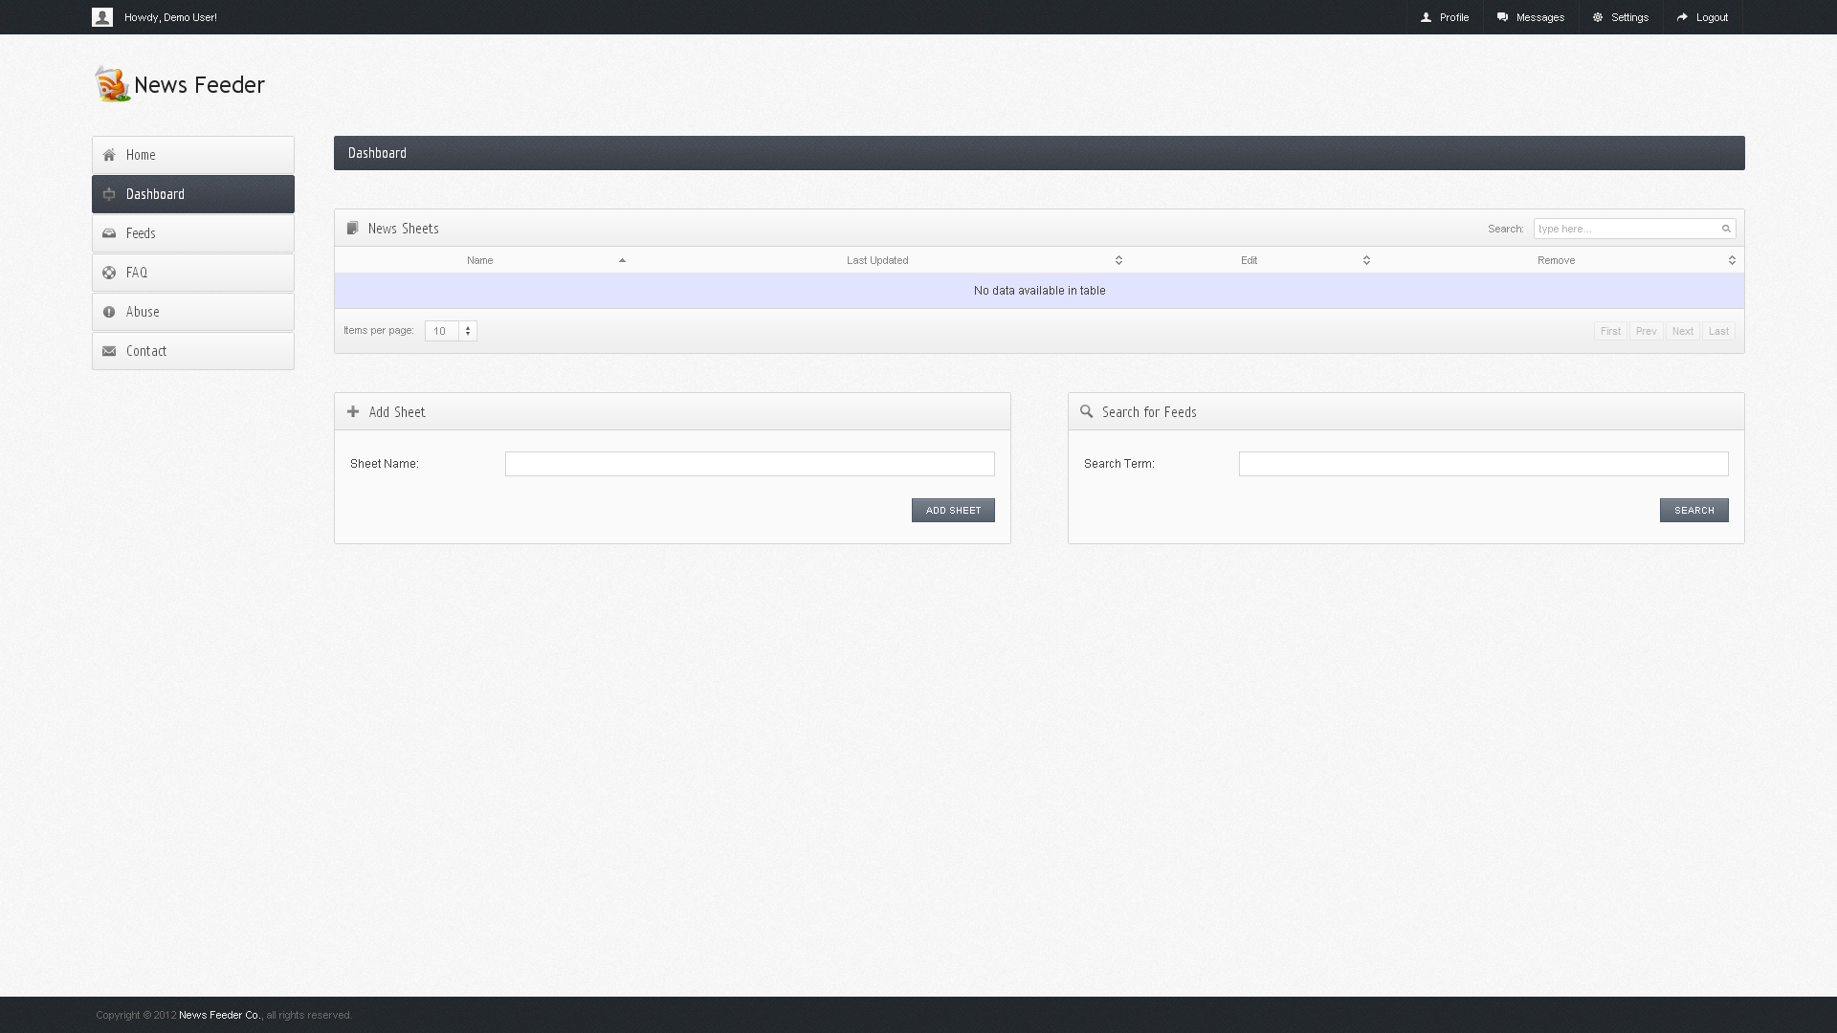

# Signing in to your account

1. Navigate to the News Feeder website.
2. Click the **Login** link in the upper-right corner



1. Enter your username in the **Username** field.
2. Enter your password in the **Password** field.
3. Check the **Remember Me** checkbox if you want the website to remember these credentials the next time you login.
4. Click the **Log Me In** button.

Using the web interface

# Adding a sheet

1. Navigate to your Account Dashboard.
2. Enter your new sheet name in the **Add Sheet** section.

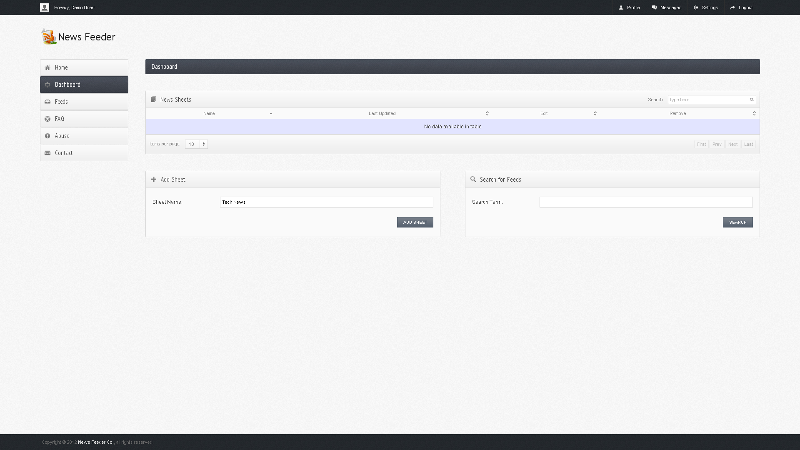

1. Click the **Add Sheet** button under your new sheet name.
2. After adding your new sheet you will be presented with a success message.

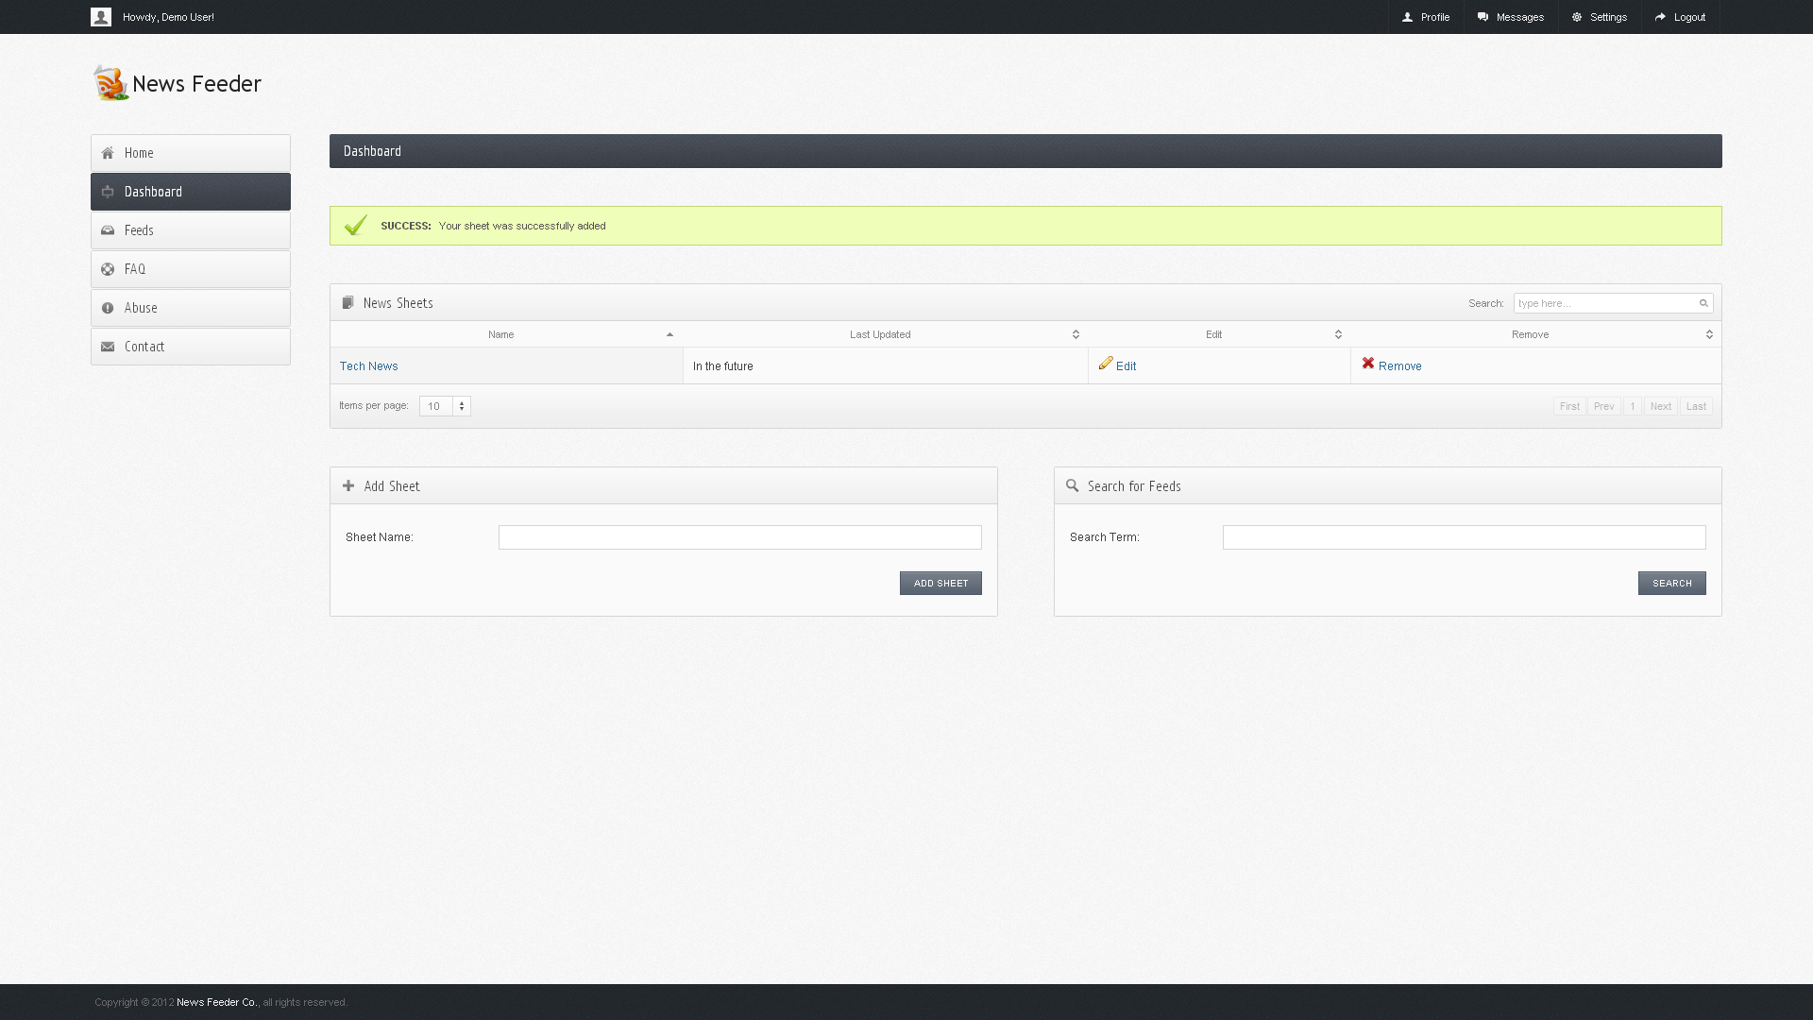

# Viewing a sheet

1. Navigate to your Account Dashboard.
2. 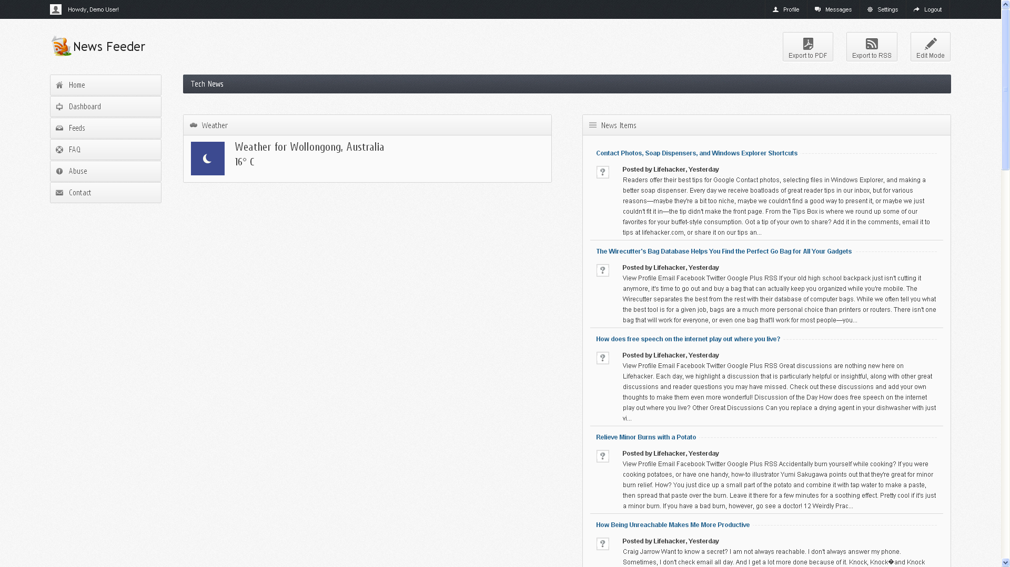Click on the sheet name of the sheet you wish to view.

# Viewing an item

1. Navigate to your Account Dashboard.
2. Click on the sheet name of the sheet which contains the item you wish to view.
3. 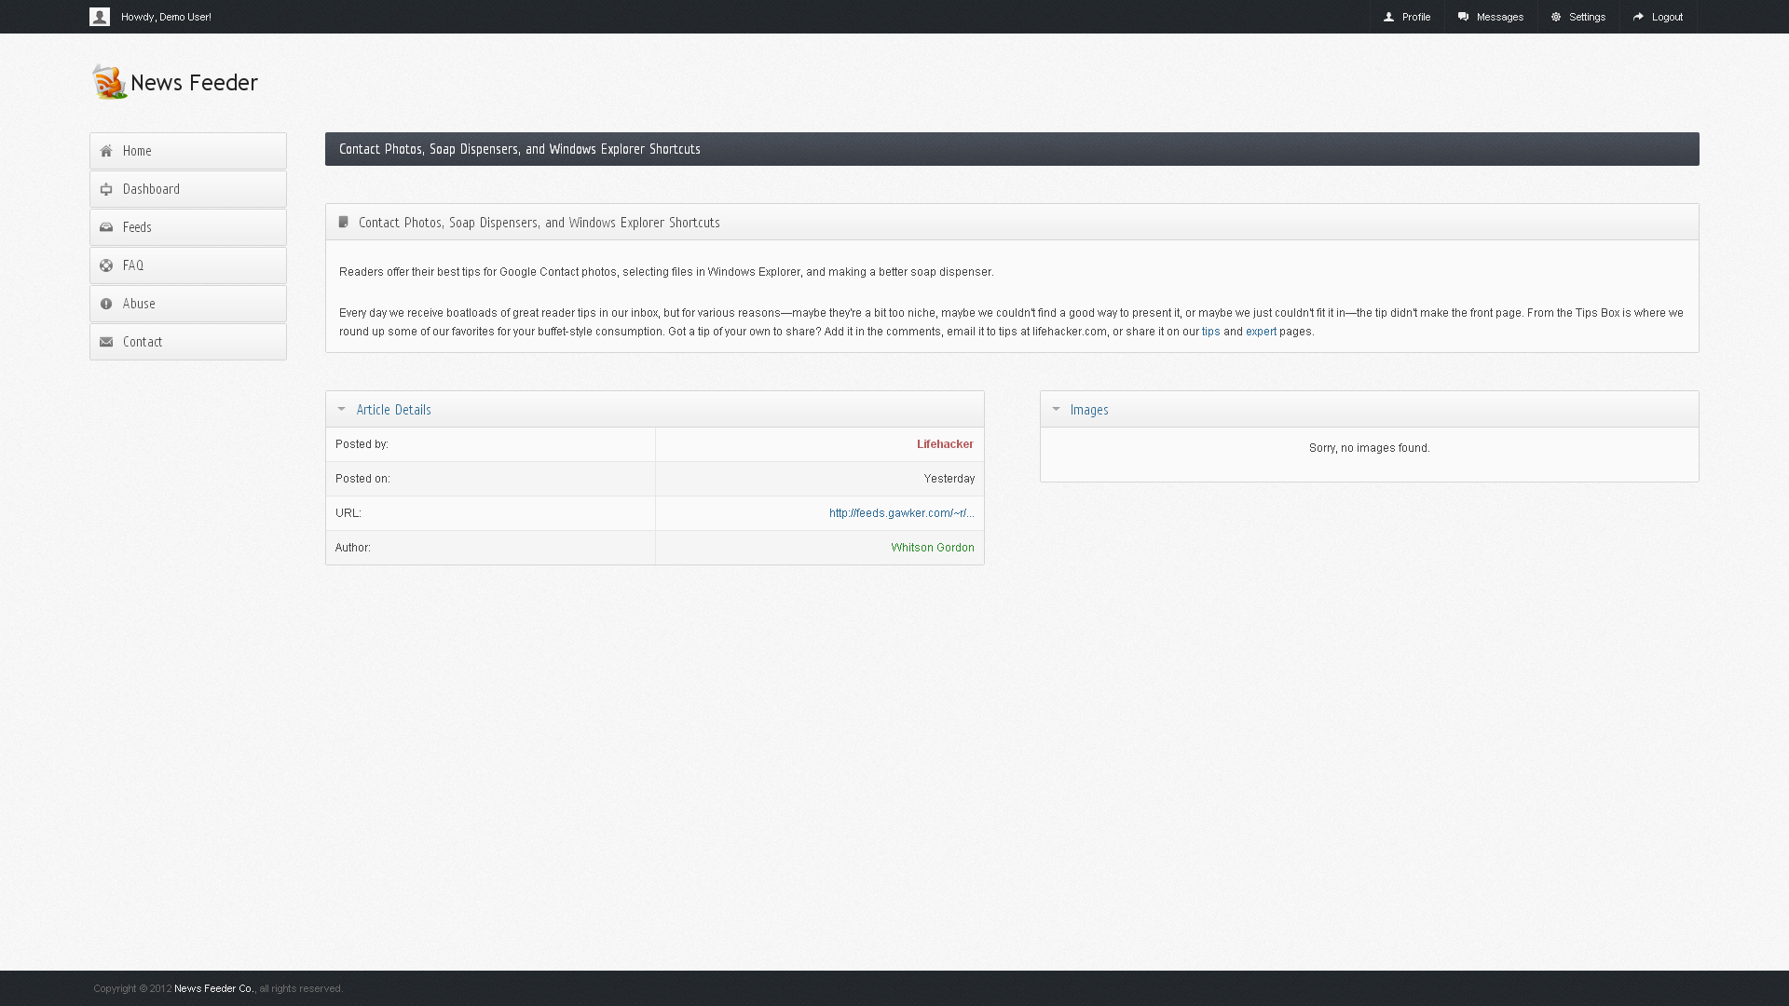Click on the item title to navigate to that item.

# Managing global settings

1. Sign in to News Feeder.
2. 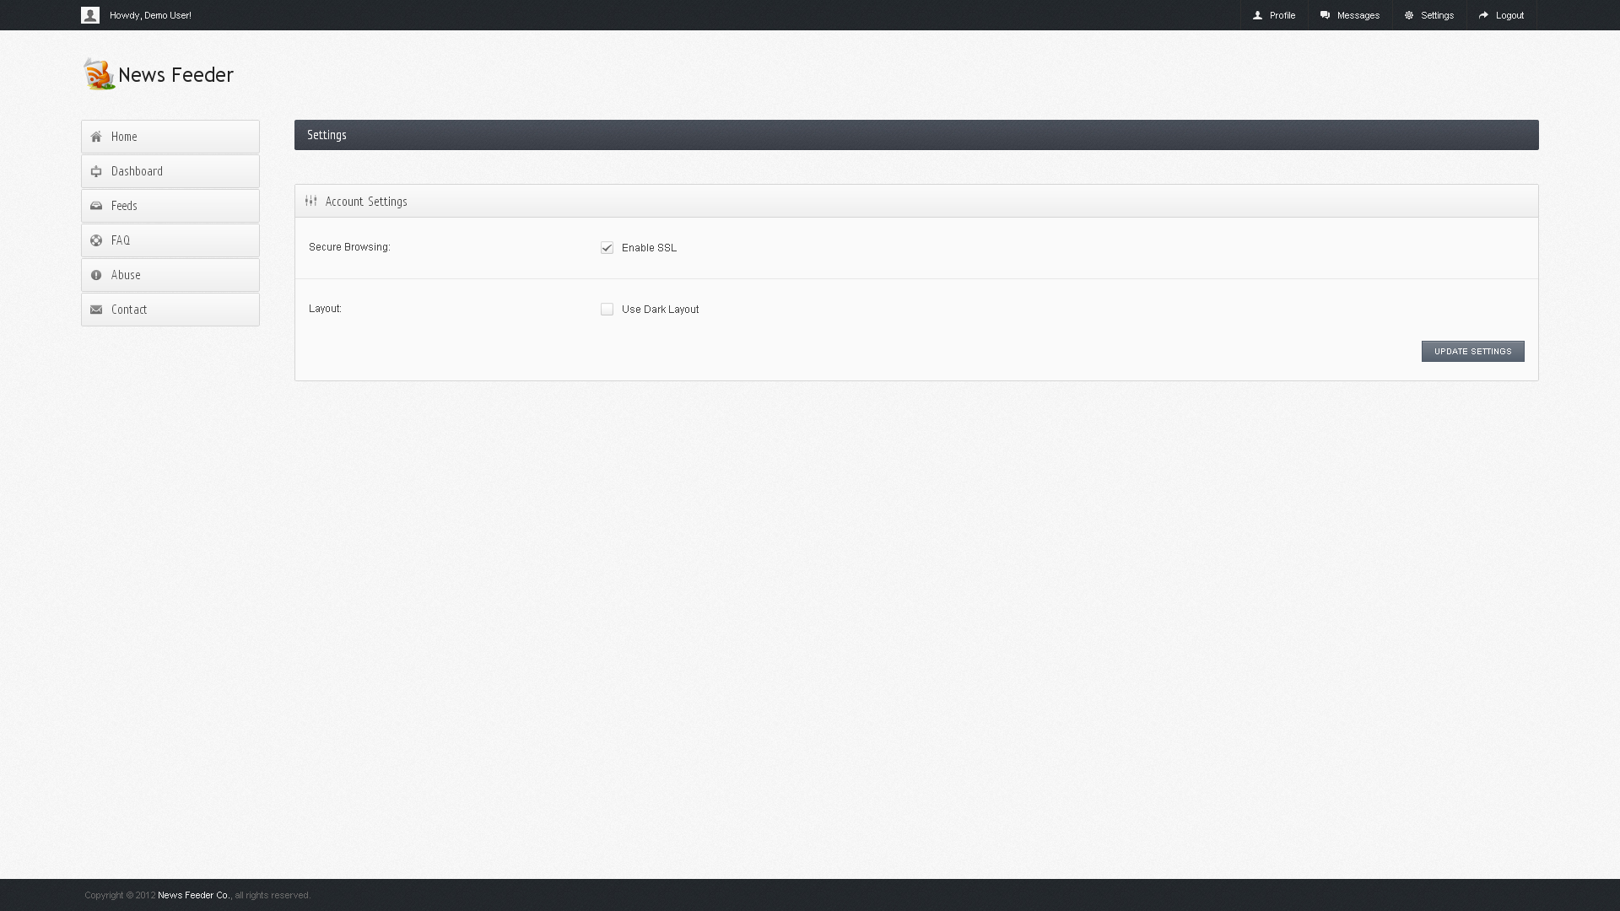Click the **Settings** link in the upper-right corner.
3. In the Settings page, change the global settings as per the following:

* **Enable SSL** – Checked if you would like SSL to be enabled. *Note: for a description of SSL please see the ‘How Secure is News Feeder?’ section in the FAQ.*

1. Click **Save Changes**.

# Managing profile information

1. Sign in to News Feeder.
2. Click the **Profile** link in the upper-right corner.

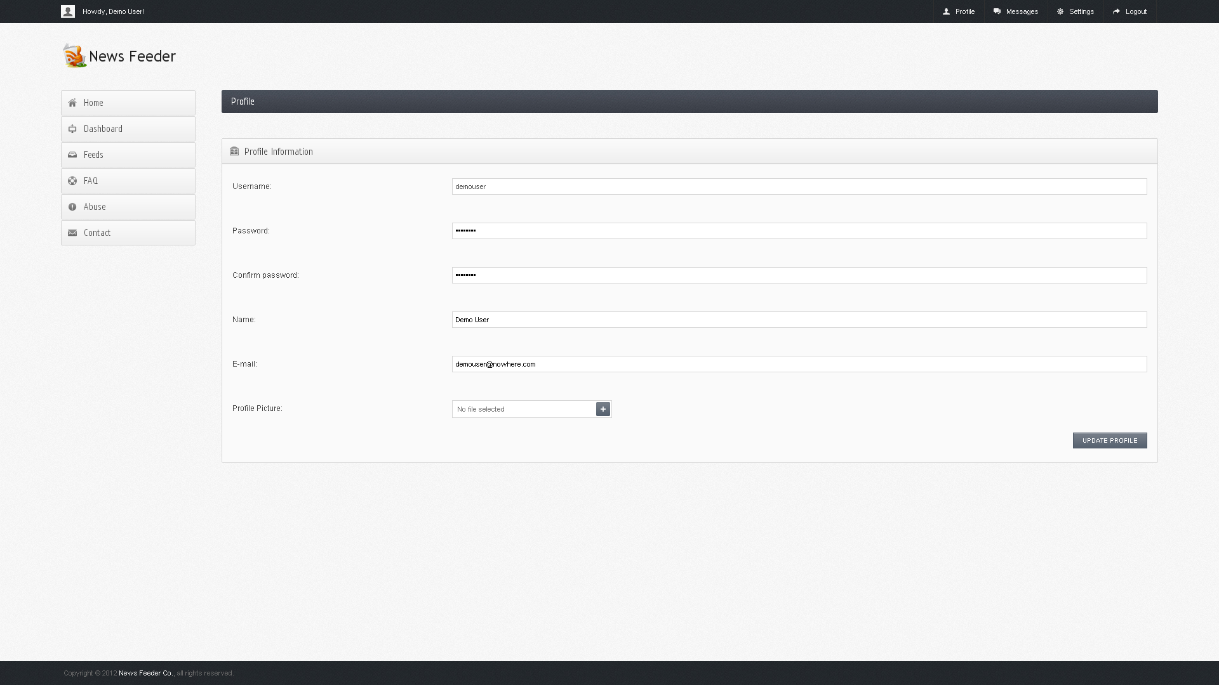

1. In the Profile page, change the global settings as per the following:

* **Password** – Enter a new password for your account. Confirm the password by retyping it in the next input field. *Note: leaving this field blank will keep your current password. Passwords are case sensitive.*
* **Name** – Enter your name to change how we greet you. Full names are optional.
* **E-mail** – Enter your new e-mail address to change where we send notifications. Please confirm you can access this e-mail address.
* **Profile Picture** – Select an image from your computer to set your new profile picture.

# Removing a sheet

1. Navigate to your Account Dashboard.
2. In the **News Sheets** section, click the **Remove** link in the same row as the sheet you want to delete.

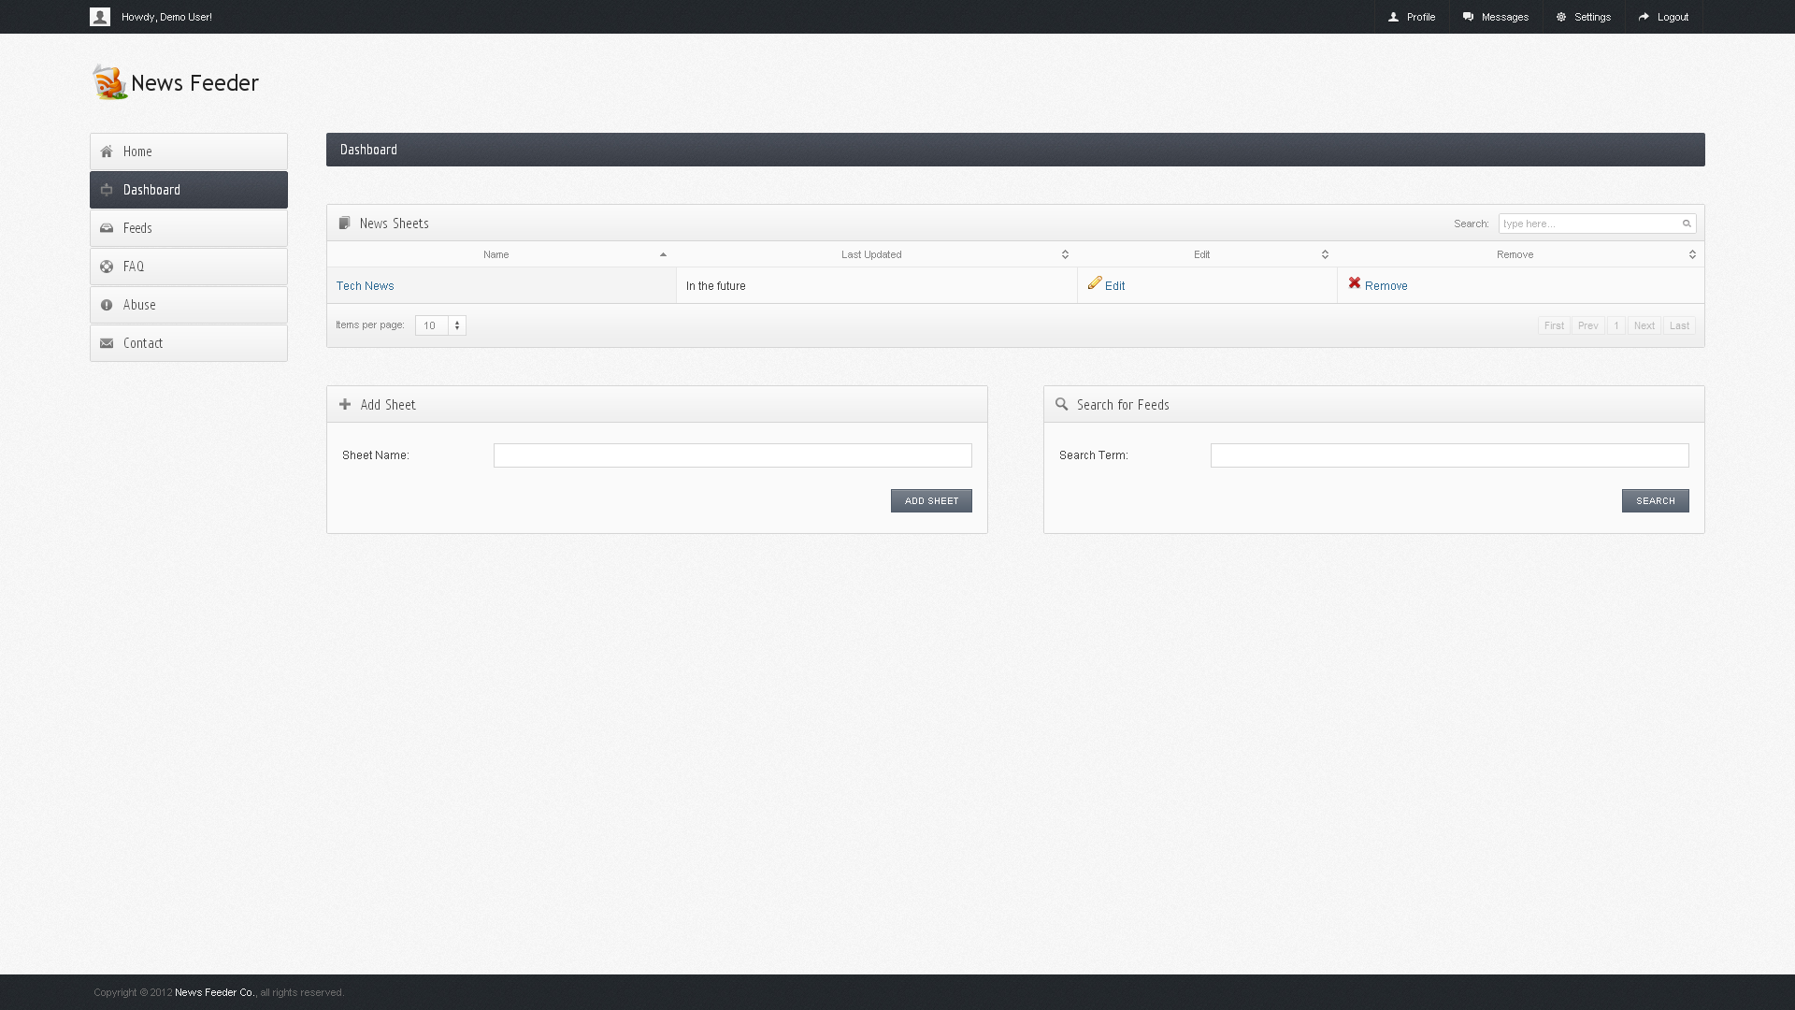

1. When prompted, confirm you wish to delete your sheet.
2. After adding your new sheet you will be presented with a success message.

# Editing a sheet

1. In the **News Sheets** section, click the **Edit** link in the same row as the sheet you want to edit.



1. Click the **Add Widget** box to begin the addition of new content.

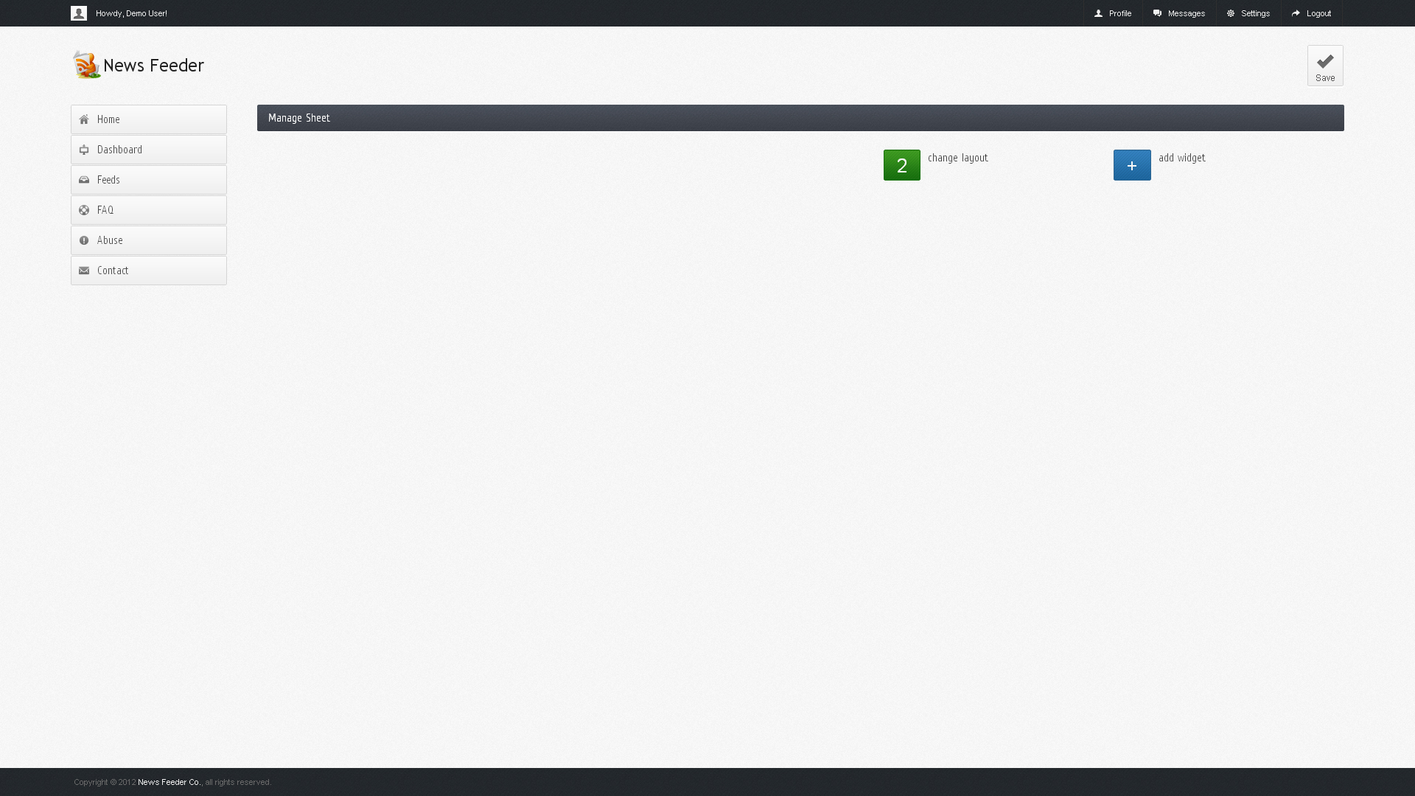

1. Select either **News** or **Weather** in the dropdown box provided. Descriptions of each will be displayed as you select them. Click **OK** to proceed.

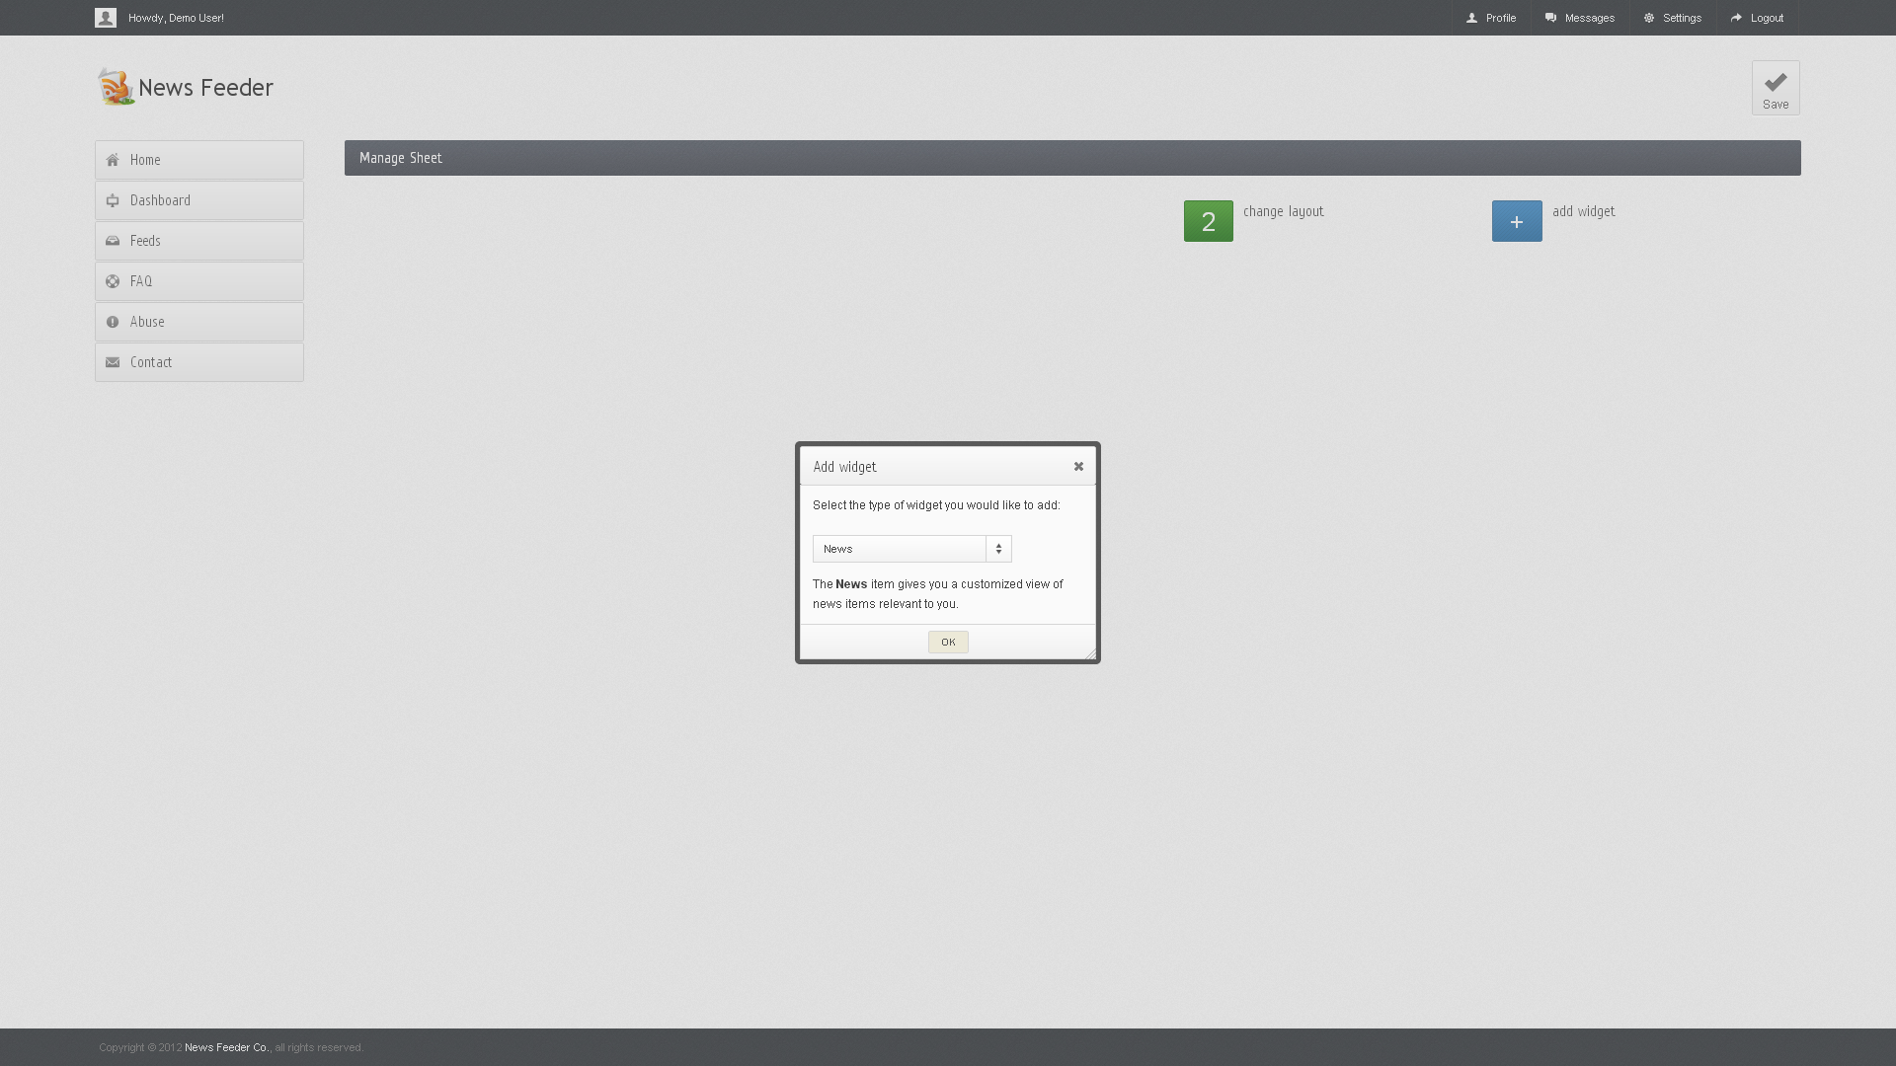

1. When you add new content, it will appear in a placeholder in the sheet space. The placeholder may be dragged into the opposing column or removed by clicking the **X** in its corner.

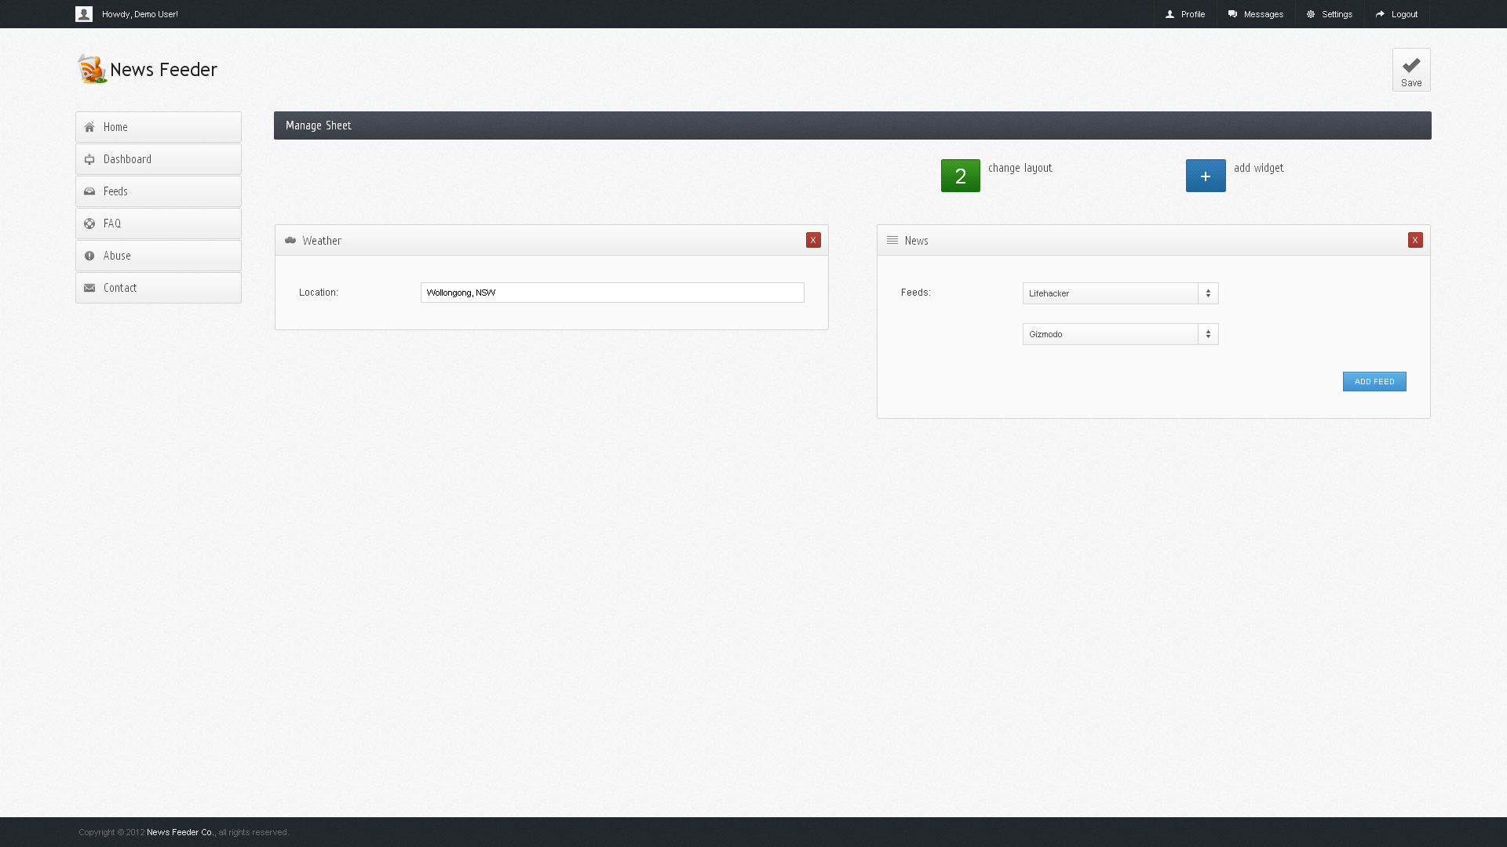

1. If you choose to include weather content, you simply type the name of the location you wish to be provided weather information about. If you choose to include news content, you may use the dropdown box to select relevant feeds and the **Add Feed** button to insert more feeds. When you have completed adding all content, click the **Save** button in the upper-right corner 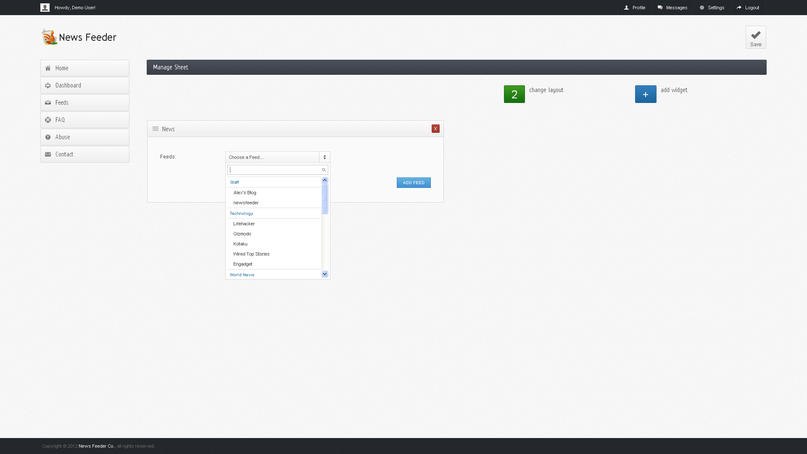and wait for the sheet to load.

# Importing OPML

1. Navigate to your Account Dashboard.
2. Enter your new sheet name in the **Import OPML** section.
3. Click the **Select File** button under your new sheet name and navigate to your XML or OPML file.
4. Click the **Begin Import** button.
5. After importing your new sheet you will be presented with a success message.



Downloader Application

# Login

To login to the downloader application, enter your username and password into the login screen and select the “Log Me In” button.

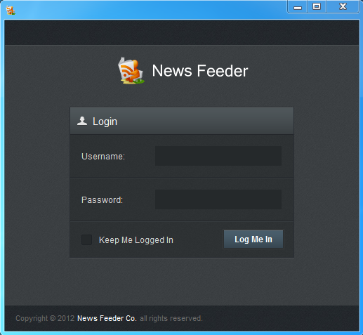

An option is provided on the login screen for staying logged in. This will allow automatic login when opening the application in the future.

On login, your credentials will be authenticated with the News feeder Web Service. This means that your username and password will be the same for the Downloader application as what is used on the website.

If you have not registered for an account to use with the downloader application, you can register by going to the website here: <http://newsfeeder.co/members/register/>

# The Task Tray

## Opening From the Task Tray

When closing the Downloader application by selecting the top cross, the application will not completely close. Instead, the downloader will run in the background.



You can re-open the application and pick up where you left off by either:

1. Double click the News feeder logo in the task tray
2. Right click and select the show button in the task tray

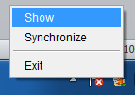

## Synchronize

The task tray allows you to perform a manual synchronize with the News feeder database. The Synchronize will connect to the web service and pull down the latest sheet information. To synchronize, right click on the News feeder icon and select Synchronize.

A synchronize is performed on a regular basis (every 5 minutes) so a synchronize button is provided for convenience.

## Exit

The exit button provides a way to exit the application. To exit the application, right click on the News feeder icon and select Exit.

# News Feeder Sheets

The main view of the downloader application provides a way to view the sheet content in offline mode. From the drop down in the top right corner, you can select a sheet to view, your default sheet used online will be the default sheet used in the application.

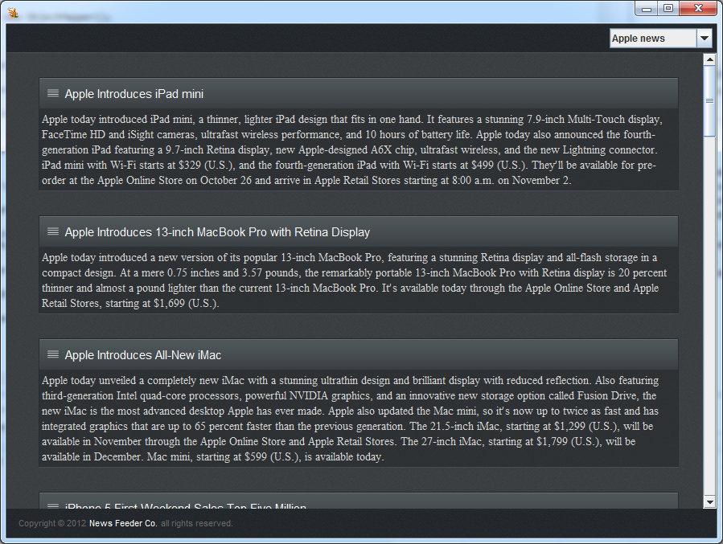

News content containing links will open in your favourite browser. The sheet layouts used on the Front-End will render similar in the downloader application creating a seamless look and feel.

Frequently Asked Questions

# What is News Feeder?

News Feeder is a service designed to pull together all the online news content relevant to you into one place.

# How secure is News Feeder?

News Feeder is set to use the 'Enable SSL' setting by default, but you can change this setting anytime. Here's some background on why we default to this option: If you sign in to News Feeder via a non-secure Internet connection, like a public wireless or non-encrypted network, your News Feeder account may be more vulnerable to hijacking. Non-secure networks make it easier for someone to impersonate you and gain full access to your News Feeder account, including any sensitive data it may contain like personal information or online log-in credentials. HTTPS, or Hypertext Transfer Protocol Secure, is a secure protocol that provides authenticated and encrypted communication.

**To disable or re-enable this feature in News Feeder:**

1. Sign in to News Feeder.
2. Click the **Settings** link in the upper-right corner.
3. In the Settings page, check or uncheck the **Enable SSL** checkbox.
4. Click **Save Changes**.

Please note that checking 'Enable SSL' will prevent you from accessing News Feeder via HTTP (Hypertext Transfer Protocol). If you trust the security of your network, you can turn this feature off at any time.

If you use a public computer to check your feeds, it's also important to sign out at the end each of your News Feeder sessions. Just click the "Sign Out" link in the upper-right corner. Also, make sure you close all News Feeder browser windows.

Glossary of Terms

**Item/Article –** An individual piece of content. This includes articles from RSS feeds or items from other types of content sources (such as an email, forum thread, weather forecast, etc).

**Feed –** A collection of items/articles all related to the same content source (i.e. the same site or RSS feed).

**Sheet –** A grouping method for feeds. It displays feeds on the website as views the user has created.

**Sheet Layout –** The view used to display feeds and content associated with the sheet. An individual sheet may have many of these views. When referring to a sheet and the way it displays its content, we are implicitly referring to its default view.

**Front-end –** The web interface of the system, where users gain access to and interact with the system.

**Back-end –** An application which runs a continuous queue and crawls/parses content sources for articles to add to the database.