Screenshots or program listings must be copied into appropriate cells in the following table.
Save this evidence document as evidence_ followed by your centre number_ candidate number. For example: evidence_ zz999_9999 and insert your name, centre number and candidate number into the header above.
Examiners must be able to read the contents including any screenshots without the use of a magnifying glass. Answers that are not readable or missing will not be awarded any marks.
Save this evidence document at regular intervals, for example, every 10 minutes.
Question 1
Part 1(a)
{Copy and paste the program code for question 1(a) here}

Part 1(b)(i)
{Copy and paste the program code for question 1(b)(i) here}

Part 1(b)(ii)
{Copy and paste the screenshot for question 1(b)(ii) here}

Part 1(c)
{Copy and paste the program code for question 1(c) here}

Part 1(d)(i)
{Copy and paste the program code for question 1(d)(i) here}

Part 1(d)(ii)
{Copy and paste the screenshot(s) for question 1(d)(ii) here}

Question 2
Part 2(a)
{Copy and paste the program code for question 2(a) here}

class Picture:
def __init__(self, Description, Width, Height, FrameColour):
self.__Description = Description # OF TYPE STRING
self.__Width = Width # OF TYPE INTEGER
self.__Height = Height # OF TYPE INTEGER
self.__FrameColour = FrameColour

Part 2(b)
{Copy and paste the program code for question 2(b) here}

def GetDescription(self):
return self.__Description

def GetHeight(self):
return self.__Height

def GetWidth(self):
return self.__Width

def GetColour(self):
return self.__FrameColour

Part 2(c)
{Copy and paste the program code for question 2(c) here}

def SetDescription(self, Description):
self.__Description = Description

Part 2(d)
{Copy and paste the program code for question 2(d) here}

picture_array = [None for _ in range(100)] # OF TYPE Picture

Part 2(e)
{Copy and paste the program code for question 2(e) here}

def ReadData():
try:
file = open("25-03-06/Pictures.txt")
index = 0
while True:
description = file.readline().strip()

if description == "": return index

width = int(file.readline().strip())
height = int(file.readline().strip())
color = file.readline().strip()

picture_array[index] = Picture(description, width, height, color)
index += 1
except FileNotFoundError:
print("File was not found")

Part 2(f)
{Copy and paste the program code for question 2(f) here}

ReadData()

Part 2(g)
{Copy and paste the program code for question 2(g) here}

frame_color = input("Enter picture color: ")
max_width = int(input("Enter picture width: "))
max_height = int(input("Enter picture height: "))

for picture in picture_array:
if picture == None: break
if picture.GetColour().lower() != frame_color.lower(): continue
if picture.GetWidth() > max_width: continue
if picture.GetHeight() > max_height: continue

print("Description: " + picture.GetDescription())
print("Width: " + str(picture.GetWidth()))
print("Height: " + str(picture.GetHeight()))

Part 2(h)
{Copy and paste the screenshot(s) for question 2(h) here}

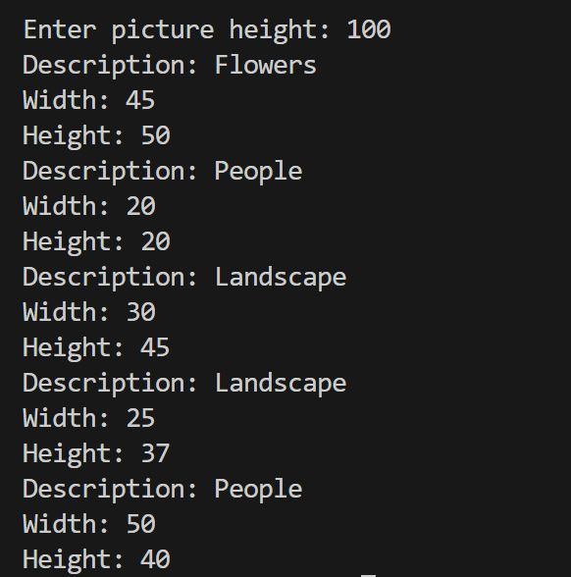

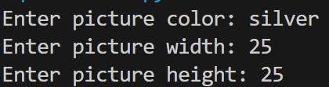

Question 3
Part 3(a)
{Copy and paste the program code for question 3(a) here}

Part 3(b)
{Copy and paste the program code for question 3(b) here}

Part 3(c)
{Copy and paste the program code for question 3(c) here}

Part 3(d)(i)
{Copy and paste the program code for question 3(d)(i) here}

Part 3(d)(ii)
{Copy and paste the screenshot for question 3(d)(ii) here}

Part 3(e)(i)
{Copy and paste the program code for question 3(e)(i) here}

Part 3(e)(ii)
{Copy and paste the screenshot for question 3(e)(ii) here}

