
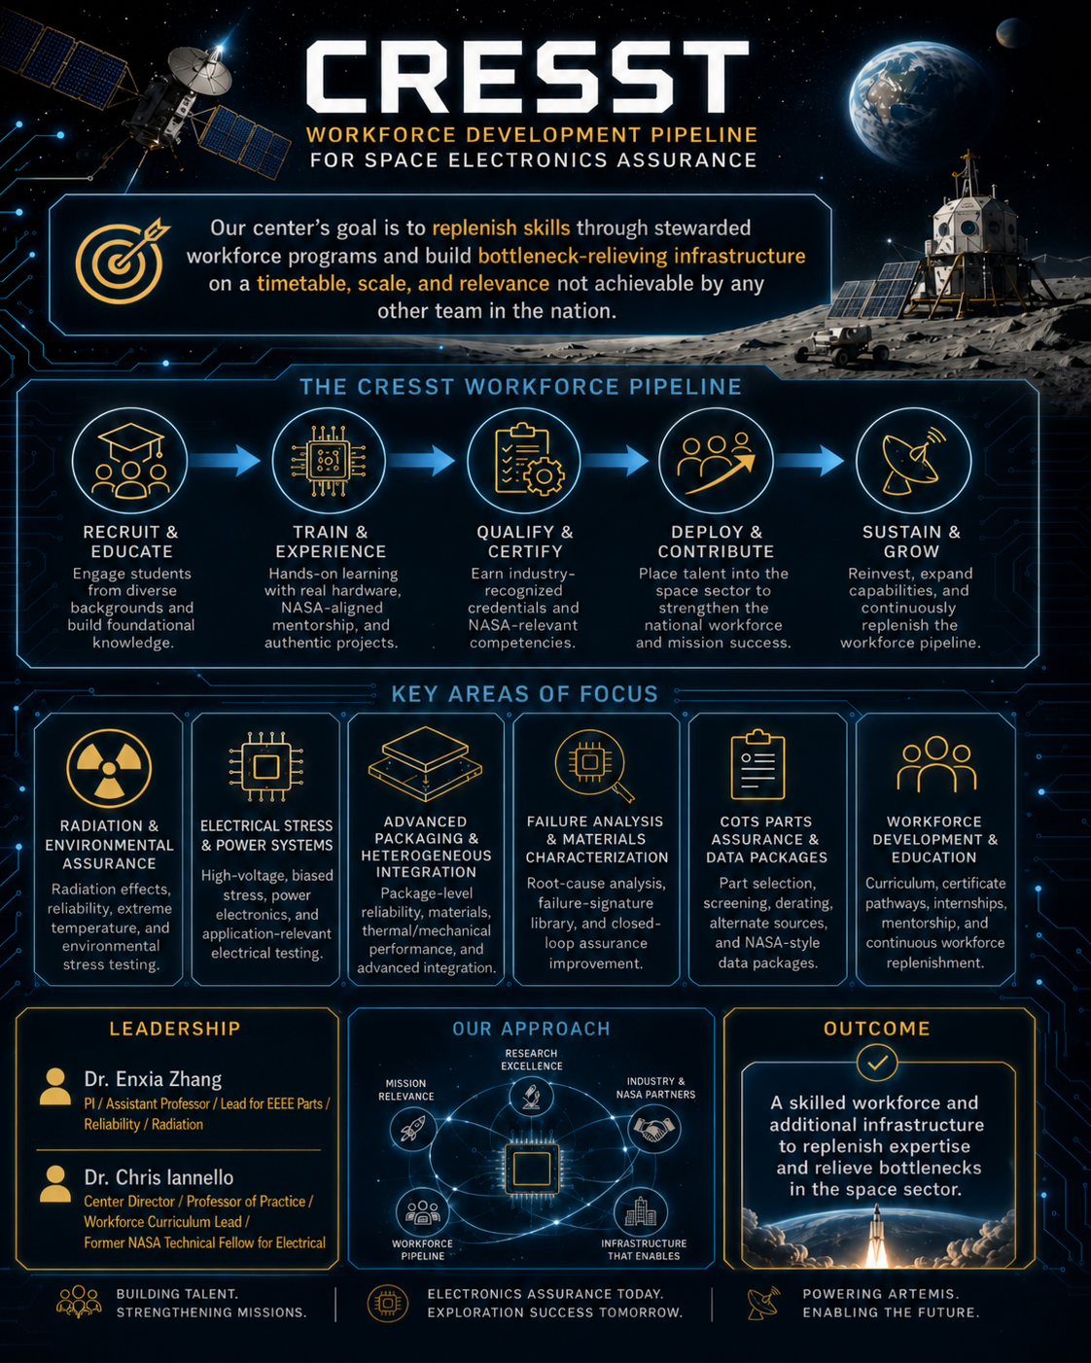
Executive Summary

CRESST-MSTAR: Center for Reliability Evaluation of Semiconductor and Space Technologies under NASA’s Minority University Research and Education Project Space Technology Artemis Research program will establish a NASA-aligned, MSI-led space electronics assurance, test infrastructure, and workforce-development capability at the University of Central Florida to support Artemis surface infrastructure, Moon-to-Mars exploration, and future NASA space technology missions. The proposed effort will build the foundation for CRESST as an integrated UCF capability focused on reliable electronics for extreme space environments, with emphasis on Electrical, Electronic, Electromechanical, and Electro-optical (EEEE) parts and systems, commercial-off-the-shelf (COTS) electronics, wide-bandgap power devices, heterogeneous assemblies, and advanced-packaged electronics.
The central challenge is that NASA and the broader aerospace community increasingly rely on COTS and rapidly evolving microelectronics, but the assurance infrastructure, test methods, data packages, and trained workforce needed to use these technologies in long-duration exploration environments have not kept pace. At the same time, there are shortages in expertise and test-facility bottlenecks in these key areas. NASA Centers such as GSFC and JPL have historically served as centers of gravity for high-reliability, environmentally hardened, long-lived electronics, but recent reductions, workforce transitions, and increasing mission demand underscore the need for additional university-based capacity that can replenish expertise and relieve specialty test and analysis bottlenecks in part by building new infrastructure but also by developing new test methods with available modalities.
Artemis surface systems will require reliable electronics capable of operating under radiation, extreme cold, thermal cycling, high-voltage power distribution, constrained maintenance, dust-adjacent conditions, and mission-specific electrical stress. These needs are directly relevant to NASA STMD and civil-space shortfalls in power management and distribution, radiation-tolerant computing, high-performance computing in harsh radiation/thermal/dust environments, extreme cold, thermal management, dust-adjacent operation, and resilient domestic space-qualified supply chains.
CRESST-MSTAR will address this gap by developing integrated assurance, test, and analysis workflows that connect COTS part selection, mission use-case definition, environmental stress mapping, radiation and reliability testing, high-voltage and biased electrical evaluation, extreme-temperature assessment, advanced-packaging assessment, physical failure analysis, and NASA-style data-package generation.
The project will be organized into three integrated pillars. First, CRESST-MSTAR will develop technical assurance methods for COTS EEEE parts, COTS dies, GaN/SiC power devices, heterogeneous assemblies, and advanced-packaged electronics used in Artemis and future exploration systems. Second, the project will build practical test and evaluation infrastructure at UCF and partnered neighboring facilities, including workflows for radiation effects, reliability testing, high-voltage application stress, extreme-temperature evaluation, package-level assessment, and failure-analysis-driven feedback. Third, CRESST-MSTAR will create a student and professional workforce pipeline aligned with NASA electronic parts engineering practice and UCF’s existing Electronic Parts Engineering certificate pathway. Together, these pillars directly support M-STAR’s goals of expanding MSI research capacity, increasing future competitiveness for NASA and federal opportunities, engaging faculty and students with NASA-relevant research and practice, and building the STEM workforce needed for future exploration missions.
A major technical thrust will be advanced packaging of COTs semiconductors as an assurance and environmental-resilience strategy. CRESST-MSTAR will investigate how packaging design, material selection, shielding-aware layouts, die integration, heterogeneous integration, interposers, substrates, encapsulation, and package-level thermal/mechanical design can improve the radiation, electrical, and environmental tolerance of COTS dies and heterogeneous electronic assemblies. This activity will connect CRESST-MSTAR with the NSF-funded Florida Semiconductor Engine ecosystem as a complementary advanced-packaging partner pathway, while keeping the primary focus on NASA-relevant electronics assurance for Artemis and future exploration missions.
UCF is an ideal home for this effort because of its MSI status, large engineering student pipeline, one of the largest in the nation, aerospace and defense workforce role, UCF’s position as the nation’s #1 supplier of aerospace and defense workforce by scale, proximity to Kennedy Space Center and Florida’s Space Coast, connection to Florida’s semiconductor and advanced-packaging ecosystem, and existing NASA-aligned electronic parts education infrastructure. Dr. Enxia Zhang’s Radiation Effects and Reliability Lab provides the technical foundation in radiation effects, EEEE parts reliability, GaN/SiC power electronics, COTS electronics evaluation, cryogenic and extreme-environment testing, and student-centered research training. Dr. Chris Iannello’s NASA experience as NASA’s longest-tenured Technical Fellow for Electrical, its senior Agency-level electrical engineer, will focus on workforce and curriculum development. His long-standing space sector network will help connect CRESST-MSTAR to NASA professional practice in EEEE parts, avionics, power systems, radiation assurance, and mission assurance in a manner not possible in any other program in the nation.
By the end of the two-year M-STAR period of performance, CRESST-MSTAR will deliver validated electronics assurance workflows, representative demonstration test campaigns, COTS and advanced-packaging data-package templates, certificate-ready training modules, student research cohorts, NASA and industry mentorship pathways, a partner-facing service catalog, and a sustainability plan. The long-term result will be a durable MSI-led capability that strengthens NASA space technology research, addresses specialty workforce shortages, reduces test-infrastructure bottlenecks, and advances reliable electronics for Artemis surface infrastructure and future exploration missions.
The proposed center can replenish skills through stewarded workforce programs and build bottleneck-relieving infrastructure on a timetable, scale, and relevance not achievable by any other organization.

REVISED to 4000 characters
The Center for Reliability Evaluation of Semiconductor and Space Technologies–MSTAR (CRESST-MSTAR) will establish at the University of Central Florida a NASA-aligned, MSI-led national hub for space electronics assurance, extreme-environment testing, advanced packaging, and workforce development. It will replenish scarce expertise and build bottleneck-relieving infrastructure on a timetable, scale, and level of mission relevance unmatched nationally.
NASA, its suppliers, and the commercial space sector increasingly depend on commercial-off-the-shelf (COTS) parts, COTS dies, wide-bandgap devices, and advanced-packaged electronics. Yet the assurance infrastructure, test methods, decision-grade data packages, and trained workforce needed to use these technologies in demanding missions have not kept pace. Existing approaches are often too slow, narrow, costly, or insufficiently integrated, while the Nation faces shortages in EEEE parts assurance, radiation effects, advanced packaging, reliability, failure analysis, and NASA-style technical documentation.
COTS parts assurance—especially radiation-effects methods for commercial parts—is a foundational enabler for LIVE and ENABLE and, in practice, every STMD/RTMD domain. LIVE systems for lunar and Martian power, computing, sensing, mobility, communications, and autonomy must survive radiation, extreme cold, thermal cycling, high voltage, dust, long-duration storage, and limited maintenance. ENABLE depends on trusted avionics, advanced computing, packaging, manufacturing assurance, relevant test environments, and resilient supply chains. GO, LAND, and EXPAND likewise rely on dependable power, control, sensing, landing, computing, and autonomous electronics. CRESST-MSTAR will reduce the component- and assembly-level risks that constrain them all.
The project will integrate mission-use-case definition, COTS selection and screening, proton and heavy-ion testing, total-ionizing-dose assessment, high-voltage and extreme-temperature stress, advanced-packaging assessment, physical failure analysis, and NASA-style data-package generation. UCF’s Radiation Effects and Exploration Laboratory, X-ray and electrical characterization resources, local high-energy proton capability, external heavy-ion access, and reusable test hardware will support repeated demonstration campaigns. Local proton access is especially important because it enables student participation, readiness reviews, anomaly follow-up, and affordable commercial-parts testing rather than isolated, one-time beam campaigns.
CRESST-MSTAR will unite three reinforcing pillars: modern COTS and EEEE assurance methods; integrated test, characterization, packaging, and failure-analysis capability; and a stewarded workforce pipeline that recruits, trains, qualifies, deploys, and continually replenishes talent. Students will progress from coursework into authentic test campaigns, NASA-style reviews, data packages, internships, credentials, and employment supporting NASA, its prime contractors, semiconductor suppliers, defense organizations, and commercial space companies.
The leadership combination is unmatched. Dr. Enxia Zhang brings deep theoretical and experimental expertise in radiation effects, semiconductor reliability, GaN/SiC devices, COTS evaluation, cryogenic behavior, modeling, and student-centered research. Dr. Chris Iannello brings more than three decades of spaceflight development, independent assessment, anomaly resolution, system-level assurance, and risk-informed use of commercial electronics, including more than a decade as NASA Technical Fellow for Electrical/Power. Together, they connect device physics and empirical evidence to qualification, mission assurance, and workforce practice. Their professional networks across academia, industry, NASA Centers, prime contractors, commercial space, semiconductor suppliers, and test facilities provide mentors, reviewers, internships, facilities, and transition pathways no conventional academic team can reproduce.
UCF multiplies this advantage through its MSI status, more than 70,000 students, one of the Nation’s largest engineering pipelines, established Electronic Parts Engineering certificate and MS pathways, proximity to Kennedy Space Center and the Space Coast, and ties to Florida’s semiconductor and advanced-packaging ecosystem. CRESST-MSTAR can therefore become the Nation’s leading hub for electronics in extreme environments—producing qualified talent, reusable methods, decision-ready evidence, and bottleneck-relieving infrastructure on a scale and timetable no other program can match.

