Ian Nelson
CMIS115
Homework 4
Puran Nebhnani

Homework 4 Analysis

For homework 4, I created the following files:
- Song.h – Interface for the Song class
- Song.m – Implementation for the Song class
- SongList.h – Interface for the SongList class
- SongList.m – Implementation for the SongList class
- Iannelsonhw4.m – Main execution branch, creates and tests classes.
- Makefile – Used to build the application with clang.
The Song.h/m files are used to create a Song class, which contains the synthesized @property variables as required in the assignment. This is used to represent a single song entry with a representative song name and artist name.
The SongList.h/m files are used to create a SongList class. This class provides the bulk of the logic for Homework 4, and uses a NSMutableArray instance to manage a collection of Song objects. The NSMutableArray is created in the default initializer, and set to only represent 10 objects total. Finally, this class contains methods for the following functionality:
- printSongAtIndex – Prints a nicely formatted log with the song name and artist at a given index within the array.
- printSongs – Prints an entire table of songs by iterating over the length of the array.
- numberOfSongs – Returns the integer count of how many Song objects are present in the array.
- addSong – Takes a song name and artist, creates a Song object, and adds it to the array. Additionally, a log is printed giving the user an indication which song was added.
Finally, in the Iannelsonhw4.m source file, an instance of the SongList class is instantiated, and used to add 10 songs based on the requirements. The citation of the source of songs (Top 10 from 1969) is also presented to the user. In this workflow, the user sees that initially, 0 songs are present. Then, 10 songs are added to the SongList, each getting a log notification. Afterwards, a count of songs is shown, and finally, two tests are done to find a song within the array bounds ( 2 of {0,9} ) and to attempt finding a song out of the array bounds ( 11 of {0,9} ). Messages to indicate these searches are also presented.
Finally, an incremented positional value is used often in the SongList class. This is to give the user a normalized position (1-10) versus the actual index of the zero-based array.

In the program output seen in the figure below, this workflow can easily be seen as described via text.
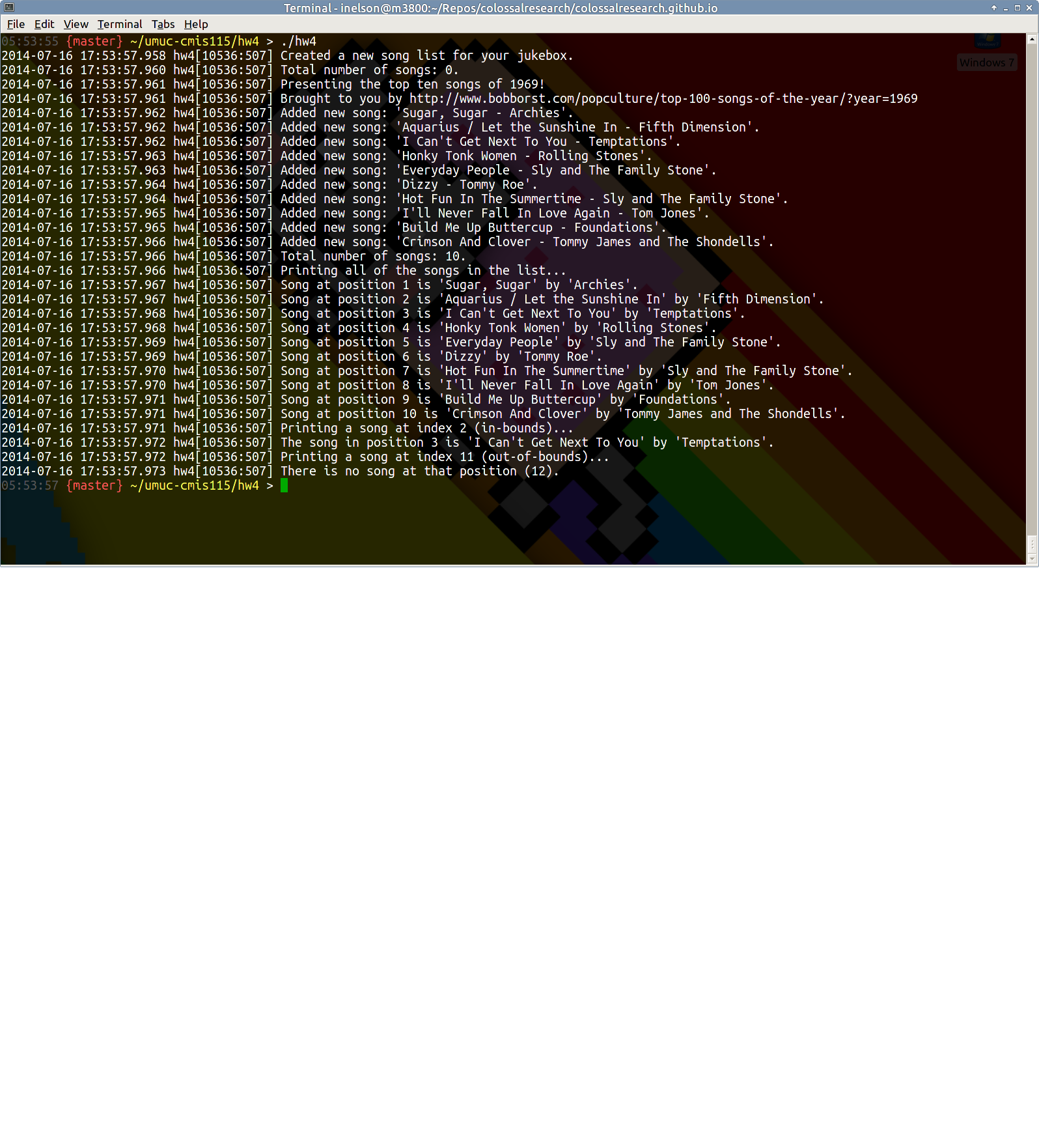
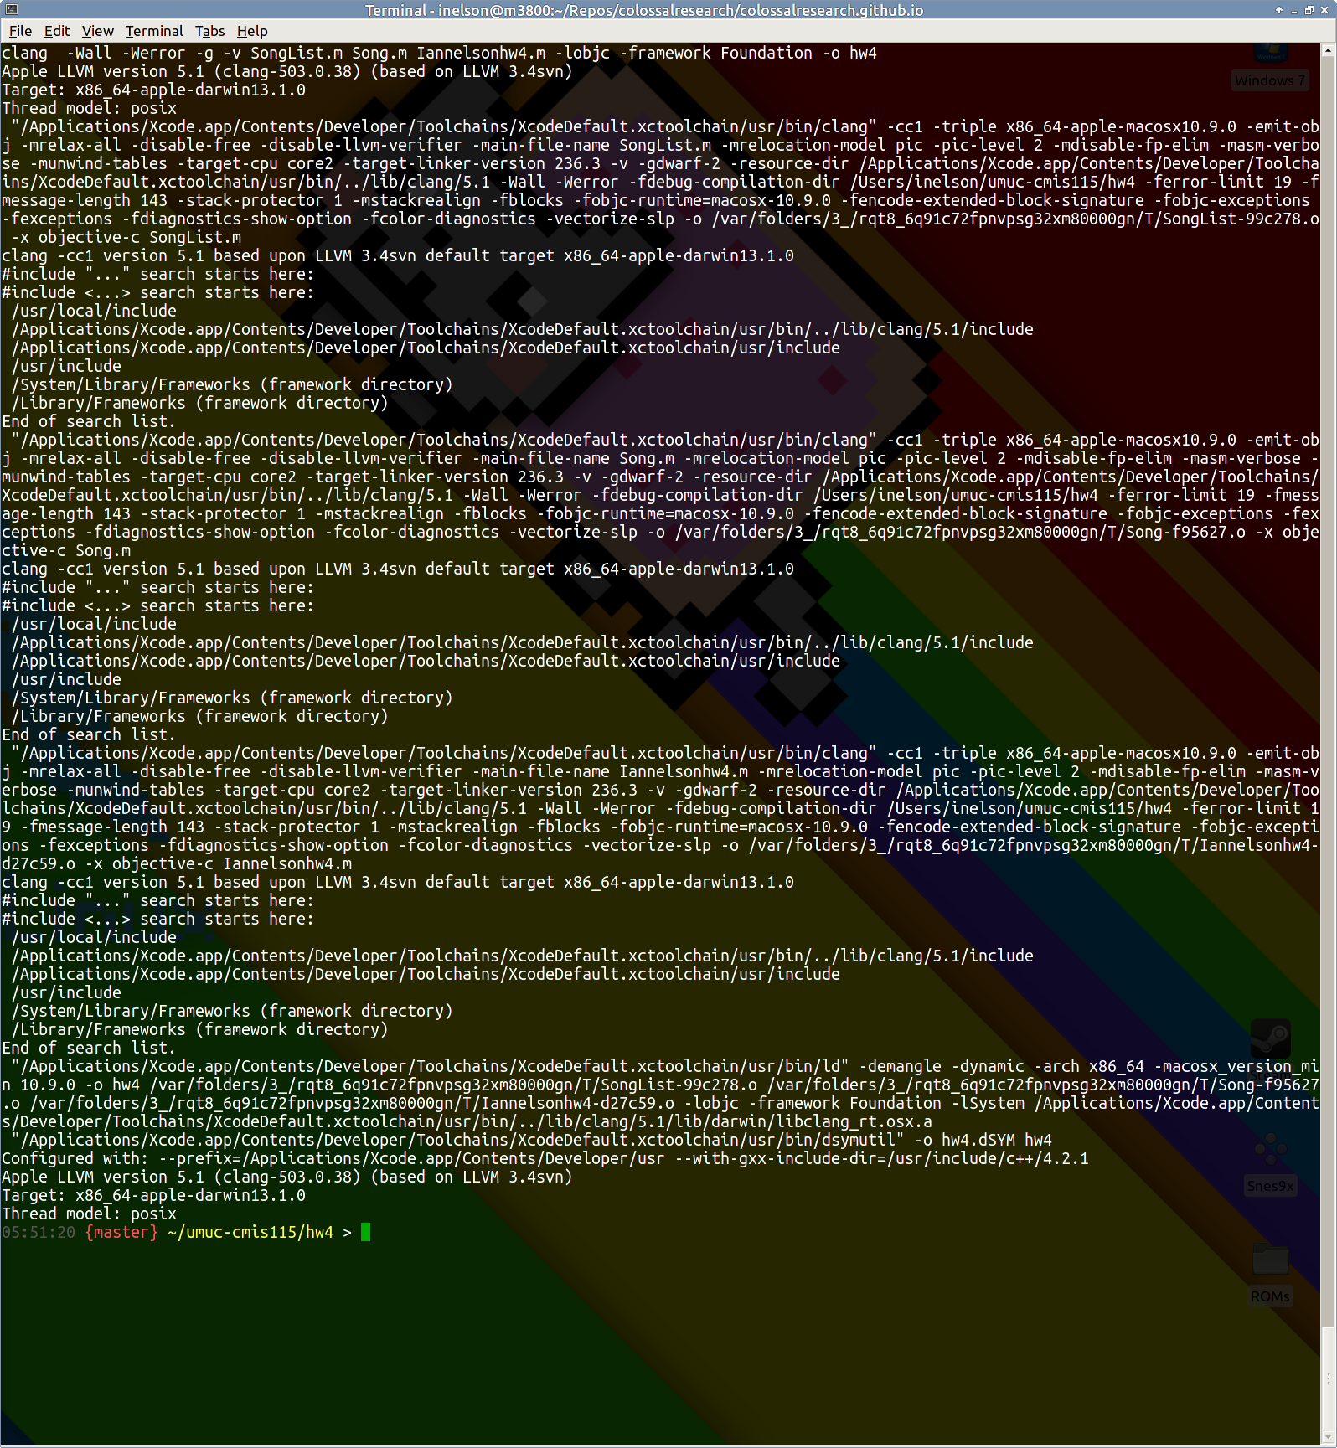
Build Output and GCC versioning from Homework 4

