Ian Nelson
CMIS115
Final Project
Puran Nebhnani

Final Project Analysis

For the final project, I used the existing files from Homework 4:
- Song.h – Interface for the Song class
- Song.m – Implementation for the Song class
- SongList.h – Interface for the SongList class
- SongList.m – Implementation for the SongList class
- Iannelsonfp.m – Main execution branch, creates and tests classes.
- Makefile – Used to build the application with clang.
The Song.h/m files are used to create a Song class, which contains the synthesized @property variables as required in the assignment. This is used to represent a single song entry with a representative song name and artist name.
The SongList.h/m files are used to create a SongList class. This class provides the bulk of the logic for Homework 4, and uses a NSMutableArray instance to manage a collection of Song objects. The NSMutableArray is created in the default initializer, and set to only represent 10 objects total. Finally, this class contains methods for the following functionality:
- printSongAtIndex – Prints a nicely formatted log with the song name and artist at a given index within the array.
- printSongs – Prints an entire table of songs by iterating over the length of the array.
- numberOfSongs – Returns the integer count of how many Song objects are present in the array.
- addSong – Takes a song name and artist, creates a Song object, and adds it to the array. Additionally, a log is printed giving the user an indication which song was added.
In addition, the following methods were added to sort and save the information to the file system, per final project requirements:
- sortSongs – Uses a descriptor sort to sort the NSMutableArray of Song objects in place, by artist, in ascending order.
- save – Creates a concatenated string of songs and artists, delimited by CRLF, and persists the string to the file system in ‘mysongs.txt’.
Finally, in the Iannelsonfp.m source file, an instance of the SongList class is instantiated, and used to add 10 songs based on the requirements. The citation of the source of songs (Top 10 from 1969) is also presented to the user. In this workflow, the user sees that initially, 0 songs are present. Then, 10 songs are added to the SongList, each getting a log notification. Afterwards, a count of songs is shown, and finally, two tests are done to find a song within the array bounds ( 2 of {0,9} ) and to attempt finding a song out of the array bounds ( 11 of {0,9} ). Messages to indicate these searches are also presented. An incremented positional value is used often in the SongList class. This is to give the user a normalized position (1-10) versus the actual index of the zero-based array.
Test Cases
Case | Input | Expected Output | Actual Output | Pass?
[songList printSongs] | None | Figure 1 | Figure 2 | Yes
[songList printSongAtIndex:2] | None | The song in position 3 is 'I Can't Get Next To You' by 'Temptations'. | The song in position 3 is 'I Can't Get Next To You' by 'Temptations'. | Yes
[songList printSongAtIndex:11] | None | There is no song at that position (12). | There is no song at that position (12). | Yes
[songList sortSongs] | None | Figure 3 | Figure 4 | Yes
[songList save] | None | Figure 5 | Figure 6 | Yes

Figure 1. Case 1 : Expected Output
Song at position 1 is 'Sugar, Sugar' by 'Archies'.
Song at position 2 is 'Aquarius / Let the Sunshine In' by 'Fifth Dimension'.
Song at position 3 is 'I Can't Get Next To You' by 'Temptations'.
Song at position 4 is 'Honky Tonk Women' by 'Rolling Stones'.
Song at position 5 is 'Everyday People' by 'Sly and The Family Stone'.
Song at position 6 is 'Dizzy' by 'Tommy Roe'.
Song at position 7 is 'Hot Fun In The Summertime' by 'Sly and The Family Stone'.
Song at position 8 is 'I'll Never Fall In Love Again' by 'Tom Jones'.
Song at position 9 is 'Build Me Up Buttercup' by 'Foundations'.
Song at position 10 is 'Crimson And Clover' by 'Tommy James and The Shondells'.

Figure 2. Case 1 : Actual Output

Song at position 1 is 'Sugar, Sugar' by 'Archies'.
Song at position 2 is 'Aquarius / Let the Sunshine In' by 'Fifth Dimension'.
Song at position 3 is 'I Can't Get Next To You' by 'Temptations'.
Song at position 4 is 'Honky Tonk Women' by 'Rolling Stones'.
Song at position 5 is 'Everyday People' by 'Sly and The Family Stone'.
Song at position 6 is 'Dizzy' by 'Tommy Roe'.
Song at position 7 is 'Hot Fun In The Summertime' by 'Sly and The Family Stone'.
Song at position 8 is 'I'll Never Fall In Love Again' by 'Tom Jones'.
Song at position 9 is 'Build Me Up Buttercup' by 'Foundations'.
Song at position 10 is 'Crimson And Clover' by 'Tommy James and The Shondells'.
Figure 3. Case 4 : Expected Output

Song at position 1 is 'Sugar, Sugar' by 'Archies'.
Song at position 2 is 'Aquarius / Let the Sunshine In' by 'Fifth Dimension'.
Song at position 3 is 'Build Me Up Buttercup' by 'Foundations'.
Song at position 4 is 'Honky Tonk Women' by 'Rolling Stones'.
Song at position 5 is 'Everyday People' by 'Sly and The Family Stone'.
Song at position 6 is 'Hot Fun In The Summertime' by 'Sly and The Family Stone'.
Song at position 7 is 'I Can't Get Next To You' by 'Temptations'.
Song at position 8 is 'I'll Never Fall In Love Again' by 'Tom Jones'.
Song at position 9 is 'Crimson And Clover' by 'Tommy James and The Shondells'.
Song at position 10 is 'Dizzy' by 'Tommy Roe'.

Figure 4. Case 4 : Actual Output

Song at position 1 is 'Sugar, Sugar' by 'Archies'.
Song at position 2 is 'Aquarius / Let the Sunshine In' by 'Fifth Dimension'.
Song at position 3 is 'Build Me Up Buttercup' by 'Foundations'.
Song at position 4 is 'Honky Tonk Women' by 'Rolling Stones'.
Song at position 5 is 'Everyday People' by 'Sly and The Family Stone'.
Song at position 6 is 'Hot Fun In The Summertime' by 'Sly and The Family Stone'.
Song at position 7 is 'I Can't Get Next To You' by 'Temptations'.
Song at position 8 is 'I'll Never Fall In Love Again' by 'Tom Jones'.
Song at position 9 is 'Crimson And Clover' by 'Tommy James and The Shondells'.
Song at position 10 is 'Dizzy' by 'Tommy Roe'.

Figure 5. Case 5 : Expected Output

'Sugar, Sugar','Archies'
'Aquarius / Let the Sunshine In','Fifth Dimension'
'Build Me Up Buttercup','Foundations'
'Honky Tonk Women','Rolling Stones'
'Everyday People','Sly and The Family Stone'
'Hot Fun In The Summertime','Sly and The Family Stone'
'I Can't Get Next To You','Temptations'
'I'll Never Fall In Love Again','Tom Jones'
'Crimson And Clover','Tommy James and The Shondells'
'Dizzy','Tommy Roe'

Figure 6. Case 6 : Actual Output

'Sugar, Sugar','Archies'
'Aquarius / Let the Sunshine In','Fifth Dimension'
'Build Me Up Buttercup','Foundations'
'Honky Tonk Women','Rolling Stones'
'Everyday People','Sly and The Family Stone'
'Hot Fun In The Summertime','Sly and The Family Stone'
'I Can't Get Next To You','Temptations'
'I'll Never Fall In Love Again','Tom Jones'
'Crimson And Clover','Tommy James and The Shondells'
'Dizzy','Tommy Roe'
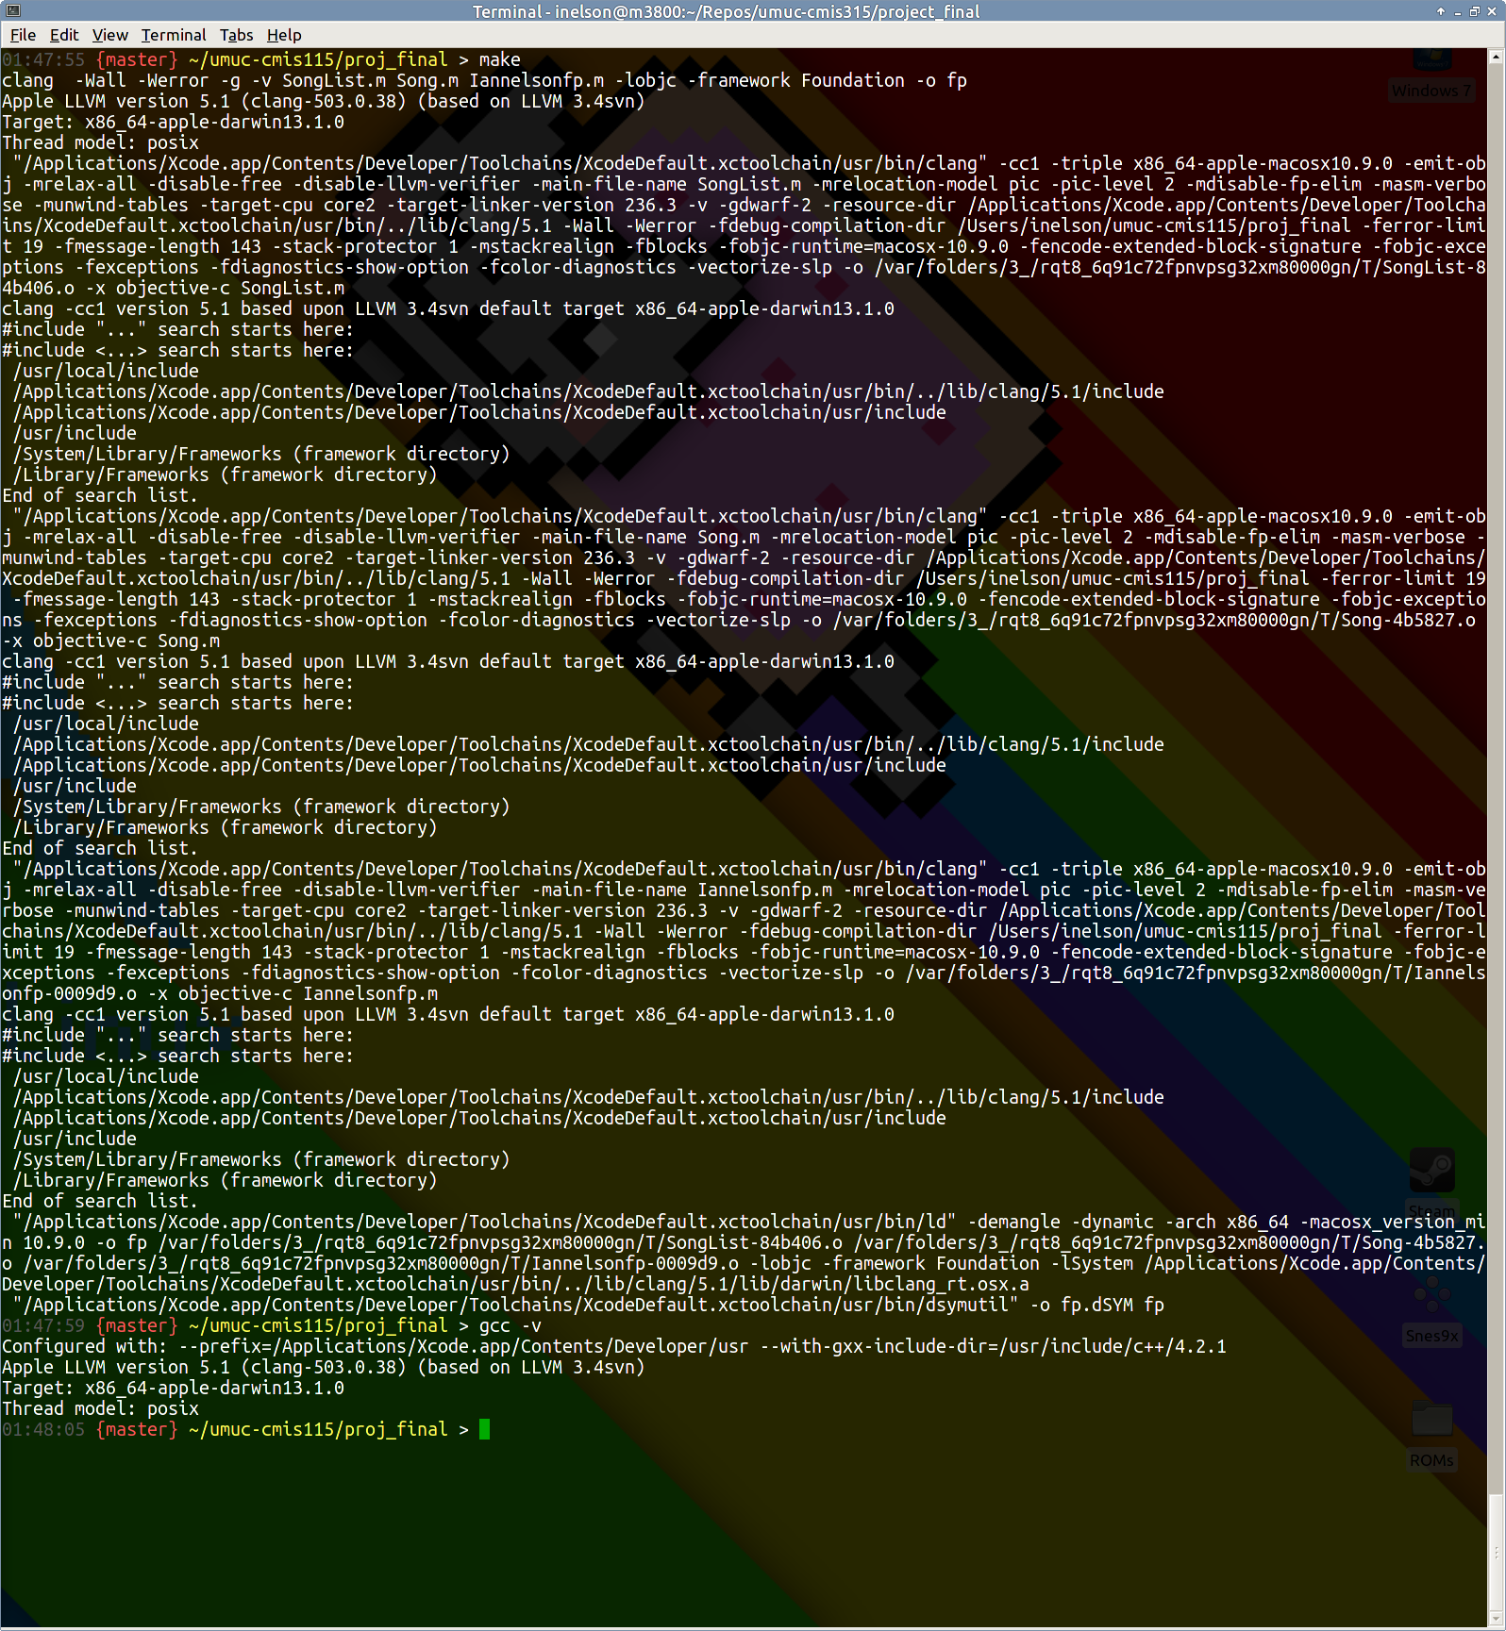
Figure 7. Build Output and GCC/Clang Versioning
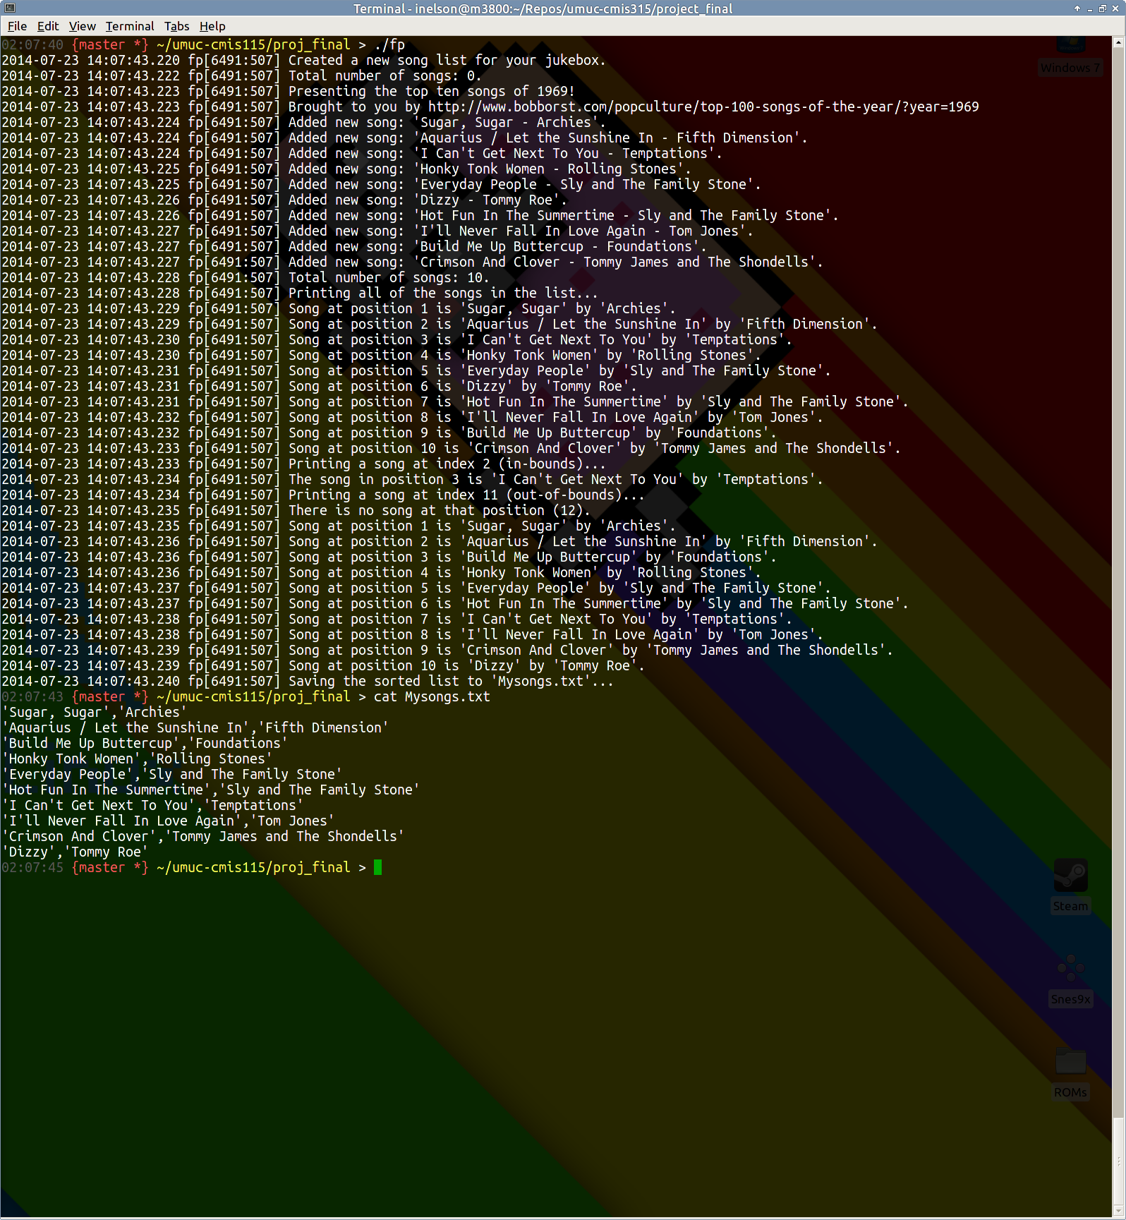
Figure 8. Program Output with before/after sorting, and ‘Mysongs.txt’ output from [songList save]

