Ian Nelson
CMIS115
Project 2
Puran Nebhnani

Project 2 Analysis

For Project 2, I started with the basic files from Homework 3. These included the interface (.h) and implementation (.m) files for both the Wheeled and Cars classes. Additionally, I renamed the main.m file to Iannelsonp2.m to match the project requirements.

To demonstrate the point of inheritance from a superclass through to the subclass, I implemented both the start() and stop() methods within the Wheeled class. This was to demonstrate that both types of functions were necessary for a wheeled vehicle. To accommodate the project 2 requirements, I overrode the start() and stop() functions in the Cars subclass to output their respective messages, and then call the superclass method. Once the superclass method was called, the speed was either set to 20 or zero, respectively.

Additionally, the Cars class uses a constructor (init) to define the wheels to 4 when a new object is instantiated. This shows that the Car object has unique properties, and while it can be changed via the accessor methods, this is the default state of a Car object.

Finally, I extended the NSLog() messages in the main function to give more information for testing, which is listed below. While the test cases do accommodate all project 2 requirements, there were not many test cases from which to work from to validate the inheritance properties in a demonstrative fashion.

In addition, this program was compiled under Mac OS X Mavericks (10.9) via the command line over SSH. A Makefile has been included (with txt extension to submit through LEO), and compiled via clang directly. Output and compilation has been attached as a screenshot to demonstrate the project’s ability to compile, as well as output from executing the project.

Test Cases

Case | Input | Expected Output | Actual Output | Pass?
[wheeled start] | None | (Starting Wheeled, should not see a message.)  Speed of Wheeled: 20 | (Starting Wheeled, should not see a message.)  Speed of Wheeled: 20 | Yes
[wheeled wheels] | None | Number of wheels on Wheeled: 2 | Number of wheels on Wheeled: 2 | Yes
[wheeled stop] | None | (Applying brakes to Wheeled, should not see a message.)  Speed of Wheeled: 0 | (Applying brakes to Wheeled, should not see a message.)  Speed of Wheeled: 0 | Yes
[car start] | None | (Starting Car, should see a message.)  Car is now moving.  Speed of Car: 20 | (Starting Car, should see a message.)  Car is now moving.  Speed of Car: 20 | Yes
[car wheels] | None | Number of wheels on car: 4 | Number of wheels on car: 4 | Yes
[car stop] | None | (Applying brakes to Car, should see a message.)  Brakes are being applied.  Speed of Car: 0 | (Applying brakes to Car, should see a message.)  Brakes are being applied.  Speed of Car: 0 | Yes

Image 1: Console / Build Output from GCC/Make:

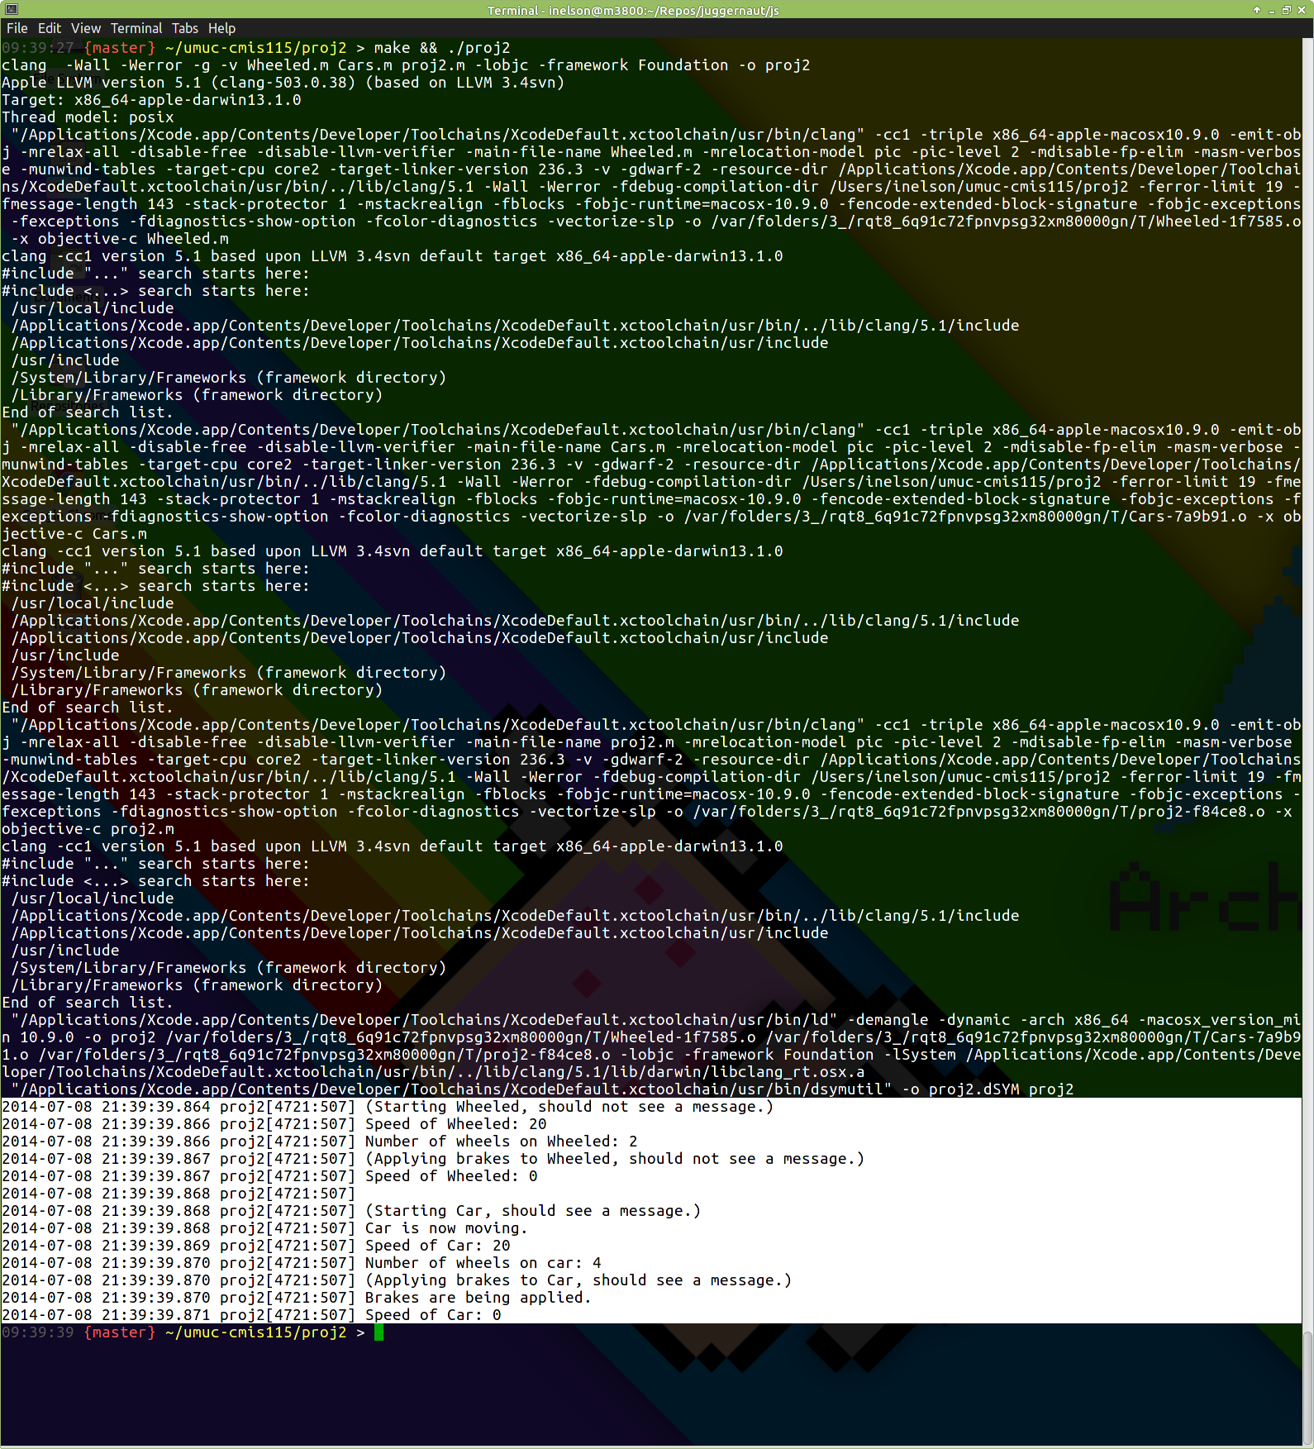
Image 2: Compiler and Makefile Output

