Ian Nelson

Homework 1

CMIS115

Puran Nebhnani

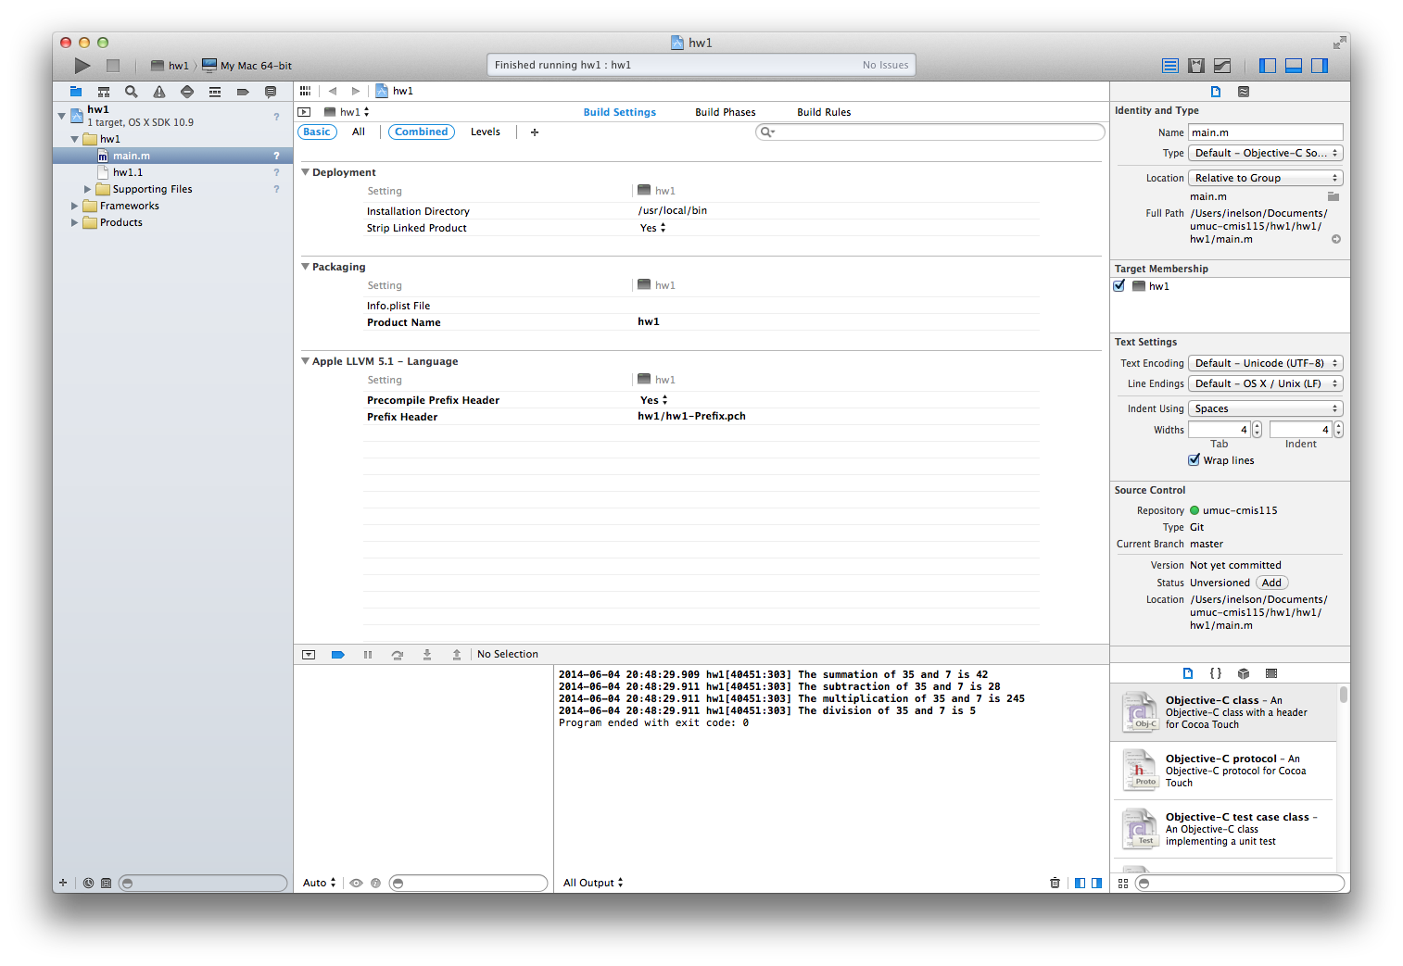

As can be seen from the output window in the above screenshot, the output for the program gives a line by line summary of two integers (in this case 35 and 7), their addition, subtraction, multiplication and division. The program also terminates cleanly with an exit code of 0.

The use of formatted strings was used in NSLog to define three numeric place values: one for the first integer, one for the second integer, and the mathematical operation result. By using formatted strings, I was able to insert the results quickly into the same string. This could have been optimized by using an external function, passing associated values, and limiting the lines of code required to generate the console statements.