Ian Nelson

CMIS115

Homework 2

Puran Nebhnani

Homework 2 Analysis

For homework 2, I started with a set of logic directly in the main() function. Since the homework assignment specifically called for no class, I proceeded to work on the input and input sanitization. The most difficult portion of this assignment was the input from the user and the validation of the integer-required input.

In order to give a good presentation for the input required by the user, I used the ‘printf’ function to format the lines and skip the CRLF. Once this occurred, I had to use a chain of ‘scanf’ input commands to retrieve an integer. The ‘scanf’ chain inputs an integer, and a follow-on character to assess if a CRLF was passed. If not, a while loop continues to scan through characters to restart the input stream if necessary, and ask for the user’s input for a valid integer between 1 and 50.

Once the input is valid, a nested set of for loops is used to process the powers table. The initial header of (n->n^4) is printed to the console using tab spacing. Each internal loop uses a range from 1-4 to calculate the power, and print it with spacing.

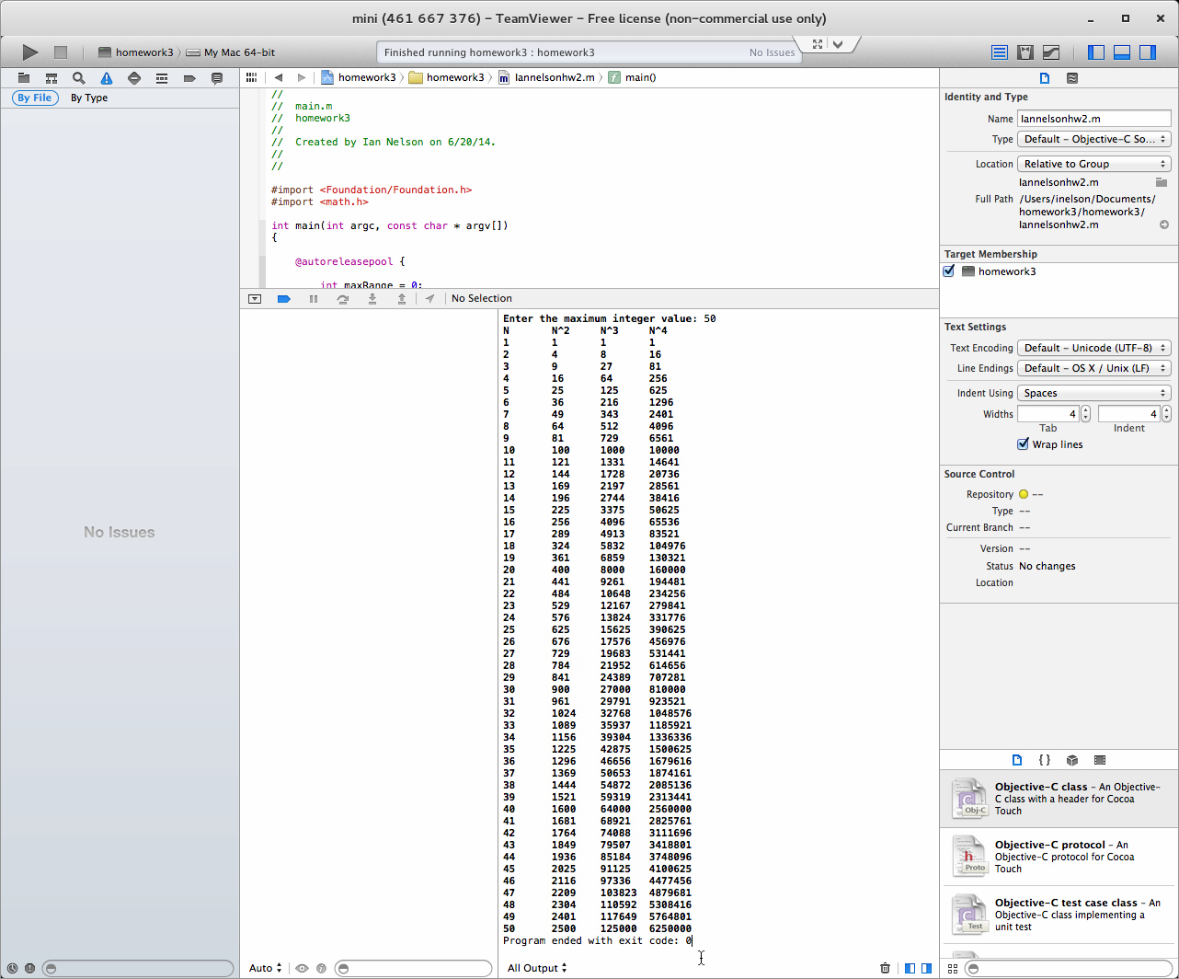

**Image 1**

This image shows a complete set of power calculations for the maximum range of 50.

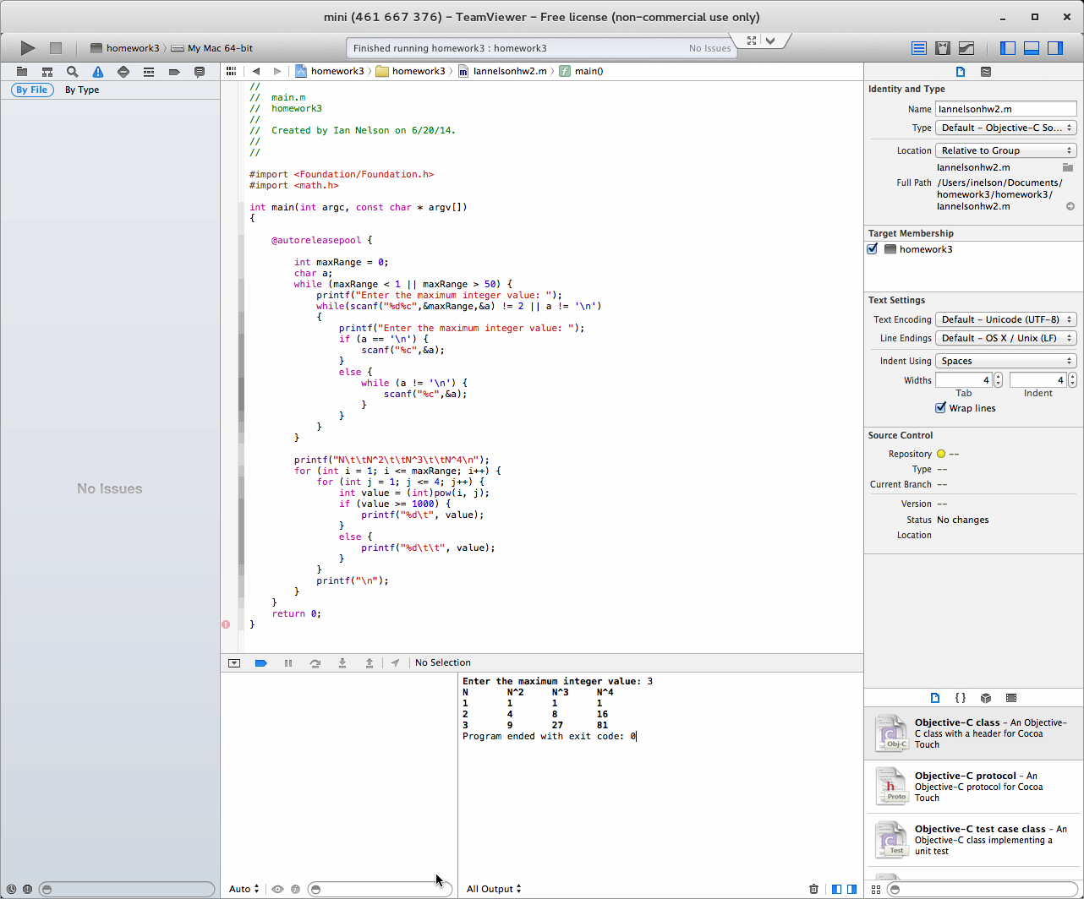

**Image 2**

This image shows the build matching the input of 3 as shown in the homework example.

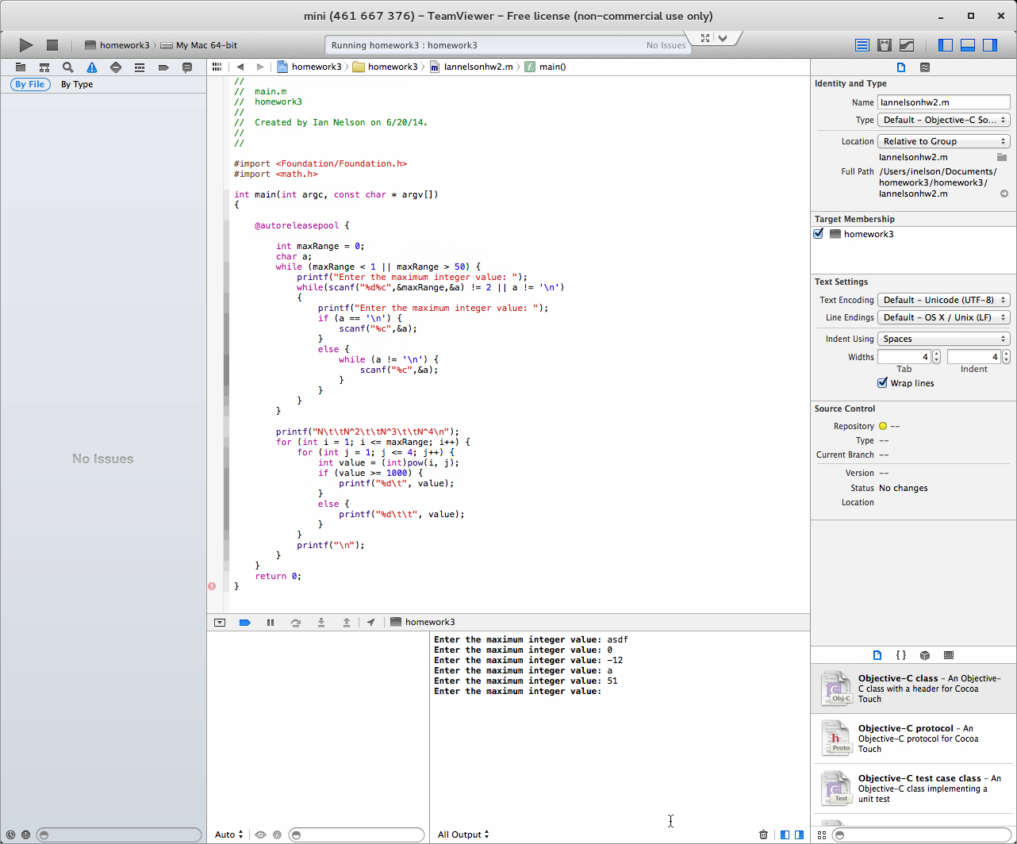

**Image 3**

This image shows the input sanitization for all types of input, as well as out-of-range integers.

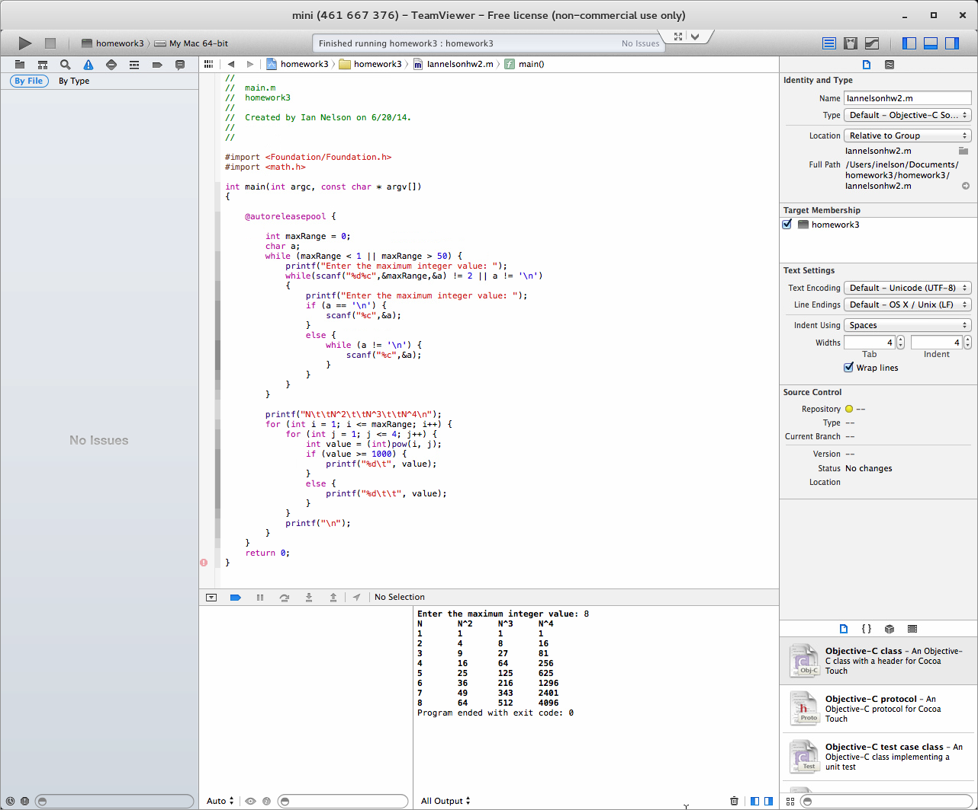

**Image 4**

This image shows an example of another valid range and powers table.