Ian Nelson

CMIS115

Project 1

Puran Nebhnani

**Project 1 Description and Analysis**

For Project 1, the default project settings for a Command Line project were used, in combination with the Foundation classes. Instead of focusing on the default ‘main.m’ file, I created a new class in line with the project requirements, ‘SimpleCalc.m’. Once the new class was created, I removed the auto-generated ‘SimpleCalc.h’ header file, and moved the @interface into the class file for a single code base. The @interface describes the internal integer variables through two @property declarations. These @property declarations describe the integer, and are annotated to generate named get and set methods instead of the generated functions via a synthesize call.

The @implemenation portion of the class define six methods: The 2 get functions and set functions for the first and second integer, as well as the addition and subtraction methods for calculation.

Finally, the main function instantiates the SimpleCalc class object, and sets test integers in place for output. The test cases are simple, and designed to test different use cases of input, as seen in the table below:

|  |  |  |  |  |  |  |
| --- | --- | --- | --- | --- | --- | --- |
| Test  Case | First Integer | Second Integer | Addition  Expected | Subtraction  Expected | Addition  Pass? | Subtraction Pass? |
| Positive | 1 | 9 | 10 | -8 | Y | Y |
| Negative | 11 | -20 | -9 | 31 | Y | Y |
| Zero | 0 | 0 | 0 | 0 | Y | Y |
| Non-Int | 0.5 | 5 | 5 | -5 | Y | Y |
| ASCII | ‘a’  (ASCII 97) | 10 | 107 | 87 | Y | Y |

As can be seen from the ‘Test Cases’ column in the table above, these were generated to test various types of input, some that apply directly in the types of integers supplied, and some that were done to test non-integer input, such as floats or ASCII character values. Of note is the testing value of 0.5. In this test, since 0.5 is not an integer the floor of the value is taken (in this case 0), and applied as the integer value.

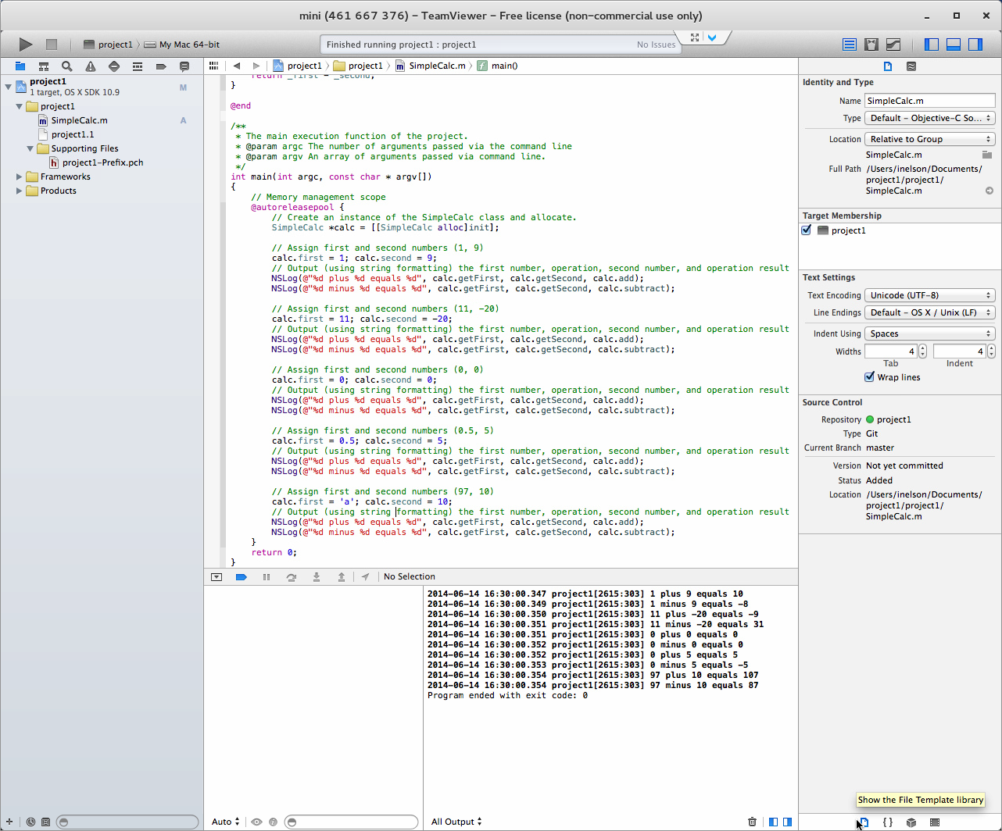

**Image 1:**

This screenshot shows the direct output from the XCode build of Project 1. As can be seen in the output, this execution of the integer test cases matches directly to the test case table presented in the project document. Additionally, a successful build and execution of Project 1 can be seen here, as well as the use of SimpleCalc.m versus the default main.m.