Ian Nelson
CMIS170
Homework 4
Nickolas Pitocco

Homework 4 Analysis

For homework 4, I started with finding a source of course material to create the elements from. Since I go to UMUC, I decided to use their course catalog:

http://webapps.umuc.edu/soc/us.cfm?fAcad=UGRD&fSess=2148&fLoc=ALL&fSubj=&fFetchRows=99999

This allowed me to do lookups of relevant CMIS and CMSC courses available to have real data in the document. Once this was finished, I created the XML document, and attached the XML schema namespace at the <courses> root. Since I did not have a location to pull the XSD from, I left the location off and would later upload to the XML validator for verification.

I sampled 8 courses from the catalog and created the elements, careful to adhere to the schema’s requirements. After I finished, I noted three things:

- In the provided XSD, the Boolean type had a typo. Instead of xs:boolean, it was printed as xs:Boolean. This caused schema validation failures when attempted.

- The date formats I extracted from the course catalog were not in the right format (as can later be seen in the attached figures). I refactored these from DD Mon YYYY to YYYY-MM-DD, and was able to successfully validate.

- Additionally, dateoffered element did not conform to camel case as the other elements had. Mine were camel case, and since I did not want to change the provided schema were possible, this was refactored in my XML document.

Following are the verification screenshots, as well as a final validation check. Each element, where possible, had the type changed to something else to verify the schema was enforcing correctly. The only exception to this rule is where the type was xs:string, as anything can be interpreted as a string.
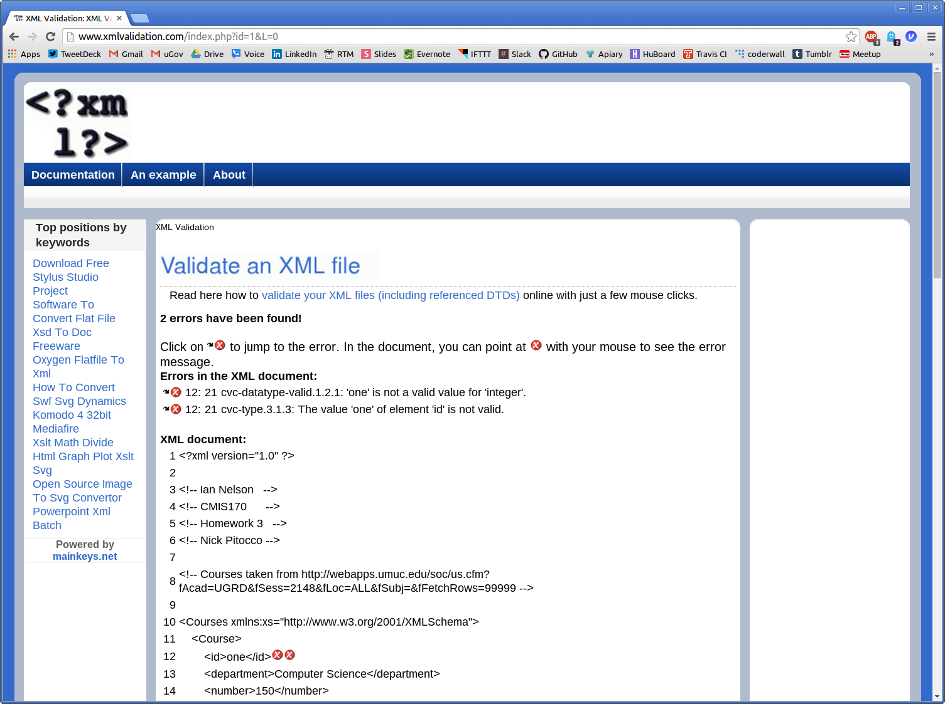
Figure 1. Enforcement of the ID element

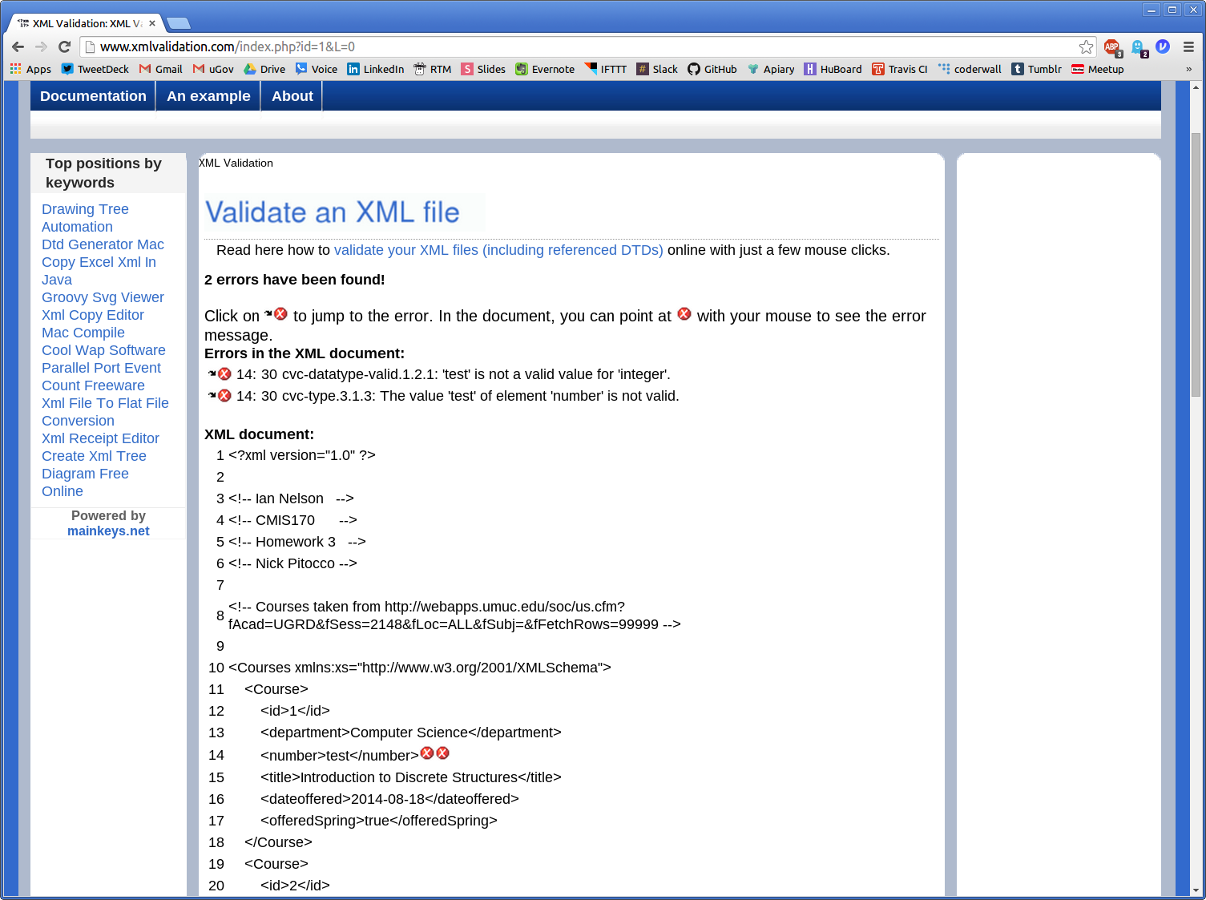
Figure 2. Enforcement of the Number element
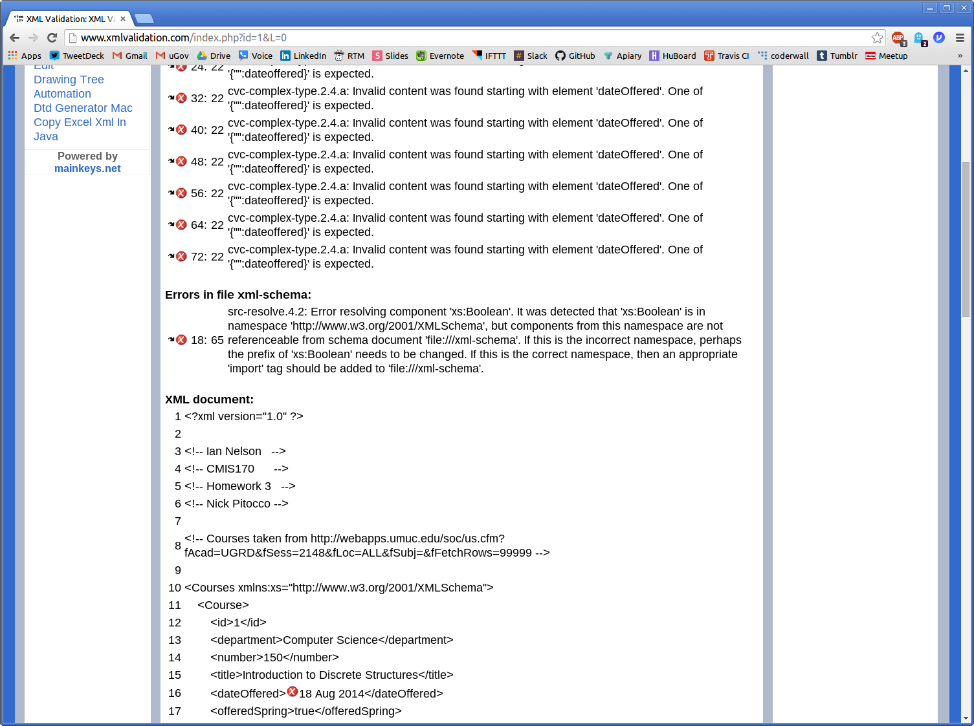
Figure 3. Enforcement of the dateOffered element

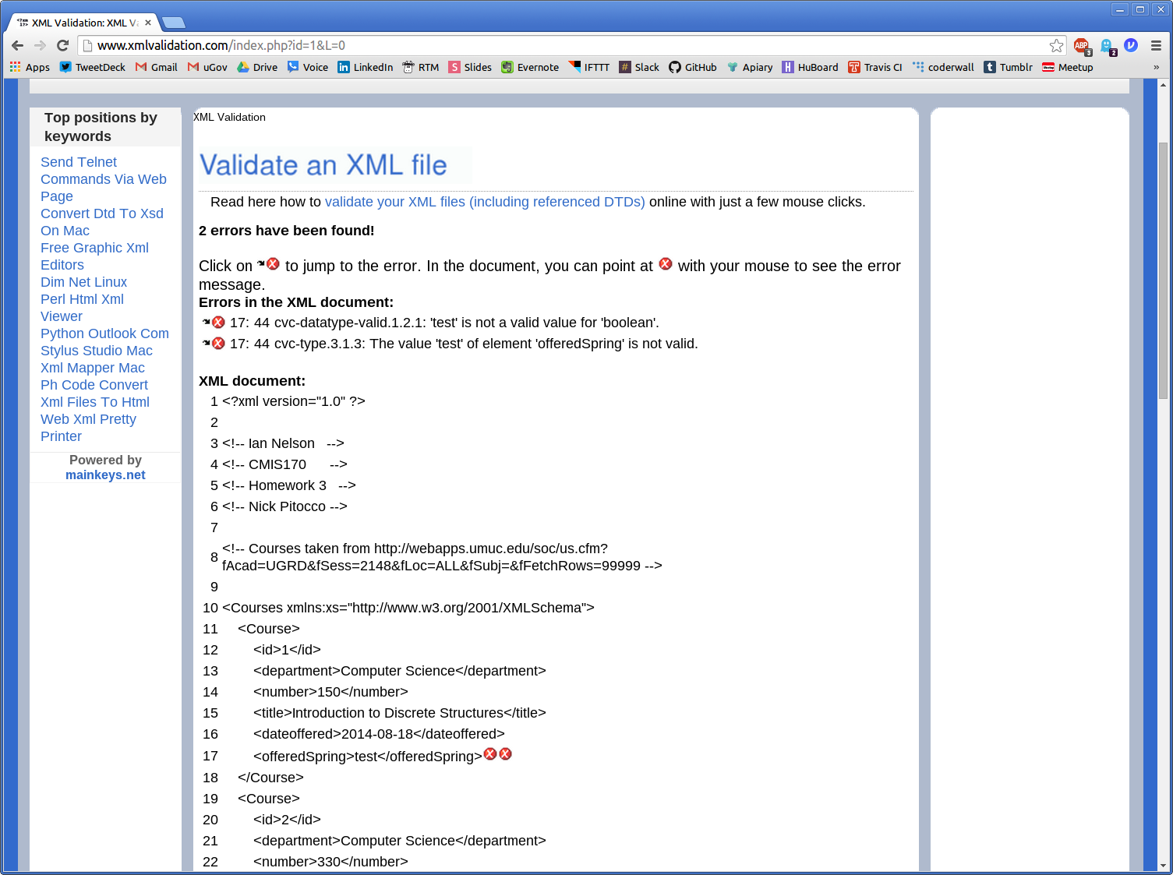
Figure 4. Enforcement of the offeredSpring element
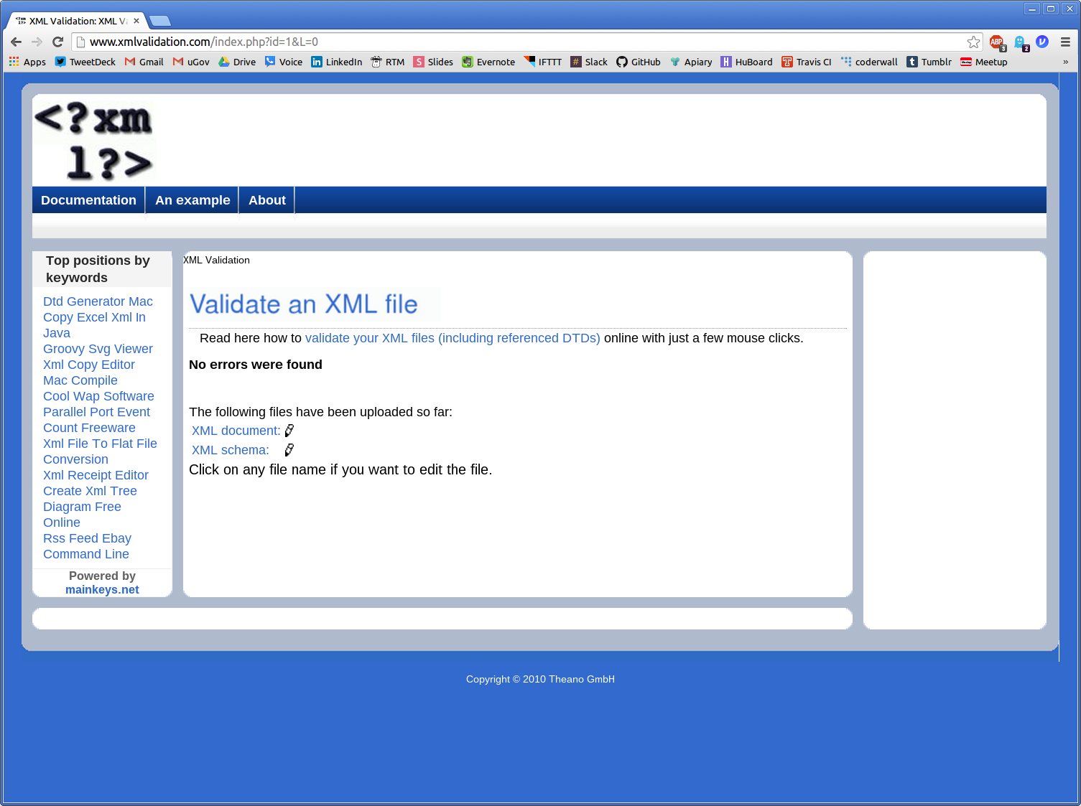
Figure 5. Final Validation of the Courses.xsd Schema
iannelson_hw4.xml

<?xml version="1.0" ?>

<!-- Ian Nelson -->
<!-- CMIS170 -->
<!-- Homework 3 -->
<!-- Nick Pitocco -->

<!-- Courses taken from http://webapps.umuc.edu/soc/us.cfm?fAcad=UGRD&fSess=2148&fLoc=ALL&fSubj=&fFetchRows=99999 -->

<Courses xmlns:xs="http://www.w3.org/2001/XMLSchema">
<Course>
<id>1</id>
<department>Computer Science</department>
<number>150</number>
<title>Introduction to Discrete Structures</title>
<dateoffered>2014-08-18</dateoffered>
<offeredSpring>true</offeredSpring>
</Course>
<Course>
<id>2</id>
<department>Computer Science</department>
<number>330</number>
<title>Advanced Programming Languages</title>
<dateoffered>2014-08-18</dateoffered>
<offeredSpring>true</offeredSpring>
</Course>
<Course>
<id>3</id>
<department>Computer Science</department>
<number>465</number>
<title>Image and Signal Processing</title>
<dateoffered>2014-10-20</dateoffered>
<offeredSpring>true</offeredSpring>
</Course>
<Course>
<id>4</id>
<department>Computer Science</department>
<number>335</number>
<title>Object-Oriented and Concurrent Programming</title>
<dateoffered>2014-10-20</dateoffered>
<offeredSpring>true</offeredSpring>
</Course>
<Course>
<id>5</id>
<department>Computer Science</department>
<number>325</number>
<title>Game Design and Development</title>
<dateoffered>2014-10-20</dateoffered>
<offeredSpring>true</offeredSpring>
</Course>
<Course>
<id>6</id>
<department>Computer and Information Science</department>
<number>320</number>
<title>Relational Database Concepts and Applications</title>
<dateoffered>2014-10-20</dateoffered>
<offeredSpring>true</offeredSpring>
</Course>
<Course>
<id>7</id>
<department>Computer and Information Science</department>
<number>420</number>
<title>Advanced Relational Database Concepts and Applications</title>
<dateoffered>2014-08-18</dateoffered>
<offeredSpring>true</offeredSpring>
</Course>
<Course>
<id>8</id>
<department>Computer and Information Science</department>
<number>320</number>
<title>Relational Database Concepts and Applications</title>
<dateoffered>2014-09-08</dateoffered>
<offeredSpring>true</offeredSpring>
</Course>
</Courses>

<!-- Validated with http://www.xmlvalidation.com/index.php -->
Modified Courses.xsd (for type issue)

<?xml version="1.0" ?>
<xs:schema xmlns:xs="http://www.w3.org/2001/XMLSchema">
<xs:element name="Courses">
<xs:complexType>
<xs:sequence>
<xs:element maxOccurs="unbounded" ref="Course"/>
</xs:sequence>
</xs:complexType>
</xs:element>
<xs:element name="Course">
<xs:complexType>
<xs:sequence>
<xs:element name="id" type="xs:integer"/>
<xs:element name="department" type="xs:string"/>
<xs:element name="number" type="xs:integer"/>
<xs:element name="title" type="xs:string"/>
<xs:element name="dateoffered" type="xs:date"/>
<xs:element name="offeredSpring" type="xs:boolean"/>
</xs:sequence>
</xs:complexType>
</xs:element>
</xs:schema>

