Ian Nelson

CMIS315

Homework 4

Jeff H. Sanford

**Homework 4 Analysis**

For Homework 4, created 3 core classes and the homework 4 main execution file

1. Square.cpp – Acts as a place holder for an individual place on the tic-tac-toe board, and represents the state of that piece.
2. Board.cpp – Represents the TicTacToe board, and manages the collection of Squares, which in turn comprises the state of all pieces within the game.
3. TicTacToe.cpp – Encapsulates the tic-tac-toe game logic, and processes rule sets to play the game.

Additionally the hw4.cpp file starts the game, and checks to ensure that all of the game state is still in flight and the game is playable.

Each class was supplied with a header file, and compiled together in gcc version 4.9.0 on ArchLinux 3.15.5-1.

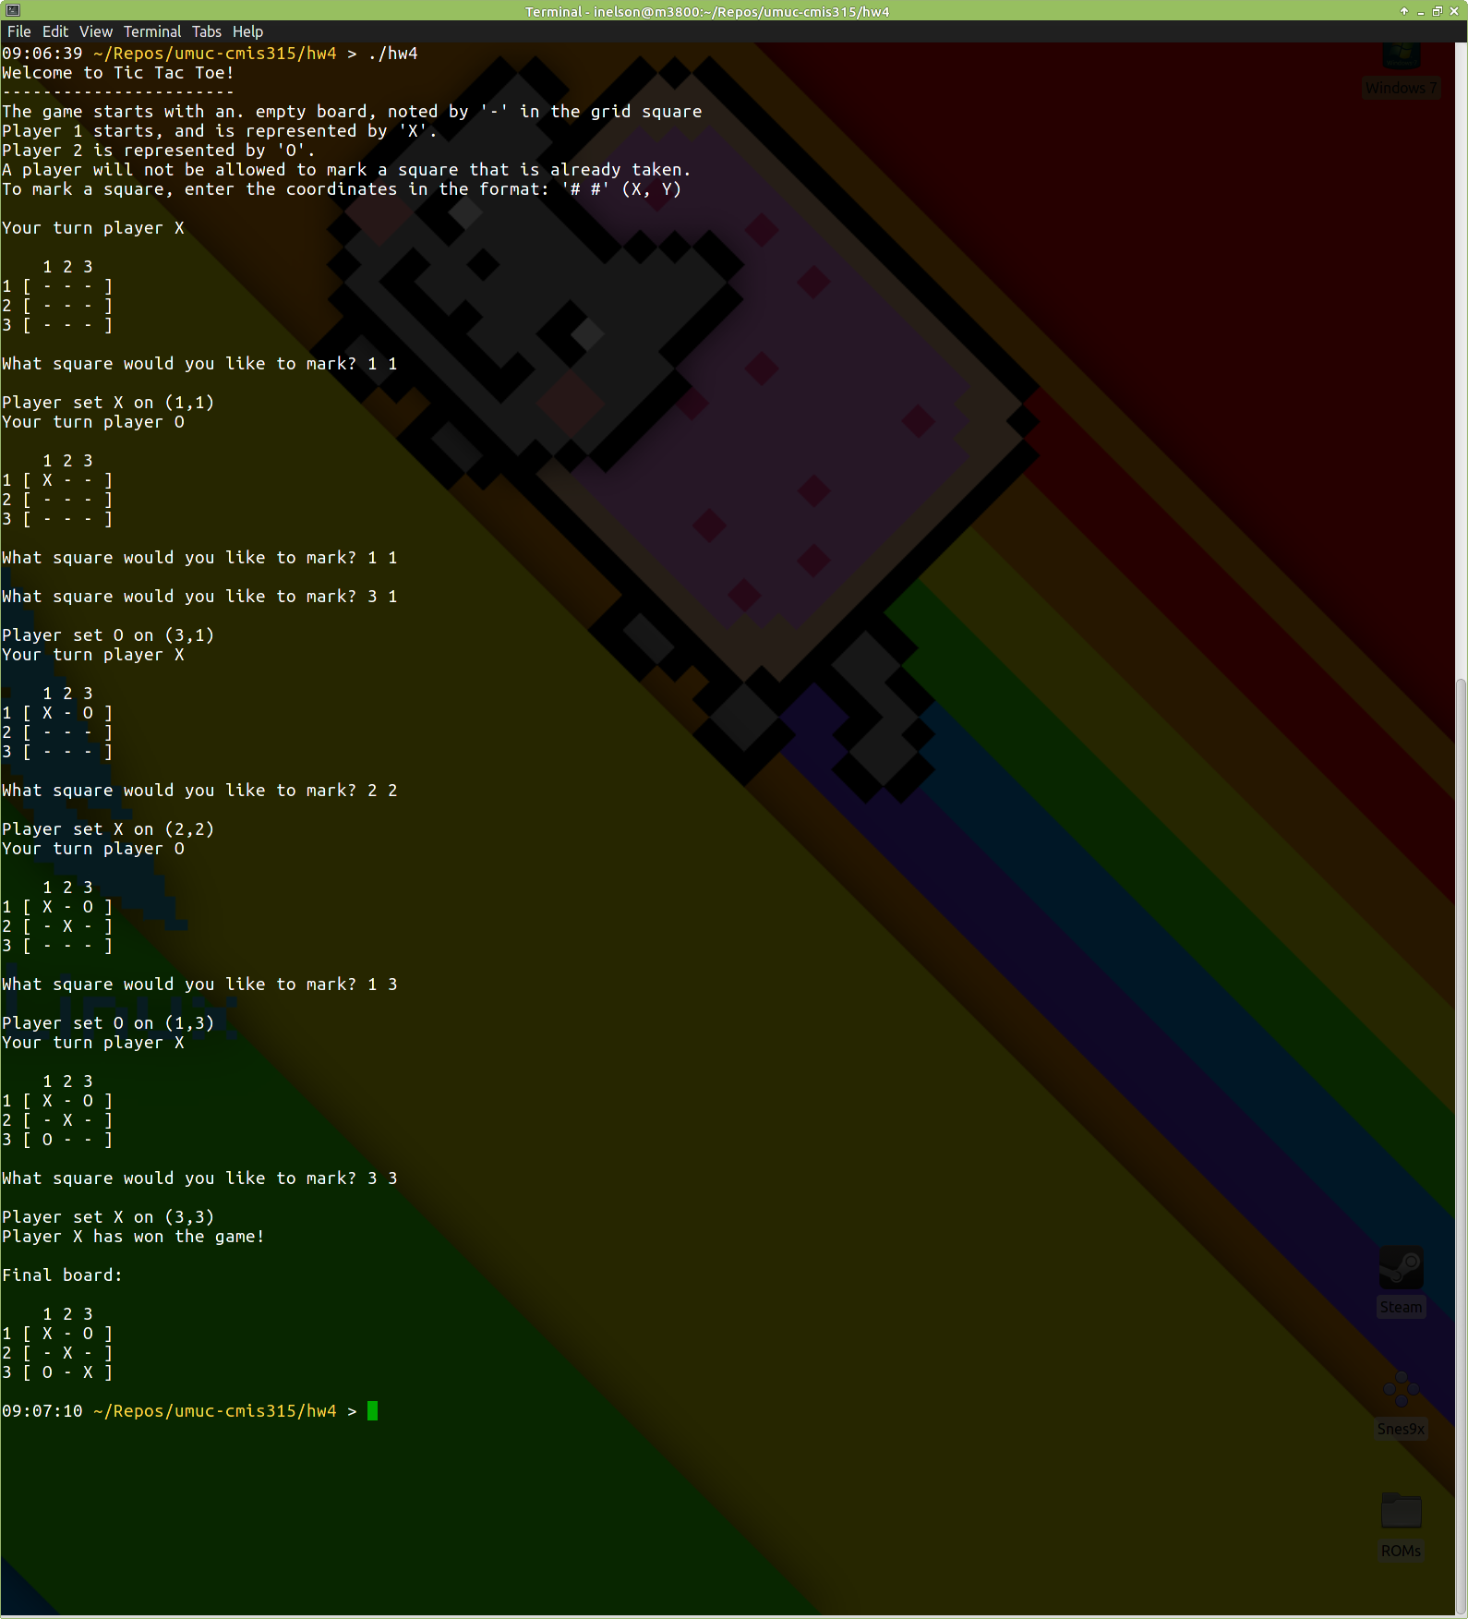

***Figure 1. A complete game played, with a winner.***

Figure 1 shows the typical game state, where the first and second players move through an entire match, with the game board being shown for each turn. At the end, Player 1 (X) wins with a diagonal win, and the game ends with that state

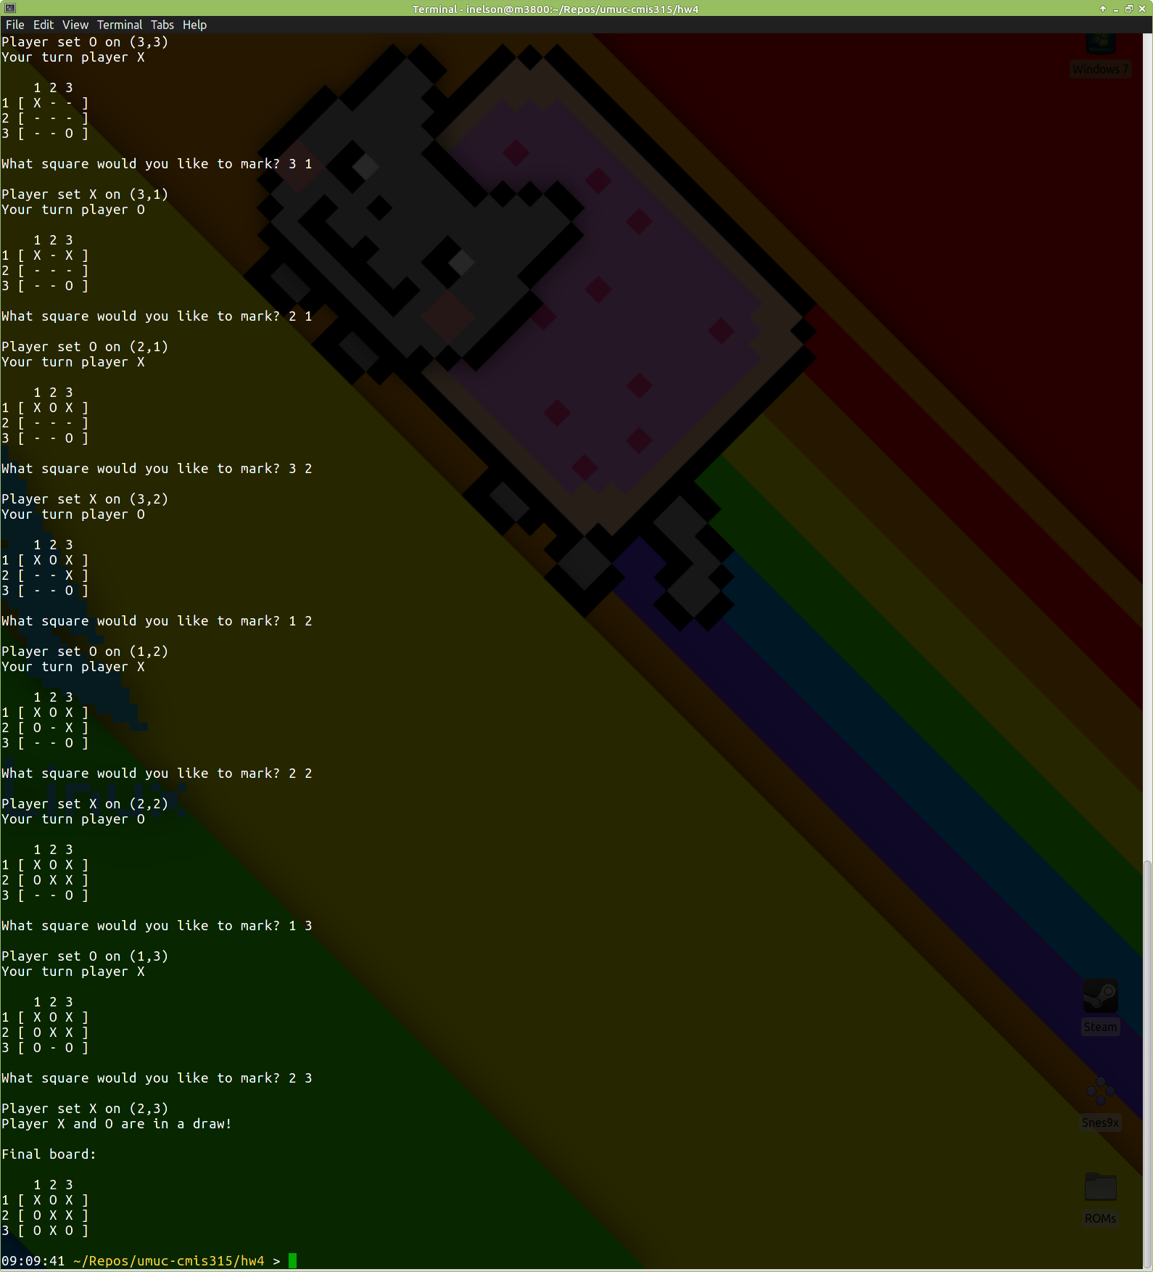

***Figure 2. A complete game played, resulting in a draw***.

Figure 12shows the typical game state, where the first and second players move through an entire match, with the game board being shown for each turn. At the end, both players have no more moves left, which results in a draw for the game state (last portion of the output).