Ian Nelson

CMIS315

Project 1

Jeff H. Sanford

Project 1 Analysis

For Project 1, I made use of the supplied class framework (FineCalculator). I made the decision to separate the program into three main components:

1. FineCalculator.cpp - Stores the court fine, speeding zone multiplier, additional fines (residential), and methods necessary to calculate the total fine for the ticket.
2. FineMenu.cpp - Holds methods for each menu options, as well as sanitization of input (via cin).
3. Project1.cpp - Main execution function for the project, and handles repetition of ticket input.

Each class was supplied with a header file, and compiled together in gcc version 4.8.2 20131212 (Red Hat 4.8.2-7) (GCC).

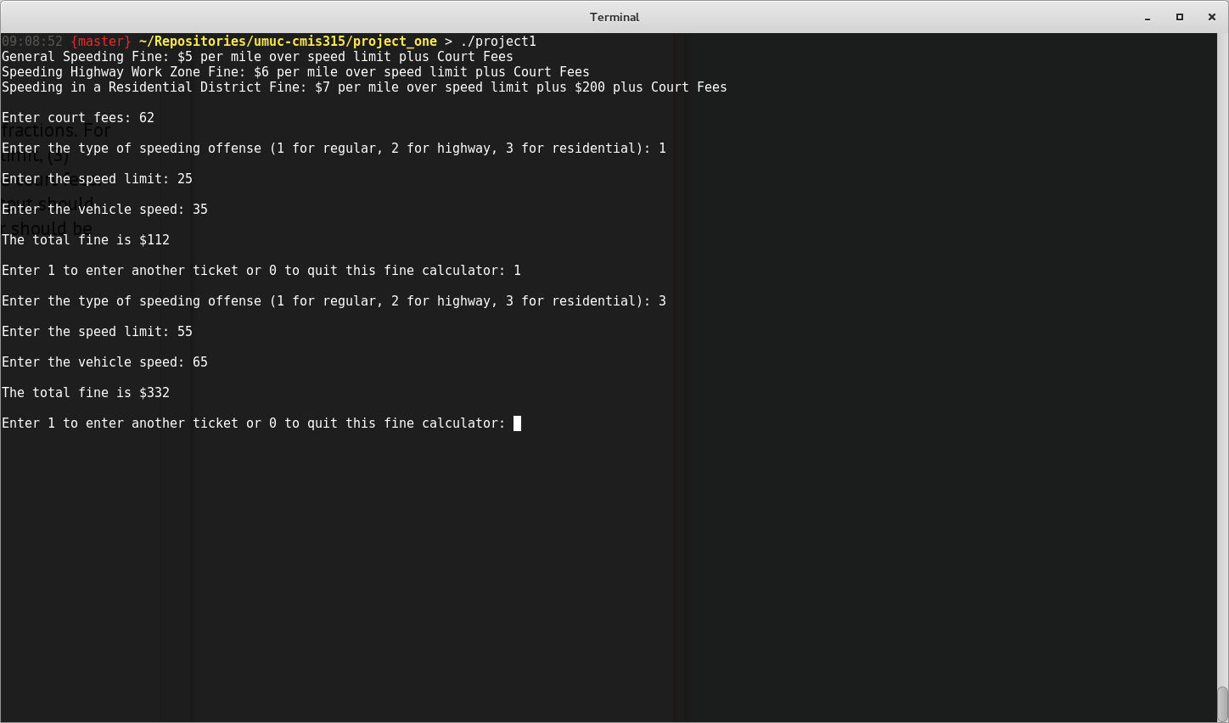

The screenshot above highlights the exact use cases shown in the Project 1 criteria, with resulting output matching the test cases.

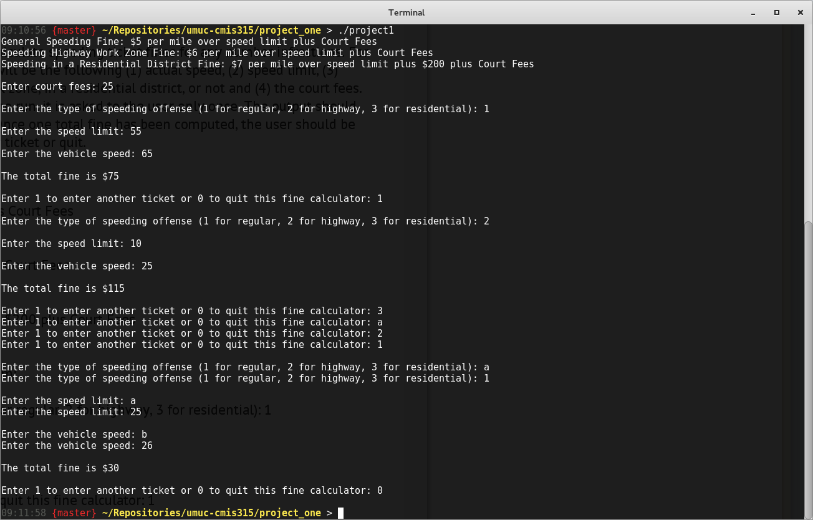

This screenshot highlights a different set of test input, as well as input validation and sanitization seen through the input of unrecognized integer options or characters.