Ian Nelson
CMIS325
Homework 4

For Homework 4, I started in the order given for the assignment with the ‘*’ operator for regular expressions. For this operator, I went through the sequence listed in the assignment, as can be seen in the screenshot below.
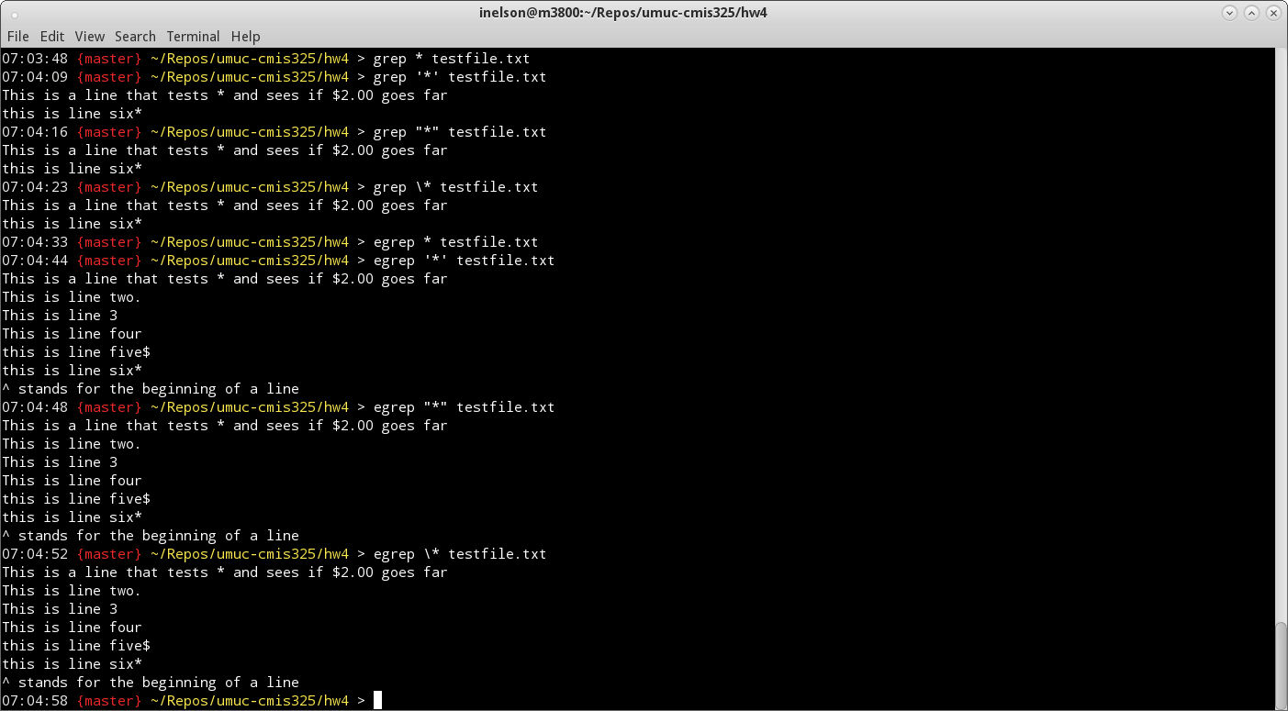
The significance of the changes with ‘*’ are due to the nature of the character as a wildcard. Through the permutations with ‘grep’ and ‘egrep’ captured in the output, it can be determined that if escaped (‘\’), the actual ‘*’ character is searched for via regular expression. Without being escaped, it acts as a wildcard for all characters within ‘egrep’. This is due to ‘egrep’ being the equivalent of ‘grep –E’, or extended pattern matching from the supplied regular expression. Without it, as seen in the regular ‘grep’ example, this extended pattern match did not occur. In summary, the ‘egrep’ or ‘grep –E’ commands provide a much richer regular expression pattern matching behavior versus a traditional ‘grep’ command.
In this example, the ‘.’ (dot) operator was used for the regular expression. The dot operator acts as a placeholder for a single character, and without being escaped, shows all patterns matching any character. This can be seen in the example below. The escaped nature of the dot operator tells the ‘grep’ and ‘egrep’ commands to search for a literal ‘.’, so all strings matching those with a period in the sentence are matched.

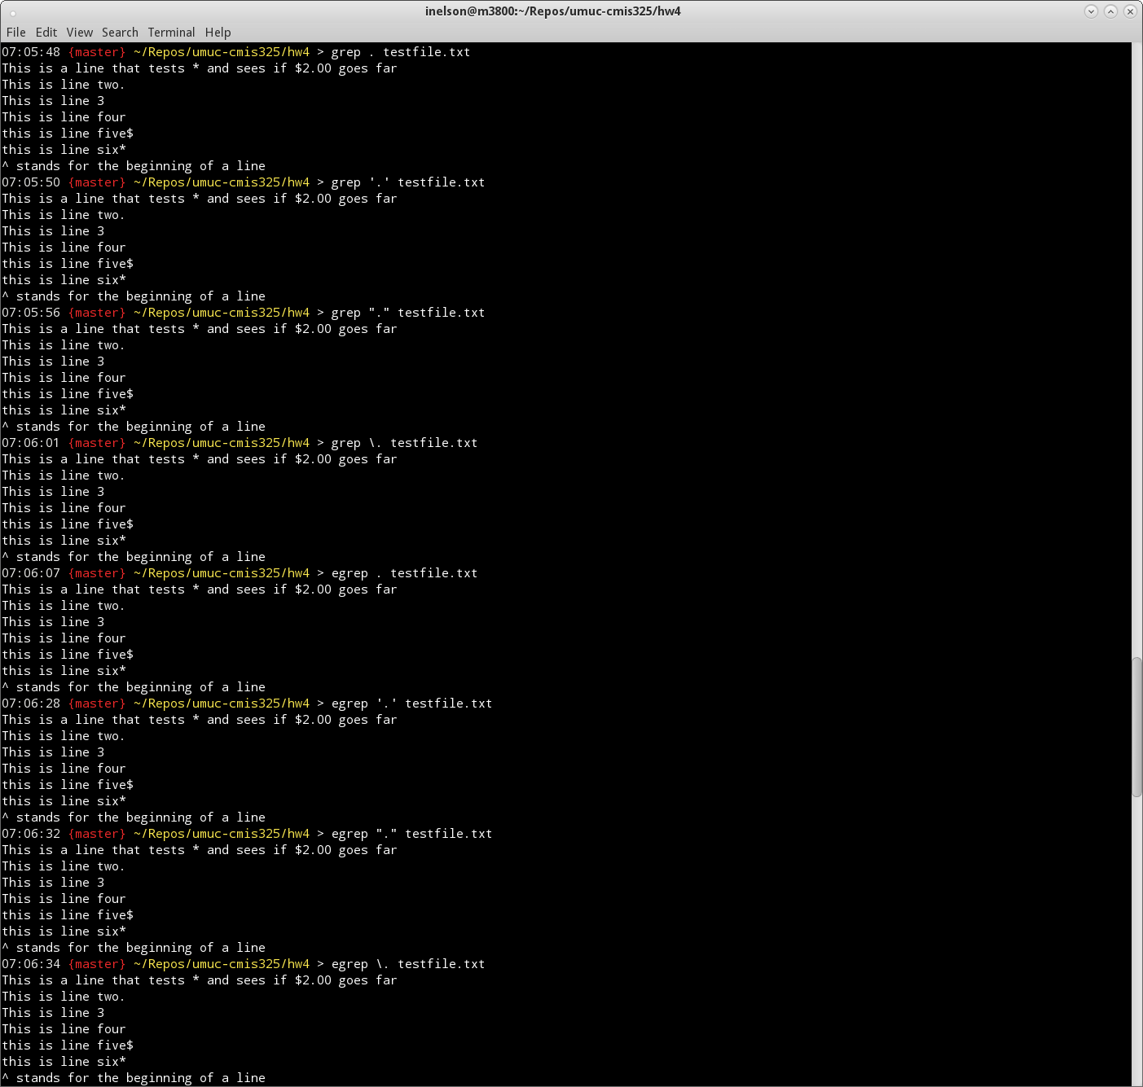
In this example, the ‘$’ (end of line) operator was used for the regular expression. The EOL operator acts as a check for anything matching prior to it, and without being escaped, shows all patterns matching that expression. This can be seen in the example below. The escaped nature of the EOL operator tells the ‘grep’ and ‘egrep’ commands to search for a literal ‘$’, so all strings matching those with a ‘$’ in the sentence are matched.

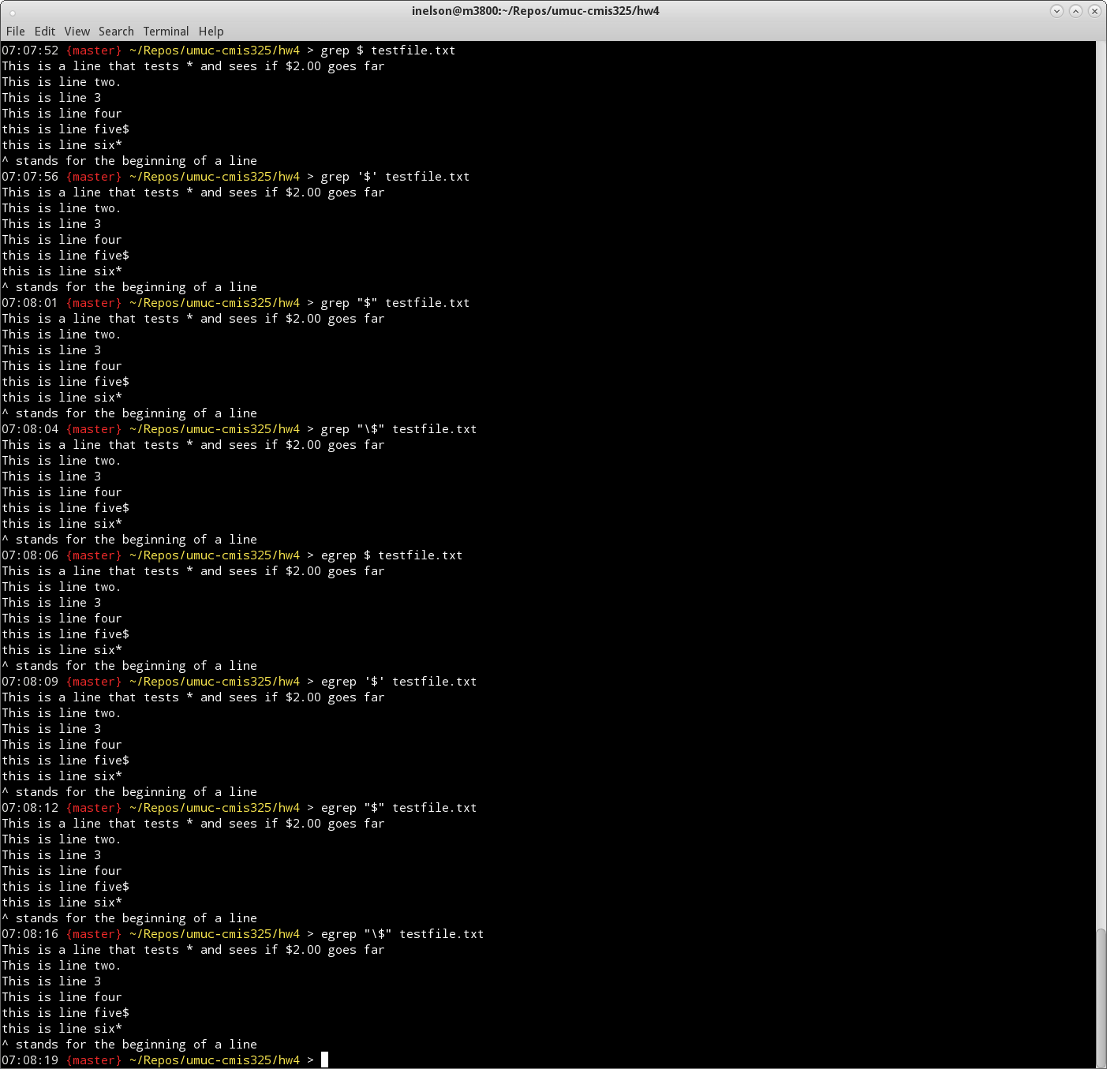
In this example, the ‘^’ (beginning of line) operator was used for the regular expression. The BOL operator acts as a check for anything matching at the beginning of the line, and without being escaped, shows all patterns matching that expression. If the BOL operator is escaped, it looks for a literal caret ‘^’ in the string being evaluated to match the pattern. I also used a set of characters at the beginning of the line ‘^This’ to highlight the evaluation and pattern matching specific to a subset of strings in the file.
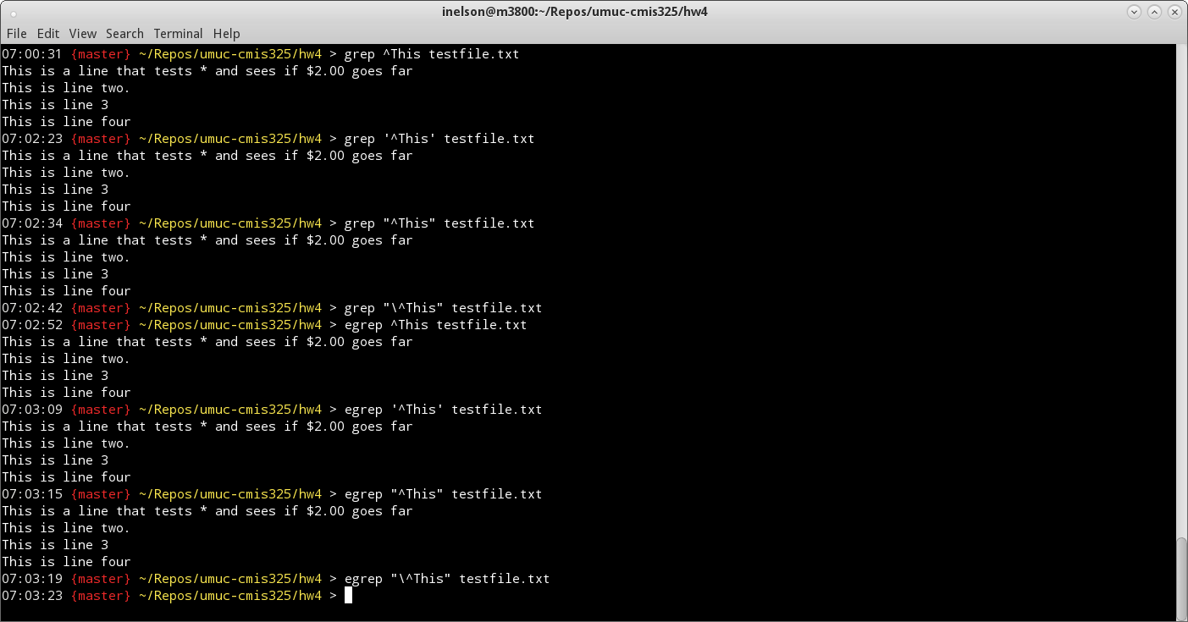
In this example, the ‘[]’ (character match) operator was used for the regular expression. The character match operator acts as a check for anything matching what is supplied in the brackets, and without being escaped, shows all patterns matching that expression. If the character match operator is escaped, it looks for a literal set of brackets and inclusive characters in the string being evaluated to match the pattern. In this case of assignment 4, it looks for a literal ‘[23]’.
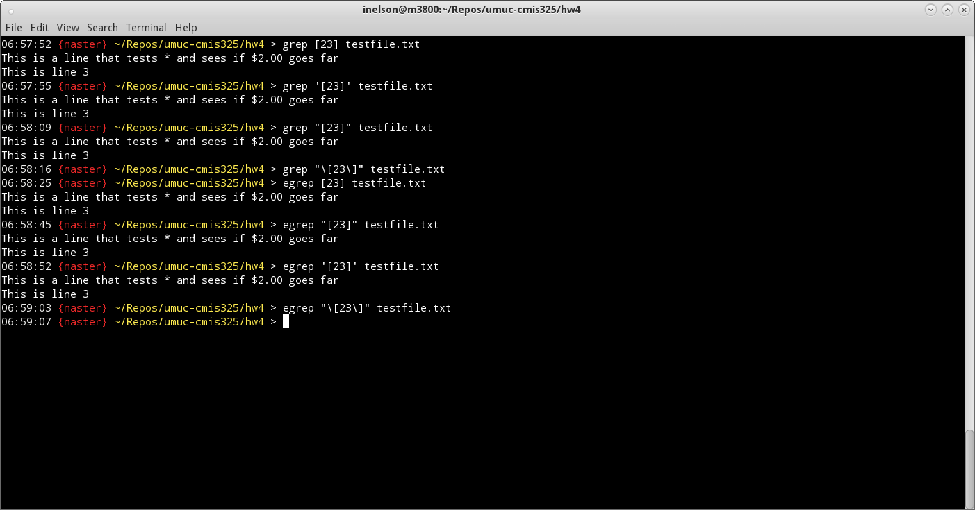
Finally, the use of single and double quotes in conjunction with the regular expression operators did not seem to have much of an impact overall. These are generally used to encapsulate an expression, and supply the literal pattern to the tool. Because of this, the output of the pattern matching did not seem to be affected.

