Ian Nelson
CMIS325
Final Project

Final Project Analysis
For the final project assignment, I create a single script file called phonebook.sh that deals with the phonebook records in supplied text files.
This shell script is constituted of the following functions:
- main script – Not a function, necessarily, but bootstraps the script execution by calling other functions. This is located at the end of the file. This portion of the file also validates the arguments and aliases them to friendly variables for later use.
- get_file () – Gets input of the filename from the user and starts the validation process.
- validate_file () – Validates that file exists, is a standard file, and is not zero bytes.
- validate_columns () –Validates that entries have three space-delimited columns in the file.
- add () – Adds a new entry to the phonebook from user input.
- delete () – Deletes a new entry from the phonebook based on user-supplied arguments.
- modify () –Modifies an entry from the phonebook based on user-supplied arguments. Will not modify if zero or more than one result is returned. This is based on what records are returned from the arguments. A last name only will generally result in not being able to modify a record.
- display_one () –Displays a search based on the user-supplied arguments for last and first name.
- display_all () – Displays an ascending sort ordered set of results from the phonebook.
- authenticate () – Checks the user’s login name against /etc/passwd to ensure they are allowed to add, modify, or delete.
- trap_terminate () – Handler function for the SIGINT/SIGTERM trap at the top of the script.
- terminate () – Terminates the program. Accepts message strings to echo before termination.
- menu () – Displays the user’s menu for input and choice selection.
- usage () – Shows the user how the program is used at the command line. Used when no or too many arguments are supplied.
This script was built on ArchLinux 3.15.5-1-ARCH using Bash 4.3.18(1)-release.

Figure 1. Phonebook (pb.txt) Output

This screenshot demonstrates a working phonebook called pb.txt. In it are 20 entries, randomly listed with last names, first names and formatted telephone numbers.
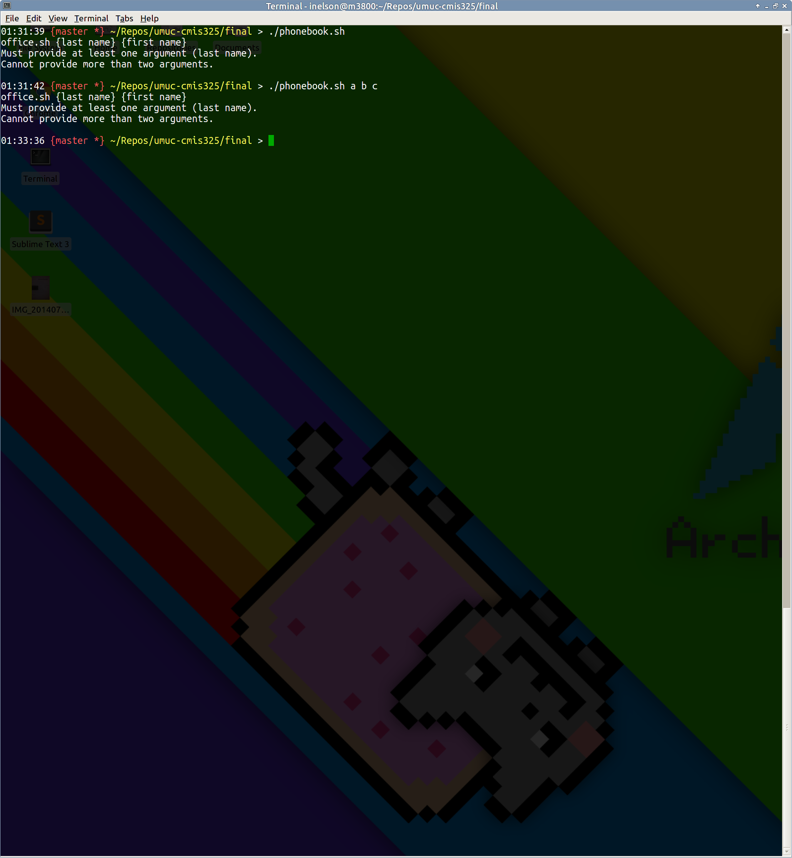
Figure 2. Zero or More than Two Arguments

This screenshot demonstrates the usage information being printed if zero or more than two arguments are supplied to the script.
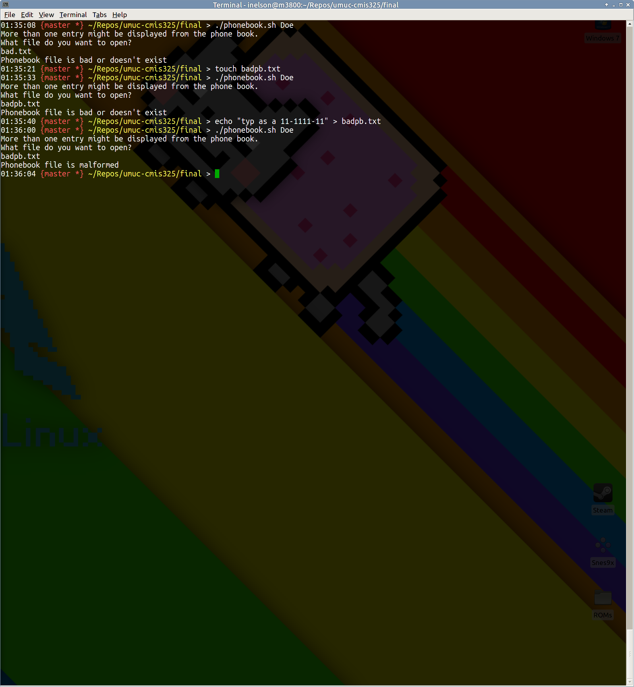
Figure 3. Phonebook File Checks and Column Validation

This screenshot demonstrates what happens if a user tries to access a file that doesn’t exist, is zero bytes, or has bad columnar data within it.
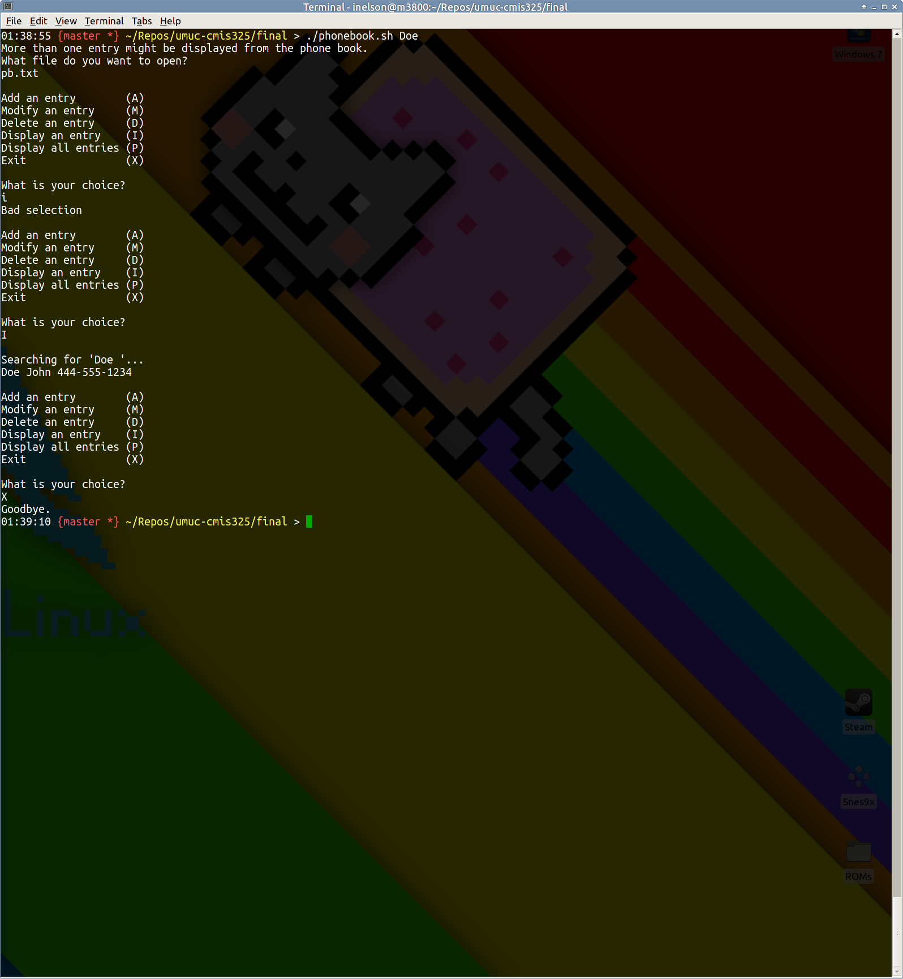
Figure 4. Only Last Name Argument with Input Validation and Single Retrieval

This screenshot demonstrates the use of a single argument (last name). When the user makes a selection that is improper, input is validated correctly and the menu options are repeated. In this selection, only a single entry is retrieved.
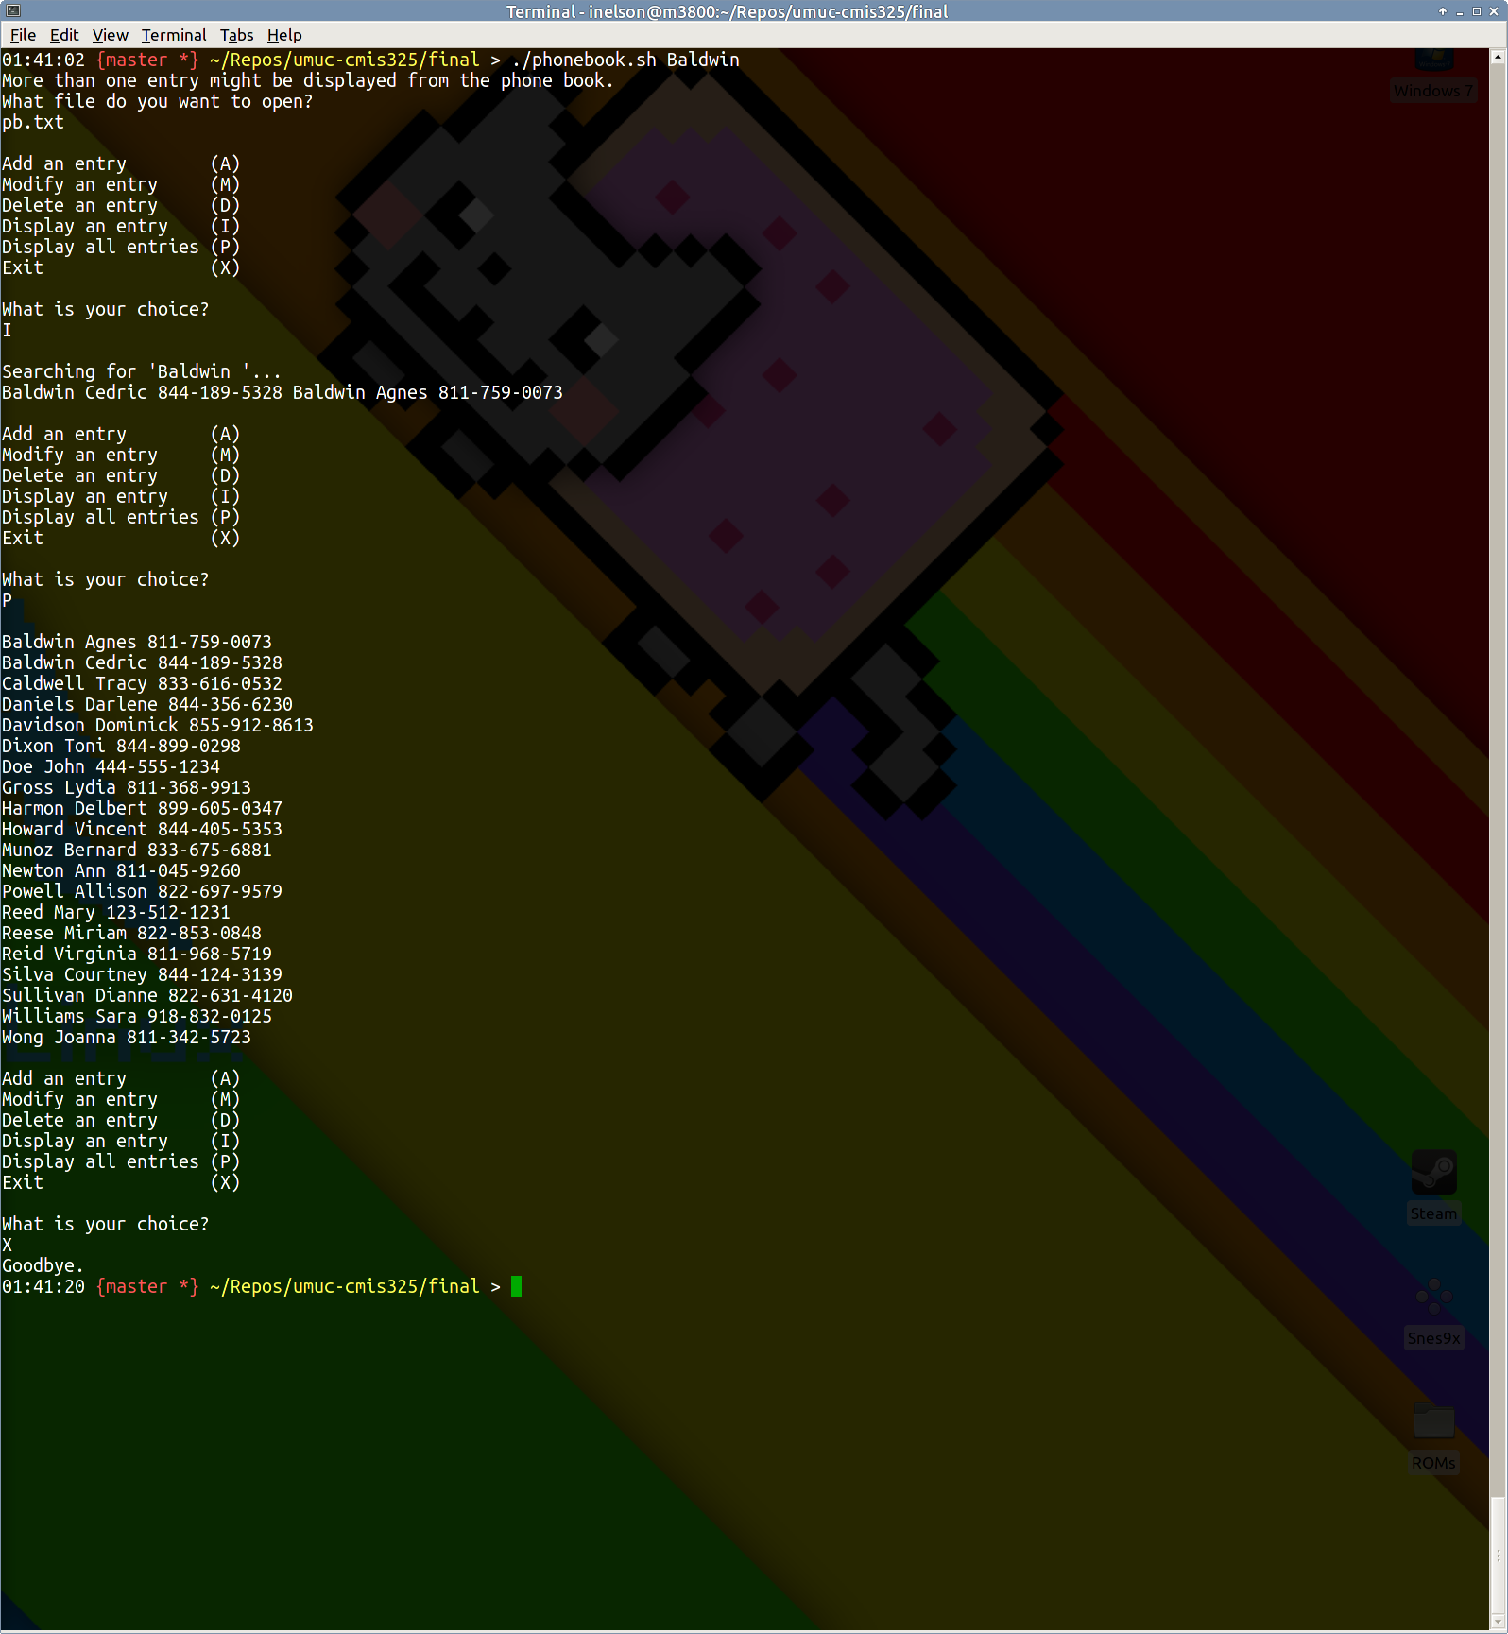
Figure 5. Multiple Entries from Last Name and All Records

This screenshot demonstrates the retrieval of multiple records from a single last name argument, as well as a complete retrieval (sorted in ascending order) of all records from the database.
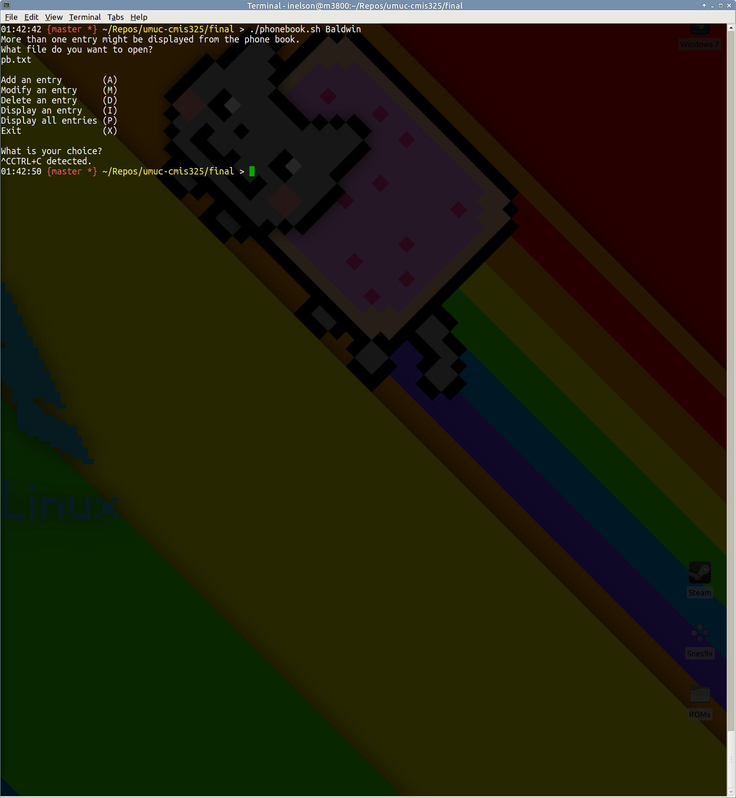
Figure 6. Trap Interception and Handling

This screenshot demonstrates the use of the trap handler, which detects the signals and terminates the script accordingly with a message to the user.
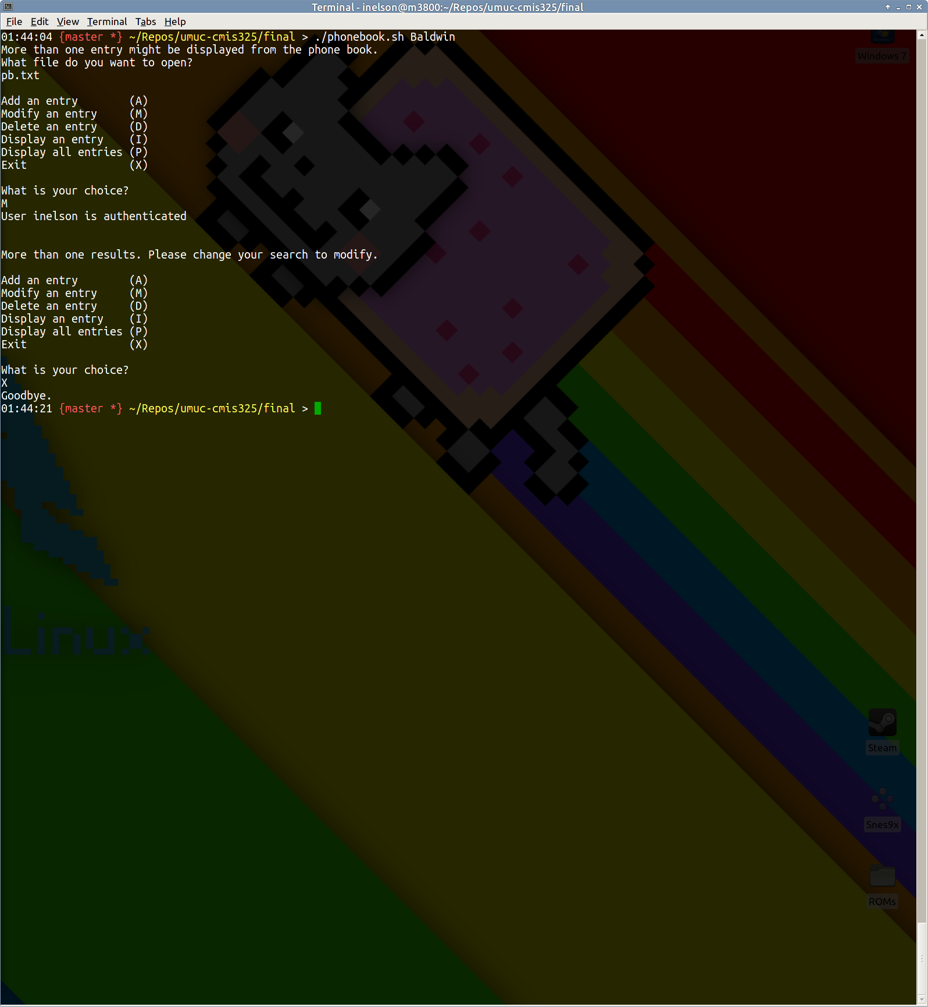
Figure 7. Single Last Name Argument with Modify Failure and Authentication

This screenshot demonstrates the failure to modify based on arguments when more than one record is found. Additionally, it also shows the authentication against /etc/password for modify.
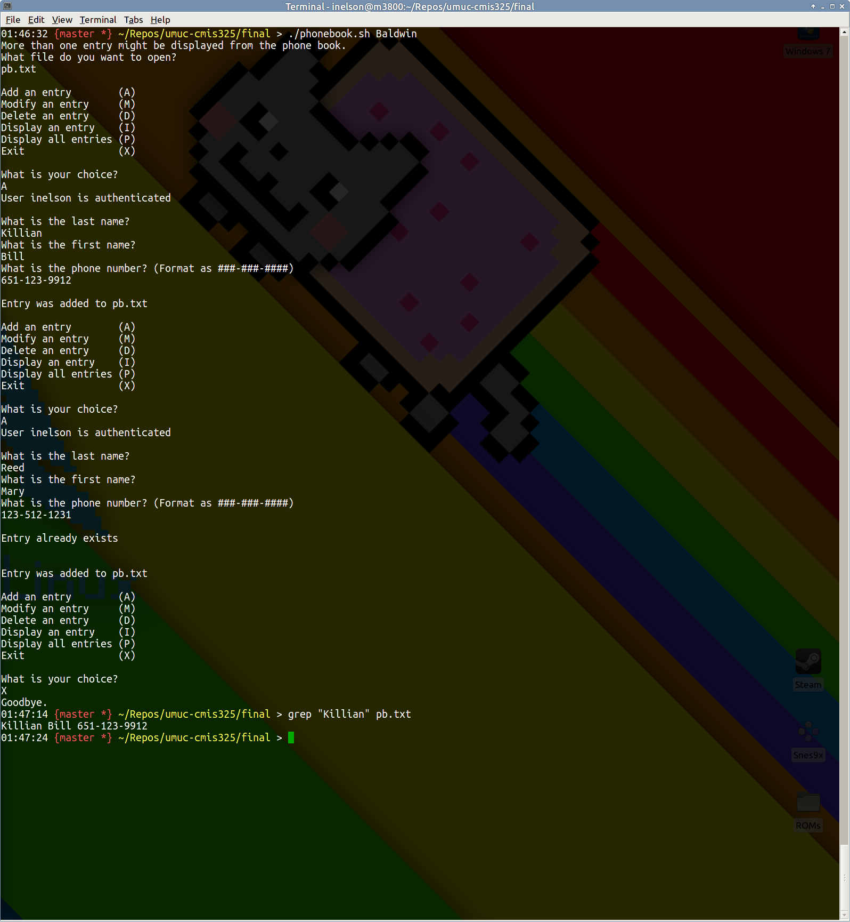
Figure 8. Adding a New Record with Validation

This screenshot demonstrates adding a new entity to the phonebook file. The ‘Killian’ entry is supplied through the UI, and added. If a new record matches an existing one, such as ‘Reed’, the attempt to add is invalidated. Additionally, this shows authentication for the user.
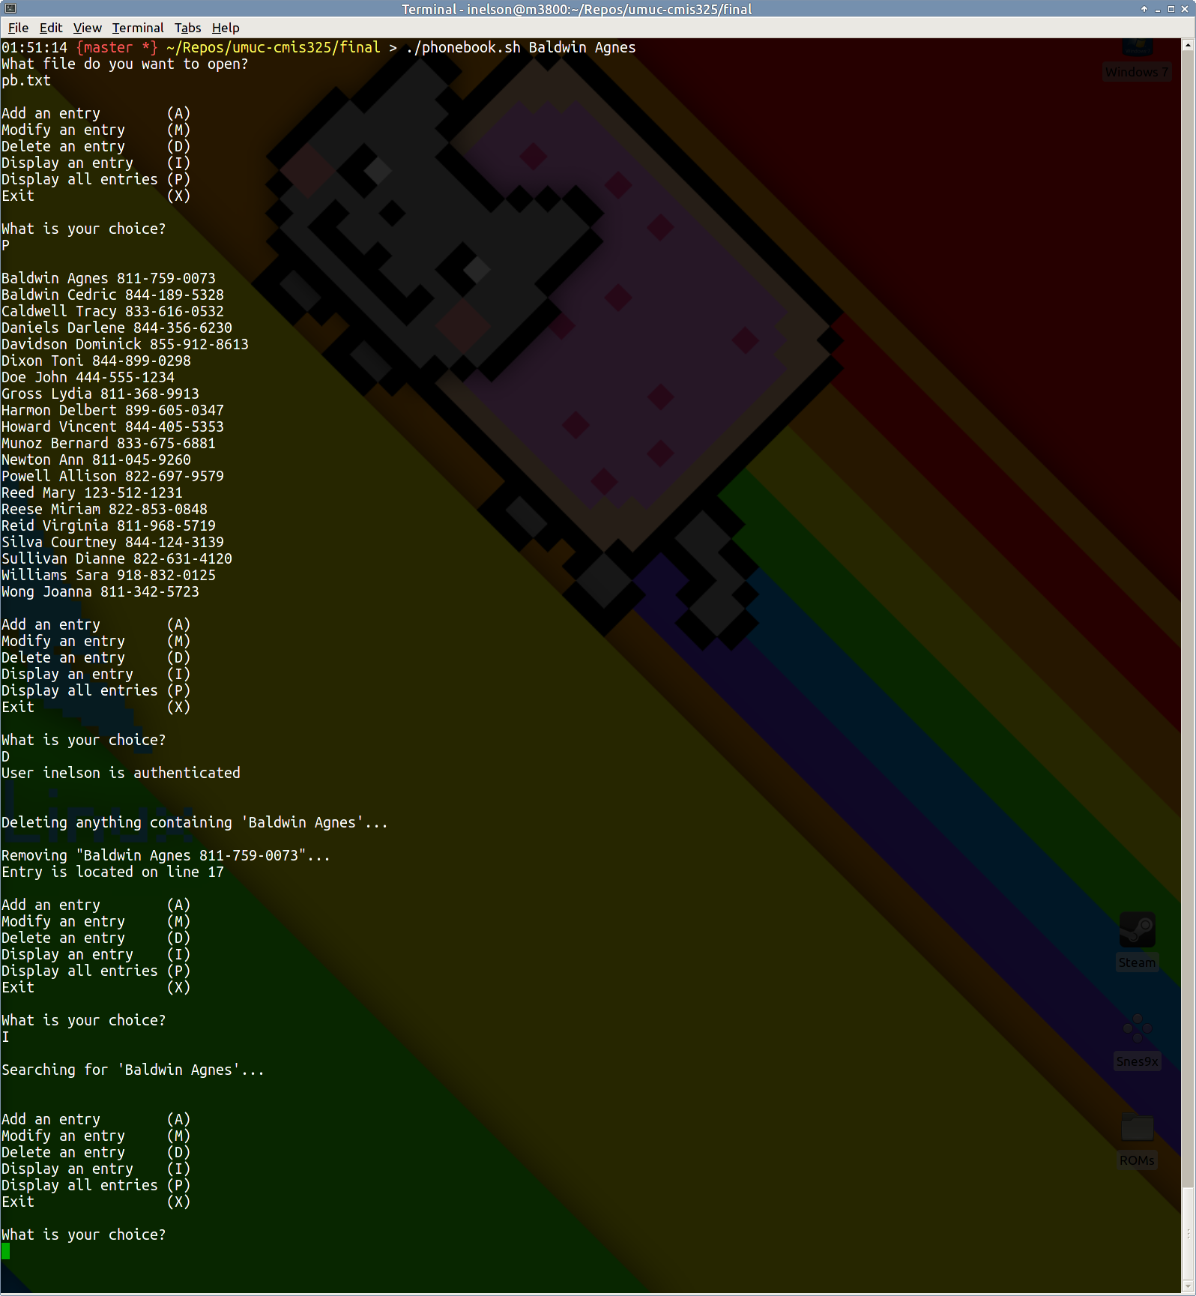
Figure 9. Deleting and Verifying Record Deletion

This screenshot demonstrates deleting a user from the phonebook file. In this case, ‘Agnes Baldwin’ is removed from the file based on first and last name arguments supplied to the script. This deletion is then verified by making an attempt to retrieve it from the file. Additionally, this also shows authentication for the user for a delete operation.

