Ian Nelson
CMIS325
Homework 7

Homework 7 Analysis

For assignment 7, I based the majority of work from assignment 6 last week. Since I already had code that would deal with summations, it was a trivial effort to change the arguments being accepted to limit the calculations to 7 only. This is done with the use of a range ( ${@:1:7} ). The regular expression from assignment 6 was still valid in validating the integer type from the argument as either positive or negative, so this remained in place.

The documentation at the CLI was also changed to reflect the number of arguments accepted, and ensure the user realizes only 7 arguments would be accepted. Finally, the use of a counter variable twoFifty was used to increment the number of arguments that were greater than 250. Finally, the output gives the final sum and number of arguments as space-delimited output to be easily piped and parsed by another script or tool.

Output of the file, validation of integer input and demonstration of only 7 arguments being accepted is shown in the attached figure.

The source code for ‘sevensum.sh’ has been provided in this document for review as an appendix.

Additionally, the different between break and continue in a script is relatively easy to validate. The break statement is used to exit the loop based on some set of logic. A branching statement is generally a good example of this condition, such as if -> then -> break. This will exit the loop at a specified point. The continue statement, on the other hand, allows for the loop to be continued but skip portions of code execution within the loop. For example, in a while loop, if a certain condition is not met on input, the continue statement can be used to skip that portion of the loop, and start again on the next line.

Console output from sevensum.sh

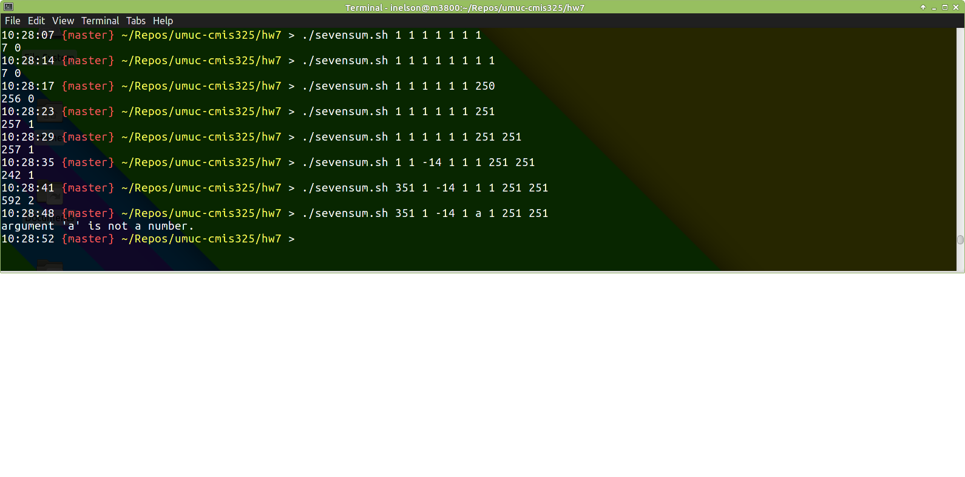

sevensum.sh

#!/bin/bash

# Ian Nelson
# CMIS325
# Homework 7
# Makes a sum of seven numbers and assess value.

## Assign the sum to zero.
sum=0

## Number of arguments greater than 250
twoFifty=0

## Create a pattern to match integers (+/-)
regex='^-?[0-9]+([.][0-9]+)?$'

## If the number of arguments is zero, print help.
if [[ $# == 0 ]] ; then
echo "usage: 'sevensum.sh # # # # # # #'"
echo "usage: Can pass up to 7 integers (positive or negative)."
echo "usage: Script will die with a bad exit code of -1 if a non-integer is passed."
exit;
fi

## For each command line argument (1-7 only)
for var in ${@:1:7}; do
## Did the variable match the pattern?
if ! [[ $var =~ $regex ]] ; then
## Print an error and die.
echo "argument '$var' is not a number." >&2; exit -1
## Yes it did.
else
let "sum = sum + $var"

## Was the argument greater than 250?
if [[ $var -gt 250 ]]; then
## If so, increment the sum found.
let "twoFifty = twoFifty + 1"
fi
fi
## Done with the loop.
done

## Print the sum.
echo $sum $twoFifty

