Ian Nelson
CMIS325
Homework 2
George Wheeler

For this assignment, I chose to use the Ford series of vehicles, which allowed me to segregate into trucks, cars, and SUVs, as well as their types and specific vehicles.

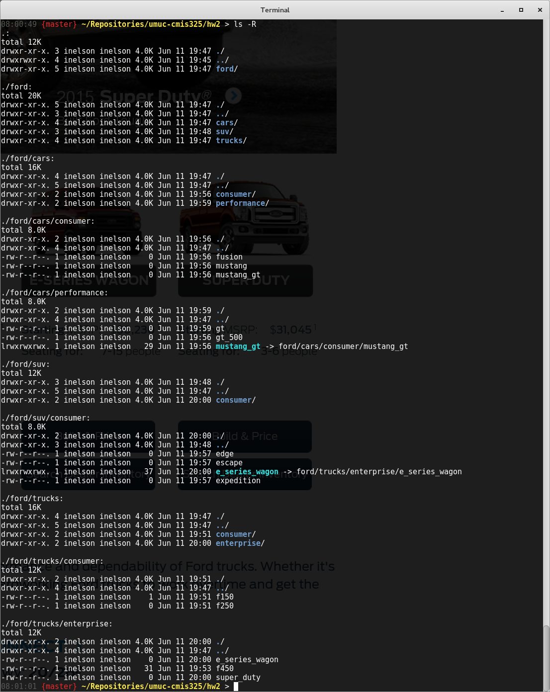

Next, I made a copy of the folder structure using ‘cp -R’:
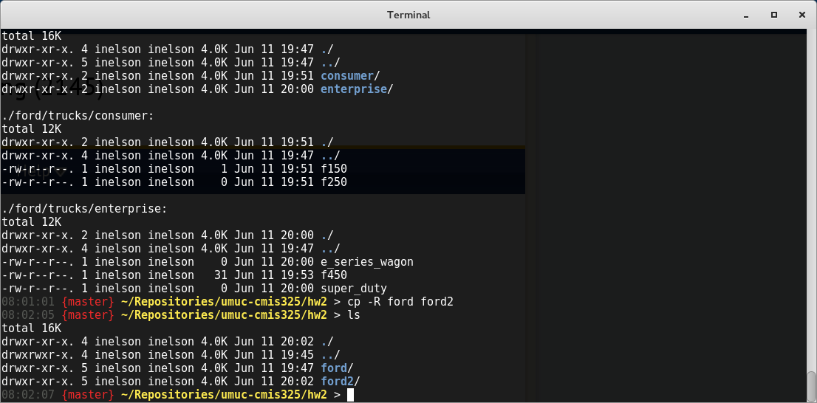

This provided a complete recursive copy of the original ‘ford’ folder as specificied in the assignment requirements.

Next, a branch of the copy was pruned, specifically the ‘suv’ branch

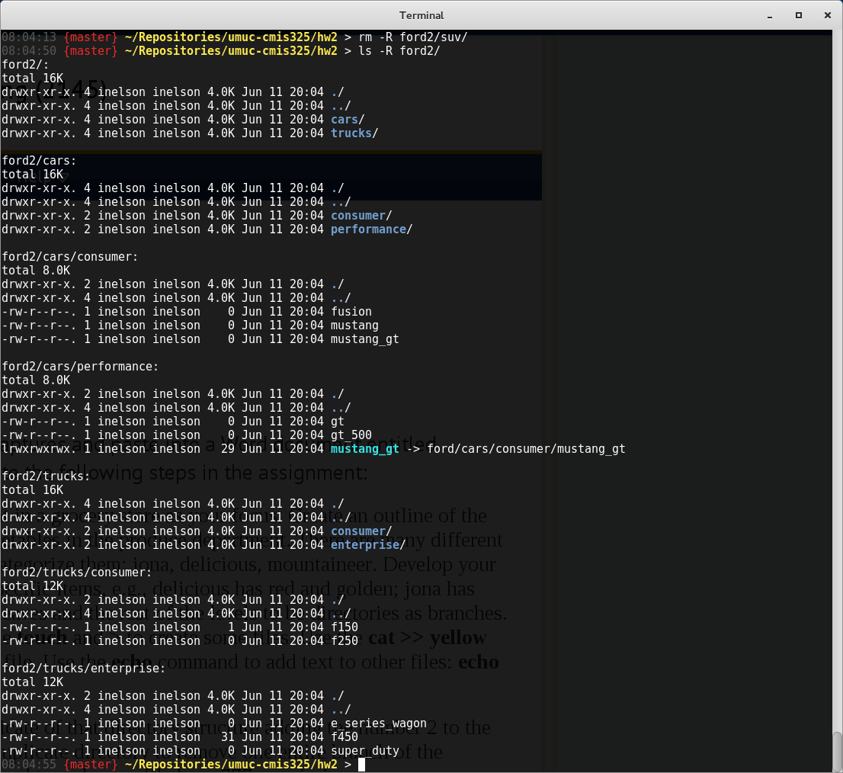

Next, the ‘super_duty’ truck was renamed with the ‘mv’ command:
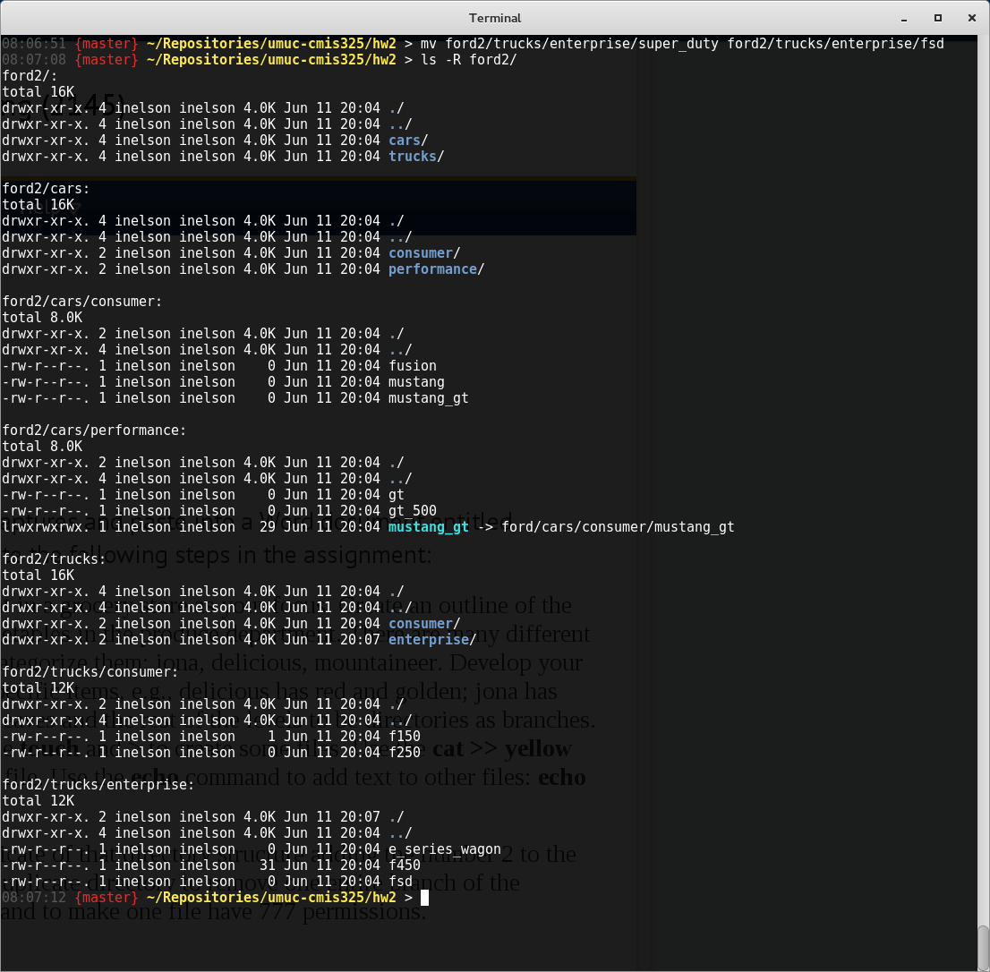

And finally, a chmod of 777 was applied to make the file executable to the user, group and others (‘f150’ shown in green):

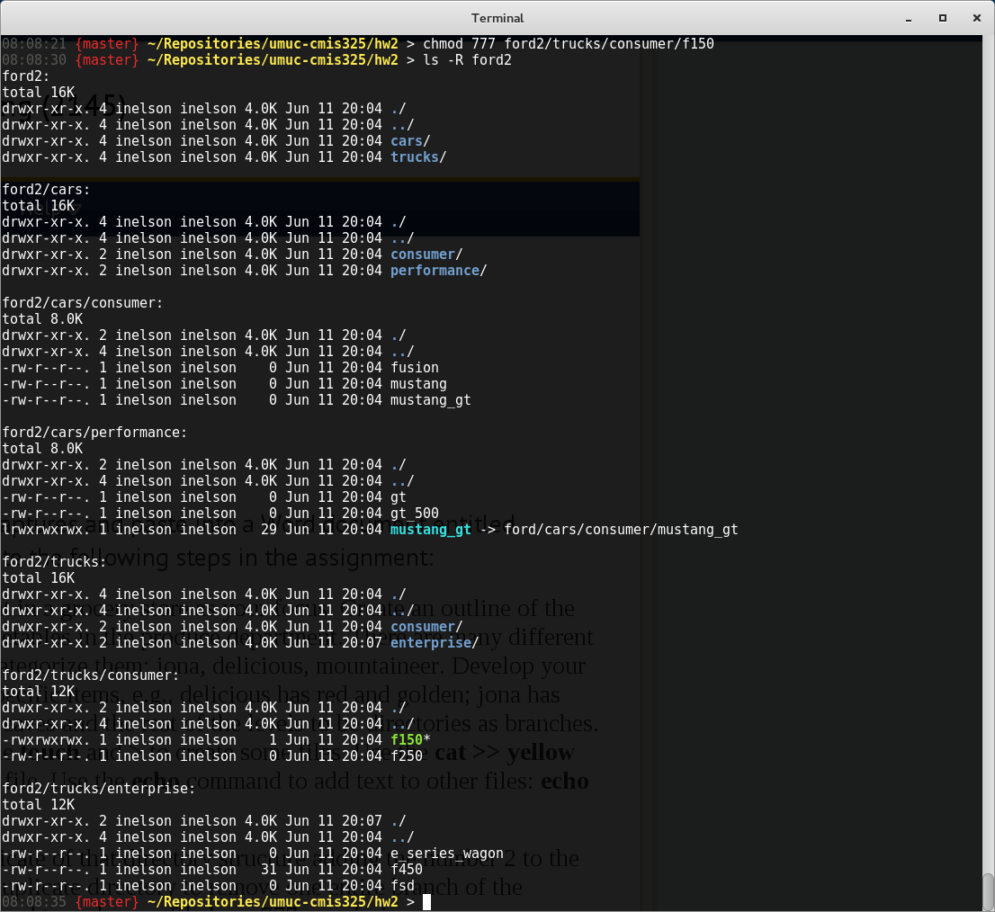

In this screenshot, the first directory was listed and inserted into ‘fordlist’, along with the specific banner signifying the action. What you may notice is the use of the recursive ‘ls’ command, as well as an environment variable to specify a larger banner width, and the use of ‘cat’ versus ‘lp’. While the banner column width was necessary to show the whole command, I wanted to show a higher level of detail from the folder listing (-R), and ‘lp’ was print specific on my Linux distribution (Fedora 20 - 3.14.5-200.fc20.x86_64). While my commands are somewhat different from the assignment requirements, I did this to accomodate my own Linux distribution and make the output more readable.

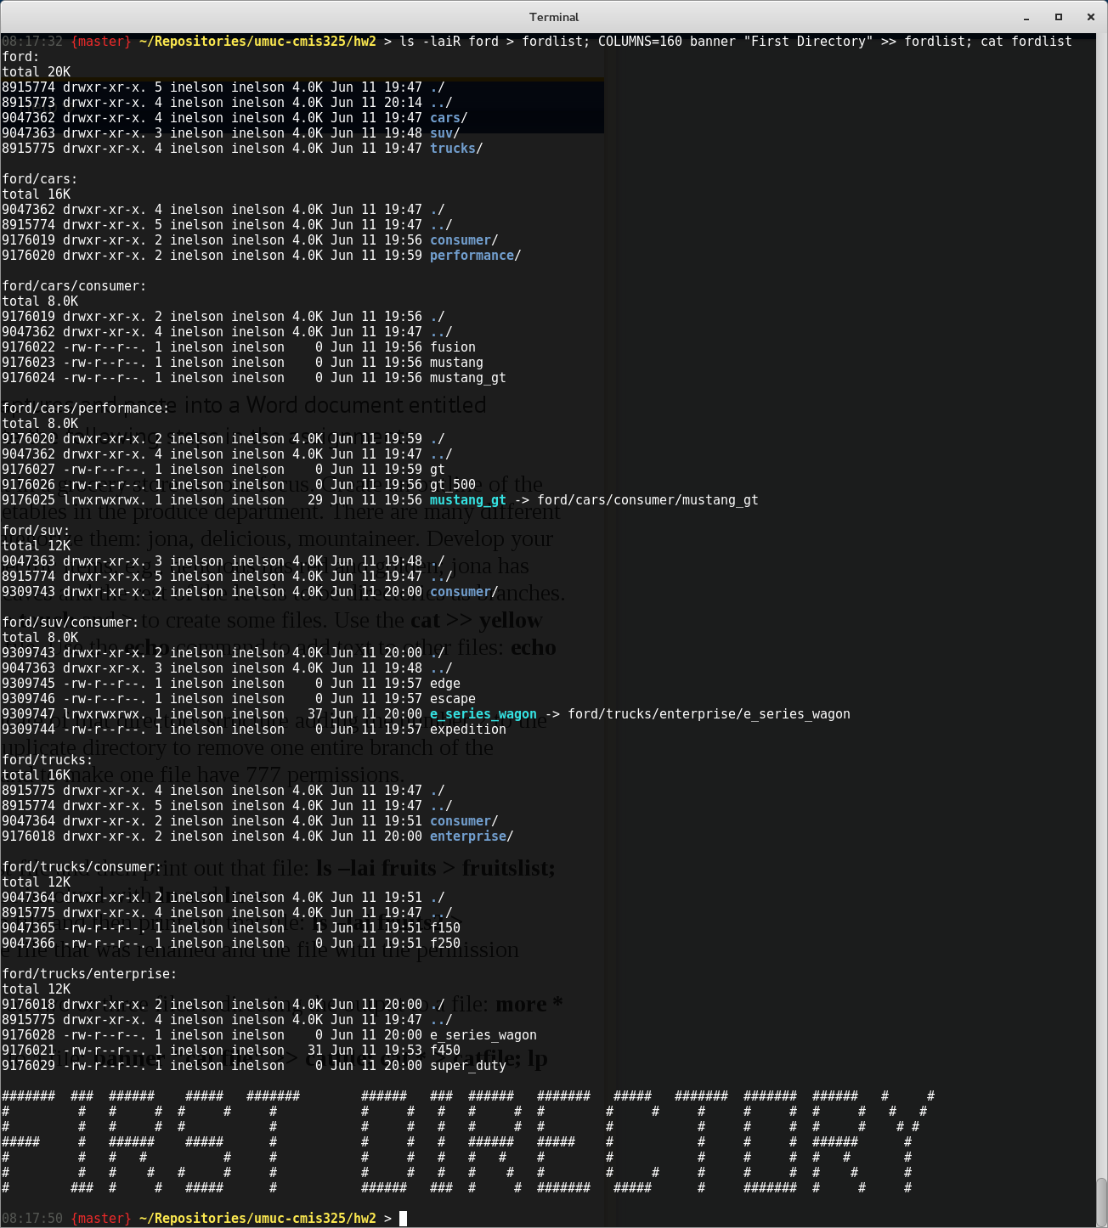

The second command was to do the same command with ‘ford2’, as you can see below. I used the same set of commands explained in the prior step. In this screenshot, note the green-colored listing in ‘ford2/trucks/consumer/f150’, which has been changed to permissions of 777. Additionally, the ‘ford2/trucks/enterprise/fsd’ file was renamed with ‘mv’ from ‘super_duty’, and the entire ‘suv’ branch was pruned with ‘rm -R’.

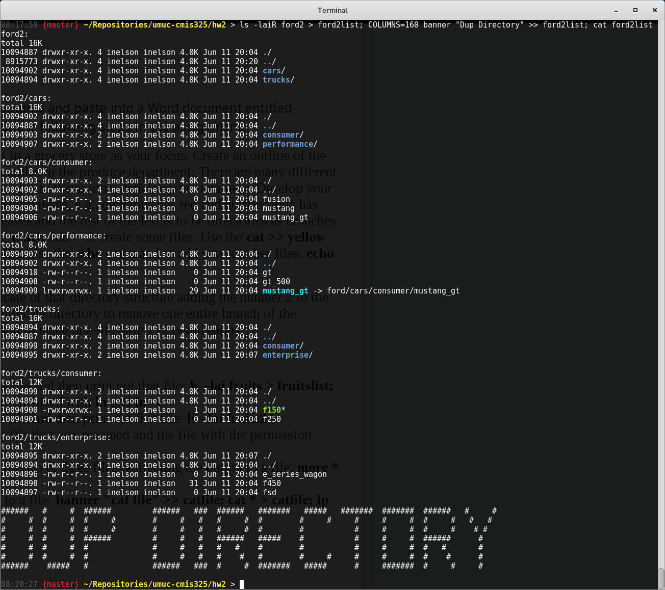

In this step, the ‘more’ command was used to aggregate the files together and inject the banner into the file. Note the failure to inject the content from ‘e_series_wagon’. This was a mistake on my part, using a relative path (‘ln -s’) between this file and ‘ford/trucks/enterprise’, and as a result, the file could not be located. SInce this is a soft link, the relative path was not sufficient to retrieve the path to open the file. I could have gone back and restructured the links to correct, but I thought my mistake was an important concept to highlight, and as a result left it in place.

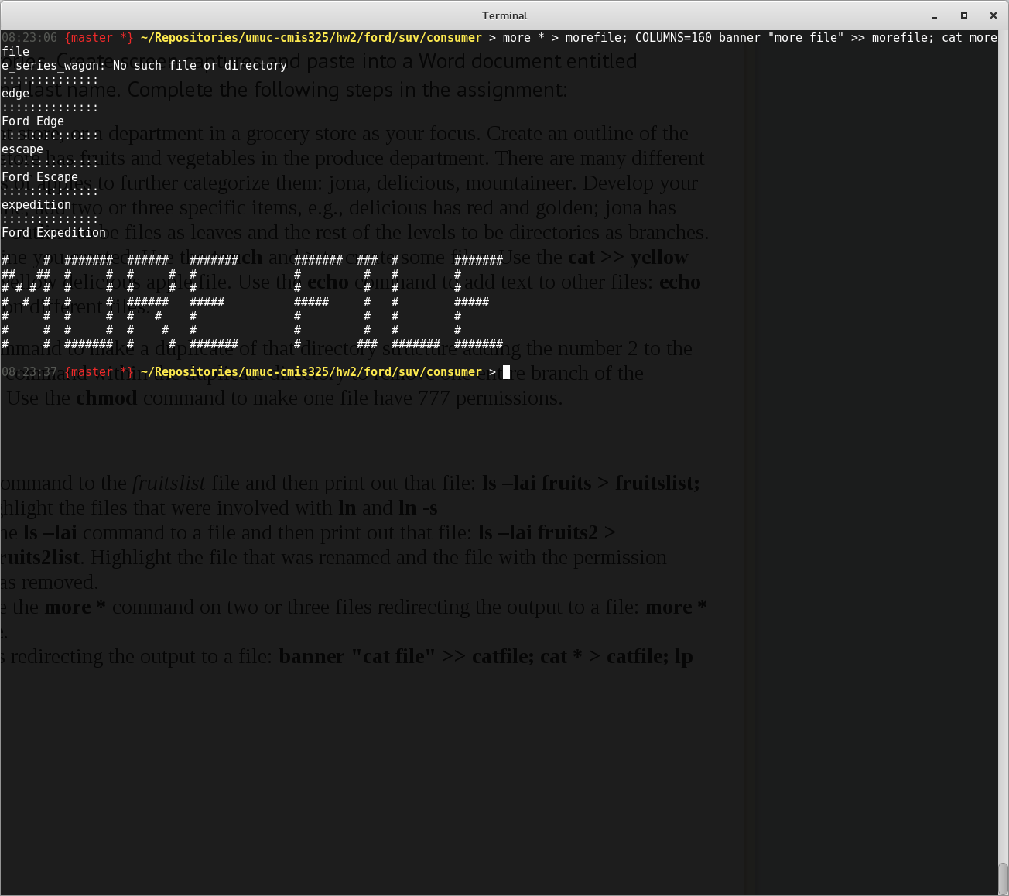

And finally, this step used ‘cat’ to aggregate the files together and show the output. Since the file from the ‘more’ aggregation step was still in place, the ‘cat’ command also aggregate that result into the final output. Again, the same error due to a relative path in the symbolic link is shown, since ‘cat’ could not resolve the file.

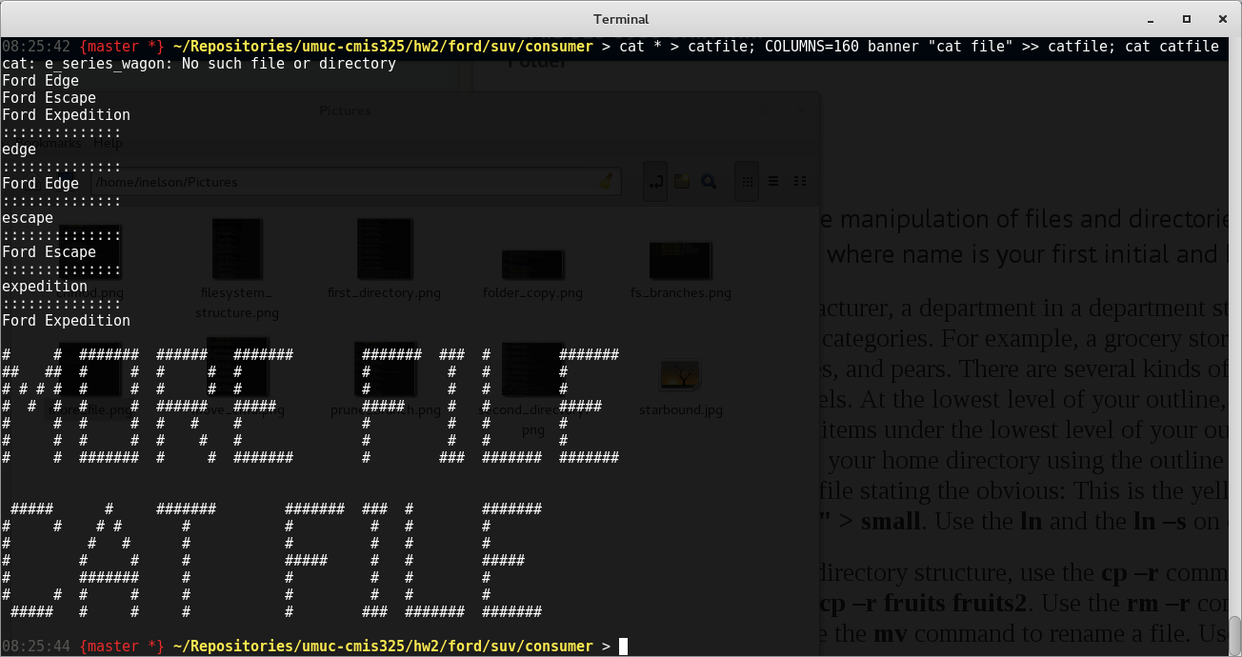

Note: The homework assignment showed the banner being placed first through concatenation (>>) in the final set of commands. I reversed this step (as seen above) to create the file first with ‘cat’, then concatenated with the banner to produce what I believed was the intent of the action. If this is incorrect, it was a best guess on my part to match existing steps.

