Ian Nelson
CMIS325
Homework 6

Homework 6 Analysis

For assignment 6, I decided to create a Bash script that acted as a proper chainable tool. In order to do this, I assessed the program requirements, and created a help output and threshold argument flag to only add numbers to the sum greater than 10.

Running the script by itself with no arguments presents the user with basic information on how to run properly. This also documents the use of the threshold argument flag. Although the assignment stated that there could be up to nine numbers, it also stated an unspecified number of command line arguments. Since I was using a ‘for’ loop to iterate through all of the supplied arguments, and supplied input validation for each argument (checking integer status against a regular expression), I decided this was preferable to the approach of only dealing with 9 arguments.

The console output provided shows the application’s help information, a large sequence of positive integers with no threshold, the ability to parse negative integers, error validation, and the use of the threshold flag.

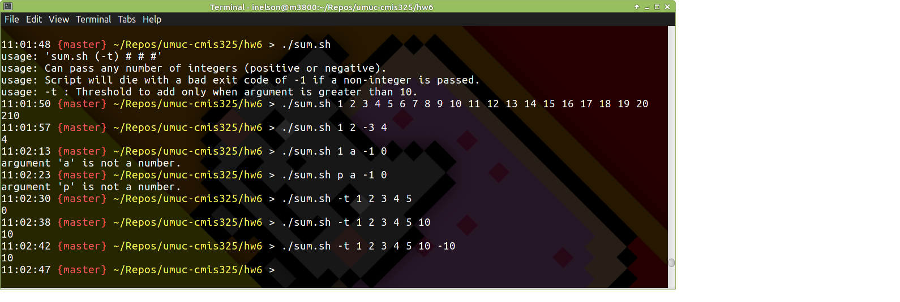

Additionally, this application provides the output directly to the shell, with no other information. This is the intent, as the output of ‘sum.sh’ could be used as a chained sequence of shell scripts.

The source code for ‘sum.sh’ has been provided in this document for review as an appendix.
sum.sh

#!/bin/bash

# Ian Nelson
# CMIS325
# Homework 6
# Summation shell script

## Assign the sum to zero.
sum=0

## Assign the threshold to zero.
threshold=0

## Create a pattern to match integers (+/-)
regex='^-?[0-9]+([.][0-9]+)?$'

## If the number of arguments is zero, print help.
if [[ $# == 0 ]] ; then
echo "usage: 'sum.sh (-t) # # #'"
echo "usage: Can pass any number of integers (positive or negative)."
echo "usage: Script will die with a bad exit code of -1 if a non-integer is passed."
echo "usage: -t : Threshold to add only when argument is greater than 10."
exit;
fi

## For each command line argument ('...unspecified number of command
## line arguments' from assignment)
for var in "$@"; do
## Did user supply the threshold flag?
if [[ $var == "-t" ]]; then
threshold=1
## Nope.
else
## Did the variable match the pattern?
if ! [[ $var =~ $regex ]] ; then
## Print an error and die.
echo "argument '$var' is not a number." >&2; exit -1
## Yes it did.
else
## Are we dealing with the >10 threshold?
if [[ $threshold == 1 ]]; then
## Is the argument greater than 10?
if [[ $var -ge 10 ]]; then
let "sum = sum + $var"
fi
## Nope. Just add.
else
let "sum = sum + $var"
fi
fi
fi
## Done with the loop.
done

## Print the sum.
echo $sum

