Ian Nelson

CMIS325

Homework 5

For this assignment, I started with the copy of the password sample file that was provided in the assignment description. I then used egrep to search for ‘cm315’ or ‘cm325’. This can be seen below:

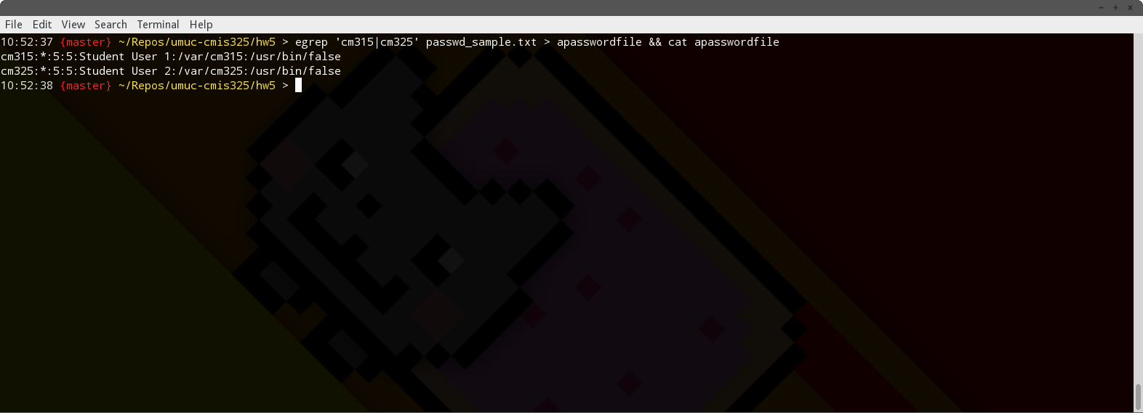

From here, I used the cut command to separate the first column into the ‘logname’ file:

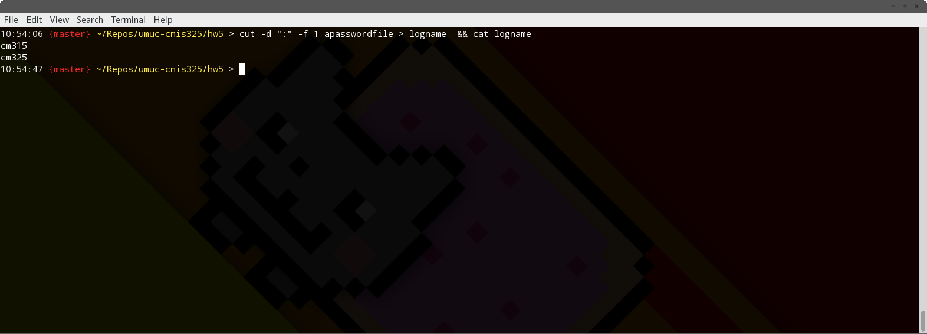

Next, I cut the 5th column into the ‘comment’ file:

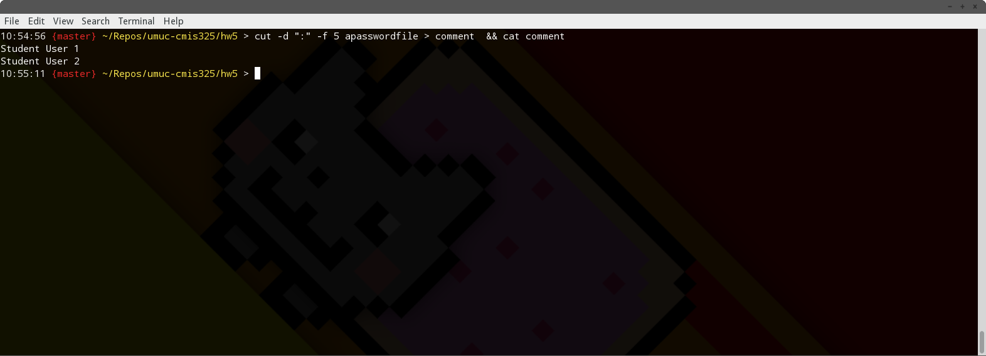

Next came the 6th column being cut into the ‘home’ file:

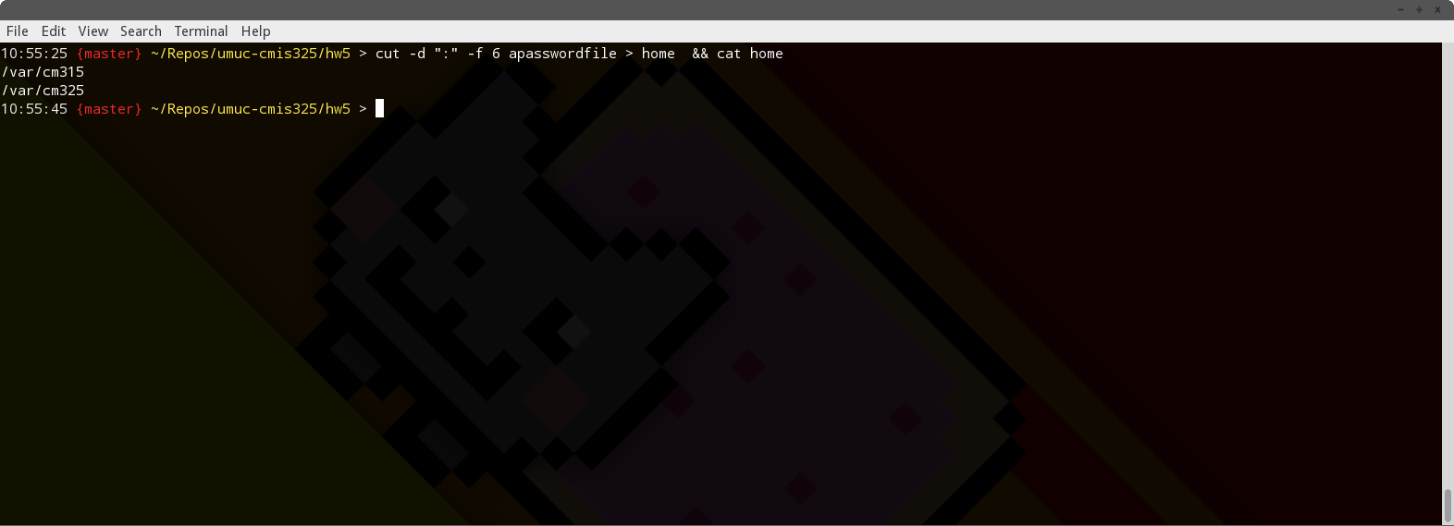

And finally, the 7th column was cut into the ‘shellfile’:

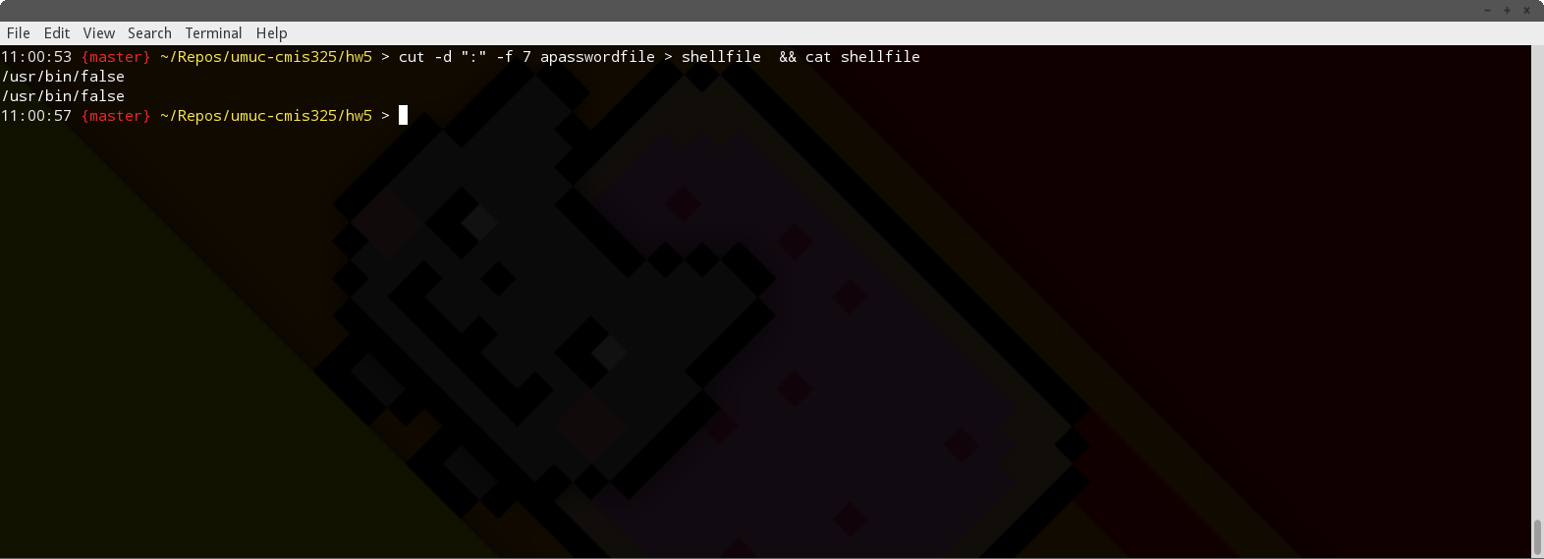

The ‘logspace’ file had 15 spaces inserted into the end. This can be seen by the use of the octal tool and a dump of raw characters:

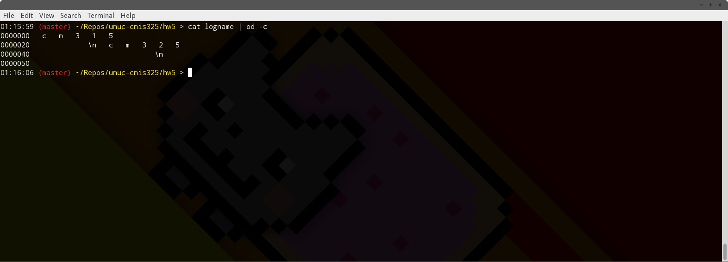

Once this was completed, I used ‘cut –c 1-15 …’ to separate the file into columns of 15 character widths and placed into the ‘loganame15’ file:

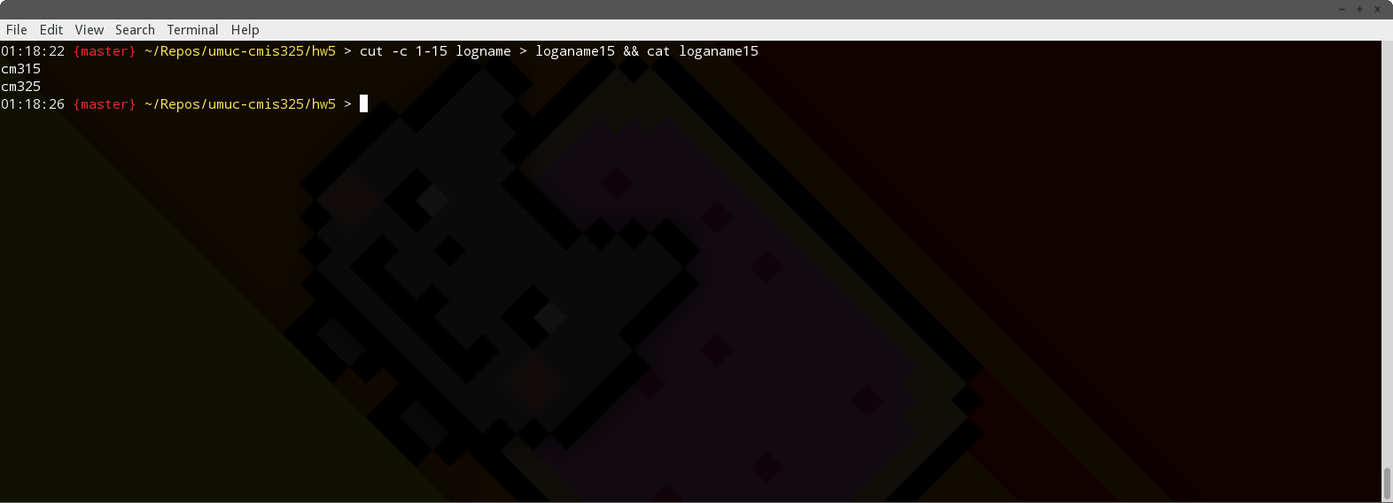

Once this was finished, I inserted ‘is the logname for‘ into the comment file:

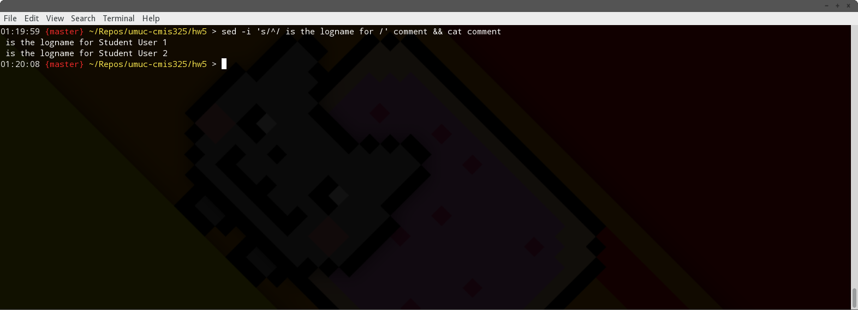

After, the ‘whose home directory is’ text was inserted into the home file:

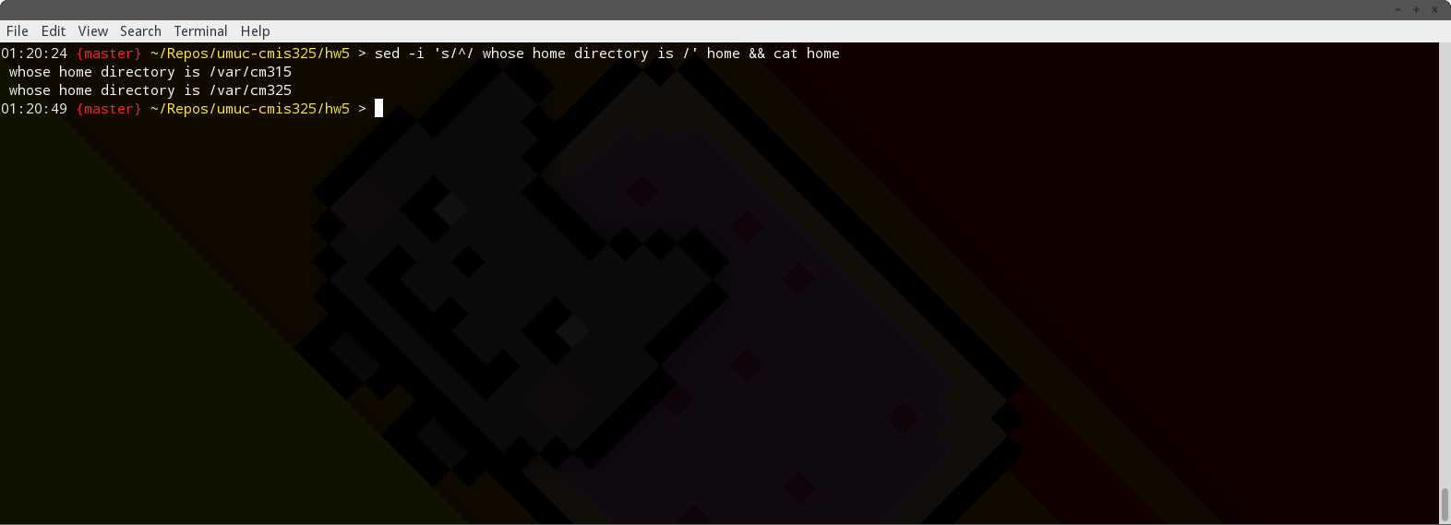

Finally, the text ‘shell with a period.’ was inserted into the shellfile:

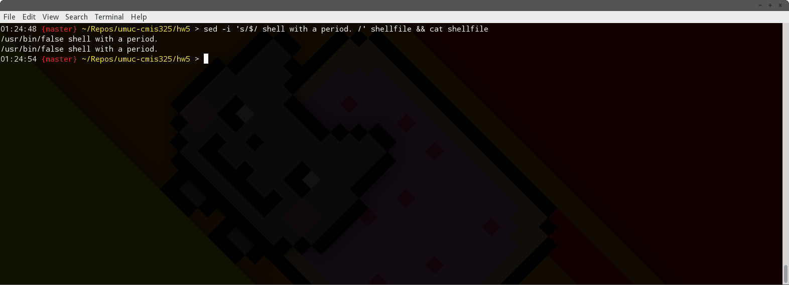

Since the example password file that was supplied did not have a shell, but a non-interactive account (false), I swapped ‘false’ with ‘Bourne Shell’ to complete the exercise:

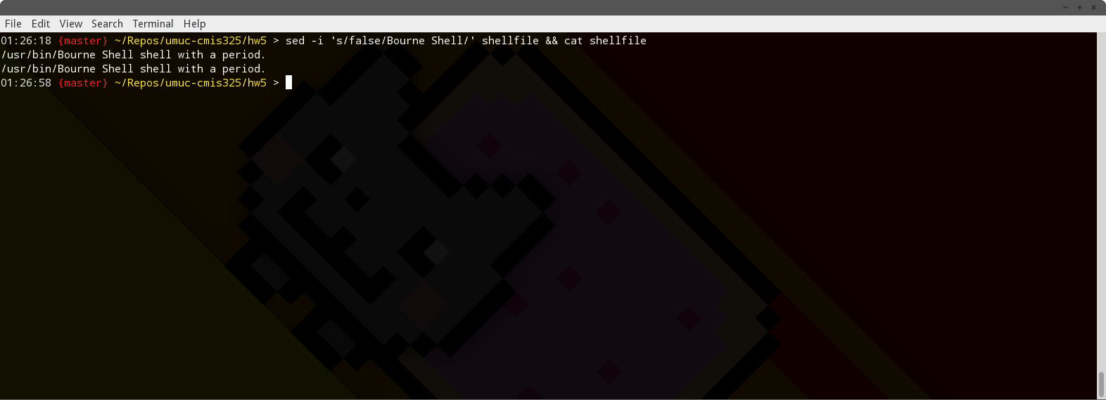

The text was then concatenated together, and the descriptive text was inserted into the file to conclude the assignment.

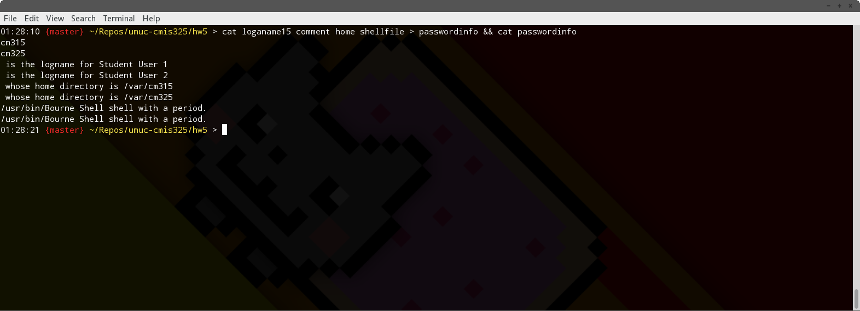

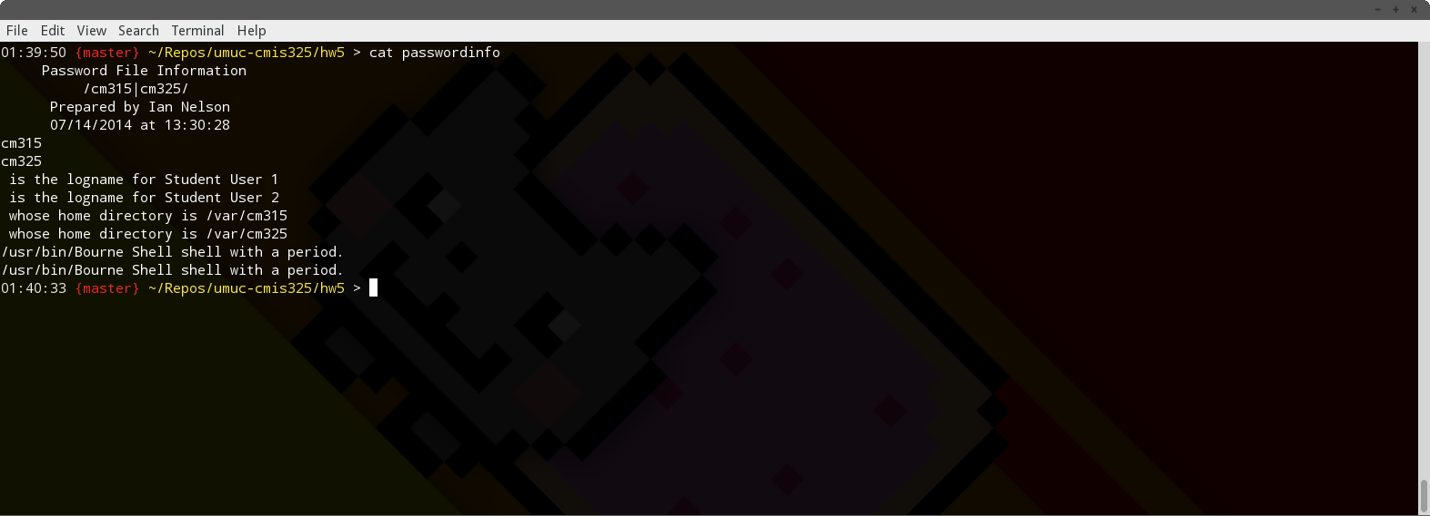

While doing this assignment, I felt as though the output came out strange. The instructions did not provide a final output example to compare against, but I felt as though using an OR’ed regular expression as defined (cm315|cm325) gave a set of listings instead of providing a single listing to change and merge together.

For example, it would make more sense to me if the final output was something like :

‘cm315 is the logname for Student User 1 whose home directory is /var/vm315 /usr/bin/Bourne Shell.’

Because I found the assignment description somewhat vague, and having a lack of sample output to compare to, I was unable to determine if I had made a mistake in the sed/regex/cat processing, or if this was the intent.