DDS-Digital Design Specification
STBIO1
Marco Leo, Ugo Garozzo, Aldo Torino, Alessandro Lucio Iannuzzi

REV. | DATE | AUTHOR
Draft 1.10 | 19 March 2026 | Ugo Garozzo, Marco Leo, Aldo Torino, Alessandro Lucio Iannuzzi
 | APPROVED By |  | DATE
 | Francesco Villa, Pasquale Biancolillo |  | 19 March 2026

2026

Table of Contents
Table of Contents 1
Table of Tables 4
Table of Figures 4
1. Abstract 6
2. Version History 7
3. Reference documents and Ip Repository 8
4. Conventions 9
4.1. Abbreviations 9
5. STBIO1 toplevel overview 11
6. Symbol 15
7. I/O List 15
8. STBIO1: Functional Modes 17
8.1. Data Storage Mode 17
8.2. Normal Mode 17
9. Digital Architecture Overview 17
9.1. TOP Pinout List 18
10. Power Domains 30
10.1. Introduction 30
10.2. Definitions 31
10.3. Power Domain Architecture 31
10.4. Power Domain Descriptions 32
10.4.1. PD_TOP1V2 32
10.4.2. PD_STREDL 32
10.4.3. PD_TOP3V3 32
10.4.4. PD_TOPIO 32
11. Interconnect 32
11.1. XBAR Connection Matrix 33
11.2. XBAR Memory Mapping 34
12. STBIO1 Operating Modes 35
13. Modules 37
13.1.1. PMU 37
13.1.2. PAD Mux 49
13.1.3. Main Controller TOP 72
13.2. IPs 86
13.2.1. ADSP integration 86
13.2.2. I2C_SPI_AHB integration 98
13.2.3. SensorHub integration 104
13.2.4. FIFO_CTRL integration 112
13.3. ISPU integration 116
13.3.1. Requirements 130
13.4. STBIO1 Register Map 133
13.4.1. STBIO1 Register Map 133
13.4.2. STBIO1 Register Map Peculiar Requirements 135
14. Soft Reset Procedures 144
14.1. Main Controller Soft Reset 144
15. Measurement Cycle Examples 144
15.1. BOOT Phase 145
15.2. Configuration Phase 146
15.3. Measurement Cycle 147
15.3.1. ECG Only 148
15.3.2. ECG and BIA 150
15.3.3. PPG Only 152
16. SCAN 156
16.1. Top Level Approach 156
17. BIST 157
17.1. Reference documents 157
17.2. Memory BIST Architecture 157
17.2.1. MBIST Collar 157
17.2.2. MBIST Controller 157
17.2.3. Top Level Approach 158
18. Digital DFT 159
18.1. Scan mode 159
18.2. Debug mode 159
18.3. ADC TEST LOW NOISE 160
18.4. ADC TEST FAST 161
18.5. BIST MODE 161
19. References 163

Table of Tables
Table 1: Revision History 7
Table 2: Revision History 8
Table 3: Git Repository Table 8
Table 4: Abbreviations Table 10
Table 5: I/O List 17
Table 6: Digital I/O List 30
Table 7: XBAR Connection Matrix 33
Table 8: Memory Map 34
Table 9: Operating modes Table 35
Table 10: PMU I/O List 42
Table 11: Clock Recap Table 46
Table 12: STBIO1 Functional reset Summary table 48
Table 13: PAD MUX I/O List 57
Table 14: PAD Configuration Table 58
Table 15: Main Controller Parameter 75
Table 16: Main Controller I/O List 85
Table 17: ADSP Parameter Table 86
Table 18: ADSP I/O List 87
Table 19: OTP I/O List 88
Table 20 Chosen OTP Timings 95
Table 21 Operation phases timings 95
Table 22: I2C/SPI AHB Parameters 99
Table 23: I2C/SPI AHB I/O List 101
Table 24: Sensor Hub Parameter 104
Table 25: Sensor Hub I/O List 105
Table 26: Fifo Parameter 112
Table 27: FIFO Controller I/O List 112
Table 28: SUB FIFO Memory Address 114
Table 29: Data Tag 115
Table 30: ISPU I/O List 129
Table 31: Address Register Map 133
Table 32: Location AFE_BLOCK Registers on the I2C/SPI pages. 134
Table 33: AFE_BLOCK register list. 140
Table 34: I2C/SPI internal registers. 143

Table of Figures
Figure 1: Time Slot Definition 12
Figure 2: STBIO1 Device Scheme 13
Figure 3: STBIO1 Reference Application 14
Figure 4: STBIO1 - Ball out. TOP View (Ball side down) 15
Figure 5: STBIO1 Digital Engine 18
Figure 6: STBIO1 Digital Scheme 33
Figure 7: Device Start-Up Phase 42
Figure 8: Mask Cell for LDO and Fast Ring Oscillator 43
Figure 9: Clocks Scheme 45
Figure 10: STBIO1 Reset Scheme 47
Figure 11: Main Controller Block Diagram 73
Figure 12: Boot Routine 91
Figure 13: Write Routine Start 92
Figure 14: WRITE routine and TEST regmap 93
Figure 15 : OTP Reading timing diagram 96
Figure 16: OTP Writing timing diagram 98
Figure 17: ISPU turn on phases 130
Figure 18: Timing turn on ISPU 131
Figure 19: Device Activity Flowchart 144
Figure 20: Boot Phase Flow 146
Figure 21: Configuration Phase Diagram 147
Figure 22: ECG ONLY FLOWCHART 150
Figure 23: ECG and BIA Measurement Flowchart 151
Figure 24: PPG Measurement Flowchart 154
Figure 25 Top Level Controller Configuration 158
Figure 26 scan mode activation timing 159
Figure 26 debug mode activation timing 160
Figure 27 bist mode activation timing 162

Abstract
This document is the specification of the STBIO1 Project.
This document describes the functions, performance characteristics and required verification tests for the STBIO1 Project.

All requirements are considered Reviewed and Accepted once the document is officially approved.

Version History

Current Version | Previous Version | Date | Author | Change description
0.1 | N.A |  | Marco Leo | Starting point from VSM01 project
STBIO1_v0.3 | 0.2 | 6/17/2025 | Marco Leo | Added page numbers, update timing slot definition
STBIO1_v0.4 | 0.3 | 8/25/2025 | Marco Leo | Fix PMU Peculiar requirements. Added Soft Reset Procedure
STBIO1_v2 | 1.6.2 | 9/1/2025 | Ugo Garozzo | Adde new OTP routines description, Adde Soft Reset Procedures
STBIO1_v3 | 2 | 9/3/2025 | Ugo Garozzo | Add new output on TOP o_BDC_PPG, added Power Domain,  Chanced ADSP IP ADSP_v0.3.21.OTP640
STBIO1_v4 | 3 | 9/22/2025 | Ugo Garozzo, Marco Leo, Aldo Torino, Alessandro Iannuzzi | 1. Added reset value TOP;  2. Added Power DomainDescription;  3. Added resets of regmap;  4. Added new A2D input;  5. POR1V2_VDDIO;  6. new ADSP IP  7. new i2c/spi IP  8. Updated Top level Digital Scheme
STBIO1_v5 | 4 | 10/10/2025 | Aldo Torino, Ugo Garozzo | Added Approvers Data, Fix Tables Size, Fix Clocks and Reset Schemes, removed scan reports section
STBIO1_v6 | 5 | 11/5/2025 | Ugo Garozzo | Added DCCK, updated DDS_STBIO1_4000 new i2c/spi IP tag documentation, add pad_mux requirements
STBIO1_v7_DOC | 6 | 11/24/2025 | Aldo Torino | Added Requirement 00001199 for sub-fifo Offset
STBIO1_v8_DOC | 7 | 11/25/2025 | Ugo Garozzo | Updated
STBIO1_v9_DOC | 8 | 1/22/2026 | Aldo Torino | Fix set user mode description
STBIO1_v10_DOC | 9 | 3/19/2026 | Aldo Torino | Add Functional Mode Chapter, Reference Table and add Reference Chapter
Table 1: Revision History

Reference documents and Ip Repository

This is a list of reference documents.
[DDS_STBIO1_0002] Definition
Current Version | Document | Author | Change Description
1.0 | Main Controller IPOS (stbio1/FE/main_controller_top/Documentation/Specification/) | Aldo Torino, Sonia Andronaco, Giuliana De Milato
3.0 | IPOS_I2C_SensorHub_Quokka_uP | Marco Leo
 | Documentation_Specification_FIFO_CTRL_dos | Roberta Priolo
3.6 | Documentation_Specification_IP_Objective_Specification | Stefano Barbieri
 | ADSP IPOS | Alessandro Alaimo, Luca Gandolfi
 | H9A_MEM_OTP_ PUMP_85AL05_2 3A User Manual 2.0- 02
 | https://developer.arm.com/documentation/ihi0033/latest/ | ARM
0.2 | STRED-LP2 Architecture Reference Manual  https://codex.cro.st.com/plugins/document/stbio1/folder/933984 | ASMS
1.0 | ADSP micro Firmware | Alessandro Alaimo, Ugo Garozzo, Luca Gandolfi
Table 2: Revision History

IP | Git address | Git branch | Git tag
ADSP | git clone ssh://gitolite@codex.cro.st.com/ip-development/ADSP.git | adsp_vecma | ADSP_v0.3.22.OTP640
i2c_spi_slave | git clone ssh://gitolite@codex.cro.st.com/ip-development/i2c_spi_slave.git | vecma | I2C_SPI_AHB_v3.1_061025_DOC
senshub_mst_i2c | ssh://gitolite@codex.cro.st.com/ip-development/senshub_mst_i2c.git | ahb_platf_ip | STBIO1_RTL100_v4.1
Table 3: Git Repository Table

IP external | Description | Author
ISPU | STRED-LP2-SVN_VERSION 9739 | SRA
BIST BLOCK | GenericMBIST | STMicroelectronics TRnD
ADSP ROM | H9A_M4_ST_ROM | STMicroelectronics TRnD
ADSP RAM | ST_SPSMALL_512x64m2_bM6_CUmr | STMicroelectronics TRnD
FIFO RAM | ST_SPSMALL_512x64m2_bM6_CUmr | STMicroelectronics TRnD
ISPU CODE | ST_SPUHD_2048x128m4_bM6_CUmr | STMicroelectronics TRnD
ISPU DATA | ST_SPUHD_2048x32m4_bM6_CUmr | STMicroelectronics TRnD
H9A_FU_OTPHV_85AL05_23A | H9A_FU_OTPHV_85AL05_23A_MIM5_6ML_ALUCU  revision 2.6.b 640-bit
XBAR | CoreLink SIE-200 System IP for Embedded - Global Bundle r3p2-00rel0
Table 1:external IPs

Conventions

[DDS_STBIO1_0003] Definition

If not otherwise noted, specification values are valid …

Abbreviations

[DDS_STBIO1_00304] Comment
The following abbreviations are used throughout this document:

[DDS_STBIO1_0006] Definition

A
AGC | Automatic Gain Control
ASIL | Automotive Safety Integrity Level
ASIC | Application Specific Intergrated Circuit
B
BIST | Built In Self Test
…
C
CRM | Clock and Reset Management
F
FMEA | Failure Mode and Effect Analysis
FMEDA | Failure Mode, Effect and Diagnostic Analysis
FSM | Functional Safety Management
FTA | Fault Tree Analysis
CTRL | Controller
PPG | Photoplethysmography
EDA | Electro-Dermal Activity
GSR | Galvanic Skin Response
PMU | Power Management Unit
Table 4: Abbreviations Table

[DDS_STBIO1_0007] Definition

Category Convention:

Comment: | This category denotes that the content of the object text is a general comment. For example, this may be an explanation why the requirement demands certain items when there would also be other possibilities. A comment should not be necessary to understand the related requirements.
Definition: | This category is used for the definition of terms, wordings, technical expressions etc. It is a documentation of design decisions and general instructions that belong to the document itself, e.g. owner of the document, structure of the document. It is needed to understand a related requirement. It is not linked to any test case.
Assumption | This category is used for requirements this document provide upstream to another document, indicating what this IP/block/system needs to work properly.
Requirement: | This category denotes a requirement that has to be implemented and verified. Accordingly, it is necessary to establish traces from the different requirement levels to the test cases for this category.

STBIO1 toplevel overview
Aim of this document is to explain main features of the ASIC STBIO1, electronic interface of ECG, Bio-impedance, EDA and PPG (Photoplethysmography) embedded in a single die.

STBIO1 is an Analog Front End Device with embedded process capabilities.
STBIO1 collects and processes different types of Vital Signals:
- ECG
- PPG
- BIA and GSR
The optical channel (PPG) is designed as an optical transceiver, stimulating up to eight LEDs and measuring the return signal on up to six separate cent inputs. The signal chain rejects signal offsets and corruption from asynchronous modulated interference, typically from ambient light, eliminating the need for optical filters or externally controlled dc cancellation circuitry.
The ECG signal acquisition is designed to support low noise, diagnostic level measurement in the presence of a variety of interferers. The ECG signal chain has several complementary features supporting ECG measurement, such as driven reference for common-mode rejection and lead off detection to identify a fallen electrode.
The BIA signal chain is designed for body impedance and human breathing measurements with a configurable excitation path and measurement path. BIA channel delivers both the real and the imaginary parts of the body and the breathing impedance.
Finally, the last Electro-Dermal Activity (EDA), also called Galvanic Skin Response (GSR) refers to changes in sweat gland activity that are reflective of the intensity of our emotional state, otherwise known as emotional arousal.
STBIO1 is optimized ultra-low-power hardware circuitry for real-time execution of the algorithms is a state-of-the-art feature for any personal electronics, from wearable accessories to high-end applications.
The STBIO1 features an advanced digital engine, composed of multiple IPs able to reduce external host processing workload, reducing bus congestion, providing meta-data useful for final application, both in time and frequency domain.
The main IPs actors in digital domain are:
- ADSP
- Sensor-Hub
- ISPU 32-bit processor
- Smart FIFO data collector

ADSP is an embedded IP able to elaborate ultra-low-power custom DSP functions. The main purpose of ADSP is to reduce the computation workload on both ISPU and host processor, while saving power through the optimization of both hardware and algorithm.

Sensor hub IP can read external sensors by means of an I2C master protocol, enabling data collection in FIFO and embedded elaboration also on external data domain. The data collected by sensor hub is accessible from the Advanced DSP and ISPU, for sensor fusion algorithm elaboration.

The advanced ISPU (32bit proprietary core) is an ultra-low-power, high-performance programmable core which can execute signal processing and AI algorithms in the edge. The main benefits of the ISPU are C programming and an enhanced ecosystem with libraries and 3rd party tools/IDE. ISPU has 32 Kbyte program RAM, 24 Kbyte Data RAM capability and Floating-point support.
FIFO digital IPs oversees data collecting from multiple sources: internal and external data read by sensor hub, meta-data generated from both ADSP and ISPU.
The internal and external data that can be collected in FIFO are:
- ECG
- BIA
- GSR & 6 channels PPG
- up to 4 external sensors (expressed on 12 bytes each).
All the data are stored inside a Smart FIFO that can be configured as:
- Unique FIFO: Classic FIFO, the First Data that is written inside the Memory is also the First that is read.
- Multiple Fifo: The FIFO is split up to 6 Sub-FIFO (one for each Channels plus one for Sensor Hub and Elaboration results). The depth of each Sub-FIFO is configurable by regmap. Each Sub-FIFO behavior as a Classic FIFO.

[DDS_STBIO1_0101] Definition:
To understand how STBIO1 works, is necessary to define some basic concepts:
- TIME_SLOT= represents the interval within measurements are performed. It can be configured by the regmap field TIME_SLOT_SELECTION and its range is from 4096Hz to 64 Hz.
- In each TIME_SLOT we can distinguish two phases:
  - Operative: where all user configured measures are executed and ADSP and/or ISPU eventually runs its algorithms.
  - Sleep: where measures are finished, eventually only ADSP and/or ISPU is terminating its algorithms and writing elaborated data in FIFO.

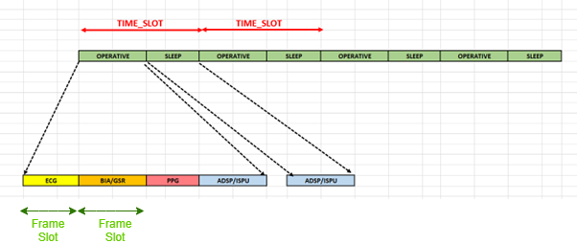
Figure 1: Time Slot Definition

If all the selected operations do not end in a single Time Slot, an error shall be raised.

The Time Slot is composed of different Frame Slot representing the time-interval of a single operation (for example, ECG).

We also need to define the other 4 parameters: Mecg, Mbia, Mgsr and Mppg, also called Division Index.
These parameters are used to define the Data Rate Interval of a single Frame Slot.

$$Rate Interval= \frac{Time Slot}{Mx}$$

With x = ecg,ppg,bia and gsr.
Depending on the value of the Mx parameters, a Time_Slot can be composed by one or more Frame Slot or none. In the last case, the device will remain in SLEEP_OPERATIVE (as described in the next paragraphs). [END]

STBIO1 die size is 3700μm x 4000μm including scribe line of 80um. Technology used is HCMOS9A (130nm)

PDK_STM_HCMOS9A 11.8.b-03
PDK_STM_PLUS 04.04-02

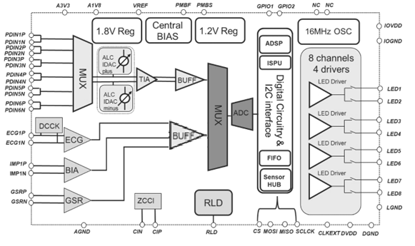
Figure 2: STBIO1 Device Scheme

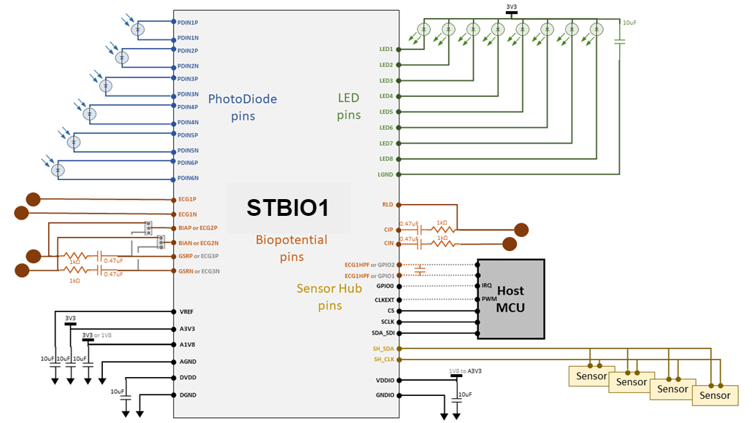
Figure 3: STBIO1 Reference Application

Symbol
[DDS_STBIO1_0008] Definition

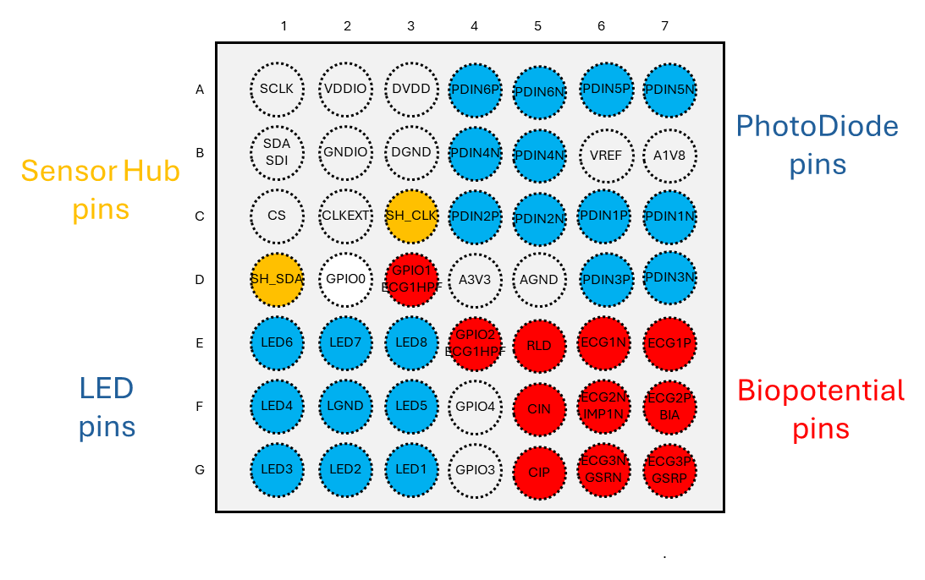
Figure 4: STBIO1 - Ball out. TOP View (Ball side down)

I/O List

[DDS_STBIO1_0009] Definition

Nr. | Name | Function | Pin No. | Type
1 | AV1V8 | 1.8 V Analog Power Supply | D5 | Power
2 | AV3V3 | 3.3 V Analog Power Supply | D4 | Power
3 | AGND | Analog Ground | D6 | Power
4 | DVDD | 1.8 V Digital Power Supply | A3 | Power
5 | GNDD | Digital Ground | B3 | Power
6 | VDDIO | I/O Power Supply. | A2 | Power
7 | GNDIO | I/O Ground | B2 | Power
8 | LGND | LED Ground | F2 | Power
9 | VREF | Voltage Reference | D7 | Analog
10 | PDIN5N | Photodiode 5 N | A7 | Analog
11 | PDIN1P | Photodiode 5 P | A6 | Analog
12 | PDIN6N | Photodiode 6 N | A5 | Analog
13 | PDIN6P | Photodiode 6 P | A4 | Analog
14 | PDIN3N | Photodiode 3 N | B7 | Analog
15 | PDIN3P | Photodiode 3 P | B6 | Analog
16 | PDIN4N | Photodiode 4 N | B5 | Analog
17 | PDIN4P | Photodiode 4 P | B4 | Analog
18 | PDIN2P | Photodiode 2 P | C4 | Analog
19 | PDIN2N | Photodiode 2 N | C5 | Analog
20 | PDIN1P | Photodiode 1 P | C6 | Analog
21 | PDIN1N | Photodiode 1 N | C7 | Analog
22 | LED1 | LED driver 1 | G3 | Analog
23 | LED2 | LED driver 2 | G2 | Analog
24 | LED3 | LED driver 3 | G1 | Analog
25 | LED4 | LED driver 4 | F1 | Analog
26 | LED5 | LED driver 5 | F3 | Analog
27 | LED6 | LED driver 6 | E1 | Analog
28 | LED7 | LED driver 7 | E2 | Analog
29 | LED8 | LED driver 8 | E3 | Analog
30 | ECGIP | ECG Positive Input | E7 | Analog
31 | ECGIN | ECG Negative Input | E6 | Analog
32 | RLD | Right LEG Driver | E5 | Analog
33 | IMPIP | BIA Positive Input | F7 | Analog
34 | IMPIN | BIA Negative Input | F6 | Analog
35 | GSRP | GSR Positive Input | G7 | Analog
36 | GSRN | GSR Negative Input | G6 | Analog
37 | CIP | BIA Injection Positive Output. | G5 | Analog
38 | CIN | BIA Injection Negative Output. | F | Analog
39 | GPIO3 | General-Purpose Input/Output 3 | G4 | Analog
40 | GPIO4 | General-Purpose Input/Output 4 | F4 | Analog
41 | SCLK | SPI Clock INPUT | A1 | Digital
42 | CLKext | External Clock | C2 | Digital
43 | SDA_SDI | I2C / SPI serial data line | B1 | Digital
44 | SH_SDA | Sensor Hub Data | D1 | Digital
45 | CS | Chip Select | C1 | Digital
46 | SH_CK | Sensor Hub Clock | C3
47 | GPIO0 | General-Purpose Input/Output 0 | D2 | Digital
48 | GPIO1 | General-Purpose Input/Output 1 | D3 | Digital
49 | GPIO2 | General-Purpose Input/Output 2 | E4 | Digital
Table 5: I/O List

STBIO1: Functional Modes
Different measurement flow can be distinguished according to the operative mode set by the user:

Data Storage Mode
- Set DS_SEL bit in Device_Config_Channel register to 1 and PPG_ELAB to 0 in General_Parameters_PPG
  - This will cut the communication between Main Controller and ADSP
- Analog control Interface samples ECG and BIA signals from ADC, average and stores data sampled in appropriate in FIFO.
- Analog control Interface samples GSR signal from ADC and stores GSR data raw in FIFO.
- Analog control Interface samples PPG signal from ADC, average (according to the user's configuration) and stores data in FIFO.
- Raw data are always available in FIFO after stored. (Except when FIFO FULL occurs)

In this mode, the ADSP is turned off, but it’s possible to turn on the ISPU before the start of a measurement Cycle. In this case, the ISPU shall read the data from FIFO and can communicate with the ADSP.

Normal Mode
- Set DS_SEL bit in Device_Config_Channel register to 0
  - Set PPG_ELAB to 1 if also PPG data shall be elaborated by the ADSP
- Analog control Interface samples of ECG, BIA or GSR from ADC, average and stores data sampled in appropriate registers (SYSTEM REGISTERS from 0x007C to 0x0094) accessible by ADSP and other AHB Master.
- Analog control Interface samples PPG signal from ADC, average (according to the user's configuration) and stores data in FIFO.
- ECG, BIA or GSR data raw in SYSTEM REGISTERS are processed by ADSP.
  - If PPG_ELAB is set to 1, ADSP Shall read PPG Raw Data Directly from FIFO
- Finished processing phase ADSP stores elaborated data in FIFO.

In this mode is possible to turn on the ISPU to work with raw data and/or ADSP elaborated Data.

Digital Architecture Overview

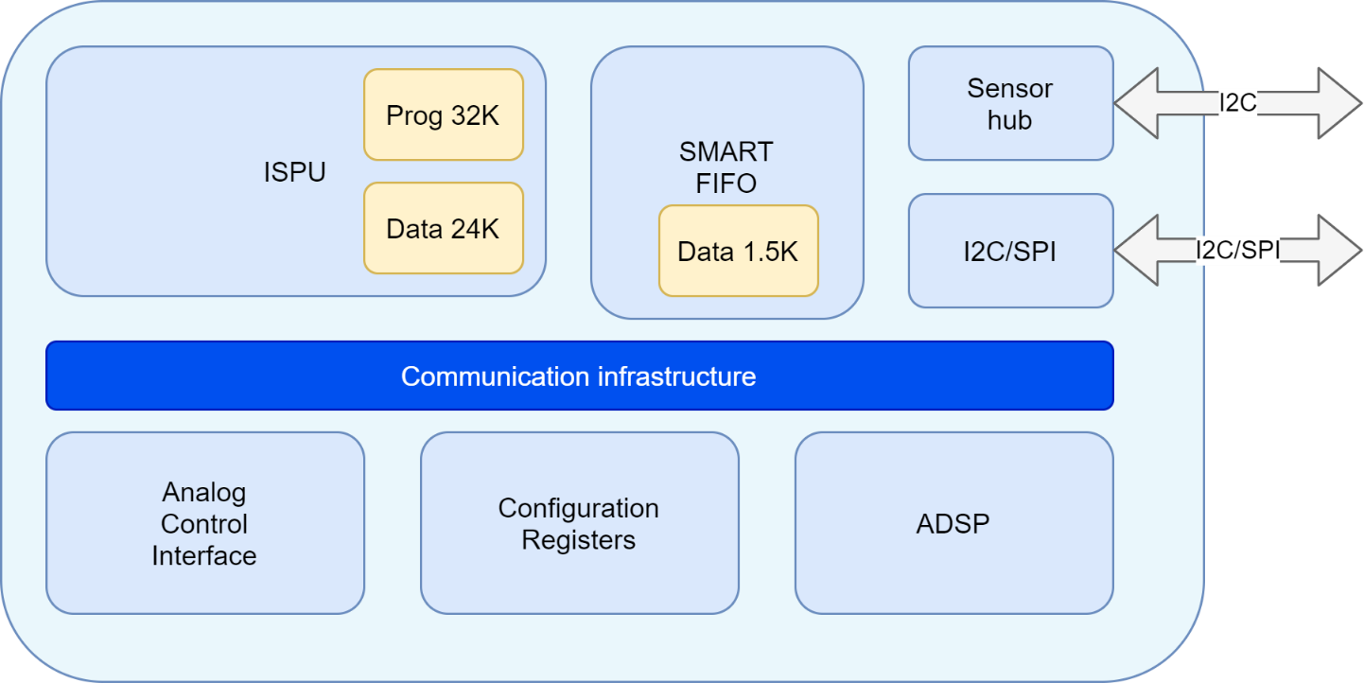
Figure 5: STBIO1 Digital Engine

TOP Pinout List
Port name | Direction | POR State of Signal | Type | Description
i_comp_rx_out | input |  | 0 | wire | to u_main_controller_top, Description: "Inserire LS
o_BIDAC | output |  | 0 | wire [11:0] | from u_scan_out_mux
o_BDC_PPG | output |  | 0 | wire [7:0] | from u_scan_out_mux
o_BTIA_gain | output |  | 0 | wire [3:0] | from u_scan_out_mux
o_PD_PGA | output |  | 1 | wire | from u_scan_out_mux
o_PD_IDAC | output |  | 1 | wire | from u_scan_out_mux
o_PD_TIA | output |  | 1 | wire | from u_scan_out_mux
o_comp_rx_ck | output |  | 0 | wire | from u_scan_out_mux
BT_IDAC_N | output | 0 | wire [6:0] | from u_scan_out_mux
BT_IDAC_P | output |  | 0 | wire [9:0] | from u_scan_out_mux
o_b_cap_idac | output |  | 0 | wire [1:0] | from u_scan_out_mux, Description: IDAC Filter Cap
o_rx_ch_frame | output |  | 0 | wire [2:0] | from u_scan_out_mux, Description: BMUX_Selection
DIS_LOOP_TIA | output |  | 0 | wire | from u_scan_out_mux, Description: Disable TIA loop
T_RX_GPIO1 | output | 0 | wire [1:0] | from u_scan_out_mux, Description: TEST RX signal on
T_RX_GPIO2 | output |  | 0 | wire [1:0] | from u_scan_out_mux, Description: TEST RX signal on
TM_SEL_1V8 | output |  | 0 | wire | from u_scan_out_mux, Description: Force PGA input
o_en_tx_1V2 | output |  | 0 | wire [3:0] | from u_scan_out_mux
o_tx1_outlab_sel_frame_x_1V2 | output |  | 0 | wire | from u_scan_out_mux
o_tx2_outlab_sel_frame_x_1V2 | output |  | 0 | wire | from u_scan_out_mux
o_tx3_outlab_sel_frame_x_1V2 | output |  | 0 | wire | from u_scan_out_mux
o_tx4_outlab_sel_frame_x_1V2 | output |  | 0 | wire | from u_scan_out_mux
o_tx_preset_1V2 | output |  | 0 | wire | from u_scan_out_mux
BtrimIREF_TX_1V2 | output |  | 0 | wire [3:0] | from u_scan_out_mux, Description: TX Ramp Current
DFT_SEL_1V2 | output | 0 | wire | from u_scan_out_mux, Description: VFEED_1V2 Monitor
o_curr_sel_tx_frame_x_1V2 | output |  | 0 | wire [7:0] | from u_scan_out_mux, Description: Selezione corrente
o_Txi_RAMP_1V2 | output |  | 0 | wire [3:0] | from u_scan_out_mux, Description: B_RAMP_1V2<3:0>
o_ck_chop_imp | output |  | 0 | wire | from u_scan_out_mux
o_ck_hc2_10k | output |  | 0 | wire | from u_scan_out_mux
o_ck_m | output |  | 0 | wire | from u_scan_out_mux, Description: inserito new bit
o_ck_p | output |  | 0 | wire | from u_scan_out_mux, Description: inserito new bit
o_ck_q | output |  | 0 | wire | from u_scan_out_mux, Description: inserito new bit
o_short_on | output |  | 0 | wire | from u_scan_out_mux, Description: (codex 1417523
o_resh_on | output |  | 0 | wire | from u_scan_out_mux, Description: (codex 1417523
o_resl_on | output |  | 0 | wire | from u_scan_out_mux, Description: (codex 1417523
o_pd_hc2 | output |  | 1 | wire | from u_scan_out_mux
o_pd_imp | output |  | 1 | wire | from u_scan_out_mux
o_rst_hc2 | output |  | 0 | wire | from u_scan_out_mux
o_rst_imp | output |  | 0 | wire | from u_scan_out_mux
o_rsti_hc2 | output |  | 0 | wire | from u_scan_out_mux
o_rsti_imp | output |  | 0 | wire | from u_scan_out_mux
o_su_hc2 | output |  | 0 | wire | from u_scan_out_mux
o_sug_imp | output |  | 0 | wire | from u_scan_out_mux
i_ADC_EOC | input |  | 0 | wire | to u_main_controller_top/u_pad_mux
i_data_ADC_out | input |  | 0 | wire [15:0] | to u_main_controller_top/u_pad_mux
o_adc_mux_bio_channel | output |  | 0 | wire [2:0] | from u_scan_out_mux
o_adc_mux_sel | output |  | 0 | wire | from u_scan_out_mux
o_gsr_curr_on | output |  | 0 | wire | from u_scan_out_mux
o_gsr_on | output |  | 0 | wire | from u_scan_out_mux
o_ADC_en | output |  | 0 | wire | from u_scan_out_mux
o_ADC_start | output |  | 0 | wire | from u_scan_out_mux
o_adc_error_cap8_1V2 | output |  | 0 | wire [6:0] | from u_scan_out_mux
o_adc_error_cap7_1V2 | output |  | 0 | wire [6:0] | from u_scan_out_mux
o_adc_error_cap6_1V2 | output |  | 0 | wire [6:0] | from u_scan_out_mux
o_adc_error_cap5_1V2 | output |  | 0 | wire [6:0] | from u_scan_out_mux
o_adc_error_cap4_1V2 | output |  | 0 | wire [6:0] | from u_scan_out_mux
o_adc_error_cap3_1V2 | output |  | 0 | wire [6:0] | from u_scan_out_mux
o_adc_error_cap2_1V2 | output |  | 0 | wire [6:0] | from u_scan_out_mux
o_adc_error_cap1_1V2 | output |  | 0 | wire [6:0] | from u_scan_out_mux
o_adc_error_cap0_1V2 | output |  | 0 | wire [6:0] | from u_scan_out_mux
o_pd_cm_buf | output |  | 1 | wire | from u_scan_out_mux
o_pd_rld | output |  | 1 | wire | from u_scan_out_mux
o_pd_avg1 | output |  | 1 | wire | from u_scan_out_mux
o_pd_avg2 | output |  | 1 | wire | from u_scan_out_mux
POR1V2_1V2 | input |  | 0 | wire | to u_pad_mux
clk_16m | input |  | 0 | wire | to u_pad_mux
clk_64k | input |  | 0 | wire | to u_pad_mux
START_CLK_16M | input |  | 0 | wire | to u_pad_mux
o_DIS_RC_VIREF | output |  | 0 | wire | from u_scan_out_mux
o_EN_LDO1V8 | output |  | 0 | wire | from u_scan_out_mux
o_PD_CLKF | output |  | 1 | wire | from u_scan_out_mux
ADC_CAL_CORR_DIS | output |  | 0 | wire | from u_scan_out_mux
ADC_ERROR_CAP9_DEBUG | output | 0 | wire [7:0] | from u_scan_out_mux
ADC_SR_ENHANCE_DIS | output |  | 0 | wire | from u_scan_out_mux
CCK_THRESHN_SEL | output | 0 | wire [3:0] | from u_scan_out_mux
CCK_THRESHP_SEL | output | 0 | wire [3:0] | from u_scan_out_mux
CURR_BG_TRIM | output | 8 | wire [3:0] | from u_scan_out_mux
CURR_PTAT_TRIM | output | 8 | wire [3:0] | from u_scan_out_mux
DCCK_CURRINJ | output | 0 | wire [1:0] | from u_scan_out_mux
DCCK_ISINK_IN | output |  | 0 | wire [2:0] | from u_scan_out_mux
DCCK_ISOURCE_IN | output |  | 0 | wire [2:0] | from u_scan_out_mux
ECG_PSDRES_DOWN | output |  | 0 | wire [2:0] | from u_scan_out_mux
ECG_PSDRES_UP | output | 0 | wire [2:0] | from u_scan_out_mux
EN_DEBUG_ADC_ERROR_CAP9 | output | 0 | wire | from u_scan_out_mux
EN_ECG_50m | output |  | 0 | wire | from u_scan_out_mux
EN_GRS_50m | output |  | 0 | wire | from u_scan_out_mux
EN_IMP_50m | output |  | 0 | wire | from u_scan_out_mux
EN_RLD_CM | output |  | 0 | wire | from u_scan_out_mux
EN_SW_IMP | output |  | 1 | wire | from u_scan_out_mux, Description: per selezionare
GAIN1_BUF | output |  | 0 | wire | from u_scan_out_mux
GSR_IN_TRIM | output |  | 0 | wire [7:0] | from u_scan_out_mux
GSR_IP_TRIM | output |  | 0 | wire [7:0] | from u_scan_out_mux
IMPP_PSDRES_DOWN | output |  | 0 | wire [2:0] | from u_scan_out_mux
IMPP_PSDRES_UP | output | 0 | wire [2:0] | from u_scan_out_mux
IMPQ_PSDRES_DOWN | output | 0 | wire [2:0] | from u_scan_out_mux
IMPQ_PSDRES_UP | output | 0 | wire [2:0] | from u_scan_out_mux
IMP_CURINJN_TRIM | output | 0 | wire [5:0] | from u_scan_out_mux
IMP_CURINJP_TRIM | output |  | 0 | wire [5:0] | from u_scan_out_mux
RLD_CAP_COMP | output |  | 0 | wire [3:0] | from u_scan_out_mux, Description: [1/2/3/…/15/16]*16pF
RLD_VREF | output |  | 0 | wire [1:0] | from u_scan_out_mux, Description: select 0.9V/ 0.6V
TRIM_LDOD_I | output |  | 0 | wire [3:0] | from u_scan_out_mux
TRIM_LDOD_V | output |  | 0 | wire [3:0] | from u_scan_out_mux
TRIM_OSC_FAST | output |  | 18 | wire [4:0] | from u_scan_out_mux
TRIM_OSC_SLOW | output |  | 0 | wire [3:0] | from u_scan_out_mux
TRIM_V1V8 | output |  | 7 | wire [2:0] | from u_scan_out_mux
VREF_TRIM | output |  | 10 | wire [4:0] | from u_scan_out_mux
CAPF_IMP_EN | output |  | 1 | wire | from u_scan_out_mux, Description: Enable filtro per
ECG0_GAIN_HC_0 | output |  | 1 | wire | from u_scan_out_mux
ECG0_GAIN_HC_1 | output |  | 1 | wire | from u_scan_out_mux
EN_EXT_CAP | output |  | 0 | wire | from u_scan_out_mux, Description: Mantenuta opzione
EN_ECG0_0P05HP | output |  | 0 | wire | from u_scan_out_mux, Description: aggiunto bit per
EN_ECG12_0P05HP | output |  | 0 | wire | from u_scan_out_mux, Description: aggiunto bit per
GAIN_IMP | output |  | 1 | wire [1:0] | from u_scan_out_mux
GIMP_DC | output |  | 1 | wire | from u_scan_out_mux
o_gsr_switchon | output |  | 0 | wire | from u_scan_out_mux, Description: spostato il bit
GSR_GAIN_SEL | output |  | 0 | wire [1:0] | from u_scan_out_mux
GSR_GAIN_X1 | output |  | 0 | wire | from u_scan_out_mux
IGSR_X10 | output |  | 0 | wire | from u_scan_out_mux
IMP_CURRINJ_CUR | output |  | 2 | wire [1:0] | from u_scan_out_mux
IMP_CURRINJ_x10 | output |  | 0 | wire | from u_scan_out_mux
SEL_GSR_CURR | output |  | 3 | wire [1:0] | from u_scan_out_mux
o_ck_bg | output |  | 0 | wire | from u_scan_out_mux
o_imp_curinj_pd | output |  | 1 | wire | from u_scan_out_mux
o_pd_p | output |  | 1 | wire | from u_scan_out_mux
o_pd_n | output |  | 1 | wire | from u_scan_out_mux
o_adc_error_cap9 | output |  | 0 | wire [7:0] | from u_scan_out_mux
o_en_bufxbio | output |  | 0 | wire | from u_scan_out_mux
o_ldo_ext | output |  | 0 | wire | from u_scan_out_mux
o_clk_ext_div | output |  | 0 | wire | from u_scan_out_mux
o_adc_test_cap | output |  | 0 | wire [9:0] | from u_scan_out_mux
if_cs_en | output |  |  | wire | from u_level_shifter_sel.if_cs_en_ls_out
if_cs_in | input |  |  | wire | to u_pad_mux
if_cs_out | output |  |  | wire | from u_level_shifter_sel.if_cs_out_ls_out
if_cs_tud | output |  | 1 | wire | from u_level_shifter_sel.if_cs_tud_ls_out, Description:
if_gpio0_en | output |  | wire | from u_level_shifter_sel.if_gpio0_en_ls_out
if_gpio0_in | input |  |  | wire | to u_pad_mux/u_pmu.if_sh_ck_in
if_gpio0_out | output |  |  | wire | from u_level_shifter_sel.if_gpio0_out_ls_out
if_gpio0_tud | output |  | 1 | wire | from u_level_shifter_sel.if_gpio0_tud_ls_out
if_gpio1_en | output |  | wire | from u_level_shifter_sel.if_gpio1_en_ls_out
if_gpio1_in | input |  |  | wire | to u_pad_mux
if_gpio1_out | output |  |  | wire | from u_level_shifter_sel.if_gpio1_out_ls_out
if_gpio1_tud | output |  | 1 | wire | from u_level_shifter_sel.if_gpio1_tud_ls_out
if_gpio2_in | input |  | wire | to u_pad_mux
if_gpio2_en | output |  |  | wire | from u_level_shifter_sel.if_gpio2_en_ls_out
if_gpio2_out | output |  | 1 | wire | from u_level_shifter_sel.if_gpio2_out_ls_out
if_gpio2_tud | output |  | 1 | wire | from u_level_shifter_sel.if_gpio2_tud_ls_out
if_gpio3_en | output |  | wire | from u_level_shifter_sel.if_gpio3_en_ls_out
if_gpio3_in | input |  |  | wire | to u_pad_mux, Description: decidere se mantenere l'IN
if_gpio3_out | output |  | 1 | wire | from u_level_shifter_sel.if_gpio3_out_ls_out
if_gpio3_tud | output |  | 1 | wire | from u_level_shifter_sel.if_gpio3_tud_ls_out
if_gpio4_en | output |  | wire | from u_level_shifter_sel.if_gpio4_en_ls_out
if_gpio4_in | input |  |  | wire | to u_pad_mux, Description: decidere se mantenere l'IN
if_gpio4_out | output |  | 1 | wire | from u_level_shifter_sel.if_gpio4_out_ls_out
if_gpio4_tud | output |  | 1 | wire | from u_level_shifter_sel.if_gpio4_tud_ls_out
if_sclk_en | output |  | wire | from u_level_shifter_sel.if_sclk_en_ls_out
if_sclk_in | input |  |  | wire | to u_pad_mux
if_sclk_out | output |  | 1 | wire | from u_level_shifter_sel.if_sclk_out_ls_out
if_sclk_tud | output |  | 1 | wire | from u_level_shifter_sel.if_sclk_tud_ls_out
if_sda_sdi_en | output |  | wire | from u_level_shifter_sel.if_sda_sdi_en_ls_out
if_sda_sdi_in | input |  |  | wire | to u_pad_mux
if_sda_sdi_out | output |  | 1 | wire | from u_level_shifter_sel.if_sda_sdi_out_ls_out
if_sda_sdi_tud | output |  | 1 | wire | from u_level_shifter_sel.if_sda_sdi_tud_ls_out
if_sh_ck_en | output |  | wire | from u_level_shifter_sel.if_sh_ck_en_ls_out
if_sh_ck_in | input |  |  | wire | to u_pad_mux
if_sh_ck_out | output |  |  | wire | from u_level_shifter_sel.if_sh_ck_out_ls_out
if_sh_ck_tud | output |  | 1 | wire | from u_level_shifter_sel.if_sh_ck_tud_ls_out
if_sh_sda_en | output |  | wire | from u_level_shifter_sel.if_sh_sda_en_ls_out
if_sh_sda_in | input |  |  | wire | to u_pad_mux
if_sh_sda_out | output |  | 1 | wire | from u_level_shifter_sel.if_sh_sda_out_ls_out
if_sh_sda_tud | output |  | 1 | wire | from u_level_shifter_sel.if_sh_sda_tud_ls_out
o_trim_ldo_d | output | 0 | wire [1:0] | from u_level_shifter_sel.o_trim_ldo_d_ls_out
ADC_BUFF_REFRESH_DIS | output |  | 0 | wire | from u_scan_out_mux
ADC_EXTRAPERIOD_DIS | output |  | 0 | wire | from u_scan_out_mux
ADC_INPUT_FROM_GPIO | output |  | 0 | wire | from u_scan_out_mux
ADC_REF_FROM_GPIO | output |  | 0 | wire | from u_scan_out_mux
AFE_SPARE_0_1V2 | output |  | 0 | wire [7:0] | from u_scan_out_mux
AFE_SPARE_1 | output |  | 0 | wire [7:0] | from u_scan_out_mux, Description: modificato l'utilizzo
DIS_LDOD_HP | output |  | 0 | wire | from u_scan_out_mux
DIS_LDOD_IP | output |  | 0 | wire | from u_scan_out_mux
EN_LDOD_FIFO | output |  | 0 | wire | from u_scan_out_mux
EN_LDOD_STREDL | output |  | 0 | wire | from u_scan_out_mux
OTP_SPARE | output |  | 00007F00 | wire [31:0] | from u_scan_out_mux, Description: i PMB_EXT sono collegati
OVERCURR_N_IN_i | input |  | 0 | wire | to u_regmap_otp
OVERCURR_P_IN_i | input |  | 0 | wire | to u_regmap_otp
O_DCCK_N_i | input |  | 0 | wire | to u_pad_mux/u_regmap_otp/u_regmap_otp.DCCK_N_IRQ_i/u_N_not_logic.A,
O_DCCK_P_i | input |  | 0 | wire | to u_pad_mux/u_regmap_otp/u_regmap_otp.DCCK_P_IRQ_i/u_P_not_logic.A,
t_en_gpio1 | output |  | 0 | wire | from u_scan_out_mux, Description: spostato il bit
t_en_gpio2 | output |  | 0 | wire | from u_scan_out_mux, Description: spostato il bit
t_en_gpio3 | output |  | 0 | wire | from u_scan_out_mux
t_en_gpio4 | output |  | 0 | wire | from u_scan_out_mux
t_ecg0_out_pre_buf | output |  | 0 | wire | from u_scan_out_mux
t_offset_gpio12 | output |  | 0 | wire | from u_scan_out_mux
t_in_bio_buf34 | output |  | 0 | wire | from u_scan_out_mux
t_ecg1_out_pre_bufp_3 | output |  | 0 | wire | from u_scan_out_mux
t_ecg1_out_pre_bufn_4 | output |  | 0 | wire | from u_scan_out_mux
t_ecg2_out_pre_bufn_3 | output |  | 0 | wire | from u_scan_out_mux
t_ecg2_out_pre_bufp_4 | output |  | 0 | wire | from u_scan_out_mux
T_CM_HLT_2 | output |  | 0 | wire | from u_scan_out_mux
T_CM_RLD_1 | output |  | 0 | wire | from u_scan_out_mux
T_ECG0_AC_1 | output |  | 0 | wire | from u_scan_out_mux
T_ECG0_DC_2 | output |  | 0 | wire | from u_scan_out_mux
T_EXT_HPF_ECG0 | output |  | 0 | wire | from u_scan_out_mux
T_FORCE_1V2 | output |  | 0 | wire | from u_pad_mux.o_t_force_1v2
T_IBG_1u_2 | output | 0 | wire | from u_scan_out_mux
T_IMPP_AC_1 | output |  | 0 | wire | from u_scan_out_mux
T_IMPP_DC_2 | output |  | 0 | wire | from u_scan_out_mux
T_IMPQ_AC_2 | output |  | 0 | wire | from u_scan_out_mux
T_IMPQ_DC_1 | output |  | 0 | wire | from u_scan_out_mux
T_IN_BIO_BUF | output |  | 0 | wire | from u_scan_out_mux
T_IPTAT_1u_1 | output |  | 0 | wire | from u_scan_out_mux
T_OP55_1 | output |  | 0 | wire | from u_scan_out_mux
T_OP90_2 | output |  | 0 | wire | from u_scan_out_mux
T_OUT_BIO_BUF | output |  | 0 | wire | from u_scan_out_mux
T_OUT_GSR | output |  | 0 | wire | from u_scan_out_mux
T_OUT_PPG_BUF | output |  | 0 | wire | from u_scan_out_mux
T_SENSE_1V2 | output |  | 0 | wire | from u_scan_out_mux
T_SENSEIBG_1V2 | output | 0 | wire | from u_scan_out_mux
T_CM_HLT_1 | output |  | 0 | wire | from u_scan_out_mux
T_SENSEVBG_1V2 | output |  | 0 | wire | from u_scan_out_mux
o_end_calibration_1V2 | output |  | 0 | wire | from u_scan_out_mux
pd_osc_clk32k | output |  | 0 | wire | from u_scan_out_mux, Description: se si seleziona
o_pd_buf_gpio1 | output |  | 1 | wire | from u_scan_out_mux
o_pd_buf_gpio2 | output |  | 1 | wire | from u_scan_out_mux
EN_CLK_EXT | output |  | 0 | wire | from u_scan_out_mux
WHO_AM_I | input |  | D7 | wire [7:0] | to u_regmap_otp.DEV_ID_i, Description: ? OK ?
if_sclk_i3c_in | input |  |  | wire | to u_pad_mux
if_sda_sdi_i3c_in | input |  |  | wire | to u_pad_mux
VREF | input |  |  | wire | to u_otp
IREF | input |  |  | wire | to u_otp
OTP_IREF_WAKEUP | output |  | 0 | wire | from u_scan_out_mux, Description: Enable Mirror OTP

Table 6: Digital I/O List

Power Domains

Introduction
This document paragraph describes the Power Domain architecture implemented in the STBIO1. The goal is to provide a detailed overview of the power domain partitioning, their functionalities, control modes, and interactions between the various functional blocks.

Definitions

- Power Domain (PD): A set of logic blocks sharing the same power supply, which can be powered on/off independently.
- Always-On Domain (AON): Domain that is always powered, even in low-power modes.
- Retention Domain: Domain that retains register state even when the main logic is powered down.
- Switchable Domain: Domain that can be completely powered off to save energy.

Power Domain Architecture
Domain Name | Included Block(s) | Domain Type | Voltage [V] | Control Mode | Notes
PD_TOP1V2 | ADSP, ca_fifo_bist_c, ca_qk_bist_c, ca_qk_rom_bist, multi_channel_fifo, i2c_spi_slave, main_controller_top, senshub_mst_i2c, pad_mux, pmu, stbio1_regmap, scan_out_mux, ta_stbio1_bist_ctlr, xbar_afe | Always-On | 1.2 | HW | Always active
PD_STREDL | STREDL | Switchable | 1.2 | SW | Can be powered down in idle
PD_TOP3V3 | H9A_MEM_OTP_ PUMP_85AL05_2 3A | Always-On | 2.7÷4.7V | HW | Always active
PD_TOPIO | level_shifter_sel | Always-On | 1.8V÷3.6V | HW | Always active

Power Domain Descriptions

PD_TOP1V2
- Function: Ensures continuity of critical functions (Data Storage Mode, Sensor-Hub acquisition, FIFO read and write data, Elaboration Mode with ADSP only).
- Characteristics: Never powered down.
- Control: Managed by hardware.

PD_STREDL
- Function: Powers the STREDL core and associated cache.
- Characteristics: Can be powered down when STREDL is not in use.
- Control: Managed via software (power management driver)(see 12.3.1)

PD_TOP3V3
- Function: power supply to the OTP memory block.
- Characteristics: Never powered down. It provides 4.7V of power supply to the OTP memory block during programming (write) operations
- Control: Managed by hardware.

PD_TOPIO
- Function: Powers communication PAD
- Characteristics: Never powered down.
- Control: Managed by hardware.

Interconnect

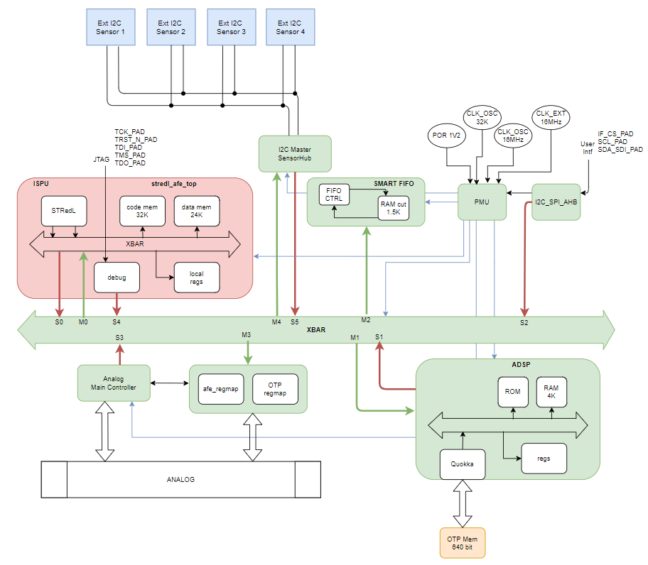
Figure 6: STBIO1 Digital Scheme

XBAR Connection Matrix
Destination  Source | Regmap | SENSOR HUB | ISPU | FIFO | ADSP
Main Controller | [DDS_STBIO1_0201] |  |  | [DDS_STBIO1_0202] | [DDS_STBIO1_0219]
ADSP | [DDS_STBIO1_0203] | [DDS_STBIO1_0204] |  | [DDS_STBIO1_0206]
I2C_SPI_AHB | [DDS_STBIO1_0207] | [DDS_STBIO1_0208] | [DDS_STBIO1_0209] | [DDS_STBIO1_0210] | [DDS_STBIO1_0221]
SENSOR HUB |  |  |  | [DDS_STBIO1_0211]
ISPU | [DDS_STBIO1_0212] | [DDS_STBIO1_0213] |  | [DDS_STBIO1_0215] | [DDS_STBIO1_0222]
ISPU debug | [DDS_STBIO1_0216] | [DDS_STBIO1_0217] | [DDS_STBIO1_0218] | [DDS_STBIO1_0220] | [DDS_STBIO1_0223]
Table 7: XBAR Connection Matrix

[DDS_STBIO1_XBAR_01] Assumption
Every master and slave supports AHBLite and none supports burst communication
[End]

XBAR Memory Mapping

AHB base start address | AHB base end address | Address block | Direct Access | Req_ID
0x0_0000 | 0x0_7FFF | ISPU CODE RAM 32KB | N.A. | [DDS_STBIO1_10100]
0x0_8000 | 0x3_FFFF | RESERVED | N.A. | [DDS_STBIO1_10101]
0x4_0000 | 0x4_5FFF | ISPU DATA RAM 24KB | N.A. | [DDS_STBIO1_10102]
0x4_6000 | 0x7_FFFF | RESERVED | N.A. | [DDS_STBIO1_10103]
0x8_0000 | 0x8_010F | ISPU SYSTEM REGISTERS | N.A. | [DDS_STBIO1_10104]
0x8_0110 | 0xB_FFFF | RESERVED |  | [DDS_STBIO1_20000]
0xC_0000 | 0xC_0800 | ADSP PROG ROM | N.A. | [DDS_STBIO1_10105]
0xC_0804 | 0xC_0FFF | RESERVED |  | [DDS_STBIO1_20001]
0xC_1000 | 0xC_1DFF | ADSP DATA MEMORY | N.A. | [DDS_STBIO1_10106]
0xC_1E00 | 0xC_1E20 | ADSP REGISTERS | N.A. | [DDS_STBIO1_10107]
0xC_1E24 | 0xC_3FFF | NOT USED
0xC_4000 | 0xC_4FFF | FIFO RAM MEMORY | N.A. | [DDS_STBIO1_10108]
0xC_5000 | 0xC_5060 | FIFO REGISTERS | N.A. | [DDS_STBIO1_10109]
0xC_5064 | 0xC_5FFF | NOT USED
0xC_6000 | 0xC_6FFF | SENSOR HUB | N.A. | [DDS_STBIO1_10110]
0xC_7000 | 0xC_7FFF | NOT USED
0xC_8000 | 0xC_DFFF | AFE SYSTEM REGISTERS | N.A. with exception (see 13.4) | [DDS_STBIO1_10111]
0xE_0000 | 0xF_FFFF | STOP CLOCK (Reserved) | N.A. | [DDS_STBIO1_10112]
Table 8: Memory Map

STBIO1 Operating Modes

Digital blocks status for different operating modes is reported in table, where ON indicates the clock is running and OFF that it is gated:

 | PMU | ADSP | Regmap | FIFO_CTRL | Sensor hub | Main CTRL | ISPU | Req_ID
Power Down | On | Off | Off | Off | Off | On | Off | DDS_STBIO1_10200
Boot | On | On | On | Off | Off | On | Off | DDS_STBIO1_10201
Configuration Phase | On | Off | On | Off | Off | On | Off | DDS_STBIO1_10202
Operative data storage mode | On | Off | Off | On | On | On | On (optionally) | DDS_STBIO1_10203
Operative elaboration mode | On | On | Off | On | On | On | On (optionally) | DDS_STBIO1_10204
Sleep | On | Off | Off | On (Optionally) | Off | On | On (optionally) | DDS_STBIO1_10205
Table 9: Operating modes Table

Modules
Instantiations
- u_pmu: pmu
- u_pad_mux: pad_mux
- u_regmap_otp: stbio1_regmap
- u_masterblaze_ahb: senshub_mst_i2c
- u_xbar_afe: xbar_afe: interconnect
- u_ADSP: ADSP
- u_fifo: Fifo Controller
- u_ispu: ispu
- u_i2c_spi_slave: i2c_spi_slave
- u_ca_fifo_bist_c: FIFO RAM (Hard Macro)
- u_ca_qk_bist_c: ADSP RAM (Hard Macro)
- u_ca_qk_rom_bist: ADSP ROM (Hard Macro)
- u_psw_ctrl: ISPU Power Island
- u_ta_afe_bist_crtl: STBIO1 Bist Controller (Hard Macro)
- u_otp: otp (Hard Macro)
- u_main_controller_top: main_controller_top

PMU

PMU TOP Description

PMU oversees the Device Start-Up phase, the clock generation to the Digital and Analog Domain and Reset Sync to the different Clock Domain.

PMU TOP I/O List
Port name | Direction | Type | Description
clk_16m | input | wire | Clock 16 MHz from analog ring oscillators
clk_64k | input | wire | Clock 64kHz from analog ring oscillators
POR1V2_1V2 | input | wire | POR Signal
START_CLK_16M | input | wire | Clock ready for 16MHz
PDClockF | input | wire | Power Down for 16MHz Ring Oscillator from main controller
i_bio_divider | input | wire | Enable 32kHz geneartion from 16MHz when a Bio-Channel is activated
EN_LDO | input | wire | enable LDO from main controller
PD_CLK_REG | input | wire | power down 16MHz from Regmap
EN_LDO1V8_REG | input | wire | Enable LDO from regmap
bist_mode | input | wire | enable bist mode
debug_mode | input | wire | enable debug
scan_mode | input | wire | enable scan mode
scan_enable | input | wire | start scan mode
scan_clk | input | wire | scan clk
scan_rstn | input | wire | scan rst
clk_bistctlr | input | wire | bist controller and collar clock
rst_bistctlr_n | input | wire | bist controller and collar resetn
clk_ext_en | input | wire | enable external clock from pad
clk_ext_slow | input | wire | external clock 32kHz
i_en_sh_clk | input | wire | enable sensor hub clock
i_senshub_clk_sel | input | wire [2:0] | selector for sensor hub clock
i_test_clk_fast | input | wire | enable test and trimming for 16MHz clock
i_half_charge_ldo | input | wire | enable the low power mode for ldo when only ppg is selected
mask_en_ldo_pdclkf | input | wire | mask the control of pdf and ldo control during boot
clk_en_s0 | input | wire | clock gating logic inside stredl_afe_top
clk_en_s1 | input | wire | if present should be HSEL STMC AHB Master
clk_en_s2_i2c | input | wire | if present should be HSEL STMC AHB Master
clk_en_s2_on | input | wire | clk gating ON from AHB I2C/SPI Interface
clk_en_s2_off | input | wire | clk gating OFF from AHB I2C/SPI Interface
clk_en_s3 | input | wire | clk gating from AHB Master Main Controller
clk_en_s4 | input | wire | clock gating logic inside stredl_afe_top
clk_en_s5 | input | wire | clock gating logic inside masterblaze_ahb
clk_en_m0 | input | wire | clock gating logic inside stredl_afe_top
clk_en_m1 | input | wire | HSEL M1 from xbar to STMC AHB Slave
clk_en_m2 | input | wire | HSEL M2 from xbar to FIFO
clk_en_m22 | input | wire | HSEL M2 from xbar to MASTERBLAZE
clk_en_m3 | input | wire | HSEL M3 from xbar to Regmap
iso_i | input | wire | from register
vdden_i | input | wire | enable ISPU Power Island
i_start_operative_16MHz | input | wire | enable the lead of check
main_ctrl_sw_resetn | input | wire | soft reset for main controller
stmc_sw_resetn | input | wire | adsp soft reset
fifo_sw_resetn | input | wire | fifo soft reset
masterblaze_sw_resetn | input | wire | sensor hub soft reset
regmap_sw_resetn | input | wire | regmap soft reset
adsp_run | input | wire | adsp is running
adsp_xbar_sw_en | input | wire | adsp clk ahb
i_en_clk_gsr_16M | input | wire | enable the clock for gsr digital circuit
i_en_ck_m_p_q | input | wire | enable quadrature and phase clock
i_en_clk_mod_debug | input | wire | enable the clock modulation debug
i_en_chop_ref | input | wire | enable chopper clock
i_en_ck_chop_imp | input | wire | enable chopper clock for bia
i_en_ck_hc2_10k | input | wire | enable health channel clock
i_freq_bia_m_p_q | input | wire [2:0] | frequency selector for phase and quadrature
i_en_clk_16MHz_sleep | input | wire | enable clock in SLEEP mode when a bio-channel is selected
EN_ADC_TEST_LOW_NOISE | input | wire | enable adc test low noise
EN_ADC_TEST_FAST | input | wire | enable adc test fast
if_sh_ck_in | input | wire | sensor hub clock interface
o_EN_LDO1V8 | output | wire | enable ldo to analog domain
o_PD_CLKF | output | wire | power down 16MHz clock to analog domain
o_CLK_16M_READY | output | wire | clock ready to the digital domain
o_DIS_RC_VIREF | output | wire | dis rc viref to the analog domain
pd_osc_clk32k | output | wire | power down for clk 64kHz
tst_clk_32k | output | wire | clock slow 32k to main_controller
tst_clk_16m | output | wire | clock fast 16M
tst_clk_bistctlr | output | wire | test clock for bist ctrl
tst_rst_bistctlr_n | output | wire | test reset for bist ctrl
clk_stredl | output | wire | clock gating logic inside stredl_afe_top
clk_xbar | output | wire | xbar clock
clk_intf | output | wire | interface clock
clk_main_ctrl | output | wire | clock for main controller
clk_stmc | output | wire | adsp clock
clk_stmc_ahb | output | wire | adsp clk elaboration
clk_fifo | output | wire | fifo clock
clk_masterblaze_m | output | wire | sensor hub master clock
clk_masterblaze_s | output | wire | sensor hub slave clock
clk_regmap | output | wire | regmap clock
o_clk_ext_en | output | wire | enable external clock
resetn_stredl | output | wire | reset mngmt inside stredl_afe_top
resetn_xbar | output | wire | xbar reset
resetn_intf | output | wire | reset interface
resetn_main_ctrl | output | wire | reset main controller
resetn_32k_main_ctrl | output | wire | reset 32kHz domain main controller
resetn_stmc | output | wire | reset adsp
resetn_fifo | output | wire | reset FIFO
resetn_masterblaze | output | wire | reset sensor hub
resetn_regmap | output | wire | reset regmap
o_trimming_clk_fast | output | wire | trimming output clock fast
iso_o | output | wire | left open . to be connected in synthesis
vdden_o | output | wire | to be connected to psw_ctrl.VDDIEN
o_ck_bg | output | wire | bg clock to analog domain
o_sh_clk | output | wire | sensor hub clock
o_ck_chop_imp | output | wire | chopper bia clock to analog domain
o_ck_m | output | wire | modulation clock to analog domain
o_ck_hc2_10k | output | wire | healt channel 10kHz clock to analog domain
o_ck_p | output | wire | phase clock to analog domain
o_ck_q | output | wire | quadrature clock to analog domain
o_clk_16M_mc | output | wire | 16MHz clock for Main Controller
o_clk_dft_adc | output | wire | 16MHz clock for ADC DFT
o_clk_gsr_16M | output | wire | gsr clock to digital domain
o_ADC_clk_serial_dft | output | wire | adc serial clock in dft
o_sh_clk_gate | output | wire | status clk reg clk sh 16Mhz

Table 10: PMU I/O List

PMU Peculiar Requirements

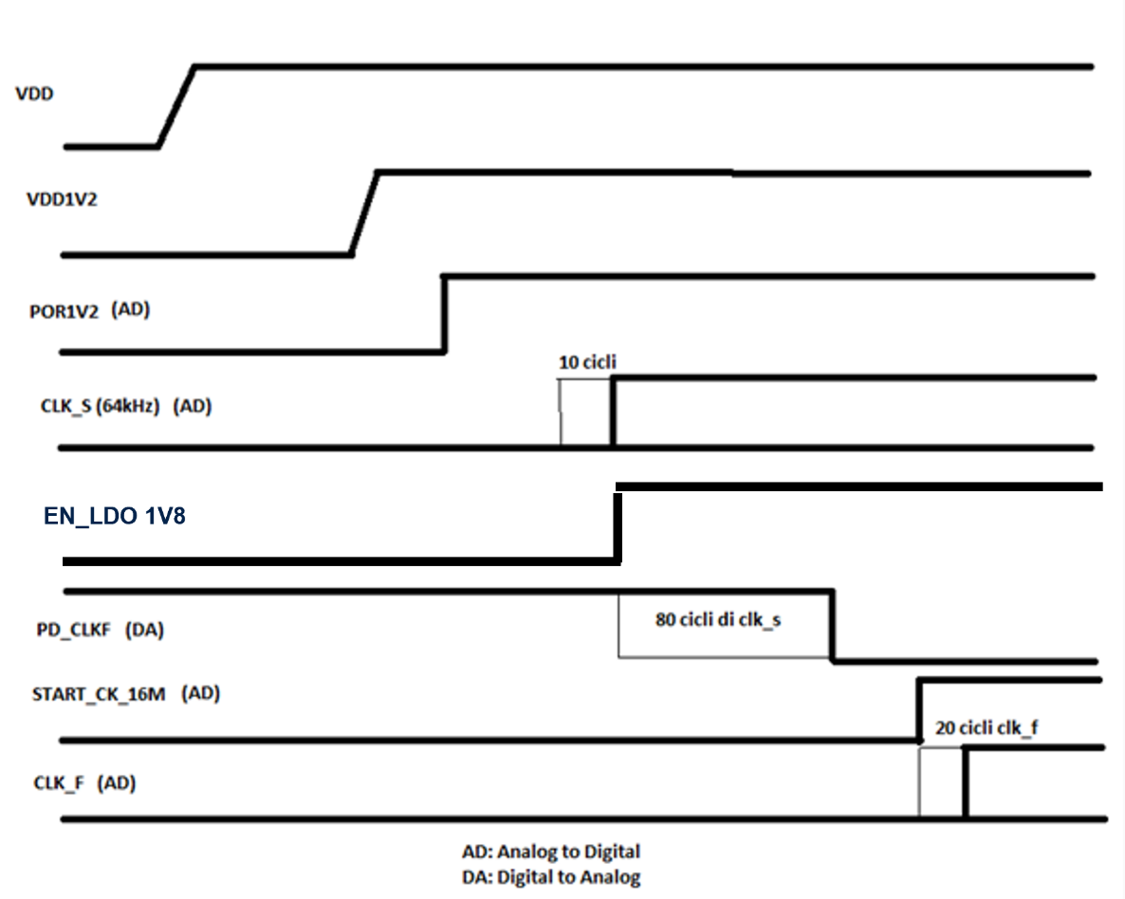
Figure 7: Device Start-Up Phase

[DDS_STBIO1_0102] Definition:
w_EN_LDO and w_PDClockF are as follows:

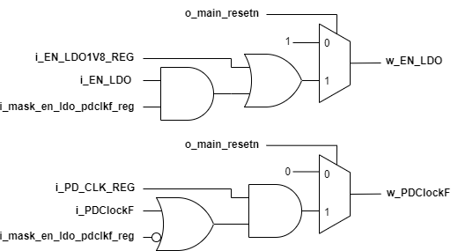
Figure 8: Mask Cell for LDO and Fast Ring Oscillator

w_EN_LDO_sync32 and w_PDClockF_sync32 are the relative 32kHz synchronized versions. [TO: IPOS_PMU] [END]

[DDS_STBIO1_0103] Definition:
clk_64k_divided (32kHz) is i_clk_64k (64kHz) divided by two. [TO: IPOS_PMU] [END]

[DDS_STBIO1_0104] Requirement:
When the device is turned on, i_POR1V2_1V2 shall be high. [TO: IPOS_PMU] [END]

[DDS_STBIO1_0105] Requirement:
When i_POR1V2_1V2 is low, o_ EN_LDO1V8 shall be low. [TO: IPOS_PMU] [END]
[DDS_STBIO1_0106] Requirement:
When i_POR1V2_1V2 is low, o_PD_CLKF shall be high. [TO: IPOS_PMU] [END]

[DDS_STBIO1_0107] Requirement:
When i_POR1V2_1V2 is low, o_CLK_16M_READY shall be low. [TO: IPOS_PMU] [END]

[DDS_STBIO1_0108] Requirement:
When i_POR1V2_1V2 is low, o_DIS_RC_VIREF shall be high. [TO: IPOS_PMU] [END]

[DDS_STBIO1_0109] Requirement:
When i_POR1V2_1V2 rises, after at least 10 cycles of i_clk_64k (64kHz), o_ EN_LDO1V8 shall be high and the clk_64k_divided is considered stable. [TO: IPOS_PMU] [END]

[DDS_STBIO1_0110] Requirement:
When clk_64k_divided is stable, after at least 352 cycles of clk_64k_divided (32kHz), o_DIS_RC_VIREF shall be low. [TO: IPOS_PMU] [END]

[DDS_STBIO1_0111] Requirement:
When i_mask_en_ldo_pdclkf_reg and o_EN_LDO1V8 are set to 1, o_PD_CLKF shall be low after at least 40 cycles of the clk_64k_divided. [TO: IPOS_PMU] [END]

[DDS_STBIO1_0112] Requirement:
When i_START_CLK_16M is high, after at least 20 cycles of i_clk_16M (16MHz), o_CLK_16M_READY shall be high. [TO: IPOS_PMU] [END]

[DDS_STBIO1_0113] Requirement:
When i_START_CLK_16M is high for the first time, after at least 20 cycles of i_clk_16M (16MHz), o_main_resetn shall be high. [TO: IPOS_PMU] [END]

Clocks and Reset

Clocks scheme is shown in the below figure
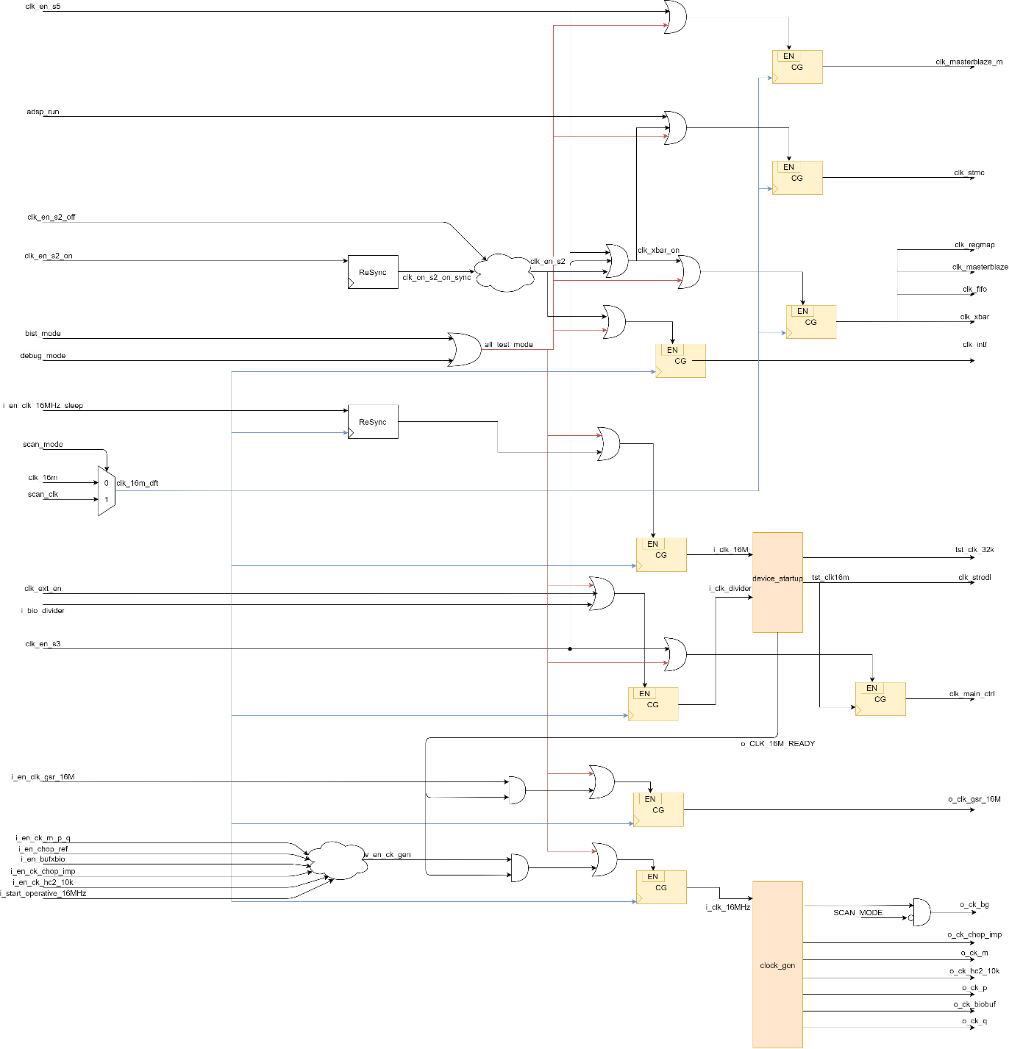
Figure 9: Clocks Scheme
Clocks scheme is shown in the above figure
Req_ID | Source | Target | Path Delay | Clock Gating | Analog Control and Description | F Max
Requirements |  |  |  |  | Definition
DDS_STBIO1_1020 | stbio1_top.clk_16m | stbio1_top.dig_wrapper_LV.u_pmu.clk_16m |  | No | Pwr_down controlled by pmu | 16 MHz
DDS_STBIO1_1021 | stbio1_top.clk_64k | stbio1_top.dig_wrapper_LV.u_pmu.clk_64k |  | No | No | 64 kHz
DDS_STBIO1_1027 | stbio1_top.dig_wrapper_LV.u_pmu.tst_clk_32k | stbio1_top.dig_wrapper_LV.u_main_controller_top.i_clk_32kHz |  | No | No | 32 kHz
DDS_STBIO1_1022 | stbio1_top.dig_wrapper_LV.u_pmu.clk_16m_dft | stbio1_top.dig_wrapper_LV.u_ADSP.stmc_clk | 1 | stbio1_top.dig_wrapper_LV.u_pmu.adsp_run | stbio1_top.dig_wrapper_LV.u_pmu.all_test_mode | ~stbio1_top.dig_wrapper_LV.u_pad_mux.scan_enable | No | 16 MHz
DDS_STBIO1_1023 | stbio1_top.dig_wrapper_LV.u_pmu.w_sh_clk | stbio1_top.dig_wrapper_LV.u_masterblaze_ahb.sys_clk | 1 | stbio1_top.dig_wrapper_LV.u_pmu.i_en_sh_clk | stbio1_top.dig_wrapper_LV.u_pmu.all_test_mode | ~stbio1_top.dig_wrapper_LV.u_pad_mux.scan_enable | No | 16 MHz
DDS_STBIO1_1024 | stbio1_top.dig_wrapper_LV.u_pmu.clk_16m_dft | stbio1_top.dig_wrapper_LV.u_xbar_afe.hclk | 1 | stbio1_top.dig_wrapper_LV.u_pmu.clk_xbar_en | stbio1_top.dig_wrapper_LV.u_pmu.all_test_mode | ~stbio1_top.dig_wrapper_LV.u_pad_mux.scan_enable | No | 16 MHz
DDS_STBIO1_2024 | stbio1_top.dig_wrapper_LV.u_pmuclk_xbar | stbio1_top.dig_wrapper_LV.u.fifo.HCLK | 1 | stbio1_top.dig_wrapper_LV.u_pmu.clk_en_m2 | stbio1_top.dig_wrapper_LV.u_pmu.all_test_mode | stbio1_top.dig_wrapper_LV.u_pmu.clk_en_m2_reg | ~stbio1_top.dig_wrapper_LV.u_pad_mux.scan_enable | No | 16 MHz
DDS_STBIO1_2025 | stbio1_top.dig_wrapper_LV.u_pmu.clk_stredl | stbio1_top.dig_wrapper_LV.u_ispu.clk |  | No | Pwr_down controlled by pmu | 16 MHz
DDS_STBIO1_2026 | stbio1_top.dig_wrapper_LV.u_pmu.clk_xbar | stbio1_top.dig_wrapper_LV.u_regmap_otp.hclk | 1 | stbio1_top.dig_wrapper_LV.u_pmu.clk_en_m3 | stbio1_top.dig_wrapper_LV.u_pmu.all_test_mode | stbio1_top.dig_wrapper_LV.u_pmu.clk_en_m3_reg | stbio1_top.dig_wrapper_LV.u_pmu.clk_en_s3 | ~stbio1_top.dig_wrapper_LV.u_pad_mux.scan_enable | No | 16 MHz
DDS_STBIO1_1025 | u_stbio1_top.u_pmu.u_device_startup.tst_clk_32k | stbio1_top.dig_wrapper_LV.tst_clk_32k |  | No | No | 32 kHz
DDS_STBIO1_1026 | stbio1_top.dig_wrapper_LV.u_pmu.tst_clk_16m | stbio1_top.dig_wrapper_LV.u_main_controller_top.i_clk_16MHz | 1 | stbio1_top.dig_wrapper_LV.u_pmu.i_en_clk_16MHz_sleep | stbio1_top.dig_wrapper_LV.u_pmu.scan_mode | ~stbio1_top.dig_wrapper_LV.u_pad_mux.scan_enable | No | 16 MHz
Table 11: Clock Recap Table

Reset scheme is shown in the below figure

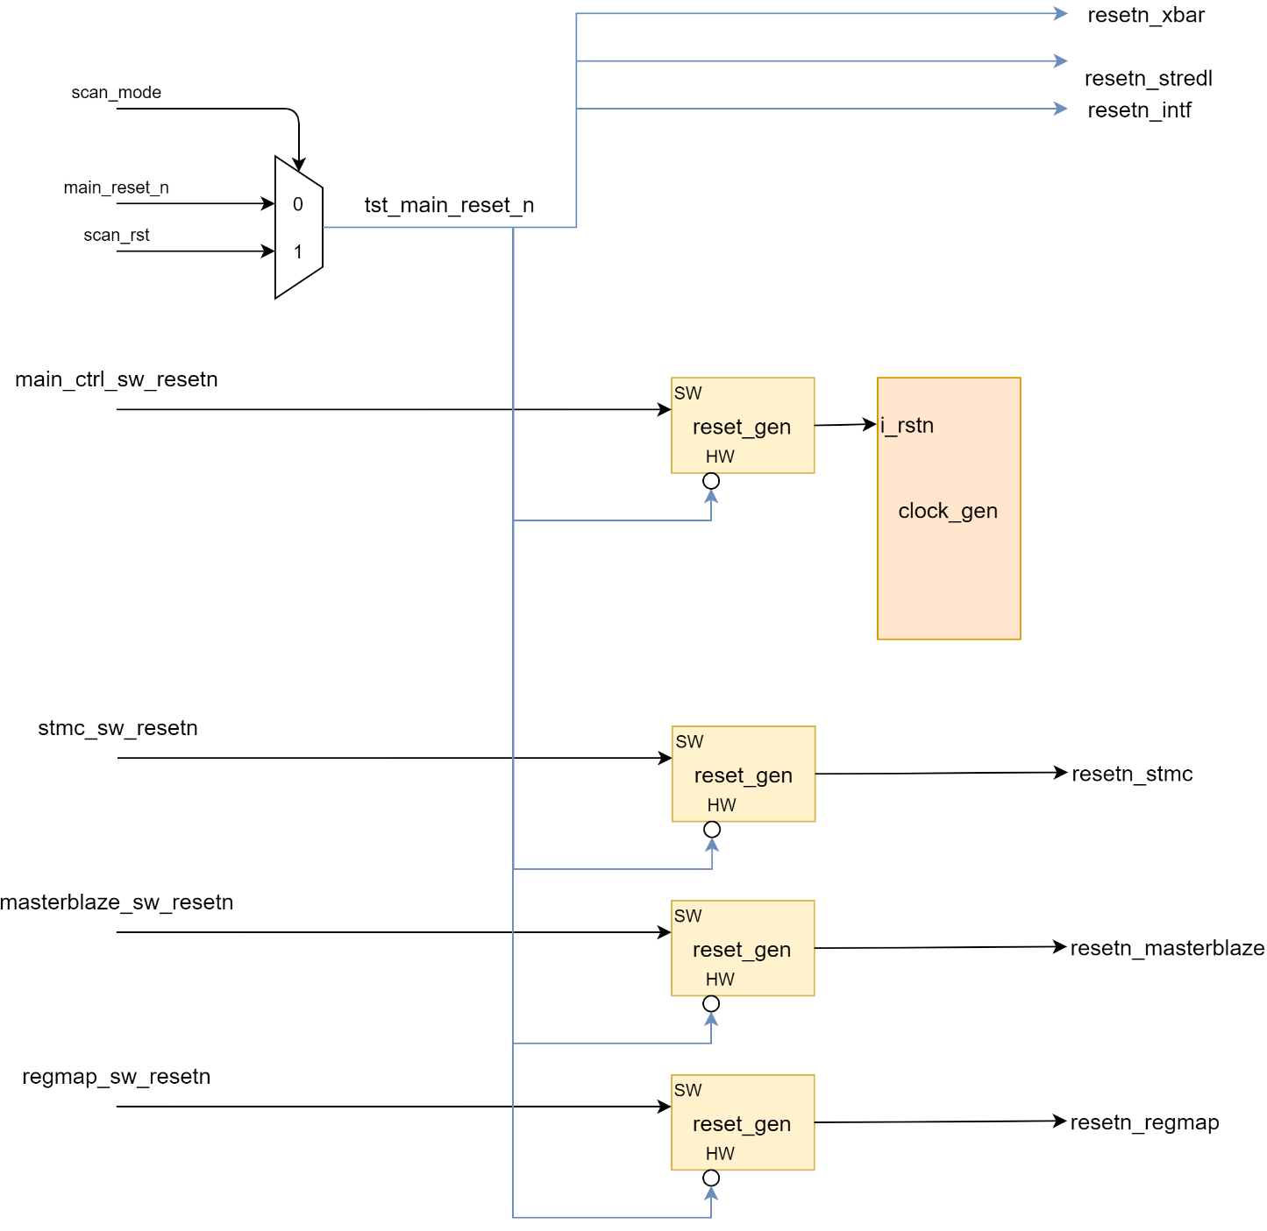
Figure 10: STBIO1 Reset Scheme
Req_ID | Source | Target
DDS_STBIO1_1050 | u_stbio1_top.dig_wrapper_LV.u_pmu.resetn_stmc | u_stbio1_top.dig_wrapper_LV.u_ADSP.HRESETn
DDS_STBIO1_1051 | u_stbio1_top.dig_wrapper_LV.u_pmu.resetn_masterblaze | u_stbio1_top.dig_wrapper_LV.u_masterblaze_ahb.HRESETn
DDS_STBIO1_1052 | u_stbio1_top.dig_wrapper_LV.u_pmu.resetn_regmap | u_stbio1_top.dig_wrapper_LV.u_regmap_otp.hresetn
DDS_STBIO1_2052 | stbio1_top.dig_wrapper_LV.u_pmu.u_device_startup.u_por_main_resetn.RST_N_FF[0] | u_stbio1_top.dig_wrapper_LV.u_xbar_afe.hresetn
DDS_STBIO1_2053 | u_stbio1_top.dig_wrapper_LV.u_pmu.resetn_regmap | u_stbio1_top.dig_wrapper_LV.u_ispu.main_rst_n
DDS_STBIO1_1053 | u_stbio1_top.dig_wrapper_LV.u_pmu.resetn_fifo | u_stbio1_top.dig_wrapper_LV.u_multi_channel_fifo_top.HRESETn
DDS_STBIO1_1054 | u_stbio1_top.dig_wrapper_LV.u_pmu.resetn_main_ctrl | u_stbio1_top.dig_wrapper_LV.u_main_controller_top.i_rstn
DDS_STBIO1_2054 | u_stbio1_top.dig_wrapper_LV.u_pmu.resetn_32k_main_ctrl | u_stbio1_top.dig_wrapper_LV.u_main_controller_top.i_rstn_sync_32

Table 12: STBIO1 Functional reset Summary table

PAD Mux
In the following table are reported the Pad Configuration for each operative mode of the device. The
BIST Mode, Scan Mode and Debug Mode are reserved for ST Testing Purpose

PAD MUX TOP I/O List
Port name | Direction | Type | Description
i_write_protection_en | input |  | write_protection_en OTP regmap enable from regmap
o_write_protection_en | output |  | write_protection_en OTP regmap enable to regmap
i_tap_bist_mode | input |  | bist_mode signal used retun in functional mode
i_EN_0P05HP_ECG0 | input |  | bit enable select PDRES 05 ECG0 channel
i_EN_0P05HP_ECG12 | input |  | bit enable select PDRES 05 ECG12 channel
IMPQ_PSDRES_UP_02 | input | [2:0] | OTP value for Analog block
IMPQ_PSDRES_DOWN_02 | input | [2:0] | OTP value for Analog block
IMPP_PSDRES_UP_02 | input | [2:0] | OTP value for Analog block
IMPP_PSDRES_DOWN_02 | input | [2:0] | OTP value for Analog block
ECG_PSDRES_DOWN_02 | input | [2:0] | OTP value for Analog block
ECG_PSDRES_UP_02 | input | [2:0] | OTP value for Analog block
IMPQ_PSDRES_UP_05 | input | [2:0] | OTP value for Analog block
IMPQ_PSDRES_DOWN_05 | input | [2:0] | OTP value for Analog block
IMPP_PSDRES_UP_05 | input | [2:0] | OTP value for Analog block
IMPP_PSDRES_DOWN_05 | input | [2:0] | OTP value for Analog block
ECG_PSDRES_DOWN_05 | input | [2:0] | OTP value for Analog block
ECG_PSDRES_UP_05 | input | [2:0] | OTP value for Analog block
IMPQ_PSDRES_UP | output | [2:0] | OTP value for Analog block
IMPQ_PSDRES_DOWN | output | [2:0] | OTP value for Analog block
IMPP_PSDRES_UP | output | [2:0] | OTP value for Analog block
IMPP_PSDRES_DOWN | output | [2:0] | OTP value for Analog block
ECG_PSDRES_DOWN | output | [2:0] | OTP value for Analog block
ECG_PSDRES_UP | output | [2:0] | OTP value for Analog block
i_TS_IRQ_ST | input |  | time slot irq
i_DCCK_IRQ_ST | input |  | DCCK irq change status
o_en_tx_1V2 | input |  | input to LED pilot
o_tx_preset_1V2 | input |  | input to LED pilot
o_tx1_outlab_sel_frame_x_1V2 | input |  | input to LED pilot
sel_irq_gpio1 | input | [3:0] | sel irq gpi1 {000:NC, 001:i_fifo_irq, 010:i_LED_Pilot, 011:i_DCCK_irq, 100:i_error_time_slot, 101:i_time_slot_irq}
sel_irq_gpio2 | input | [3:0] | sel irq gpi2 {000:NC, 001:i_fifo_irq, 010:i_LED_Pilot, 011:i_DCCK_irq, 100:i_error_time_slot, 101:i_time_slot_irq}
sel_irq_gpio3 | input | [3:0] | sel irq gpi3 {000:NC, 001:i_fifo_irq, 010:i_LED_Pilot, 011:i_DCCK_irq, 100:i_error_time_slot, 101:i_time_slot_irq}
sel_irq_gpio4 | input | [3:0] | sel irq gpi4 {000:NC, 001:i_fifo_irq, 010:i_LED_Pilot, 011:i_DCCK_irq, 100:i_error_time_slot, 101:i_time_slot_irq}
DCCK_P_en | input |  | Manages lead off mode DCCK_P, Source: Regmap
DCCK_N_en | input |  | Manages lead off mode DCCK_P, Source: Regmap
MODE_OPERATION | input |  | Start Divice operations status
o_pd_p | output |  | enable lead off mode DCCK_P, Destination:Analog block
o_pd_n | output |  | enable lead off mode DCCK_N, Destination:Analog block
O_DCCK_P_i | input |  | status lead off mode DCCK_P {0:low impedance,1:floating electrode}, Source: Analog block
O_DCCK_N_i | input |  | status lead off mode DCCK_N {0:low impedance,1:floating electrode}, Source: Analog block
if_gpio1_in_reg | output |  | ZI value from regmap
if_gpio1_en_reg | input |  | EN value from regmap
if_gpio1_out_reg | input |  | OUT value from regmap
if_gpio2_in_reg | output |  | ZI value from regmap// ZI
if_gpio2_en_reg | input |  | EN value from regmap
if_gpio2_out_reg | input |  | OUT value from regmap
if_gpio3_in_reg | output |  | ZI value from regmap
if_gpio3_en_reg | input |  | EN value from regmap
if_gpio3_out_reg | input |  | OUT value from regmap
if_gpio4_in_reg | output |  | ZI value from regmap
if_gpio4_en_reg | input |  | EN value from regmap
if_gpio4_out_reg | input |  | OUT value from regmap
o_ext_reg_dt_afe | input | [7:0] | i2c/spi read data u_regmap_otp
o_ext_reg_dt | output | [7:0] | i2c/spi read data output
i_ext_reg_add | input | [7:0] | i2c/spi address
i_ext_reg_dt | input | [7:0] | i2c/spi write data
i_ext_reg_ck_wr | input |  | i2c/spi clk
i_ext_reg_we | input |  | i2c/spi regmap direct write enable
if_sclk_in | input |  | ZI_I2C
if_sclk_i3c_in | input |  | ZI_I3C
if_sclk_out | output |  | A
if_sclk_en | output |  | EN
if_sclk_tud | output |  | TUD
if_sda_sdi_in | input |  | ZI_I2C
if_sda_sdi_i3c_in | input |  | ZI_I3C
if_sda_sdi_out | output |  | A
if_sda_sdi_en | output |  | EN
if_sda_sdi_tud | output |  | TUD
if_cs_in | input |  | ZI CS
if_cs_out | output |  | A
if_cs_en | output |  | EN
if_cs_tud | output |  | TUD
if_gpio0_in | input |  | ZI GPIO0
if_gpio0_out | output |  | A
if_gpio0_en | output |  | EN
if_gpio0_tud | output |  | TUD
if_gpio1_in | input |  | ZI GPIO1
if_gpio1_out | output |  | A
if_gpio1_en | output |  | EN
if_gpio1_tud | output |  | TUD
if_gpio2_in | input |  | ZI GPIO2
if_gpio2_out | output |  | A
if_gpio2_en | output |  | EN
if_gpio2_tud | output |  | TUD
if_gpio3_in | input |  | ZI GPIO3
if_gpio3_out | output |  | A
if_gpio3_en | output |  | EN
if_gpio3_tud | output |  | TUD
if_gpio4_in | input |  | ZI GPIO4
if_gpio4_out | output |  | A
if_gpio4_en | output |  | EN
if_gpio4_tud | output |  | TUD
if_sh_ck_in | input |  | ZI sensor hub ck
if_sh_ck_out | output |  | A
if_sh_ck_en | output |  | EN
if_sh_ck_tud | output |  | TUD
if_sh_sda_in | input |  | ZI sensor hub SDA
if_sh_sda_out | output |  | A
if_sh_sda_en | output |  | EN
if_sh_sda_tud | output |  | TUD
POR1V2_1V2 | input |  | POR
ispu_tck | output |  | jtag clk port ispu in ispu debug mode
ispu_tdi | output |  | jtag data in port ispu in ispu debug mode
ispu_tdo | input |  | jtag data out port ispu in ispu debug mode
ispu_tdo_en | input |  | jtag en port ispu in ispu debug mode
ispu_tms | output |  | jtag state in port ispu in ispu debug mode
ispu_trst_n | output |  | jtag reset in port ispu in ispu debug mode
i_if_ck | output |  | i2c/spi clk
i_if_cs | output |  | i2c/spi cs
i_if_sda_sdi_in | output |  | i2c/spi data
o_if_cs_en_n | input |  | i2c/spi cs en from i2c/spi ip
o_if_cs_out_n | input |  | i2c/spi cs out from i2c/spi ip
o_if_cs_tud | input |  | i2c/spi cs tud from i2c/spi ip
o_if_sda_sdi_en_n | input |  | i2c/spi data en from i2c/spi ip
o_if_sda_sdi_out | input |  | i2c/spi data out from i2c/spi ip
scl_master_in | output |  | from sensorhub
scl_master_out | input |  | from sensorhub
sda_master_in | output |  | to sensorhub
sda_master_out | input |  | from sensorhub
afe_bist_ctrl_tdi | output |  | bist jtag port
afe_bist_ctrl_trstn | output |  | bist jtag port
afe_bist_ctrl_tms | output |  | bist jtag port
afe_bist_ctrl_tdo | input |  | bist jtag port
afe_bist_ctrl_tdo_en_n | input |  | bist jtag port
afe_bist_ctrl_tck | output |  | bist jtag port
ck_16m | input |  | clk16MHz trimming in debug mode
ck_2m | input |  | clk2MHz trimming in debug mode
ck_64k | input |  | clk64MHz trimming in debug mode
scan_rstn | output |  | scan reset
scan_enable | output |  | scan enable
scan_clk | output |  | scan clock
ext_cap_en | input |  | extenal cap in debug mode
irq_fifo | input |  | fifo irq from main controller - regmap
error_time_slot | input |  | error timeslot from error time slot
gpio_in | output |  | gpio0 in in functional mode from regmap
gpio_out | input |  | gpio0 out in functional mode from regmap
gpio_en | input |  | gpio0 en in functional mode from regmap
irq_SENSHUB_STS | input |  | sensorhub status
irq_ISPU_MC_INTR_STS | input |  | irq main controller data-valid
scan_mode | output |  | stbio1 scan mode
bist_mode | output |  | stbio1 bist mode
debug_mode | output |  | stbio1 debug mode
memsafe | output |  | memsafe for bist
test_clk_fast | input |  | enable test clk 16MHz trimming
test_clk_slow | input |  | enable test clk 64kHz trimming
if_sclk_tud_reg | input |  | if sclk_tud from reg
if_sda_sdi_tud_reg | input |  | if sda_sdi_tud from re
if_sh_sda_tud_reg | input |  | if sh_sda_tud from reg
if_gpio0_tud_reg | input |  | if gpio0_tud from reg
if_gpio1_tud_reg | input |  | if gpio1_tud from reg
if_gpio2_tud_reg | input |  | if gpio2_tud from reg
if_gpio3_tud_reg | input |  | if gpio3_tud from reg
if_gpio4_tud_reg | input |  | if gpio4_tud from reg
if_sh_ck_tud_reg | input |  | if sh_ck_tud from reg
clk_dft_adc | input |  | 16MHz adc dft clk
i_ADC_clk_serial_dft | input |  | serial clk for adc dft 16Mhz:Fast mode, if_sh_ck_in:Low noise mode
EN_ADC_TEST_FAST | input |  | enable adc test fast
EN_ADC_TEST_LOW_NOISE | input |  | enable adc test low noise
i_ADC_EOC | input |  | adc eoc input
i_ADC_start | input |  | adc star from main controller
i_data_ADC_out | input | [15:0] | adc data input
o_ADC_start | output |  | adc star output
i_N_clk | input | [6-1:0] | n clk start time high
i_saturation_irq | input |  | interrupt saturation from main controller
i_end_boot | input |  | end boot signal from adsp
quokka_run | input |  | status quokka elaboration 1:run 0:not elaboration
sensor_hub_status | input |  | status sensor_hob from regmap
SH_CKL_EN | input |  | sensorhub clk enable from regmap (master_end_op_clr or sleep_master_clr or ahb_master_on_clr)
i_t_force_1v2 | input |  | input force signal to IDDQ test
o_t_force_1v2 | output |  | force signal to IDDQ test
i_bfail_fifo | input |  | bist fail fifo ram
i_bfail_qk | input |  | bist fail adsp ram
i_bfail_ispu1 | input |  | bist fail ispu ram instruction mem
i_bfail_ispu2 | input |  | bist fail ispu ram data mem 1
i_bfail_ispu3 | input |  | bist fail ispu ram data mem 2
i_bfail_ispu4 | input |  | bist fail ispu ram data mem 3
i_bend | input |  | bist end signal
i_bbad | input |  | signal fail bist test
o_bypass | output |  | bypass memory signal

Table 1313: PAD MUX I/O List

Requirements
[DDS_STBIO1_300] Definition:
The operative mode is selected by a i2c/spi write on register
MODE_CONFIG | MODE_CONFIG_0 register
7 | 6 | 5 | 4 | 3 | 2 | 1 | 0
RESERVED | bypass | memsafe | ispu_debug_mode | debug_mode | bist_mode | SCAN_COMPR_EN | scan_mode
 | rw | rw | rw | rw | w | w | w

- 0xFE
- RW
- 0x00
[6] | SPIRIT parameter _clockPort_:clk_no_scan
  bypass: | SPIRIT parameter _resetPort_:reset_no_scan
[5] | SPIRIT parameter _clockPort_:clk_no_scan
  memsafe: | SPIRIT parameter _resetPort_:reset_no_scan
[4]
  ispu_debug_mode:
[3]
  debug_mode:
[2]
  bist_mode:
[1] | SPIRIT parameter _customType_:W1S  SPIRIT parameter _clockPort_:clk_no_scan
  SCAN_COMPR_EN: | SPIRIT parameter _resetPort_:reset_no_scan
[0] | SPIRIT parameter _resetPort_:reset_no_scan  SPIRIT parameter _clockPort_:clk_no_scan
  scan_mode: | SPIRIT parameter _customType_:W1S

[Vpriority High] [End]

Table 1414: PAD Configuration Table

[DDS_STBIO1_301] Assumption
It will be enabled by two consecutive writes, pag. 3 to address 0x40 to set the page and 0x00 to address 0x3E
[End]

[DDS_STBIO1_302] Requirement
If MODE_CONFIG register is 0x00 the operative mode shall be functional.
[Vpriority High] [End]

[DDS_STBIO1_303] Requirement
If MODE_CONFIG register is 0x01 the operative mode shall be SCAN.
[End]

[DDS_STBIO1_304] Requirement
If MODE_CONFIG register is 0x04 the operative mode shall be BIST.
[End]

[DDS_STBIO1_305] Requirement
If MODE_CONFIG register is 0x08 the operative mode shall be DEBUG.
[End]

[DDS_STBIO1_306] Requirement
If MODE_CONFIG register is 0x10 the operative mode shall be ISPU_DEBUG.
[Vpriority High] [End]

[DDS_STBIO1_307] Requirement
If MODE_CONFIG register is 0x20 the operative mode shall be Bist MEMSAFE mode.
[Vpriority High] [End]

[DDS_STBIO1_308] Requirement
If MODE_CONFIG register is 0x40 the operative mode shall be Bist Bypass mode.
[Vpriority High] [End]

[DDS_STBIO1_314] Requirement
In function mode, the GPIO1,2,3,4_out shall be General-Purpose if sel irq gpi1,2,3,4 is 0x00 and ext_cap_en is “0”
[Vpriority High][End]

[DDS_STBIO1_309] Requirement
In function mode, the GPIO1,2,3,4_out shall be irq_fifo if sel irq gpio1,2,3,4 is 0x01 and ext_cap_en is “0”
[Vpriority High] [End]

[DDS_STBIO1_310] Requirement
In function mode, the GPIO1,2,3,4_out shall be i_LED_Pilot if sel irq gpi1,2,3,4 is 0x02
and ext_cap_en is “0”
[Vpriority High] [End]

[DDS_STBIO1_311] Requirement
In function mode, the GPIO1,2,3,4_out shall be i_DCCK_irq if sel irq gpi1,2,3,4 is 0x03 and ext_cap_en is “0”
[Vpriority High] [End]

[DDS_STBIO1_312] Requirement
In function mode, the GPIO1,2,3,4 output shall be i_error_time_slot if sel irq gpi1,2,3,4 is 0x04 and ext_cap_en is “0”
[Vpriority High] [End]

[DDS_STBIO1_313] Requirement
In function mode, the GPIO1,2,3,4 output shall be i_time_slot_irq if sel irq gpi1,2,3,4 is 0x05 and ext_cap_en is “0”
[Vpriority High] [End]

Table 15 functional mode Static Connectivity Checks
ENABLE | SOURCE | DESTINATION | NAME
{(stbio1_top.dig_wrapper_LV.u_regmap_otp.gpio1_irq_sel == 1) && !pad_mux__path.scan_mode && (pad_mux__path.mission_mode == 1) && !pad_mux__path.ext_cap_en} | stbio1_top.dig_wrapper_LV.u_fifo.irq_FIFO_U_M_IRQ_STATUS | stbio1_top.if_gpio1_out | DDS_STBIO1_GPIO1_309
{(stbio1_top.dig_wrapper_LV.u_regmap_otp.gpio2_irq_sel == 1) && !pad_mux__path.scan_mode && (pad_mux__path.mission_mode == 1) && !pad_mux__path.ext_cap_en} | stbio1_top.dig_wrapper_LV.u_fifo.irq_FIFO_U_M_IRQ_STATUS | stbio1_top.if_gpio2_out | DDS_STBIO1_GPIO2_309
{(stbio1_top.dig_wrapper_LV.u_regmap_otp.gpio3_irq_sel == 1) && !pad_mux__path.scan_mode && (pad_mux__path.mission_mode == 1) } | stbio1_top.dig_wrapper_LV.u_fifo.irq_FIFO_U_M_IRQ_STATUS | stbio1_top.if_gpio3_out | DDS_STBIO1_GPIO3_309
{(stbio1_top.dig_wrapper_LV.u_regmap_otp.gpio4_irq_sel == 1) && !pad_mux__path.scan_mode && (pad_mux__path.mission_mode == 1)} | stbio1_top.dig_wrapper_LV.u_fifo.irq_FIFO_U_M_IRQ_STATUS | stbio1_top.if_gpio4_out | DDS_STBIO1_GPIO4_309
{(stbio1_top.dig_wrapper_LV.u_regmap_otp.gpio1_irq_sel == 1) && !pad_mux__path.scan_mode && (pad_mux__path.mission_mode == 1) && !pad_mux__path.ext_cap_en} | 1'b0 | stbio1_top.if_gpio1_en | DDS_STBIO1_GPIO1_EN_309
{(stbio1_top.dig_wrapper_LV.u_regmap_otp.gpio2_irq_sel == 1) && !pad_mux__path.scan_mode && (pad_mux__path.mission_mode == 1) && !pad_mux__path.ext_cap_en} | 1'b0 | stbio1_top.if_gpio2_en | DDS_STBIO1_GPIO2_EN_309
{(stbio1_top.dig_wrapper_LV.u_regmap_otp.gpio3_irq_sel == 1) && !pad_mux__path.scan_mode && (pad_mux__path.mission_mode == 1) } | 1'b0 | stbio1_top.if_gpio3_en | DDS_STBIO1_GPIO3_EN_309
{(stbio1_top.dig_wrapper_LV.u_regmap_otp.gpio4_irq_sel == 1) && !pad_mux__path.scan_mode && (pad_mux__path.mission_mode == 1)} | 1'b0 | stbio1_top.if_gpio4_en | DDS_STBIO1_GPIO4_EN_309
{(stbio1_top.dig_wrapper_LV.u_regmap_otp.gpio1_irq_sel == 5) && !pad_mux__path.scan_mode && (pad_mux__path.mission_mode == 1) && !pad_mux__path.ext_cap_en} | stbio1_top.dig_wrapper_LV.u_regmap_otp.irq_TS_IRQ_ST | stbio1_top.if_gpio1_out | DDS_STBIO1_GPIO1_313
{(stbio1_top.dig_wrapper_LV.u_regmap_otp.gpio1_irq_sel == 5) && !pad_mux__path.scan_mode && (pad_mux__path.mission_mode == 1) && !pad_mux__path.ext_cap_en} | 1'b0 | stbio1_top.if_gpio1_en | DDS_STBIO1_GPIO1_EN_313
{(stbio1_top.dig_wrapper_LV.u_regmap_otp.gpio2_irq_sel == 5) && !pad_mux__path.scan_mode && (pad_mux__path.mission_mode == 1) && !pad_mux__path.ext_cap_en} | stbio1_top.dig_wrapper_LV.u_regmap_otp.irq_TS_IRQ_ST | stbio1_top.if_gpio2_out | DDS_STBIO1_GPIO2_313
{(stbio1_top.dig_wrapper_LV.u_regmap_otp.gpio2_irq_sel == 5) && !pad_mux__path.scan_mode && (pad_mux__path.mission_mode == 1) && !pad_mux__path.ext_cap_en} | 1'b0 | stbio1_top.if_gpio2_en | DDS_STBIO1_GPIO2_EN_313
{(stbio1_top.dig_wrapper_LV.u_regmap_otp.gpio3_irq_sel == 5) && !pad_mux__path.scan_mode && (pad_mux__path.mission_mode == 1) } | stbio1_top.dig_wrapper_LV.u_regmap_otp.irq_TS_IRQ_ST | stbio1_top.if_gpio3_out | DDS_STBIO1_GPIO3_313
{(stbio1_top.dig_wrapper_LV.u_regmap_otp.gpio3_irq_sel == 5) && !pad_mux__path.scan_mode && (pad_mux__path.mission_mode == 1) } | 1'b0 | stbio1_top.if_gpio3_en | DDS_STBIO1_GPIO3_EN_313
{(stbio1_top.dig_wrapper_LV.u_regmap_otp.gpio4_irq_sel == 5) && !pad_mux__path.scan_mode && (pad_mux__path.mission_mode == 1)} | stbio1_top.dig_wrapper_LV.u_regmap_otp.irq_TS_IRQ_ST | stbio1_top.if_gpio4_out | DDS_STBIO1_GPIO4_313
{(stbio1_top.dig_wrapper_LV.u_regmap_otp.gpio4_irq_sel == 5) && !pad_mux__path.scan_mode && (pad_mux__path.mission_mode == 1)} | 1'b0 | stbio1_top.if_gpio4_en | DDS_STBIO1_GPIO4_EN_313
{(stbio1_top.dig_wrapper_LV.u_regmap_otp.gpio1_irq_sel == 4) && !pad_mux__path.scan_mode && (pad_mux__path.mission_mode == 1) && !pad_mux__path.ext_cap_en} | stbio1_top.dig_wrapper_LV.u_main_controller_top.o_error_time_slot | stbio1_top.if_gpio1_out | DDS_STBIO1_GPIO1_312
{(stbio1_top.dig_wrapper_LV.u_regmap_otp.gpio1_irq_sel == 4) && !pad_mux__path.scan_mode && (pad_mux__path.mission_mode == 1) && !pad_mux__path.ext_cap_en} | 1'b0 | stbio1_top.if_gpio1_en | DDS_STBIO1_GPIO1_EN_312
{(stbio1_top.dig_wrapper_LV.u_regmap_otp.gpio2_irq_sel == 4) && !pad_mux__path.scan_mode && (pad_mux__path.mission_mode == 1) && !pad_mux__path.ext_cap_en} | stbio1_top.dig_wrapper_LV.u_main_controller_top.o_error_time_slot | stbio1_top.if_gpio2_out | DDS_STBIO1_GPIO2_312
{(stbio1_top.dig_wrapper_LV.u_regmap_otp.gpio2_irq_sel == 4) && !pad_mux__path.scan_mode && (pad_mux__path.mission_mode == 1) && !pad_mux__path.ext_cap_en} | 1'b0 | stbio1_top.if_gpio2_en | DDS_STBIO1_GPIO2_EN_312
{(stbio1_top.dig_wrapper_LV.u_regmap_otp.gpio3_irq_sel == 4) && !pad_mux__path.scan_mode && (pad_mux__path.mission_mode == 1) } | stbio1_top.dig_wrapper_LV.u_main_controller_top.o_error_time_slot | stbio1_top.if_gpio3_out | DDS_STBIO1_GPIO3_312
{(stbio1_top.dig_wrapper_LV.u_regmap_otp.gpio3_irq_sel == 4) && !pad_mux__path.scan_mode && (pad_mux__path.mission_mode == 1) } | 1'b0 | stbio1_top.if_gpio3_en | DDS_STBIO1_GPIO3_EN_312
{(stbio1_top.dig_wrapper_LV.u_regmap_otp.gpio4_irq_sel == 4) && !pad_mux__path.scan_mode && (pad_mux__path.mission_mode == 1)} | stbio1_top.dig_wrapper_LV.u_main_controller_top.o_error_time_slot | stbio1_top.if_gpio4_out | DDS_STBIO1_GPIO4_312
{(stbio1_top.dig_wrapper_LV.u_regmap_otp.gpio4_irq_sel == 4) && !pad_mux__path.scan_mode && (pad_mux__path.mission_mode == 1)} | 1'b0 | stbio1_top.if_gpio4_en | DDS_STBIO1_GPIO4_EN_312
{(stbio1_top.dig_wrapper_LV.u_regmap_otp.gpio1_irq_sel == 2) && !pad_mux__path.scan_mode && (pad_mux__path.mission_mode == 1) && !pad_mux__path.ext_cap_en} | stbio1_top.dig_wrapper_LV.u_main_controller_top.o_en_tx & stbio1_top.dig_wrapper_LV.u_main_controller_top.o_tx_preset & stbio1_top.dig_wrapper_LV.u_main_controller_top.o_tx1_outlab_sel_frame_x | stbio1_top.if_gpio1_out | DDS_STBIO1_GPIO1_310
{(stbio1_top.dig_wrapper_LV.u_regmap_otp.gpio1_irq_sel == 2) && !pad_mux__path.scan_mode && (pad_mux__path.mission_mode == 1) && !pad_mux__path.ext_cap_en} | 1'b0 | stbio1_top.if_gpio1_en | DDS_STBIO1_GPIO1_EN_310
{(stbio1_top.dig_wrapper_LV.u_regmap_otp.gpio2_irq_sel == 2) && !pad_mux__path.scan_mode && (pad_mux__path.mission_mode == 1) && !pad_mux__path.ext_cap_en} | stbio1_top.dig_wrapper_LV.u_main_controller_top.o_en_tx & stbio1_top.dig_wrapper_LV.u_main_controller_top.o_tx_preset & stbio1_top.dig_wrapper_LV.u_main_controller_top.o_tx1_outlab_sel_frame_x | stbio1_top.if_gpio2_out | DDS_STBIO1_GPIO2_310
{(stbio1_top.dig_wrapper_LV.u_regmap_otp.gpio2_irq_sel == 2) && !pad_mux__path.scan_mode && (pad_mux__path.mission_mode == 1) && !pad_mux__path.ext_cap_en} | 1'b0 | stbio1_top.if_gpio2_en | DDS_STBIO1_GPIO2_EN_310
{(stbio1_top.dig_wrapper_LV.u_regmap_otp.gpio3_irq_sel == 2) && !pad_mux__path.scan_mode && (pad_mux__path.mission_mode == 1) } | stbio1_top.dig_wrapper_LV.u_main_controller_top.o_en_tx & stbio1_top.dig_wrapper_LV.u_main_controller_top.o_tx_preset & stbio1_top.dig_wrapper_LV.u_main_controller_top.o_tx1_outlab_sel_frame_x | stbio1_top.if_gpio3_out | DDS_STBIO1_GPIO3_310
{(stbio1_top.dig_wrapper_LV.u_regmap_otp.gpio3_irq_sel == 2) && !pad_mux__path.scan_mode && (pad_mux__path.mission_mode == 1) } | 1'b0 | stbio1_top.if_gpio3_en | DDS_STBIO1_GPIO3_EN_310
{(stbio1_top.dig_wrapper_LV.u_regmap_otp.gpio4_irq_sel == 2) && !pad_mux__path.scan_mode && (pad_mux__path.mission_mode == 1)} | stbio1_top.dig_wrapper_LV.u_main_controller_top.o_en_tx & stbio1_top.dig_wrapper_LV.u_main_controller_top.o_tx_preset & stbio1_top.dig_wrapper_LV.u_main_controller_top.o_tx1_outlab_sel_frame_x | stbio1_top.if_gpio4_out | DDS_STBIO1_GPIO4_310
{(stbio1_top.dig_wrapper_LV.u_regmap_otp.gpio4_irq_sel == 2) && !pad_mux__path.scan_mode && (pad_mux__path.mission_mode == 1)} | 1'b0 | stbio1_top.if_gpio4_en | DDS_STBIO1_GPIO4_EN_310
{(stbio1_top.dig_wrapper_LV.u_regmap_otp.gpio1_irq_sel == 3) && !pad_mux__path.scan_mode && (pad_mux__path.mission_mode == 1) && !pad_mux__path.ext_cap_en} | stbio1_top.dig_wrapper_LV.u_regmap_otp.irq_DCCK_IRQ_ST | stbio1_top.if_gpio1_out | DDS_STBIO1_GPIO1_311
{(stbio1_top.dig_wrapper_LV.u_regmap_otp.gpio1_irq_sel == 3) && !pad_mux__path.scan_mode && (pad_mux__path.mission_mode == 1) && !pad_mux__path.ext_cap_en} | 1'b0 | stbio1_top.if_gpio1_en | DDS_STBIO1_GPIO1_EN_311
{(stbio1_top.dig_wrapper_LV.u_regmap_otp.gpio2_irq_sel == 3) && !pad_mux__path.scan_mode && (pad_mux__path.mission_mode == 1) && !pad_mux__path.ext_cap_en} | stbio1_top.dig_wrapper_LV.u_regmap_otp.irq_DCCK_IRQ_ST | stbio1_top.if_gpio2_out | DDS_STBIO1_GPIO2_311
{(stbio1_top.dig_wrapper_LV.u_regmap_otp.gpio2_irq_sel == 3) && !pad_mux__path.scan_mode && (pad_mux__path.mission_mode == 1) && !pad_mux__path.ext_cap_en} | 1'b0 | stbio1_top.if_gpio2_en | DDS_STBIO1_GPIO2_EN_311
{(stbio1_top.dig_wrapper_LV.u_regmap_otp.gpio3_irq_sel == 3) && !pad_mux__path.scan_mode && (pad_mux__path.mission_mode == 1) } | stbio1_top.dig_wrapper_LV.u_regmap_otp.irq_DCCK_IRQ_ST | stbio1_top.if_gpio3_out | DDS_STBIO1_GPIO3_311
{(stbio1_top.dig_wrapper_LV.u_regmap_otp.gpio3_irq_sel == 3) && !pad_mux__path.scan_mode && (pad_mux__path.mission_mode == 1) } | 1'b0 | stbio1_top.if_gpio3_en | DDS_STBIO1_GPIO3_EN_311
{(stbio1_top.dig_wrapper_LV.u_regmap_otp.gpio4_irq_sel == 3) && !pad_mux__path.scan_mode && (pad_mux__path.mission_mode == 1)} | stbio1_top.dig_wrapper_LV.u_regmap_otp.irq_DCCK_IRQ_ST | stbio1_top.if_gpio4_out | DDS_STBIO1_GPIO4_311
{(stbio1_top.dig_wrapper_LV.u_regmap_otp.gpio4_irq_sel == 3) && !pad_mux__path.scan_mode && (pad_mux__path.mission_mode == 1)} | 1'b0 | stbio1_top.if_gpio4_en | DDS_STBIO1_GPIO4_EN_311
{ !pad_mux__path.scan_mode && (pad_mux__path.mission_mode == 1) && pad_mux__path.ext_cap_en} | stbio1_top.dig_wrapper_LV.u_fifo.irq_FIFO_U_M_IRQ_STATUS | stbio1_top.dig_wrapper_LV.u_main_controller_top.o_error_time_slot | stbio1_top.if_gpio0_out | DDS_STBIO1_GPIO0_EXT_CAP_315
{ !pad_mux__path.scan_mode && (pad_mux__path.mission_mode == 1) && pad_mux__path.ext_cap_en} | 1'b0 | stbio1_top.if_gpio0_en | DDS_STBIO1_GPIO0_EN_EXT_CAP_315
{ !pad_mux__path.scan_mode && (pad_mux__path.mission_mode == 1) && pad_mux__path.ext_cap_en} | 1'b1 | stbio1_top.if_gpio1_en | DDS_STBIO1_GPIO1_EN_EXT_CAP_315
{ !pad_mux__path.scan_mode && (pad_mux__path.mission_mode == 1) && pad_mux__path.ext_cap_en} | 1'b1 | stbio1_top.if_gpio2_en | DDS_STBIO1_GPIO2_EN_EXT_CAP_315
{ !pad_mux__path.scan_mode && ((pad_mux__path.mission_mode == 1) || pad_mux__path.debug_mode || pad_mux__path.ispu_debug_mode) } | stbio1_top.if_cs_in | stbio1_top.dig_wrapper_LV.u_i2c_spi_slave.i_if_cs | DDS_STBIO1_CS_316
{ !pad_mux__path.scan_mode && ((pad_mux__path.mission_mode == 1) || pad_mux__path.debug_mode || pad_mux__path.ispu_debug_mode) } | !stbio1_top.dig_wrapper_LV.u_i2c_spi_slave.o_if_cs_en_n | stbio1_top.if_cs_en | DDS_STBIO1_CS_EN_316
{ !pad_mux__path.scan_mode && ((pad_mux__path.mission_mode == 1) || pad_mux__path.debug_mode || pad_mux__path.ispu_debug_mode) } | !stbio1_top.dig_wrapper_LV.u_i2c_spi_slave.o_if_cs_out_n | stbio1_top.if_cs_out | DDS_STBIO1_CS_OUT_316
{ !pad_mux__path.scan_mode && ((pad_mux__path.mission_mode == 1) || pad_mux__path.ispu_debug_mode) && stbio1_top.dig_wrapper_LV.u_regmap_otp.SH_CKL_EN } | stbio1_top.dig_wrapper_LV.u_masterblaze_ahb.sda_master_out | stbio1_top.if_sh_sda_en | DDS_STBIO1_SH_SDA_EN_317
{ !pad_mux__path.scan_mode && !pad_mux__path.w_bist_mode && !pad_mux__path.debug_mode} | 1'b0 | stbio1_top.if_sh_sda_out | DDS_STBIO1_SH_SDA_OUT_317
{ !pad_mux__path.scan_mode && ((pad_mux__path.mission_mode == 1) || pad_mux__path.ispu_debug_mode)} | stbio1_top.if_sh_sda_in | stbio1_top.dig_wrapper_LV.u_masterblaze_ahb.sda_master_in | DDS_STBIO1_SH_SDA_IN_317
{ !pad_mux__path.scan_mode && ((pad_mux__path.mission_mode == 1) || pad_mux__path.ispu_debug_mode) && stbio1_top.dig_wrapper_LV.u_regmap_otp.SH_CKL_EN } | stbio1_top.dig_wrapper_LV.u_masterblaze_ahb.scl_master_out | stbio1_top.if_sh_ck_en | DDS_STBIO1_SH_SCL_EN_317
{ !pad_mux__path.scan_mode && !pad_mux__path.w_bist_mode && !pad_mux__path.debug_mode} | 1'b0 | stbio1_top.if_sh_ck_out | DDS_STBIO1_SH_SCL_OUT_317
{ !pad_mux__path.scan_mode && ((pad_mux__path.mission_mode == 1) || pad_mux__path.ispu_debug_mode)} | stbio1_top.if_sh_ck_in | stbio1_top.dig_wrapper_LV.u_masterblaze_ahb.scl_master_in | DDS_STBIO1_SH_SCL_IN_317
{(stbio1_top.dig_wrapper_LV.u_regmap_otp.gpio1_irq_sel == 0) && !pad_mux__path.scan_mode && (pad_mux__path.mission_mode == 1) && !pad_mux__path.ext_cap_en} | stbio1_top.dig_wrapper_LV.u_regmap_otp.gpio1_out | stbio1_top.if_gpio1_out | DDS_STBIO1_GPIO1_314
{(stbio1_top.dig_wrapper_LV.u_regmap_otp.gpio1_irq_sel == 0) && !pad_mux__path.scan_mode && (pad_mux__path.mission_mode == 1) && !pad_mux__path.ext_cap_en} | stbio1_top.dig_wrapper_LV.u_regmap_otp.gpio1_en | stbio1_top.if_gpio1_en | DDS_STBIO1_GPIO1_EN_314
{(stbio1_top.dig_wrapper_LV.u_regmap_otp.gpio1_irq_sel == 0) && !pad_mux__path.scan_mode && (pad_mux__path.mission_mode == 1) && !pad_mux__path.ext_cap_en} | stbio1_top.if_gpio1_in | stbio1_top.dig_wrapper_LV.u_regmap_otp.gpio1_in_i | DDS_STBIO1_GPIO1_IN_314
{(stbio1_top.dig_wrapper_LV.u_regmap_otp.gpio2_irq_sel == 0) && !pad_mux__path.scan_mode && (pad_mux__path.mission_mode == 1) && !pad_mux__path.ext_cap_en} | stbio1_top.dig_wrapper_LV.u_regmap_otp.gpio2_out | stbio1_top.if_gpio2_out | DDS_STBIO1_GPIO2_314
{(stbio1_top.dig_wrapper_LV.u_regmap_otp.gpio2_irq_sel == 0) && !pad_mux__path.scan_mode && (pad_mux__path.mission_mode == 1) && !pad_mux__path.ext_cap_en} | stbio1_top.dig_wrapper_LV.u_regmap_otp.gpio2_en | stbio1_top.if_gpio2_en | DDS_STBIO1_GPIO2_EN_314
{(stbio1_top.dig_wrapper_LV.u_regmap_otp.gpio2_irq_sel == 0) && !pad_mux__path.scan_mode && (pad_mux__path.mission_mode == 1) && !pad_mux__path.ext_cap_en} | stbio1_top.if_gpio2_in | stbio1_top.dig_wrapper_LV.u_regmap_otp.gpio2_in_i | DDS_STBIO1_GPIO2_IN_314
{(stbio1_top.dig_wrapper_LV.u_regmap_otp.gpio3_irq_sel == 0) && !pad_mux__path.scan_mode && (pad_mux__path.mission_mode == 1) } | stbio1_top.dig_wrapper_LV.u_regmap_otp.gpio3_out | stbio1_top.if_gpio3_out | DDS_STBIO1_GPIO3_314
{(stbio1_top.dig_wrapper_LV.u_regmap_otp.gpio3_irq_sel == 0) && !pad_mux__path.scan_mode && (pad_mux__path.mission_mode == 1) } | stbio1_top.dig_wrapper_LV.u_regmap_otp.gpio3_en | stbio1_top.if_gpio3_en | DDS_STBIO1_GPIO3_EN_314
{(stbio1_top.dig_wrapper_LV.u_regmap_otp.gpio3_irq_sel == 0) && !pad_mux__path.scan_mode && (pad_mux__path.mission_mode == 1) } | stbio1_top.if_gpio3_in | stbio1_top.dig_wrapper_LV.u_regmap_otp.gpio3_in_i | DDS_STBIO1_GPIO3_IN_314
{(stbio1_top.dig_wrapper_LV.u_regmap_otp.gpio4_irq_sel == 0) && !pad_mux__path.scan_mode && (pad_mux__path.mission_mode == 1)} | stbio1_top.dig_wrapper_LV.u_regmap_otp.gpio4_out | stbio1_top.if_gpio4_out | DDS_STBIO1_GPIO4_314
{(stbio1_top.dig_wrapper_LV.u_regmap_otp.gpio4_irq_sel == 0) && !pad_mux__path.scan_mode && (pad_mux__path.mission_mode == 1)} | stbio1_top.dig_wrapper_LV.u_regmap_otp.gpio4_en | stbio1_top.if_gpio4_en | DDS_STBIO1_GPIO4_EN_314
{(stbio1_top.dig_wrapper_LV.u_regmap_otp.gpio4_irq_sel == 0) && !pad_mux__path.scan_mode && (pad_mux__path.mission_mode == 1)} | stbio1_top.if_gpio4_in | stbio1_top.dig_wrapper_LV.u_regmap_otp.gpio4_in_i | DDS_STBIO1_GPIO4_IN_314
{!pad_mux__path.scan_mode && (pad_mux__path.mission_mode == 1) && !pad_mux__path.ext_cap_en} | stbio1_top.dig_wrapper_LV.u_regmap_otp.gpio0_out | stbio1_top.if_gpio0_out | DDS_STBIO1_GPIO0_318
{!pad_mux__path.scan_mode && (pad_mux__path.mission_mode == 1) && !pad_mux__path.ext_cap_en} | stbio1_top.dig_wrapper_LV.u_regmap_otp.gpio0_en | stbio1_top.if_gpio0_en | DDS_STBIO1_GPIO0_EN_318
{!pad_mux__path.scan_mode && (pad_mux__path.mission_mode == 1) && !pad_mux__path.ext_cap_en} | stbio1_top.if_gpio0_in | stbio1_top.dig_wrapper_LV.u_regmap_otp.gpio0_in_i | DDS_STBIO1_GPIO0_IN_318

DCCK Requirement
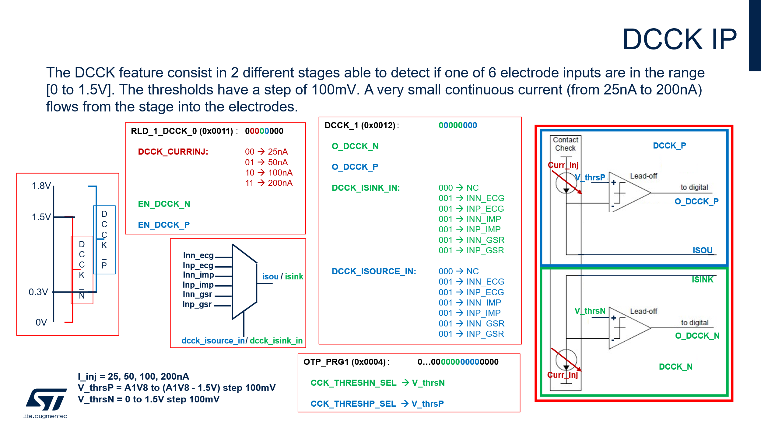

[DDS_STBIO1_390] Assumption
O_DCCK_P_i(A2D input) will be “1” in floating electrode P state else it will be “0”
[End]

DDS_STBIO1_391] Assumption
O_DCCK_N_i(A2D input) will be “1” in floating electrode N state else it will be “0”
[End]

[DDS_STBIO1_392] Requirement
If O_DCCK_P_i changes its value from '0' to '1' and DCCK_IRQ_MASK is set to '1', then irq_DCCK_IRQ_ST, output of u_regmap_otp, shall be set to '1'
[End]

[DDS_STBIO1_393] Requirement
If O_DCCK_N_i changes its value from '0' to '1' and DCCK_IRQ_MASK is set to '1', then irq_DCCK_IRQ_ST, output of u_regmap_otp, shall be set to '1'
[End]

[DDS_STBIO1_394] Requirement
If O_DCCK_P_i changes its value from '1' to '0' and DCCK_IRQ_MASK is set to '1', then irq_DCCK_IRQ_ST, output of u_regmap_otp, shall be set to '1'
[End]

[DDS_STBIO1_395] Requirement
If O_DCCK_P_i changes its value from '1’ to '0' and DCCK_IRQ_MASK is set to '1', then irq_DCCK_IRQ_ST, output of u_regmap_otp, shall be set to '1'
[End]

Main Controller TOP

Instantiations
- inst_main_controller_fsm: main_controller_fsm
- inst_configuration_register_update: configuration_register_update
- inst_ECG_S_U: ECG_S_U
- inst_BIA_S_U: BIA_S_U
- inst_ppg_fsm: ppg_fsm
- inst_Digital_ramp_case: Digital_ramp_case
- inst_ALC_compensation: ALC_compensation
- inst_ADC_phases: ADC_phases
- inst_average_block: average_block
- inst_mainctrl_ahb_master: mainctrl_ahb_master
- inst_main_controller_clock_gatin_unit: main_controller_clock_gatin_unit

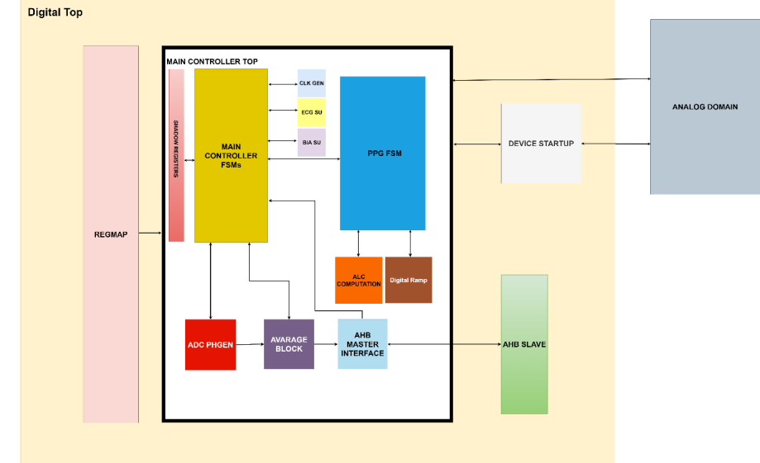
Figure 11: Main Controller Block Diagram

Main Controller TOP Description
The Main Controller is in charge of generating and receiving all the control signals for the Analog
Domain, furthermore, performs DSP elaboration on ADC Output and writes it in different Address.
The IP is divided into different sub-blocks, all at the same hierarchy level and described in the next chapter. Together with the Analog Domain, this IP is interfaced with the FIFO Controller, the ADSP and the PMU, these last two will not be described in this document. The IP is divided into different sub-blocks, all at the same hierarchy level and described in the next chapter.

Main Controller TOP I/O List

Generic name | Type | Value | Description
ppg_frame_bit_top |  | 4
n_max_frame |  | 12
ppg_rx_channel_bit_top |  | 3
T_tx_led_set_bit_top |  | 9
T_tx_led_off_max_bit_top |  | 11
m_odr_max_bit_top |  | 12
mode_operation_n_bit_top |  | 2
idac_dc_ppg_frame_bit_top |  | 6
time_slot_sel_bit_top |  | 3
T_tx_startup_bit_top |  | 8
T_rx_set_bit_top |  | 9
Nmax_bit_top |  | 4
base_address_bit_top |  | 12
delta_bit_top |  | 4
gain_max_bit_top |  | 4
T1_max_bit_top |  | 9
T2_max_bit_top |  | 5
N_clk_max_bit_top |  | 6
n_average_ppg_max_bit_top |  | 3
rx_ch_gain_max_bit_top |  | 4
BTIA_ALC_register_bit_top |  | 9
n_channel_bit_top |  | 4
n_channel_adc_bit |  | 4
quokka_routine_bit_top |  | 16
vcm_bit_top |  | 14
gnc_cmm_top |  | 15
id_frame_max_bit_top |  | 4
data_in_size_bit_top |  | 16
ppg_start_up_bit_top |  | 9
data_out_size_bit_top |  | 20
n_average_ecg_bia_gsr_max_bit_top |  | 8
rx_ch_frame_n_bit_top |  | 3
curr_sel_bit_top |  | 8
bit_outab_sel_top |  | 1
n_average_ppg_max_value |  | 128
n_average_ecg_bia_gsr_max_value |  | 16
max_frame_repetition_top |  | 2
n_tx_channel |  | 4
ahb_base_address | [31:0] | 32'h000C4000
time_buffer_const_bit_top |  | 10
T1_max_bit_from_decoder_top |  | 4
T2_max_bit_from_decoder_top |  | 2
ppg_frame_bit_ALC_BTIA_top |  | 12
ecg_channel_bit |  | 2
Table 16: Main Controller Parameter

Port name | Direction | Type | Output Reset Value | Description
i_clk_32kHz | input |  |  | clk 32kHz from pmu
i_clk_16MHz | input |  |  | clk 16MHz from pmu
i_clk_gsr_16M | input |  |  | clk for gsr signal
i_clk_ahb_master | input |  |  | clock for ahb master
i_rstn | input |  |  | reset in 16MHz domain
i_rstn_sync_32 | input |  |  | reset in 32kz domain
i_wave_velocity_mode | input |  |  | enable of the wave velocity mode
i_ispu_end_elab | input
i_n_ppg_frame | input | [ppg_frame_bit_top-1:0] |  | number of frame selected
i_const_value_ioff | input | [data_in_size_bit_top-1:0] |  | constant value from regmap used for ppg ioff calibraton
i_rx_ch_frame | input | [n_max_frame-1:0] |  | ppg rx channel frame from regamp
i_T_tx_led_set | input | [n_max_frame-1:0] |  | tx led set time from regmap
i_T_tx_led_off | input | [n_max_frame-1:0] |  | tx led off time from regmap
i_curr_sel_tx_frame_x | input | [n_max_frame-1:0] |  | current injection
i_tx1_outlab_sel_frame_x | input | [n_max_frame-1:0] |  | led output selected from regmap for each frame
i_tx2_outlab_sel_frame_x | input | [n_max_frame-1:0] |  | led output selected from regmap for each frame
i_tx3_outlab_sel_frame_x | input | [n_max_frame-1:0] |  | led output selected from regmap for each frame
i_tx4_outlab_sel_frame_x | input | [n_max_frame-1:0] |  | led output selected from regmap for each frame
i_idac_dc_ppg_frame | input | [n_max_frame-1:0] |  | idac value for each frame selected from regmap
i_average_ppg | input | [n_max_frame-1:0] |  | average ppg for each frame selected from regmap
i_gain_alc_start | input | [gain_max_bit_top-1:0] |  | btia gain for alc from regmap
i_gain_start | input | [n_max_frame-1:0] |  | btia gain start for compensation from regmap
i_Tx_idac_Vref_debug | input | [Nmax_bit_top-1:0] |  | Idac value for debug from regmap
i_ppg_start_up_time | input | [ppg_start_up_decod_bit_top-1:0] |  | start up time for ppg from regmap
i_en_txi | input | [n_max_frame-1:0] |  | tx enabling for each frame from regmap
i_frame_repetition | input | [n_max_frame-1:0] |  | i frame repetition for each frame from regmap
i_T_preset | input | [1:0] |  | Preset time for digital ramp from regmap
i_m_ecg | input | [m_odr_max_bit_top-1:0] |  | m parameter for ecg from regmap
i_m_bia | input | [m_odr_max_bit_top-1:0] |  | m parameter for bia from regmap
i_m_gsr | input | [m_odr_max_bit_top-1:0] |  | m parameter for gsr from regmap
i_m_ppg | input | [m_odr_max_bit_top-1:0] |  | m parameter for ppg from regmap
i_debug_adc_error_cap8_0_bypass | input |  |  | error cap bypass for adc from regmap
i_base_address_ecg0 | input | [base_address_bit_top-1:0] |  | base address for ecg0 in multiple fifo
i_base_address_bia | input | [base_address_bit_top-1:0] |  | base address for bia/ecg1-2 in multiple fifo
i_base_address_gsr | input | [base_address_bit_top-1:0] |  | base address for gsr in multiple fifo
i_base_address_ppg | input | [base_address_bit_top-1:0] |  | base address for ppg in multiple fifo
i_frame_ppg_debug | input | [ppg_frame_bit_top-1:0] |  | frame selection for ppg data debug
i_en_buf_gpio1 | input |  |  | enable buffer on gpio1
i_en_buf_gpio2 | input |  |  | enable buffer on gpio2
i_en_biobuf | input |  |  | enable biobuffer
i_do_calibration | input |  |  | enabling for adc calibration
i_mode_operation | input | [mode_operation_n_bit_top-1:0] |  | mode operation selection
i_T_rx_set | input | [T1_max_bit_from_decoder_top-1:0] |  | rx channel time set
i_en_clkf | input |  |  | en 16 MHz clock
i_quokka_boot_end | input |  |  | from quokka
i_quokka_run | input |  |  | from quokka
i_clk_16MHz_ready | input |  |  | (from analog circuit)
i_imp_curinj_en | input |  |  | enabling current injection for bia
i_en_ldo_1v8 | input |  |  | enabling ldo 1v8
i_debug_comp_rx_ck | input |  |  | enabling debug for comp rx ck
i_debug_gsr_on | input |  |  | gsr on debug mode
i_debug_gsr_curr_on | input |  |  | gsr curr on debug mode
i_alc_disabled | input | [n_max_frame-1:0] |  | disabling alc bit for each frame
i_en_cm_buf | input |  |  | enabling common buffer
i_en_rld | input |  |  | enabling rld
i_en_avg1 | input |  |  | enabling avg1
i_en_avg2 | input |  |  | enabling avg1
i_hc_en | input |  |  | enabling health channel
i_debug | input |  |  | enabling debug mode
i_imp_en | input |  |  | enabling bia channel
i_debug_en_tia | input |  |  | enabling debug tia
i_debug_en_buffer | input |  |  | enabling debug for buffer
i_debug_en_idac | input |  |  | enabling debug for IDAC
i_en_clk_chop10k | input |  |  | enabling chopper clock
i_debug_tx_preset | input |  |  | enabling tx preset
i_en_ldo_1v8_ext | input |  |  | enabling external ldo 1v8
i_clk_imp_10k_en | input |  |  | enabling clock chopper for bia
i_b_cap_idac | input | [1:0] |  | enabling cap for idac
i_adc_mux_bio_channel_debug | input | [2:0] |  | enabling debug adc mux bio channel
i_adc_mux_sel_debug | input |  |  | enabling adc mux
i_ispu_core_sw_rstn | input |  |  | ispu core enabling
i_T_TIAON | input | [T1_max_bit_from_decoder_top-1:0] |  | TIA Time
i_scan_mode | input |  |  | scan mode enabling
i_reset_debug_adc_data | input |  |  | reset adc data debug
i_start_adc_debug | input |  |  | pilot adc start om debug
i_en_ADC_debug | input |  |  | enabling adc debug
i_debug_adc_readout_bypass | input |  |  | enabling adc readout bypass
i_su_hlt_dly | input |  |  | enabling start up delay for ecg
i_multiple_fifo_sel | input |  |  | enabling multiple fifo
i_debug_calibration | input |  |  | enabling debug calibraiton
i_en_gsr_dc_cds | input | [1:0] |  | enabling gsr cds mode
i_ADC_EOC | input |  |  | end of conversion from adc
i_ecg0_sel | input |  |  | select ecg0 channel
i_bia_sel | input |  |  | select bia channel
i_gsr_sel | input |  |  | select gsr channel
i_ppg_sel | input |  |  | select ppg channel
i_ppg_ioff_calibration | input |  |  | enabling ppg ioff calibration
i_ecg1_ecg2_sel | input |  |  | enabling ecg1 and ecg2 channel
i_rst_async_ecg | input |  |  | reset async for ecg
i_rst_async_bia | input |  |  | reset async for bia
i_ppg_quokka_elab_sel | input |  |  | enabling adsp elab for ppg
i_data_ADC_out | input | [data_in_size_bit_top-1:0] |  | (from analog circuit)
i_time_slot_selection | input | [time_slot_sel_bit_top-1:0] |  | odr selection from regmap
i_Nmax_to_reg | input | [Nmax_bit_top-1:0] |  | Max value for digital ramp
i_nstart_case | input | [Nmax_bit_top-1:0] |  | n_start value for frist sterp
i_debug_rx_ch | input | [rx_ch_frame_n_bit_top-1:0] |  | enabling debug for rx channel
i_T_delta1_to_reg | input | [delta_bit_top-1:0] |  | delta 1 time for digital ramp
i_gain_max_set | input | [gain_max_bit_top-1:0] |  | gain max for alc
i_BTIA_ALC_debug | input | [BTIA_ALC_register_bit_top-1:0] |  | BTIA ALC Debug enable
i_comp_rx_out | input |  |  | input from analog comparator
i_adc_error_cap8_debug | input | [6:0] |  | adc cap error debug
i_adc_error_cap7_debug | input | [6:0] |  | adc cap error debug
i_adc_error_cap6_debug | input | [6:0] |  | adc cap error debug
i_adc_error_cap5_debug | input | [6:0] |  | adc cap error debug
i_adc_error_cap4_debug | input | [6:0] |  | adc cap error debug
i_adc_error_cap3_debug | input | [6:0] |  | adc cap error debug
i_adc_error_cap2_debug | input | [6:0] |  | adc cap error debug
i_adc_error_cap1_debug | input | [6:0] |  | adc cap error debug
i_adc_error_cap0_debug | input | [6:0] |  | adc cap error debug
i_BIDAC_debug_register | input | [IDAC_offset-1:0]
i_sleep_master | input
i_lpm | input | [1:0] |  | low power mode for ldo
i_mpm | input | [1:0] |  | medium power mode for ldo
i_hpm | input | [1:0] |  | high power mode for ldo
i_dis_rc_viref | input |  |  | dis rc viref
i_T1 | input | [T1_max_bit_from_decoder_top-1:0] |  | 4 to 10 us=160nclk
i_T2 | input | [T2_max_bit_from_decoder_top-1:0] |  | 0.5 to 2 us=~32
i_N_clk_ppg | input | [N_clk_max_bit_top-1:0] |  | Sample time for ppg
i_N_clk_ecg | input | [N_clk_max_bit_top-1:0] |  | Sample time for ecg
i_N_clk_cal | input | [N_clk_max_bit_top-1:0] |  | Sample time for adc calibration
scan_enable | input |  |  | scan enable for scan mode
i_timer_buffer_config | input | [1:0] |  | timer buffer configuration
i_ppg_alc_frame_save | input | [ppg_frame_bit_top-1:0] |  | alc data frame to save
i_reset_ppg_ioff_calib | input
HRDATA | input | [31:0] |  | AHB Protocol signals
HREADY | input |  |  | AHB Protocol signals
HRESP | input | [1:0] |  | AHB Protocol signals
HGRANT | input |  |  | AHB Protocol signals
SCANENABLE | input |  |  | Scan Test Mode Enbl
SCANINHCLK | input |  |  | Scan Chain Input
SCANOUTHCLK | output |  |  | Scan Chain Output
HSEL | output |  | 0 | AHB Protocol signals
HADDR | output | [31:0] | 0 | AHB Protocol signals
HTRANS | output | [1:0] | 0 | AHB Protocol signals
HWRITE | output |  | 0 | AHB Protocol signals
HSIZE | output | [2:0] | 0 | AHB Protocol signals
HBURST | output | [2:0] | 0 | AHB Protocol signals
HPROT | output | [3:0] | 0 | AHB Protocol signals
HWDATA | output | [31:0] | 0 | AHB Protocol signals
HBUSREQ | output |  | 0 | AHB Protocol signals
HLOCK | output |  | 0 | AHB Protocol signals
o_bio_clock_div | output |  | 0 | output for clock chopper
o_BIDAC | output | [IDAC_offset-1:0] | 0 | IDAC for top
o_rst_imp | output |  | 1 | bia start up rst signal
o_rsti_imp | output |  | 1 | bia start up rsti signal
o_sug_imp | output |  | 1 | bia start up sug channel
o_pd_imp | output |  | 1 | bia start up pd channel
o_start_operative_16MHz | output |  | 0 | start operative 16MHz
o_su_hc2 | output |  | 1 | ecg start up hc2 signal
o_rst_hc2 | output |  | 1 | ecg start up rst signal
o_rsti_hc2 | output |  | 1 | ecg start up rsti signal
o_pd_hc2 | output |  | 1 | ecg start up pd signal
o_reset_reg_rst | output |  | 1 | end of reset async phase
o_reset_reg_rst_imp_async | output |  | 1 | end of reset async phase
o_imp_curinj_pd | output |  | 0 | bia current injection output
o_Txi_IDAC_Vref | output | [Nmax_bit_top-1:0] | 0 | TX IDAC VREF TO analog domain
o_comp_rx_ck | output |  | 0 | output for comparator debug
o_BTIA_gain | output | [gain_max_bit_top-1:0] | 0 | BTIA gain output to analog domain
o_data_out_debug_adc | output | [15:0] | 0 | o data output for adc debug
o_en_mask_ldo_pdclkf_reg | output |  | 1 | mask for en_ldo and pdf
o_pd_clkf | output |  | 1 | pd_clkf
o_trim_ldo_d | output | [1:0] | 3 | trim ldo value
o_BDC_PPG | output | [idac_dc_ppg_frame_bit_top-1:0] | 0 | idac dc ppg frame output
o_adc_mux_bio_channel | output | [2:0] | 0 | adc mux bio channel
o_adc_mux_sel | output |  | 0 | adc mux sel output
o_error_time_slot | output |  | 0 | error time slot irq
o_curr_sel_tx_frame_x | output | [curr_sel_bit_top-1:0] | 0 | current selection for tx channel output
o_tx1_outlab_sel_frame_x | output | [bit_outab_sel_top-1:0] | 0 | tx outlab sel frame x
o_tx2_outlab_sel_frame_x | output | [bit_outab_sel_top-1:0] | 0 | tx outlab sel frame x
o_tx3_outlab_sel_frame_x | output | [bit_outab_sel_top-1:0] | 0 | tx outlab sel frame x
o_tx4_outlab_sel_frame_x | output | [bit_outab_sel_top-1:0] | 0 | tx outlab sel frame x
o_tx_preset | output |  | 0 | tx prese to analog domain
o_en_tx | output | [n_tx_channel-1:0] | 0 | tx enable to analog domain
o_PD_TIA | output |  | 1 | enabling tia to analog domain
o_PD_PGA | output |  | 1 | enabling buffer to analog domain
o_PD_IDAC | output |  | 1 | enabling idac to analog domain
o_gsr_curr_on | output |  | 0 | gsr curr on pilot to analog domain
o_gsr_on | output |  | 0 | grs on on pilot to analog domain
o_ADC_en | output |  | 0 | ADC enabling
o_half_charge_ldo | output |  | 0
o_ADC_start | output |  | 0 | ADC Start sampling
o_N_step2_to_reg | output | [rx_ch_gain_limit-1:0] | 0 | N_Step2 calibration value
o_adc_test_cap | output | [9:0] | 0 | adc test cap
o_adc_error_cap9 | output | [7:0] | 0 | adc calibration result
o_adc_error_cap8 | output | [6:0] | 0 | adc calibration result
o_adc_error_cap7 | output | [6:0] | 0 | adc calibration result
o_adc_error_cap6 | output | [6:0] | 0 | adc calibration result
o_adc_error_cap5 | output | [6:0] | 0 | adc calibration result
o_adc_error_cap4 | output | [6:0] | 0 | adc calibration result
o_adc_error_cap3 | output | [6:0] | 0 | adc calibration result
o_adc_error_cap2 | output | [6:0] | 0 | adc calibration result
o_adc_error_cap1 | output | [6:0] | 0 | adc calibration result
o_adc_error_cap0 | output | [6:0] | 0 | adc calibration result
o_pd_cm_buf | output |  | 1 | power down common buffer
o_pd_rld | output |  | 1 | power down rld
o_pd_avg1 | output |  | 1 | power down avg1
o_pd_avg2 | output |  | 1 | power down avg2
o_mc_ahb_clk_en | output |  | 0 | enable for master ahb clock
o_main_controller_device_status_register | output | [2:0] | 0 | device status register
o_main_controller_elab_status_register | output | [3:0] | 0 | device status register
o_en_ldo_1v8 | output |  | 0 | enable ldo
o_en_bufxbio | output |  | 0 | enable biobuffer to analog domain
o_rx_ch_frame | output | [ppg_rx_channel_bit_top-1:0] | 0 | selected rx ch frame to analog domain
o_ldo_ext | output |  | 0 | enable external ldo
o_ppg_status_register | output | [n_state_bit-1:0] | 0 | ppg state status register
o_b_cap_idac | output | [1:0] | 0 | b cap idac to analog domain
o_ispu_irq_ctrl | output | [3:0] | 0 | ispu irq
o_irq_start_measurement | output |  | 0 | irq start measurement to GPIO
o_end_calibration | output |  | 1 | end calibration to analog domain
o_alc_data | output | [data_out_size_bit_top+2:0] | 0 | alc data to regmap
o_ppg_data_raw | output | [data_out_size_bit_top+2:0] | 0 | ppg raw data to regmap
o_pd_buf_gpio1 | output |  | 1 | power down for buffer gpio1
o_pd_buf_gpio2 | output |  | 1 | power down for buffer gpio2
o_adc_data_debug_alc_1 | output | [frame_ppg_debug_alc_top-1:0] | 0 | alc 1 registers data debug
o_adc_data_debug_alc_2 | output | [frame_ppg_debug_alc_top-1:0] | 0 | alc 2 registers data debug
o_adc_data_debug_ppg_raw | output | [frame_ppg_debug_ppg_raw_top-1:0] | 0 | ppg raw registers data debug
o_en_lead_off | output |  | 0 | mask lead off
o_mc_busy | output |  | 0 | main controller is working
o_en_ck_m_p_q | output |  | 0 | clock m and q bia
o_en_ck_chop_imp | output |  | 0 | clock chopper bia
o_saturation_flag | output | [n_max_frame-1:0] | 0 | ppg saturation flag
o_en_ck_hc2_10k | output |  | 0 | clock chipper ecg
o_en_clk_16MHz_sleep | output |  | 1 | sleep signal for pmu
o_gsr_clk_en_16M | output |  | 0 | enable clock for gsr channel
Table 17: Main Controller I/O List

Main Controller Peculiar Requirements
Main Controller manage all the Analog domain, so all its requirements shall be considered as High Priority. To check correctly the requirements, it’s important to cover all the different phase described, partially, in chapter 12 and its IPOS.

IPs

ADSP integration

Generic name | Type | Value | TOP CONNECTION
ADDRWIDTH |  | 12
Table 18: ADSP Parameter Table

Port name |  | Direction | Type | TOP CONNECTION
stmc_clk |  | input | wire | u_pmu.tst_clk_16m
HCLK |  | input | wire | u_pmu.clk_stmc
HRESETn |  | input | wire | u_pmu.resetn_stmc
HSELS |  | input | wire | u_xbar_afe.
HADDRS |  | input | wire [ADDRWIDTH-1:0] | u_xbar_afe.haddr_M1
HTRANSS |  | input | wire [ 1:0] | u_xbar_afe.htrans_M1
HSIZES |  | input | wire [ 2:0] | u_xbar_afe.
HWRITES |  | input | wire | u_xbar_afe.
HREADYS |  | input | wire | u_xbar_afe.
HWDATAS |  | input | wire [ 31:0] | u_xbar_afe.
HREADYOUTS |  | output | wire | u_xbar_afe.
HRESPS |  | output | wire | u_xbar_afe.
HRDATAS |  | output | wire [ 31:0] | u_xbar_afe.
HRDATAM |  | input | wire [ 31:0]
HREADYM |  | input | wire
HRESPM |  | input | wire [ 1:0]
HGRANTM |  | input | wire
HSELM |  | output | wire
HADDRM |  | output | wire [ 31:0]
HTRANSM |  | output | wire [ 1:0]
HWRITEM |  | output | wire
HSIZEM |  | output | wire [ 2:0]
HBURSTM |  | output | wire [ 2:0]
HPROTM |  | output | wire [ 3:0]
HWDATAM |  | output | wire [ 31:0]
HBUSREQM |  | output | wire
HLOCKM |  | output | wire
stmc_data_CSN |  | output | wire
stmc_data_WEN |  | output | wire
stmc_data_A |  | output | wire [ 8:0]
stmc_data_D |  | output | wire [ 63:0]
stmc_data_M |  | output | wire [ 63:0]
stmc_data_Q |  | input | wire [ 63:0]
stmc_rom_CLK |  | output | wire
stmc_rom_CSN |  | output | wire
stmc_rom_A |  | output | wire [ 10:0]
stmc_rom_Q |  | input | wire [ 22:0]
quokka_run |  | output | wire | u_pmu.adsp_run  main_controller_top.i_quokka_run
quokka_boot_end |  | output | wire | main_controller_top.i_quokka_boot_end
ahb_master_clk_en |  | output | wire | U_pmu.clk_en_s1
scan_mode |  | input | wire
scan_en |  | input | wire
scan_clk |  | input | wire
scan_rst_n |  | input | wire
Table 19: ADSP I/O List

ADSP Peculiar Requirements

[DDS_STBIO1_0010] Definition:
ADSP is responsible for managing signals for the OTP memory H9A_FU_OTPHV_85AL05_23A_MIM5_6ML_ALUCU/2.6.b-00, which are required for its reading, programming and testing procedures.
The selected OTP memory has a data bit cut size of 640 bits with an 8-bit word size.
Each data bit is physically redundant to optimize memory yield. Consequently, the OTP memory is organized into 2 banks, each containing 80 addresses of 8-bit size.
[End]

OTP I/O List

[DDS_STBIO1_0011] Definition:

Pin Name | Function
PDN | Power down command.  Memory is in low power mode when PDN is low.
A<6:0> | A<6:0> is the word address for read or programming operation
BANKEN<1:0> | Bank selection bits.  Used to program and read each bank separately.  Or to activate redundancy when reading (2 banks read simultaneously,  correction enabled)
BITSEL<2:0> | To define the bit to be programmed in the 8 bit word.  Decimal value of (BITSEL<2:0>)
SELECTWLBL | To select antifuse block to be programmed
PRG | To select programming mode (active high)
FUSE | Fuse command to program bit cell.
TREAD<3:0> | For read condition trimming (sense current and read voltage).
VREF | Analog 1.25V+/-5% bandgap reference voltage
IREF | Pin requiring external current sink of 10uA+/-30%
Table 20: OTP I/O List
[End]

Requirements

[DDS_STBIO1_0012] Definition:
There are three routine that the ADSP use to interact with the OTP memory, which are the Write, Boot and Test routine. In ADSP registers map there are 3 specific bits used to trigger these OTP routines:

AHB ADDRESS | AHB REGISTER | 7 | 6 | 5 | 4 | 3 | 2 | 1 | 0
C1E02 | CONTROL_A | // | // | // | // | OTP_TEST | OTP_WRITE | OTP_BOOT | SOFT_RESET

- OTP BOOT Bit used to trigger Boot Routine.
- OTP WRITE Bit used to trigger Write routine.
- OTP TEST Bit used to trigger Test routine.

The same register also contain a SOFT_RESET bit used to trigger the corresponding soft reset routine.
[End]

[DDS_STBIO1_0013] Requirement:
To move OTP signal, ADSP shall writes new value in a regbank by AHB protocol.
Register Name | Register Title | Address Offset | Reset value | Bits | Field name | Access
OTP_PDN | OTP_PDN register | 0xc9000 | 0x0000 | 0 | OTP_PDN | RW
OTP_A | OTP_A register | 0x c9004 | 0x0000 | 6:0 | OTP_A | RW
OTP_BANKEN | OTP_BANKEN register | 0x c9008 | 0x0000 | 1:0 | OTP_BANKEN | RW
OTP_BITSEL | OTP_BITSEL register | 0x c900C | 0x0000 | 2:0 | OTP_BITSEL | RW
OTP_SELECTWLBL | OTP_SELECTWLBL register | 0x c9010 | 0x0000 | 0 | OTP_SELECTWLBL | RW
OTP_PRG | OTP_PRG register | 0x c9014 | 0x0000 | 0 | OTP_PRG | RW
OTP_FUSE | OTP_FUSE register | 0x c9018 | 0x0000 | 0 | OTP_FUSE | RW
OTP_TREAD | OTP_TREAD register | 0x c9020 | 0x08 | 3:0 | OTP_TREAD | RW
OTP_D | OTP_D register | 0x c9024 | 0x0000 | 7:0 | OTP_D | R
OTP_IREF_WAKEUP | OTP_IREF_WAKEUP register | 0x c9028 | 0x0000 | 0 | OTP_IREF_WAKEUP | RW
OTP_D_TEST | OTP_D_TEST register | 0x c902C | 0x0000 | 7:0 | OTP_D_TEST | RW
[Vpriority High] [End]

[DDS_STBIO1_0014] Requirement:
The BOOT routine shall starts when the OTP_BOOT bit rises and shall completes when quokka_boot_end rises.
[Vpriority High] [End]

[DDS_STBIO1_0015] Requirement:
During OTP boot operation, the ADSP shall copy the content of the OTP memory into the OTP registers, following the procedure to access OTP memory
[Vpriority High] [End]

[DDS_STBIO1_0016] Requirement:
During BOOT routine, ADSP shall first read the last location of the OTP memory, at address 0x7F. If the content is 0xFF, called “lifecycle” byte, then the READ operation proceeds from address 0 to address 0x2F; otherwise, ADSP shall not perform any further reads.
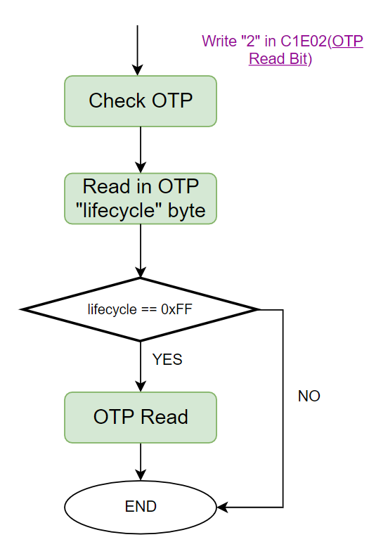
Figure 12: Boot Routine
[Vpriority High] [End]

[DDS_STBIO1_0017] Requirement:
To perform a BOOT routine, OTP_BOOT bit shall be written when quokka_run is low.
[Vpriority High] [End]

[DDS_STBIO1_0018] Requirement:
The WRITE routine shall start when OTP Write Bit rises and completes when quokka_run falls.
[Vpriority High] [End]

[DDS_STBIO1_0019] Requirement:
During WRITE routine ADSP shall copy the content of the OTP regmap into the OTP memory, following the procedure to burn the fuses as expressed in the OTP datasheet
[Vpriority High] [End]

[DDS_STBIO1_0020] Requirement:
During WRITE routine, ADSP shall allow copying all OTP Registers into the OTP Memory only if the location 0x24 of OTP Memory (OTP[24] in the following diagram) is not set to 0xFF.
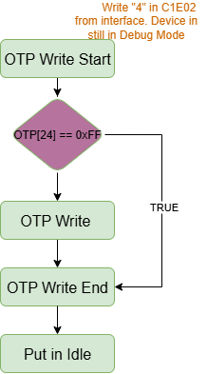

Figure 13: Write Routine Start
[Vpriority High] [End]

[DDS_STBIO1_0021] Requirement:
During the WRITE routine and after copying all OTP Registers into the OTP Memory, ADSP shall compare each value inside the OTP memory with the corresponding value in OTP Registers to check if the WRITE routine has been succesfull. In that case ADSP shall write 0xFF into the last location of the OTP memory.
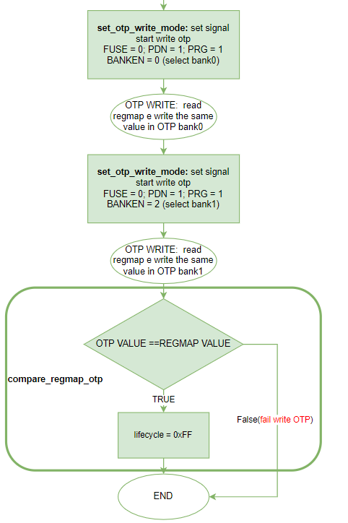
Figure 14: WRITE routine and TEST regmap
[Vpriority High] [End]

[DDS_STBIO1_0022] Requirement:
OTP_WRITE, OTP_BOOT and OTP_TEST bits shall be cleared by ADSP at the end of their respective operation
[Vpriority High] [End]

[DDS_STBIO1_0023] Requirement:
A new operation shall start only when quokka_run is low, and one between OTP_TEST bit, OTP_WRITE bit or OTP_BOOT bit is written to 1
[Vpriority High] [End]

[DDS_STBIO1_0024] Requirement:
OTP_IREF_WAKEUP shall be set to one by an external I2C/SPI to AHB write before initiating a new OTP_TEST or OTP_WRITE operation
[Vpriority High] [End]

[DDS_STBIO1_0025] Requirement:
OTP_IREF_WAKEUP shall be setted to zero by an external I2C/SPI to AHB write at the end of OTP_TEST or OTP_WRITE operation
[Vpriority High] [End]

[DDS_STBIO1_0026] Requirement:
After startup phase, once started with an operation, the IP shall ignore any further start incoming transactions.
[Vpriority High] [End]

[DDS_STBIO1_0027] Requirement:
The TEST routine shall start when OTP Test Bit rises and completes when quokka_run falls.
[Vpriority High] [End]

[DDS_STBIO1_0028] Requirement:
The TEST routines shall allow reading an 8-bit word on OTP of a specific address written in OTP_A register, and write this value in OTP_D_TEST register.
[Vpriority High] [End]

[DDS_STBIO1_0029] Definition:
Timing parameter | Value
ts_pdnr_tread | 3 µs
ts_pdnr_fuse | 3 µs
th_pdnr_selectwlbl | 8 µs
ts_selectwlblr_a | 6 µs
ts_selectwlblr_prg | 5 µs
ts_fuser_selectwlbl | 5 µs
tfuse_high | 100 µs
th_fusef_selectwlbl | 5 µs
t_selectwlbl_high_read | 10 µs
td_selectwlblr_dout | 8 µs
tselectwbl_low | 7 µs
th_selectwlblf_a | 2*clk_period
ts_pdnf_selectwlbl | 500 ns
th_pdnf_tread | 150 ns
th_pdnf_fuse | 150 ns
th_selectwlblf_prg | 2*clk_period
clk_period | 31ns
n_mirror_reg | 6
Table 21 Chosen OTP Timings
[End]

[DDS_STBIO1_0030] Definition:
Timing parameter | Value
t_state1_cycles | ts_pdnr_tread_fuse_cycles + th_pdnr_selectwlbl_cycles
t_s1_int1_cycles | ts_pdnr_tread_fuse_cycles
t_s1_int2_cycles | t_state1_cycles - ts_selectwlblr_a_cycles
t_s1_int3_cycles | t_state1_cycles - ts_selectwlblr_prg_cycles
t_state2_write_cycles | ts_fuser_selectwlbl_cycles + tfuse_high_cycles + th_fusef_selectwlbl_cycles
t_s2_int1_write_cycles | ts_fuser_selectwlbl_cycles
t_s2_int2_write_cycles | t_state2_write_cycles - th_fusef_selectwlbl_cycles
t_state2_read_cycles | t_selectwlbl_high_read_cycles
t_s2_int1_read_cycles | td_selectwlblr_dout_cycles
t_state3_cycles | tselectwbl_low_cycles
t_s3_int1_cycles | th_selectwlblf_a_cycles
t_s3_int2_cycles | tselectwbl_low_cycles - ts_selectwlblr_a_cycles
t_state4_cycles | ts_pdnf_selectwlbl_cycles + th_pdnf_tread_fuse_cycles
t_s4_int1_cycles | th_selectwlblf_a_cycles
t_s4_int2_cycles | th_selectwlblf_prg_cycles
t_s4_int3_cycles | ts_pdnf_selectwlbl_cycles
Table 22 Operation phases timings
[End]

[DDS_STBIO1_0031] Definition:
Figure 15 : OTP Reading timing diagram
[End]

[DDS_STBIO1_0032] Requirement:
After each Boot routine performed by the ADSP, a value of 0x04 shall be written once to address 0x0CA00C to ensure correct operation of the AHB transactions.
[Vpriority High] [End]

[DDS_STBIO1_0033] Requirement:
The Soft Reset routine shall start when SOFT_RESET Bit (in CONTROL_A register) rises and completes when quokka_run falls.
[Vpriority High] [End]

[DDS_STBIO1_0034] Requirement:
During the Soft Reset routine, ADSP shall write the ADSP RAM with the value 0. Only the first 3.5Kbyte of ADSP RAM shall be cleared, from address 0x000 to address 0xDFF
[Vpriority High] [End]

[DDS_STBIO1_0035] Requirement:
If during the start of a new operation, more than one bit is written into CONTROL_A reg in the same write operation, ADSP shall execute only the routine at higher priority and discard the others.
Priority is listed below, with first routine at higher priority:
- SOFT RESET routine
- OTP WRITE routine
- OTP TEST routine
- OTP BOOT routine
[Vpriority High] [End]

[DDS_STBIO1_0036] Requirement:
If bit OTP_PRG10[31] in OTP Registers, called write_protection_en, is set to 1, and STBIO1 is not in debug_mode, register map shall refuse any incoming write request if the transaction address is within the OTP Registers space (from 0xCD000 to 0xCD02F).
[End]

[DDS_STBIO1_0037] Definition:
Figure 16: OTP Writing timing diagram
[End]

I2C_SPI_AHB integration

Generic name |  | Type | Value | TOP CONNECTION
fifo_dpt |  |  | 8 | FIFO depth. Suggested val 8 | [DDS_STBIO1_8100]
rd_to_max_val |  |  | 6000 | Time available between double byte write to communicate the number of bytes to be read and the following read. If timer expires the operation is aborted and proper flag is activated. Suggested val. 1200 | [DDS_STBIO1_8101]
i2c_hs_mode |  |  | 1'b0 | To activate HS I2C | [DDS_STBIO1_8102]
i2c_master_code |  |  | 8'h00 | Master code for HS I2C | [DDS_STBIO1_8103]
ser_mode |  |  | "i2c_spi" | To choose if the interface is SPI only, I2C only or both. Suggested : i2c_spi | [DDS_STBIO1_8104]
ip_version |  |  | 8'haa | IP version | [DDS_STBIO1_8105]
i2c_dev_id |  |  | 7'h5f | I2C device address | [DDS_STBIO1_8106]
Table 23: I2C/SPI AHB Parameters

Port name | Direction | Type | TOP CONNECTION
rst_n | input |  | POR
i_if_cs | input |  | CS for SPI interface
o_if_cs_tud | output |  | Control for CS PAD. 1 in scan mode 0 otherwise
o_if_cs_en_n | output |  | Set to 0 for CS pad id bidir pad is used. Could be inverted depending on the PAD
o_if_cs_out_n | output |  | Set to 0 for CS pad id bidir pad is used. Could be inverted depending on the PAD
i_if_ck | input |  | Interface clock
i_if_sda_sdi_in | input |  | SDA/SDI from pad
o_if_sda_sdi_en_n | output |  | SDA/SDI pad enable
o_if_sda_sdi_out | output |  | SDA/SDI to pad
o_ctrl_reg_7 | output | [7:0] | 8 configuration bit set by local register (addr. 0x5e)
i_ext_reg_dt | input | [7:0] | Data from external register block (if present)
o_ext_reg_wr_add | output | [7:0] | Write address to external register block (if present)
o_ext_reg_rd_add | output | [7:0] | Read address to external register block (if present)
o_ext_reg_dt | output | [7:0] | Data to external register block (if present)
o_ext_reg_ck_wr | output |  | Write enable for external register block (if present)
o_ext_reg_we | output |  | Write direct enable for external register block (if present)
rst_16m_n |  |  | Sw reset for AHB domain
sys_16m_clk | input |  | AHB clock
o_hselm | output |  | AHB_M
o_haddrm | output | [31:0] | AHB_M
o_htransm | output | [1:0] | AHB_M
o_hmasterm | output | [3:0] | AHB_M
o_hwritem | output |  | AHB_M
o_hsizem | output | [2:0] | AHB_M
o_hmastlockm | output |  | AHB_M
o_hwdatam | output | [31:0] | AHB_M
o_hburstm | output | [2:0] | AHB_M
o_hprotm | output | [3:0] | AHB_M
i_hrdatam | input | [31:0] | AHB_M
i_hreadym | input |  | AHB_M
i_hrespm | input |  | AHB_M
o_gt_ck_on | output |  | Pulse on interface clock to inform system that AHB clock must be switched on
o_gt_ck_off | output |  | Pulse on AHB clock to inform system that AHB clock can be switched off
o_ahb_error | output |  | Error on AHB side. Active if bit 1 or of register at address 0x4f are active.
o_rd_byte_nr_err | output |  | Active when
o_req_error | output |  | Active when number of byte is missing for read or timeout between double yte write and read is expired
scan_mode | input |  | Scan mode
scan_enable | input |  | Scan enable
scan_clk | input |  | Scan clk
scan_rst | input |  | Scan reset
Table 24: I2C/SPI AHB I/O List

I2C_SPI_AHB Peculiar Requirements

[DDS_STBIO1_8000] Requirement: I2C interface shall support all the specified modalities (Standard, FM, FM+) and, if configured, HS is also supported.
[End]

[DDS_STBIO1_8001] Requirement: Clock frequency ratio between system (AHB) and I2C/SPI interfaces domains shall be at least 2 times.
[TO: IPOS_I2C_SPI_AHB_0006]
[Vpriority High]
[End]

[DDS_STBIO1_8002] Requirement: The IP has a serial interface (I2C or SPI) and a parallel bus interface AHB.
[TO: IPOS_I2C_SPI_AHB_0007]
[End]

[DDS_STBIO1_8003] Requirement: An I2C/SPI write access to the address 0x60-0x67 shall be translated in an AHB write access to the configured AHB address (contained in registers SAM_ADDR_BYTE0/1/2/3, address 0x50/0x51/0x52/0x53).
[TO: IPOS_I2C_SPI_AHB_0009]
[Vpriority High]
[End]

[DDS_STBIO1_8004] Requirement: A double byte write access to the address 0x68-0x6f (with data that is the number of bytes that the master wants to read) shall start the data preload from AHB in order to have the internal fifo not empty when the read request will be done by the master.
[TO: IPOS_I2C_SPI_AHB_0010]
[Vpriority High]
[End]

[DDS_STBIO1_8005] Requirement: An I2C/SPI read access to the address 0x70-0x7f shall be translated in an AHB read access to the configured AHB address (contained in registers SAM_ADDR_BYTE0/1/2/3, address 0x50/0x51/0x52/0x53).
[TO: IPOS_I2C_SPI_AHB_0011]
[Vpriority High]
[End]

[DDS_STBIO1_8006] Requirement: On AHB interface, data size shall be limited to BYTE and WORD.
[TO: IPOS_I2C_SPI_AHB_0361]
[End]

[DDS_STBIO1_8007] Requirement: On AHB interface, BURST shall not be supported as well as LOCKED transfers.
[TO: IPOS_I2C_SPI_AHB_0362]
[End]

SensorHub integration
Generic name | Type | Value | TOP CONNECTION
ADDRWIDTH
EBMwriteAddr
TAGid
Table 25: Sensor Hub Parameter

Port name | Direction | Type | TOP CONNECTION
scan_mode | input
scan_enable | input
scan_rstn | input
HCLKM | input
HCLKS | input
sys_clk | input
HRESETn | input
DEBUG_MODE_i | input
scl_master_in | input
sda_master_in | input
scl_master_out | output
sda_master_out | output
dvalid_masterblaze_ext | input
dvalid_masterblaze_ext_enable | input
sleep_master | output
master_end_op_pulse | output
SH_SMARTFIFO_OCCUPATION | Input
fifo_mode | input
fifo_offset | input | [11:0]
HSELS | input
HADDRS | input | [ADDRWIDTH-1:0]
HTRANSS | input | [1:0]
HSIZES | input | [2:0]
HWRITES | input
HREADYS | input
HWDATAS | input | [31:0]
HREADYOUTS | output
HRESPS | output
HRDATAS | output | [31:0]
ahb_master_on | output
HRDATAM | input | [31:0]
HREADYM | input
HRESPM | input | [1:0]
HGRANTM | input
HSELM | output
HADDRM | output | [31:0]
HTRANSM | output | [1:0]
HWRITEM | output
HSIZEM | output | [2:0]
HBURSTM | output | [2:0]
HPROTM | output | [3:0]
HWDATAM | output | [31:0]
HBUSREQM | output
HLOCKM | output
Table 26: Sensor Hub I/O List

[DDS_STBIO1_XXXX] Description
Sensor hub related data flow is composed by the following phases :

  - Initial configuration of STBIO1 registers through I2C/SPI interface
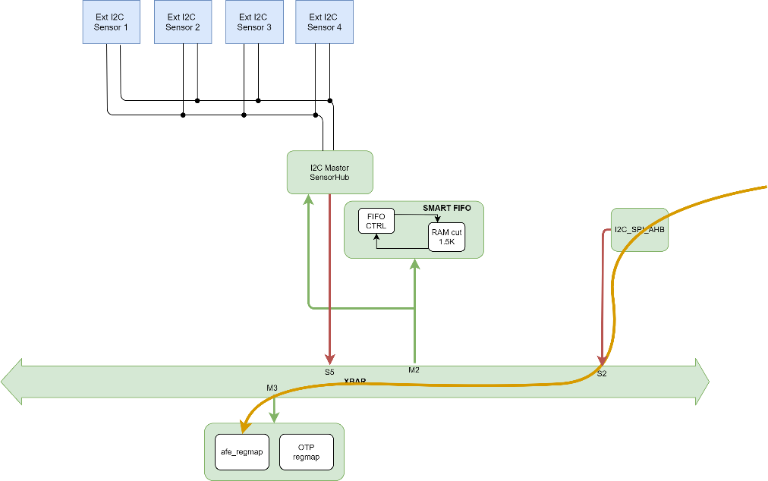

  - I2C master trigger generation through I2C/SPI interface
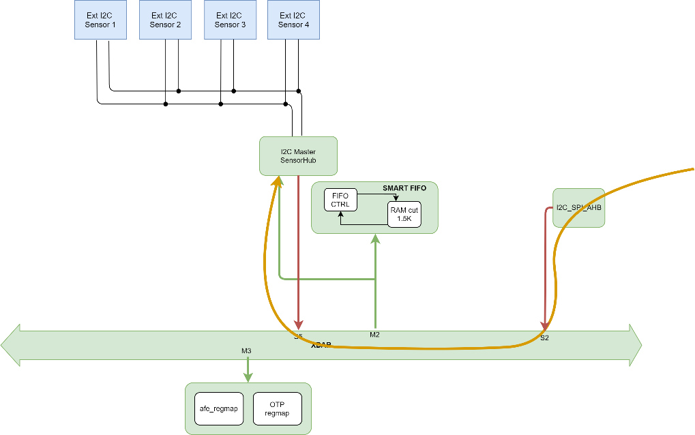

  - External I2C sensors are read by sensor hub

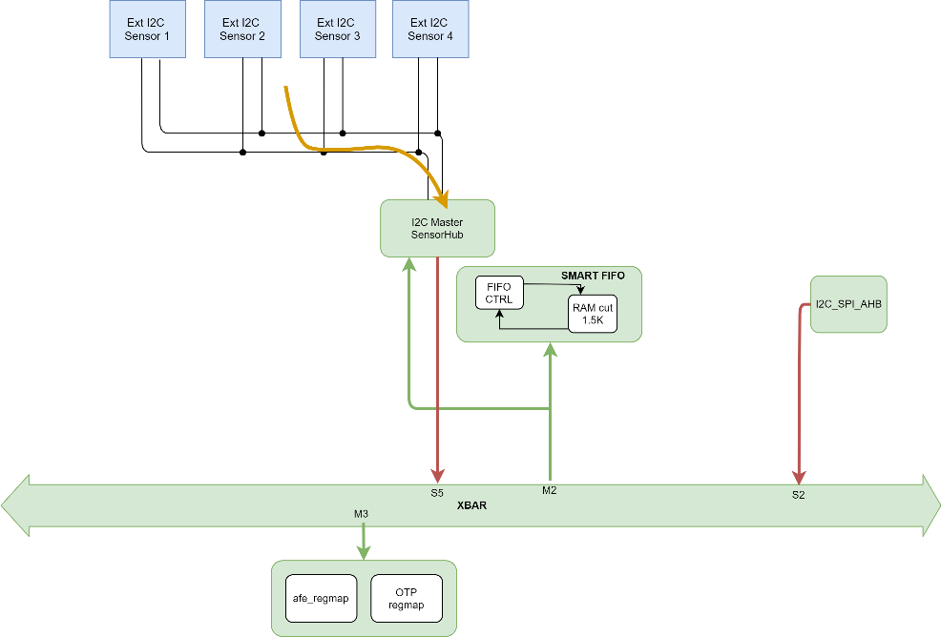

  - Data read is sent to FIFO
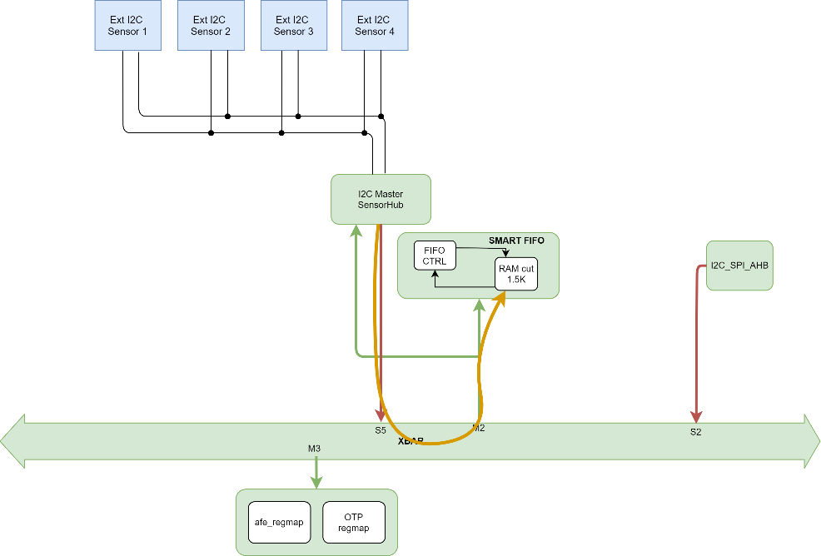

  - Data read can be read through I2C/SPI interface
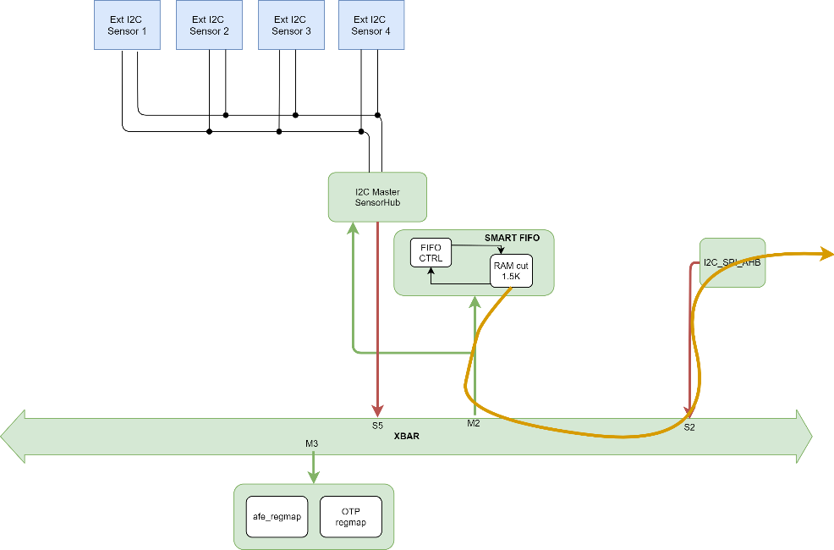

[End]

[DDS_STBIO1_XXXX] Description
Sensor hub configuration sequence at system level to be added
[End]

SensorHub Peculiar Requirements

[DDS_STBIO1_9000] Description
Sensor hub IP is an IP used to read up-to 4 external I2C devices.
Sensor hub IP is compliant with FM+ I2C standard.
Both read and write operation are possible:
- Write:
  - 1 byte on one I2C target
- Read:
  - up-to 12byte on each I2C target
  - up-to 4 I2C target

[End]

[DDS_STBIO1_9317] Requirement
If the sensor hub IP is not enabled, the SCL and SDA pad shall not toggle.
[Vpriority High] [TO: IPOS_Senshub_MB_i2c]
[End]

[DDS_STBIO1_9011] Requirement
Input scl_master_in of sensor hub shall be connected to input buffer from sensor hub’s SCL PAD.
[Vpriority High] [TO: IPOS_Senshub_MB_i2c]
[End]

[DDS_STBIO1_9012] Requirement
Input sda_master_in of sensor hub shall be connected to input buffer from sensor hub’s SDA PAD.
[Vpriority High] [TO: IPOS_Senshub_MB_i2c]
[End]

[DDS_STBIO1_9013] Requirement
Output scl_master_out of sensor hub shall be connected to enable of output buffer of sensor hub’s SCL PAD (in case it is a bi-directional PAD).
[Vpriority High] [TO: IPOS_Senshub_MB_i2c]
[End]

[DDS_STBIO1_9014] Requirement
Output sda_master_out of sensor hub shall be connected to enable of output buffer of sensor hub’s SDA PAD.
[Vpriority High] [TO: IPOS_Senshub_MB_i2c]
[End]

[DDS_STBIO1_9017] Requirement
The output port sleep_master shall be set to 1 when an I2C operation is not on-going.
[Vpriority High] [TO: IPOS_Senshub_MB_i2c]
[End]

[DDS_STBIO1_9004] Requirement
Input sys_clk of sensor hub shall be connected to 8MHz clock to generate I2C communications compliant with FM+ I2C standard.
[TO: IPOS_Senshub_MB_i2c]
[End]

[DDS_STBIO1_9018] Requirement
The trigger of sensor hub shall be possible in both ways, HW via dvalid_masterblaze_ext signal or SW using DVALID_REGISTER.
[TO: IPOS_Senshub_MB_i2c]
[End]

[DDS_STBIO1_9024] Requirement
Only I2C target addressed through SLAVE0_DEV_ADD register shall be the destination of an I2C Write Operation.
[TO: IPOS_Senshub_MB_i2c]
[End]

[DDS_STBIO1_9027] Requirement
The bit 0 of SLAVE1_DEV_ADD, SLAVE2_DEV_ADD, SLAVE3_DEV_ADD registers shall be ignored: ONLY read operations towards I2C target 1, 2 and 3 shall be performed.
[TO: IPOS_Senshub_MB_i2c]
[End]

[DDS_STBIO1_9029] Requirement
AUX_SENS_ON possible values shall be 0,1,2,3. All the values shall be tested since MasterBlaze supports up-to 4 I2C targets connected to I2C network.
[TO: IPOS_Senshub_MB_i2c]
[End]

[DDS_STBIO1_9030] Requirement
SLAVEx_NUMOP bit-fields of SLAVEx_CONFIG registers shall define how many bytes per slave are read as per effect of an I2C operation (x from 1 to 12).
[TO: IPOS_Senshub_MB_i2c]
[End]

[DDS_STBIO1_9031] Requirement
All the values from 1 to 12 shall be valid for SLAVEx_NUMOP bit-fields of SLAVEx_CONFIG registers.
[TO: IPOS_Senshub_MB_i2c]
[End]

[DDS_STBIO1_9032] Requirement
SLAVE0_NUMOP bitfield shall be ignored if an I2C Write operation is issued to the I2C Slave 0.
[TO: IPOS_Senshub_MB_i2c]
[End]

[DDS_STBIO1_9033] Requirement
All the SENSOR_HUB_x registers shall be reset every time a new I2C operation starts.
[TO: IPOS_Senshub_MB_i2c]
[End]

[DDS_STBIO1_9035] Requirement
When Quokka MasterBlaze µP runs (sleep_master signal = 0), any dvalid triggered (HW or SW) shall be ignored.
[TO: IPOS_Senshub_MB_i2c]
[End]

[DDS_STBIO1_9034] Requirement
The NACK_REGISTER register is reset every time a new I2C operation starts.
[TO: IPOS_Senshub_MB_i2c]
[End]

[DDS_STBIO1_9260] Requirement
Each data stored in FIFO shall be composed by 4 words (16bytes).
[TO: IPOS_Senshub_MB_i2c]
[End]

[DDS_STBIO1_9261] Requirement
3 words (12bytes) of the data stored in FIFO shall contain the data from each I2C slave.
[TO: IPOS_Senshub_MB_i2c]
[End]

[DDS_STBIO1_9262] Requirement
24-bits of the data stored in FIFO shall be reserved at ‘0’.
[TO: IPOS_Senshub_MB_i2c]
[End]

[DDS_STBIO1_9263] Requirement
The last 8-bits of the data stored in FIFO shall contain the TAG field.
[TO: IPOS_Senshub_MB_i2c]
[End]

[DDS_STBIO1_9300] Requirement
The AHB Write to registers has no effect if the IP masterblaze processor is busy (I2C operation on-going); the registers value shall not be updated.
[TO: IPOS_Senshub_MB_i2c]
[End]

[DDS_STBIO1_9500] Requirement
In case also other sources that writes into FIFO are active, then sensor hub shall work always in multi-fifo mode (fifo_mode input of sensor hub set to ‘1’).
[End]

FIFO_CTRL integration

Generic name | Type | Value | TOP CONNECTION
AW |  | 13
Table 27: Fifo Parameter
Port name |  | Direction | Type | Description | TOP CONNECTION
TEST_MODE |  | input |  | ScanMode | u_pad_mux. scan_mode
HCLK |  | input |  | AHB Master Handler Clock 16MHz clock | u_pmu.clk_fifo
HRESETn |  | input |  |  | u_pmu.resetn_fifo
HSEL |  | input |  | AHB Slave Port | u_afa_xbar.hsel_M2
HADDR |  | input | [AW-1:0] | AHB Slave Port | u_afa_xbar.haddr_M2
HMASTER |  | input | [3:0] | AHB Slave Port | u_afa_xbar.hmaster_M2
HTRANS |  | input | [1:0] | AHB Slave Port | u_afa_xbar.htrans_M2
HSIZE |  | input | [2:0] | AHB Slave Port | u_afa_xbar.hsize_M2
HWRITE |  | input |  | AHB Slave Port | u_afa_xbar.
HWDATA |  | input | [31:0] | AHB Slave Port | u_afa_xbar.
HREADY |  | input |  | AHB Slave Port | u_afa_xbar.
HREADYOUT |  | output |  | AHB Slave Port | u_afa_xbar.
HRDATA |  | output | [31:0] | AHB Slave Port | u_afa_xbar.
HRESP |  | output |  | AHB Slave Port | u_afa_xbar.
O_FIFO_RAM_A |  | output | [ADDR_WIDTH-1:0] |  | u_ca_fifo_bist_c.ags_1
O_FIFO_RAM_D |  | output | [23:0] |  | u_ca_fifo_bist_c.csns_1
O_FIFO_RAM_CSN |  | output |  |  | u_ca_fifo_bist_c.dgs_1
O_FIFO_RAM_M |  | output | [23:0] |  | u_ca_fifo_bist_c.wens_1
O_FIFO_RAM_WEN |  | output |  |  | u_ca_fifo_bist_c.mgs_1
I_FIFO_RAM_Q |  | input | [23:0] |  | u_ca_fifo_bist_c.dgrs_1
Table 28: FIFO Controller I/O List

FIFO_CTRL Peculiar Requirements
[DDS_STBIO1_00000102] Requirement
The parameter MEM_LOC shall define the first Memory Location of the FIFO RAM: 0xC4000.
[TO: IPOS_FIFO_CTRL_00000102]
[End]
[DDS_STBIO1_00000202] Requirement
The FIFO register map first memory location shall be defined as MEM_LOC + 0x1000: 0xC5000.
[TO: IPOS_FIFO_CTRL_00000202]
[End]
[DDS_STBIO1_89456557] Requirement:
The FIFO Controller shall be able to address 1.5 kbyte divided into 32-bit address.
[TO: IPOS_FIFO_CTRL_89456557]
[End]
[DDS_STBIO1_89459082] Requirement:
The FIFO Controller shall work at 16 MHz clock frequency.
[TO: IPOS_FIFO_CTRL_89459082]
[End]
[DDS_STBIO1_89455261] Requirement:
The FIFO Controller shall have an AHB Slave Interface connected to the AHB BUS and a Memory Master Interface connected to the Physical Memory.
[TO: IPOS_FIFO_CTRL_89455261]
[End]
[DDS_STBIO1_89455449] Requirement:
The FIFO Controller shall have two working modes: Multiple FIFO and Unique FIFO. These two modes are mutually exclusive.
[TO: IPOS_FIFO_CTRL_89455449]
[End]
[DDS_STBIO1_89455232] Requirement:
As default, the FIFO shall work in Unique FIFO Mode.
[TO: IPOS_FIFO_CTRL_89455232]
[End]
[DDS_STBIO1_89456975] Requirement:
The user shall select the Multiple FIFO mode setting to 1 the first bit into the FIFO_CFG_MODE and 0 for the Unique FIFO mode.
[TO: IPOS_FIFO_CTRL_89456975]
[End]
[DDS_STBIO1_89457435] Requirement:
The FIFO Controller shall have a 6 i_depth input of 8 bit to be used in Multiple FIFO Mode to define the depth of each subFIFOs.
[TO: IPOS_FIFO_CTRL_89457435]
[End]
[DDS_STBIO1_89457790] Requirement:
The FIFO 6 memory locations to access each sub-FIFO in Multiple mode are obtained adding multiples of 256 to the memory base address.
Example: FIFO Memory Base Address = 0xC4000, then:
FIFO 0 memory location | 0xC4000
FIFO 1 memory location | 0xC4100
FIFO 2 memory location | 0xC4200
FIFO 3 memory location | 0xC4300
FIFO 4 memory location | 0xC4400
FIFO 5 memory location | 0xC4500
Table 29: SUB FIFO Memory Address
[TO: IPOS_FIFO_CTRL_89457790]
[End]
[DDS_STBIO1_00000008] Requirement:
If input signal HMASTER is set to 0 or 1, the FIFO Controller shall enter Memory mode.
[TO: IPOS_FIFO_CTRL_00000008]
[End]
[DDS_STBIO1_00000199] Requirement
DATA TYPE | BIT: 23 - 20 | BIT: 19 - 16 | BIT: 15 - 0
PPG FRAME 0 | 0000 | 20 BIT DATA
PPG FRAME 1 | 0001 | 20 BIT DATA
PPG FRAME 2 | 0010 | 20 BIT DATA
PPG FRAME 3 | 0011 | 20 BIT DATA
PPG FRAME 4 | 0100 | 20 BIT DATA
PPG FRAME 5 | 0101 | 20 BIT DATA
PPG FRAME 6 | 0110 | 20 BIT DATA
PPG FRAME 7 | 0111 | 20 BIT DATA
PPG FRAME 8 | 1000 | 20 BIT DATA
PPG FRAME 9 | 1001 | 20 BIT DATA
PPG FRAME 10 | 1010 | 20 BIT DATA
PPG FRAME 11 | 1011 | 20 BIT DATA
TIME SLOT DATA | 1111 | 0000 | 16 BIT DATA
ECG0_AC | 1100 | 0000 | 16 BIT DATA
ECG0_DC | 1101 | 0000 | 16 BIT DATA
ECG1_AC | 1100 | 0001 | 16 BIT DATA
ECG1_DC | 1101 | 0001 | 16 BIT DATA
ECG2_AC | 1100 | 0010 | 16 BIT DATA
ECG2_DC | 1101 | 0010 | 16 BIT DATA
BIA_AC_P | 1110 | 0001 | 16 BIT DATA
BIA_DC_P | 1110 | 0011 | 16 BIT DATA
BIA_AC_Q | 1110 | 0000 | 16 BIT DATA
BIA_DC_Q | 1110 | 0010 | 16 BIT DATA
GSR | 1111 | 1000 | 16 BIT DATA
DATA_QUOKKA_ELAB | 1111 | 0001 to 0111 | 16 BIT DATA
Table 30: Data Tag
00000199
[End]

[DDS_STBIO1_00001199] Requirement
When in Multiple Fifo, the 6 sub-FIFO offset shall coincide with the following table :
FIFO OFFSET | DATA TYPE
ECG FIFO OFFSET | ECG0_AC, ECG0_DC
BIA FIFO OFFSET | BIA_AC_P, BIA_DC_P, BIA_AC_Q, BIA_DC_Q, ECG1_AC, ECG2_DC
GSR FIFO OFFSET | GSR, ECG1_DC, ECG2_AC
PPG FIFO OFFSET | PPG
Table 31 : FIFO Offset Data Table
[END]

ISPU integration
Por name | Direction | Comment | TOP CONNECTION
clk | input | clk 16MHz from pmu | u_pmu_clk_stredl_sig
main_rst_n | input | reset in 16MHz domain | u_pmu_resetn_stredl_sig
POR_n | input | reset in 16MHz domain | u_pmu_resetn_stredl_sig
ispu_xbar_sw_resetn | input | Software reset ISPU xbar | u_regmap_otp_ispu_xbar_sw_resetn_sig
ispu_core_sw_resetn | input | Software reset ISPU core | u_regmap_otp_ispu_core_sw_resetn_sig
scan_mode | input | Scan mode | u_pad_mux_scan_mode_sig
scan_enable | input | Scan enable | u_pad_mux_scan_enable_sig
test_rst_n | input | Scan reset | u_pad_mux_scan_rstn_sig
bist_mode | input | Bist mode enable | u_pad_mux_bist_mode_sig
interrupt | input | Interrupt lines | u_ca_fifo_bist_c_oen_1,  u_fifo_irq_FIFO_U_M_IRQ_STATUS_sig,  u_regmap_otp_irq_SENSHUB_STS_sig,  u_regmap_otp_irq_ISPU_MC_INTR_STS_sig, u_regmap_otp_sw_interrupt_sig, u_ca_fifo_bist_c_oen_1, u_ca_fifo_bist_c_oen_1, u_ca_fifo_bist_c_oen_1, u_ca_fifo_bist_c_oen_1, u_ca_fifo_bist_c_oen_1, u_ca_fifo_bist_c_oen_1, u_ca_fifo_bist_c_oen_1, u_ca_fifo_bist_c_oen_1, u_ca_fifo_bist_c_oen_1
clk_en | output | Enable clock at ISPU core | u_ispu_clk_en_sig
S_HSEL | input | AHB HSEL Slave Port | u_xbar_afe_hsel_M0_sig
S_HREADY | input | AHB HREADY Slave Port | u_xbar_afe_hreadymux_M0_sig
S_HREADYOUT | output | AHB HREADYOUT Slave Port | u_ispu_S_HREADYOUT_sig
S_HTRANS | input | AHB HTRANS Slave Port | u_xbar_afe_htrans_M0_sig
S_HADDR | input | AHB HADRR Slave Port | u_xbar_afe_haddr_M0_sig
S_HSIZE | input | AHB HSIZE Slave Port | u_xbar_afe_hsize_M0_sig[1:0]
S_HWRITE | input | AHB HWRITE Slave Port | u_xbar_afe_hwrite_M0_sig
S_HWDATA | input | AHB HWDATA Slave Port | u_xbar_afe_hwdata_M0_sig
S_HRDATA | output | AHB HRDATA Slave Port | u_ispu_S_HRDATA_sig
S_HRESP | output | AHB HRESP Slave Port | u_ispu_S_HRESP_sig
M_HSEL | output | AHB HSEL Master Port | u_ispu_M_HSEL_sig
M_HREADY | input | AHB HREADY Master Port | u_xbar_afe_hready_S0_sig
M_HTRANS | output | AHB HTRANS Master Port | u_ispu_M_HTRANS_sig
M_HADDR | output | AHB HADDR Master Port | u_ispu_M_HADDR_sig
M_HSIZE | output | AHB HSIZE Master Port | u_ispu_M_HSIZE_sig
M_HWRITE | output | AHB HWRITE Master Port | u_ispu_M_HWRITE_sig
M_HWDATA | output | AHB HWDATA Master Port | u_ispu_M_HWDATA_sig
M_HRDATA | input | AHB HRDATA Master Port | u_xbar_afe_hrdata_S0_sig
M_HRESP | input | AHB HRESP Master Port | u_xbar_afe_hresp_S0_sig
DBG_HREADY | input | AHB HREADY Debug Master Port | u_xbar_afe_hready_S4_sig
DBG_HTRANS | output | AHB HTRANS Debug Master Port | u_ispu_DBG_HTRANS_sig
DBG_HADDR | output | AHB HADDR Debug Master Port | u_ispu_DBG_HADDR_sig
DBG_HSIZE | output | AHB HSIZE Debug Master Port | u_ispu_DBG_HSIZE_sig
DBG_HWRITE | output | AHB HWRITE Debug Master Port | u_ispu_DBG_HWRITE_sig
DBG_HBURST | output | AHB DHBURST ebug Master Port | NO CONN
DBG_HWDATA | output | AHB HWDATA Debug Master Port | u_ispu_DBG_HWDATA_sig
DBG_HRDATA | input | AHB HRDATA Debug Master Port | u_xbar_afe_hrdata_S4_sig
DBG_HRESP | input | AHB HRESP Debug Master Port | u_xbar_afe_hresp_S4_sig
trst_n | input | JTAG Test Reset | u_pad_mux_ispu_trst_n_sig
tck | input | JTAG Test Clock | u_pad_mux_ispu_tck_sig
tms | input | JTAG Test Mode Select | u_pad_mux_ispu_tms_sig
tdi | input | JTAG Test Data In | u_pad_mux_ispu_tdi_sig
tdo | output | JTAG Test Data Out | u_ispu_tdo_sig
tdo_en | output | JTAG Test Data Out Enable | u_ispu_tdo_en_sig
ca_stredl_bist_c_rst_bistctlr_n | input | BIST Asynchronous Reset Pin for collar Serial Interface and Controller | u_pmu_tst_rst_bistctlr_n_sig
ca_stredl_bist_c_clk_bistctlr | input | BIST Low Frequency Serial Shift Clock for the controller | u_pmu_tst_clk_bistctlr_sig
ca_stredl_bist_c_bist_mode | input | BIST Global BIST Mode Selection Bus | u_ta_afe_bist_crtl_bist_mode_ctlr_sig
ca_stredl_bist_c_march_shift | input | BIST March element serial data out enable to SP/ROM/RF/DP collars | u_ta_afe_bist_crtl_march_shiftSP_sig
ca_stredl_bist_c_collar_config | input | BIST Mode selection pins for SP/ROM/RF/DP memory collars (modefunc, modestab, modecoll) | u_ta_afe_bist_crtl_collar_configSP_sig
ca_stredl_bist_c_march_in | input | BIST March element serial data in | u_ta_afe_bist_crtl_march_outSP_sig
ca_stredl_bist_c_march_run | input | BIST March run to SP/ROM/RF/DP collars | u_ta_afe_bist_crtl_march_runSP_sig
ca_stredl_bist_c_memsafe | input | BIST Pin to globally deactivate the selected memories by making CSN high internally | u_ta_afe_bist_crtl_memsafe_ctlr_sig
ca_stredl_bist_c_sif_reg_en | input | BIST Enable for various types of data transfer (Bitmap, memory selection, programmable algorithms) through serial interface. | u_ta_afe_bist_crtl_sif_reg_en_ctlr_sig
ca_stredl_bist_c_sif_load_en | input | BIST Allows to control the data loading from collar registers to serial interface registers of the collar | u_ta_afe_bist_crtl_sif_load_en_ctlr_sig
ca_stredl_bist_c_shift_en | input | BIST Enable for Serial Input Data from Tester/External World | u_ta_afe_bist_crtl_shift_en_ctlr_sig
ca_stredl_bist_c_sif_update_en | input | BIST Allows to control the data loading from collar registers to serial interface registers of the collar | u_ta_afe_bist_crtl_sif_update_en_ctlr_sig
ca_stredl_bist_c_march_end | output | BIST March end signal from each SP / ROM / RF / DP collar type | u_ispu_ca_stredl_bist_c_march_end_sig
ca_stredl_bist_c_bbad_1 | output | BIST Indicates bbad for a specific memory. There are as many bbad signals as the number of memories. | NO CONN
ca_stredl_bist_c_bfail_1 | output | BIST Indicates bfail for a specific memory. There are as many bbad signals as the number of memories. | u_ispu_ca_stredl_bist_c_bfail_1_sig
ca_stredl_bist_c_repairable_1 | output | BIST Indicates repairable for a specific memory.There are as many repairable signals as the number of memories. For a shared collar there would be as many repairable outputs as the number of memories | NO CONN
ca_stredl_bist_c_bbad_2 | output | BIST Indicates bbad for a specific memory. There are as many bbad signals as the number of memories. | NO CONN
ca_stredl_bist_c_bfail_2 | output | BIST Indicates bfail for a specific memory. There are as many bbad signals as the number of memories. | u_ispu_ca_stredl_bist_c_bfail_2_sig
ca_stredl_bist_c_repairable_2 | output | BIST Indicates repairable for a specific memory.There are as many repairable signals as the number of memories. For a shared collar there would be as many repairable outputs as the number of memories | NO CONN
ca_stredl_bist_c_bbad_3 | output | BIST Indicates bbad for a specific memory. There are as many bbad signals as the number of memories. | NO CONN
ca_stredl_bist_c_bfail_3 | output | BIST Indicates bfail for a specific memory. There are as many bbad signals as the number of memories. | u_ispu_ca_stredl_bist_c_bfail_3_sig
ca_stredl_bist_c_repairable_3 | output | BIST Indicates repairable for a specific memory.There are as many repairable signals as the number of memories. For a shared collar there would be as many repairable outputs as the number of memories | NO CONN
ca_stredl_bist_c_bbad_4 | output | BIST Indicates bbad for a specific memory. There are as many bbad signals as the number of memories. | NO CONN
ca_stredl_bist_c_bfail_4 | output | BIST Indicates bfail for a specific memory. There are as many bbad signals as the number of memories. | u_ispu_ca_stredl_bist_c_bfail_4_sig
ca_stredl_bist_c_repairable_4 | output | BIST Indicates repairable for a specific memory.There are as many repairable signals as the number of memories. For a shared collar there would be as many repairable outputs as the number of memories | NO CONN
ca_stredl_bist_c_serial_out | output | BIST Serial Output Data from Tester / External World | u_ispu_ca_stredl_bist_c_serial_out_sig
ca_stredl_bist_c_bypass | input | BIST Memory Bypass Pin for RAM type memories. One top level port per collar. | u_pad_mux_scan_mode_sig
ca_stredl_bist_c_serial_in | input | BIST Serial Input Data from Tester / External World | u_ta_afe_bist_crtl_serial_out_ctlr_sig
ca_stredl_bist_c_test_se | input | BIST Scan Enable Signal Used internally by the BIST to prevent memory operation during scan shifting (a dedicated test_se (one test_se per collar) is provided at the top level | u_pad_mux_scan_enable_sig
ca_stredl_bist_c_tst_gatedclock | input | BIST Clock Gating Signal for the entire BIST. Used to force clock gating cell transparency in ATPG mode . | u_pad_mux_scan_enable_sig
ca_stredl_bist_c_tst_reset_mux | input | BIST Bypass for reset synchronizer. allows to force reset synchronizing circuit transparency in ATPG mode. | u_pad_mux_scan_mode_sig
ca_stredl_bist_c_oen_1 | input | BIST Memory Output Enable 1 | u_ca_fifo_bist_c_oen_1
ca_stredl_bist_c_oen_2 | input | BIST Memory Output Enable 2 | u_ca_fifo_bist_c_oen_1
ca_stredl_bist_c_oen_3 | input | BIST Memory Output Enable 3 | u_ca_fifo_bist_c_oen_1
ca_stredl_bist_c_oen_4 | input | BIST Memory Output Enable 4 | u_ca_fifo_bist_c_oen_1
ca_stredl_bist_c_mem_atpg_mode | input | BIST For ATPG purpose: Used to constraint few memory inputs and improve controllability and observability. | u_ca_fifo_bist_c_oen_1
ca_stredl_bist_c_tst_mem_selck_1 | input | BIST To select the clock and memory ports in ATPG mode 0: Functional Clock / Functional Ports 1: Test Clock/ Test Ports | u_ca_fifo_bist_c_oen_1
ca_stredl_bist_c_tst_mem_selck_2 | input | BIST To select the clock and memory ports in ATPG mode 0: Functional Clock / Functional Ports 1: Test Clock/ Test Ports | u_ca_fifo_bist_c_oen_1
ca_stredl_bist_c_tst_mem_selck_3 | input | BIST To select the clock and memory ports in ATPG mode 0: Functional Clock / Functional Ports 1: Test Clock/ Test Ports | u_ca_fifo_bist_c_oen_1
ca_stredl_bist_c_tst_mem_selck_4 | input | BIST To select the clock and memory ports in ATPG mode 0: Functional Clock / Functional Ports 1: Test Clock/ Test Ports | u_ca_fifo_bist_c_oen_1
ca_stredl_bist_c_par_memsel | input | BIST Parallel Memory Selection Bus | { 1'b0, u_ca_fifo_bist_c_oen_1, u_ca_fifo_bist_c_oen_1, u_ca_fifo_bist_c_oen_1 }

Table 32: ISPU I/O List

Requirements
[DDS_STBIO1_0500] Requirement: ] Requirement:
Interrupt lines list:
Interrupt | bit | Description
irq_FIFO_U_M_IRQ_STsATUS | 29 | FIFO status [DDS_STBIO1_0501]
irq_SENSHUB_STS | 28 | SENSOR HUB status [DDS_STBIO1_0502]
irq_ISPU_MC_INTR_STS | 27 | ECG, BIA or PPG samples ready for elaboration[DDS_STBIO1_0503]
sw_interrupt | 26:11 | 16 sw interrupt used by ADSP or external user [DDS_STBIO1_0504]
irq_timer | 1 | Internal timer [DDS_STBIO1_0505]
[END]

[DDS_STBIO1_0506] Description:
The ISPU is a dedicated IP for implementing complex processing algorithms. By default, it is turned off. This is located inside a power island
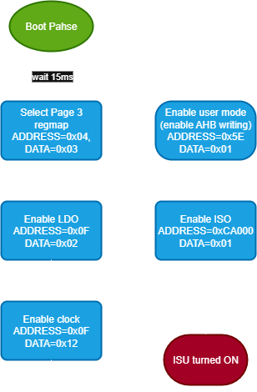
[End]
Figure 17: ISPU turn on phases

[DDS_STBIO1_0507] Requirement:
After the initial boot phase, to turn on the ISPU shall be:
- Select page 3 of the regmap (ADDRESS=0x04, DATA=0x03)
- Enable LDO 1V8 by writing to regmap VIREF_LDO1V8_CLK16M register (ADDRESS=0x0F, DATA=0x02)
- Enable clock by writing to regmap VIREF_LDO1V8_CLK16M register (ADDRESS=0x0F, DATA=0x12)
- Enable user mode by writing to regmap (ADDRESS=0x5E, DATA=0x01)
- Enable the power island by writing to regmap POWER CONFIGURATION REGISTER via AHB interface (ADDRESS=0xCA000, DATA=0x01)
[End]
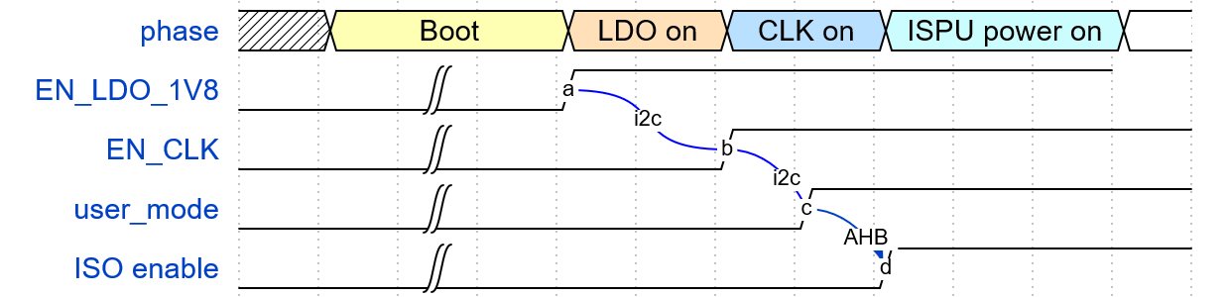
Figure 18: Timing turn on ISPU
[DDS_STBIO1_0508] Requirement:
To turn off the ISPU shall be:
- Disable the power island by writing to regmap POWER CONFIGURATION REGISTER via AHB interface (ADDRESS=0xCA000, DATA=0x00)
[End]

[DDS_STBIO1_0509] Requirement:
To put the ISPU into sleep mode, it is necessary to perform a read at address 0x80054.
[End]

[DDS_STBIO1_05010] Requirement:
To wake up the ISPU, it is necessary to trigger an interrupt.
[End]

[DDS_STBIO1_05011] Requirement:
When the ISPU is in sleep mode, it is possible to perform reads and writes from the data and code memory by triggering an AHB transition.
[End]

Stato corrente | TMS = 0 | TMS = 1
**Test-Logic-Reset** | Run-Test/Idle | Test-Logic-Reset
**Run-Test/Idle** | Run-Test/Idle | Select-DR-Scan
**Select-DR-Scan** | Capture-DR | Select-IR-Scan
**Capture-DR** | Shift-DR | Exit1-DR
**Shift-DR** | Shift-DR | Exit1-DR
**Exit1-DR** | Pause-DR | Update-DR
**Pause-DR** | Pause-DR | Exit2-DR
**Exit2-DR** | Shift-DR | Update-DR
**Update-DR** | Run-Test/Idle | Select-DR-Scan
**Select-IR-Scan** | Capture-IR | Test-Logic-Reset
**Capture-IR** | Shift-IR | Exit1-IR
**Shift-IR** | Shift-IR | Exit1-IR
**Exit1-IR** | Pause-IR | Update-IR
**Pause-IR** | Pause-IR | Exit2-IR
**Exit2-IR** | Shift-IR | Update-IR
**Update-IR** | Run-Test/Idle | Select-DR-Scan

STBIO1 Register Map

STBIO1 Register Map
Here is described the list of registers in the register map. The AFE_BLOCK registers are accessible by I2C/SPI direct access and AHB interface, while the others are only by AHB.
The I2C/SPI direct access mode is done by the HOST INTF port (I2C/SPI AHB) and the address of the AFE_BLOCK registers are arranged in 4 pages of 64 registers.

BASE START ADDRESS​ | ADDRESS BLOCK​ | REGISTER WIDTH | BASE END ADDRE VREF_TRIM SS | RESET | REQ_ID
0xC8000​ | AFE_BLOCK​ | 8​ | 0xC80EB | tst_main_reset_n, regmap_sw_resetn | DDS_STBIO1_3000
0xC80EC | RESERVED |  | 0xC8FFF | tst_main_reset_n, regmap_sw_resetn | DDS_STBIO1_3001
0xC9000​ | OTP REGISTER​ | 8​ | 0xC902C | tst_main_reset_n | DDS_STBIO1_3002
0xC9030​ | RESERVED |  | 0xC9FFF | tst_main_reset_n, regmap_sw_resetn | DDS_STBIO1_3003
0xCA000​ | SYSTEM_REGISTER​ | 32​ | 0xCA140 | tst_main_reset_n, regmap_sw_resetn | DDS_STBIO1_3004
0xCA144 | RESERVED |  | 0xCCFFF | tst_main_reset_n, regmap_sw_resetn | DDS_STBIO1_3005
0xCD000​ | OTP (TRIMM REGS)​ | 32​ | 0xCD02F | tst_main_reset_n, regmap_sw_resetn | DDS_STBIO1_3006

Table 33: Address Register Map

The device is configurable/readable by the I2C/AHB bridge. This IP is in charge of take an I2C/SPI access and (eventually) transform it into an AHB transaction, to allow the configuration/reading of the device using the ISPU.
The only registers that are accessible also by an I2C/SPI direct access, are the ones of the AFE BLOCK section.
To reach a very Low-Power consumption, the AHB interface is disabled as default.
The I2C/SPI direct access mode is done by the HOST INTF port (I2C/SPI AHB) and the address of the AFE_BLOCK registers are arranged in 4 pages of 64 registers (Table 24).
In the following table are the base address and the size of each one page.

BASE ADDRESS​ | SIZE | PAGE
0x00​ | 0x3F | 0​
0x40​ | 0x3F | 1​
0x80​ | 0x3F​ | 2​
0xC0​ | 0x3F​ | 3​
Table 34: Location AFE_BLOCK Registers on the I2C/SPI pages.
For direct access operation two I2C/SPI operations need for reading/writing an AFE_BLOCK register:
- Page Selection -> I2C write operation for writing the 2 bits of the PAGE_SEL (address 0x40 of I2C/SPI AHB Bridge)
- AFE_BLOCK register R/W -> Read/Write the AFE_BLOCK register with the address reported in one of 4 pages.
  - e.g.: for reading the DEVICE_STATUS_REG (Register Map address 0x0096) the PAGE_SEL=0x02, I2C/SPI direct access address=0x16

To enable AHB Access, it needs using I2C/SPI direct access mode, for:
- First turn-on the LDO1V8 and the Fast-Ring Oscillator (set EN_LDO1V8 and EN_CLKF of VIREF_LDO1V8_CLK16M, see address in the Table 34).
- Check the Fast Clock(16MHz), is stable (when the Fast-Ring Oscillator is stable, the CLK_READY bit in DEVICE_CONFIG_OPERATION (0x0000) register is set to 1).

Now it’s possible to configure the registers that are mapped on AHB_Interface as explained in the following example:
- Run an I2C/SPI transaction, with the type of AHB access word/byte, at the address 0x59 (one of I2C/SPI Internal Configuration Registers).
- Run an I2C/SPI transaction, with the register address that you want to configure, at the address 0x50 (one of I2C/SPI Internal Configuration Registers), starting from the LSB. In other word, if you need to access at register VIREF_LDO1V8_CLK16M at AHB address 0x000C_00CF, you have to perform four I2C/SPI accesses to write:
  - At address 0x50 0xCF
  - At address 0x51 0x00
  - At address 0x52 0x0C
  - At address 0x53 à 0x00
- Run an I2C/SPI write, of the new data, at address 0x60 (one of I2C/SPI Internal Configuration Registers).

- Run an I2C/SPI read transition, with the number of byte that you read, at address 0x68 (one of I2C/SPI Internal Configuration Registers).
- Run an I2C/SPI transaction with the data that you want to read, at address loaded into the previous step, at the address 0x70 (one of I2C/SPI Internal Configuration Registers).

It’s possible remap the whole AFE register map with AHB addresses (column “AHB Start Address” of Table 34), included the AFE_BLOCK block: in this case each registers is accessible with own AHB address (AHB start address + offset) and the I2C/SPI access to these registers must follow the previous procedure. To do that:
- Set the user_mode at 1 (set first bit-field of CTRL_REG_7 (0x5E), one of I2C/SPI Internal Configuration Registers).
This procedure is useful when you are thinking of configuring the STBIO1 by ISPU (with a code previously charged in code memory), leaving to host interface (I2C/SPI) the rule to collect the data from FIFO after AFE sampling and processing phases.
The same procedure can be used also to consider the Regmap only for AHB, allowing the host interface to convert the I2C/SPI Transaction into AHB Transaction.

Pay Attention: is strictly recommended to change the user_mode only when the Device is in IDLE STATE (check DEVICE_STATUS_REGISTER in REGMAP).

STBIO1 Register Map Peculiar Requirements
[DDS_STBIO1_4000] Requirement:
Write enable for each OTP REGISTER shall be 0, in functional mode, if bit 31 of OTP_PRG10 is set 1.
[Vpriority High] [End]

AFE_BLOCK Register Summary
Offset | Register Name | Register Title | Direct Access | PAGE SEL
0x0000 | DEVICE_CONFIG_OPERATION | DEVICE_CONFIG_OPERATION register | 0x00 | 0x00
0x0001 | DEVICE_CONFIG_CHANNEL | DEVICE_CONFIG_CHANNEL register | 0x01 | 0x00
0x0002 | SET_ECG_FREQ_l | SET_ ECG_FREQ_l register | 0x02 | 0x00
0x0003 | SET_ECG_FREQ_h | SET_ ECG_FREQ_h register | 0x03 | 0x00
0x0004 | SET_BIA_FREQ_l | SET_BIA_FREQ_l register | 0x04 | 0x00
0x0005 | SET_BIA_FREQ_h | SET_BIA_FREQ_h register | 0x05 | 0x00
0x0006 | SET_GSR_FREQ_l | SET_GSR_FREQ_l register | 0x06 | 0x00
0x0007 | SET_GSR_FREQ_h | SET_GSR_FREQ_h register | 0x07 | 0x00
0x0008 | SET_PPG_FREQ_l | SET_PPG_FREQ_l register | 0x08 | 0x00
0x0009 | SET_PPG_FREQ_h | SET_PPG_FREQ_h register | 0x09 | 0x00
0x000A | ADC_GENERAL_CONFIG | ADC_GENERAL_CONFIG register | 0x0A | 0x00
0x000B | ADC_CAL_CONFIG | ADC_CAL_CONFIG register | 0x0B | 0x00
0x000C | ADC_CONFIG_ECG | ADC_CONFIG_ECG register | 0x0C | 0x00
0x000D | ADC_CONFIG_PPG | ADC_CONFIG_PPG register | 0x0D | 0x00
0x000E | LDO1V2 | LDO1V2 register | 0x0E | 0x00
0x000F | DEVICE_ID_REG | DEVICE ID REGISTER | 0x0F | 0x00
0x0010 | RLD_0 | RLD_0 register | 0x10 | 0x00
0x0011 | RLD_1_DCCK_0 | RLD_1_DCCK_0 register | 0x11 | 0x00
0x0012 | DCCK_1 | DCCK_1 register | 0x12 | 0x00
0x0013 | CURR_INJ | CURR_INJ register | 0x13 | 0x00
0x0014 | CONTROL_CIP_CIN | CONTROL_CIP_CIN register | 0x14 | 0x00
0x0015 | IMP_OVERCURR | IMP_OVERCURR register | 0x15 | 0x00
0x0016 | BIO_BUF_AND_BIO_ASYNC_RST | BIO_BUF_AND_BIO_ASYNC_RST register | 0x16 | 0x00
0x0017 | IN_MUX | IN_MUX register | 0x17 | 0x00
0x0018 | ECG_CTRL | ECG_CTRL register | 0x18 | 0x00
0x0019 | IMP_CTRL | IMP_CTRL register | 0x19 | 0x00
0x001A | GSR_CTRL | GSR_CTRL register | 0x1A | 0x00
0x001B | EN_CHOP_FREQ_MOD_DEMOD | EN_CHOP_FREQ_MOD_DEMOD register | 0x1B | 0x00
0x001C | PPG_ALC_CONFIG_PARAM_1 | PPG_ALC_CONFIG_PARAM_1 register | 0x1C | 0x00
0x001D | PPG_ALC_CONFIG_PARAM_2 | PPG_ALC_CONFIG_PARAM_2 register | 0x1D | 0x00
0x001E | DIGITAL_RAMP_CONFIG_PARAM_1 | DIGITAL_RAMP_CONFIG_PARAM_1 register | 0x1E | 0x00
0x001F | DIGITAL_RAMP_CONFIG_PARAM_2 | DIGITAL_RAMP_CONFIG_PARAM_2 register | 0x1F | 0x00
0x0020 | DIGITAL_RAMP_CONFIG_PARAM_3 | DIGITAL_RAMP_CONFIG_PARAM_3 register | 0x20 | 0x00
0x0021 | GENERAL_PPG_PARAMETERS_1 | GENERAL_PPG_PARAMETERS_1 register | 0x21 | 0x00
0x0023 | GENERAL_PPG_PARAMETERS_2 | GENERAL_PPG_PARAMETERS_2 register | 0x23 | 0x00
0x0024 | GENERAL_PPG_PARAMETERS_3 | GENERAL_PPG_PARAMETERS_3 register | 0x24 | 0x00
0x0025 | FRAME_1_PARAMETERS_1 | FRAME_1_PARAMETERS_1 register | 0x25 | 0x00
0x0026 | FRAME_2_PARAMETERS_1 | FRAME_2_PARAMETERS_1 register | 0x26 | 0x00
0x0027 | FRAME_3_PARAMETERS_1 | FRAME_3_PARAMETERS_1 register | 0x27 | 0x00
0x0028 | FRAME_4_PARAMETERS_1 | FRAME_4_PARAMETERS_1 register | 0x28 | 0x00
0x0029 | FRAME_5_PARAMETERS_1 | FRAME_5_PARAMETERS_1 register | 0x29 | 0x00
0x002A | FRAME_6_PARAMETERS_1 | FRAME_6_PARAMETERS_1 register | 0x2A | 0x00
0x002B | FRAME_7_PARAMETERS_1 | FRAME_7_PARAMETERS_1 register | 0x2B | 0x00
0x002C | FRAME_8_PARAMETERS_1 | FRAME_8_PARAMETERS_1 register | 0x2C | 0x00
0x002D | FRAME_9_PARAMETERS_1 | FRAME_9_PARAMETERS_1 register | 0x2D | 0x00
0x002E | FRAME_10_PARAMETERS_1 | FRAME_10_PARAMETERS_1 register | 0x2E | 0x00
0x002F | FRAME_11_PARAMETERS_1 | FRAME_11_PARAMETERS_1 register | 0x2F | 0x00
0x0030 | FRAME_12_PARAMETERS_1 | FRAME_12_PARAMETERS_1 register | 0x30 | 0x00
0x0031 | FRAME_1_PARAMETERS_2 | FRAME_1_PARAMETERS_2 register | 0x31 | 0x00
0x0032 | FRAME_2_PARAMETERS_2 | FRAME_2_PARAMETERS_2 register | 0x32 | 0x00
0x0033 | FRAME_3_PARAMETERS_2 | FRAME_3_PARAMETERS_2 register | 0x33 | 0x00
0x0034 | FRAME_4_PARAMETERS_2 | FRAME_4_PARAMETERS_2 register | 0x34 | 0x00
0x0035 | FRAME_5_PARAMETERS_2 | FRAME_5_PARAMETERS_2 register | 0x35 | 0x00
0x0036 | FRAME_6_PARAMETERS_2 | FRAME_6_PARAMETERS_2 register | 0x36 | 0x00
0x0037 | FRAME_7_PARAMETERS_2 | FRAME_7_PARAMETERS_2 register | 0x37 | 0x00
0x0038 | FRAME_8_PARAMETERS_2 | FRAME_8_PARAMETERS_2 register | 0x38 | 0x00
0x0039 | FRAME_9_PARAMETERS_2 | FRAME_9_PARAMETERS_2 register | 0x39 | 0x00
0x003A | FRAME_10_PARAMETERS_2 | FRAME_10_PARAMETERS_2 register | 0x3A | 0x00
0x003B | FRAME_11_PARAMETERS_2 | FRAME_11_PARAMETERS_2 register | 0x3B | 0x00
0x003C | FRAME_12_PARAMETERS_2 | FRAME_12_PARAMETERS_2 register | 0x3C | 0x00
0x003D | FRAME_1_PARAMETERS_3 | FRAME_1_PARAMETERS_3 register | 0x3D | 0x00
0x003E | FRAME_2_PARAMETERS_3 | FRAME_2_PARAMETERS_3 register | 0x3E | 0x00
0x003F | FRAME_3_PARAMETERS_3 | FRAME_3_PARAMETERS_3 register | 0x3F | 0x00
0x0040 | FRAME_4_PARAMETERS_3 | FRAME_4_PARAMETERS_3 register | 0x00 | 0x01
0x0041 | FRAME_5_PARAMETERS_3 | FRAME_5_PARAMETERS_3 register | 0x01 | 0x01
0x0042 | FRAME_6_PARAMETERS_3 | FRAME_6_PARAMETERS_3 register | 0x02 | 0x01
0x0043 | FRAME_7_PARAMETERS_3 | FRAME_7_PARAMETERS_3 register | 0x03 | 0x01
0x0044 | FRAME_8_PARAMETERS_3 | FRAME_8_PARAMETERS_3 register | 0x04 | 0x01
0x0045 | FRAME_9_PARAMETERS_3 | FRAME_9_PARAMETERS_3 register | 0x05 | 0x01
0x0046 | FRAME_10_PARAMETERS_3 | FRAME_10_PARAMETERS_3 register | 0x06 | 0x01
0x0047 | FRAME_11_PARAMETERS_3 | FRAME_11_PARAMETERS_3 register | 0x07 | 0x01
0x0048 | FRAME_12_PARAMETERS_3 | FRAME_12_PARAMETERS_3 register | 0x08 | 0x01
0x0049 | FRAME_1_PARAMETERS_4 | FRAME_1_PARAMETERS_4 register | 0x09 | 0x01
0x004A | FRAME_2_PARAMETERS_4 | FRAME_2_PARAMETERS_4 register | 0x0A | 0x01
0x004B | FRAME_3_PARAMETERS_4 | FRAME_3_PARAMETERS_4 register | 0x0B | 0x01
0x004C | FRAME_4_PARAMETERS_4 | FRAME_4_PARAMETERS_4 register | 0x0C | 0x01
0x004D | FRAME_5_PARAMETERS_4 | FRAME_5_PARAMETERS_4 register | 0x0D | 0x01
0x004E | FRAME_6_PARAMETERS_4 | FRAME_6_PARAMETERS_4 register | 0x0E | 0x01
0x004F | FRAME_7_PARAMETERS_4 | FRAME_7_PARAMETERS_4 register | 0x0F | 0x01
0x0050 | FRAME_8_PARAMETERS_4 | FRAME_8_PARAMETERS_4 register | 0x10 | 0x01
0x0051 | FRAME_9_PARAMETERS_4 | FRAME_9_PARAMETERS_4 register | 0x11 | 0x01
0x0052 | FRAME_10_PARAMETERS_4 | FRAME_10_PARAMETERS_4 register | 0x12 | 0x01
0x0053 | FRAME_11_PARAMETERS_4 | FRAME_11_PARAMETERS_4 register | 0x13 | 0x01
0x0054 | FRAME_12_PARAMETERS_4 | FRAME_12_PARAMETERS_4 register | 0x14 | 0x01
0x0055 | FRAME_1_PARAMETERS_5 | FRAME_1_PARAMETERS_5 register | 0x15 | 0x01
0x0056 | FRAME_2_PARAMETERS_5 | FRAME_2_PARAMETERS_5 register | 0x16 | 0x01
0x0057 | FRAME_3_PARAMETERS_5 | FRAME_3_PARAMETERS_5 register | 0x17 | 0x01
0x0058 | FRAME_4_PARAMETERS_5 | FRAME_4_PARAMETERS_5 register | 0x18 | 0x01
0x0059 | FRAME_5_PARAMETERS_5 | FRAME_5_PARAMETERS_5 register | 0x19 | 0x01
0x005A | FRAME_6_PARAMETERS_5 | FRAME_6_PARAMETERS_5 register | 0x1A | 0x01
0x005B | FRAME_7_PARAMETERS_5 | FRAME_7_PARAMETERS_5 register | 0x1B | 0x01
0x005C | FRAME_8_PARAMETERS_5 | FRAME_8_PARAMETERS_5 register | 0x1C | 0x01
0x005D | FRAME_9_PARAMETERS_5 | FRAME_9_PARAMETERS_5 register | 0x1D | 0x01
0x005E | FRAME_10_PARAMETERS_5 | FRAME_10_PARAMETERS_5 register | 0x1E | 0x01
0x005F | FRAME_11_PARAMETERS_5 | FRAME_11_PARAMETERS_5 register | 0x1F | 0x01
0x0060 | FRAME_12_PARAMETERS_5 | FRAME_12_PARAMETERS_5 register | 0x20 | 0x01
0x0061 | FRAME_1_PARAMETERS_6 | FRAME_1_PARAMETERS_6 register | 0x21 | 0x01
0x0062 | FRAME_2_PARAMETERS_6 | FRAME_2_PARAMETERS_6 register | 0x22 | 0x01
0x0063 | FRAME_3_PARAMETERS_6 | FRAME_3_PARAMETERS_6 register | 0x23 | 0x01
0x0064 | FRAME_4_PARAMETERS_6 | FRAME_4_PARAMETERS_6 register | 0x24 | 0x01
0x0065 | FRAME_5_PARAMETERS_6 | FRAME_5_PARAMETERS_6 register | 0x25 | 0x01
0x0066 | FRAME_6_PARAMETERS_6 | FRAME_6_PARAMETERS_6 register | 0x26 | 0x01
0x0067 | FRAME_7_PARAMETERS_6 | FRAME_7_PARAMETERS_6 register | 0x27 | 0x01
0x0068 | FRAME_8_PARAMETERS_6 | FRAME_8_PARAMETERS_6 register | 0x28 | 0x01
0x0069 | FRAME_9_PARAMETERS_6 | FRAME_9_PARAMETERS_6 register | 0x29 | 0x01
0x006A | FRAME_10_PARAMETERS_6 | FRAME_10_PARAMETERS_6 register | 0x2A | 0x01
0x006B | FRAME_11_PARAMETERS_6 | FRAME_11_PARAMETERS_6 register | 0x2B | 0x01
0x006C | FRAME_12_PARAMETERS_6 | FRAME_12_PARAMETERS_6 register | 0x2C | 0x01
0x006D | FRAME_1_PARAMETERS_7 | FRAME_1_PARAMETERS_7 register | 0x2D | 0x01
0x006E | FRAME_2_PARAMETERS_7 | FRAME_2_PARAMETERS_7 register | 0x2E | 0x01
0x006F | FRAME_3_PARAMETERS_7 | FRAME_3_PARAMETERS_7 register | 0x2F | 0x01
0x0070 | FRAME_4_PARAMETERS_7 | FRAME_4_PARAMETERS_7 register | 0x30 | 0x01
0x0071 | FRAME_5_PARAMETERS_7 | FRAME_5_PARAMETERS_7 register | 0x31 | 0x01
0x0072 | FRAME_6_PARAMETERS_7 | FRAME_6_PARAMETERS_7 register | 0x32 | 0x01
0x0073 | FRAME_7_PARAMETERS_7 | FRAME_7_PARAMETERS_7 register | 0x33 | 0x01
0x0074 | FRAME_8_PARAMETERS_7 | FRAME_8_PARAMETERS_7 register | 0x34 | 0x01
0x0075 | FRAME_9_PARAMETERS_7 | FRAME_9_PARAMETERS_7 register | 0x35 | 0x01
0x0076 | FRAME_10_PARAMETERS_7 | FRAME_10_PARAMETERS_7 register | 0x36 | 0x01
0x0077 | FRAME_11_PARAMETERS_7 | FRAME_11_PARAMETERS_7 register | 0x37 | 0x01
0x0078 | FRAME_12_PARAMETERS_7 | FRAME_12_PARAMETERS_7 register | 0x38 | 0x01
0x0079 | SAVE_FRAME_DATA_RAW | SAVE_FRAME_DATA_RAW register | 0x39 | 0x01
0x0080 | DIGITAL_RAMP_DEBUG_REG | DIGITAL_RAMP_DEBUG_REG register | 0x00 | 0x02
0x0086 | PPG_DEBUG_REG_0 | PPG_DEBUG_REG_0 register | 0x06 | 0x02
0x0087 | PPG_DEBUG_REG_1 | PPG_DEBUG_REG_1 register | 0x07 | 0x02
0x0088 | PPG_DEBUG_REG_2 | PPG_DEBUG_REG_2 register | 0x08 | 0x02
0x0089 | ADC_GENERAL_DEBUG_0 | ADC_GENERAL_DEBUG_0 register | 0x09 | 0x02
0x008A | ADC_GENERAL_DEBUG_1 | ADC_GENERAL_DEBUG_1 register | 0x0A | 0x02
0x008B | ADC_ERROR_CAP_9_DEBUG | ADC_ERROR_CAP_9_DEBUG register | 0x0B | 0x02
0x008C | ADC_ERROR_CAP_8_DEBUG | ADC_ERROR_CAP_8_DEBUG register | 0x0C | 0x02
0x008D | ADC_ERROR_CAP_7_DEBUG | ADC_ERROR_CAP_7_DEBUG register | 0x0D | 0x02
0x008E | ADC_ERROR_CAP_6_DEBUG | ADC_ERROR_CAP_6_DEBUG register | 0x0E | 0x02
0x008F | ADC_ERROR_CAP_5_DEBUG | ADC_ERROR_CAP_5_DEBUG register | 0x0F | 0x02
0x0090 | ADC_ERROR_CAP_4_DEBUG | ADC_ERROR_CAP_4_DEBUG register | 0x10 | 0x02
0x0091 | ADC_ERROR_CAP_3_DEBUG | ADC_ERROR_CAP_3_DEBUG register | 0x11 | 0x02
0x0092 | ADC_ERROR_CAP_2_DEBUG | ADC_ERROR_CAP_2_DEBUG register | 0x12 | 0x02
0x0093 | ADC_ERROR_CAP_1_DEBUG | ADC_ERROR_CAP_1_DEBUG register | 0x13 | 0x02
0x0094 | ADC_ERROR_CAP_0_DEBUG | ADC_ERROR_CAP_0_DEBUG register | 0x14 | 0x02
0x0095 | DEVICE_STATUS_REG | DEVICE_STATUS_REG register | 0x15 | 0x02
0x0096 | ELAB_STATUS_REG | ELAB_STATUS_REG register | 0x16 | 0x02
0x0097 | ANA_TEST_0 | ANA_TEST_0 register | 0x17 | 0x02
0x0098 | ANA_TEST_1 | ANA_TEST_1 register | 0x18 | 0x02
0x0099 | ANA_TEST_2 | ANA_TEST_2 register | 0x19 | 0x02
0x009A | ANA_TEST_3 | ANA_TEST_3 register | 0x1A | 0x02
0x009B | ANA_TEST_4 | ANA_TEST_4 register | 0x1B | 0x02
0x009C | ADC_DATA_OUT_DEBUG_LOW | ADC_DATA_OUT_DEBUG_l register | 0x1C | 0x02
0x009D | ADC_DATA_OUT_DEBUG_HIGH | ADC_DATA_OUT_DEBUG_h register | 0x1D | 0x02
0x009E | DEBUG_GSR_REG | DEBUG GSR REGISTER | 0x1E | 0x02
0x009F | B_IDAC_DEBUG_LOW | B_IDAC_DEBUG_l register | 0x1F | 0x02
0x00A0 | B_IDAC_DEBUG_HIGH | B_IDAC_DEBUG_h register | 0x20 | 0x02
0x00A1 | SPARE_0_REG | AFE SPARE 0 REGISTER | 0x21 | 0x02
0x00A2 | SPARE_1_REG | AFE SPARE 1 REGISTER | 0x22 | 0x02
0x00A3 | TEST_GPIO | TEST_GPIO REGISTER | 0x23 | 0x02
0x00A4 | PPG_STATUS | PPG_STATUS REGISTER | 0x24 | 0x02
0x00CF | VIREF_LDO1V8_CLK16M | VIREF_LDO1V8_CLK16M register | 0x0F | 0x03
0x00D2 | GPIO_CTRL_OUT | GPIO_CONTROL_OUTPUT register | 0x12 | 0x03
0x00D3 | GPIO1_CTRL_IN | GPIO1_CONTROL _INPUT register | 0x13 | 0x03
0x00D4 | GPIO2_CTRL_IN | GPIO2_CONTROL_INPUT register | 0x14 | 0x03
0x00D5 | GPIO3_CTRL_IN | GPIO3_CONTROL _INPUT register | 0x15 | 0x03
0x00D6 | GPIO4_CTRL_IN | GPIO4_CONTROL_INPUT register | 0x16 | 0x03
0x00D7 | PAD_CTRL | PAD_CTRL register | 0x17 | 0x03
0x00D8 | PAD_CTRL_GPIO | PAD_CTRL_GPIO register | 0x18 | 0x03
0x00D9 | OFFSET_CALIBRATION_DATA1_LOW | OFFSET_CALIBRATION_DATA1_l register | 0x19 | 0x03
0x00DA | OFFSET_CALIBRATION_DATA1_HIGH | OFFSET_CALIBRATION_DATA1_h register | 0x1A | 0x03
0x00DB | OFFSET_CALIBRATION_DATA2_LOW | OFFSET_CALIBRATION_DATA2_l register | 0x1B | 0x03
0x00DC | OFFSET_CALIBRATION_DATA2_HIGH | OFFSET_CALIBRATION_DATA2_h register | 0x1C | 0x03
0x00DD | OFFSET_CALIBRATION_DATA3_LOW | OFFSET_CALIBRATION_DATA3_l register | 0x1D | 0x03
0x00DE | OFFSET_CALIBRATION_DATA3_HIGH | OFFSET_CALIBRATION_DATA3_h register | 0x1E | 0x03
0x00DF | OFFSET_CALIBRATION_DATA4_LOW | OFFSET_CALIBRATION_DATA4_l register | 0x1F | 0x03
0x00E0 | OFFSET_CALIBRATION_DATA4_HIGH | OFFSET_CALIBRATION_DATA4_h register | 0x20 | 0x03
0x00E1 | OFFSET_CALIBRATION_DATA5_LOW | OFFSET_CALIBRATION_DATA5_l register | 0x21 | 0x03
0x00E2 | OFFSET_CALIBRATION_DATA5_HIGH | OFFSET_CALIBRATION_DATA5_h register | 0x22 | 0x03
0x00E3 | OFFSET_CALIBRATION_DATA6_LOW | OFFSET_CALIBRATION_DATA6_l register | 0x23 | 0x03
0x00E4 | OFFSET_CALIBRATION_DATA6_HIGH | OFFSET_CALIBRATION_DATA6_h register | 0x24 | 0x03
0x00E5 | OFFSET_CALIBRATION_DATA7_LOW | OFFSET_CALIBRATION_DATA7_l register | 0x25 | 0x03
0x00E6 | OFFSET_CALIBRATION_DATA7_HIGH | OFFSET_CALIBRATION_DATA7_h register | 0x26 | 0x03
0x00E7 | OFFSET_CALIBRATION_DATA8_LOW | OFFSET_CALIBRATION_DATA8_l register | 0x27 | 0x03
0x00E8 | OFFSET_CALIBRATION_DATA8_HIGH | OFFSET_CALIBRATION_DATA8_h register | 0x28 | 0x03
0x00E9 | OFFSET_CALIBRATION_DATA9_LOW | OFFSET_CALIBRATION_DATA9_l register | 0x29 | 0x03
0x00EA | OFFSET_CALIBRATION_DATA9_HIGH | OFFSET_CALIBRATION_DATA9_h register | 0x2A | 0x03
0x00EB | RESET_ASYNC_BIO_CH | RESET_ASYNC_BIO_CH REGISTER | 0x2B | 0x03

Table 35: AFE_BLOCK register list.

In the following are reported the configuration internal registers of HOST_IF I2C/SPI AHB. For more information and details regarding to IP functionalities and register it’s need to reference the IP documentation.

Register Name | Address Offset | Reset Value | Access | Bits | Field name
PAGE_SEL | 0x40 | 0x00 | RW | 7:2 | Unused
 |  |  |  | 1:0 | In case of external 4 pages registers expansion these bits are used to choose the page
ERROR_BYTE | 0x41 | 0x00 | RW | 7:0 | Byte send to the I2C/SPI master in case of error
FLUSH_FIFO | 0x4B | 0x00 | RW | 7:2 | Unused
 |  |  |  | 1 | Force flush of write fifo. Write 0 and then 1 to activate the function
 |  |  |  | 0 | Force flush of read fifo. Write 0 and then 1 to activate the function
FIFO_STATUS | 0x4C | 0x00 | RO | 7:4 | Unused
 |  |  |  | 3 | Read fifo full
 |  |  |  | 2 | Read fifo not empty
 |  |  |  | 1 | Write fifo full
 |  |  |  | 0 | Write fifo not empty
ERR_ITF | 0x4E | 0x00 | RC | 7:6 | Unused
 |  |  |  | 5 | Unexpected read fifo empty
 |  |  |  | 4 | Unexpected write fifo full
 |  |  |  | 3 | Number of bytes write operation already done, read operation is expected
 |  |  |  | 2 | Read operation done without writing nr bytes before
 |  |  |  | 1 | Write fifo flushed since not empty before write operation
 |  |  |  | 0 | Read fifo flushed since not empty before read operation
ERR_AHB | 0x4F | 0x00 | RC | 7:5 | Unused
 |  |  |  | 4 | Time out reached from single write for BYTE_NR to following read
 |  |  |  | 3 | Unused
 |  |  |  | 2 | AHB error on read
 |  |  |  | 1 | AHB error on write
 |  |  |  | 0 | Unused
SAM_ADDRESS_BYTE0 | 0x50 | 0x00 | RW | 7:0 | First (LSB) byte of the AHB address
SAM_ADDRESS_BYTE1 | 0x51 | 0x00 | RW | 7:0 | Second byte of the AHB address
SAM_ADDRESS_BYTE2 | 0x52 | 0x00 | RW | 7:0 | Third byte of the AHB address
SAM_ADDRESS_BYTE3 | 0x53 | 0x00 | RW | 7:0 | Fourth (MSB) byte of the AHB address
CTRL_REG_0 | 0x57 | 0x00 | RW | 7:1 | Unused
 |  |  |  | 0 | Increment address flag. If ‘1’ the AHB address is incremented after each access. If ‘0’ the address is not incremented (fifo access)
CTRL_REG_1 | 0x58 | 0x00 | RW | 7:1 | Unused
 |  |  |  | 0 | I2C disable. If ‘1’ the i2c slave is switched off. Every request from master gets all ‘0’
CTRL_REG_2 | 0x59 | 0x00 | RW | 7:1 | Unused
 |  |  |  | 0 | AHB access. If ‘1’ the access is by word, by byte otherwise
CTRL_REG_3 | 0x5A | 0x00 | RW | 7:0 | Unused. Available for future expansion
CTRL_REG_4 | 0x5A | 0x00 | RW | 7:0 | Unused. Available for future expansion
CTRL_REG_5 | 0x5A | 0x00 | RW | 7:0 | Unused. Available for future expansion
CTRL_REG_6 | 0x5A | 0x00 | RW | 7:0 | Unused. Available for future expansion
CTRL_REG_7 | 0x5A | 0x00 | RW | 7:0 | Connected to 8 bit output o_ctrl_reg_7. They can be used during integration
IP_VERSION | 0x5F | 0x00 | RO | 7:0 | Byte to specify IP version. To be used at integration time by means of IP parameter "ip_version"
Table 36: I2C/SPI internal registers.

Soft Reset Procedures

Main Controller Soft Reset
This procedure reset all the Main Controller FSMs and related IPs, reperforming the BOOT Phase without reset the Regmap.

[DDS_STBIO1_1114] Requirement:
To perform a SOFT Reset procedure, the user shall perform the following steps:
- If Mode Operation has been set to 1, shall be reset to 0
- Set the Soft Reset Main Controller Bit (SW_RESETN_REG[0]) to 0 for at least 1 ms
- Set the Soft Reset Main Controller Bit (SW_RESETN_REG[0]) to 1
- Wait for the DEVICE_STATUS_REGISTER to reach the IDLE Value
[END]

Measurement Cycle Examples

The Device Activity can be summarized by the following Flowchart:
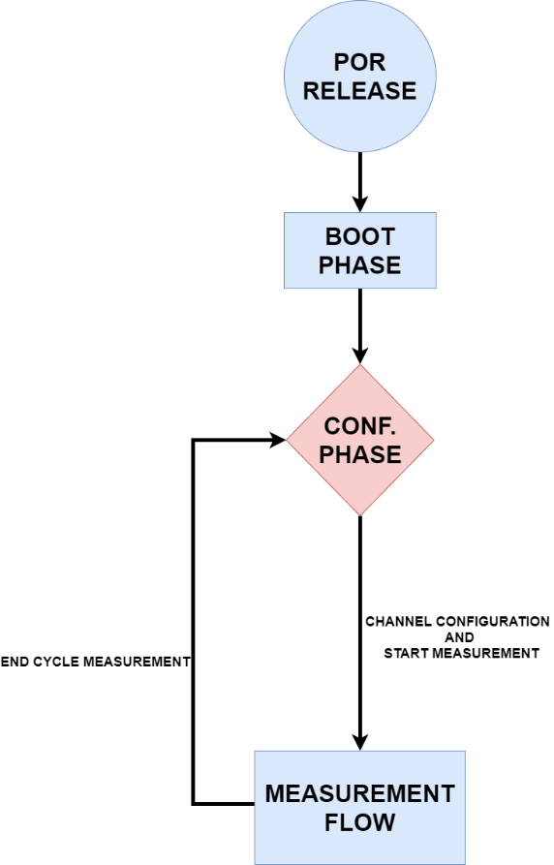
Figure 19: Device Activity Flowchart
In the next paragraphs, each phase will be explicated.

BOOT Phase

[DDS_STBIO1_0114] Requirement:
At the release of the POR signal from the analog domain, the PMU shall manage the turn-on of the LDO1V8 and starts clocks Start-Up Sequence (reported in PMU IPOS) [TO: IPOS_PMU] [END]
[DDS_STBIO1_0115] Requirement:
After At least 2 ms from the Release of the POR, the reset of the digital domain shall be de-asserted (an overlook on this part is described in the PMU IPOS) and the device shall start the Boot Phase [TO: IPOS_PMU] [END]
[DDS_STBIO1_0116] Requirement:
To check the end of the BOOT phase, the user shall read the main_controller_status_register (DEVICE_STATUS_REG register [2:0]) and follow these steps:
- Read the DEVICE_STATUS_REG [2:0]
- Check if the Value is 1 (BOOT phase still in process)
- If the value is 2, then the BOOT phase is ended and the device is in IDLE. [TO: IPOS_MAIN_CTRL] [END]

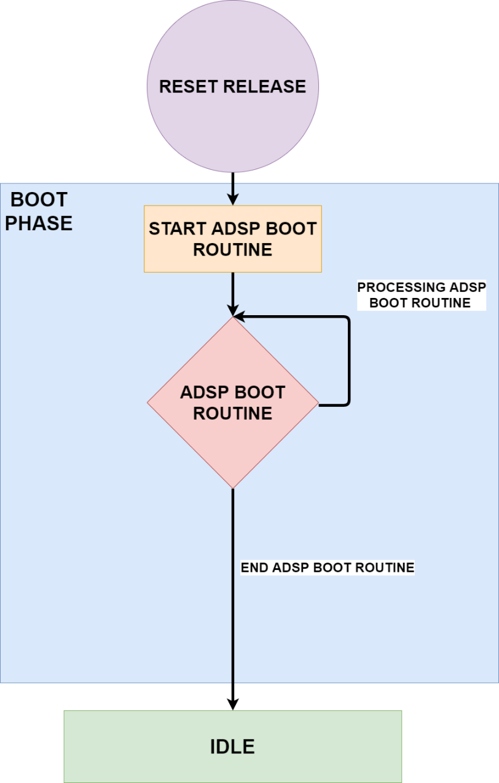
Figure 20: Boot Phase Flow

Configuration Phase

[DDS_STBIO1_ 0117] Requirement:
During the Configuration Phase (IDLE STATE of the Device_FSM), the user shall be able to:
- Configure Bio-Channel or Optical Channel, the ADC Calibration and then Start a measurement cycle.
- Put the device in Debug-Mode. [TO: IPOS_MAIN_CTRL] [END]

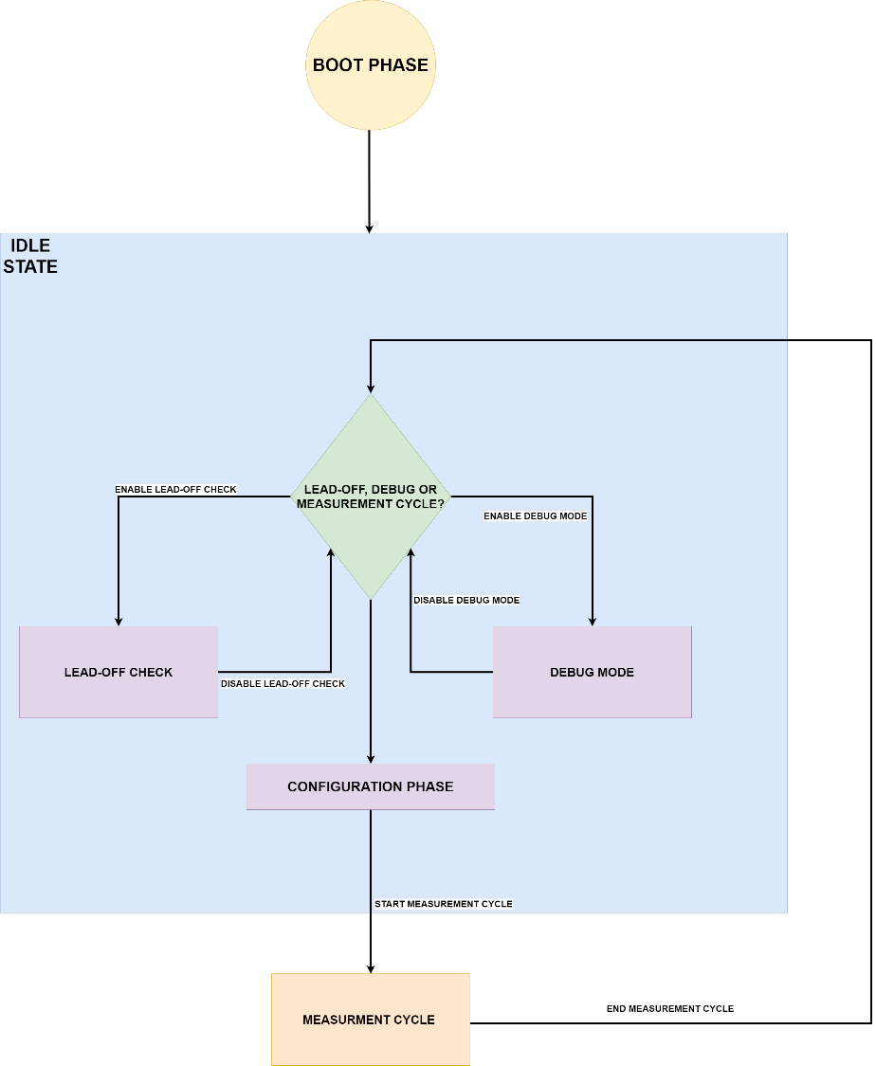
Figure 21: Configuration Phase Diagram
The start and the end of a Measurement Cycle is selected by the writing of the dedicated register as described in following examples.

Measurement Cycle
In this paragraph, different examples of Measurement Cycle will be analyzed to give the Application User an overview of the Device Workflow. All measurements will be performed in Data Storage Mode

ECG Only
This configuration generates each time slot, two averaged ECG data, which are ECG AC and ECG DC, respectively.

- TIME SLOT LENGTH:
[DDS_STBIO1_0118] Requirement:
  - The user shall configure time slot duration in DEVICE_CONFIG_OPERATION register [4:2] [TO: IPOS_MAIN_CTRL] [END]
- SELECT CHANNEL:
[DDS_STBIO1_0119] Requirement:
  - The user shall select active channel, in this case only ECG0_SEL and DS_SEL (Data Storage Mode) in DEVICE_CONFIG_CHANNEL register writing 0x21. [TO: IPOS_MAIN_CTRL] [END]
- SELECT DIVISION INDEX FOR CONFIGURED CHANNELS:
[DDS_STBIO1_0120] Requirement:
  - The user shall select a division index for ECG, configuring M_ECG_l and M_ECG_h in SET_ECG_FREQ_l register and SET_ECG_FREQ_h register. [TO: IPOS_MAIN_CTRL] [END]
- CONFIGURE ADC SAMPLING PERIOD:
[DDS_STBIO1_0121] Requirement:

  - The user shall set the number of clocks for sampling ECG data from ADC in ADC_CONFIG_ECG register. [TO: IPOS_MAIN_CTRL] [END]
- GENERAL CONFIG:
[DDS_STBIO1_0122] Requirement:
  - The User shall set at 1 HC_EN in ECG_CTRL register. [TO: IPOS_MAIN_CTRL] [END]
- SELECT OPERATIVE MODE:
[DDS_STBIO1_0123] Requirement:

  - The user shall start measurement writing register DEVICE_CONFIG_OPERATION [0] at 1. [TO: IPOS_MAIN_CTRL] [END]
- CHECK DATA:
[DDS_STBIO1_0124] Requirement:
  - To check data in unique FIFO (default config) the user shall check the first MSB which will have to be equal to the table in DATA TAG Table. [TO: IPOS_MAIN_CTRL] [END]

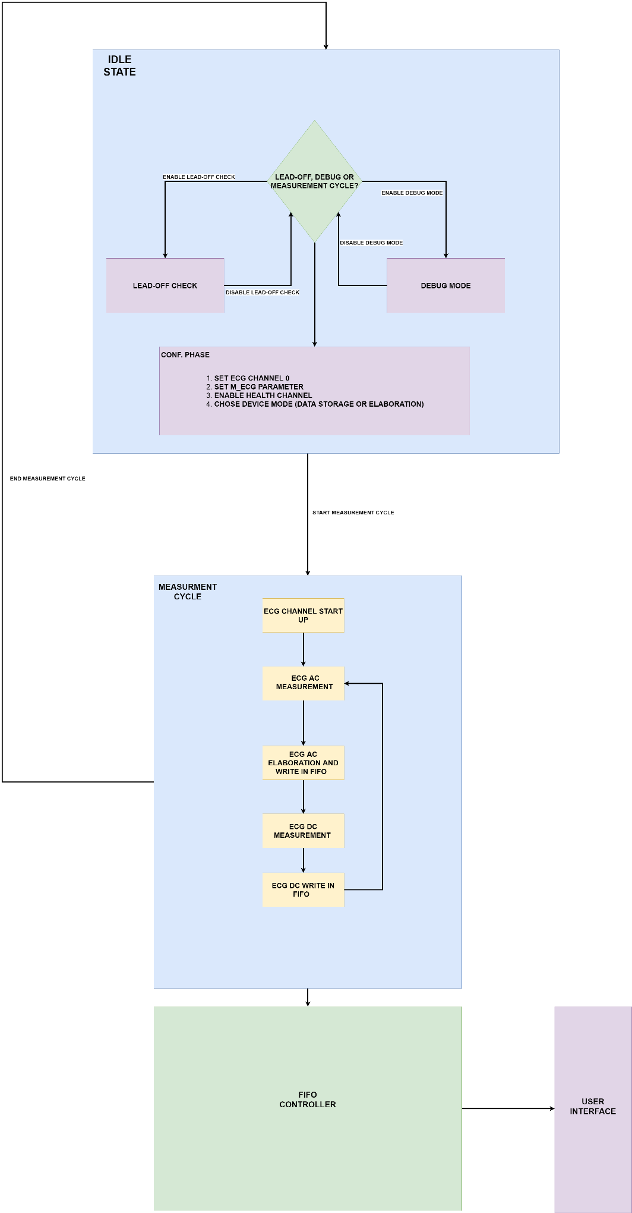
Figure 22: ECG ONLY FLOWCHART

ECG and BIA

This configuration generates each time slot, two averaged ECG data, which are ECG AC and ECG DC, respectively and four averaged BIA data which are BIA_AC_P, BIA_DC_P, BIA_AC_Q and BIA_DC_Q.

- TIME SLOT LENGTH:
[DDS_STBIO1_0125] Requirement:
- The user shall configure the time slot duration in DEVICE_CONFIG_OPERATION register [4:2]. [TO: IPOS_MAIN_CTRL] [END]
- SELECT CHANNEL:
[DDS_STBIO1_0126] Requirement:
- The user shall select active channel, in this case ECG0_SEL, BIA_SEL and DS_SEL (Data Storage Mode) in DEVICE_CONFIG_CHANNEL writing 0x23. [TO: IPOS_MAIN_CTRL] [END]
- SELECT DIVISION INDEX FOR CONFIGURED CHANNELS:
[DDS_STBIO1_0127] Requirement:
- The user shall select a division index for ECG, configuring M_ECG_l and M_ECG_h in SET_ECG_FREQ_l register and SET_ECG_FREQ_h register. [TO: IPOS_MAIN_CTRL] [END]
[DDS_STBIO1_0128] Requirement:
- The user shall select a division index for ECG, configuring M_BIA_l and M_BIA_h in
SET_BIA_FREQ_l register and SET_BIA_FREQ_h register. [TO: IPOS_MAIN_CTRL] [END]
- CONFIGURE ADC SAMPLING PERIOD:
[DDS_STBIO1_0129] Requirement:
- The user shall set number of clocks for sampling ECG and BIA data from ADC in ADC_CONFIG_ECG register. [TO: IPOS_MAIN_CTRL] [END]
- GENERAL CONFIG:
[DDS_STBIO1_0130] Requirement:
- The user shall set at 1 HC_EN in ECG_CTRL register. [TO: IPOS_MAIN_CTRL] [END]
[DDS_STBIO1_0140] Requirement:
- The user shall set at 1 IMP_EN in IMP_CTRL register. [TO: IPOS_MAIN_CTRL] [END]
- SELECT OPERATIVE MODE:
[DDS_STBIO1_0141] Requirement:
  - The user shall start measurement writing register DEVICE_CONFIG_OPERATION [0] at 1. [TO: IPOS_MAIN_CTRL] [END]
- CHECK DATA:
[DDS_STBIO1_0142] Requirement:
- To check data in unique FIFO (default config) the user shall check the first MSB which will have to be equal to the one described in the DATA TAG Table. [TO: IPOS_MAIN_CTRL] [END]
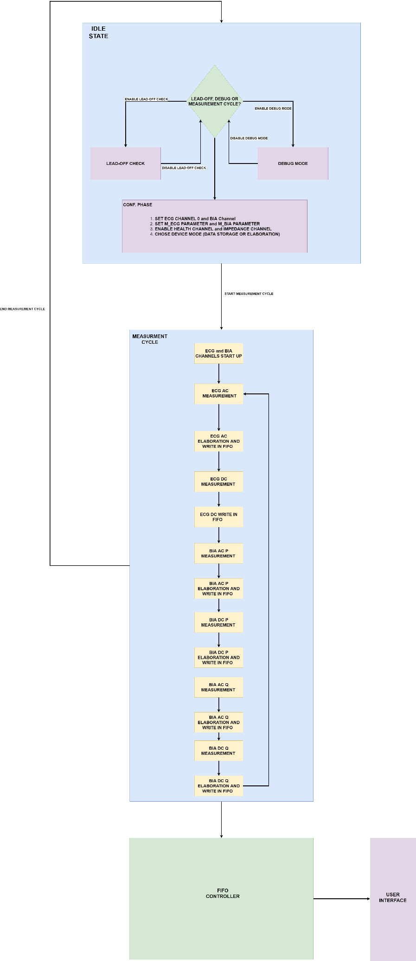
Figure 23: ECG and BIA Measurement Flowchart

PPG Only

This configuration generates each time slot, a number of PPG DATA according to user configuration.

- TIME SLOT LENGTH:
[DDS_STBIO1_0143] Requirement:
  - The User shall configure time slot duration in DEVICE_CONFIG_OPERATION register [4:2].
- SELECT CHANNEL:
[DDS_STBIO1_0144] Requirement:
  - The user shall select active channel, in this case only PPG_SEL and DS_SEL (data Storage) in DEVICE_CONFIG_CHANNEL register shall be set to 0x30.
- SELECT DIVISION INDEX FOR CONFIGURED CHANNELS:
[DDS_STBIO1_0145] Requirement:
  - The user shall configure a division index PPG, writing M_PPG_l and M_PPG_h in SET_PPG_FREQ_l register and SET_PPG_FREQ_h register.
- CONFIGURE ADC SAMPLING PERIOD:
[DDS_STBIO1_0146] Requirement:
  - The user shall configure the number of clocks for sampling PPG data from ADC in ADC_CONFIG_PPG register.
- PPG FRAMES CONFIG:
[DDS_STBIO1_0147] Requirement:
The user shall configure each frame following these steps:
  - ALC PARAMETERS:
  - T1 in PPG_ALC_CONFIG_PARAM_1 register.
  - T2, GAIN_START_SET, GAIN_MAX_SET in PPG_ALC_CONFIG_PARAM_2 register.
  - DIGITAL RAMP PARAMETERS:
- N_MAX, T_DELTA in DIGITAL_RAMP_CONFIG_PARAM_1 register.
- DELTA, T_DELTA1 in DIGITAL_RAMP_CONFIG_PARAM_2 register.
- DELTA1 in DIGITAL_RAMP_CONFIG_PARAM_3 register.
  - GENERAL PPG PARAMETERS:
- N_PPG_FRAME, WAVE_VELOCITY_MODE, SEL_PPG_ELAB in GENERAL_PPG_PARAMETERS_1 register.
- T_TX_STARTUP in GENERAL_PPG_PARAMETERS_2 register.
- T_RX_SET, PPG_START_UP_TIME_l in GENERAL_PPG_PARAMETERS_3 register.
- PPG_START_UP_TIME_h in GENERAL_PPG_PARAMETERS_4 register.
  - PARAMETERS FOR EACH FRAME CONFIGURED BY USER:
- RX_CH_FRAME_{n}, FRAME_{n}_SAMPLES, FRAME_{n}_REPETITION in FRAME_n_PARAMETERS_1 register.
- BTIA_GAIN_FRAME_{n}, TX_LEDSET_FRAME_l_{n} in FRAME_n_PARAMETERS_2 register.
- TX_LEDSET_FRAME_h_{n}, TX_LEDOFF_FRAME_l_{n} in FRAME_n_PARAMETERS_3 register.
- TX_LEDOFF_FRAME_h_{n} in FRAME_n_PARAMETERS_4 register.
- IDAC_DC_PPG_FRAME_{n} in FRAME_n_PARAMETERS_5 register.
- EN_TX_i in FRAME_n_PARAMETERS_6 register.
- CURR_SEL_TX_FRAME{n} in FRAME_n_PARAMETERS_7 register.
- TX1_OUTAB_SEL_FRAME_{n}, TX2_OUTAB_SEL_FRAME_{n}, TX3_OUTAB_SEL_FRAME_{n}, TX4_OUTAB_SEL_FRAME_{n} in FRAME_n_PARAMETERS_10 register.
- SELECT OPERATIVE MODE:
[DDS_STBIO1_0148] Requirement:
- The user shall write DEVICE_CONFIG_OPERATION register [0] at 1.
- CHECK DATA:
[DDS_STBIO1_0149] Requirement:
- To check data in unique FIFO (default config) the user shall check the first MSB. PPG DATA has 20 bits of data and 4 of TAG. The 4 bits, from 0 to 11, are used to identify the frame (as described in the table in DATA TAG table).
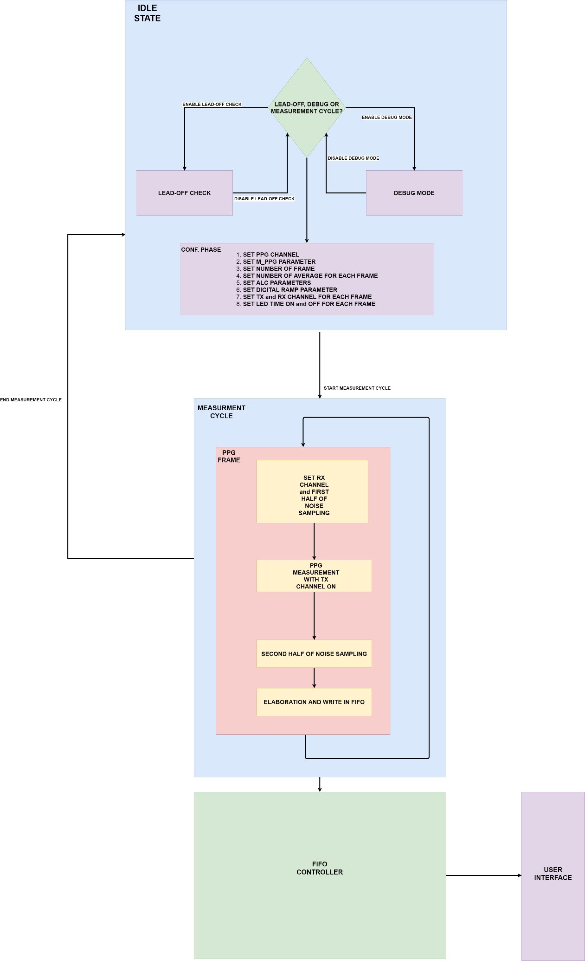
Figure 24: PPG Measurement Flowchart

SCAN

Top Level Approach
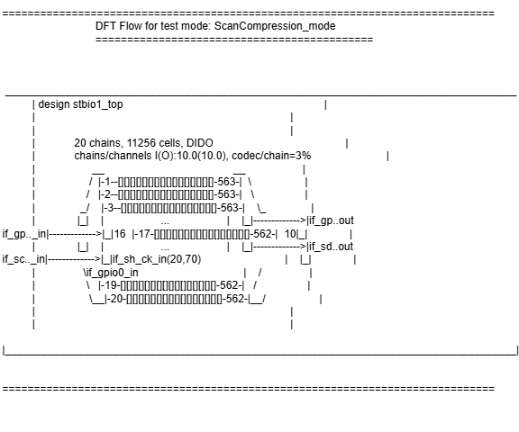

OUTPUT
- Scan out 1 (GPIO3/PMBF)
- Scan out 2 (SDA_SDI)
INPUT FROM PADS
- Scan in 1 (GPIO4/PMBS)
- Scan in 2 (SCLK)
- Scan clk (SH_CK)
- Scan en (GPIO0)
- Scan reset (CS)

INPUT FROM REGISTER
- Scan mode (ADDRESS=0x3E, BIT=0x01)
- SCAN_COMPR_EN (ADDRESS=0x3E, BIT=0x02)

ANALOG PADS:
- sense internal V1V2 (GPIO1)
- force = V1V2 SUPPLY (GPIO2)
- T_force_v1v2 (SH_SDA)

BIST

Reference documents
Current Version | Document | Author | Change Description
1.0-17.00 | /prj/ams_DELIVERIES/H9A_STBIO1/memorycuts/H9A_STBIO1--GenericMBIST_CONFIG--BIST_STBIO1/1.0-17.00/  /doc/ref_manual/generic_mbist_um.pdf | STMicroelectronics TRnD | User manual, release notes and KPS for the GenericMBIST
1.0-17.00 | /prj/ams_DELIVERIES/H9A_STBIO1/memorycuts/H9A_STBIO1--GenericMBIST_CONFIG--BIST_STBIO1/1.0-17.00/  /doc/user_manual/generic_mbist_rm.pdf | STMicroelectronics TRnD | Reference manual for the GenericMBIST

Memory BIST Architecture
The BIST solution consists of memory-wrapper “collar” and common master “controller” and an IEEE 1149.1 compliant Test Access Port (TAP).

MBIST Collar
The BIST collar is a wrapper which is placed closest to memory. It executes the instructions received from controller in the form of march elements to test the memory. It runs at the speed of the memory under test.
After testing it reports the execution status to the controller and manages all the BIST status, diagnosis, repair information and debug data. The collar also provides support for testing multiple memories in parallel or in sequential order.

MBIST Controller
The controller acts as an interface between the collars and the user. All user BIST control is done through the controller. The controller controls various testing and reporting activities of the memory test. It allows various mode selections and programs the pre-stored synthesized algorithms instructions into collars attached to it.

Main functionalities of controller are:
• Mode management (RunBIST mode, Retention mode etc.)
• Program the configurable collar with default algorithms, march element by march element and initiate the activities on memory through collars by launching the march run.
• Compute the Global status based on the individual status from the collar.

TAP
• It includes a TAP controller, a 7-bit instruction register, three test data registers, and the bypass register.
• This responds to the control sequences supplied through the test access port (TAP) and generates the control signals required for BIST operation

Top Level Approach
Figure 66: Top Level Controller Configuration
In this configuration, there is only one controller for the entire chip. All associated collars are spread into the design (at top level and within subblocks)
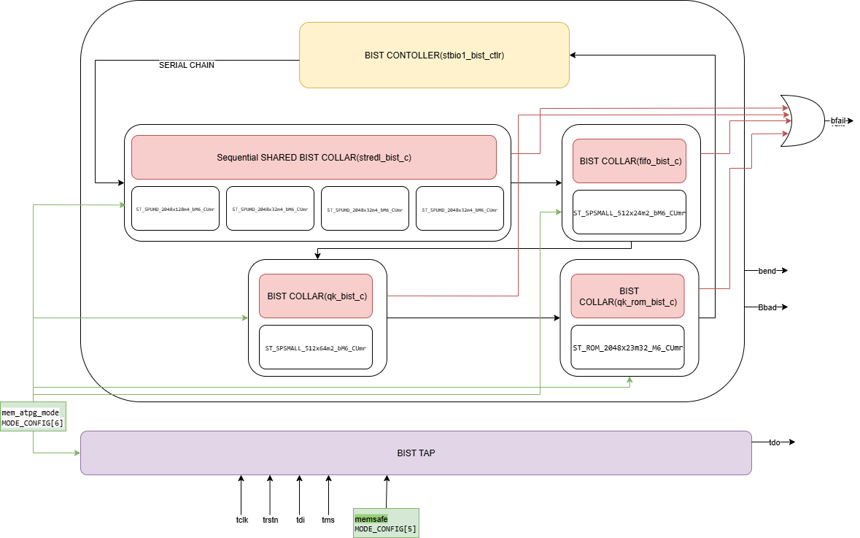
Figure 25 Top Level Controller Configuration
OUTPUT
- Bend: Indicates that all the activities of the test run of all Memories in the current BIST mode are complete
- Bfail: Indicates bfail for a specific memory. There are as many bfail signals as the number of memories. Bfail also goes high at the first cycle of each march element run. This pulse should be used as a reference in clk_m domain to calculate the number of cycles after which bfail went high in case of a failure in a specific march sequence run.
- Tdo:TAP serial output Updated on falling edge of tck
INPUT FROM PAD
- Tck: TAP clock
- Tdi: TAP serial input Sampled on rising edge of tck
- Tms: TAP test mode select Sampled on rising edge of tck
- Trstn: TAP reset
INPUT FROM REGISTER
- Memsafe (ADDRESS=0x3E, BIT=0x05): to globally deactivate the memory by making CSN high internally
- Mem_atpg_mode (ADDRESS=0x3E, BIT=0x06): Used to constraint few memory inputs and improve controllability and observability.
ANALOG PADS:
- sense internal V1V2 (GPIO1)
- force = V1V2 SUPPLY (GPIO2)

Digital DFT

Scan mode
[DDS_STBIO1_0699] Requirement:
After the initial boot phase, only with SPI interface, to turn on the Scan mode shall be:
- Select page 3 of the regmap (ADDRESS=0x40, DATA=0x03)
- Enable LDO 1V8 by writing to regmap VIREF_LDO1V8_CLK16M register (ADDRESS=0x0F, DATA=0x02)
- Enable clock by writing to regmap VIREF_LDO1V8_CLK16M register (ADDRESS=0x0F, DATA=0x12)
- Enable debug mode by writing to regmap (ADDRESS=0x3E, DATA=0x01)
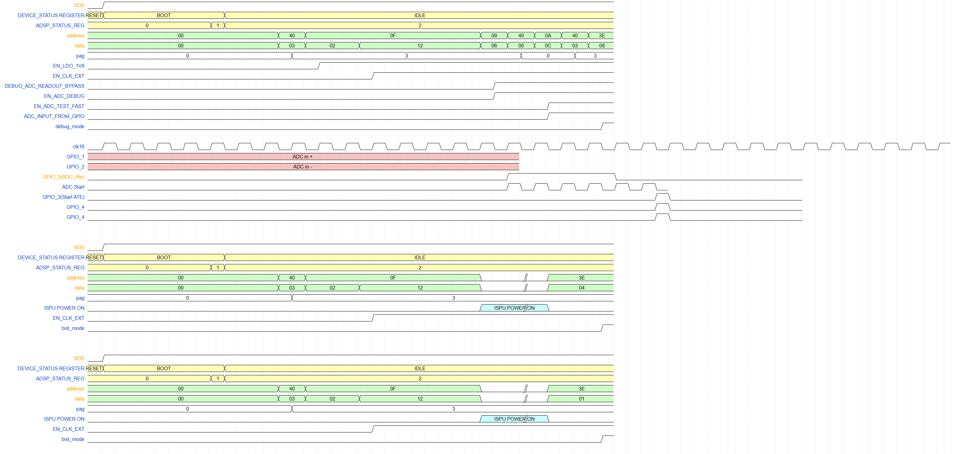
Figure 26 scan mode activation timing
[End]

Debug mode
[DDS_STBIO1_0700] Requirement:
After the initial boot phase, to turn on the Debug mode shall be:
- Select page 3 of the regmap (ADDRESS=0x40, DATA=0x03)
- Enable LDO 1V8 by writing to regmap VIREF_LDO1V8_CLK16M register (ADDRESS=0x0F, DATA=0x02)
- Enable clock by writing to regmap VIREF_LDO1V8_CLK16M register (ADDRESS=0x0F, DATA=0x12)
- Enable debug mode by writing to regmap (ADDRESS=0x3E, DATA=0x08)
[End]

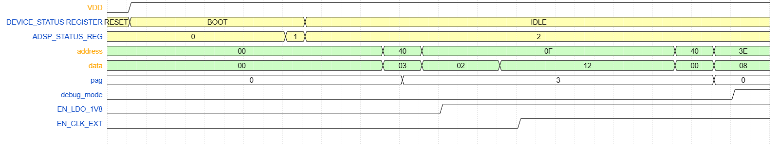
Figure 27 debug mode activation timing

ADC TEST LOW NOISE
[DDS_STBIO1_0701] Requirement:
To turn on the ADC TEST LOW NOISE mode shall be:
- Select page 3 of the regmap (ADDRESS=0x40, DATA=0x03)
- Enable LDO 1V8 by writing to regmap VIREF_LDO1V8_CLK16M register (ADDRESS=0xF, DATA=0x02)
- Enable clock by writing to regmap VIREF_LDO1V8_CLK16M register (ADDRESS=0x0F, DATA=0x12)
- Enable ADC in debug mode (ADDRESS=0x09, DATA=0x06)
- Select page 2 of the regmap (ADDRESS=0x40, DATA=0x02)
- Enable ADC TEST LOW NOISE and input of ADC from GPIO (ADDRESS=0x0A, DATA=0x14)
- Select page 3 of the regmap (ADDRESS=0x40, DATA=0x02)
- Enable debug mode by writing to regmap (ADDRESS=0x3E, DATA=0x08)

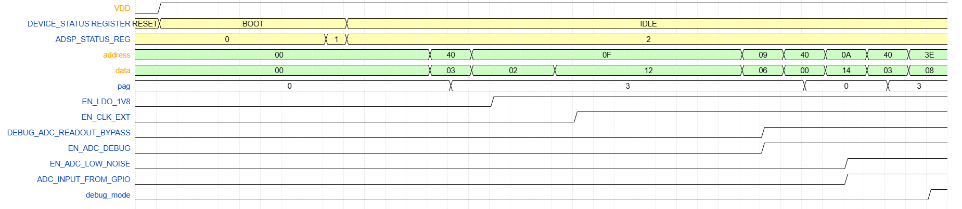
[End]

[DDS_STBIO1_0702] Requirement:
To turn on the ADC TEST LOW NOISE mode shall be:
- Select page 3 of the regmap (ADDRESS=0x40, DATA=0x03)
- Enable LDO 1V8 by writing to regmap VIREF_LDO1V8_CLK16M register (ADDRESS=0xF, DATA=0x02)
- Enable clock by writing to regmap VIREF_LDO1V8_CLK16M register (ADDRESS=0x0F, DATA=0x12)
- Enable ADC in debug mode (ADDRESS=0x09, DATA=0x06)
- Select page 2 of the regmap (ADDRESS=0x40, DATA=0x02)
- Enable ADC TEST LOW NOISE and input of ADC from GPIO (ADDRESS=0x0A, DATA=0x14)
- Select page 3 of the regmap (ADDRESS=0x40, DATA=0x02)
- Enable debug mode by writing to regmap (ADDRESS=0x3E, DATA=0x08)

[End]

ADC TEST FAST
[DDS_STBIO1_1507] Requirement:
To turn on the ADC TEST LOW NOISE mode shall be:
- Select page 3 of the regmap (ADDRESS=0x40, DATA=0x03)
- Enable LDO 1V8 by writing to regmap VIREF_LDO1V8_CLK16M register (ADDRESS=0xF, DATA=0x02)
- Enable clock by writing to regmap VIREF_LDO1V8_CLK16M register (ADDRESS=0x0F, DATA=0x12)
- Enable ADC in debug mode (ADDRESS=0x09, DATA=0x06)
- Select page 2 of the regmap (ADDRESS=0x40, DATA=0x02)
- Enable ADC TEST LOW NOISE and input of ADC from GPIO (ADDRESS=0x0A, DATA=0x0C)
- Select page 3 of the regmap (ADDRESS=0x40, DATA=0x02)
- Enable debug mode by writing to regmap (ADDRESS=0x3E, DATA=0x08)

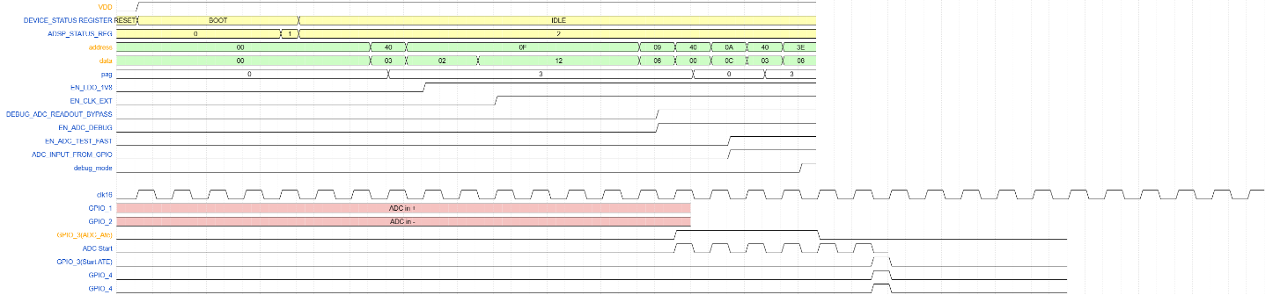

[End]

BIST MODE
[DDS_STBIO1_2507] Requirement:
After the initial boot phase, to turn on the Debug mode shall be:
- Select page 3 of the regmap (ADDRESS=0x40, DATA=0x03)
- Enable LDO 1V8 by writing to regmap VIREF_LDO1V8_CLK16M register (ADDRESS=0x0F, DATA=0x02)
- Enable clock by writing to regmap VIREF_LDO1V8_CLK16M register (ADDRESS=0x0F, DATA=0x12)
- Enable the power island [DDS_STBIO1_0507]
- Enable bist mode by writing to regmap (ADDRESS=0x3E, DATA=0x04)

[End]

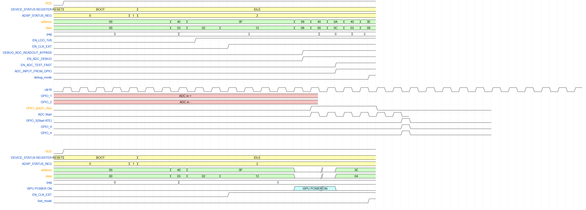
Figure 28 bist mode activation timing

References

- ADSP Document: ADSP micro Firmware

