VIETNAM GENERAL CONFEDERATION OF LABOUR
TON DUC THANG UNIVERSITY
FACULTY OF INFORMATION TECHNOLOGY



BUI PHUONG NAM – 522H0002,
BUI NGOC HIEU – 523H0027,
NGUYEN BAO MINH – 523H0054

QR ATTENDANCE SYSTEM

END-TERM PROJECT

SERVICE-ORIENTED ARCHITECTURE

HO CHI MINH CITY, 2025

VIETNAM GENERAL CONFEDERATION OF LABOUR
TON DUC THANG UNIVERSITY
FACULTY OF INFORMATION TECHNOLOGY



BUI PHUONG NAM – 522H0002,
BUI NGOC HIEU – 523H0027,
NGUYEN BAO MINH – 523H0054

QR ATTENDANCE SYSTEM

END-TERM PROJECT

SERVICE-ORIENTED ARCHITECTURE

Instructor
M.Sc. DUONG HUU PHUC

HO CHI MINH CITY, 2025

ACKNOWLEDGMENT

We sincerely thank M.Sc. Duong Huu Phuc, our instructor, for his valuable guidance, encouragement, and continuous support throughout the completion of this mid-term project. His expertise and insightful feedback have been a great source of learning and motivation for us.

We are also thankful to our teammates for their collaboration and contributions, which made this project possible. Finally, we sincerely appreciate Ton Duc Thang University – Faculty of Information Technology for providing us with the knowledge and resources to apply what we have learned into practice.

Ho Chi Minh City, August 25th, 2025
Author

Bui Phuong Nam
Nguyen Bao Minh
Bui Ngoc Hieu

THE PROJECT HAS BEEN ACCOMPLISHED
AT TON DUC THANG UNIVERSITY

We hereby declare that this project was carried out by our team under the guidance and supervision of M.Sc. Duong Huu Phuc. The work presented and the results contained in this project are true and have not been either submitted anywhere for any previous purpose or published in any other literature. The data and figures presented in this project are for analysis, comments, and evaluations from various resources by my own work and have been fully acknowledged in the reference part.
In addition, other comments, reviews and data from other authors, and organizations used in this project have been acknowledged, and explicitly cited.
We will take full responsibility for any fraud detected in our project. Ton Duc Thang University is unrelated to any copyright infringement caused on my work (if any).

Ho Chi Minh City, August 25th, 2025
Author

Bui Phuong Nam
Nguyen Bao Minh
Bui Ngoc Hieu

TABLE OF CONTENTS

CHAPTER 1: SYSTEM OVERVIEW 7
1.1 - Introduction to the topic 7
1.2 - System Specification 7
1.3 - Scope of the project 8
1.3.1 - Object and function limitations 8
1.3.2 - Limitations on technology 8
1.4 - Practical significance 9
CHAPTER 2: SYSTEM ANALYSIS AND DESIGN 10
2.1 - System Functional Requirements 10
2.2 - Non-functional requirements of the system 10
2.3 - System Function Schema 11
2.3.1 - Use-case scheme 11
2.3.2 - Use-case specification 11
2.4 - System Database Schema 19
2.4.1 - ERD Schema 19
2.4.2 - Physical-level DB schema 20
3.1 - Technology stack overview 22
3.2 - List of APIs 23
3.2.1 - Login 23
3.2.2 - Get Current User 23
3.2.3 - Check-in by QR Code 24
3.2.4 - Check-in by OTP and Photo 25
3.2.5 - Get Session Attendances 26
3.2.6 - Approve Attendance 27
3.2.7 - Reject Attendance 28
3.2.8 – Get Class Attendance Report 28
3.2.9 – Get All Classes Attendance Report 29
3.2.10 – Create Session 30
3.2.11 – Update Session 31
3.2.12 – Get Session by ID 32
3.2.13 – Get Session by Public Code 33
3.2.14 – Get QR Token 33
3.2.15 – Get OTP 34
3.2.16 – Delete Session by ID 35
3.2.17 – Delete Session by Code 35
3.2.18 – Get All Classes 36
3.2.19 – Create Class 37
3.2.20 – Get Class by ID 37
3.2.21 – Enroll Students 39
3.2.22 – Get Upload File 39
CHAPTER 4: SYSTEM DEMO 40
4.1 - System demo scenarios 40
4.2 - System demo 40
REFERENCES 47
APPENDIX A – LIST OF REQUIREMENTS ELICITATION QUESTIONS 48

LIST OF FIGURES

Figure 1 General Use case 11
Figure 2 Physical-level DB schema 21
Figure 3 Login page 41
Figure 4 Admin Homepage 42
Figure 5 Student Homepage (QR scan) 42
Figure 6 Student Homepage (OTP + Picture check) 43
Figure 7 Lecturer dashboard 43
Figure 8 Create new class 44
Figure 9 Create new session 44
Figure 10 View session 45
Figure 11 Display QR and OTP (maximize) 45
Figure 12 View attendance list 46

CHAPTER 1: SYSTEM OVERVIEW

1.1 - Introduction to the topic
The QR Attendance System modernizes attendance management for schools by combining dynamic QR codes with GPS geofencing to validate every check-in. Rotating QR tokens, OTP fallbacks, and watermarked photo verification closes the door on spoofing or proxy attendance. Designed under Service-Oriented Architecture principles, the platform splits responsibilities across specialized services—authentication, session control, and attendance processing—so modules can scale independently and stay maintainable as the project grows.

1.2 - System Specification
The system pairs a NestJS backend - organized into modular services - with a React/Vite/TypeScript frontend. Core services include:
- Authentication: JWT login with STUDENT, LECTURER, ADMIN roles.
- Class management: class creation plus enrollment logic.
- Session management: sessions expose public codes while issuing rotating QR tokens every 60 s and OTPs every 30 s.
- Attendance: check-ins via QR or OTP, backed by GPS validation and photo submissions.
- Evidence: watermarks and persists photo proof.

Roles behave as follows:
- Students check in through QR (GPS required) or OTP plus photo.
- Lecturers manage classes/sessions and review attendance with attached evidence.
- Admins supervise user administration and reporting.

Data lives in PostgreSQL via Prisma ORM. Docker Compose orchestrates the containers, and production deployments run on defined domains with HTTPS enforcement, so browser camera/GPS features work reliably. RESTful JSON APIs bridge frontend and backend, secured by JWT headers, with typical ports such as 8080 for the backend and 3000 for the frontend. This architecture keeps the attendance workflow scalable, secure, and resistant to fraud.

1.3 - Scope of the project

1.3.1 - Object and function limitations
The system targets university classroom attendance and is limited to Students (e.g., IDs like 523H0001), lecturers, and admins.
About the functions, the project contains following core’s function
- User authentication
- class/session creation
- QR/OTP-based attendance with GPS validation
- photo evidence
- and basic reporting.
Limitations exclude advanced features like Integration with external systems (e.g., university LMS), advanced analytics, or support for non-educational use cases. The system assumes a single institution and does not include features like real-time notifications, or large-scale events exceeding 100 participants per session or multi-language support beyond Vietnamese/English.

1.3.2 - Limitations on technology
The backend combines NestJS with Prisma ORM in a modular-but-monolithic structure: services stay neatly separated within the codebase, yet everything ships as a single deployable package instead of independent microservices. Data persists exclusively in PostgreSQL - no PostGIS or alternate stores - so every feature relies on standard relational capabilities. The React/Vite/TypeScript frontend taps browser APIs for QR scanning and GPS, which makes HTTPS a requirement and can expose compatibility gaps on older devices. Deployments run through Docker Compose on managed hosts, without cloud orchestration or auto-scaling layers, so capacity is tuned for small to mid-sized cohorts. Security centers on JWT-based authentication and role-aware authorization; there’s no multi-factor step or advanced crypto. Altogether the stack prioritizes clarity and maintainability for moderate workloads over elastic, high-concurrency infrastructure.

1.4 - Practical significance
This system enhances efficiency by automating attendance, reducing errors, and deterring fraud via geofencing and evidence. It supports educational institutions like Ton Duc Thang University in digitizing processes, allowing lecturers more teaching time and providing verifiable data for administration. Overall, it advances smart education by promoting sustainability (paperless) and data accuracy.

CHAPTER 2: SYSTEM ANALYSIS AND DESIGN

2.1 - System Functional Requirements
Functional coverage spans the full attendance lifecycle. Authentication delivers secure logins and issues JWT tokens scoped to each role. User management maintains profiles and ties students to their classes. Lecturers handle class creation and enrollment through structured DTOs. Session management captures session metadata—title, schedule, location, geofence, publicCode - and spins up rotating QR (every 60 s) and OTP (every 30 s) tokens. Attendance flow lets students check in via QR with GPS validation or OTP plus a watermarked photo, preserving method, status, and coordinates. Evidence handling stores those watermarked images alongside attendance records. Viewing tools give lecturers complete session rosters with their associated proof. End to end, the workflow runs Authentication → Management → Check-in → Validation → Viewing.

2.2 - Non-functional requirements of the system
The system meets these non-functional requirements:
- Performance: It crucial that API latency under 1 second and QR/OTP timers (60s/30s) for real-time security.
- Security: There will be mechanisms to mandate HTTPS, server-side validations, and watermarks to prevent tampering.
- Usability: some role-specific UIs must be provided (e.g., student scan page, teacher dashboard) that are mobile-responsive.
- Scalability: It is important to leverage modular NestJS for potential microservices and Prisma for efficient queries.
- Reliability: the system includes error handling for GPS/OTP failures and logging in the backend.
- Maintainability: TypeScript for typing and Docker for reproducibility. Compatibility supports modern browsers with device permissions for camera/GPS.

2.3 - System Function Schema

2.3.1 - Use-case scheme

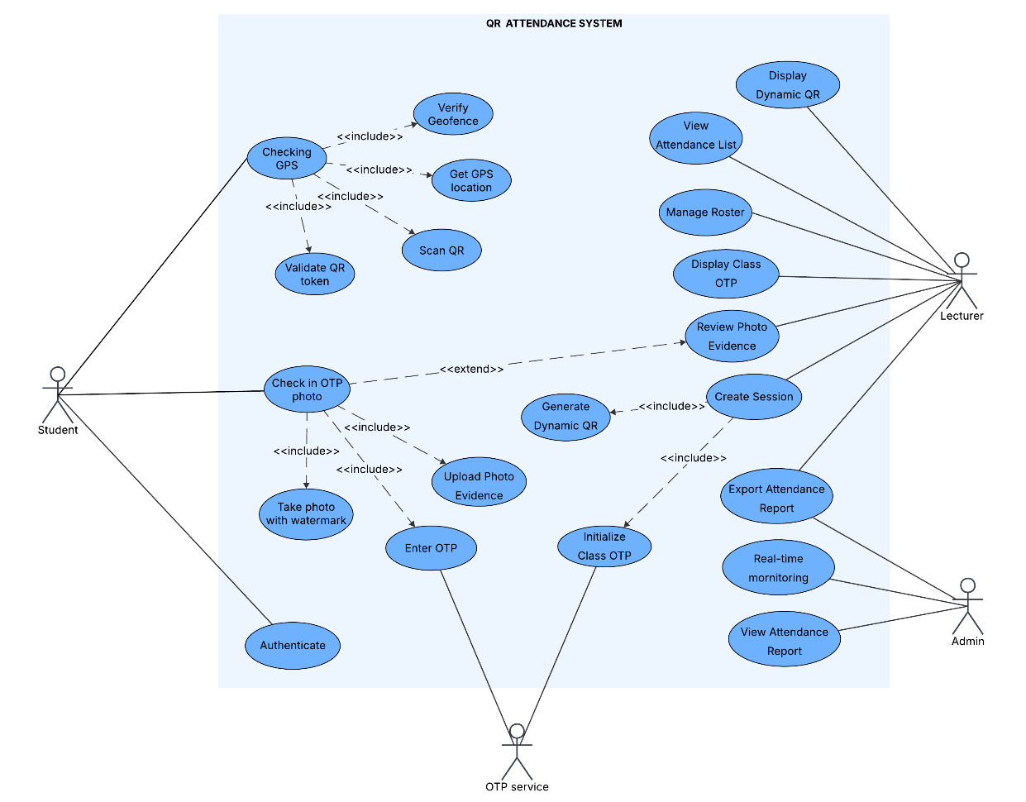

Figure 1: General Use case

2.3.2 - Use-case specification

2.3.2.1 - Authenticate

Use Case Name | Authenticate
Actor | Student
Related Use Case | None
Brief Description | Student authenticates to access the system with credentials.
Preconditions | Student has an account in the system.
Postconditions | Authenticated successfully with JWT token issued.
Flow of events | - Student: Enters login credentials (username, password).  - System: Receives credentials and checks them against stored data.  - Student: Submits credentials.  - System: Verifies credentials and issues JWT token if correct.
Exception/Error | Invalid credentials  Student enters invalid credentials.  System rejects login and displays error message.

2.3.2.2 - Checking GPS

Use Case Name | Checking GPS
Actor | Student
Related Use Case | - Get GPS Location (“Checking GPS” include “Get GPS Location”)  - Verify Geofence (“Checking GPS” include “Verify Geofence”).  - Scan QR (“Checking GPS” include “Scan QR”).  - Validate QR Token (“Checking GPS” include “Validate QR Token”).
Brief Description | Student checks in with GPS location for geofence validation during QR attendance.
Preconditions | Student is authenticated and session is active.
Postconditions | GPS location verified within geofence, enabling attendance recording.
Flow of events | - Student: Initiates QR check-in process.  - System: Prompts for camera and GPS access.  - Student: Scans QR and grants GPS permission.  - System: Extracts token and receives location data (latitude, longitude).  - System: Validates token and geofence using Haversine formula.  - System: Confirms validity and records attendance.
Exception/Error | GPS outside geofence or invalid token  Student receives error;  System rejects and suggests OTP fallback.

2.3.2.3 - Check in OTP photo

Use Case Name | Check in OTP photo
Actor | Student
Related Use Cases | - Upload Photo (“Check in OTP photo” include “Upload Photo”).  - Review Photo Evidence (“Check in OTP photo” include “Review Photo Evidence”).  - Enter OTP (“Check in OTP photo” include “Enter OTP”).  - Take photo with watermark (“Check in OTP photo” include “Take photo with watermark”).
Brief Description | Student checks in using OTP and photo as fallback, with watermark applied.
Preconditions | Student is authenticated and session is active.
Postconditions | Attendance recorded with watermarked photo evidence.
Flow of events | - Student: Enters OTP value.  - Student: Takes photo with device camera.  - System: Applies watermark (student Code, public Code, OTP, timestamp) server-side.  - Student: Reviews and uploads photo.  - System: Validates OTP against session OTP Secret and stores evidence.  - System: Records attendance.
Exception/Errors | Invalid OTP or photo issue  Student receives error.  System rejects submission and prompts retry.

2.3.2.4 - Display Dynamic QR

Use Case Name | Display Dynamic QR
Actor | Lecturer
Related Use Case | None
Brief Description | Lecturer displays the dynamic QR code for student scanning.
Preconditions | Lecturer is authenticated and session is active.
Postconditions | Dynamic QR displayed and rotating every 60 seconds.
Flow of events | 1. Lecturer: Selects session in dashboard.  2. Lecturer: Requests QR display.  3. System: Generates current QR token.  4. System: Displays QR in UI and starts rotation timer.
Exception/Error | Session inactive.  Lecturer sees error.  System prompts session activation.

2.3.2.5 - Manage Roster

Use Case Name | Manage Roster
Actor | Lecturer
Related Use Case | None
Brief Description | Lecturer manages the student roster for a class.
Preconditions | Lecturer is authenticated and class exists.
Postconditions | Roster updated with enrolled students.
Flow of events | 1. Lecturer: Selects class in dashboard.  2. Lecturer: Adds or removes student IDs.  3. System: Validates student existence.  4. System: Updates enrollment table.
Exception/Error | Invalid student ID.  Lecturer sees error.  System prompts valid input.

2.3.2.6 - Display Class OTP

Use Case Name | Display Class OTP
Actor | Lecturer
Related Use Case | None
Brief Description | Lecturer displays the class OTP for student use.
Preconditions | Lecturer is authenticated and session is active.
Postconditions | OTP displayed and rotating every 30 seconds.
Flow of events | 1. Lecturer: Selects session.  2. Lecturer: Requests OTP display.  3. System: Initializes OTP secret if needed.  4. System: Generates current OTP.  5. System: Displays OTP in UI and starts rotation timer.
Exception/Error | Session inactive.  Lecturer sees error.  System prompts activation.

2.3.2.7 - Create Session

Use Case Name | Create Session
Actor | Lecturer
Related Use Case | - Generate Dynamic QR (Create Session include Generate Dynamic QR)  - Initialize Class OTP (Create Session include Initialize Class OTP)
Brief Description | Lecturer creates a new session for attendance tracking.
Preconditions | Lecturer is authenticated.
Postconditions | Session created and active, with QR/OTP initialized.
Flow of events | 1. Lecturer: Submits session details (title, times, latitude/longitude/radius, public Code).  2. Lecturer: Confirms creation.  3. System: Validates input and creates session record.  4. System: Initializes QR/OTP generation and timers.
Exception/Error | Invalid details.  Lecturer sees validation error.  System prompts corrections.

2.3.2.8 - Export Attendance Report

Use Case Name | Export Attendance Report
Actor | Admin
Related Use Case | None
Brief Description | Admin exports attendance reports for analysis.
Preconditions | Admin is authenticated and data exists.
Postconditions | Report exported as CSV or similar format.
Flow of events | 1. Admin: Selects class or session.  2. Admin: Requests export.  3. System: Queries aggregated attendance data.  4. System: Generates and provides report file.
Exception/Error | No data.  Admin sees warning.  System exports empty report.

2.3.2.9 - Review Photo Evidence

Use Case Name | Review Photo Evidence
Actor | Lecturer
Related Use Case | None
Brief Description | Lecturer reviews the captured photo evidence of student before submission.
Preconditions | Photo has been taken and watermarked.
Postconditions | Photo reviewed and approved for upload.
Flow of events | 1. Lecturer: Views the watermarked photo in UI preview.  2. System: Displays photo with watermark.  3. Lecturer: Approves or retakes photo.  4. System: Proceeds to upload if approved.
Exception/Error | Photo unsatisfactory.  Student retakes photo.  System discards current photo and restarts capture.

2.3.2.10 - View Attendance Report

Use Case Name | View Attendance Report
Actor | Admin
Related Use Case | None
Brief Description | The admin accesses and views comprehensive aggregated attendance reports for selected classes, sessions, or time periods, including detailed summaries of attendance statuses.
Preconditions | Admin is authenticated and data exists in the system.
Postconditions | Report is displayed with summaries and export options.
Flow of events | 1. Admin: Selects session(s) in dashboard.  2. Admin: Activates monitoring mode.  3. System: Establishes connection (WebSocket/polling) for updates.  4. System: Displays incoming check-ins, statuses, and alerts.
Exception/Error | No data available.  Admin sees "No records found" message.  System prompts to select different criteria.

2.3.2.11 - Real-time Monitoring

Use Case Name | Real-time Monitoring
Actor | Admin
Related Use Case | None
Brief Description | Admin monitors ongoing sessions and attendance check-ins in real-time.
Preconditions | Admin is authenticated and active sessions exist.
Postconditions | Real-time dashboard is displayed and updated with live attendance data.
Flow of events | 1. Admin: Selects session(s) in dashboard.  2. Admin: Activates real-time monitoring.  3. System: Establishes connection (e.g., WebSocket or polling) for live updates.  4. System: Displays incoming check-ins, statuses, alerts for anomalies (e.g., geofence breaches), and allows interventions.
Exception/Error | No active sessions. Admin sees error. System prompts to select active sessions or refresh.

2.4 - System Database Schema

2.4.1 - ERD Schema

The ERD comprises core entities: User, Classroom, Session, Attendance, and Evidence.
Relationships include: Classroom to Session (one-to-many, as a class can have multiple sessions), User to Enrollment and to Classroom (many-to-many, enabling student enrollments), Session to Attendance (one-to-many, linking sessions to multiple attendances), User to Attendance (many-to-one, associating students with their records), and Attendance and to Evidence (one-to-one or one-to-many, attaching evidence to attendances).

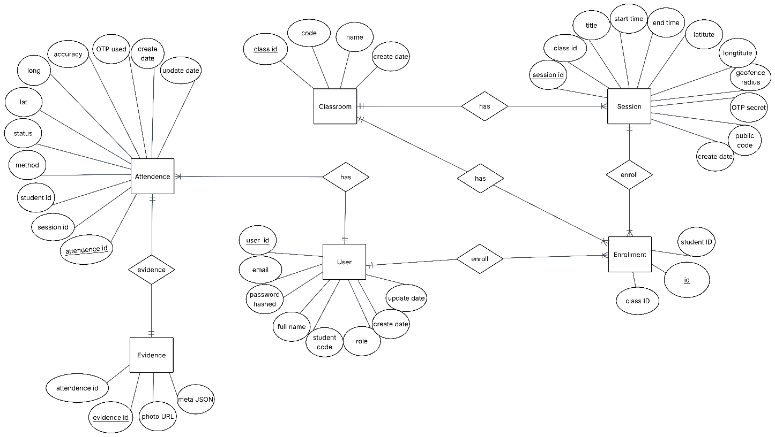

Figure 2: ERD schema

2.4.2 - Physical-level DB schema

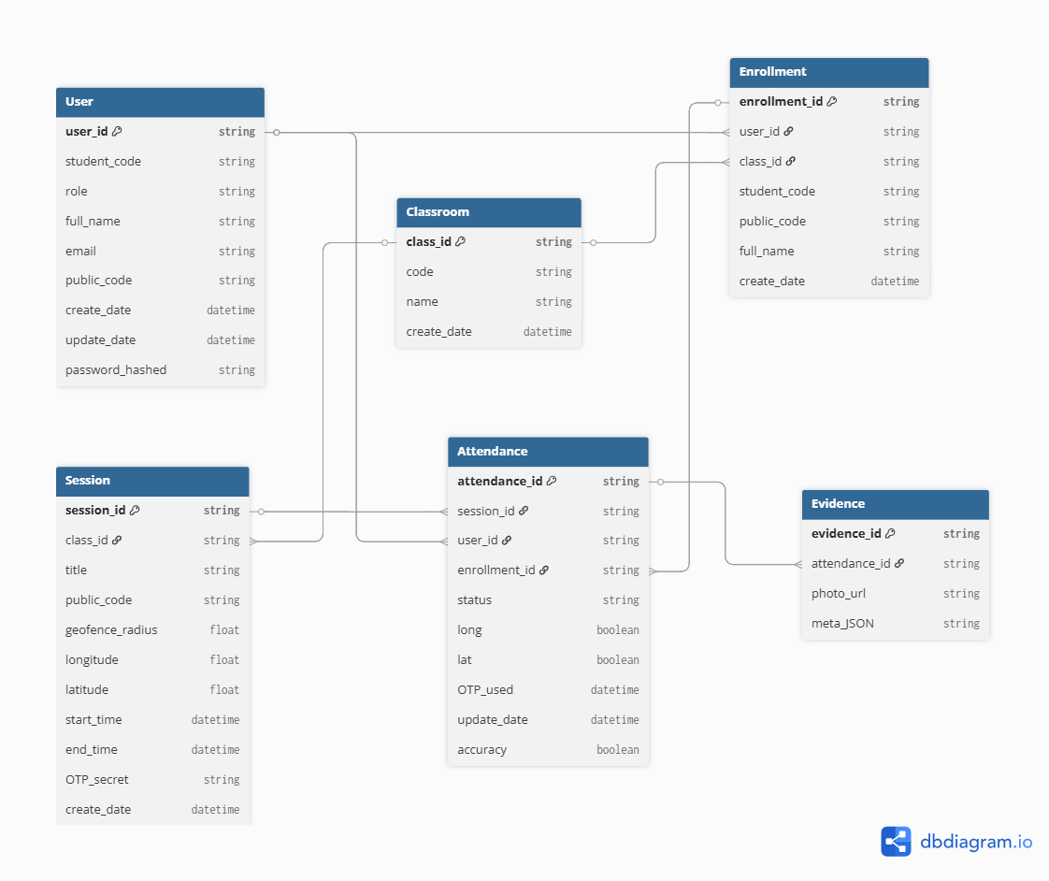

Figure 2 Physical-level DB schema

CHAPTER 3: SYSTEM REALIZATION

3.1 - Technology stack overview
- NestJS + TypeScript: Back-end foundation offering a structured, opinionated framework with decorators, inversion of control, and built-in testing utilities. It keeps services modular while remaining a single monolith, accelerates API development, and integrates natively with TypeScript for type safety.
- Prisma ORM + PostgreSQL: Prisma supplies an expressive schema DSL, migrations, and type-safe queries, while PostgreSQL delivers reliable relational storage. The pair simplifies data modeling, enforces referential integrity, and keeps performance predictable for complex attendance relations.
- React + Vite + TypeScript: React handles dynamic UI with component-driven patterns; Vite provides fast dev tooling and optimized builds; TypeScript ensures type safety in the browser. This trio suits a responsive dashboard that manages sessions, evidence, and attendance logs.
- Browser APIs (Camera, QR, Geolocation): Native APIs enable real-time QR scanning and GPS geofencing without extra plugins, ensuring smooth check-ins directly from modern browsers as well as avoiding third-party SDK lock-in and align with security requirements (HTTPS).
- JWT Authentication: JSON Web Tokens encode user identity and roles, making stateless authorization straightforward for frontend-to-backend calls. Also, JWT keeps session checks lightweight, ideal for distributed clients hitting REST endpoints.
  - Docker Compose: Containerizes backend, frontend, and database, keeping environments consistent and reproducible for local testing and deployment. Furthermore, docker compose ensures every discipline (API, web, DB) runs the same stack anywhere, minimizing “works on my machine” drift.
  - NestJS/TypeScript: unifies backend logic under familiar enterprise patterns, reducing boilerplate and easing onboarding.
  - Prisma/PostgreSQL: balance developer productivity with a robust SQL engine suited to transactional attendance data.
  - React/Vite/TypeScript: ship a modern UX quickly and integrate well with camera/GPS features.

3.2 - List of APIs

3.2.1 - Login
URL: POST /auth/login
Public: Yes (no JWT required)
Description: Login to the system using username/email and password
Input (Body):
{
"username": "string",
"email": "string",
"password": "string"
}

Output:
{
"accessToken": "string",
"user": {
"id": "string",
"email": "string",
"fullName": "string",
"studentCode": "string | null",
"role": "STUDENT | LECTURER | ADMIN"
}
}
Possible Errors:
- 401 Unauthorized: Incorrect password or account does not exist

3.2.2 - Get Current User
URL: GET /auth/me
Authentication: JWT Required
Description: Get information of the currently logged-in user
Input: None (uses JWT from header Authorization: Bearer <token>)
Output:
{
"id": "string",
"email": "string",
"fullName": "string",
"studentCode": "string | null",
"role": "STUDENT | LECTURER | ADMIN"
}

3.2.3 - Check-in by QR Code
URL: POST /attendance/checkin-qr
Authentication: JWT Required
Role: STUDENT
Description: Student checks in by scanning QR code, requires GPS within allowed range
Input (Body):
{
"qrToken": "string",
"lat": "number",
"lng": "number",
"accuracy": "number"
}
Output:
{
"id": "string",
"sessionId": "string",
"studentId": "string",
"method": "QR_GPS",
"status": "APPROVED | TOO_FAR",
"lat": "number",
"lng": "number",
"accuracy": "number",
"otpUsed": null,
"createdAt": "ISO 8601 datetime",
"updatedAt": "ISO 8601 datetime" }
Possible Errors:
  - 400 Bad Request: Invalid or expired QR token, session does not exist
  - 401 Unauthorized: Not enrolled in this class

3.2.4 - Check-in by OTP and Photo
URL: POST /attendance/checkin-otp
Authentication: JWT Required
Role: STUDENT
Description: Student checks in using OTP and uploads photo as evidence (requires teacher approval)
Input (Form Data):
file: Image file (multipart/form-data, required)
sessionId: string (Session ID or publicCode)
otp: string (6-digit OTP code)
meta: JSON string
{
"studentCode": "string",
"timestamp": "string"
}
Output:
{
"id": "string",
"sessionId": "string",
"studentId": "string",
"method": "OTP_PHOTO",
"status": "PENDING",
"lat": null,
"lng": null,
"accuracy": null,
"otpUsed": "string",
"createdAt": "ISO 8601 datetime",
"updatedAt": "ISO 8601 datetime"
}
Possible Errors:
- 400 Bad Request: Image file is required, invalid or expired OTP, session does not exist
- 401 Unauthorized: Not enrolled in this class

3.2.5 - Get Session Attendances
URL: GET /attendance/session/:id
Authentication: JWT Required
Role: LECTURER, ADMIN
Description: Get all attendance records for a session
Input (Path Parameter):
id: string (Session ID)
Output: Array of attendance records
[
{
"id": "string",
"sessionId": "string",
"studentId": "string",
"method": "QR_GPS | OTP_PHOTO | AUTO_IMPORT",
"status": "NOT_ATTENDED | PENDING | APPROVED | REJECTED | TOO_FAR",
"lat": "number | null",
"lng": "number | null",
"accuracy": "number | null",
"otpUsed": "string | null",
"createdAt": "ISO 8601 datetime",
"updatedAt": "ISO 8601 datetime",
"student": {
"id": "string",
"email": "string",
"fullName": "string",
"studentCode": "string | null"
},
"evidence": {
"id": "string",
"attendanceId": "string",
"photoUrl": "string",
"metaJson": "string"
}
}
]

Possible Errors:
- 400 Bad Request: Session does not exist

3.2.6 - Approve Attendance
URL: PATCH /attendance/:id/approve
Authentication: JWT Required
Role: LECTURER, ADMIN
Description: Teacher/Admin approves student attendance
Input (Path Parameter):
id: string (Attendance record ID)
Output:
{
"id": "string",
"sessionId": "string",
"studentId": "string",
"method": "QR_GPS | OTP_PHOTO | AUTO_IMPORT",
"status": "APPROVED",
"lat": "number | null",
"lng": "number | null",
"accuracy": "number | null",
"otpUsed": "string | null",
"createdAt": "ISO 8601 datetime",
"updatedAt": "ISO 8601 datetime",
"student": {
"id": "string",
"email": "string",
"fullName": "string",
"studentCode": "string | null",
"role": "STUDENT | LECTURER | ADMIN"
},
"evidence": {
"id": "string",
"attendanceId": "string",
"photoUrl": "string",
"metaJson": "string"
}
}

3.2.7 - Reject Attendance
URL: PATCH /attendance/:id/reject
Authentication: JWT Required
Role: LECTURER, ADMIN
Description: Teacher/Admin rejects student attendance
Input (Path Parameter):
id: string (Attendance record ID)
Output: Similar to approve, but status is "REJECTED"

3.2.8 – Get Class Attendance Report
URL: GET /attendance/report/class/:classId
Authentication: JWT Required
Role: LECTURER, ADMIN
Description: Get detailed attendance report for a class
Input (Path Parameter):
classId: string (Class ID)

Output:
{
"class": {
"id": "string",
"code": "string",
"name": "string"
},
"totalSessions": "number",
"totalStudents": "number",
"report": [
{
"studentId": "string",
"studentCode": "string",
"fullName": "string",
"email": "string",
"totalSessions": "number",
"attendedSessions": "number",
"attendanceRate": "number",
"sessionDetails": [
{
"sessionId": "string",
"sessionTitle": "string",
"sessionDate": "ISO 8601 datetime",
"status": "NOT_ATTENDED | PENDING | APPROVED | REJECTED | TOO_FAR",
"method": "QR_GPS | OTP_PHOTO | AUTO_IMPORT | null",
"checkedInAt": "ISO 8601 datetime | null"
}
]
}
]
}
Possible Errors:
- 400 Bad Request: Class does not exist

3.2.9 – Get All Classes Attendance Report
URL: GET /attendance/report/all
Authentication: JWT Required
Role: ADMIN
Description: Get attendance report for all classes
Input: None
Output: Array of class reports
[
{
"class": {
"id": "string",
"code": "string",
"name": "string"
},
"totalSessions": "number",
"totalStudents": "number",
"students": [
{
"studentId": "string",
"studentCode": "string",
"fullName": "string",
"email": "string",
"totalSessions": "number",
"attendedSessions": "number",
"attendanceRate": "number"
}
]
}
]

3.2.10 – Create Session
URL: POST /sessions
Authentication: JWT Required
Role: LECTURER, ADMIN
Description: Create a new session with QR code and OTP
Input (Body):
{
"classId": "string",
"title": "string",
"startTime": "ISO 8601 datetime string",
"endTime": "ISO 8601 datetime string",
"latitude": "number",
"longitude": "number",
"geofenceRadius": "number",
"publicCode": "string"
}
Output: Session object
{
"id": "string",
"classId": "string",
"title": "string",
"startTime": "ISO 8601 datetime",
"endTime": "ISO 8601 datetime",
"latitude": "number",
"longitude": "number",
"geofenceRadius": "number",
"otpSecret": "string",
"publicCode": "string",
"createdAt": "ISO 8601 datetime"
}

Possible Errors:
- 400 Bad Request: Public code is required, public code already exists

3.2.11 – Update Session
URL: PATCH /sessions/:id
Authentication: JWT Required
Role: LECTURER, ADMIN
Description: Update session information
Input (Path Parameter):
Id: string (Session ID)
Input (Body) - All fields are optional:
{
"classId": "string",
"title": "string",
"startTime": "ISO 8601 datetime string",
"endTime": "ISO 8601 datetime string",
"latitude": "number",
"longitude": "number",
"geofenceRadius": "number",
"publicCode": "string"
}
Output: Updated session object
Possible Errors:
- 404 Not Found: Session does not exist
- 400 Bad Request: Public code cannot be empty, public code already exists

3.2.12 – Get Session by ID
URL: GET /sessions/:id
Authentication: JWT Required
Description: Get detailed information of a session
Input (Path Parameter):
id: string (Session ID)
Output:
{
"id": "string",
"classId": "string",
"title": "string",
"startTime": "ISO 8601 datetime",
"endTime": "ISO 8601 datetime",
"latitude": "number",
"longitude": "number",
"geofenceRadius": "number",
"otpSecret": "string",
"publicCode": "string",
"createdAt": "ISO 8601 datetime",
"class": {
"id": "string",
"code": "string",
"name": "string",
"createdAt": "ISO 8601 datetime"
},
"attendances": [
{
"id": "string",
"sessionId": "string",
"studentId": "string",
"method": "QR_GPS | OTP_PHOTO | AUTO_IMPORT",
"status": "NOT_ATTENDED | PENDING | APPROVED | REJECTED | TOO_FAR",
"lat": "number | null",
"lng": "number | null",
"accuracy": "number | null",
"otpUsed": "string | null",
"createdAt": "ISO 8601 datetime",
"updatedAt": "ISO 8601 datetime",
"student": {
"id": "string",
"email": "string",
"fullName": "string",
"studentCode": "string | null"
},
"evidence": {
"id": "string",
"attendanceId": "string",
"photoUrl": "string",
"metaJson": "string"
}
}
]
}
Possible Errors:
- 404 Not Found: Session does not exist

3.2.13 – Get Session by Public Code
URL: GET /sessions/code/:code
Authentication: JWT Required
Description: Get session information by public code (publicCode)
Input (Path Parameter):
code: string (Session public code)
Output: Similar to GET /sessions/:id
Possible Errors:
404 Not Found: Session does not exist

3.2.14 – Get QR Token
URL: GET /sessions/:id/qr
Authentication: JWT Required
Role: LECTURER, ADMIN
Description: Get QR token (JWT) to generate QR code for the session
Input (Path Parameter):
id: string (Session ID)
Output:
{
"token": "string",
"payload": {
"sessionId": "string",
"classCode": "string",
"className": "string",
"nonce": "string",
"exp": "number"
},
"deepLink": "string | null"
}
Possible Errors:
- 404 Not Found: Session does not exist

3.2.15 – Get OTP
URL: GET /sessions/:id/otp
Authentication: JWT Required
Role: LECTURER, ADMIN
Description: Get current OTP (TOTP) for the session
Input (Path Parameter):
id: string (Session ID)
Output:
{
"otp": "string"
}
Possible Errors:
- 404 Not Found: Session does not exist

Note: OTP changes periodically (default 30-60 seconds depending on configuration

3.2.16 – Delete Session by ID
URL: DELETE /sessions/:id
Authentication: JWT Required
Role: LECTURER, ADMIN
Description: Delete a session
Input (Path Parameter):
id: string (Session ID)
Output:
{
"success": true
}
Possible Errors:
- 404 Not Found: Session does not exist

3.2.17 – Delete Session by Code
URL: DELETE /sessions/code/:code
Authentication: JWT Required
Role: LECTURER, ADMIN
Description: Delete a session by public code
Input (Path Parameter):
code: string (Session public code)
Output:
{
"success": true
}
Possible Errors:
- 404 Not Found: Session does not exist

3.2.18 – Get All Classes
URL: GET /classes
Authentication: JWT Required
Role: LECTURER, ADMIN
Description: Get list of all classes
Input: None
Output: Array of classes

[
{
"id": "string",
"code": "string",
"name": "string",
"createdAt": "ISO 8601 datetime",
"sessions": [
{
"id": "string",
"publicCode": "string",
"title": "string",
"startTime": "ISO 8601 datetime",
"endTime": "ISO 8601 datetime"
}
],
"_count": {
"students": "number"
}
}
]

3.2.19 – Create Class
URL: POST /classes
Authentication: JWT Required
Role: LECTURER, ADMIN
Description: Create a new class
Input (Body):

{
"code": "string",
"name": "string"
}

Output:
{
"id": "string",
"code": "string",
"name": "string",
"createdAt": "ISO 8601 datetime"
}

3.2.20 – Get Class by ID
URL: GET /classes/:id
Authentication: JWT Required
Description: Get detailed information of a class
Input (Path Parameter):
id: string (Class ID)

Output:
{
"id": "string",
"code": "string",
"name": "string",
"createdAt": "ISO 8601 datetime",
"students": [
{
"id": "string",
"classId": "string",
"studentId": "string",
"student": {
"id": "string",
"email": "string",
"fullName": "string",
"studentCode": "string | null"
}
}
],
"sessions": [
{
"id": "string",
"classId": "string",
"title": "string",
"startTime": "ISO 8601 datetime",
"endTime": "ISO 8601 datetime",
"latitude": "number",
"longitude": "number",
"geofenceRadius": "number",
"otpSecret": "string",
"publicCode": "string",
"createdAt": "ISO 8601 datetime"
}
]
}

Possible Errors:
- 404 Not Found: Class does not exist

3.2.21 – Enroll Students
URL: POST /classes/:id/enroll
Authentication: JWT Required
Role: LECTURER, ADMIN
Description: Enroll students into a class using student codes or user IDs
Input (Path Parameter):
id: string (Class ID)
Input (Body):
{
"studentCodes": ["string"],
"userIds": ["string"]
}
Output: Array of enrollment records
[
{
"id": "string",
"classId": "string",
"studentId": "string"
}
]
Possible Errors:
- 404 Not Found: Class does not exist
- 400 Bad Request: Student with student code does not exist
Note: If student is already enrolled, it will be skipped (no duplicate created)

3.2.22 – Get Upload File
URL: GET /uploads/:filename
Public: Yes (no JWT required)
Description: Access uploaded image files (attendance evidence)
Input (Path Parameter):
filename: string (File name, e.g., 7d5aac68a5aa1e1feafcffa7ecda561a.jpg)
Output: Image file (image/jpeg, image/png, etc.)

CHAPTER 4: SYSTEM DEMO

4.1 - System demo scenarios
The demo highlights key workflows to showcase the system's functionality, anti-fraud features, and usability:
- Lecturer Creates Class and Session: Lecturer logs in, creates a new class, enrolls students, then sets up a session with details like time, GPS coordinates, geofence radius, and public Code. System initializes dynamic QR and OTP rotations.
- Student QR Check-in with GPS Validation: Student logs in, scans the lecturer-displayed QR using the web app's camera. Browser fetches GPS location; system validates token, geofence (via Haversine), and records "Present" or "Late" if within radius and time.
- Student OTP Fallback with Photo Evidence: If QR fails (e.g., no GPS), student enters OTP, captures photo; system applies watermark and validates, recording attendance with evidence.
- Validation Failure Case: Student attempts check-in outside geofence or with expired QR/OTP; system rejects and logs error, demonstrating fraud prevention.
- Lecturer Views Attendance: Lecturer selects session, views real-time list with statuses, methods, timestamps, and linked photo evidence; can edit session if needed.
- Admin Exports Report: Admin logs in, selects class/session, exports aggregated attendance as CSV for analysis, including totals for Present/Late/Absent.

These scenarios demonstrate SOA modularity, security (JWT, geofence), and user roles in a 10–15-minute live demo.

4.2 - System demo
4.2.1 Demo script descriptions and illustrations
The demo script follows a step-by-step narrative: Start with login screens for all roles, proceed to creation workflows (e.g., class/session setup with screenshots of forms), simulate student check-ins (live QR scan and OTP entry with real-time feedback alerts), and end with viewing/exporting data (tables and CSV previews). Illustrations include annotated screenshots (e.g., QR display with rotation timer, attendance list with evidence links) to highlight interactions.
4.2.2 Ensure aesthetics and readability for viewers
Use high-resolution images with clear labels, consistent color schemes (blue for actions, green for success), and zoomed views for key UI elements. Limit text overlays to concise captions; present in slideshow format for smooth transitions and easy following during presentation.

4.2.3 Demo result
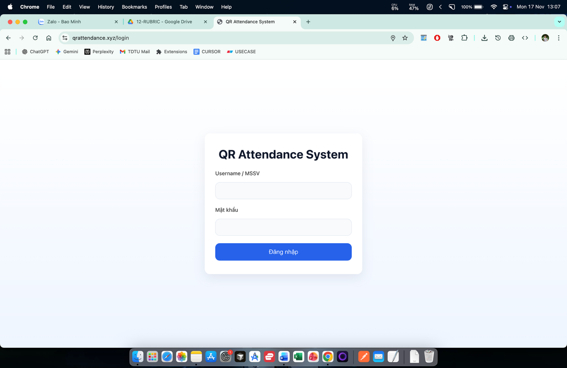

Figure 3 Login page

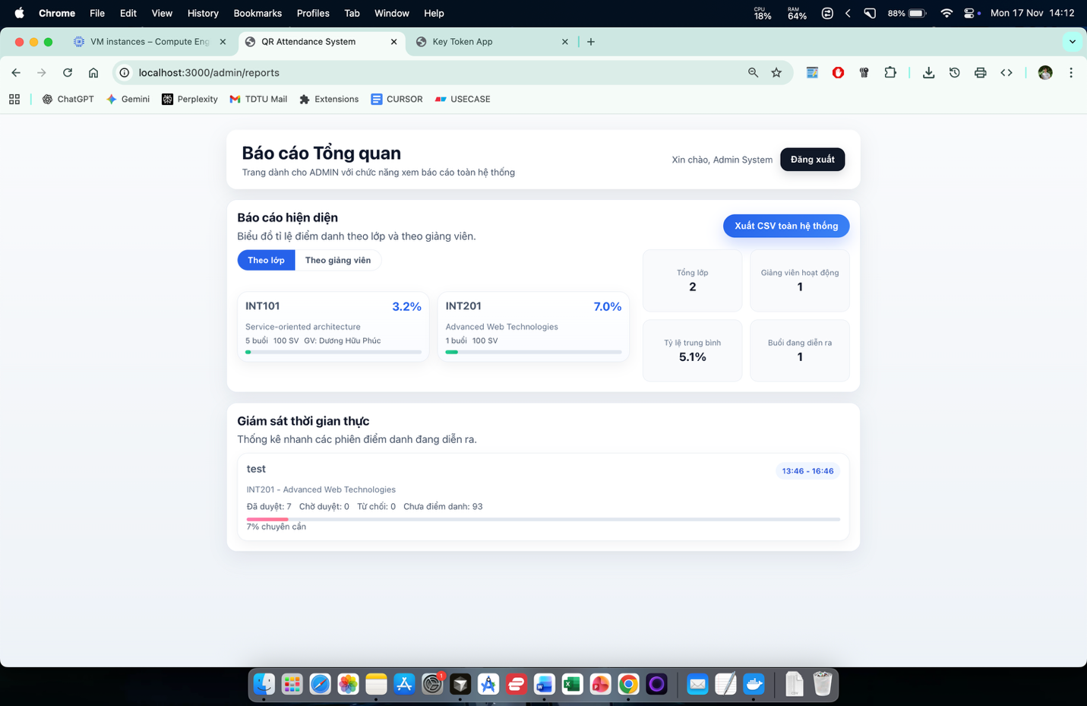

Figure 4 Admin Homepage

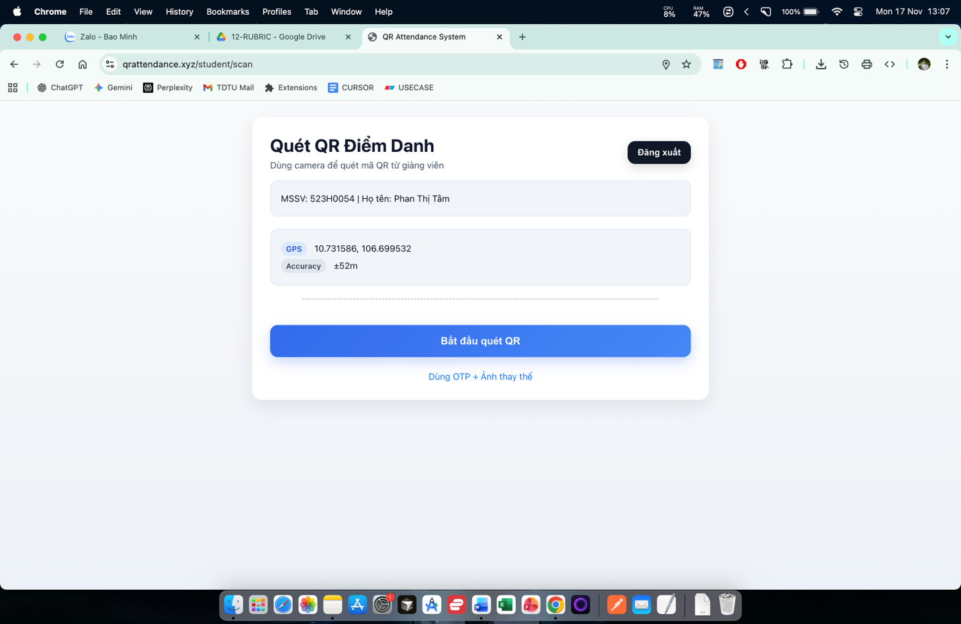

Figure 5 Student Homepage (QR scan)
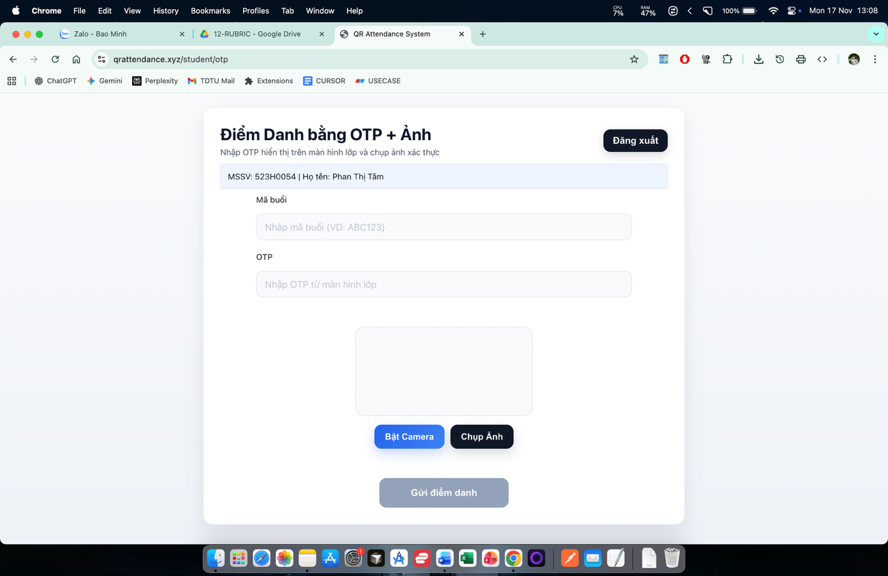

Figure 6 Student Homepage (OTP + Picture check)

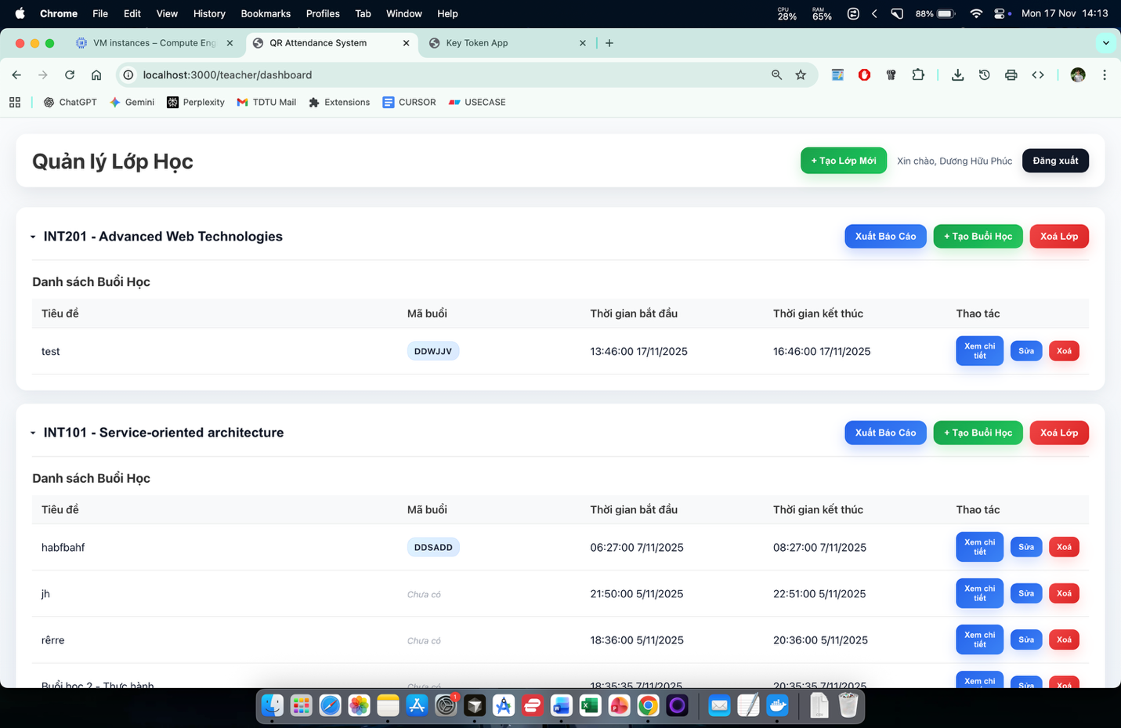

Figure 7 Lecturer dashboard

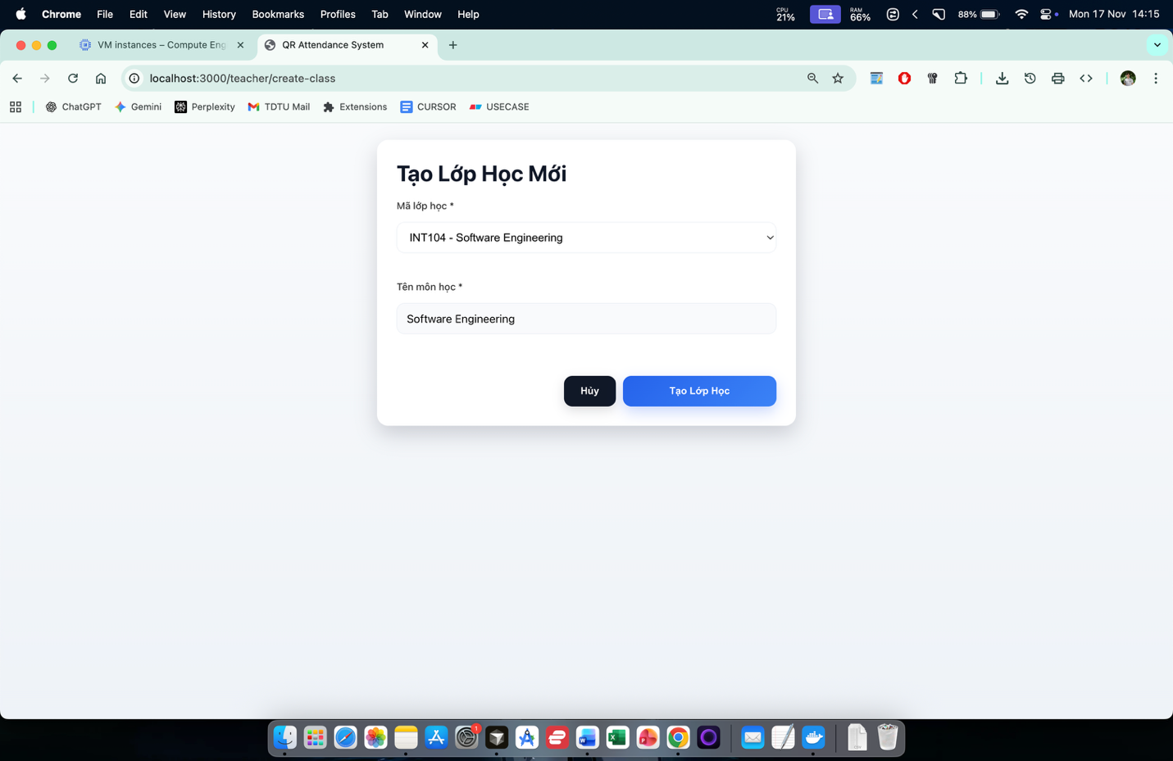

Figure 8 Create new class

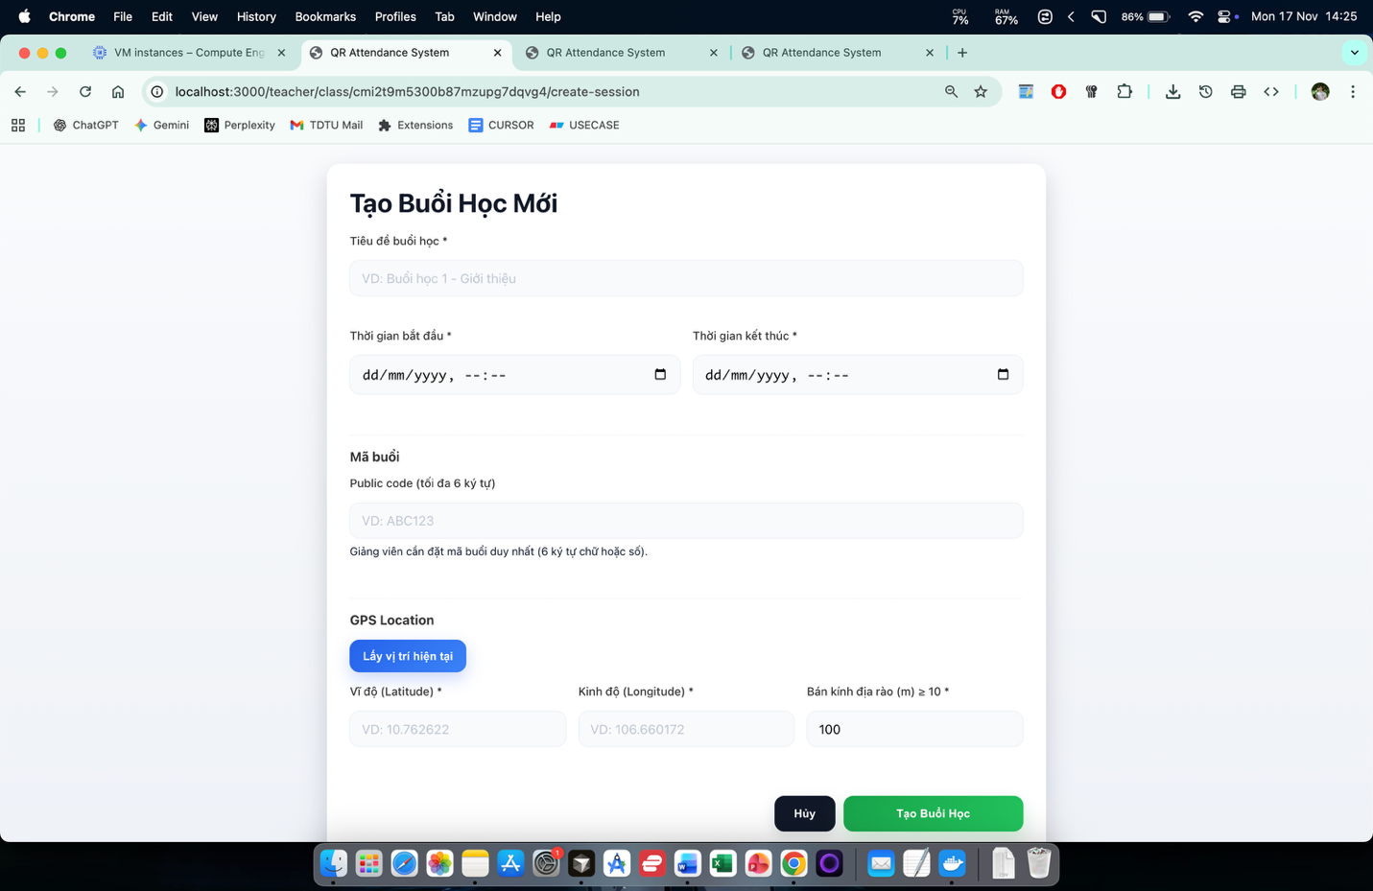

Figure 9 Create new session

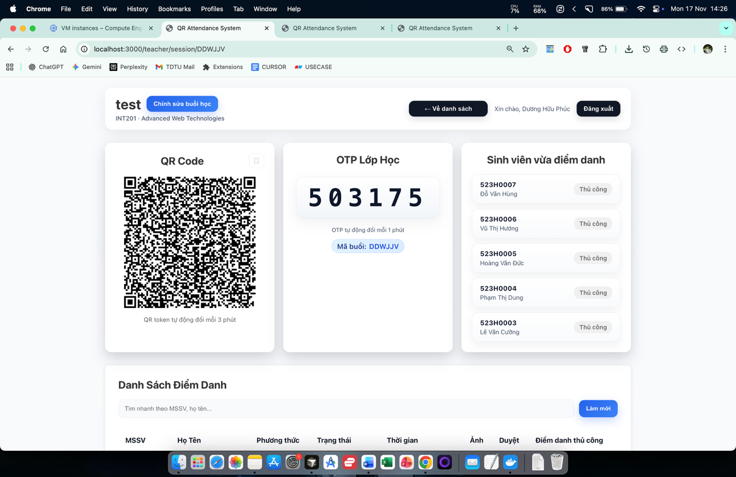

Figure 10 View session

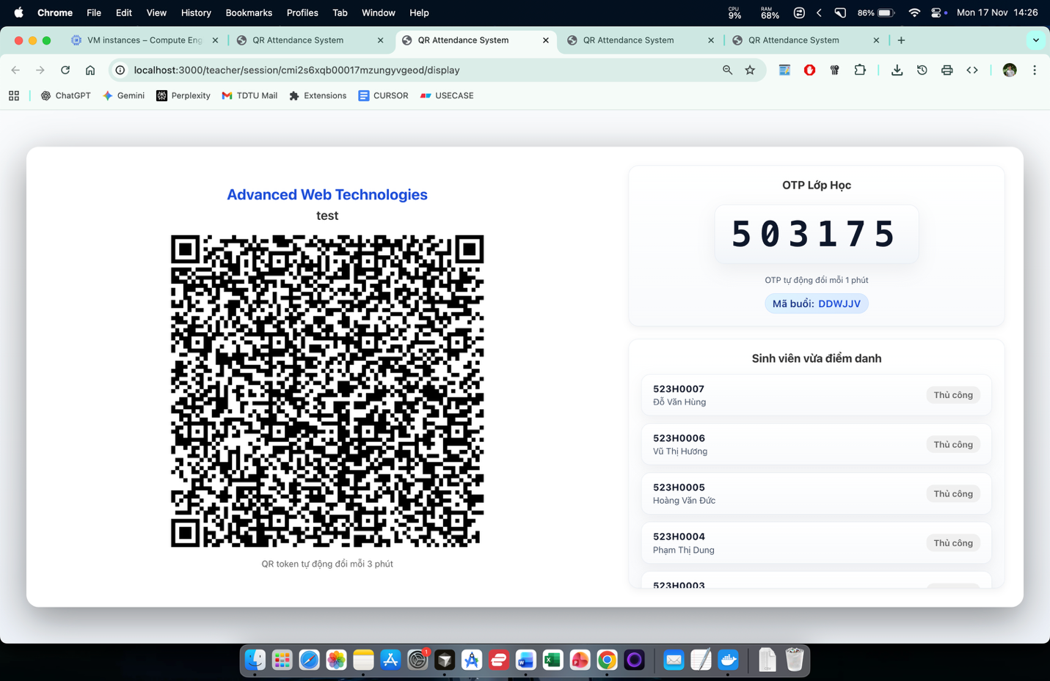

Figure 11 Display QR and OTP (maximize)

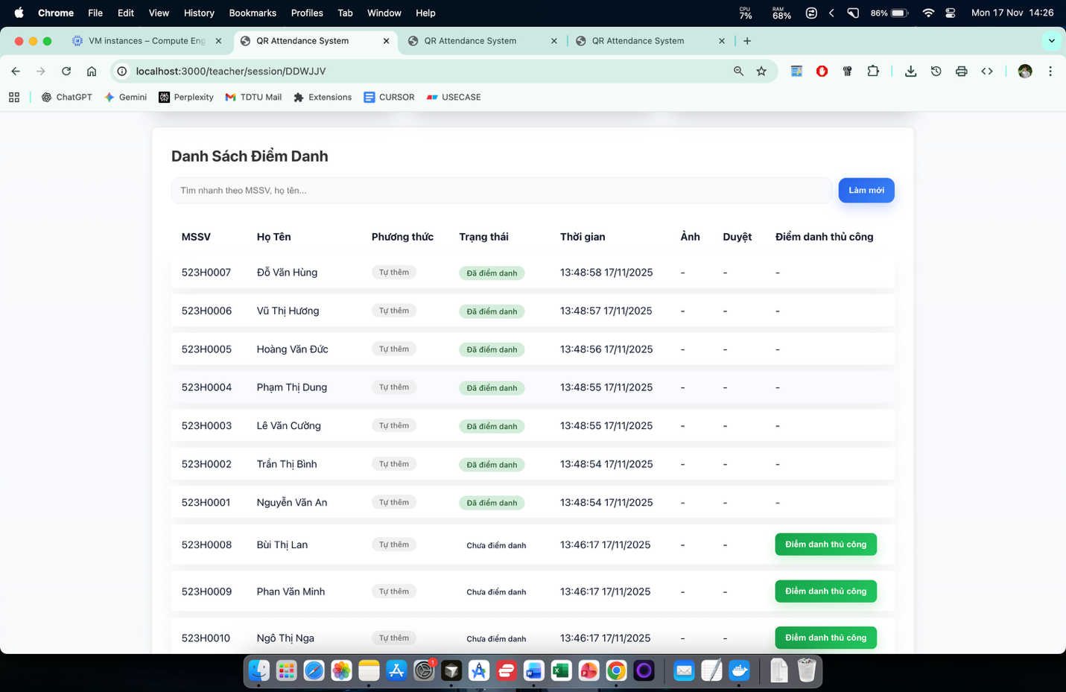

Figure 12 View attendance list

REFERENCES

[1] Sam Newman. Building Microservices. O'Reilly Media, Inc., 2021..
[2] Phuc H. Duong. FastAPI Tutorials, 2024.
[3] Systems Analysis and Design — Use Case Analysis & Data Modeling.
[4] Vaughn Vernon. Domain-Driven Design Distilled, 1/e. O'Reilly Media, Inc., 2016.
[5] Get started with GitHub and Visual Studio Code. Microsoft Learn.

APPENDIX A – LIST OF REQUIREMENTS ELICITATION QUESTIONS

1. Interview Questions
Target interviewees: System administrators, lecturers, training department staff.
- Can you describe the current attendance process used in your classes or organization?
- What are the main challenges you face with the current attendance method (time-consuming, fraud, inaccurate data, etc.)?
- What key features do you expect the QR attendance system to have?
- Do you want to track attendance history by class, subject, or employee?
- Should the generation and distribution of QR codes be automatic or manual?
- Do you think the system should detect fraud (e.g., multiple scans, proxy scanning)?
- Which user roles need access to the system (Admin, Lecturer, Student, etc.)?
- Do you require attendance reports on a weekly, monthly, or semester basis?
- Should the attendance data be integrated with existing systems (e.g., LMS, HRM)?
- What security measures do you expect from the system (OTP, IP restrictions, camera verification, etc.)?

2. Questionnaire (Survey Form)
Target participants: Students / Employees using QR for attendance.

Question | Answer Options
1. Do you feel the current attendance method is convenient? | ☐ Yes ☐ Neutral ☐ No
2. Do you think QR attendance will help save time? | ☐ Yes ☐ No
3. Do you have a smartphone that can scan QR codes? | ☐ Yes ☐ No
4. Which attendance method do you prefer? | ☐ Scan QR in class ☐ QR with GPS verification ☐ Both
5. Would you like to view your personal attendance history in the system? | ☐ Yes ☐ No
6. Do you need reminder notifications when the attendance time is about to close? | ☐ Yes ☐ No
7. Which interface style do you prefer? | ☐ Simple ☐ Advanced
8. What is most important to you in the new system? | ☐ Speed ☐ Ease of use ☐ Anti-fraud ☐ Clear reports
9. Are you concerned about others checking attendance on your behalf? | ☐ Yes ☐ No
10. Which login method do you prefer? | ☐ Email ☐ Student ID ☐ SSO ☐ Others: …

