

**Starbucks Coffee USA**

**BI Specification Report**

1. Background Information

Starbucks was founded in 1971 in Seattle, Washington, by Jerry Baldwin, Zev Siegl and Gordon Bowker. The company originally only sold roasted whole coffee beans and did not sell brewed coffee till later. The number of stores grew over the years and the company diversified outside coffee and began to offer food, tea and other drinks.

The very first Starbucks Caffe Latte was served in 1984 and proved to be a massive success. The well known Frappucino drink was first offered in 1995. The company has strived to innovate and come up with new products to maintain its competitive advantage in the retail coffee industry.

Since its inception, the company has developed into one of the largest coffee chains in the world with over 30,000 stores worldwide as of 2019. [1] Starbucks’ mission statement is to “inspire the human spirit - one person, one cup and one neighborhood at a time”.

1. Marketplace

Starbucks primarily operates in the retail coffee and snacks store industry. The size of the coffee shop market in the US alone was 47.5 billion US dollars in 2019. [2] The company offers a range of different products such as coffee, beverages such as iced coffee and frappuccinos, food and merchandise such as mugs and coffee brewing equipment in order to maximise its sales and increase its revenue.

1. Scope of Processes

**Digital Rewards Program:**

We will use the digital rewards program to engage more customers. The program allows Starbucks customers to keep track of the various deals that are available at the different stores. Customers are able to collect stars (2 stars for every $1 spent) that can be redeemed in-store or on the app.

**Customers Experience and Feedback Analysis:**

We will utilise Dynamics 365 Powerapps for CRM. Customer details will be included that includes any comments or feedback that they made regarding certain aspects of their experience in-store. A customer repository will be created that stores various pieces of information about the customer and their responses. As Starbucks’ success is related to the customers experience and feelings it is important to ensure that the customers feel they are being looked after and have positive experiences with Starbucks. Keeping track of customer experiences is critical to Starbucks survival.

1. System Design

System design is the process of defining, developing and designing systems which satisfies the needs and requirements of a business.

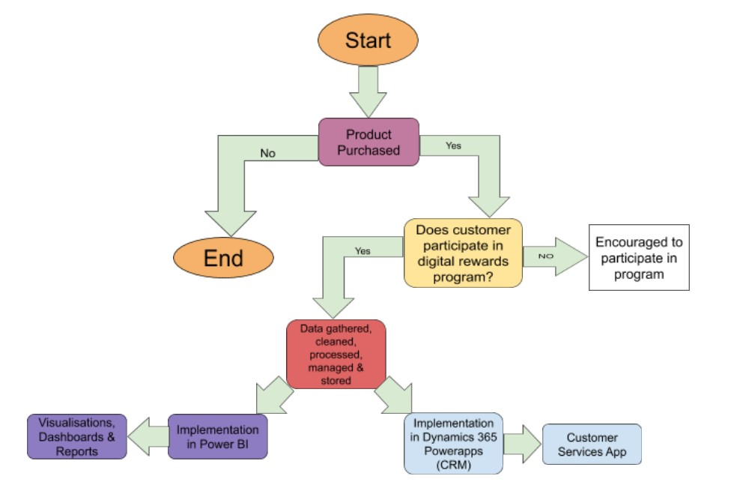

There are three different design methods which are highlighted below.

* **Architectural Design**

Architectural design is related to the models, structure and behavior of the system.

* **Logical Design**

Logical design is related to the data flow, inputs and outputs of the sample. An example of logical design is creating the entity relationship diagram.

* **Physical Design**

Physical design deals with how the data is gathered, validated, secured and/or transformed as it traverses through the system. How the data is stored in the system also forms part of physical design.

**Digital Rewards Program;**

In order to successively integrate customers into our system the concept of a digital rewards program is created. Stars can be collected that can be redeemed in-store or on the app. The digital rewards program creates a connection between the customer and the business. The customer is encouraged to return to collect more stars and obtain more products such as a free caffeinated beverage.

|  |  |
| --- | --- |
| **Digital Rewards Program** | |
| *Stars* | *Reward Description* |
| 25 | Customize your drink (espresso shot, dairy substitute, syrup and more) |
| 50 | Brewed hot coffee or hot tea |
| 100 | Hot breakfast or parfait |
| 200 | Lunch sandwich, protein box or salad |
| 400 | Merchandise (t-shirt, mug) or starbucks whole coffee beans |

1. Data Capture Points

Data capture is the process of collecting data which will be processed and used later to fulfill certain requirements. Data capture points are the marks at which the data is obtained. The processes should be documented and reproducible. The process of capturing data should also comply with any regulatory laws.

|  |  |  |
| --- | --- | --- |
|  | **Capture Point** | **Description** |
| **Digital Rewards Program** | In-store at transaction | Employee will ask the customer if they are part of the digital rewards program |
| Online Transaction | The option to opt-in to the digital rewards program online |
| **Products** | Collecting from supplier | Scanning a barcode when collecting product from a supplier |
| During transaction | Unique product id during in-store or online transaction |

1. Analytics Requirements

The business analyst who is specifying the kind of information that will be available for the reports, views and dashboards needs to be aware of certain requirements. They need to ensure that the data is suitable for visualisation purposes and that meaningful information can be obtained from it.

* ***Business Requirements:***

When developing analytical requirements, you need to identify high level business requirements that the project will focus on. Defining the relevant measures and dimensions that the project will focus on is important too. In the case of Starbucks, a requirement could be determining how well a new product will perform.

* ***Architectural Requirements:***

These needs cover the design and implementation of different architecture that can be used to meet the business needs. For Starbucks, designing a suitable database and hiring a competent database designer who can show the different relationships between the various entities would count as an architectural requirement.

* ***Integration Requirements:***

Integration requirements involve a description of how you will integrate different features into your solution. It covers a wide range of topics ranging from how customers will be integrated into your solution and also how the technical aspects can be integrated into your solution. For Starbucks, integrating customer information in CRM would be classified as an integration requirement.

1. Customer Integration

In order to integrate customers into our process the digital rewards program was offered on the starbucks app. This allowed us to gather information about the customers such as their email to send information regarding new products and sales. Dynamics CRM can be used with the digital rewards program by including customer issues and information.

1. Database Design (with ER diagram)

sIn order to build a fully functional business analysis system for Starbucks, publically available data is extracted from data.world [3] and some mock data is generated using mockaroo [4].

**Entity Relationship Diagram**

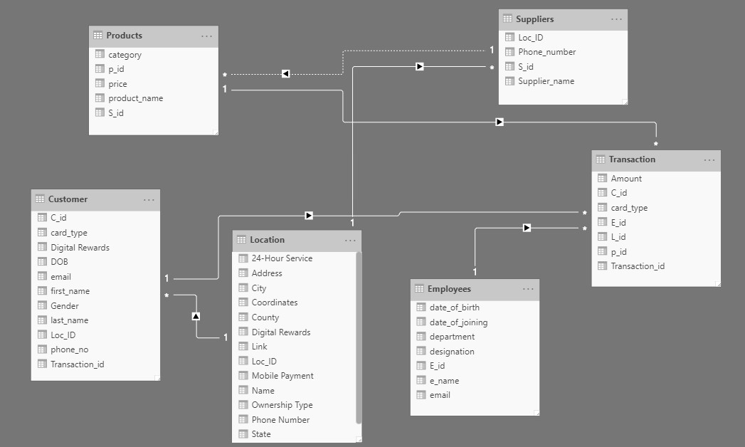

An Entity Relationship (ER) diagram shows the different relationships between entities that are stored in the database.

The entities in the above database are: Location, Products, Suppliers, Transaction, Customer and Employees. An in-depth description of each entity is given below.

1. **Location**

The location dataset contains information about different Starbucks stores. The primary key is location id (Loc_ID). The columns in the dataset are location id, name, phone number, state, address, zip code, digital rewards (whether digital rewards are offered or not), 24-hour service, city, coordinates, county, link and mobile payment. This dataset can be used to visualise where stores are located and which of them offer different services (such as 24-hour service)

1. **Employees**

The employees dataset contains information about the employees who work in different Starbucks stores. The primary key is employee id (E_id). The columns in the dataset are employee id, name, date of birth, date of joining (date the employee started working), department, designation and email. This dataset can be used to visualise the breakdown of employees by department and/or designation.

1. **Customer**

The customers dataset contains information about the customers who purchase products at Starbucks stores. The primary key is customer id (C_id). The columns in the dataset are customer id, first name, last name, gender, location id (store they were at), phone number, transaction id, card type, digital rewards (whether they opted to use digital rewards or not). This dataset can be used to visualise how many customers opted to use the rewards program and at which stores.

1. **Suppliers**

The suppliers dataset gives information about the different suppliers that provide starbucks with their goods. The primary key is supplier id (S_id). The columns in the dataset are supplier id, supplier name, location id (what starbuck store they deliver to) and phone number. The dataset can be used to see what suppliers deliver the most amount of products.

1. **Products**

The products dataset gives information about the various products that starbucks offers. The primary key is product id (p_id). The columns in this dataset are product id, product name, price, category and supplier id. The dataset can be used to visualise what are the most expensive products in Starbucks stores.

1. **Transaction**

The transaction dataset gives information about the transactions that took place across all Starbucks stores. The primary key is transaction id (T_id). The columns in this dataset are transaction id, amount (amount paid in transaction), customer id, card type, employee id,product id and location id (what store the transaction took place at). The dataset can be used to visualise what stores had the most transactions, what card types were used the most and more.

**Data Dictionary:**

A data dictionary contains information about the database. Database administrators usually deal with the data dictionary.

|  |  |  |  |  |
| --- | --- | --- | --- | --- |
| **Location** | | | | |
| **Field Name** | **Data Type** | **Width** | **Description** | **Example** |
| Location id | Integer | 4 | Location id of store | 8721 |
| Name | String | 20 | Name of Store | 10th & Market, San Diego |
| Phone number | String | 12 | Phone number of store | 619-696-3750 |
| State | String | 10 | State where store is located | California |
| Zip code | Integer | 9 | Zip code of store | 941033004 |
| Address | String | 50 | Address of store | 1011 Market Street, 921017233 San Diego County, California |
| Digital Rewards | Boolean | 3 | Whether digital rewards is offered | Yes |
| 24-hour service | Boolean | 3 | Whether 24 service is offered | No |
| City | String | 15 | City the store is in | San Diego |
| Coordinates | Float | 21 | Coordinates of store | 34.041593,-118.262377 |
| County | String | 20 | County of store | San Diego County |
| Link | String | 56 | Website link | http://www.starbucks.com/store/8147/us |
| Mobile Payment | Boolean | 3 | Whether mobile payment is accepted | Yes |

|  |  |  |  |  |
| --- | --- | --- | --- | --- |
| **Employee** | | | | |
| **Field Name** | **Data Type** | **Width** | **Description** | **Example** |
| Employee id | Integer | 5 | An employee’s unique id | 57897 |
| Name | String | 25 | Name of the employee | Gianni Goldwater |
| Date of birth | String | 10 | Employee’s date of birth | 5/21/1980 |
| Date of joining | String | 10 | Date employee joined Starbucks | 5/20/2006 |
| Department | String | 23 | What department they work | Customer service |
| Designation | String | 10 | Their job title | Barista |
| Email | String | 40 | Their email | gianni1980@gmail.com |

|  |  |  |  |  |
| --- | --- | --- | --- | --- |
| **Customer** | | | | |
| **Field Name** | **Data Type** | **Width** | **Description** | **Example** |
| Customer id | Integer | 10 | Unique customer id | 739 |
| First Name | String | 13 | First name of customer | Ralph |
| Last Name | String | 15 | Last name of customer | Stevens |
| Gender | String | 6 | Gender of customer | Male |
| Phone number | String | 12 | Phone number of customer | 888-8888-888 |
| Transaction id | integer | 8 | Unique transaction id | 89365839 |
| Location id | integer | 4 | Location id of store | 8731 |
| Card Type | String | 18 | Type of card used | Mastercard |
| Digital rewards | Boolean | 3 | Whether customer used digital rewards at store | Yes |

|  |  |  |  |  |
| --- | --- | --- | --- | --- |
| **Suppliers** | | | | |
| **Field Name** | **Data Type** | **Width** | **Description** | **Example** |
| Supplier id | Integer | 7 | Unique id of supplier | 7327592 |
| Supplier name | String | 25 | Name of supplier | Lindy’s Coffee Machines |
| Phone Number | String | 12 | Phone number of supplier | 641-564-7532 |
| Location id | Integer | 4 | Location id of store supplier delivers to | 8721 |

|  |  |  |  |  |
| --- | --- | --- | --- | --- |
| **Products** | | | | |
| **Field Name** | **Data Type** | **Width** | **Description** | **Example** |
| Product id | Integer | 3 | Unique id of product | 285 |
| Product name | String | 15 | Name of product | Starbucks caffe latte |
| Category | String | 15 | Category of product | Hot drink |
| Price | Float | 6 | Price of the product | 5.30 |
| Supplier id | Integer | 7 | Supplier id who delivers product | 7327592 |

|  |  |  |  |  |
| --- | --- | --- | --- | --- |
| **Transaction** | | | | |
| **Field Name** | **Data Type** | **Width** | **Description** | **Example** |
| Transaction id | Integer | 8 | Unique id of transaction | 95797492 |
| Amount | Float | 6 | Amount paid in transaction | 12.50 |
| Card Type | String | 18 | Type of card used | Mastercard |
| Customer id | Integer | 10 | Customer id for transaction | 7693927592 |
| Employee id | Integer | 5 | Employee id | 55928 |
| Product id | Integer | 3 | Product id | 664 |
| Location id | Integer | 4 | Location id of store | 8721 |

References:

1. S. Lock, *Number of Starbucks stores worldwide from 2003 to 2019*, Statista, Nov. 2019. Accessed on: Apr. 12, 2020. [Online] Available: <https://www.statista.com/statistics/266465/number-of-starbucks-stores-worldwide/>
2. S. Lock, *Size of the coffee shop market in the United States in 2018 and 2019*, Statista, Nov. 2019. Accessed on: Apr. 12, 2020. [Online] Available:

## <https://www.statista.com/statistics/1032200/coffee-shop-industry-market-size-us/>

1. Alice, *Starbucks dataset*, data.world, 2017, Accessed on: Apr. 12, 2020. [Online] Available: <https://data.world/alice-c/starbucks/workspace/file?filename=Starbucks+in+California+-+City+Stats.csv>
2. Mockaroo, *Random Data Generator and API Mocking Tool*, Accessed on: Apr. 14, 2020. [Online] Available: <https://www.mockaroo.com/>