SVM RBF kernel random parameter search for C and gamma

Search time ~ 27 mins

{'mean_fit_time': array([82.50242774, 67.45352173, 85.53523556, 64.2335279 , 68.34747783,

82.75189606, 72.87863684, 69.35841123, 62.0209082 , 81.68202003,

71.34391975, 70.5515306 , 81.66855001, 63.46789289, 79.20612915,

65.11260986, 74.94382699, 82.13831798, 65.44436351, 73.18653973]),

'std_fit_time': array([1.20059079, 2.62097677, 2.95528542, 2.00355471, 1.21054149,

2.54919522, 1.49441518, 1.92071124, 1.54111244, 3.17094404,

1.99339709, 1.25984937, 1.13215097, 0.87075891, 1.59105211,

0.28644096, 3.07455063, 3.68414421, 1.63620297, 2.74103997]),

'mean_score_time': array([8.46242825, 8.37090246, 8.35678474, 8.32820837, 8.51468412,

8.68935402, 8.28368155, 8.20656641, 8.74902598, 8.63254166,

8.19849269, 8.21440808, 8.30691632, 7.41313728, 8.41603247,

7.90485708, 8.23335918, 8.43844787, 7.57773884, 7.90612555]),

'std_score_time': array([0.0610581 , 0.19801566, 0.06479037, 0.16585066, 0.15363718,

0.17500876, 0.03214849, 0.00882779, 0.11636823, 0.35846796,

0.033085 , 0.03152709, 0.00615013, 0.10965557, 0.14231577,

0.02975601, 0.05200163, 0.10898639, 0.04268954, 0.1702375 ]),

'param_C': masked_array(data=[2.209602254061174, 6.479197998006022,

11.307729610869862, 3.4067106021701203,

4.264752906385946, 3.128722503275811,

5.873081336593579, 8.308905941545847,

11.448645291386914, 2.7616900754057934,

2.7008015635852494, 5.320191775455632,

6.3765532905229225, 6.733970816481659,

9.012736172332481, 2.284060232418668,

9.062264858625882, 9.033197579781678,

6.082342548346405, 8.217581835073421],

mask=[False, False, False, False, False, False, False, False,

False, False, False, False, False, False, False, False,

False, False, False, False],

fill_value='?',

dtype=object),

'param_gamma': masked_array(data=[0.8670701646824878, 0.22054161556730448,

0.7495504104423961, 0.33159433754757905,

0.36005494534932125, 0.7319048399664801,

0.4162456205956463, 0.3946510812889229,

0.2516257130972007, 0.8039096066639619,

0.40703819349926096, 0.4096226804289601,

0.8668440989734274, 0.10614926514043757,

0.7293403609566396, 0.18526529667690875,

0.5565289675398223, 1.0312187582625605,

0.13839085006161692, 0.46062922824524044],

mask=[False, False, False, False, False, False, False, False,

False, False, False, False, False, False, False, False,

False, False, False, False],

fill_value='?',

dtype=object),

'params': [{'C': 2.209602254061174, 'gamma': 0.8670701646824878},

{'C': 6.479197998006022, 'gamma': 0.22054161556730448},

{'C': 11.307729610869862, 'gamma': 0.7495504104423961},

{'C': 3.4067106021701203, 'gamma': 0.33159433754757905},

{'C': 4.264752906385946, 'gamma': 0.36005494534932125},

{'C': 3.128722503275811, 'gamma': 0.7319048399664801},

{'C': 5.873081336593579, 'gamma': 0.4162456205956463},

{'C': 8.308905941545847, 'gamma': 0.3946510812889229},

{'C': 11.448645291386914, 'gamma': 0.2516257130972007},

{'C': 2.7616900754057934, 'gamma': 0.8039096066639619},

{'C': 2.7008015635852494, 'gamma': 0.40703819349926096},

{'C': 5.320191775455632, 'gamma': 0.4096226804289601},

{'C': 6.3765532905229225, 'gamma': 0.8668440989734274},

{'C': 6.733970816481659, 'gamma': 0.10614926514043757},

{'C': 9.012736172332481, 'gamma': 0.7293403609566396},

{'C': 2.284060232418668, 'gamma': 0.18526529667690875},

{'C': 9.062264858625882, 'gamma': 0.5565289675398223},

{'C': 9.033197579781678, 'gamma': 1.0312187582625605},

{'C': 6.082342548346405, 'gamma': 0.13839085006161692},

{'C': 8.217581835073421, 'gamma': 0.46062922824524044}],

'split0_test_score': array([0.80883291, 0.80532526, 0.80851403, 0.80691964, 0.80644133,

0.80835459, 0.8075574 , 0.80691964, 0.80500638, 0.80883291,

0.80739796, 0.80739796, 0.80883291, 0.80197704, 0.80835459,

0.80612245, 0.80867347, 0.80899235, 0.80420918, 0.80787628]),

'split1_test_score': array([0.80656993, 0.80194546, 0.80641046, 0.80306171, 0.80369957,

0.806251 , 0.80385903, 0.80417796, 0.80306171, 0.80641046,

0.8040185 , 0.8040185 , 0.80656993, 0.79859672, 0.806251 ,

0.80290225, 0.806251 , 0.806251 , 0.80066975, 0.80513475]),

'split2_test_score': array([0.80526316, 0.80191388, 0.80478469, 0.8030303 , 0.80287081,

0.80526316, 0.80350877, 0.80255183, 0.8030303 , 0.80494418,

0.8030303 , 0.8030303 , 0.80494418, 0.79138756, 0.80494418,

0.8 , 0.80366826, 0.80494418, 0.79649123, 0.80430622]),

'mean_test_score': array([0.80688885, 0.80306171, 0.80656993, 0.80433743, 0.80433743,

0.80662308, 0.80497528, 0.80455005, 0.80369957, 0.80672939,

0.80481582, 0.80481582, 0.80678254, 0.797321 , 0.80651677,

0.80300856, 0.80619784, 0.80672939, 0.80045713, 0.8057726 ]),

'std_test_score': array([0.00147469, 0.00160081, 0.00152667, 0.00182617, 0.00152584,

0.00128921, 0.00183164, 0.00180246, 0.00092425, 0.0016035 ,

0.0018701 , 0.0018701 , 0.00159467, 0.00441625, 0.00140492,

0.00250061, 0.00204371, 0.00168692, 0.00315443, 0.00152566]),

'rank_test_score': array([ 1, 17, 6, 14, 14, 5, 10, 13, 16, 3, 11, 11, 2, 20, 7, 18, 8,

3, 19, 9]),

'split0_train_score': array([0.99816602, 0.9979268 , 0.99832549, 0.9979268 , 0.99800654,

0.99824575, 0.99824575, 0.99824575, 0.99816602, 0.99824575,

0.9979268 , 0.99824575, 0.99832549, 0.99657125, 0.99832549,

0.99521569, 0.99824575, 0.99832549, 0.99736863, 0.99824575]),

'split1_train_score': array([0.99792697, 0.99768777, 0.99816616, 0.99760804, 0.99792697,

0.99792697, 0.9980067 , 0.9980067 , 0.9977675 , 0.99792697,

0.99784723, 0.9980067 , 0.99824589, 0.99593366, 0.99816616,

0.99513634, 0.99816616, 0.99832563, 0.99697018, 0.99808643]),

'split2_train_score': array([0.9978474 , 0.99760823, 0.99824603, 0.9975285 , 0.99776768,

0.9978474 , 0.99792713, 0.99800686, 0.99792713, 0.9978474 ,

0.9975285 , 0.9978474 , 0.99816631, 0.99633262, 0.99824603,

0.99577454, 0.99816631, 0.99824603, 0.99728932, 0.99824603]),

'mean_train_score': array([0.99798013, 0.99774093, 0.9982459 , 0.99768778, 0.99790039,

0.99800671, 0.99805986, 0.99808644, 0.99795355, 0.99800671,

0.99776751, 0.99803329, 0.9982459 , 0.99627918, 0.9982459 ,

0.99537552, 0.99819274, 0.99829905, 0.99720938, 0.99819274]),

'std_train_score': array([1.35395504e-04, 1.35380544e-04, 6.50465540e-05, 1.72103698e-04,

9.93074818e-05, 1.72123315e-04, 1.35400491e-04, 1.12654844e-04,

1.63761731e-04, 1.72123315e-04, 1.72098794e-04, 1.63708422e-04,

6.49867936e-05, 2.63021030e-04, 6.50465540e-05, 2.83997908e-04,

3.74857241e-05, 3.74887183e-05, 1.72209709e-04, 7.51722264e-05])}

Best params

{'C': 2.209602254061174, 'gamma': 0.8670701646824878}

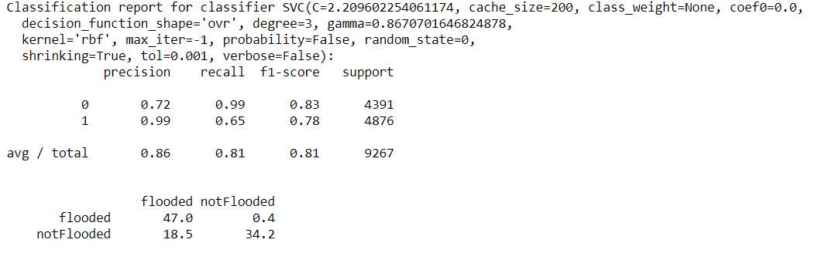

Best params for random forest

{'n_estimators': 800,

'min_samples_split': 10,

'min_samples_leaf': 2,

'max_features': 'sqrt',

'max_depth': 20,

'bootstrap': False}