1. ***Story***

The world is dying. Legend has it that only the three legendary orbs of Fire, Water and Nature, can save the world. 3 legendary figures, the Rocket (Warrior), the Wiz (Magician) and the Wind (Crossbow Master) was chosen to retrieve the orbs from the Lands of Raeth.

1. ***Scope***

**Raeth** is a 2D side-scrolling action game that focuses on combat, skills and puzzle. You play as one of the legendary figures to obtain the 3 legendary orbs. In this game, we try to focus on new skills for traditional characters, and tweak the map objective so that players can play through different pathways in a same or different map.

1. ***Mechanics***

\***Players can switch to melee or ranged skills**

\***Each character has different map** that it must go through.

* For Rocket, the map will have no check points, pure hack and slash.
* For Wiz, the map will have certain enclosed boxes with enemies/heals. (Teleportation)
* For Wind, the map is full of tall obstacles. (Fire fly)

Players collect Shards of the Unknown scattered throughout every level. These shards are required to proceed and finish the level.

**Characters**

1. **Warrior – Rocket (red theme)**
   * Weapon - Fist of Fire
   * Skills/Perks:
     1. Can double jump with his jetpack.
     2. When in the air, can fly down and punch enemies. (AOE)
     3. Every punch generates burst of fire cone in front of the Fist of Fire, deals more damage every third punch. (AOE)
     4. Can force all enemies on the screen to appear in front of you. *(cooldown)* (AOE)
     5. Block – Creates a shield of fire around you and block all projectiles for 0.3s. Uses 10 hp.
     6. Ultimate – Nuclear Blast: Deals immense damage half the screen in front of you. After that, your Fists becomes hot and deals more dmg for 10 seconds. (AOE)
2. **Magician – Wiz (blue theme)**
   * Weapon – Creator’s staff
   * Skills/Perks:
     1. Manipulate objects, enemies with the use of telepathy.
     2. Teleport to any point on the screen. *cooldown*.
     3. Shoots homing projectiles that pierces through enemies. Can charge longer to deal more damage.
     4. Completely stops time *around you*, enemies are invincible for the duration, and you can move freely.
     5. White hole – Simulate a white hole by distorting space time to block and expels attacks and skills directed towards you. (AOE)
     6. Ultimate – Adaptation: Creator’s Staff glows brightly, stunning all enemies and turn you into a Magical Warrior that have immensely powerful melee attacks.
3. **Crossbow Master – Wind (green theme)**
   * Weapon – Tornado (Xbow); Shield – Shield of Nature.
   * Skills/Perks
     1. Every shot ricochet between enemies for 5 times.
     2. Fire Fly: When in the air, shoots an arrow with that explodes with fire downwards, that detonates right below you. The blast from this explosion makes you jump twice.
     3. Freezing arrow: Shoots an arrow forward and freezes enemies.
     4. Fire arrow: Shoots an arrow forward that light up enemies. Can spread to other enemies as well.
     5. Dark arrow: Shoots an arrow forward that forces enemy to run away from you.
     6. Shield – For 5 seconds, every damage you received is converted into a shield that absorb damage.
     7. Ultimate – Mother Nature: The Shield of Nature reveals its true form, and attaches to Tornado for 25 seconds, while attached, extra homing leaf pellets are release whenever player uses skill or attack.
4. ***Challenges***

Every level has a different boss with unique skill. Bosses can make the level harder as it has global skills. Each map has enemies with varying strength as you progress.

1. ***Winning & Losing conditions***

**Win**

* whole game by obtaining all three orbs.
* each level by defeating its boss

**Lose**

* when HP = zero

1. ***Rewards & Punishments***

**WIN:**

* Gain gold, which can be used to upgrade weapons.
* Gain exp, which levels up your character and weapon.
  + Reasoning: Players can still progress if they keep losing.
* Rewards
  + 10 shards, 3*, 3SP, 1000 gold
  + >7 shards, 2*, 2SP, 750 gold
  + < 5 shards, 1*, no SP, 250 golds

**LOSE:**

* Gain only exp.
* Each losing spree decrease max HP of character by 10%, up to -30%.

1. ***Audio & Visual***

**Audio**

Natural, soothing, directional audio/music. No loud music, music is only an addition not compulsory.

Mobbing: <https://www.youtube.com/watch?v=kM5-Umevzbs>

Boss: <https://www.youtube.com/watch?v=oy53Zy9Bjf4>

Sources: Music from Terraria.

**Visual**

Somewhat similar to Maplestory and Terraria, but instead of portals leading to new map, each portal is the end of a level and shows results.

Flashy skills that appeal to all MMORPG, MOBA players.

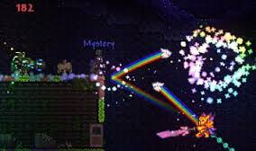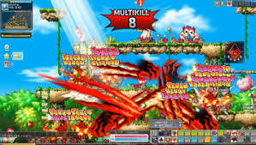

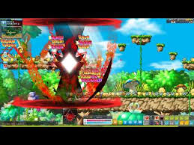**Fig 7.0** Melee AOE attacks **Fig 7.1** Sword that shoots projectiles

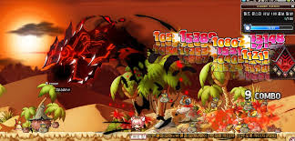

**Fig 7.2** Melee AOE attacks **Fig 7.3** Skills with a gauntlet

**Sources:** Terraria, Maplestory gameplay.

1. ***Bartle taxonomy of player types***



This game focuses on **Killer/Achiever** players. As a player progresses into the game, their skills will be more powerful and look better. This game is also a kill to win game as fighting/combating is the essence of this game. This game might have some storyline built into each level, so it can also be classified a little towards **socializer**.