# Phase 1 – A2

Ian Stewart

## Design Rainfall Hyetographs

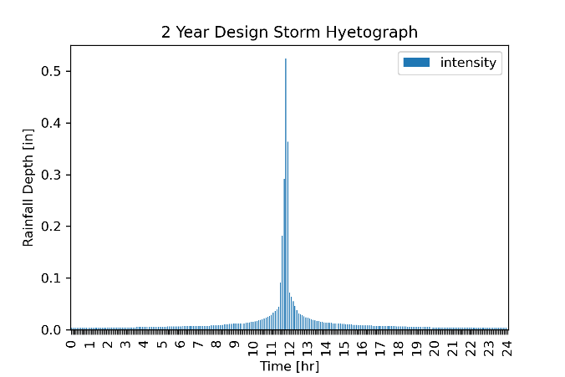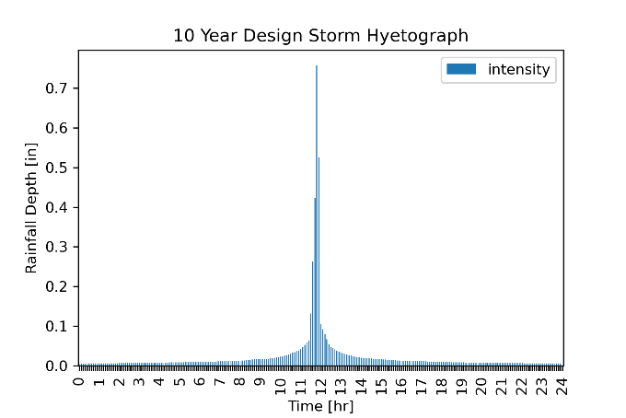

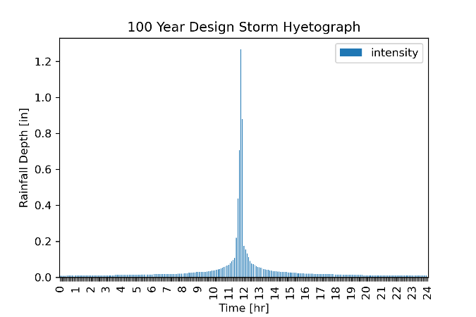

## Soil Report

|  |  |
| --- | --- |
| Area (ft2) | Hydrological Soil Group |
| 155091.02 | B |
| 1001.88 | B |
| 44283.1 | A/D |

Report from NRCS is attached below.

## Curve Number Calculation

|  |  |  |
| --- | --- | --- |
| Area Name | Area [ft2] (percent) | Curve Number |
| A­1 | 155091.02 (77.4) | 65 |
| A2 | 1001.88 (0.5) | 65 |
| A3 | 44283.1 (22.1) | 43 |
| Total | 200376 (100) | 60 |

$$CN=\frac{{C_{1}A}_{1}+C_{2}A_{2}+C_{3}A_{3}}{A_{1}+A_{2}+A_{3}}=\frac{0.774×65+0.005×65+0.221×43}{1}=60.14$$

$$S_{D}=\frac{1000-10CN}{CN}=6.66$$

$$I_{α}=0.2S_{D}$$

