Generate an app to display and change equipment. First page should show the list of equipment records with filter field for equipment number. Once the user selects a table record, a new page opens up showing the data for the selected record. This new page MUST contain the following Tabs: General, Location, Organization, Structure, Warranty data, Sales and Distribution, SerData It is vital that these tabs are created. The general Tab is displayed as in the image:

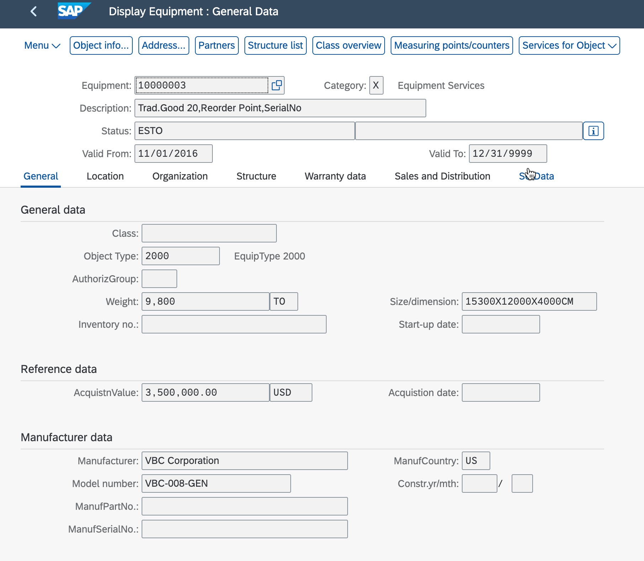

Category field represents a code list with values X (Equipment services) and M (Machines) This page also contains the following Tabs: Location, Organization, Structure, Warranty data, Sales and Distribution, SerData, each of these tabs contains fields and/or tables. Location tab contains fields as in the image:

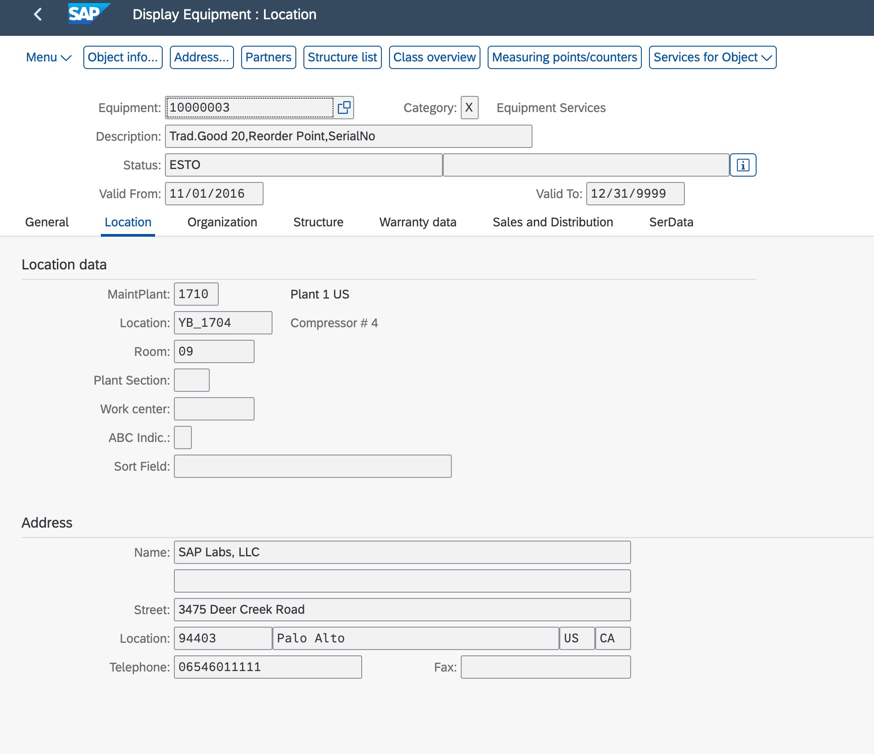

Organization tab contains fields as in the image:

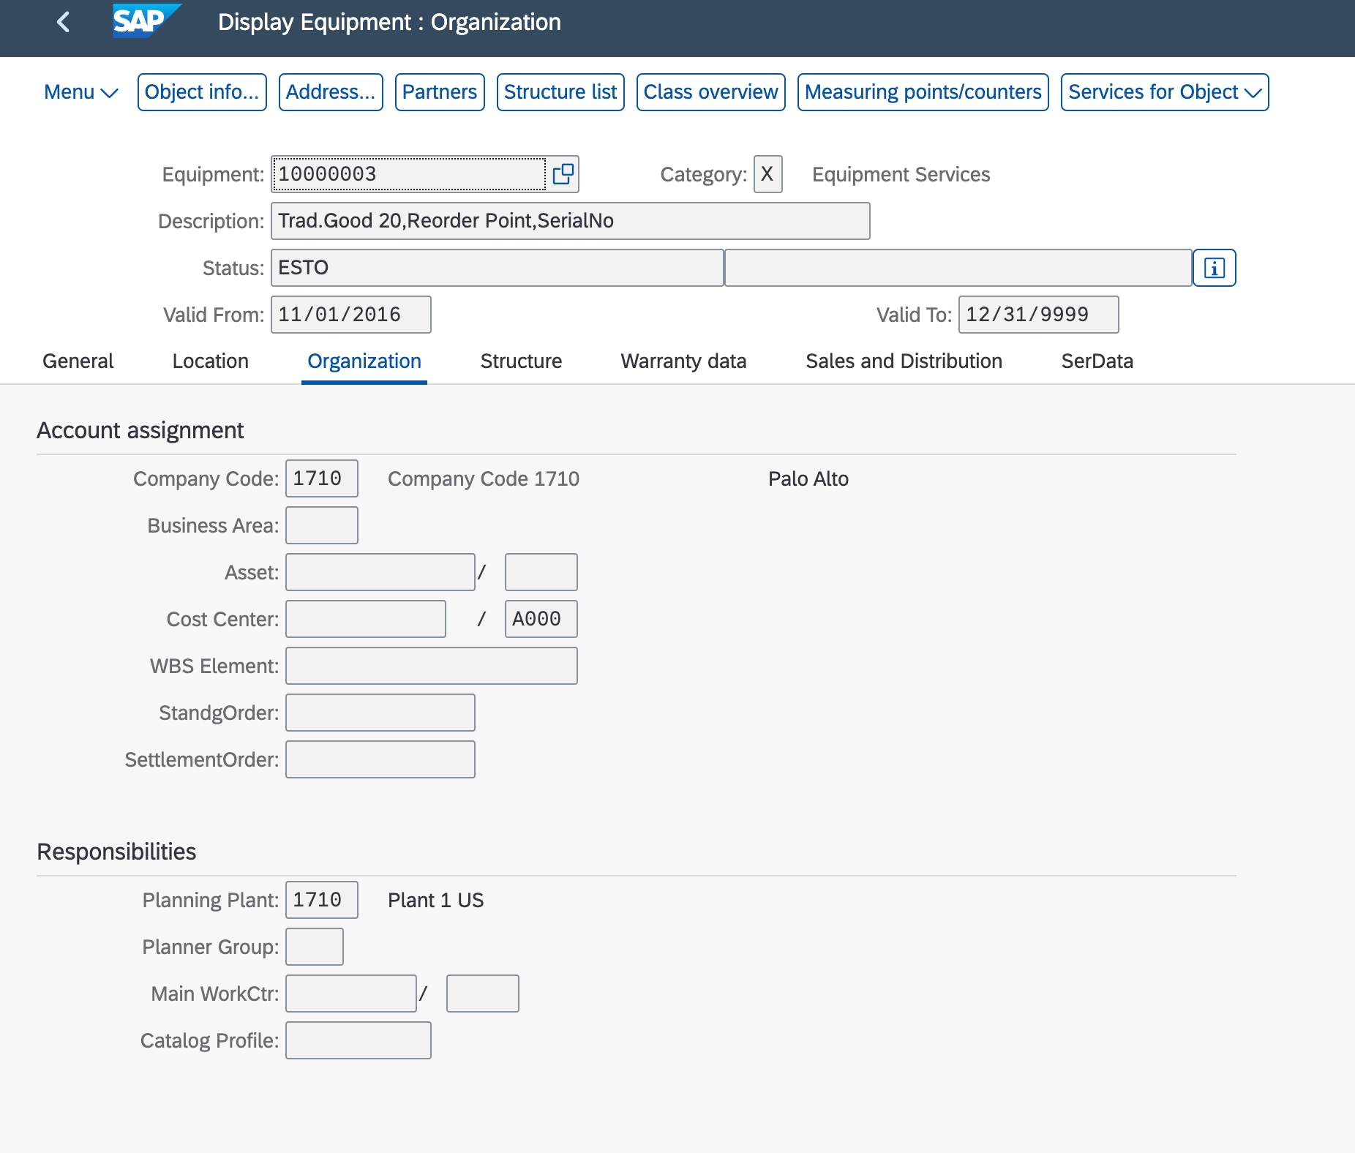

Structure tab contains fields and a table listing related equipment as in the image:

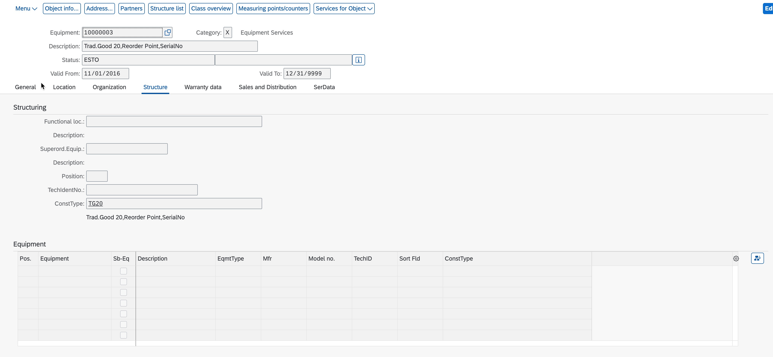

Warranty data tab contains fields as in the image:

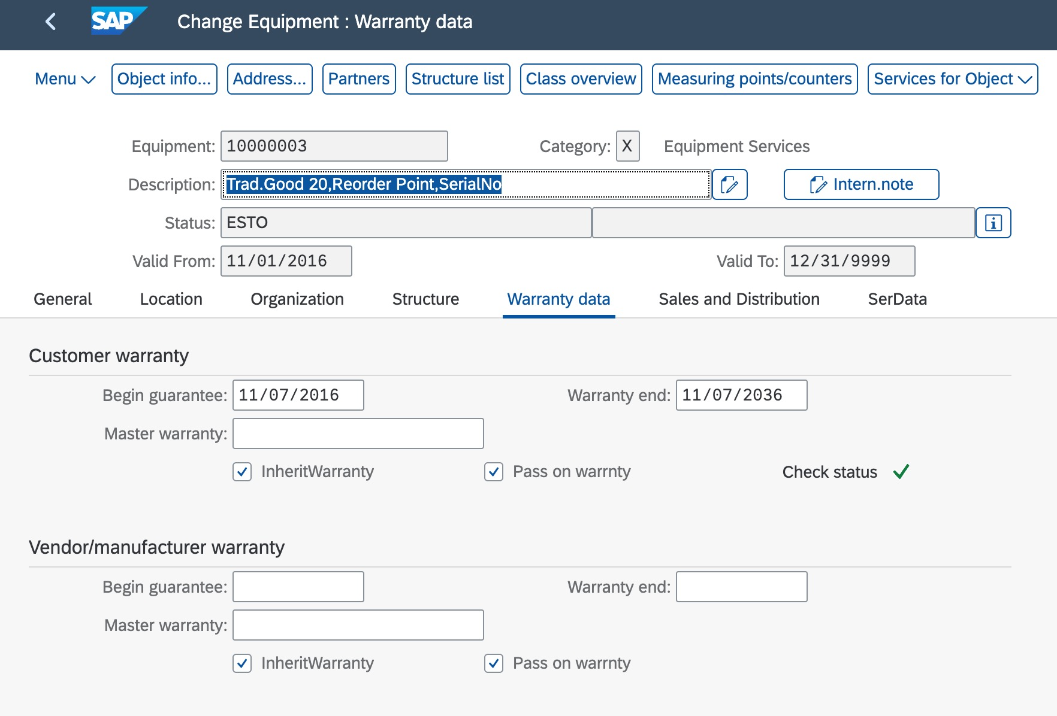

Sales and Distribution tab contains fields as in the image:

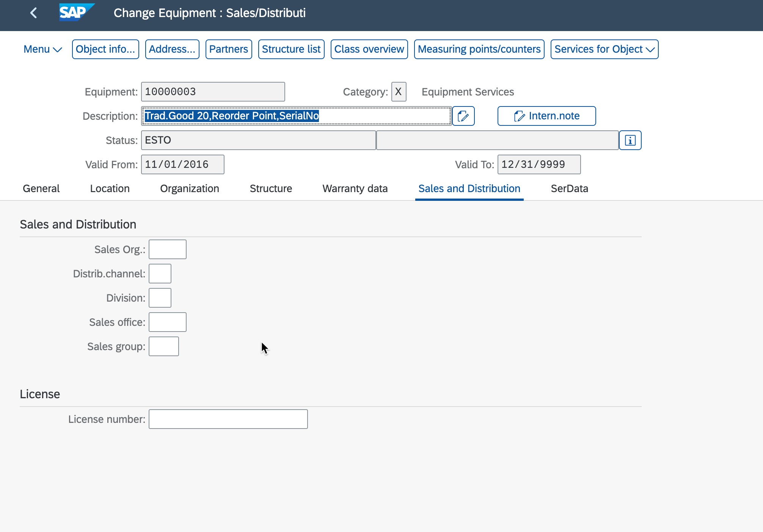

SerData tab contains fields related to the general serial data and stock information as in the image:

