# Population Growth and Intra-district Divergence

v.0 12/8/14

Misalignment between the policy positions of legislators and their constituency preferences motivates a large portion of contemporary research in American electoral politics. One example is the gap between strong partisan polarization in legislatures, and weaker polarization among voters. The best measures of legislator ideology suggest that the aggregate extremism of roll call behavior does not reflect relatively moderate self-reported issue preferences among voters.

The search for explanations of this gap has engaged several of the most important theories in the field. Some research emphasizes structural problems that interfere with legislative accountability, including the influence of campaign finance, gerrymandering, the importance of primary elections, and the practices and incentives of modern election campaigns. The Conditional Party Government theory tells important stories about both sides of the legislator-constituency relationship. This theory describes contemporary expectations of partisan consistency within legislatures, implied by stronger institutional role of parties and their pull on legislators. Other research emphasizes the complexity of legislative accountability to voters, and demonstrates that the public will sometimes judge legislator performance in ways that accommodate legislators' freedom to diverge from constituency preferences. For example, voters may be more sensitive a legislator's ability to explain their position taking even when it is inconsistent with voters’ modal preferences. A legislator’s visibility, district service, and acquisition of pork can also buy forgiveness from voters. When the public does hold legislators accountable for their position taking, the issue dimension of greatest importance can change from place to place. The rising importance of a single issue dimension also hinders responsiveness to constituency preferences, partly because the public expects legislators to pick sides and differentiate themselves.

Recently, some scholars have suggested that uncertainty about constituency preferences contributes to greater divergence by legislators. The claim is that uncertainty adds to the willingness of legislators to diverge, beyond the divergence attributable to partisanship alone. This paper is motivated by recent work that has offered theoretical explanations that highlight uncertainty and its effect on legislators' position taking.

One example is Bawn et al. (2011), which argues that legislators will stray from the median voter to the extent that voters cannot recognize the difference between centrist and a relatively extremist platform. Although their paper focuses on uncertainty about legislators rather than the public, it seems plausible that uncertainty about policy preferences moves in both directions. Recent work from McCarty et al. (2014, referred to here as MRSTW) adds a formal theoretical basis to this explanation. They propose a formal model derived from Wittman (1981) and Calvert (1985) suggesting that uncertainty about the location of the median voter will move legislators away from the center. The authors apply this reasoning to an empirical analysis of U.S. state legislatures, using a new and extensive dataset of constituency policy preferences of every individual state legislative constituency across the country.

MRSTW’s empirical analysis uses an analytical technique from McCarty Poole Rosenthal (2009) which decomposes aggregate polarization into two parts. The technique estimates the gap between Republican and Democratic ideology scores for districts with similar or identical partisanship. This gap, labeled intra-district divergence, is separated from the polarization that is attributable to partisan differences between districts. MRSTW propose a linear model of intra-district deviation, and show that increasing variance of constituents’ preferences increases IDD, as predicted by their formal model.

We think uncertainty about constituency preferences will predict greater partisan divergence. In our paper, we also look to U.S. state legislatures for answers, exploiting an opportunity presented by two new datasets. Shor and McCarty (2011) have generated an updated set of state legislator ideology scores for the last twenty years, based on the Poole and Rosenthal methodology, while adding survey data that standardizes ideology scores across legislatures. We combine this data with the survey-based constituency preference from Tausanovitch and Warshaw (2013). We compare ideology scores and preferences at the state legislature level, which afford enormous leverage, thanks to more than 6000 observations per year. We adapt the MRSTW approach and offer two original contributions. First, we think that uncertainty about voter preferences can be characterized and estimate in a variety of ways. The MRSTW paper measures uncertainty as the variance of voter preferences using the survey that captures each district's preference mean, but this approach suggests just one of many possibilities. In our paper, we try to observe uncertainty about voters by applying intra-decade population growth within districts. We think that rapid population growth of a legislative district provides a useful example of uncertainty about constituents, and serves to demonstrate how other kinds of observable data can be adapted as well. We test another example that applies the average and variance of individual voter age, using a snapshot of the Washington state voter rolls. Secondly, we exploit the unusual practice of multi-member districts, which are used for all seats in lower houses of four states. In these instances, as we will show below, intra-district deviation can be observed directly, using the instances of multi-member districts that elect one member from each party. From these direct observations, we can refine our estimates of intra-district deviation for each of those legislatures, and potentially translate them into better estimates for every other district across the country.

**The link between uncertainty and divergence**

We make the assumption that divergence represents a choice that legislators exercise to pull their policy positions closer to their own ideal points, even though the policy positions represent a compromise. In this characterization, uncertainty presents an opportunity for politicians looking to deviate from general constituents' preferences. Why should uncertainty lead to this type of divergence? One explanation appears in the formal model proposed by MRSTW. The model's result follows from three restrictive assumptions: 1) that legislators and their electoral challengers from the two parties do not share the same underlying policy preferences, 2) politicians do share the same understanding about the distribution of possible median voter positions and most importantly 3) politicians respond to a single policy dimension.

This expectation could seem counterintuitive. We might suppose that a risk averse politician would respond to uncertainty by conceding more ground and adopting policy positions that, if anything, err towards positions further her own preferences. In any case, uncertainty might not be a useful premise, if we think that a politicians essential task is to characterize all of the preferences in their district knowledgably, and that legislators will exercise the requisite skill to manage this knowledge effectively, or else they will become ex-legislators. Moreover, MRSTW recognize that other explanations of divergence become relevant once the uncertainty is reduced or eliminated.

Despite this reasoning, we think that uncertainty and intra-district divergence ought to be correlated. To politicians, the real risk of greater uncertainty about the median voter comes absorbing the cost of conceding ground with less certainty of a payback. To test this assertion, we need to find observable feature of districts and constituents that suggest uncertainty about the median. MRSTW identify size of the variance of voter preferences as the best place to start. Heterogeneity of preferences does suggest that the estimate of a district median is harder to locate, their research finds a positive relationship between heterogeneity and AIDD. We think other district-level indicators of uncertainty are available, and this paper considers two of them. The first is the intra-district population growth that occurs over a decade following redistricting. Unsurprisingly, this growth varies significantly across legislative districts, within states and nationwide. In the decade ending in 2010, the mean population growth of all state legislative districts was 5.7%, but the top 20% of districts grew by 19% or more, while 27% lost population. This variation suggests that constituencies could be changing dramatically over a short period of time, and we think short-term growth is also a reflection of overall fluidity in the electoral environment. Our research examines the relationship between intradistrict growth and AIDD, and finds a positive relationship after accounting for district partisanship. The second possibility sign of uncertainty is heterogeneity of voter characteristics, such as age. Using voter rolls from two states (Ohio and Washington), we compare districts by mean and variance of the ages of their voters, and we expect each of these characteristics will correlate with divergence.

Model and Data

Estimating polarization

Our model estimates intra-district divergence by applying the technique introduced in McCarty Poole Rosenthal (2009, herein referred to as MPR). This technique uses three sets of data: 1)legislator ideology scores based on roll calls, 2) estimates of district partisanship, and 3) other district characteristics that could move legislator position taking. We begin with an overview of the MPR model, from which will derive our core hypothesis.

Aggregate polarization in a legislature is customarily quantified as the difference between the averages of ideology scores of Republican and Democratic legislators. A widely published example is the Congressional polarization measures reported in Voteview.com and dervied from DW-NOMINATE scores computed by the Poole and Rosenthal algorithm.

We can express the concept with this stylized equation:

**[Polarization = Mean Ideology Score of R – Mean Ideology Score of D]**

where R and D are indicators of the legislator's partisanship. The time series that applies this measure is one of the most widely used representations of increased congressional polarization.

**[Time series graph showing decline and rise of polarization since 1900]**

Polarization represents a combination of electoral preferences and legislative behavior. The MPR formula disaggregates these two independent elements of polarization and labels them as average intra-district divergence, and sorting. As suggested above, intra-district divergence captures the gap between Repubican and Democratic districts whose likelihood of electing a Republican is identical. These two hypothetical distributions of ideology scores help illustrate the distinction.

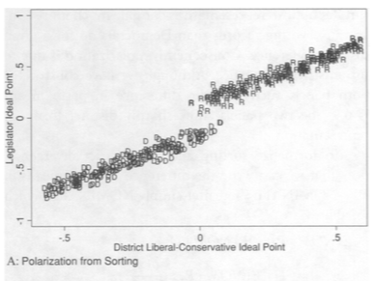

In the first example, polarization is primarily an artifact of district sorting. Districts have varying likelihood of electing a Republican or Democrat. If Republican districts expect more conservative representation, then partisan polarization will emerge, even if there is no intradistrict divergence. Without divergence, polarization will simply reflect different expectations of different kinds of districts.

The second plot emphasizes intra-district divergence comes from the differences between Republican and Democratic representatives for districts with similar partisanship.

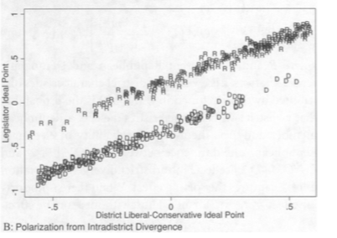

Notice the gap for any given level of partisanship, which provides an estimate of intradistrict divergence for a given level of p(z). Footnote: In the strict sense, intradistrict divergence is more properly conceived as a counterfactual comparison between a Republican and Democrat representing the same district. In the case of single member district representation, divergence is, essentially, an estimate between two or more districts of similar partisanship.

MPR describe this effect formally as follows. As shown above, R and D are indicators of Republican or Democratic representation. Let *z* represent district characteristics, and *p(z)* is the probability a district with characteristics *z* will elect a Republican, according to probability distribution function *f(z*). Total polarization in a legislature is:

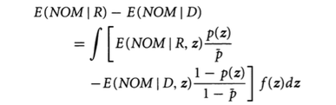

[NOTE: I’ll rewrite the formula so that “NOM” will be “x”. The formula describes the summation of all the individual combinations of z. We can demonstrate how the equation works by describing three examples.

***Example 1. Zero IDD and Positive Sorting***. If IDD for all values of z equals 0, then the Republican and the Democrat represent any given district identically, and they would both generate the same DW-NOMINATE or np_score for that district. In terms of the formula, E(x|R,z) = E(x|D,z). Polarization would be greater than zero only to the extent that the probabilities of electing Republicans would differ among the districts, i.e., the variance of p(z). We assume that p(z) varies only because districts with differing characteristics expect different policy positions between the parties. Republicans would generate different ideology scores because they would be elected in greater numbers from districts whose voters expect different policy outcomes and expect Republicans to respond. Legislators vote differently because they are responding to the greater or less Republican partisanship of their districts. **Result: Polarization = Sorting**

**Example 2. Positive IDD and Zero Sorting**. Suppose that all districts are equally likely to elect a Republican. This means that **p(z)** would necessarily equal **mean(p(z))** for all districts. Note that districts may have differing policy expectations, but those expectations do not translate into greater or less desire to elect Republicans or Democrats to the legislature. For example, districts could also be wildly dissimilar in terms of their livelihood to prefer the Republican presidential candidate, but not congress members. If IDD is positive, Republican Congress members will generate higher DW-NOMINATE scores than Democrats, even though every district is identical in its willingness to elect them. In this case, polarization reduces to the average of each individual IDD, or AIDD. Result: **Polarization = Average IDD**.

**Example 3. Zero IDD and Zero Sorting.** Accordingly, partisan polarization would be driven to zero as well. Again, this outcome doesn't imply that district preferences are identical, and it doesn't imply that polarization defined on another axis doesn't exist. But it would necessarily move differences in party means to zero.

Figure 1: Distribution of nationwide state lower house population growth. [Note: The boxplot shows the middle 2/3 of the distribution, so the top of the box represents the boundary of the top 1/3 of all districts.

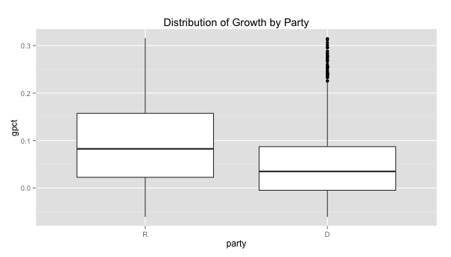

Figure 2: Conditional density plot showing the party share of districts by percentage growth. This plot shows that growth is strongly associated with districts represented by Republicans. The hashed lines on the bottom show the overall distribution.

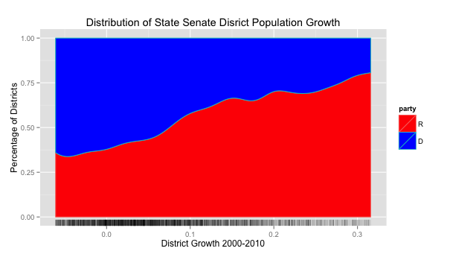

Figure 3: District constituency partisanship (i.e., “mrp estimate”) and legislator ideology (“np_score”).

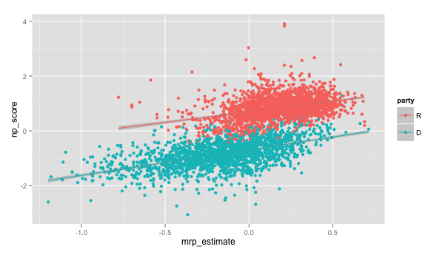

Table 1: Raw output from hierarchical regression. Important finding is that a growth rate of 100% moves ideology scores up by .11. Not a lot, but something.

> s <- lmer(np_score ~ pindex * gpct + mrp_estimate + (1|st) + (1|year) + (1|first_term),data=house); summary(s)

Linear mixed model fit by REML ['lmerMod']

Formula: np_score ~ pindex * gpct + mrp_estimate + (1 | st) + (1 | year) +

(1 | first_term)

Data: house

REML criterion at convergence: 30883.5

Scaled residuals:

Min 1Q Median 3Q Max

-6.5991 -0.6013 -0.0148 0.5729 8.7583

Random effects:

Groups Name Variance Std.Dev.

st (Intercept) 0.0380825 0.19515

year (Intercept) 0.0000000 0.00000

first_term (Intercept) 0.0001128 0.01062

Residual 0.1265196 0.35570

Number of obs: 39712, groups: st, 45; year, 10; first_term, 2

Fixed effects:

Estimate Std. Error t value

(Intercept) -0.017656 0.030133 -0.59

pindex 0.643744 0.002300 279.94

gpct 0.052933 0.009189 5.76

mrp_estimate 0.642847 0.008554 75.15

**pindex:gpct 0.116614 0.008752 13.32 NOTE: This is the important piece.**

Correlation of Fixed Effects:

(Intr) pindex gpct mrp_st

pindex 0.010

gpct -0.030 -0.033

mrp_estimat -0.007 -0.455 -0.138

pindex:gpct -0.005 -0.370 -0.278 0.102