$F_{λ}({10}^{-17}erg s^{-1}{cm}^{-1}Å^{-1})$

Observed Wavelength ()

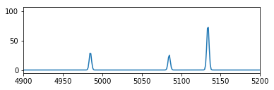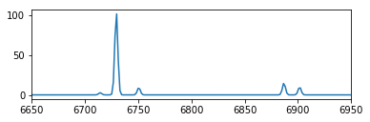

|  |  |  |
| --- | --- | --- |
| Fit Parameter | value | error |
| HB amplitude (4984.793565Å) | 30.6432852956 | +/- 0.720610781215 |
| OIII amplitude (5084.817039 Å) | 25.8787649587 | +/- 0.666493445815 |
| OIII amplitude (5133.964614 Å) | 78.2802675966 | +/- 1.19200344135 |
| NII amplitude (6714.286093 Å) | 2.72670255911 | +/- 0.304518218533 |
| Ha amplitude (6729.410474 Å) | 104.687893374 | +/- 1.35576125368 |
| NII amplitude (6750.585017 Å) | 9.11916546734 | +/- 0.366274042712 |
| SII amplitude (6886.944319 Å) | 14.9161975033 | +/- 0.433803385444 |
| SII amplitude (6901.695562 Å) | 9.89451512255 | +/- 0.422863828241 |
| line width | 1.41890625617 | +/- 0.00957684314179 |
| Redshift | 0.0251037569164 | +/- 1.88081258937e-06 |

Flux = 372.3403463396133 $erg s^{-1}{cm}^{-2}$

Luminosity= 1.5449948329955599e+30 $erg s^{-1}$

Star Formation Rate= 1.2205459180664923e-11 $M_{⊙}{yr}^{-1}$

Velocity dispersion= 63.2116878359 $km s^{-1}$

True velocity dispersion= 38.6745068367 $km s^{-1}$

Galactic Mass= 35976285.4295 $M_{⊙}$