Project Management – WDD33
12th April, 2008

Aims
You will learn about tools and techniques for project management and scheduling and apply these to your projects.
This session will also discuss risk management, writing proposals, the development cycle and the roles of staff, models for development and the costing of projects as seen from the perspective of:
- the developer
- the internal commissioner
- the external commissioner

Objectives
At the end of the session students will be able to identify, implement and apply to their projects:
- the key stages of the project cycle (client-centred)
- deliverables and milestones in the development process
- the key elements of scheduling
- the importance of work breakdown structures
- the main roles of different staff in the development cycle
- the key elements in a proposal
- the key elements of costing a project

The Client-centred Multimedia Project Cycle/Phases
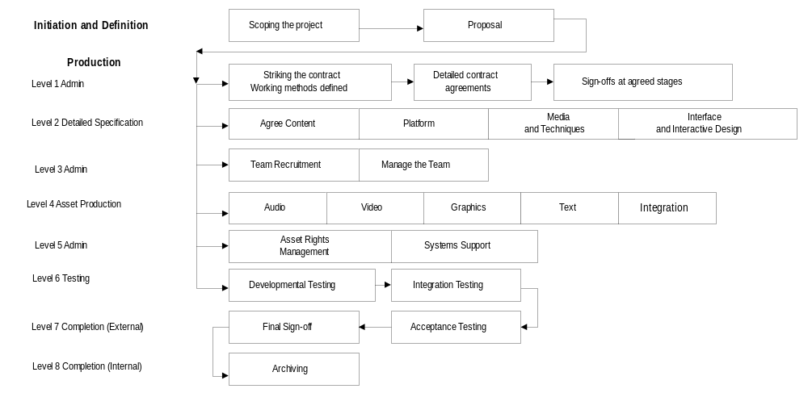 From: Managing Multimedia, Elaine England & Andy Finney, Addison-Wesley

Analysing and Evaluating progress
Two ways of analysing and evaluating a project: using milestones and deliverables.
- Milestones are the points between phases where the team and client can take stock of progress.
- Deliverables can be a paper document or an electronic file. They are items that need to be developed, reviewed and released during the project
What deliverables would you expect to see at different phases in the lifecycle?

Project Scheduling
Project phases can be divided into activities with functional, cost, time and quality objectives
- Write the objectives of the phase
- Define the deliverables (output)
- For each output work backwards and to ensure all the inputs are available to complete each deliverable

Creating the schedule
Below is a simple schedule that works well if the:
- resources are human
- resources are dedicated
- activity durations can be well predicted
- control only need be exercised on effort

ABC Project Schedule Project Manager: Date:

Estimated Actual
Code | Activity | Depend | Who | Mhrs | Start | End | Mhrs | Start | End

Some people find the above helpful and others look for a more visual representation of the process that gives them a view of concurrent activities.

Planning through breakdown structures
Breakdown structures are useful tools to start planning a project. They are a hierarchical breakdown of the project using different levels. There are a number of different breakdown structures.
- Work breakdown structure (WBS) – this is the most important breakdown. It produces a list of all the activities required to produce the outputs in the different phases
- Organisation breakdown structure (OBS) – identifies who is responsible for each phase, product, resource and activity
- Cost breakdown structure (CBS) – identifies the cost centres for each activity, phase, product and resource.
- Location breakdown structure (LBS) – which locations are responsible for products and resources
- Resources breakdown structure (RBS) – the resources used on the project – their costs and availability

Work breakdown structure
This is a family tree composed of all the products of the project and the activities required to
- Level one consists of project phases
- Project phases are divided into general kinds of work/disciplines such as marketing, design, testing and documentation
- Each category identified is divided into the products produced within each category
- The work required to complete each product is identified
- These are work-packages that can be described, estimated, planned and scheduled

Work breakdown features
A work package:
- Comprises one action
- Its cost and time duration can be predicted
- Applies to one phase or part of a project
- Involves the same resource throughout
- Is owned by one person accountable to the project manager
- Its performance can be measured
- Is unlikely to be interrupted
- Can be critical or non-critical
- Is a manageable chunk of work – (5 days)

Roles in the Development Life-Cycle
Individually complete the following table by filling in the boxes below. Indicate on a scale of 0 - 5 what you think the involvement of the different roles should be at various stages of the project.
0 = none 5 = frequent
Compare with other members of the group.
How do you work currently?
How does this vary between commissioner and developer?
What problems have you encountered?

 | Role | Account  Manager | Project Manager | Designer | Author  Programmer | Graphics  Artist
Phase
Pre-Project

Proposal

Design

Development

Implementation

Follow-up

Models for Development
Complete this table from the point of view of the developer. What are the advantages and disadvantages of working on different size projects and different types of teams?
 | Advantages | Disadvantages
Big Project

Small Project

Freelance Team

In-company team

Complete this table from the point of view of the commissioner. What are the advantages and disadvantages of working with different models for development?
 | Advantages | Disadvantages
Internal team

Freelance

Small company

Big company

Client Liaison and Process Control List
Complete the following thinking of the company you are working with, or for one that you have worked for. Then, consider your reaction to these processes and see if you feel they will act as a straightjacket, or free you of some constraints to allow a better focus on projects.
 | Management processes in place | Yes | No
1 | A written, defined way of working given to clients at the beginning of the project. An overview - This is how we work and what we expect.
2a | Company Project Template - a clear written specification of categories that need to be answered by the clients for all projects - the scope of the project.
2b | The proposal is drafted according to defined parameters
2c | This is refined into an agreement on time and cost to develop the specified project, and signed.
3 | Extra contractual agreements drawn up and signed.  Rights and intellectual property agreed if necessary etc.
4a | Budget authority identified and any delegation agreed.
4b | Sign-off authority agreed.
5a | Project Outline defined and signed off.
5b | Content defined and signed off at each stage
6. | Change Management process defined and agreed
7. | Roles and responsibilities defined and agreed
8. | A plan of education for new clients in place

Proposal Content
Work in a group. Choose whether you are a developer or commissioner of multimedia projects. What are the key elements you would expect to see/put in a proposal?
Are you Commissioner or Developer?
- Choose section headings of the proposal
- Choose major points to include under each heading
- Order the headings as you would have them in the proposal

Headings | Summary of Content | Order

Part 2
Who is the audience for your proposal? How will this impact on your approach to the proposal?

Part 3
Discuss, in your group, how you can add value to the written proposal to put you in a better position with the client. What will add value to your proposal?

