Pg Certificate in Web Design and Development
December 10th , 2011

Activities
- Stakeholder Analysis – team working
- Time management planning

Exercise 1 - Stakeholder Analysis
The Scenario:
Imagine that the Management in the Media Group is carrying out some research for the Amazon Travel Information Web site - an online guide for people travelling to the Brazilian Amazon. The Amazon Chamber of Commerce and the Hackett Lumber Company of Brazil are sponsoring the site. The Group has been asked to develop a design for the user-interface. At this stage the client has told the group that all options are open as far as hardware and software are concerned. The company wishes to be ‘user-driven’.
As part of its initial work the group is considering the interests of different stakeholders. It is conducting a small number of stakeholder analysis meetings using role-playing and will follow these with a small number of such sessions using representatives from actual stakeholder groups. You have been asked to participate in one of the role-playing meetings because of your professional background and your interest in design.
The meeting will be divided into three main parts:
- Identification of the main stakeholder groups
- The key stakeholders groups research their rewards, punishments, wants and needs.
- Team work culminating in a presentation by each team
Key points for the teamwork:
Your team should agree on the following:
- What rewards you (role-playing the stakeholder group you are representing) can offer to persuade the university team (representing the client corporation) to accept your wishes
- What punishments you can offer if they do not
- Your lists of wants – the features your team wants to see in the design to the service, and a rating of how important each of these is. Rate the wants on a scale of 5 (extremely important this feature is included) to 0 (do not mind at all whether it is included or not). There is normally no point in including an item rated 0 unless you are trying to make a special point.
- Your list of avoids – the features your team wants to avoid having in the design of the service, and a rating of how important each of these is. Rate the avoids on a scale of 5 (extremely important this feature is not included) to 0 (Do not mind at all whether it is included or not). There is normally no point in including an item rated 0 unless you are trying to make a special point.
- Be prepared to explain your lists and give your team’s arguments in support of them. Decide how you are going to make the presentation. The other teams and the course tutor(s) will rate how convincing your team is.

Time Management
The session discusses the key areas including:

SMART OBJECTIVES
- Specific
- Measureable
- Achievable
- Realistic
- Timebound

Five Principles of Goal Setting
Goal Setting (SMART)
To motivate, goals must take into consideration the degree to which each of the following exists:
- Clarity.
- Challenge.
- Commitment.
- Feedback.
- Task complexity.
Prioritising
Prioritise activities on your To Do List
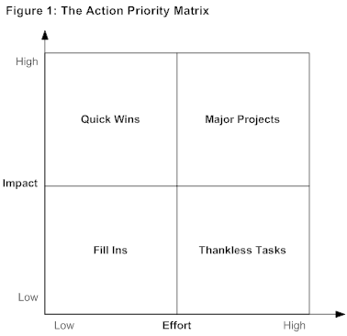

Scheduling
U r g e n t
I m p o r t a n t
Decide when you will do it
Do it immediately
Do it later
Delegate to somebody else
- Start by identifying the time you want to make available for your work. This will depend on the design of your job and on your personal goals in life.
- Next, block in the actions you absolutely must take to do a good job. These will often be the things you are assessed against.
For example, if you manage people, then you must make time available for coaching, supervision, and dealing with issues that arise.
- Review your To Do List, and schedule in the high-priority, urgent activities, as well as the essential maintenance tasks that cannot be delegated and cannot be avoided.
- Next, block in appropriate contingency time. You will learn how much of this you need by experience. Normally, the more unpredictable your job, the more contingency time you need. The reality of many people's work is of constant interruption: Studies show some managers getting an average of as little as six minutes uninterrupted work done at a time.
Obviously, you cannot tell when interruptions will occur. However, by leaving space in your schedule, you give yourself the flexibility to rearrange your schedule to react effectively to urgent issues.
- What you now have left is your "discretionary time": the time available to deliver your priorities and achieve your goals. Review your Prioritized To Do List and personal goals, evaluate the time needed to achieve these actions, and schedule them in. (Mindtools)

