
KaiOS

VISION

An operating system for intentional action.
True connection requires the space to think. KAIROS OS replaces the overwhelming grid of apps with a single line of intent - transforming the smartphone from a landscape of distraction into an instrument of narrow, deep, and uncompromised focus.
APP
A text-first Android launcher. One cursor. No icon grid. No ambient noise.
SOLUTION
Intentional friction that forces users to be mindful of their phone usage and
VISION
Rescue attention from Chronos - endless scrolling - and restore Kairos: the right moment to act.
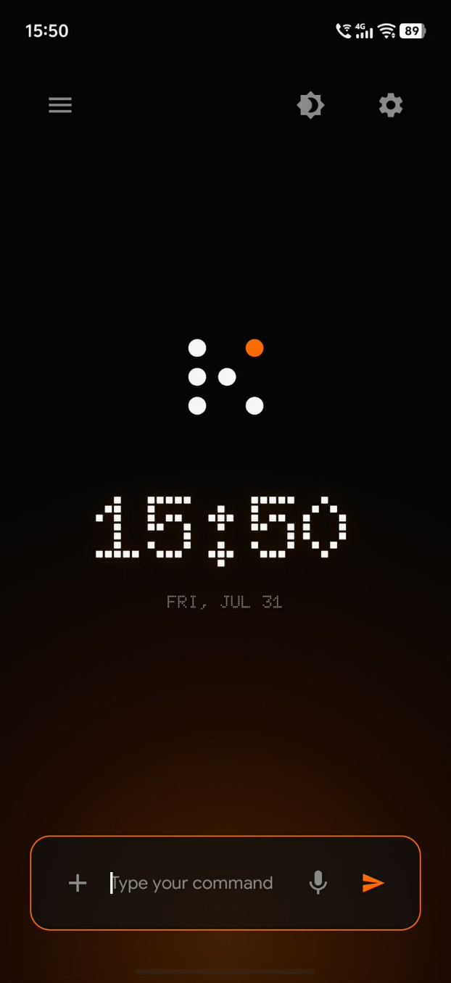

CORE FUNCTIONALITY

Command the phone. Don't browse it.
KAIROS OS centers every interaction on a blinking cursor. You name the app, state the intent, and receive a focused result - as a widget, a deep link, or a quiet confirmation.

01  Text-first command interface  A blank home screen with one input. Use @app mentions to route work to Gmail, Calendar, Slack, Notes, Spotify, and more - the same mental model as attaching connectors in a desktop AI app. | 02  Tiered AI intent routing  Simple utilities dispatch in milliseconds. Lightweight on-device models handle routine intent. Cloud models take complex tool-calling - so the OS feels fast when it should, and smart when it must.
03  Server-driven widgets  Responses render as interactive cards inside the stream: prioritized emails, today's schedule, digests. Read via widgets. Execute via deep links only when you choose to enter the native app. | 04  Background agents  Delegate longer work - news digests, research, recurring jobs - then stay present. Running agents surface status without pulling you into another feed.

How it sounds in practice

@gmail show my important emails
@googlecalendar show today's schedule
@slack summarize unread highlights
@alarm set an alarm for 6am tomorrow

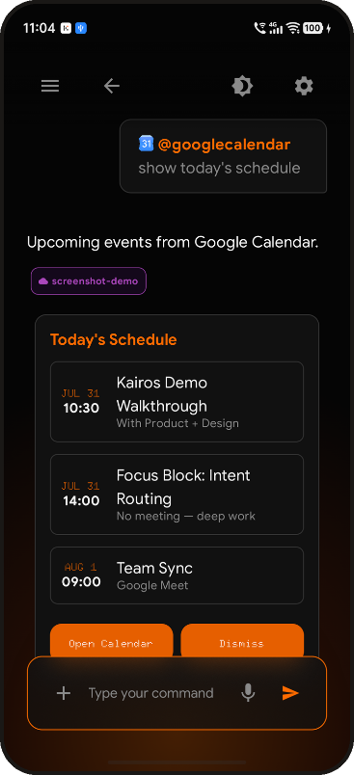
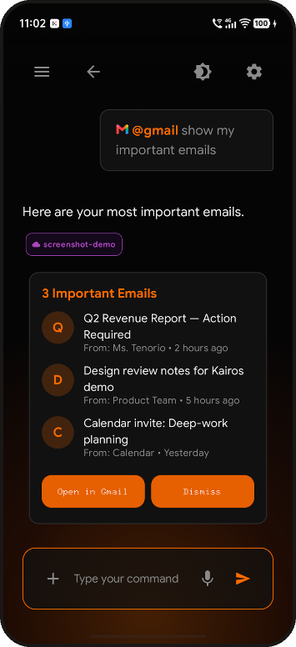
Widgets in the command stream
Gmail - important emails widget | Calendar - today's schedule widget

01 · CORE FUNCTIONALITY

Guardrails that protect attention.
Convenience without boundaries becomes capture. KAIROS OS adds deliberate friction where distraction thrives - and stays quiet where urgency is real.
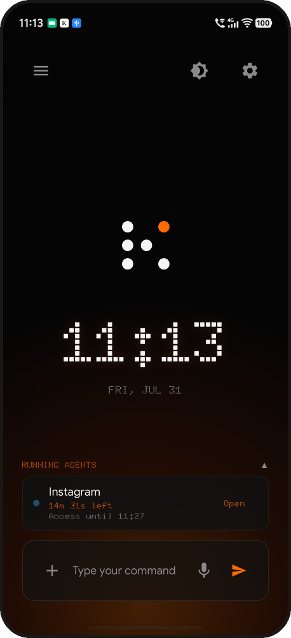
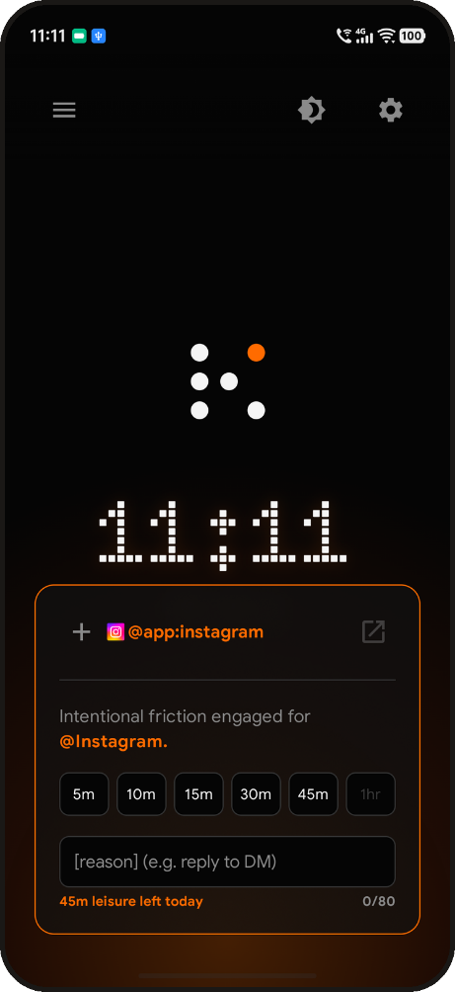
INTENT GATE
Trap apps (Instagram, TikTok, and anything you mark) refuse a casual open. State a reason, pick a timebox, then go in with a mission. Leisure budgets make the cost of distraction visible before you spend it.
NOTIFICATION INTERCEPTOR
Push noise is captured silently. Critical signals - calls, calendar, VIP contacts - pass through. Everything else waits for an intentional pull: your daily digest, on your terms.
PERSISTENT CONTEXT ANCHOR
When a native app opens, a floating bubble keeps the mission visible - countdown included - and one tap returns you to the command line without losing the thread.
CONFIGURABLE, NOT IMPULSIVE
You set Utility vs Trap apps and strictness during onboarding. Softening guardrails later takes friction (cooling-off), so a weak moment can't erase a clear-minded decision.

02 · TARGET USERS

Built for people who want their phone back.
KAIROS OS is not for everyone who wants a prettier launcher. It is for people ready to trade autopilot for agency - professionals, teams, and minimalists who feel the cost of shallow attention.
PRIMARY Ages 22-40
The Overwhelmed Professional
WHO  Knowledge workers, students, and creatives who know their phone usage is excessive but lack tools that change the habit - not just track it. | PAIN  Doomscrolling, notification anxiety, broken deep-work blocks, guilt after unproductive sessions.
GOAL A phone that serves intention instead of exploiting impulse.

SECONDARY Ages 25-45
The Enterprise User
WHO  Employees on company-issued devices who need Workspace, Slack, and calendars without social media as the default landscape. | PAIN  Burnout from context-switching, meeting overload, inbox black holes mid-task.
GOAL A command line for business tools - and a Deep-Work profile for working hours.

TERTIARY Ages 18-35
The Digital Minimalist
WHO  Privacy-conscious or philosophy-driven users chasing dumbphone calm with smartphone capability. | PAIN  Discomfort with the attention economy; apps designed to harvest, not help.
GOAL A device that is hard to use unintentionally - by design.

Shared thread across all three: they do not need more apps. They need a layer that restores the capacity to choose - before the feed chooses for them.

03 · PRACTICAL APPLICATIONS

A day run by intent, not habit.
From morning triage to evening wind-down, KAIROS OS turns scattered app rituals into deliberate, bounded actions.
Morning triage  @gmail show my important emails  Surface only what needs a decision. Open Gmail when you must reply - not when a badge demands your presence. | 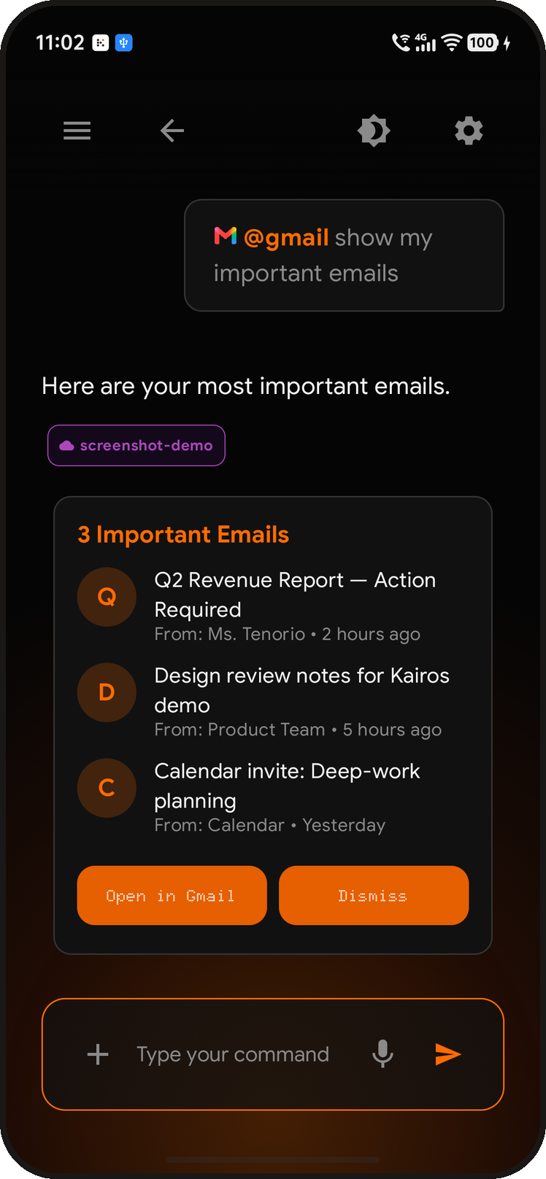

Protect the calendar  @googlecalendar show today's schedule  See the day as a sequence of commitments and focus blocks. Add meetings by saying them - without wandering the month grid. | 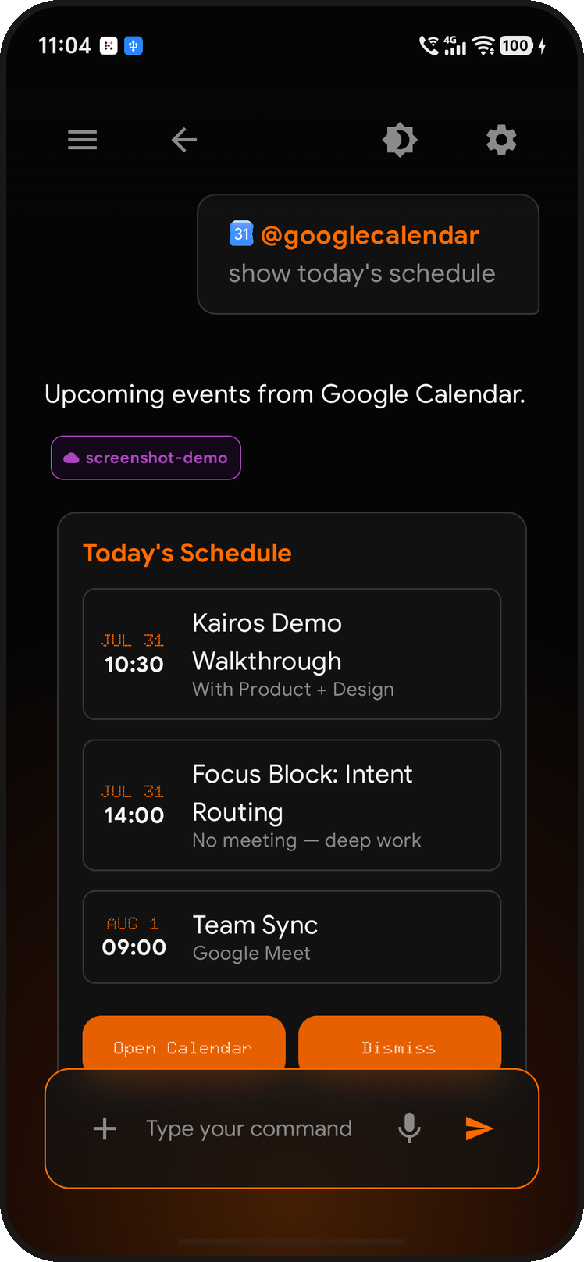

Catch up without drowning  @slack summarize unread highlights  Get channel and DM highlights as an action brief. Re-enter Slack with a reason, not because the red circle said so. | 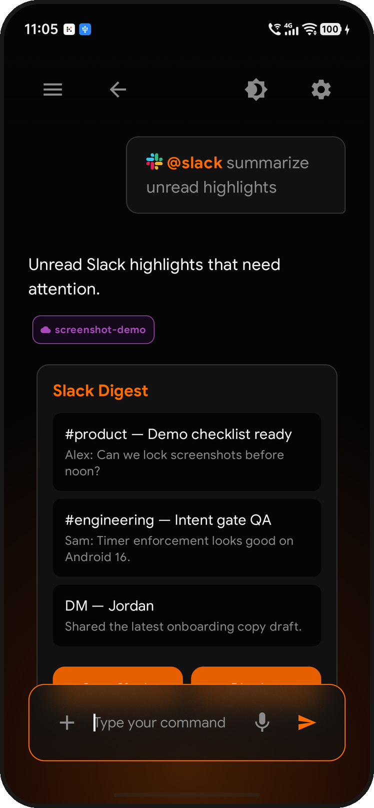

Also in the field
Bounded leisure  Open Instagram for 5 minutes to reply to a DM - then the gate closes. | Capture without hop  Drop a shopping list or launch plan into Kai Notes from the same stream. | Deep-work hours  Enterprise profile prioritizes Workspace and silences social noise on company devices. | On-demand digest  Pull a daily summary when you are ready - never when an algorithm is.

04 · REAL-WORLD VALUE

Less noise. More agency. Measurable calm.
KAIROS OS creates value where attention leaks today: fewer context switches, fewer accidental doomscrolls, and faster paths to the one next action that matters.
Reclaim time from Chronos  Replace open-ended scrolling with timeboxed, reason-backed sessions. Leisure budgets make distraction a conscious spend - not an ambient default. | Narrow and deep work  One command stream keeps email, calendar, and chat in a single cognitive lane. Widgets answer; deep links open only when execution requires the full app.
Business-ready focus  On corporate devices, Deep-Work mode turns the launcher into an executive command line for Workspace and team tools - cutting burnout from feed-shaped interfaces on company time. | Privacy-minded architecture  The phone stays a thin client for presentation and local utilities. Secrets and OAuth live on the backend. Simple tasks can stay on-device when possible.

The shift in practice
BEFORE · CHRONOS  - Icon grids that invite browsing  - Badges and push as constant pull  - Social apps open in one tap  - Hours lost without a decision | WITH KAIROS OS  - A blank slate that demands intent  - Digests you request on purpose  - Trap apps gated by reason + time  - Actions that feel chosen, not stolen

CLOSING
To be human is to choose. KAIROS OS restores that capacity by removing the autopilot of modern UI - so what remains is you, your intention, and the right moment to act.
KAIROS OS · Disconnected by Design · Intent over impulse

