
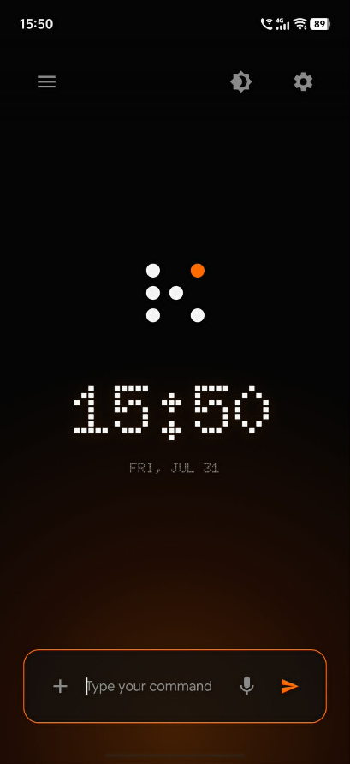
KaiOS
Application Document

True connection requires the space to think. KaiOS embraces the "Disconnected by Design" philosophy by replacing the overwhelming grid of apps with a single line of intent, transforming the smartphone from a landscape of distraction into an instrument of narrow, deep, and uncompromised focus.
In ancient Greek there are two words for time. Chronos is quantitative time: the ticking clock, the endless feed, the hours lost to doomscrolling. Kairos is qualitative time: the right moment, the opportune moment for deliberate action. Modern operating systems trap us in Chronos. KaiOS is built to rescue human attention from that loop, so every interaction with the device happens in a moment of Kairos - with intention and purpose.

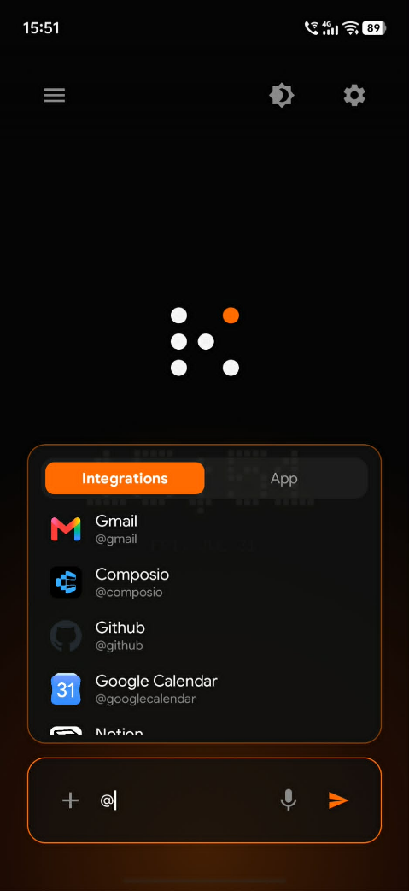
1. What KaiOS Is
KaiOS is an agentic Android launcher. It replaces the traditional app-grid home screen with a minimalist, text-first command interface powered by AI. The phone becomes a thin client: it captures what the user wants, talks to a backend that classifies intent and calls the right tools, and returns either a structured widget in the command stream, a detailed response of the user’s query, and/or a deep link into a native app.
The product is deliberately uncomfortable at the first unlock. There is no colorful grid doing the thinking for you. There is a blank canvas and a blinking cursor. That blankness is not a missing feature. It is the designed friction that breaks autopilot phone use. This unique nature of the launcher makes unintentional phone use hard.
Architecturally, the Android app stays light. Complex routing, OAuth, and tool execution live on a Next.js backend connected to AI models and integrations. Simple on-device utilities can still be reached quickly through Android’s native intent launcher and utilization of local, on-device models.
2. The Problem
Modern smartphones are engineered to maximize engagement. Visual bombardment, colorful icons, badge counts, infinite scrolls triggers dopamine loops and passive consumption. Push notifications shatter focus by pulling users out of whatever they were doing. Social platforms favor broad and shallow connections over narrow and deep ones. Zero-friction access means one tap opens any app, including the ones users later regret opening.
The result? Hours on the phone without intention, digital fatigue, anxiety, and a gradual erosion of agency over attention. Convenience is treated as an absolute good. KaiOS challenges that assumption. Convenience without boundaries becomes capture.

3. Core Functionality
Everything in KAIROS OS exists to force articulation of intent before the device offers a path. The following capabilities form the core of the product.

3.1 Command interface
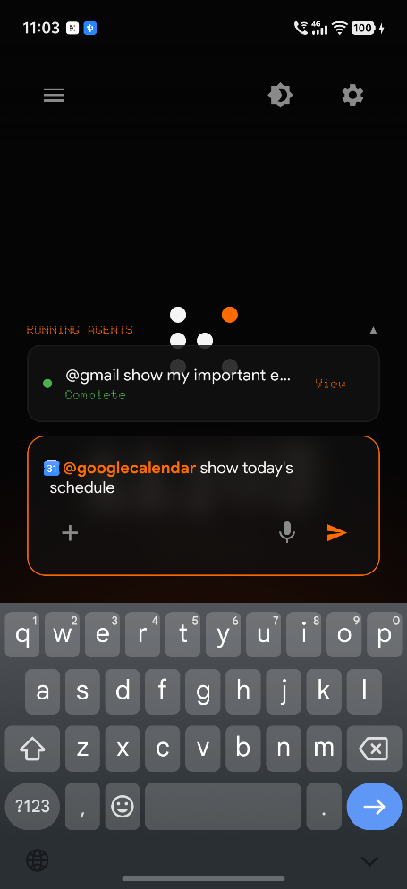
The home screen is a minimal text input with a blinking cursor as the primary interaction surface. Users direct work with an @app mention syntax, similar to attaching connectors in a desktop AI app. Available connections can be selected from a dropdown. Responses appear chronologically in a scrollable stream of interactions. For native utilities that do not need language understanding, switching from “integrations “to the “app” mode on the input allows you to view your installed android apps and open them.
Typical commands look like this:
- @alarm set an alarm for 6am tomorrow morning
- @google-calendar set the meeting for Ms. Tenorio tomorrow at 3pm
- @gmail fetch my most important emails
- @notes Shopping list for tomorrow: eggs, chicken, rice
- @slack summarize what the #dev channel has been working on.
- @spotify give me something random to play
The point is not that typing is always faster than tapping icons. The point is that typing forces the user to know what they want before the phone can respond.

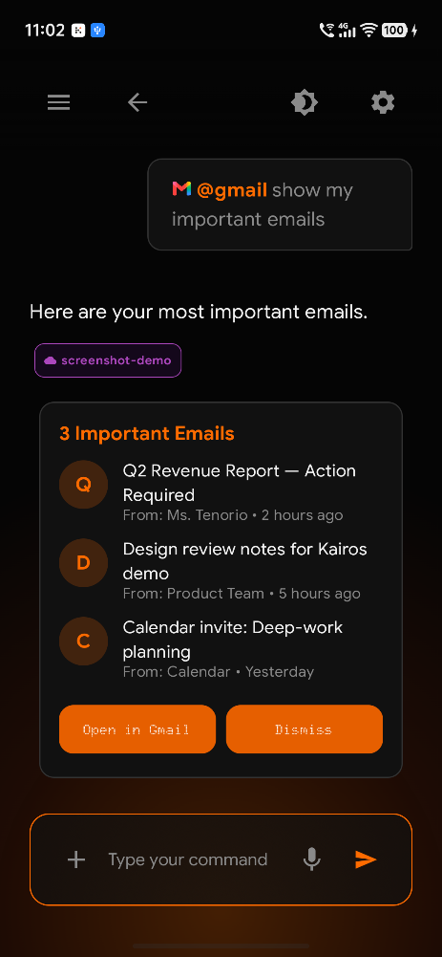
3.2 AI-powered intent routing
Not every prompt should hit a heavy model. The system classifies incoming text into tiers. Simple tasks go to a lightweight, on-device model (Gemma-4-E2B). Currently, agentic local tool calling for synthesizing notes, to-do-lists, calendar events, and alarm functionalities are supported, meaning these data never leave the device. Complex tool-calling tasks - querying Gmail, operating Cloud calendars, or utilizing 3rd party applications such as Slack, Teams, etc. - go to a more capable model (Gemini 3.5 Flash and/or Flash-Lite). Active sessions also keep conversation context so follow-ups are supported. This tiering is how the product stays usable. Instant utilities should feel instant. Agentic work can take a few seconds.

3.3 Integrations and widgets
KaiOS connects to Google Workspace apps (Gmail, Calendar, Sheets, Drive, etc.), popular business apps (Slack, Microsoft Office, Github, Jira, etc.) and native Android utilities (Alarm, Calendar, Notes, and installed apps), and third-party services where APIs or MCP servers exist.
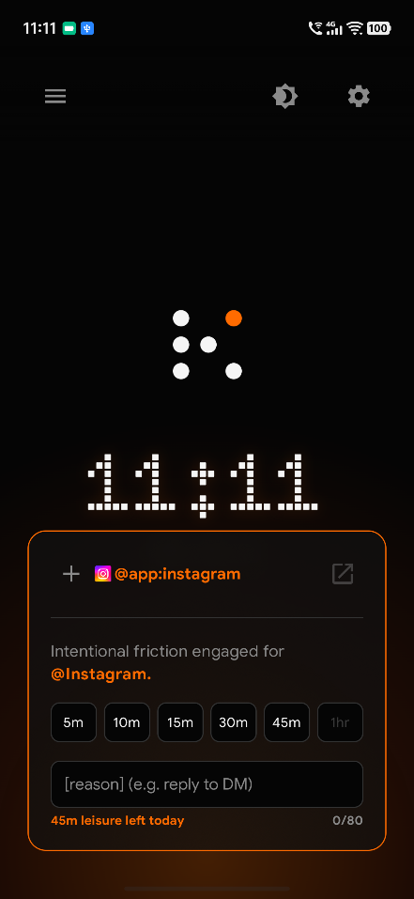
3.4 Intent Gate (anti-doomscroll)
Supported apps fall into two tiers: Utility and Trap. Utilities (Camera, Calculator, Maps, and similar) open immediately. Trap apps - social feeds and anything the user marks as distracting - refuse a casual open. The system asks for a reason and a time limit before launching. Enforcement uses a foreground overlay or kill-switch so the timebox is real, not decorative.
Users configure which apps are Utility versus Trap during onboarding and in settings. That flexibility matters: a tool that feels like a prison gets uninstalled. But changes to guardrails are themselves subject to friction - for example a cooling-off period before Strict Mode becomes Free Mode - so a weak late-night impulse cannot instantly erase a clear-minded decision. Onboarding sets that psychological contract early.

3.5 Agentic notification interceptor
Outbound friction is not enough if inbound noise still owns the lock screen. KaiOS uses Android's Notification Listener Service to capture notifications silently. They are classified into Critical (instant passthrough) and Digest (batched and held). Critical covers phone calls, calendar alerts, and messages from user-defined VIP contacts. Everything else waits until the user asks - for example with a daily digest command. Users define these rules during onboarding. Notifications become a pull request, not a bombardment.
3.6 Scheduled Tasks
KaiOS includes a Scheduled Tasks subsystem for recurring, intent-driven work - cron-style jobs that run prompts on a cadence without asking the user to reopen the phone and remember the command.
Users define a task from a dedicated Scheduled screen with the same command input pattern used on the home screen: choose an @app target, write the prompt, then set frequency (daily or weekly), days of the week when needed, and an execution time. Activating the job stores it on the backend. Supported targets include agentic apps such as Kai Notes, Kai Calendar, and Kai Clock, plus connected third-party integrations.
At the scheduled time, the backend executes the prompt, creates a conversation tagged as scheduled, and dispatches the same agent intent path used for live commands. Each run is logged with status (pending, running, completed, or failed) and linked back to the resulting conversation. Users can also trigger a job manually; completed runs surface as agent cards on the home screen so results are visible without hunting through settings.
In practice this covers recurring digests, morning briefings, reminder-style notes, and other repeatable intents - plan once, keep moving - while staying inside the intentional command model rather than burying automation in a separate productivity maze.

4. Target Users
KaiOS is not for someone who only wants a prettier launcher. It is for people ready to trade autopilot for agency. The primary audiences are summarized below.
Persona | Age | Profile | Pain points | Goal
Primary - The Overwhelmed Professional | 22-40 | Knowledge workers, students, and creatives who know their phone usage is excessive but lack tools that change the habit instead of merely tracking it. | Doomscrolling, notification anxiety, inability to hold deep work, guilt after unproductive sessions. | A phone experience that serves them rather than exploits them.
Secondary - The Enterprise User | 25-45 | Employees on company-issued phones who need Workspace and team tools without social media as the default landscape. | Corporate burnout, context-switching overhead, meeting overload. | A streamlined command line for email, calendar, and sheets - without the visual noise - and a Deep-Work profile for working hours.
Tertiary - The Digital Minimalist | 18-35 | Privacy-conscious or philosophy-driven users who want dumbphone calm with smartphone capability. | Philosophical discomfort with the attention economy. | A phone that is impossible to use unintentionally.
The shared thread across all three: they do not need more apps. They need a layer that restores the capacity to choose before the feed chooses for them.

5. Practical Applications
In daily life, KAIROS OS turns scattered app rituals into deliberate, bounded actions. The following scenarios show how the same command stream covers personal and professional use.

5.1 Morning triage
Instead of opening Gmail into an unread mountain, the user asks for important emails. The stream returns a prioritized widget (see Figure 2). The user reads what needs a decision, then opens Gmail only if a reply is required - not because a red badge demanded presence.

5.2 Protecting the calendar
The day appears as a sequence of commitments and focus blocks (see Figure 3). Meetings can be created or inspected by saying them. The user avoids wandering a month grid in search of a single afternoon.

5.3 Catching up without drowning
Team chat is summarized on request. Channel and DM highlights become an action brief. Re-entering Slack happens with a reason, not because a notification circle said so.
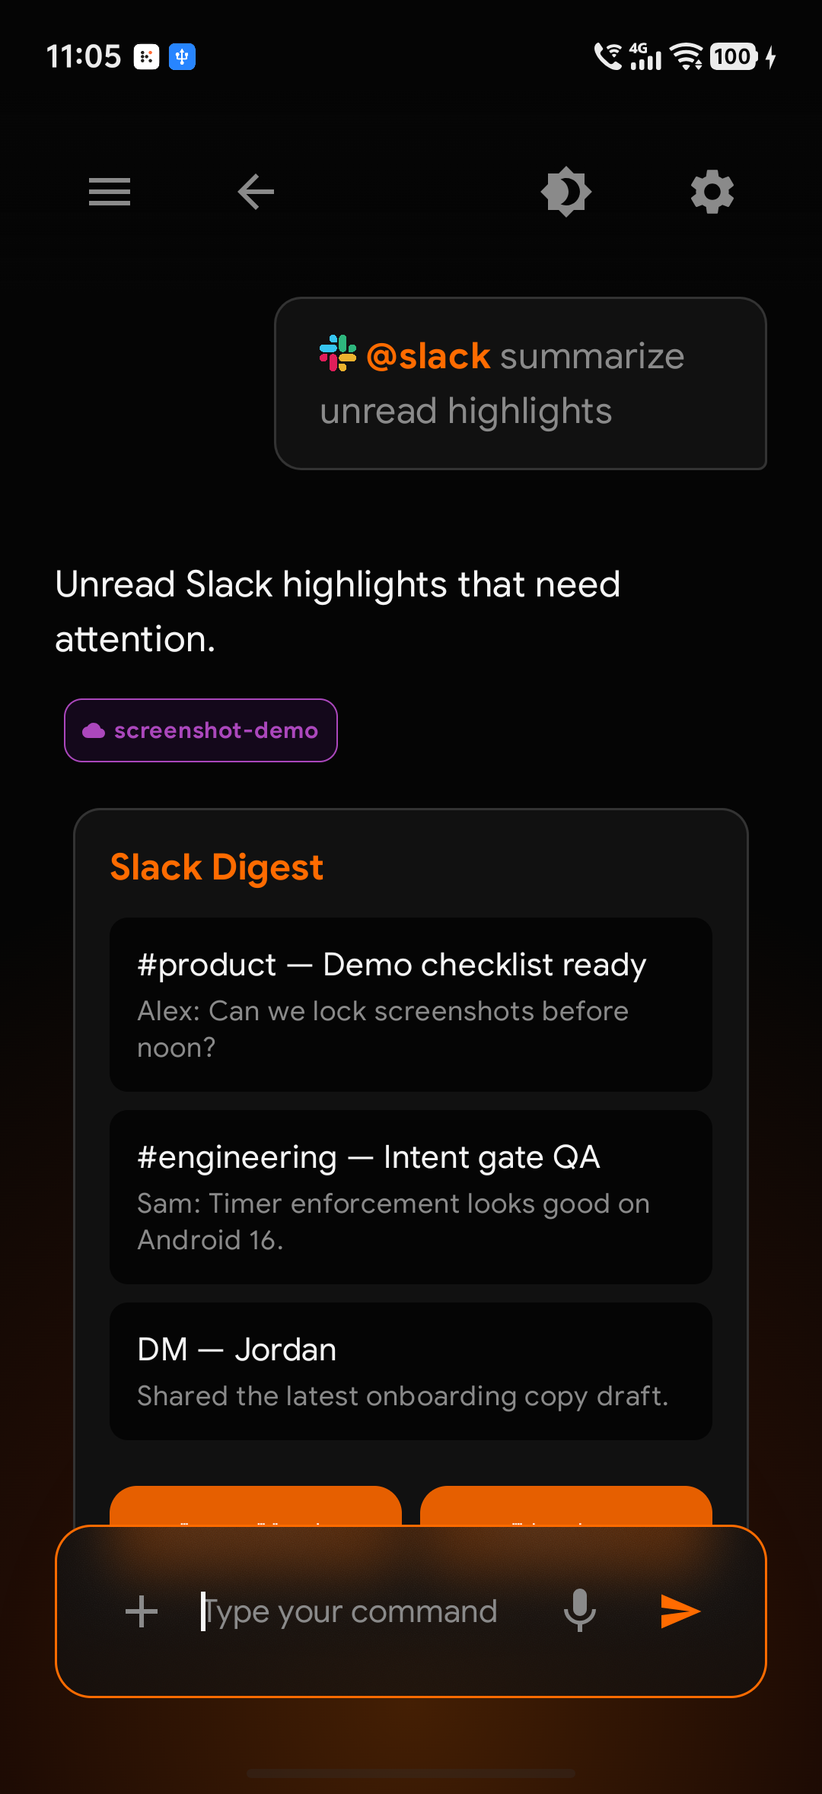
Figure 5. Slack highlights summarized into a digest card for intentional follow-up.

5.4 Bounded leisure
Opening Instagram requires a timebox and a reason - reply to a DM for five minutes, for example. Leisure budgets make the cost of distraction visible before it is spent. When the timer ends, the gate closes. The floating bubble keeps the mission visible while inside the app.

5.5 Capture and research without app hopping
Notes, browser answers, and background agents live in the same stream. A shopping list or launch plan can be captured without opening another app. Longer research can run as an agent while the user stays present. Search recovers prior conversations and context later.

5.6 Deep-work hours on company devices
During working hours, Deep-Work mode can silence social noise and prioritize Workspace and team tools. Status updates and CRM-style logging can happen from the command line without falling into an email black hole mid-task. That is the enterprise application of the same intentional interface.

6. Real-world Value
The value of KaiOS is not novelty for its own sake. It is measurable change in how attention is spent. Open-ended scrolling becomes timeboxed, reason-backed sessions, and leisure budgets turn distraction into a conscious spend instead of an ambient default. Users who want social media still get it - with boundaries they set while thinking clearly.
At the same time, email, calendar, and chat stay in one cognitive lane. Widgets answer inside the stream; deep links open only when execution needs the full native app. Context-switching drops because the home screen no longer advertises fifty other destinations. On corporate devices, Deep-Work mode can turn the launcher into an executive command line for Workspace and team tools, cutting burnout from feed-shaped interfaces on company time.
Architecturally, the phone remains a thin client for presentation and local utilities. API keys and OAuth tokens live on the backend, and simple tasks can stay on-device when possible, so users get smartphone capability without putting every secret on the handset.
The shift in practice is straightforward. Before KaiOS, icon grids invite browsing, badges and push notifications act as a constant pull, social apps open in one tap, and hours disappear without a decision. With KaiOS, a blank slate demands intent, digests arrive only when requested, trap apps are gated by reason and time, and actions feel chosen rather than stolen.

7. Closing
To be human is to choose. KAIROS OS restores that capacity by removing the autopilot of modern UI design. When there are no icons to tap mindlessly, no feeds to scroll by default, and no notifications to react to on impulse, what remains is the user - alone with intention, forced to decide what they truly want from their device.
Society is the sum of our attention. When that attention is harvested by algorithms optimized for engagement, society becomes shallow. KAIROS OS proposes a different contract with technology: the device serves human intent rather than exploiting human impulse.
Disconnected by Design. Intent over impulse. Depth over noise.

