Clicklable V1.2

Quick Start User Guide

Chi Ian Tang

5 October 2017

# Main Interface

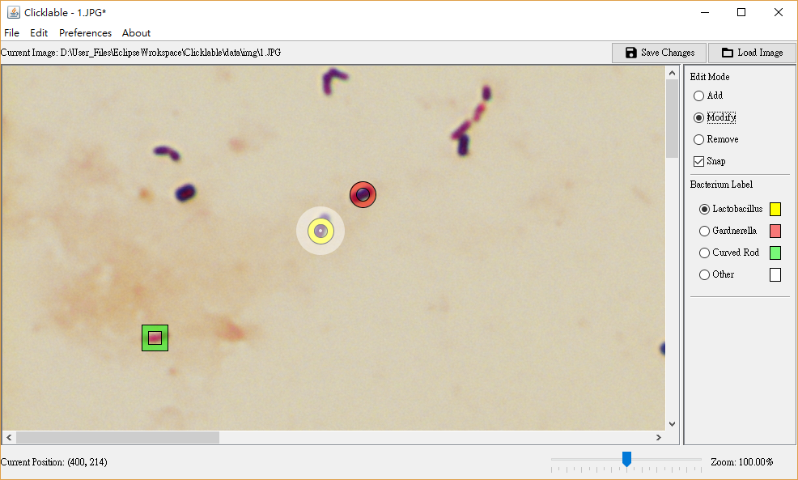

6

1

5

6

3

2

4

1. Image Panel (Main Panel)

* The main panel in the application.
* The image is displayed here and various levels of zooming can be specified.
* Scroll the mouse wheel to change the level of zooming. The mouse position affects the centre of zooming
* Right click to call the popup menu (details given in “Popup Menu” section)
* Left clicking and dragging in different edit mode trigger different functions

1. Edit Mode Control Panel
2. Snap: The closest existing label point will be locked when the cursor comes close to it, enabling various additional functions.
3. Add

* Mainly used for adding new labels.
* Click the centre of the bacteria on the image to create a new label.
* Drag on the main panel to move the visible area.
* When snap mode is enable, clicking on the closest label point triggers a modification of bacterium label

1. Modify

* Used for modifying existing labels.
* Snap mode is automatically turned on.
* Click the locked label point, triggers a modification of bacterium label
* Click the image when no label point is locked creates a new label
* Drag the locked label point to move it to the desired location
* Drag on the main panel when no label point is locked to move the visible area

1. Remove

* Used for removing labels
* Snap mode is automatically turned on
* Click the locked label point to remove the label
* Drag on the main panel to move the visible area

1. Bacterium Label Control Panel

* Select the type of bacterium to be used when creating new labels
* There is a small box next to each level which shows the corresponding colours of the visual label points on the image. These colours can be changed in settings.

1. “Save Changes”, “Load Image”

* Save Changes: Click this button to save all the changes you made to the current image
* Load Image: Load a new image (A reminder window will pop-up if there are unsaved changes)

1. Zooming

* Move the slider to use different levels of zooming of the image
* This can also be done by scrolling the mouse wheel on the main panel

1. Locked Label Point

* When “Snap” function is turned on and the cursor is close to one of the label point, a highlight of the point as shown here can be seen. This indicates that the corresponding label point is locked, and interactions including clicking and dragging will only affect this point.

1. Tool bar

* Various functions are provided here, details are in “Tool bar” section below.

# Popup Menu

Right clicking the main panel will call up a popup menu.

“Change” Menu

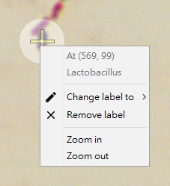

1. When right clicking on a position where a label point is present, the above menu will appear. You may select the corresponding functions to modify the locked label point.

“Add” Menu

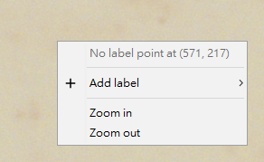

1. When right clicking on a position where no label point is present, the above menu will appear. You may select the corresponding functions to add a new label point.

# Tool Bar

File

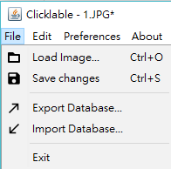

1. Load Image

* A file chooser will pop up, and the selected image will be loaded (A reminder window will pop-up if there are unsaved changes)

1. Save changes

* Save all changes to the labels for the current image

1. Export Database

* A file will be created which contains all information about the data labelling.
* Select the desired export path through the file chooser
* Used for data exchange

1. Import Database

* Importing a label database (created by previous exports)
* Only files exported previous through Clicklable (or files in the same format) are supported
* Replacing all the current information with those in the imported database

1. Exit

* Exit the application

Edit

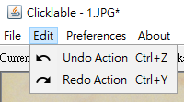

1. Undo Action

* Undo the last modification to the current image

1. Redo Action

* Redo the undone action

Preferences

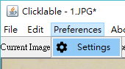

1. Settings

* Open the settings interface which allows high level of customization of user experience

About

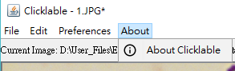

1. About Clicklable

* Information about this application

# Settings

General

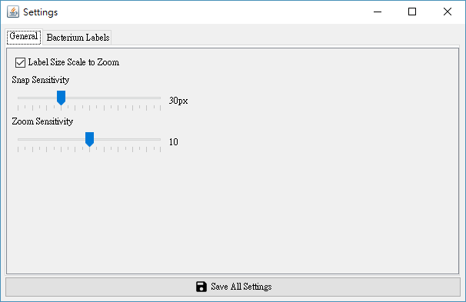

3

2

1

1. “Label Size Scale to Zoom”

* If enabled, the sizes of the label shapes will scale according to the level of zooming

1. Snap Sensitivity

* The maximum distance to a certain label point such that it is locked when the snap function is enabled

1. Zoom Sensitivity

* This corresponds to how much the image is enlarged / shrunken when the zoom level is adjusted

Bacterium Labels

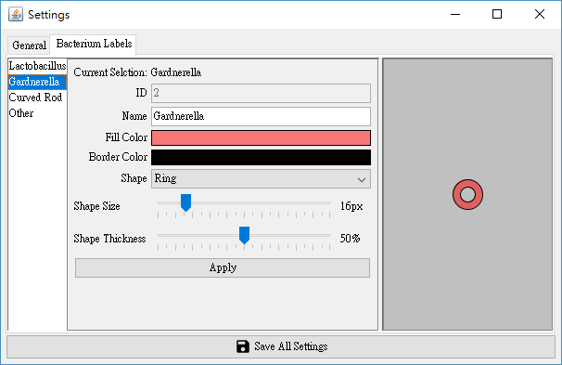

3

2

1

1. Bacterium Label Selection Panel

* Select the bacterium label whose settings are to be changed by clicking on the name

1. Graphical Preview Panel

* Previews the shape of label points that will be drawn on the image

1. Bacterium Label Setting Panel

* This shows the current settings of the corresponding label
* Change the name of the bacterium by typing in the text box
* Change the visual representation by clicking the colour box and select the desired colours, or adjusting the slider position
* Change the shape by selected the desired representation from the drop-down menu
* Click “Apply” to commit to the changes, otherwise they will be disposed