Team 3

Module 5.1

Moffat Bay: Database Dev Assignment

Ian Lewis

Robert Minkler

Kevin Ramirez

GitHub Repository: <https://github.com/rminkler1/MoffatBay/tree/main/sql>

Kanban Board: <https://github.com/users/rminkler1/projects/3/views/1>

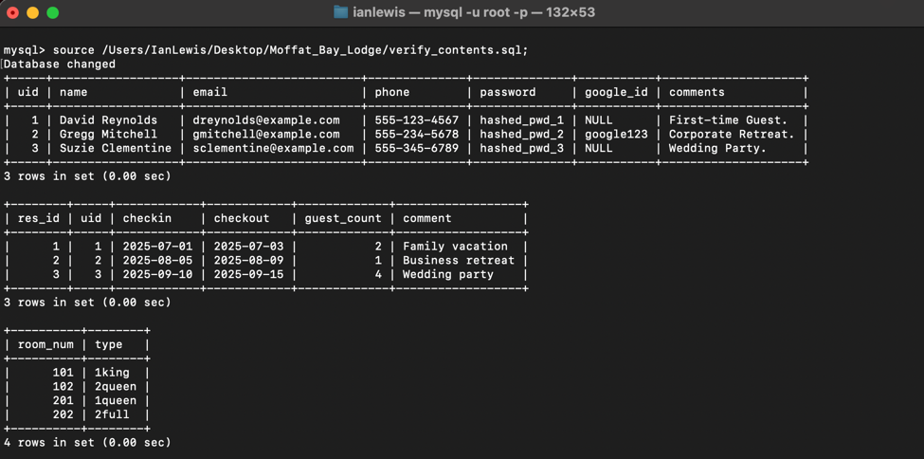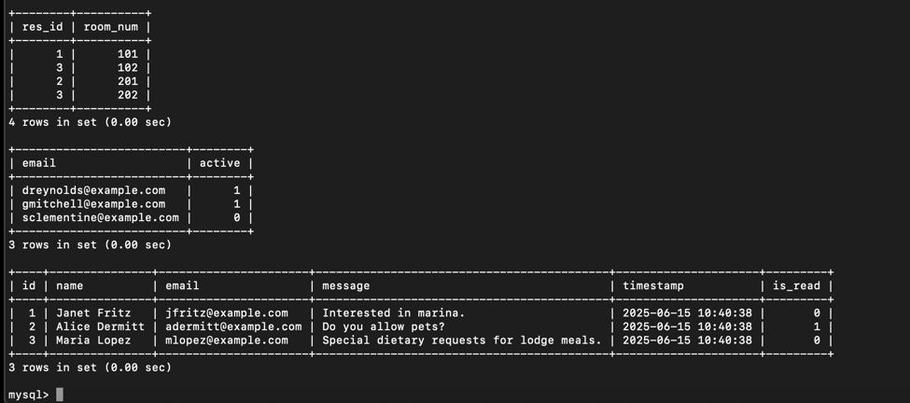

Team 3 ERD:

