**Technical Design Document (TDD)**

**Project: Moffat Bay Lodge**

**Team Name:** Team 3  
**Team Members:** Ian Lewis, Robert Minkler, Kevin Ramirez

**Date: June 1, 2025**

**1. Introduction**

**Purpose:** Enabling Moffat Bay Lodge customers to learn about the lodge’s amenities and services and streamlining the reservation process.

**1.2 Terminology**

| **Term** | **Definition** |
| --- | --- |
| Conference Room Names  (call to reserve) | Seashell, Barnacle, The Sand Bar, Coral Cave |
| Joviedsa Island | The Island that Moffat Bay resides |
| Cafe Joviedsa | The cafe located at Moffat Bay Lodge. Serves meals and drinks. |
| Moffat Bay Marina | A local attraction at Moffat Bay |

**1.3 User Personas**

Use this section to describe three user personas.

**Persona Name: David Reynolds**

**Age:** 42  
**Background:** Works as a construction supervisor for a real estate developer. He is married with three kids.   
**Goals:** Avoids long forms and complicated steps on a sign-up page. Keeps stress levels low while planning a relaxing vacation.   
**Quote:** “Let’s go fishing!”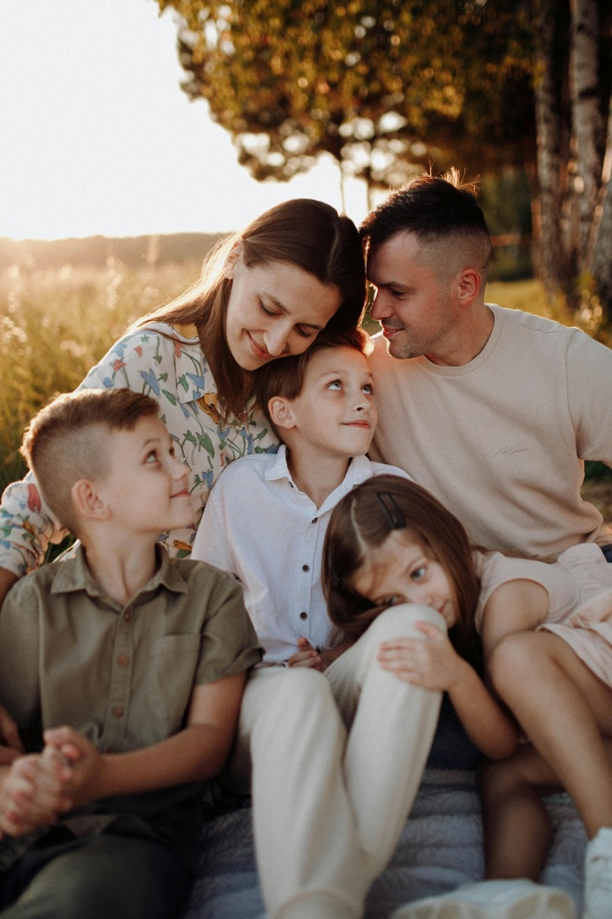

**Persona Name: Gregg Mitchell**

**Age:** 48  
**Background:** A small business owner who wants to treat his sales team to an amazing retreat at the bay.  
**Goals:** Book multiple rooms quickly and easily. Locate nearby attractions for group events. Needs a conference space for team activities.  
**Quote:** “I have such a great team and I’m excited to treat them to a memorable weekend where we can grow closer as a team.”

**Persona Name: Suzie Clementine**

**Age:** 23  
**Background:** About to get married at the bay with all her friends and family present.  
**Goals:** Find enough accommodation for everyone attending the wedding, and a beautiful wedding and reception space on the bay.  
**Quote:** “I’m so excited for my dream destination wedding.”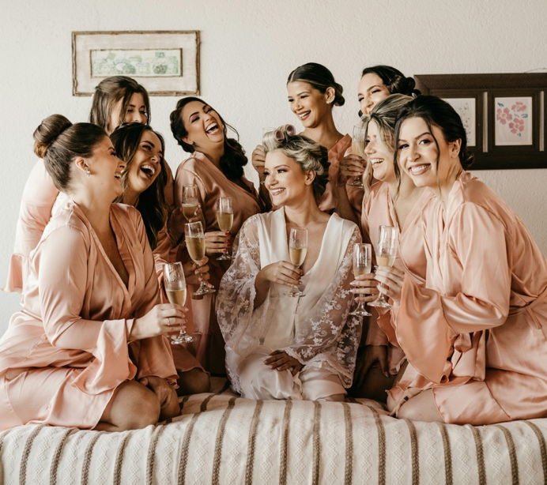

**1.4 User Stories**

Each persona should have **3 stories** with story points.

**Persona Name: David Reynolds**

1. As David, I want to register and log in easily using my phone so I can get started without delays.
2. As David, I want to save my reservation and return later to finish the booking so I can handle interruptions.
3. As David, I want to look up past reservations by email so I can quickly check what I booked for my family.

**Persona Name: Gregg Mitchell**

1. As Gregg, I want book multiple rooms for my team so I can ensure we have enough room for my entire team.
2. As Gregg, I want to view local attractions so I can organize an event for my team.
3. As Gregg, I want to be add or remove a room from my reservation so I can bring additional team members on the retreat.

**Persona Name: Suzie Clementine**

1. As Suzie, I want to book a venue for my wedding, reception, and lodging in one place right on the bay so I can simplify the planning process and reduce stress on my guests.
2. As Suzie, I want to book rooms online for my guests so I can ensure everyone has a place to stay at the bay.
3. As Suzie, I want to reserve a space by the water so I can have a beautiful outdoor wedding.

**1.5 Work Estimations (To-Do List)**

Each team member adds tasks they will take responsibility for.

* Landing Page Mockup – Assigned to Ian – Story Points: 5
* About Us Page Prototype – Assigned to Ian – Story Points: 3
* Contact Us Page Prototype – Assigned to Ian – Story Points: 3
* Attractions Page Prototype – Assigned to Kevin – Story Points: 4
* Registration Page Prototype – Assigned to Kevin – Story Points: 4
* Login Page Prototype – Assigned to Kevin – Story Points: 3
* Lodge Reservation page Prototype – Assigned to Robert – Story Points: 4
* Reservation Summary Page – Assigned to Robert - Story Points: 3
* Reservation Look up page – Assigned to Robert - Story Points: 4