# Group 3

### Mikaela June

### Hector Lara

### Ian Lewis

### Robert Minkler

Bacchus Winery

## Revised ERD

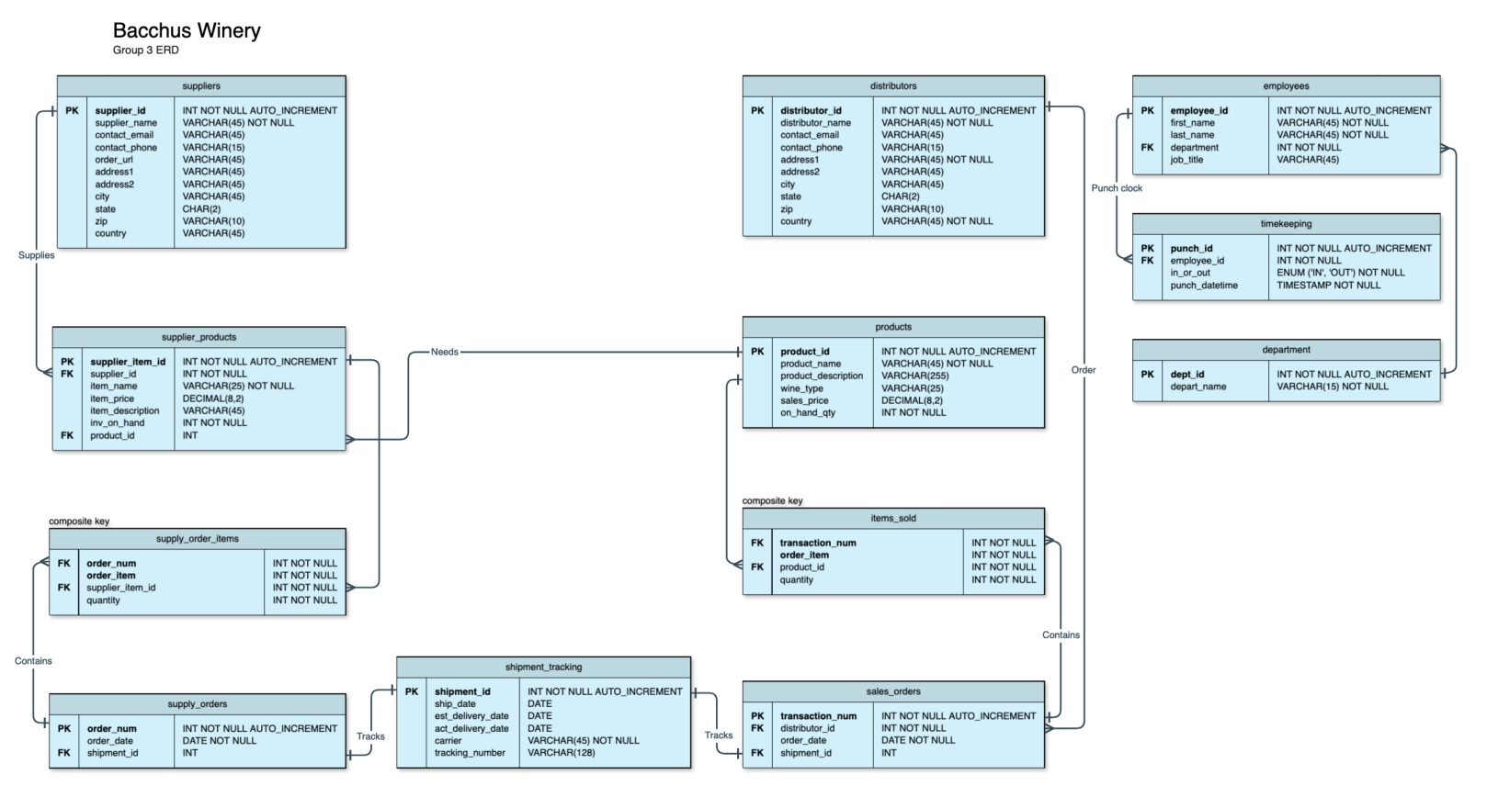

Data Screenshots

##### Python Script Display Data:

