08/31/24

Ian Lewis  
CSD310  
  
Module 3_2 Assignment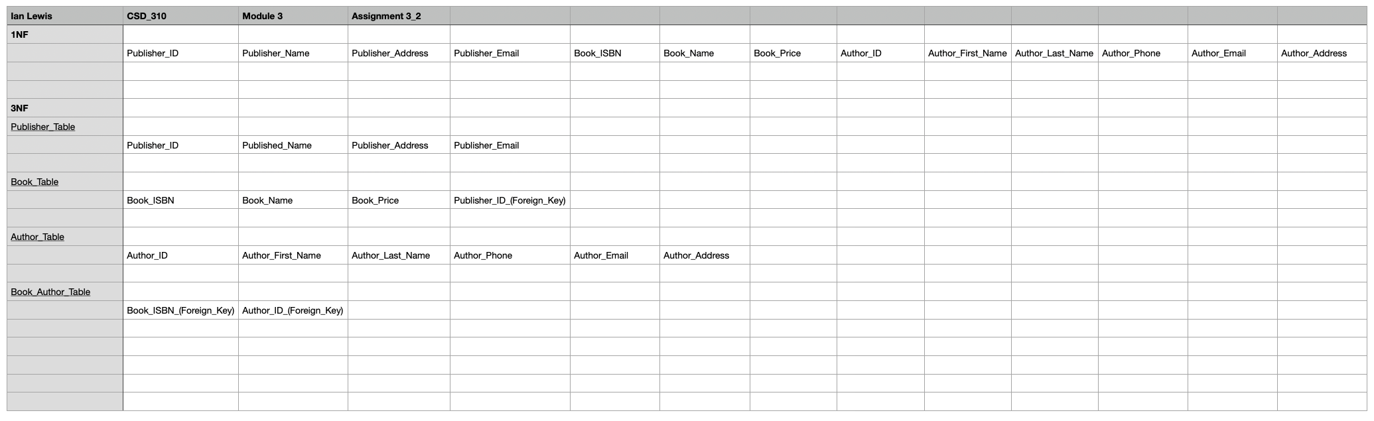  
  
**Assumptions:**

* Publisher ID is unique to each publisher.
* Book ISBN is unique to each book.
* Author ID is unique to each author. If not part of the initial data set, can be produced.
* Multiple authors can be associated with each book, and each author can be associated with multiple books. This is evidence for a many-to-many relationship.

**Sources:**

<https://www.geeksforgeeks.org/first-normal-form-1nf/>

<https://www.geeksforgeeks.org/third-normal-form-3nf/>

<https://www.w3schools.com/mysql/mysql_rdbms.asp>

<https://www.w3schools.in/dbms/database-normalization>

https://www.simplilearn.com/tutorials/sql-tutorial/what-is-normalization-in-sql