09/07/24

Ian Lewis

CSD310  
  
Module 5_2 Assignment

**ASCII()**

* Returns the ASCII value for the specific character
* **Alias**: SELECT ASCII('A') AS ASCII_Value;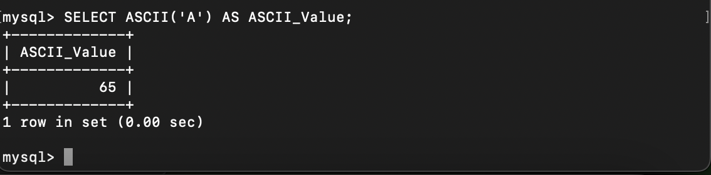

**REPEAT()**

* **Use**: Repeats a string a specified number of times.
* **Alias**: SELECT REPEAT('*', 5) AS Stars;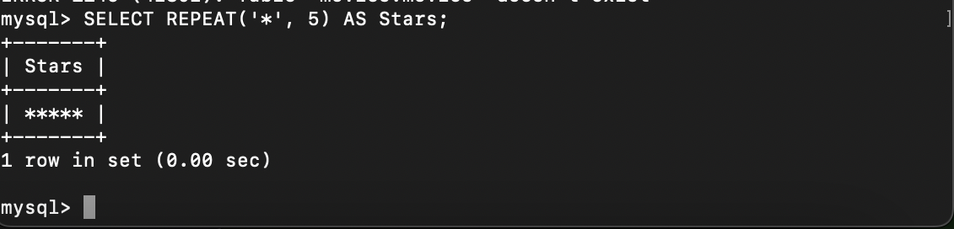

**RAND()**

* **Use**: Returns a random floating-point value.
* **Alias**: SELECT RAND() AS Random_Number;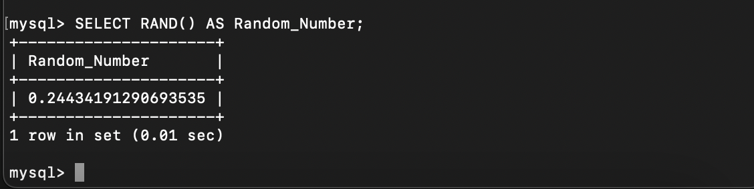

**Sources:**

<https://www.studytonight.com/dbms/introduction-to-sql.php>

<https://www.w3schools.com/mysql/mysql_alias.asp>

<https://www.w3schools.com/sql/sql_ref_mysql.asp>