10/27/24

Ian Lewis

CSD340

Module 1.2 Assignment: GitHub Repository Setup

GitHub link:

<https://github.com/iantruelewis/csd-340/blob/main/README.md>

Local directory: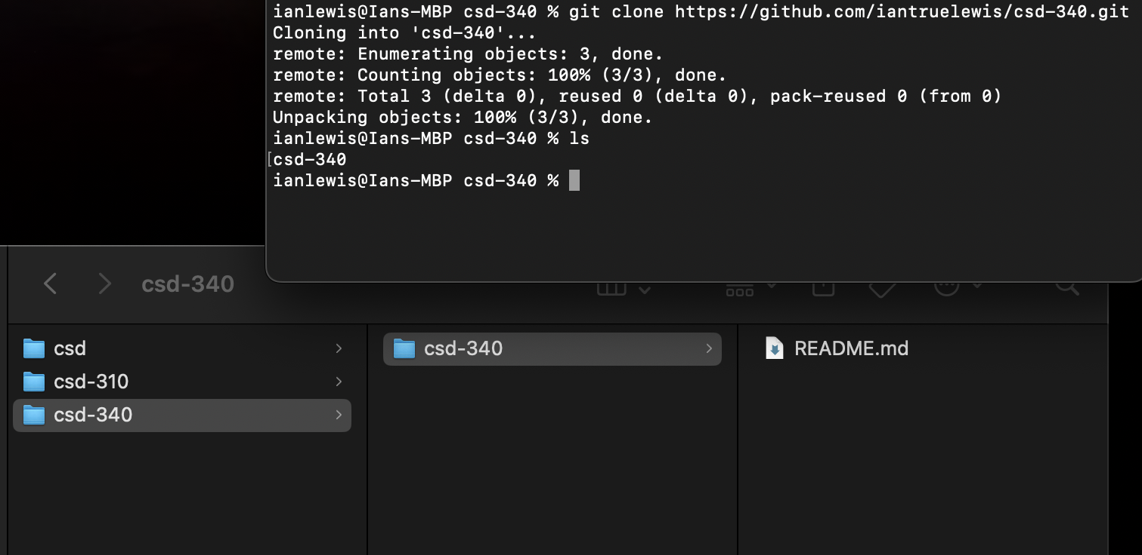

GitHub Repository: