Assessment report
AI Adoption Assessment
Readiness, priorities and a 12-month roadmap

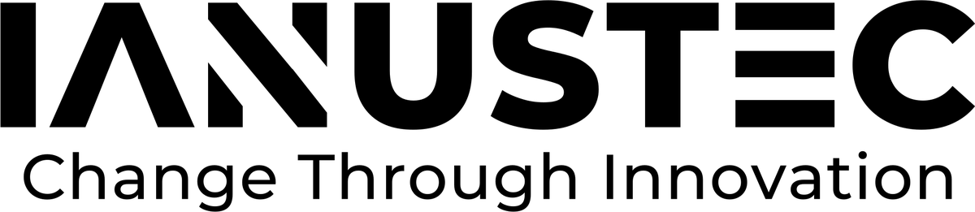
Client  Northwind Analytics | Reference  NW-2026-014
Version  1.0 | Date  29 October 2026

Prepared with NEURA | IANUSTEC IANUSTEC S.r.l.

1 Summary
The assessment covered 14 business processes across sales, operations and finance. Nine of them are ready for automation today; the other five need data work first.
✔ Quick win
Invoice matching alone frees 1.6 FTE and pays back in under four months.

2 Readiness by area
Area | Processes | Ready now | Data work needed | Estimated saving
Sales | 4 | 3 | 1 | €84,000
Operations | 6 | 4 | 2 | €132,000
Finance | 4 | 2 | 2 | €96,000
Total | 14 | 9 | 5 | €312,000

3 Roadmap

3.1 Quarter 1
- Invoice matching and supplier onboarding
- Data model for the order backlog

3.2 Quarter 2
- Demand forecast for the three main product lines
- Assistant for the customer service team
“The goal is not to replace the team but to give back the hours it spends copying data between systems.”

