GoChip Design Specification

# Table of Contents

Table of Contents 1

Revision History 1

1 Introduction 2

1.1 Functional Blocks 3

2 Mechanical 5

2.1 Dimensions 5

2.2 Printed Circuit Board 6

2.3 USB Contact Pads 7

2.4 Metal Enclosure 8

2.5 Plastic Enclosure 9

2.6 Magnet 9

3 USB Compliance 10

3.1 Electrical Constraints 10

3.2 Device Descriptor Table 11

3.3 Data Transfer Performance 11

4 Environmental 12

5 Agency Testing and Compliance 12

6 Legal 12

# Revision History

|  |  |  |  |
| --- | --- | --- | --- |
| Version | Date | Contributor(s) | Description |
| 0.1 | 10/10/2017 | Dave Lockett | Initial outline/draft |
|  |  |  |  |
|  |  |  |  |
|  |  |  |  |

# Introduction

GoChip is a custom USB-2.0 Mass Storage Device, available in a variety of different capacity options from 8GB to 128GB, or larger. It incorporates a magnet that “snaps” and holds it in place in a mating connector on the Beam product or a PC USB adapter.

etc etc..

Figure 1 shows the bottom side of the GoChip with exposed PCB and USB contact pads.

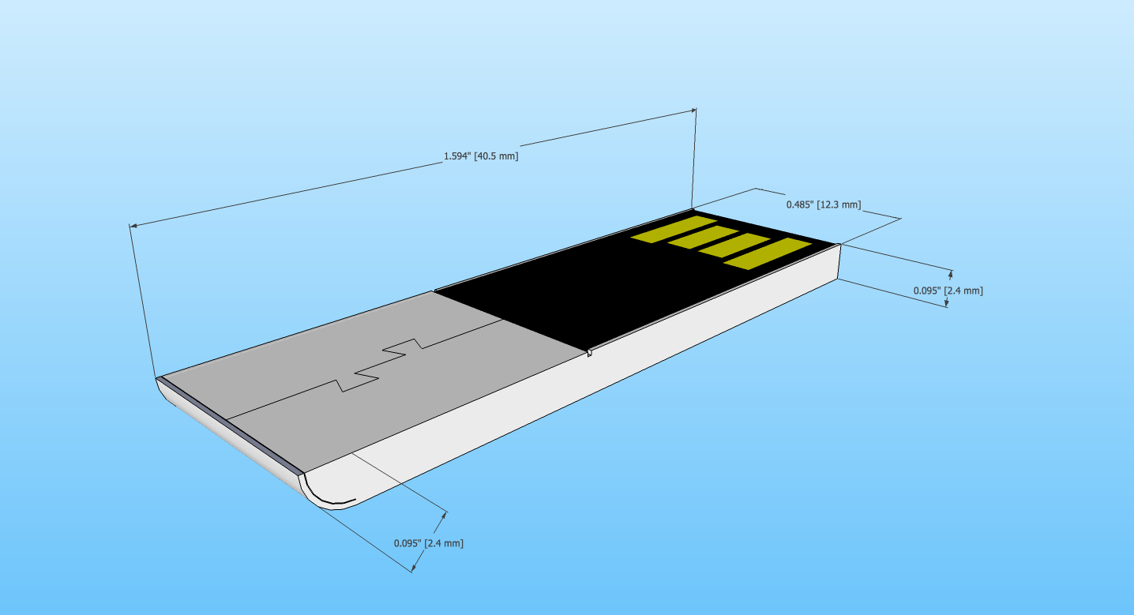

Figure

## Functional Blocks

5V

USB Pads

Vss

D-

D+

USB 2.0 Device

Bridge

NAND

FLASH

NAND

FLASH

NAND

Controller

Micro SD Card, e-MMC Module, UFS, or MCM

The major functional blocks that make up GoChip are:

Figure

USB Connection Pads

* Gold plated pads on bottom of exposed PCB

USB Interface Bridge

* Custom descriptor values
* Single LUN (if implemented with e-MMC)

Local nonvolatile storage for firmware and custom VID/PID and mfg strings

NAND Flash Controller

* Wear leveling
* Bad block management

NAND Flash array(s)

* Error Correction

The NAND Flash and NAND Controller functions may be implemented as separate discrete components, a multichip module(s), or as a integrated solutions such as MicroSD Card, embedded Multi-Media Card (e-MMC), or Universal Flash Storage (UFS). In the case of an integrated solution the interface will comply with the appropriate standards, listed below.

Micro-SD Card

* Support Secure Digital v2.0, SDHC or SDXC.
* Support Secure Digital v3.01 UHS-I (Ultra High Speed) SDR25 or greater, i.e. SDR50, DDR50, SDR104
* Support Secure Digital v5.0 ??

e-MMC module

* e*-*MMC specification v4.3/ v4.4/ v4.5/ v5.0
* High Speed SDR/ High Speed DDR/ HS200

USF

# Mechanical

The GoChip can be implemented with either a metal enclosure, molded plastic enclosure, or ..

## Dimensions

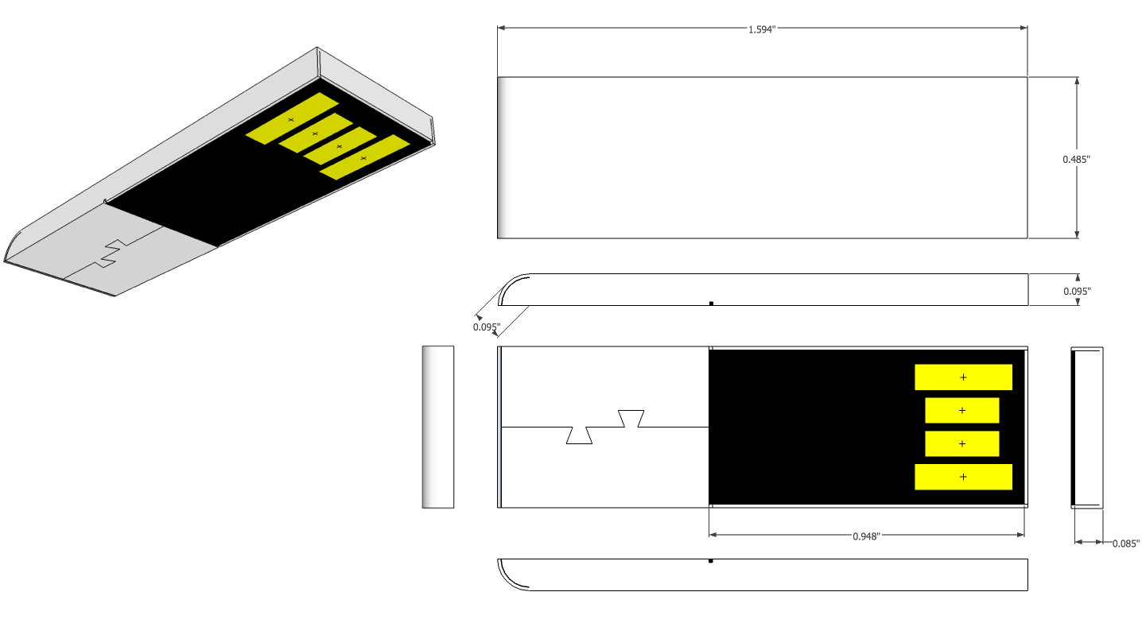

Figure

|  |  |  |  |
| --- | --- | --- | --- |
| Dimensions | Nominal – in [mm] | (+) Tolerance – in [mm] | (-) Tolerance – in [mm] |
| Height (H) | 0.095 [2.4] | xx [xx] | xx [xx] |
| Width (W) | 0.485 [12.3] | xx [xx] | xx [xx] |
| Length (L) | 1.594 [40.5] | xx [xx] | xx [xx] |
| End Radius (R) | 0.095 [2.4] | xx [xx] | xx [xx] |

Table - Overall Dimensions

## Printed Circuit Board

The PCB provides the electrical connection between components and a substrate for mechanically supporting the components, magnet, and case. A portion of the PCB becomes the finished exterior surface of the GoChip, and therefore has a smooth black solder mask finish that covers all vias and is free of any silkscreen or fabrication markings. The USB contacts are on the bottom of the PCB and are gold plated.

The exact shape of the PCB depends on the type of enclosure used. The metal enclosure wraps around a portion of the PCB, which requires that part of the PCB be milled so the exterior surface between the enclosure and PCB remain flush. The molded plastic enclosure surrounds the edges of the PCB without the need for milling and is attached by adhesive (??).

Figure 4 shows the PCB fabrication detail for a metal enclosure.

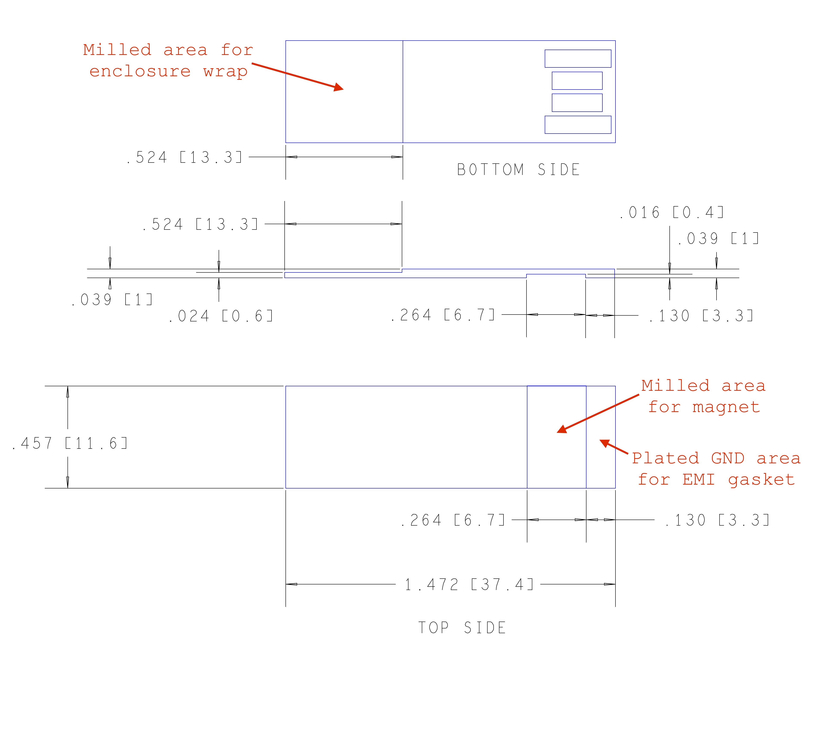

Figure

Add fab drawing for plastic enclosure

## USB Contact Pads

The USB contacts are located on the bottom side of the exposed PCB, and are spaced equally on 100 mil centers. The outer power/ground pads are longer than the signal pads and positioned closer to the front edge of the PCB to insure they make electrical contact with the mating connector pins before the signal pads.

Figure 5 shows the location and dimensions of the USB pads on the bottom side of the GoChip.

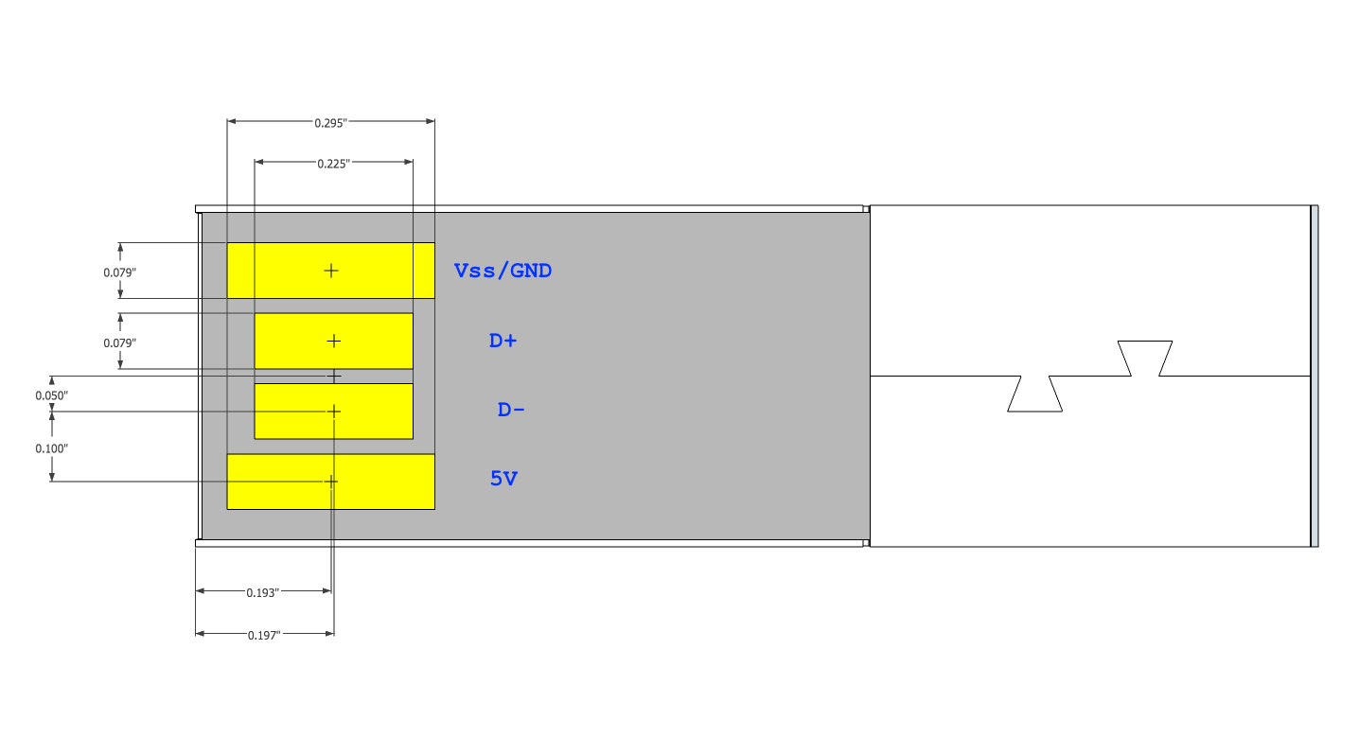

Figure - Contact PADs

|  |  |  |  |  |
| --- | --- | --- | --- | --- |
| Pad | Pad Dimensions | Solder Mask  Opening | Plating Material | Minimum Plating Thickness (uInch) |
| Vss/GND | 0.295” x 0.079” | 0.300” x 0.084” | Au | 30 |
| D+ | 0.225” x 0.079” | 0.230” x 0.084” | Au | 30 |
| D- | 0.225” x 0.079” | 0.230” x 0.084” | Au | 30 |
| +5V | 0.295” x 0.079” | 0.300” x 0.084” | Au | 30 |

Table - Contact PAD Details

## Metal Enclosure

The metal enclosure is made from 10 mil thick stamped brass (or other non-Ferris material?) and is folded into a rectangular shape, with an opening for the exposed surface of the PCB. Interlocking tabs on the bottom of the enclosure are compression-welded to securely hold the edges of the case together.

The enclosure is painted xx white with a smooth gloss finish and cured by xx process. A rectangular area on the inside surface is free of paint or other coatings to provide a conductive surface that aligns with an EMI gasket attached to the PCB.

The PCB assembly is inserted into the enclosure opening, and held in place by adhesive between the top surface of the magnet and the inside surface of the case. The front lip of the enclosure is slightly shorter than other edges to ease the insertion of the PCB assembly.

An opening on the bottom side allows a portion of the PCB to protrude and become flush with the bottom surface of the enclosure.

Exterior finish spec? – paint, color, texture, etc

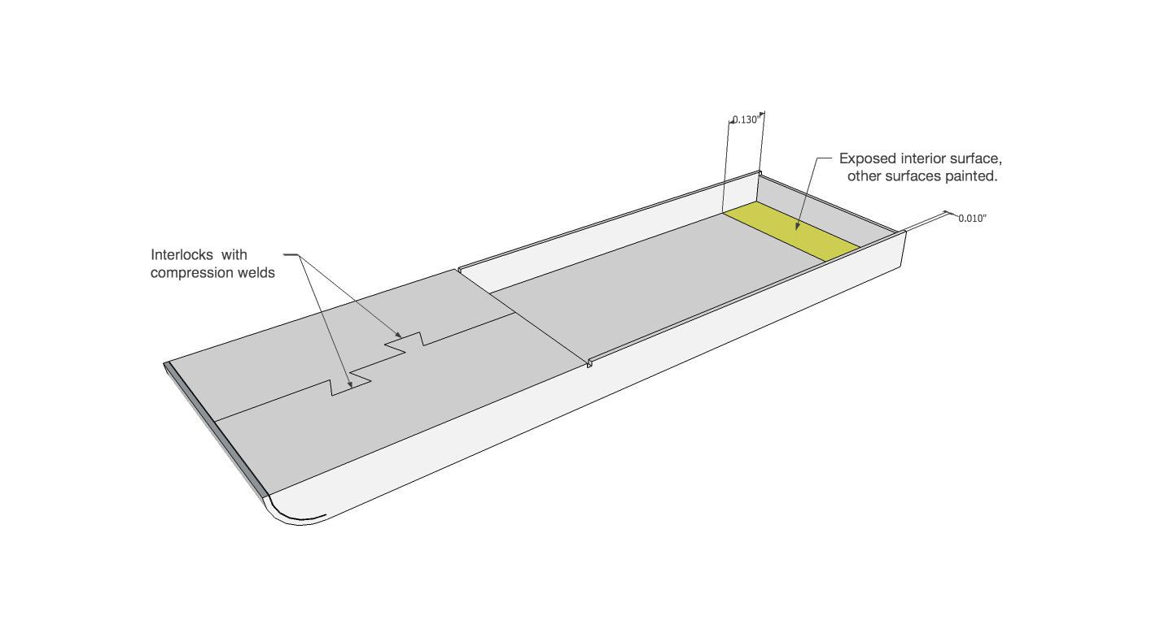

Figure

## Plastic Enclosure

Outline diagram

Encapsulation

Exterior finish – plastic material, paint?, color, texture

## Magnet

Location and field orientation

Field strength spec - min/max

Assembly diagram w/ adhesive detail

# USB Compliance

GoChip complies with the following USB standards:

* Universal Serial Bus Specification revision 2.0
* USB Mass Storage Class Specification revision 1.0
* USB 2.0 LPM (Link Power Management)
* USB Mass Storage Class Bulk-Only Transport (BOT)
* Supports 480 Mbps high-speed and 12 Mbps full-speed transfer rates

One device address and three endpoints for Control (0), Bulk Data Read In (1), and Bulk Data Write Out (2)

(If we choose to spec a USB 3.0 implementation at some point.. )

* Universal Serial Bus 3.0 Specification revision 1.0
* Support 5 Gbps SuperSpeed

## Electrical Constraints

In addition to the USB compliance listed above, the GoChip has the following electrical constraints.

|  |  |  |  |  |  |  |
| --- | --- | --- | --- | --- | --- | --- |
| Parameter | Symbol | Test Conditions | Min | Nom | Max | Unit |
| Supply Voltage | Vcc |  | 4.75 | 5.00 | 5.25 | V |
| Inrush Current | I-max | See Appendix A – Test Procedures | - |  | xx | mA |
| Operating Current –Reads | I-read | Read Transfers – maximum averaged over 100 uS | - |  |  | mA |
| Operating Current - Writes | I-write | Write Transfers – maximum averaged over 100 uS |  |  |  | mA |
| Crystal Oscillator | F | Four corner - operating voltage and temperature range | -x | - | +x | ppm |
|  |  |  |  |  |  |  |
|  |  |  |  |  |  |  |
|  |  |  |  |  |  |  |

Table

## Device Descriptor Table

GoChip responds to a USB query with the descriptor response data in table 4.

|  |  |  |
| --- | --- | --- |
| Descriptor Field | Value | |
| idVendor | 0x174C (0x147C ??) | |
| idProduct | PID Value | Capacity |
| 0xA008 | 8 GB |
| 0xA010 | 16 GB |
| 0xA020 | 32 GB |
| 0xA040 | 64 GB |
| 0xA080 | 128 GB |
| bcdDevice |  | |
| iManufacturer | “GoChip Inc.” | |
| iProduct | “GoChip” | |
| iSerialNumber | 0x0000 – 0xXXXX  (should the SN include a date code?)  YYMMDDxxxx | |
| bMaxPower | 200mA | |

Table

## Data Transfer Performance

|  |  |  |
| --- | --- | --- |
| Operation | Read Bandwidth | Write Bandwidth |
| Sequential |  |  |
| 512KB |  |  |
| 4KB |  |  |
| Quad Byte (32 bit) |  |  |

Underlying FLASH Memory performance

-Write/Erase Endurance

-Data Retention

-Read Disturb

# Environmental

**Storage Conditions - Temperature and Humidity**

-40°C to +85°C, and 0%RH to 95%RH non-condensing

**Operating Conditions - Temperature and Humidity**

-25°C to +85°C, and 0%RH to 95%RH non-condensing

# Agency Testing and Compliance

US/EU/Asia equivalents for:

FCC part B

Immunity

ESD

UL

# Legal

Trademark

License

Design Ownership

Restrictions Of Use

Change Notification – ECO/MCO process requirements

* BOM
* AVL
* Notification, review, and signoff
* Component spec review, proto/pilot run, qualification, signoff