R Notebook

## Fourier Series

The Fourier series for a periodic function of any period $(T)$ is given by:

$$\begin{matrix}f(t)=\frac{a_{0}}{2}+\sum_{i=1}^{∞}{\{}a_{n}cos(\frac{2nπt}{T})+b_{n}sin(\frac{2nπt}{T})\}\end{matrix}$$

Where $a_{n}$ and $b_{n}$ are given by:

$$\begin{matrix}a_{n}=\frac{2}{T}\sum_{\frac{−T}{2}}^{\frac{T}{2}}{f}(t)cos(\frac{2nπt}{T}) & & & & & & for & n=0,1,2...\end{matrix}$$

$$\begin{matrix}b_{n}=\frac{2}{T}\sum_{\frac{−T}{2}}^{\frac{T}{2}}{f}(t)sin(\frac{2nπt}{T}) & & & & & & for & n=1,2,3...\end{matrix}$$

#### Example 1

A periodic function is given by:

$$\begin{matrix}f(t)=\{ & 0 & −2<t<0 & & & f(t+4)=f(t) \\ \{ & t & 0<t<2 & & \end{matrix}$$

* Period given is $T=4$
* Limits for this period are $−2<t<2$

This periodic function can be plotted as a piecewise periodic function.

Using ***Ft.func*** the periodic function can be coded using ***ifelse*** commands.  
The ***Ft.func*** can then be plotted using the ***plot.piecewise.fnc***.

***plot.piecewise.fnc*** inputs:

* ***FUN = …***  Name given to the peridoic function eg: ***Ft.func***
* ***.piece.range = …***  Limits of the period eg: ***c(-2, 2)***
* ***.pieces = …***  Number of pieces to be included in the piecewise plot eg: ***c(-2,-1,0,1)*** (4 pieces)
* ***.resolution = …*** Number of points plotted eg: ***101***

library(tidyverse)

## -- Attaching packages ------------------------------------------------------------------------------ tidyverse 1.2.1 --

## v ggplot2 3.2.0 v purrr 0.3.2  
## v tibble 2.1.3 v dplyr 0.8.3  
## v tidyr 0.8.3 v stringr 1.4.0  
## v readr 1.3.1 v forcats 0.4.0

## -- Conflicts --------------------------------------------------------------------------------- tidyverse_conflicts() --  
## x dplyr::filter() masks stats::filter()  
## x dplyr::lag() masks stats::lag()

source("scr_functions.R")  
Ft.func = function(t){  
 ifelse(t<0, 0, t)  
}  
  
plot.piecewise.fnc(.FUN = Ft.func, .piece.range = c(-2, 2), .pieces = c(-2,-1,0,1), .resolution = 101)

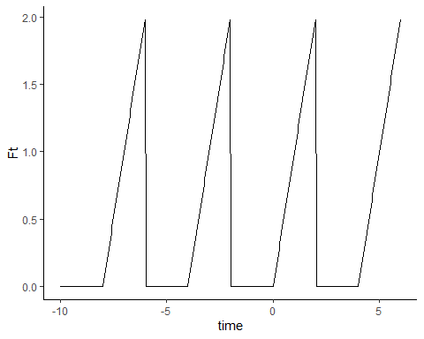

#### Example 2

A periodic function is given by:

$$\begin{matrix}f(t)=\{ & t^{2} & −3<t<3 & & & f(t+6)=f(t)\end{matrix}$$

* Period given is $T=6$
* Limits for this period are $−3<t<3$

Ft.func2 = function(t){  
 t^2  
}  
  
plot.piecewise.fnc(.FUN = Ft.func2, .piece.range = c(-3, 3))

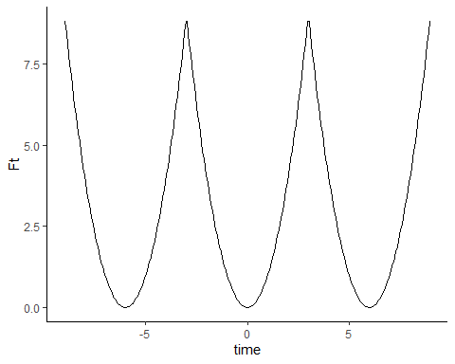 *** #### Example 3

A periodic function is given by:

$$\begin{matrix}f(t)=\{ & −t & −2<t<0 & & & f(t+4)=f(t) \\ \{ & 7 & 0<t<2 & & \end{matrix}$$

* Period given is $T=4$  
* Limits for this period are $−2<t<2$

Ft.func3 = function(t){  
 ifelse(t<0, -t, 7)  
}  
  
plot.piecewise.fnc(.FUN = Ft.func3, .piece.range = c(-2, 2))

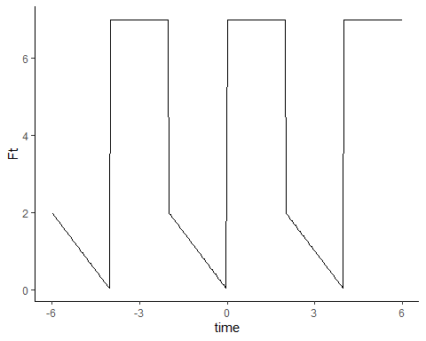 *** #### Example 4

A periodic function is given by:

$$\begin{matrix}f(t)=\{ & −t−3 & −5<t<−3 & & & f(t+13)=f(t) \\ \{ & t+3 & −3<t<0 & & \\ \{ & −2t+3 & 0<t<3 & & \\ \{ & t−6 & 3<t<8 & & \end{matrix}$$

* Period given is $T=13$  
* Limits for this period are $−5<t<8$

Periodic functions with mulitple definitions for different parts of the domain require more ***ifelse*** commands.

Ft.func4 = function(t){  
 ifelse(t<=-3, -t-3,  
 ifelse(t>-3 & t<=0, t+3,  
 ifelse(t>0 & t<=3, -2*t+3,  
 t-6)))  
}  
  
plot.piecewise.fnc(.FUN = Ft.func4, .piece.range = c(-5, 8), .pieces = seq(-2,2))

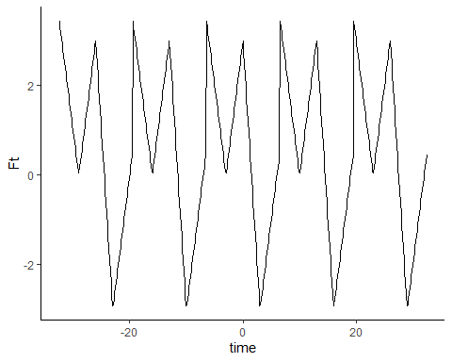

#### Example 5: Functions of period $2π$

The Fourier series for a periodic function of period $T=2π$ has the general form:

$$\begin{matrix}f(t)=\frac{a_{0}}{2}+\sum_{i=1}^{∞}{\{}a_{n}cos(nt)+b_{n}sin(nt)\}\end{matrix}$$

A piecewise plot for the function $sin(t)$ can be seen:

Ft.func5 = function(t){  
 sin(t)  
}  
  
plot.piecewise.fnc(.FUN = Ft.func5, .piece.range = c(0, 2*pi), .pieces = 0)

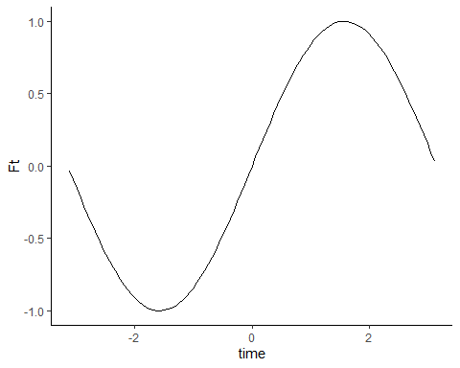

#### Example 6

A periodic function (***example 1***) is given by:

$$\begin{matrix}f(t)=\{ & 0 & −2<t<0 & & & f(t+4)=f(t) \\ \{ & t & 0<t<2 & & \end{matrix}$$

This periodic function is plotted as a piecewise periodic function:



The Fourier Series $f(t)$ including constants $a_{0}$, $a_{n}$ and $b_{n}$ are calculated.

$$\begin{matrix}a_{0}= & 1 & & \\ & & & \\ a_{n}= & \{ & \frac{−4}{π^{2}n^{2}} & n=1,3,4... \\ & \{ & 0 & n=2,4,6...\end{matrix}$$

$$\begin{matrix}b_{n}= & \frac{−2}{πn}cos(πn) & =\frac{−2}{πn}(−1)^{n} & \end{matrix}$$

The constants are then coded using using ***ifelse*** commands.  
The Fourier series can then be plotted using the ***plot.fourier.series*** function.

a0 = 1  
an.fn = function(n) {  
 ifelse(as.logical(n%%2), -4/(n^2*pi^2), 0)  
}  
  
bn.fn = function(n) {  
 2/(n*pi) * ifelse(as.logical(n%%2), 1, -1)  
}  
  
plot.fourier.series(.T = 4, .a0 = a0, .an.fun = an.fn, .bn.fun = bn.fn,  
 .t.range = c(-10,6), .n.max = 10, .resolution = 300)

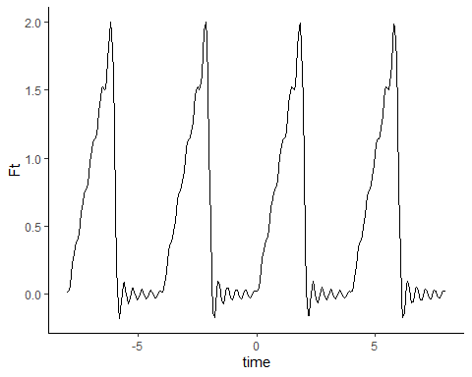

Increasing ***.n.max*** (number of terms in Fourier Series) gives a closer approximation of $f(t)$

***.n.max = 20*** 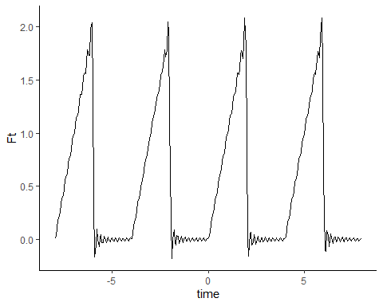

***.n.max = 30*** 