# [p-50005]

## **အင်္ဂုတ္တရပါဠိ နိဿယ(ပဉ္စမတွဲ)**

## Aṅguttarapāḷi nissaya(9-11)

[Link: https://bit.ly/3wtwFDs](https://bit.ly/3wtwFDs)

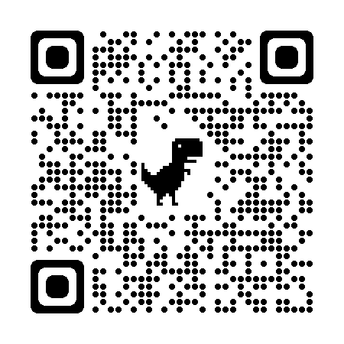

# [p-60022]

## ပဋိသမ္ဘိဒါမဂ္ဂပါဠိ နိဿယ

## paṭisambhidāmaggapāḷi nissaya

Link: https://bit.ly/3FNrhza

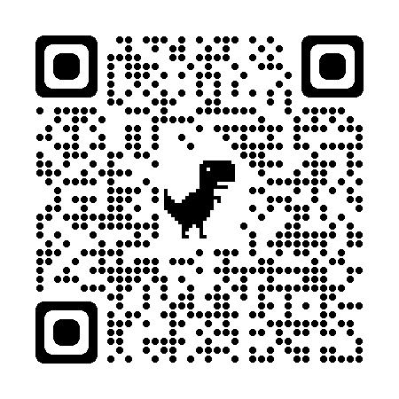

# [a-068]

## သံယုတ္တအဋ္ဌကထာ(နိဒါနဝဂ္ဂဂ)(ဒု)

## saṃyutta aṭṭhakathā(nidānavagga)-2

Link: https://bit.ly/3wgFhhM

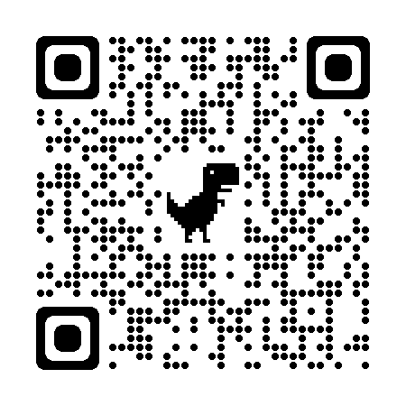

# [a-062]

## မဇ္ဈိမပဏ္ဏာသအဋ္ဌကထာ နိဿယ(ဒု)

## Majjhimapaṇṇāsa-aṭṭhakathā-2

Link: <https://bit.ly/3PrjYS7>

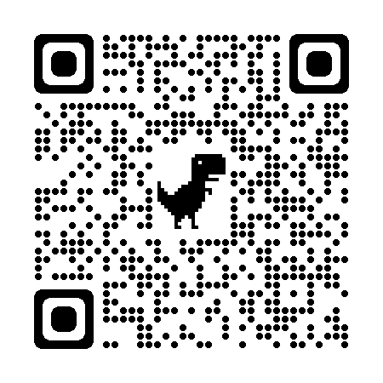

# [a-069]

## သံယုတ္တ အဋ္ဌကထာ(ခန္ဓဝဂ္ဂ)

## saṃyutta aṭṭhakathā(khandhavagga)

Link: https://bit.ly/3NfB2ZE

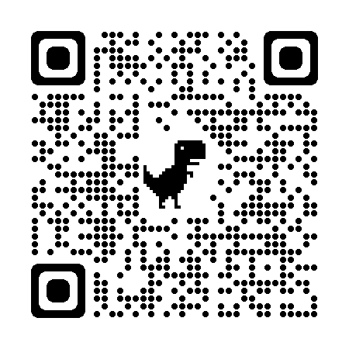

# [p-50002]

## အင်္ဂုတ္တရပါဠိ နိဿယ(ဒုတိယတွဲ)(စတုက္ကနိပါတိ)

## Aṅguttarapāḷi nissaya(4)

Link: https://bit.ly/3sEpvel

